ESG Emissions Analysis — Final Report

Introduction
This report presents an Environmental, Social, and Governance (ESG) emissions analysis for major industrial facilities, focusing on greenhouse gas (GHG) emissions across Scope 1, Scope 2, and Scope 3 categories. The objective of this analysis is to identify emission patterns, detect operational inefficiencies, evaluate sustainability risks, and recommend strategies that support Net Zero emission goals by 2050.

Objective of ESG Analysis
The primary objectives of the analysis are:
-To identify high-emitting facilities and dominant emission sources -To analyze quarterly emission trends and operational variability -To detect anomalies and inconsistencies in emissions reporting -To support sustainability-driven strategic decision-making -To recommend emission reduction strategies aligned with ESG and Net Zero goals

Methodology and Tools Used
The analysis was performed using:
Microsoft Excel (Pivot Tables, Charts, Dashboarding) Python (Pandas for data cleaning and preprocessing) Streamlit and Plotly for interactive dashboard visualization
The workflow included:
Data cleaning and validation Exploratory data analysis (EDA) Pivot-table based aggregation Dashboard visualization ESG risk assessment and strategic recommendation generation

Data Cleaning
The original dataset contained several inconsistencies: - Duplicate and conflicting facility IDs were checked and resolved for unique mapping. - Inconsistent GHG type symbols (e.g., CO₂, CH₄, N₂O) were standardized. - Decimal precision was unified for emissions values. - Missing values were identified and handled. - Scope and reporting period formats were validated and corrected. - Outliers were flagged and reviewed for accuracy.
These steps ensured a reliable foundation for analysis.

Key Findings
The analysis revealed several important ESG insights:
Adani Green and Tata Steel were identified as the highest cumulative emitters, contributing significantly to total emissions across reporting periods. Scope 3 emissions represented the largest share of total emissions, indicating substantial indirect environmental impact across supply chains and operational ecosystems. Scope 1 emissions also remained high, highlighting continued dependency on direct fuel combustion and carbon-intensive operations. Quarterly emission analysis showed emission peaks during 2022 Q2, followed by moderate reductions in later quarters; however, fluctuations remained inconsistent. CO₂ was identified as the dominant greenhouse gas contributor, followed by CH₄ and N₂O emissions. Several facilities demonstrated temporary reductions in emissions, but long-term consistency in sustainability performance was limited.
Dashboard visualizations and pivot-table analysis further highlighted operational hotspots and facility-level emission concentration patterns.

Challenges

1. High Emissions in Specific Facilities
- Adani Green and Tata Steel contribute disproportionately to total emissions levels. This indicates:
High operational intensity Large-scale industrial activity Dependence on fossil-fuel-based processes
These facilities represent major carbon reduction priority areas.

2. Scope 1 Emissions Dominance
High Scope 1 emissions indicate substantial direct operational emissions from:
Fuel combustion Industrial processing Energy-intensive manufacturing systems
This suggests the need for cleaner technologies and operational optimization.

3. Quarterly Emission Variability
- Significant quarter-to-quarter emission fluctuations suggest:
Inconsistent sustainability practices Variable production demand Operational inefficiencies Lack of stable carbon management frameworks
Such variability may increase ESG compliance and regulatory risks.

Recommendations

Net Zero Strategy
- Invest in energy-efficient machinery and process optimization.
- Accelerate renewable energy adoption (solar, wind, green electricity sourcing).
- Engage suppliers with strong ESG credentials to reduce Scope 3 emissions.
- Implement waste heat recovery and low-carbon logistics.

LCA (Life Cycle Assessment) Integration
- Evaluate emissions across the full product lifecycle.
- Prioritize sustainable material sourcing and increase recycled content.
- Require supplier ESG audits and integrate LCA into procurement decisions.

Future Scope
Future enhancements may include:
AI-based emission forecasting models Real-time ESG monitoring dashboards Predictive sustainability analytics Carbon neutrality simulation models Automated anomaly detection systems
These approaches can strengthen data-driven ESG decision-making.

Charts
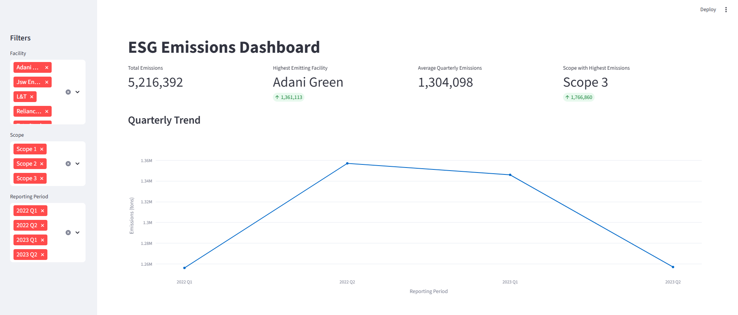
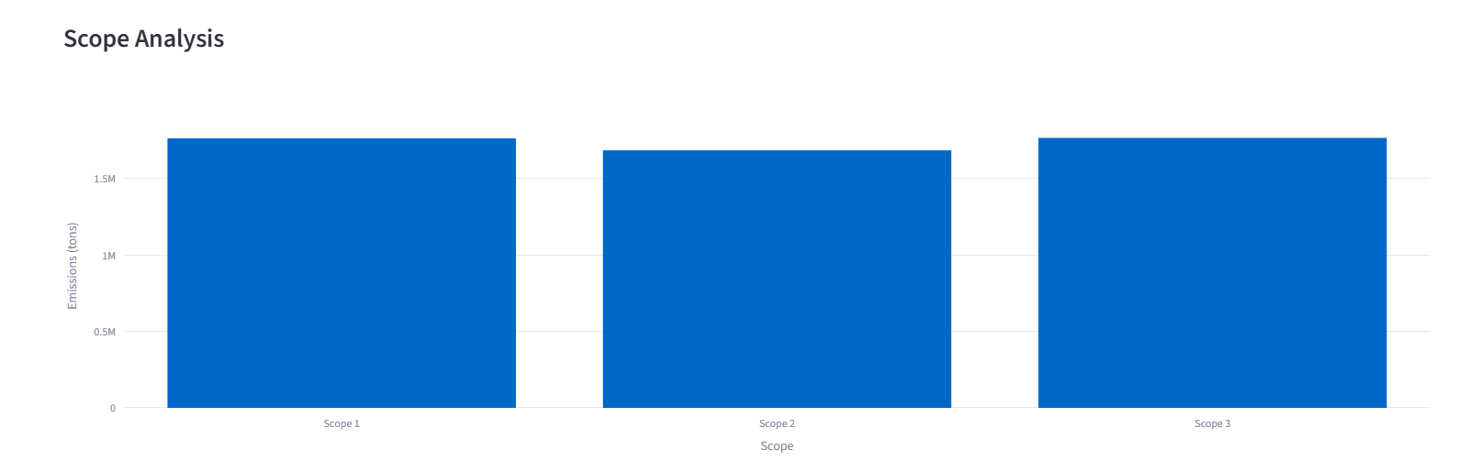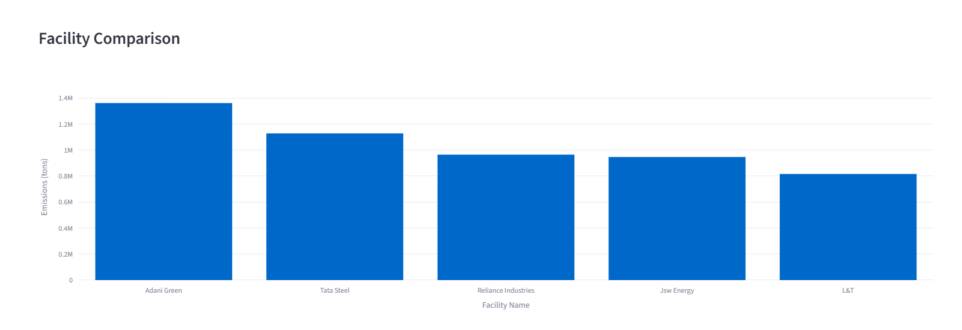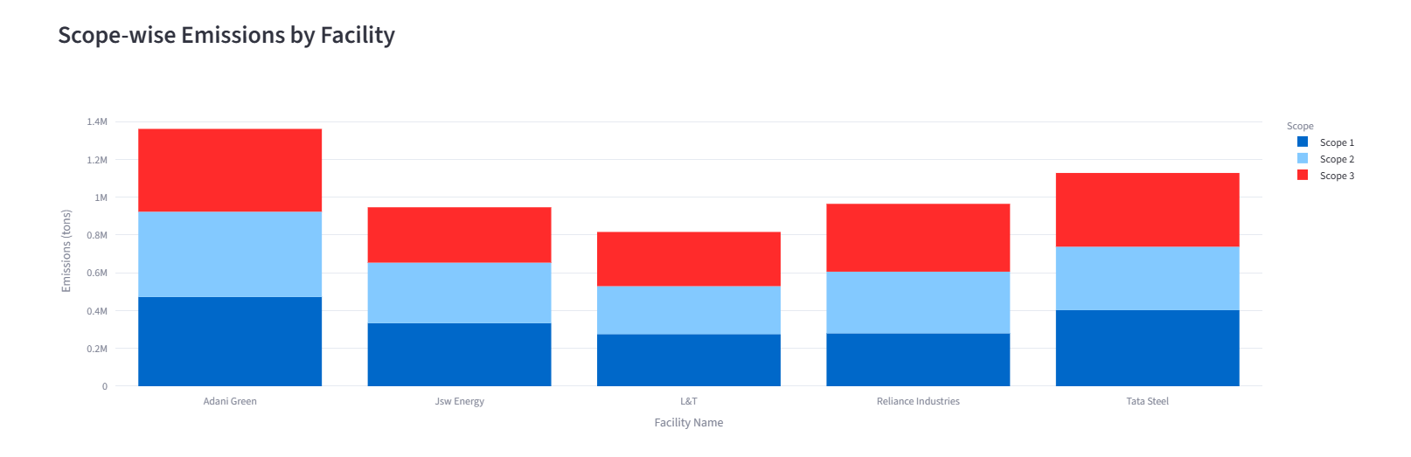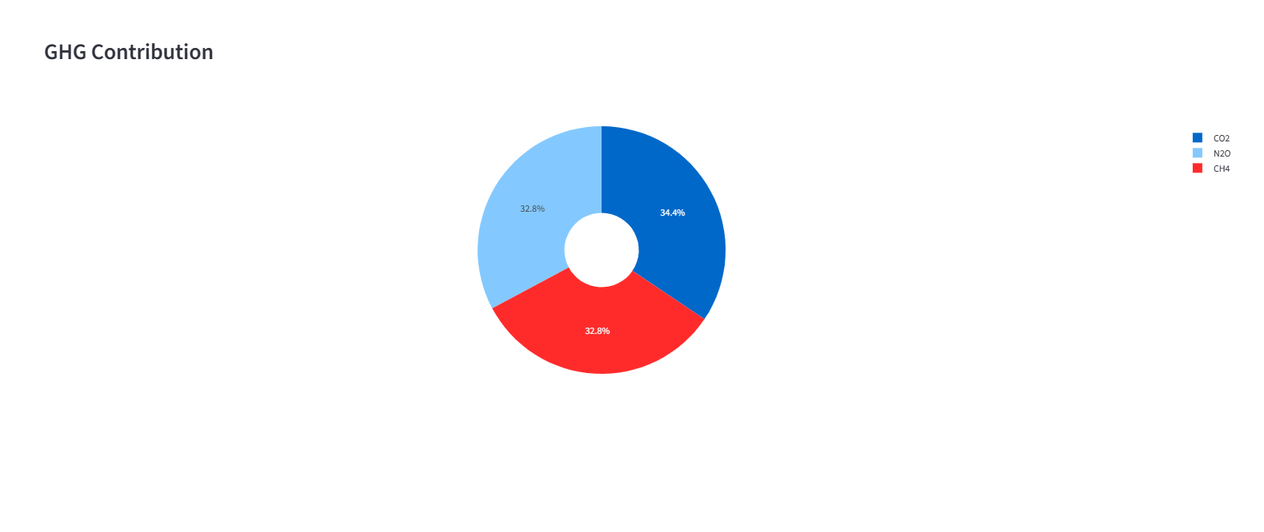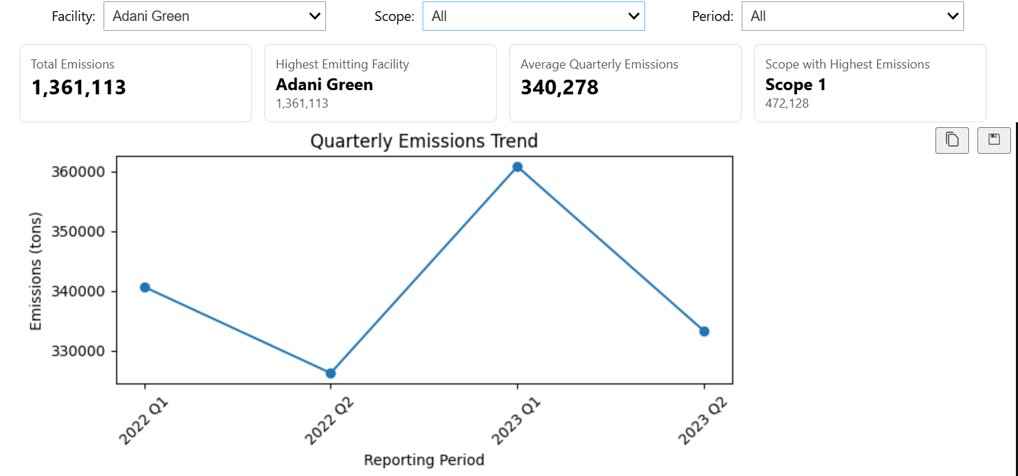

Conclusion
The analysis highlights both progress and persistent challenges in emissions management. While some reduction is evident, high emissions from key facilities and operational variability must be addressed. A robust Net Zero strategy, combined with LCA integration, will be essential for long-term sustainability and regulatory compliance.

