**Creating Microservices for account and loan**

**Account Microservice:**

AccountController.java

~Import this project in Eclipse and implement a controller method for getting account details based on account number.

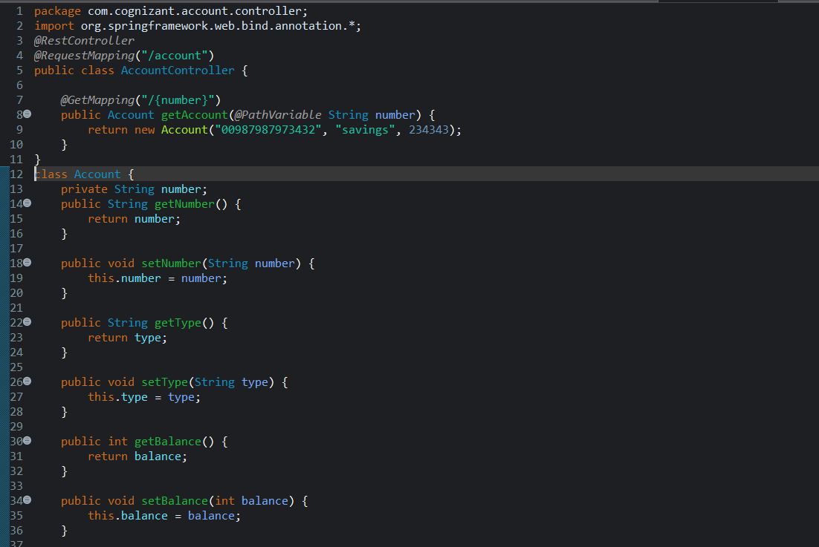

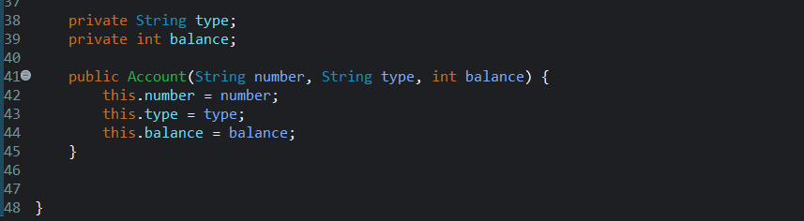

**Open command prompt in account folder and build using mvn clean package command:**

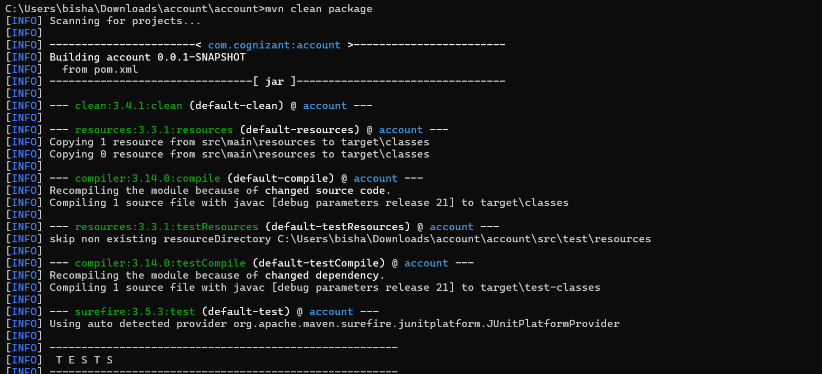

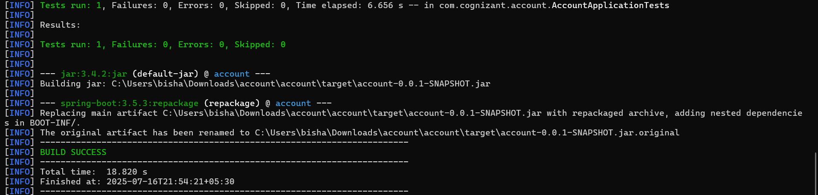

Output

Launch by running the application class and test the service in browser

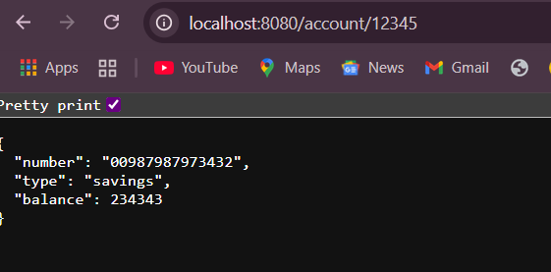

**Loan Microservice:**

LoanController.java

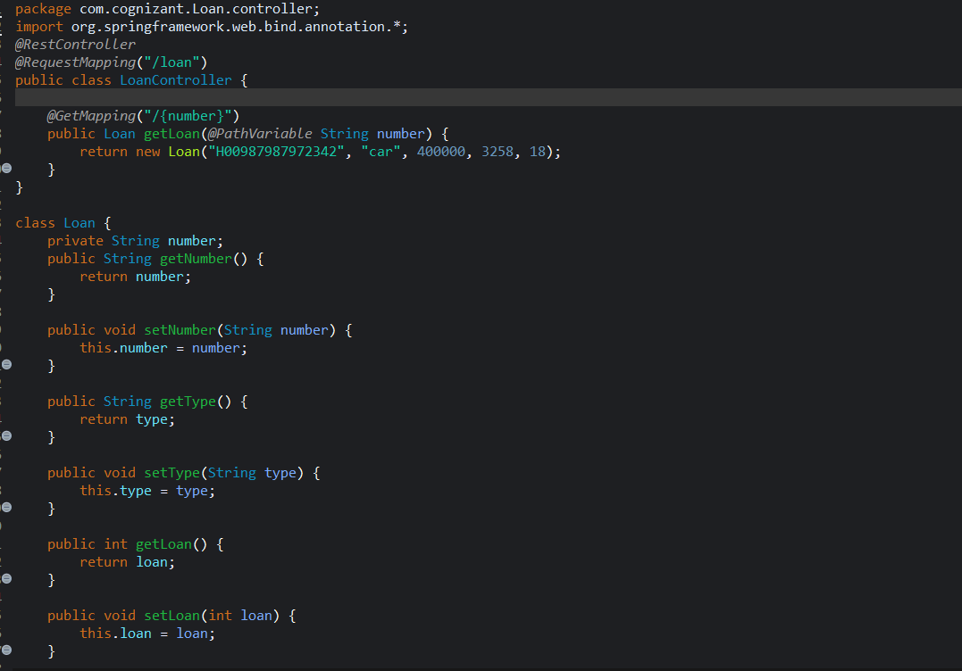

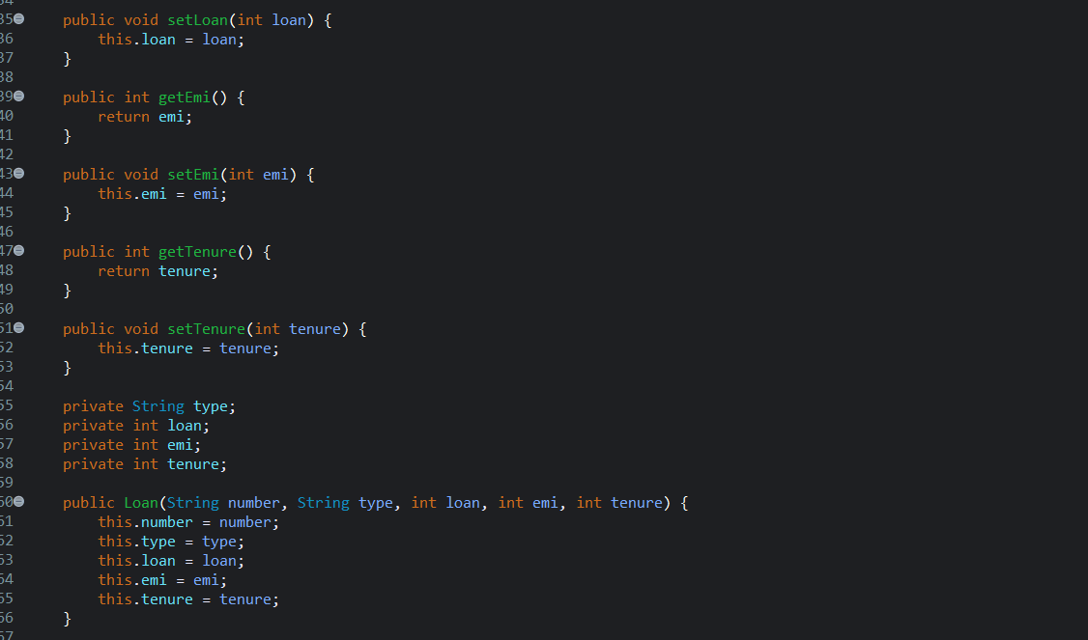

Application.properties

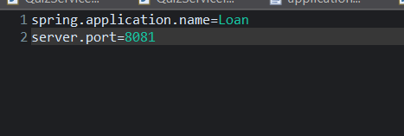

Open command prompt in loan folder and build using mvn clean package command:

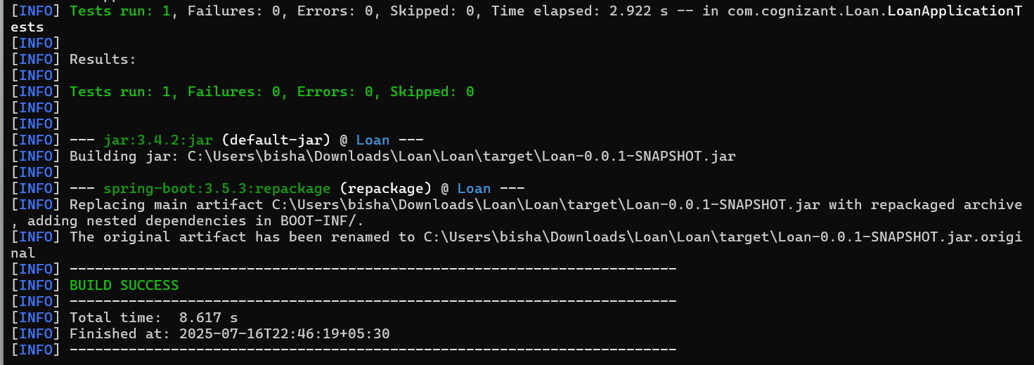

Output

