REACT-09
Objectives

- List the features of ES6
- Explain JavaScript let
let allows you to declare block-scoped variables.It can be updated but not re-declared in the same scope.

- Identify the differences between var and let
Var is a function based scope.It allows re-declaration,it is not applicable for temporal dead zone
Let is a block scoped,it does not allow re declaration,It exists until initialization of temporal dead zone.
- Explain JavaScript const
const creates a read-only reference to a value. Must be initialized during declaration.

- Explain ES6 class fundamentals
Instead of using constructor functions and prototypes like we did before, we can now define a class with a constructor() method to initialize values, and then just add methods inside the class body
- Explain ES6 class inheritance
ES6 class fundamentals means , If I want one class to inherit from another, I just use extends, and then I can call the parent class’s constructor using super(). This allows the child class to access properties and methods from the parent
- Define ES6 arrow functions
Arrow functions in ES6 are a shorthand way to write functions using the => syntax . we can inherit this from their surrounding scope, which is super helpful in scenarios like event handlers or callbacks inside class methods where this can be tricky.
- Identify set(), map()
SET:Collection of unique values (no duplicates). Order is preserved.
MAP:Collection of key-value pairs.Keys can be any type (objects, functions, etc).

In this hands-on lab, you will learn how to:
- Use map() method of ES6
- Apply arrow functions of ES6
- Implement Destructuring features of ES6
Prerequisites

The following is required to complete this hands-on lab:
- Node.js
- NPM
- Visual Studio Code

Notes

Estimated time to complete this lab: 60 minutes.
Create a React Application named “cricketapp” with the following components:
- ListofPlayers
- Declare an array with 11 players and store details of their names and scores using the map feature of ES6

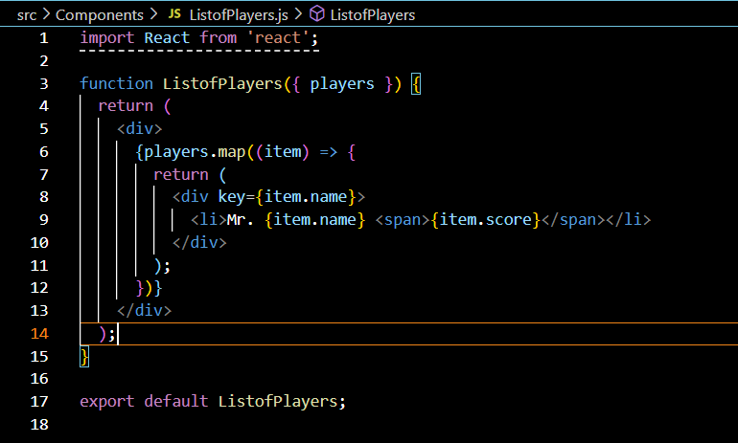

- Filter the players with scores below 70 using arrow functions of ES6.

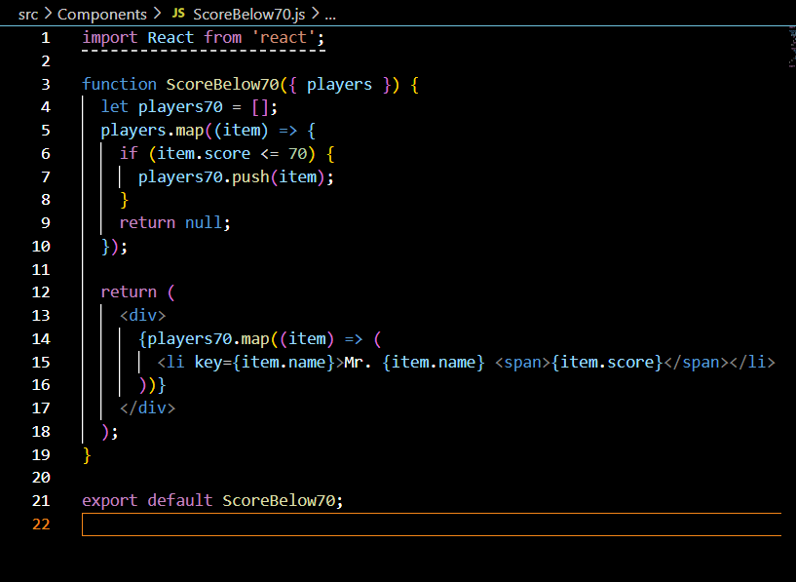

- IndianPlayers

  - Display the Odd Team Player and Even Team players using the Destructuring features of ES6
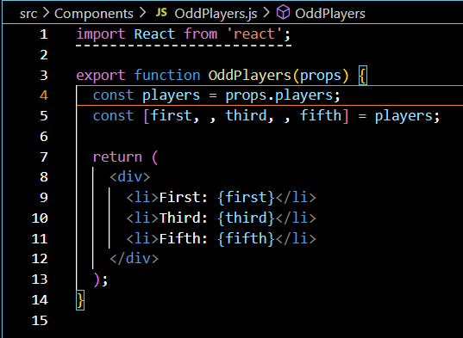
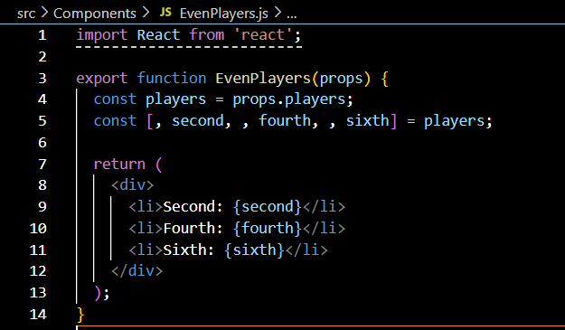

  - Declare two arrays T20players and RanjiTrophy players and merge the two arrays and display them using the Merge feature of ES6
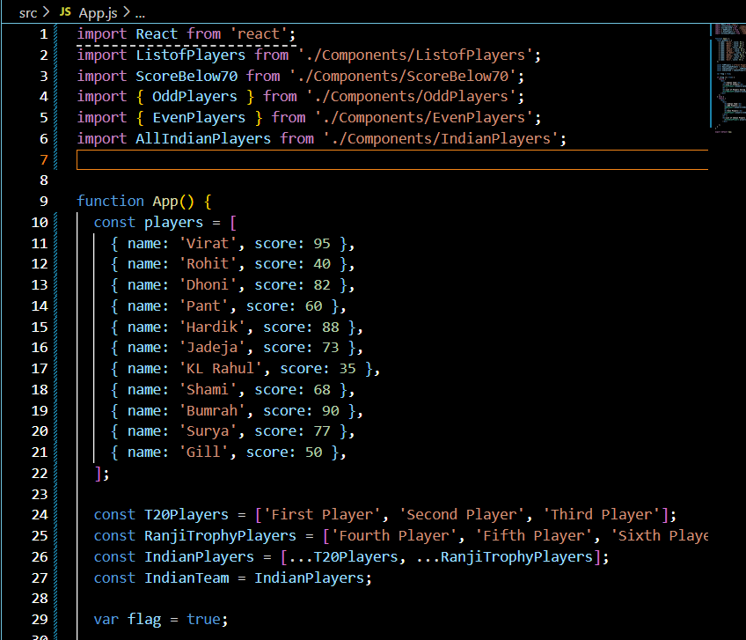
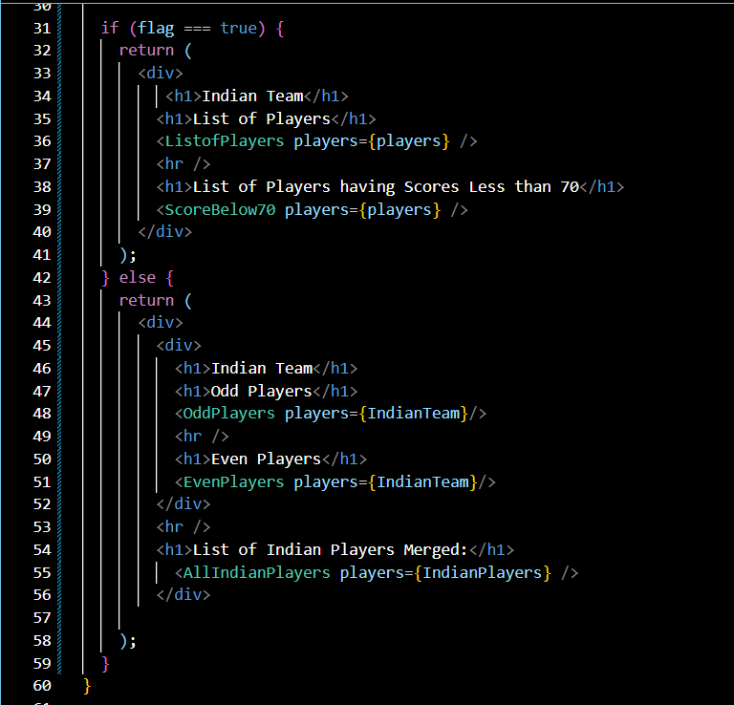

Display these two components in the same home page using a simple if else in the flag variable.
Output:
When Flag=true
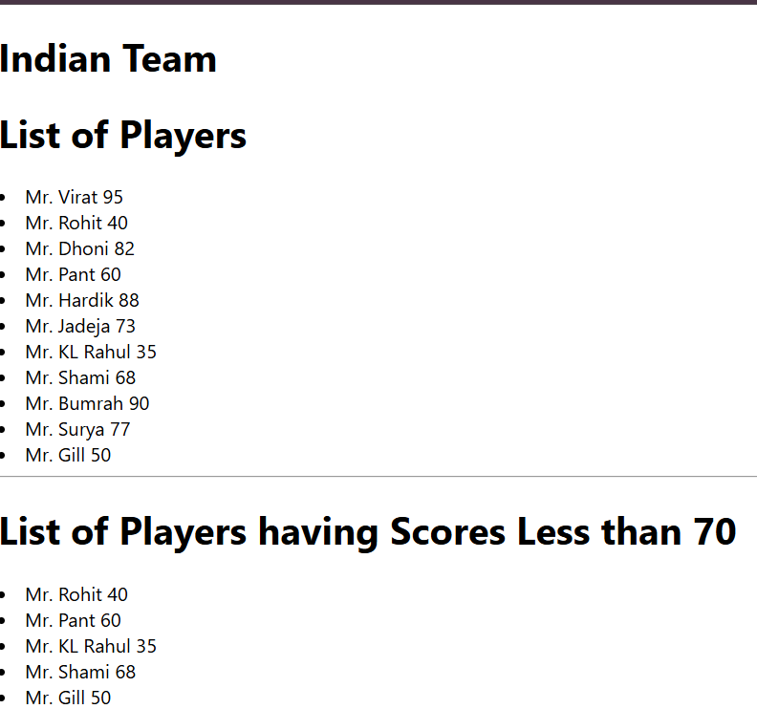

When Flag=false

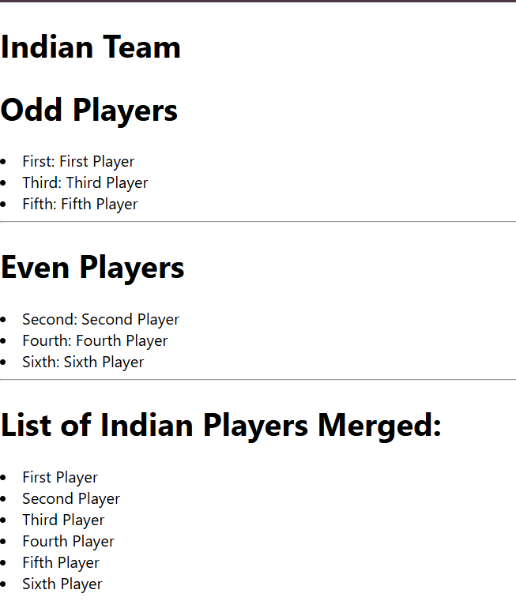

REACT-10
Objectives

- Define JSX
JSX (JavaScript XML) is a syntax extension for JavaScript used with React to describe what the UI should look like. It allows writing HTML elements in JavaScript and placing them in the DOM.
- Explain about ECMA Script
ECMAScript (ES) is the scripting language standard used by JavaScript. Modern JavaScript (ES6 and above) includes features like:let and const,arrow function etc.
- Explain React.createElement()
React.createElement() is the core API that JSX compiles down to.
- Explain how to create React nodes with JSX
It can be created like:
const element = <h1>{office.Name}</h1>;
- Define how to render JSX to DOM
We can use reactDom.render() to render JSX elements to the DOM
ReactDOM.render(<App />, document.getElementById('root'));
- Explain how to use JavaScript expressions in JSX
JSX supports using javasrcipt expressions by writing inside{} this:
<h3>Rent: {office.Rent}</h3>
- Explain how to use inline CSS in JSX
const style = { color: 'red' };
<h3 style={style}>Rent: Rs. 50000</h3>

In this hands-on lab, you will learn how to:
- Use JSX syntax in React applications
- Use inline CSS in JSX
Prerequisites

The following is required to complete this hands-on lab:
- Node.js
- NPM
- Visual Studio Code

Notes

Estimated time to complete this lab: 60 minutes.
Create a React Application named “officespacerentalapp” which uses React JSX to create elements, attributes and renders DOM to display the page.

Create an element to display the heading of the page.
Attribute to display the image of the office space
Create an object of office to display the details like Name, Rent and Address.
Create a list of Object and loop through the office space item to display more data.
To apply Css, Display the color of the Rent in Red if it’s below 60000 and in Green if it’s above 60000.
App.js
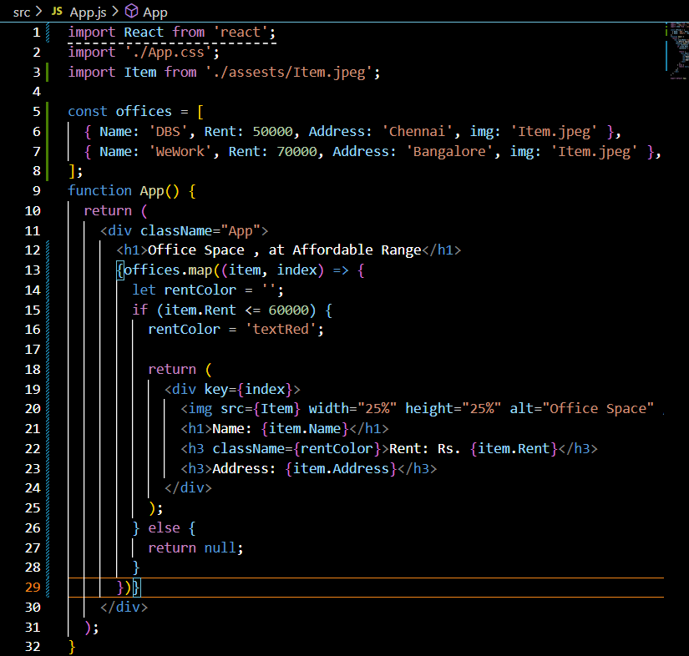

App.css
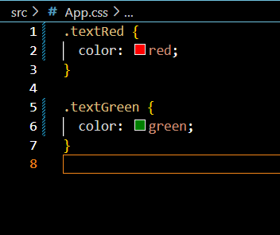

Output:


REACT-11
Objectives

- Explain React events
React events are objects that behave similarly to DOM events (like onClick, onChange, etc.) but are wrapped in a SynthethicEvent wrapper provided by React
- Explain about event handlers
Event handlers are functions in React that get triggered when a specific event (like a click or form submission) happens. They are usually defined as methods in class components or functions in functional components.
- Define Synthetic event
A SyntheticEvent is React's cross-browser wrapper around the browser's native event. It ensures consistency and provides a normalized set of properties and methods across different browsers.
- Identify React event naming convention
In React, event names use camelCase instead of lowercase. Also, instead of passing a string, a function reference is passed.

In this hands-on lab, you will learn how to:
- Implement Event handling concept in React applications
- Use this keyword
- Use synthetic event
Prerequisites

The following is required to complete this hands-on lab:
- Node.js
- NPM
- Visual Studio Code

Notes

Estimated time to complete this lab: 90 minutes.

Create a React Application “eventexamplesapp” to handle various events of the form elements in HTML.

- Create “Increment” button to increase the value of the counter and “Decrement” button to decrease the value of the counter. The “Increase” button should invoke multiple methods.
  - To increment the value
  - Say Hello followed by a static message.
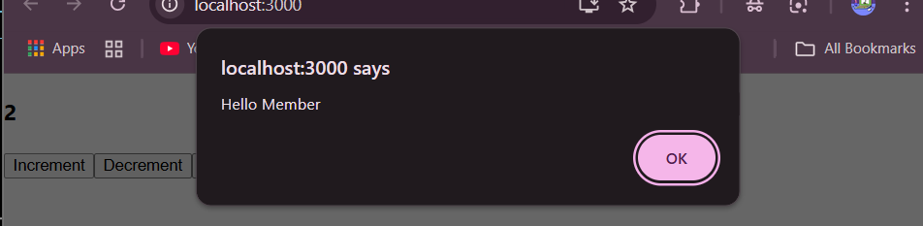

- Create a button “Say Welcome” which invokes the function which takes “welcome” as an argument.

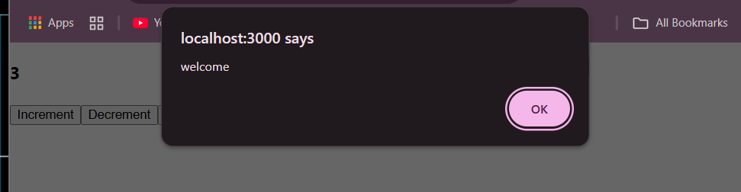

- Create a button which invokes synthetic event “OnPress” which display “I was clicked”

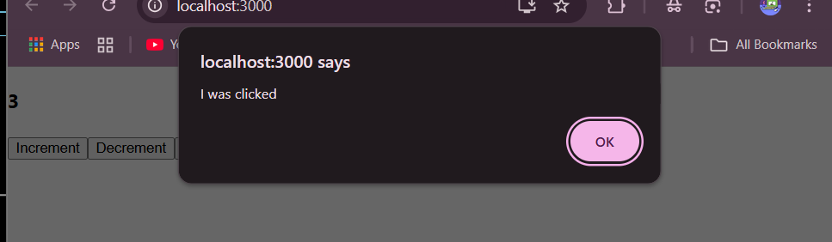

App.js
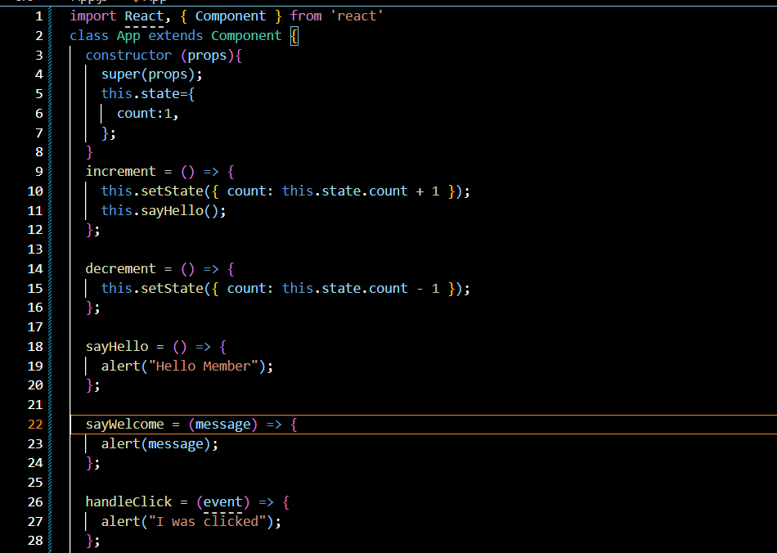
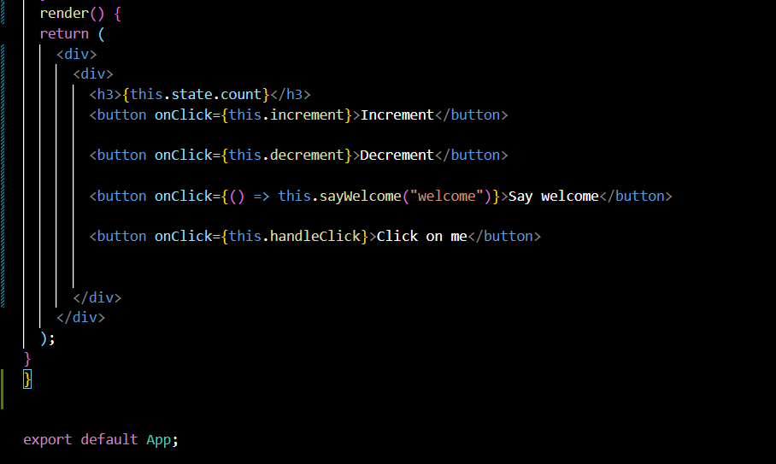

Create a “CurrencyConvertor” component which will convert the Indian Rupees to Euro when the Convert button is clicked.

Handle the Click event of the button to invoke the handleSubmit event and handle the conversion of the euro to rupees.
CurrencyConvertor.js
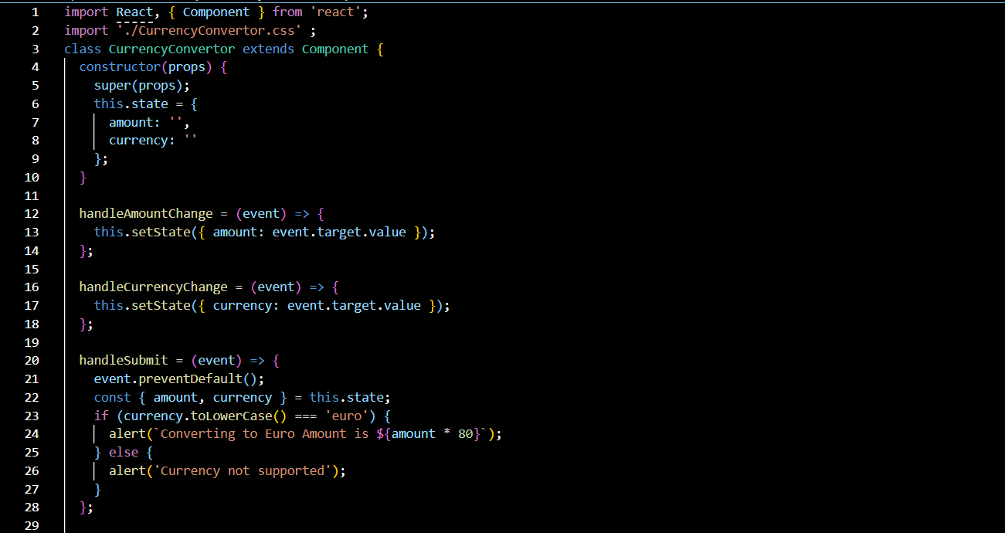
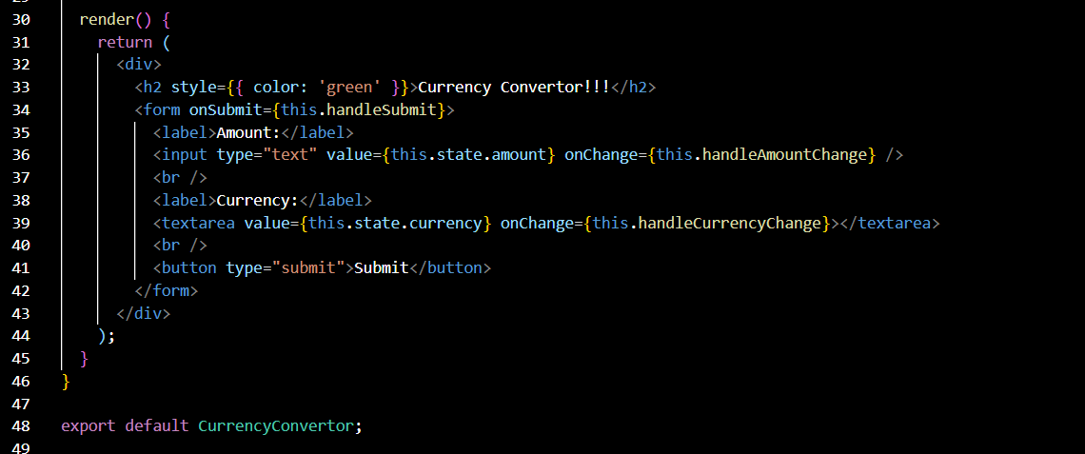

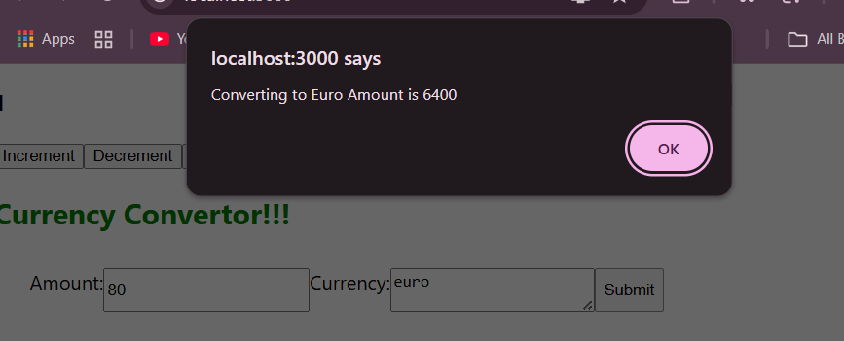
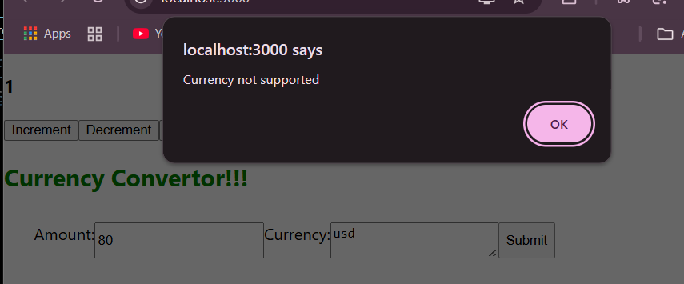

REACT-12
Objectives

- Explain about conditional rendering in React
Conditional rendering in React means showing different UI elements or components based on a condition.In JSX we can do it by-IF ELSE, TERNARY OPERATOR, LOGICAL OPERATOR.
- Define element variables
Element variables hold JSX and help render different elements conditionally.
- Explain how to prevent components from rendering
We can return null in a component to prevent it from rendering.

In this hands-on lab, you will learn how to:
- Implement conditional rendering in React applications

Prerequisites

The following is required to complete this hands-on lab:
- Node.js
- NPM
- Visual Studio Code

Notes

Estimated time to complete this lab: 60 minutes.
Create a React Application named “ticketbookingapp” where the guest user can browse the page where the flight details are displayed whereas the logged in user only can book tickets.

The Login and Logout buttons should accordingly display different pages. Once the user is logged in the User page should be displayed. When the user clicks on Logout, the Guest page should be displayed.

PROJECT STRUCTURE:
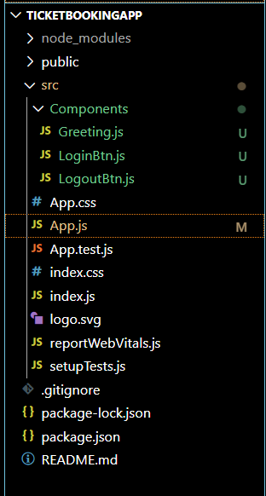

App.js
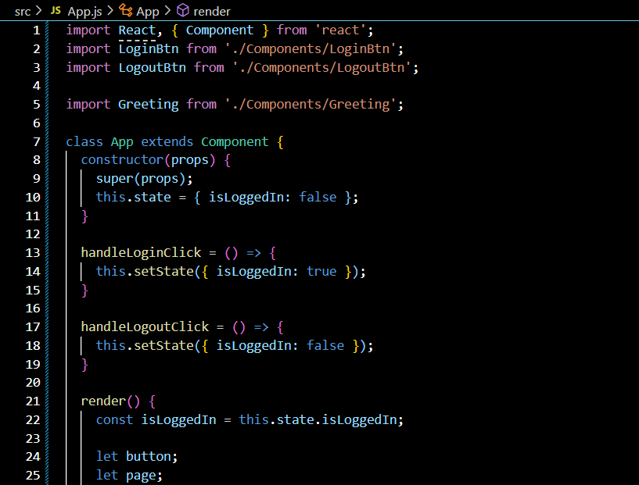
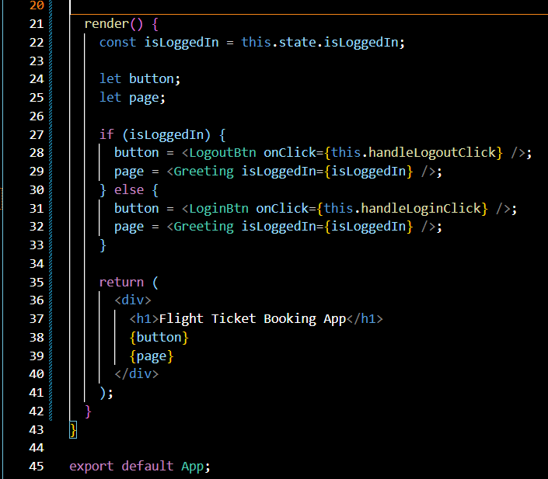

Greeting.js
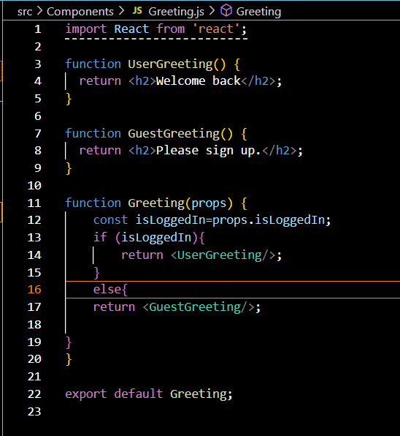
LoginBtn.js
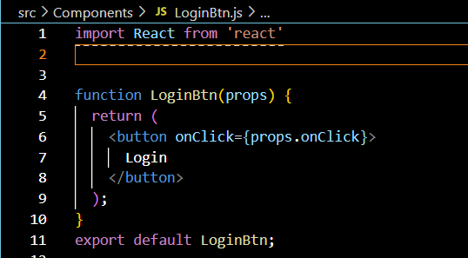

LogoutBtn.js
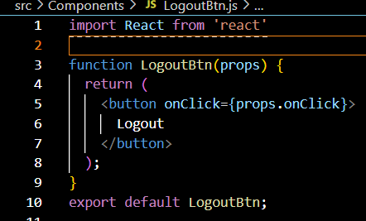

OUTPUT:

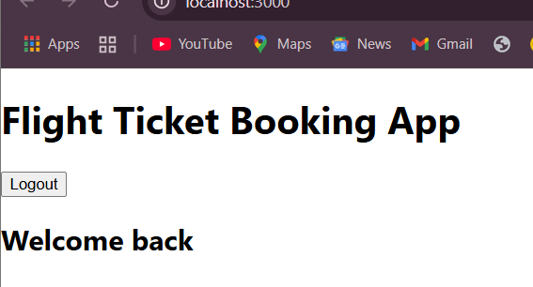

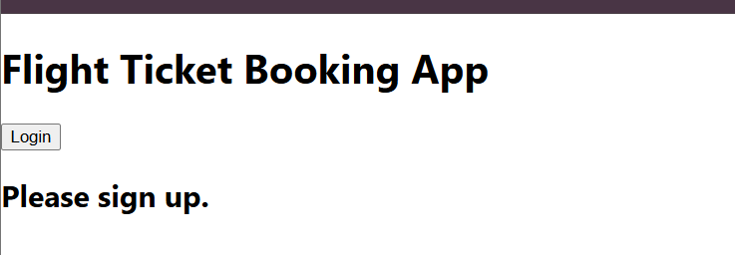

REACT-13
Objectives

- Explain various ways of conditional rendering
The various ways of using Conditional rendering are:
Using If-Else,Ternary Operator,Using logical operator
- Explain how to render multiple components
We can render multiple components inside a parent component using JSX.
- Define list component
A list component displays a list of items using the map() function.
- Explain about keys in React applications
Keys are unique identifiers assigned to elements in a list. React uses them to identify which items changed, added, or removed

- Explain how to extract components with keys
We can extract a list item into a separate component and still use key in the parent list:
- Explain React Map, map() function
The map() function in React is used to loop over arrays and return JSX for each item.

In this hands-on lab, you will learn how to:
- Implement conditional rendering in React applications

Prerequisites

The following is required to complete this hands-on lab:
- Node.js
- NPM
- Visual Studio Code

Notes

Estimated time to complete this lab: 60 minutes.
Create a React App named “bloggerapp” in with 3 components.

- Book Details.js
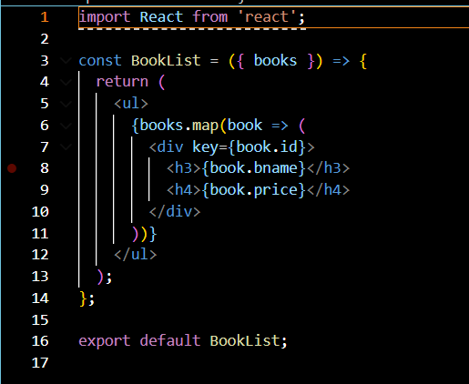
- Blog Details
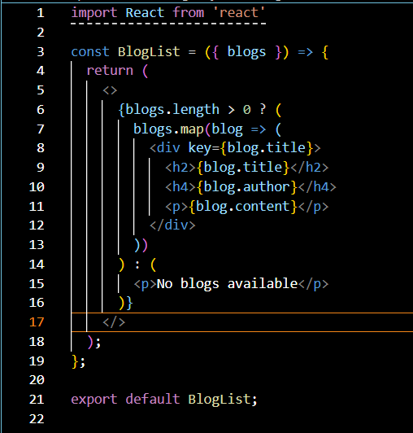
- Course Details
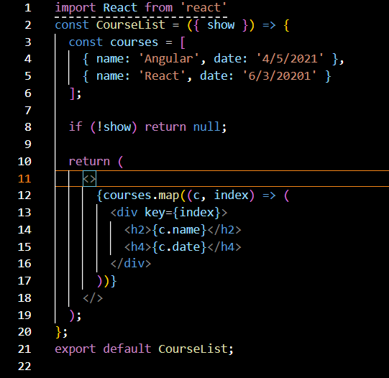

OUTPUT:

