# GANASALESLITE

(Web Based Sales and Customer Management System)

**BY**

**Pranish Sris**

**TU Roll Number: 14208/21**

**TU Registration Number: 7-2-559-45-2021**

**And**

**Bishal Somare**

**TU Roll Number: 14196/21**

**TU Registration Number: 7-2-559-33-2021**

Oxford College, Butwal

*A Project Report Submitted to*

**Faculty of Management, Tribhuvan University**

in partial fulfillment the requirement for the degree of

**Bachelor of Information Management (BIM)**

Butwal

May, 2025

# STUDENT DECLARATION

This is to certify that we have completed the Project entitled “**GanaSalesLite: for Ganapati Enterprise**” under the guidance of **Mr. Suraj Khatri** in partial fulfillment of the requirements for the degree of Bachelor of Information Management at Faculty of Management, Tribhuvan University. This is our original work and we have not submitted it earlier elsewhere.

Signature:………………………..  
Name:

Name: Pranish Sris

Date: 2025/05/16

Signature:………………………   
Name:

Name: Bishal Somare

# CERTIFICATE FROM THE SUPERVISOR

This is to certify that the project entitled “**GanaSalesLite**” is an academic work done by **Pranish Sris** and **Bishal Somare** submitted in the partial fulfillment of the requirements for the degree of Bachelor of Information Management at Faculty of Management, Tribhuvan University under my guidance and supervision. To the best of my knowledge, the information presented by them in the project report has not been submitted earlier.

……………………………

Signature of the Supervisor

Name: Suraj Khatri

Designation: Lecturer at Oxford College, Butwal

Date:

# APPROVAL SHEET

This is to certify that the project titled “**GanaSalesLite**” submitted by**Pranish Sris**and **Bishal Somare** has been examined and approved. In our opinion, it meets the required scope and quality standards for a project submitted in partial fulfillment of the requirements for the degree of Bachelor of Information Management (BIM).

Approval Panel:

|  |  |  |  |
| --- | --- | --- | --- |
| **S.N** | **Name** | **Designation** | **Signature** |
| 1. | Suraj Khatri | Project Supervisor |  |
| 2. | Lalit Ashok Gurung | Program Head |  |
| 3. | Manoj Marasini | Campus Chief |  |
| 4. | Om Bhadhur Khatri | Internal Examiner |  |
| 5. | Bikash Balami | External Examiner |  |

Date of Defense: ……………………

Department:

Faculty: Management

# COLLEGE RECOMMENDATION LETTER

# ACKNOWLEDGEMENTS

The successful completion of this project, “**GanaSalesLite**” is the culmination of dedicated effort, guidance, and support from various individuals, to whom we extend our deepest gratitude.

First and foremost, we are immensely grateful to our project supervisor **Mr. Suraj Khatri**, for his invaluable guidance, constructive feedback, and unwavering support throughout the project lifecycle. His insights and expertise were instrumental in shaping this project and navigating challenges.

We would like to express our sincere thanks to **Mr. Lalit Ashok Gurung**, Program Coordinator (BIM), and the **Faculty of Management, Tribhuvan University**, for providing us with the opportunity to undertake this project as part of our curriculum and for their continuous encouragement.

Our heartfelt appreciation goes to **Oxford College**, **Butwal**, for providing the necessary resources and a conducive learning environment.

We are also thankful to **Ganapati Enterprise** for allowing us to understand their operational context, which formed the basis of this project.

**Name:** Pranish Sris

**TU Roll Number:** 14208/21 TU

**Registration Number:** 7-2-559-45-2021

**Name:** Bishal Somare

**TU Roll Number:** 14196/21 TU

**Registration Number:** 7-2-559-33-2021

# ABSTRACT

*Small and Medium Enterprises (SMEs) like Ganapati Enterprise often face challenges in efficiently managing their sales and customer data due to reliance on manual processes or overly complex software. This project, “GanaSalesLite” presents a streamlined Sales and Customer Management System designed specifically for the single user (admin) of Ganapati Enterprise. The system aims to automate and simplify core business operations, including product management, customer record keeping, sales transaction entry, billing, and basic inventory overview and sales reporting.*

*Developed using the itterative waterfall model, GanaSalesLite employs a technology stack comprising Python with the Django framework for the backend, postgresql for database management, and HTML, CSS, and JavaScript for a responsive and user-friendly frontend. The system focuses on providing essential functionalities without the overhead of features typically found in larger ERP**systems, making it suitable for a small-scale enterprise with a single primary user.*

Keywords: Web based application, Dynamic user interface, improve data accuracy, day-to-day business activities, provide better insights through simple reports, enhance operational efficiency.

**TABLE OF CONTENTS**

GANASALESLITE i

STUDENT DECLARATION ii

CERTIFICATE FROM THE SUPERVISOR iii

APPROVAL SHEET iv

COLLEGE RECOMMENDATION LETTER v

ACKNOWLEDGEMENTS vi

ABSTRACT vii

TABLE OF CONTENTS viii

LIST OF FIGURES x

LIST OF TABLES xi

LIST OF ABBREVIATIONS xii

CHAPTER ONE: INTRODUCTION 1

1.1 Project Background 1

1.2 Problem Statement 1

1.3 Objectives 2

1.4 Review of Related Work and Literature 2

1.5 Development Methodology 4

1.6 Scope and Limitations 5

1.6.1 Scope 5

1.6.2 Limitations 5

1.7 Report Organization 5

CHAPTER TWO: SYSTEM DEVELOPMENT PROCESS 7

2.1 Analysis 7

2.1.1 Requirement Analysis 7

2.1.2 Feasibility Study 8

2.1.3 Modelling 9

2.2 Design 12

2.2.1 UI Design 12

2.2.2 Database Design 13

2.3 Implementation 13

2.3.1 Tools and Technologies Used 14

2.3.2 Module Description 15

2.3.3 Testing 16

CHAPTER THREE: CONCLUSION AND RECOMMENDATION. 20

3.1 Summary 20

3.2 Conclusion 21

3.3 Recommendation 22

REFERENCES 24

APPENDICES 25

# LIST OF FIGURES

Figure 1.1: Itterative Waterfall Model 4

Figure 2.1: Use Case Diagram 10

Figure 2.2: Sales Processing 11

Figure 2.3: Activity for Product Management 12

Figure 2.4: Sequence Diagram 13

Figure 2.5: ER Diagram 15

# LIST OF TABLES

Table 2. 1: Tools and Technologies Used in GanaSalesLite Development 17

Table 2. 2: Sample Test Case-Login Module 19

Table 2. 3: Sample Test Case-Product Management 20

Table 2. 4: Sample Test Case-Sales and Billing Module 20

Table 2. 5: Sample Test Case-Reporting Module 21

# LIST OF ABBREVIATIONS

|  |  |
| --- | --- |
| ADMIN | Administrator |
| AJAX | Asynchronous JavaScript and XML |
| BIM | Bachelor of Information Management |
| CRM | Customer Relationship Management |
| CSS | Cascading Style Sheets |
| ER | Entity-Relationship |
| ERP | Enterprise Resource Planning |
| HTML | Hyper Text Markup Language |
| JS | JavaScript |
| ORM | Object-Relational Mapping |
| SMEs | Small and Medium Enterprises |
| TU | Tribhuvan University |
| UI | User Interface |
| UML | Unified Modeling Language |
| VS Code | Visual Studio Code |

# CHAPTER ONE: INTRODUCTION

## Project Background

In today’s competitive business environment, efficient management of sales, customer relationships, and inventory is crucial for the success and sustainability of any enterprise, regardless of its size. SMEs often struggle with these aspects due to limited resources, reliance on manual record-keeping, or the use of disparate, non-integrated tools. Ganapati Enterprise a cosmetics distributor located in Devdaha, currently manages its operations using traditional methods, which can be time-consuming, prone to errors, and may not provide timely insights for decision-making.

The “GanaSalesLite” project is conceived to address these challenges by developing a dedicated sales and customer management system tailored to the specific needs of Ganapati Enterprise. The system is designed for a single user the owner/admin to provide a simple, intuitive, and effective tool for managing daily business operations. By automating key processes such as product tracking, customer data management, sales recording, and basic reporting, GanaSalesLite aims to empower Ganapati Enterprise with better control and visibility over its business.

## Problem Statement

Ganapati Enterprise currently faces several operational inefficiencies due to its manual process for managing sales and customer interactions. The primary problems identified are:

* **Inefficient data management:** Tracking product details, customer information, and sales transactions manually (e.g., in ledgers or basic spreadsheets) is laborious and susceptible to human error. This can lead to inaccurate records and difficulty in retrieving information quickly.
* **Time consuming sales process:** Generating bills, updating inventory after each sale, and tracking customer purchase history by hand consumes significant time that could be utilized for other core business activities.
* **Lack of real-time inventory overview:**Manual tracking makes it difficult to ascertain current stock levels accurately, potentially leading to stock-outs or overstocking, both of which impact the fulfillment of the customer on demands requirements.
* **Difficulty in generating reports:** Extracting meaningful insights from manual records to understand sales , products.
* **No centralized system:**Information might be scattered across different physical books or files, making it hard to get a holistic view of the business operations.

The proposed “GanaSalesLite” system aims to provide a centralized, user-friendly solution to these problems, specifically for the single owner/admin of Ganapati Enterprise.

## Objectives

* To simplify daily business operations by automating sales, customer, and product management tasks.
* To provide a centralized and secure platform for managing reliable business information
* To assist in informed decision-making through dashboards, reports, and stock alerts.
* To ensure ease of use and accuracy, making the system accessible even to non-technical users.

## Review of Related Work and Literature

Sales and customer management systems play a crucial role in helping businesses maintain competitiveness, optimize service delivery, and improve customer satisfaction. The need for integrated systems that manage both sales operations and customer data has led to the development of various CRM and sales tracking platforms.

1. **Customer Relationship Management (CRM) Systems**

CRM systems are designed to facilitate the efficient management of customer interactions, service processes, and data analytics. (Buttle & Maklan, 2019) emphasized that CRM systems help businesses in organizing and automating marketing, sales, and customer support processes. Popular tools like Salesforce and Zoho CRM provide powerful automation, lead tracking, and data analysis features. However, many of these platforms are resource-intensive, costly, and may not be suitable for SMEs.

1. **Sales Management and Performance Tracking**

(Kotler & Keller, 2016) highlighted the importance of effective sales management systems in enhancing sales team performance, forecasting demand, and improving customer acquisition. Sales management tools like pipedrive and freshsales offer lead scoring, sales pipeline visualization, and performance analytics. While feature-rich, such tools often come with limited customization for niche business needs.

1. **Gaps in Existing Solutions**

Despite the presence of multiple commercial tools, many businesses still face challenges such as high licensing costs, lack of localized features, and difficulty integrating sales data with customer service tools (Chaffey, 2018). SMEs, in particular, often require affordable, customizable, and web-based platforms tailored to their specific workflows.

1. **Benefits of Web-Based Systems**

Web-based systems offer real-time access, centralized databases, and seamless updates, which make them ideal for dynamic business environments. They eliminate the need for complex installations and reduce operational costs. According to Laudon and Laudon, web-based systems also support greater scalability and flexibility compared to traditional desktop applications.

1. **Technological Framework**

Modern development frameworks such as Django, JavaScript, and PostgreSQL allow developers to create secure, maintainable, and scalable web- based systems. These technologies facilitate the development of customized dashboards, notification systems, billing features, and customer tracking mechanisms, offering an all-in- one solution for SMEs.

## Development Methodology

The iterative waterfall model has been implemented in the development process of “GanaSalesLite”. The iterative waterfall Model is a software development approach that combines the sequential steps of the traditional waterfall model with the flexibility of iterative design.

It allows for improvements and changes to be made at each stage of the development process, instead of waiting until the end of the project.

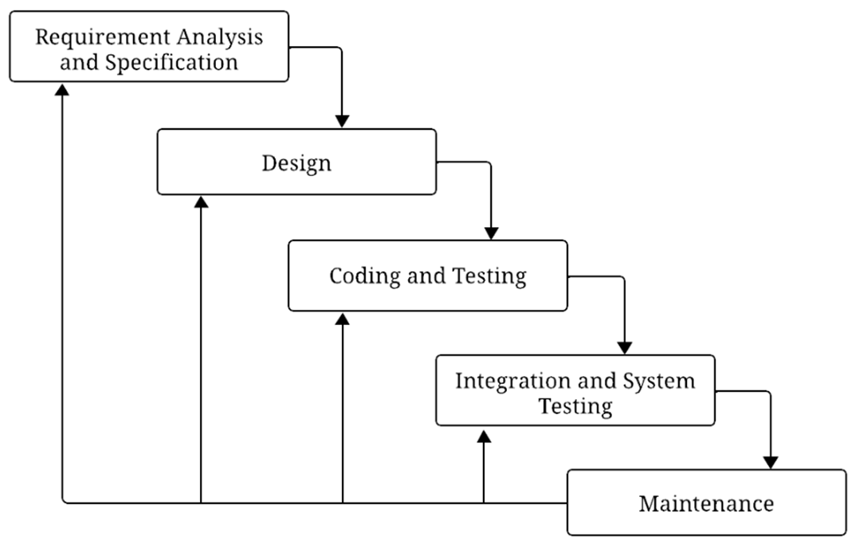

**Figure 1.1: Itterative Waterfall Model**

## Scope and Limitations

Scope defines the broader parameters and boundaries of the project, while limitations are the factors and variables not included in the project. Here is the description of scope and limitation of the system.

### 1.6.1 Scope

The scope of "GanaSalesLite" within Ganapati Enterprises encompasses the sales and customer management domain, focusing on enhancing inventory management planning, execution, and monitoring. It includes robust record-keeping functionality for efficient management of product and customer related information.

### 1.6.2 Limitations

While “GanaSalesLite” is designed for small and medium scaled enterprises, there are certain things it does not cover.

* It is a single-user system, meant for use by the admin only. Currently it does not support multiple user logins or roles with different permissions.

* “GanaSalesLite” does not handle payment processing. It cannot connect with credit card machines or online payment gateways. It only records transactions.

## Report Organization

This project report for “GanaSalesLite: A Sales and Customer Management System for Ganapati Enterprise” is structured into several key parts to provide a clear and comprehensive overview of the project from its conception to its conclusion.

The report begins with preliminary sections such as the Title Page, Student Declaration, Certificate from the Supervisor, Approval Sheet, Acknowledgements, Abstract, Table of Contents, List of Figures, List of Tables, and a List of Abbreviations used throughout the document.

Following these, the main body of the report is divided into three primary chapters**:**

* **Chapter I: Introduction**

This chapter sets the stage for the project. It starts with the background of the project, explaining the context and need for a system like “GanaSalesLite” for Ganapati Enterprise. It then clearly defines the problem statement that the project aims to address, followed by the main, general, and Specific Objectives of the system. A review of related work and literature is presented, discussing existing similar systems and relevant theoretical concepts. The development methodology chosen for the project itterative waterfall model is explained along with its justification. Finally, this chapter outlines the scope and limitations of “GanaSalesLite,” detailing what the system will and will not cover, and concludes with this section on Report Organization.

* **Chapter II: System Development Process**

This chapter explores the practical journey of creating “GanaSalesLite” using the iterative waterfall model. It is organized into iterative phases, with each phase building upon the previous one. The Analysis subsection details the process of requirement gathering (both functional and non-functional requirements) and the feasibility study (technical, operational, and economic) conducted in the initial iteration, including system modeling artifacts like use case diagrams and activity diagrams to illustrate system behavior. The design subsection describes the planning of the system across iterations, covering UI design considerations, database design (including Entity-Relationship Diagrams and schema/data dictionary. The implementation subsection outlines the development process across iterations, detailing the tools and technologies used, describing the core modules developed, and explaining the testing strategies employed (including unit, integration, system, and user acceptance testing) along with sample test cases, refined in each iteration.

* **Chapter III: Conclusion and Recommendation**

This final chapter wraps up the project report. It includes a summary of the entire project and its key activities. The conclusion discusses whether the project objectives were met, the overall success of the system, and any significant findings or lessons learned during the development process. Finally, the recommendationsection suggests potential future enhancements and directions for “GanaSalesLite” that could further improve its functionality and benefit Ganapati Enterprise.

The report concludes with a references section, listing all the sources cited, and appendices, which contain supplementary materials such as system screenshots.

# CHAPTER TWO: SYSTEM DEVELOPMENT PROCESS

## 2.1 Analysis

The analysis phase focused on thoroughly understanding the requirements for "GanaSalesLite," assessing its viability, and creating initial models to represent the system's intended functionality and scope.

### 2.1.1 Requirement Analysis

This sub-section details the process of identifying and documenting the needs that "GanaSalesLite" must fulfill for Ganapati Enterprise.

#### 2.1.1.1 Functional Requirements:

Below is a list of functional requirements that the system must satisfy:

* Admin must securely log in and log out with access restricted to authorized users.
* Admin must be able to add, update, delete, and view products along with their categories.
* Admin must be able to manage customer details, including adding and updating information.
* Admin must be able to record sales with multiple items, and the system must automatically calculate the total and generate printable bills.
* The system must update inventory levels after each sale and alert for low or expired stock.

#### 2.1.1.2 Non-Functional Requirements:

* **Performance:** The system should respond to user actions within 2–3 seconds.
* **Security:** User data and login credentials must be securely stored and protected.
* **Usability:** The interface must be user-friendly, suitable for a non-technical user.
* **Reliability:** The system should handle multiple operations without crashing.
* **Maintainability:** The codebase should follow best practices to allow future enhancements.

### 2.1.2 Feasibility Study

#### 2.1.2.1 Technical Feasibility:

The system is developed using simple and widely adopted technologies such as the Django framework for backend development, PostgreSQL for database management, and HTML/CSS/JavaScript with Bootstrap for the frontend. These technologies are well-documented and popular among developers, making it easier to find skilled developers for maintenance and future enhancements.

#### 2.1.2.2 Operational Feasibility:

The system has been developed with a user-friendly interface, keeping the client (operator of Ganapati Enterprise) in mind. It’s simple and intuitive design helps reduce manual workload, improves data accuracy, and requires minimal training to operate. The system seamlessly integrates with existing business operations, enhancing overall efficiency without causing any disruption to current workflows.

#### 2.1.2.3 Economic Feasibility:

The system is economically feasible as it has been developed using open-source technologies such as Django, PostgreSQL, and Bootstrap, which do not require licensing fees. Development tools like VS Code and GitHub are freely available, reducing overall project costs. Since the system reduces manual effort and operational inefficiencies, it offers long-term cost savings for Ganapati Enterprise.

### 2.1.3 Modelling

#### 2.1.3.1 Use Case Diagram:

The below use case diagram illustrates the interactions of admin with the system.

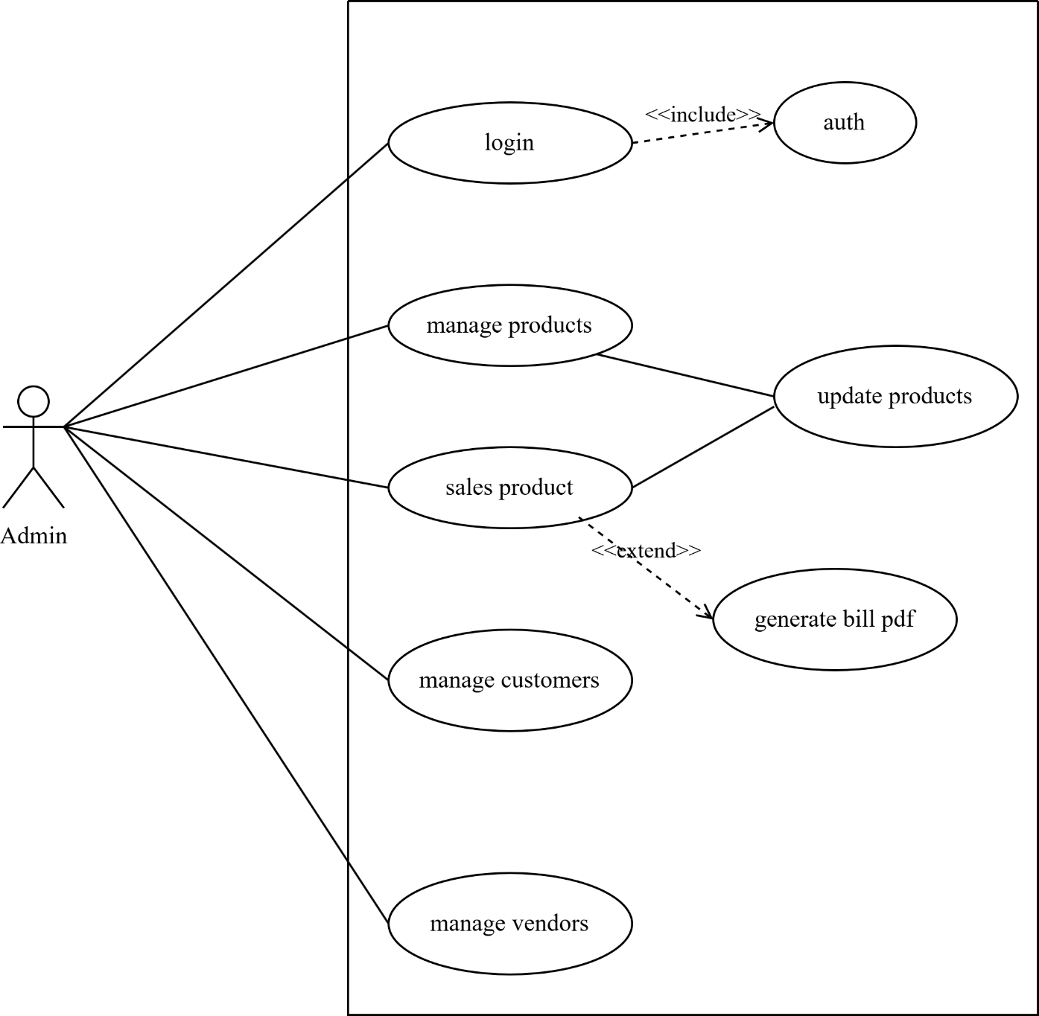**Figure 2.1: Use Case Diagram**

#### 2.1.3.2 Activity Diagram:

The activity diagrams below illustrate the procedures for the selling process and product management

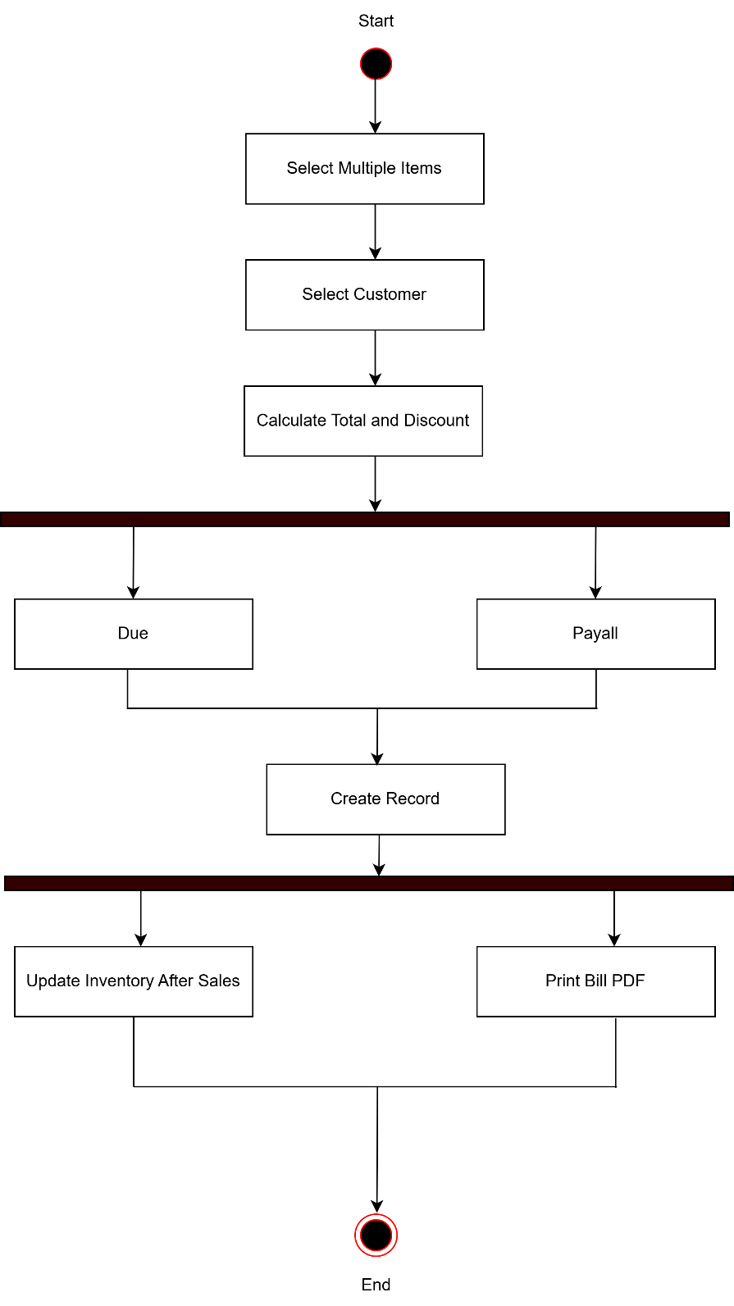

**Figure 2.2: Activity Diagram of Sales Processing**

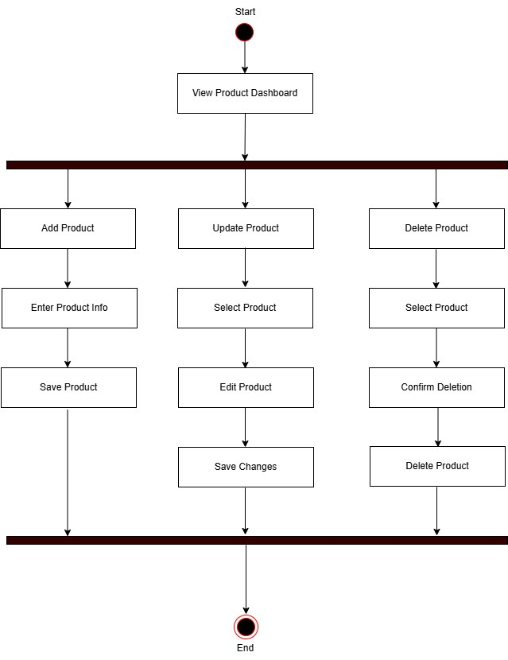

**Figure 2.3: Activity Diagarm for Product Management**

#### 2.1.3.3.Sequence Diagram

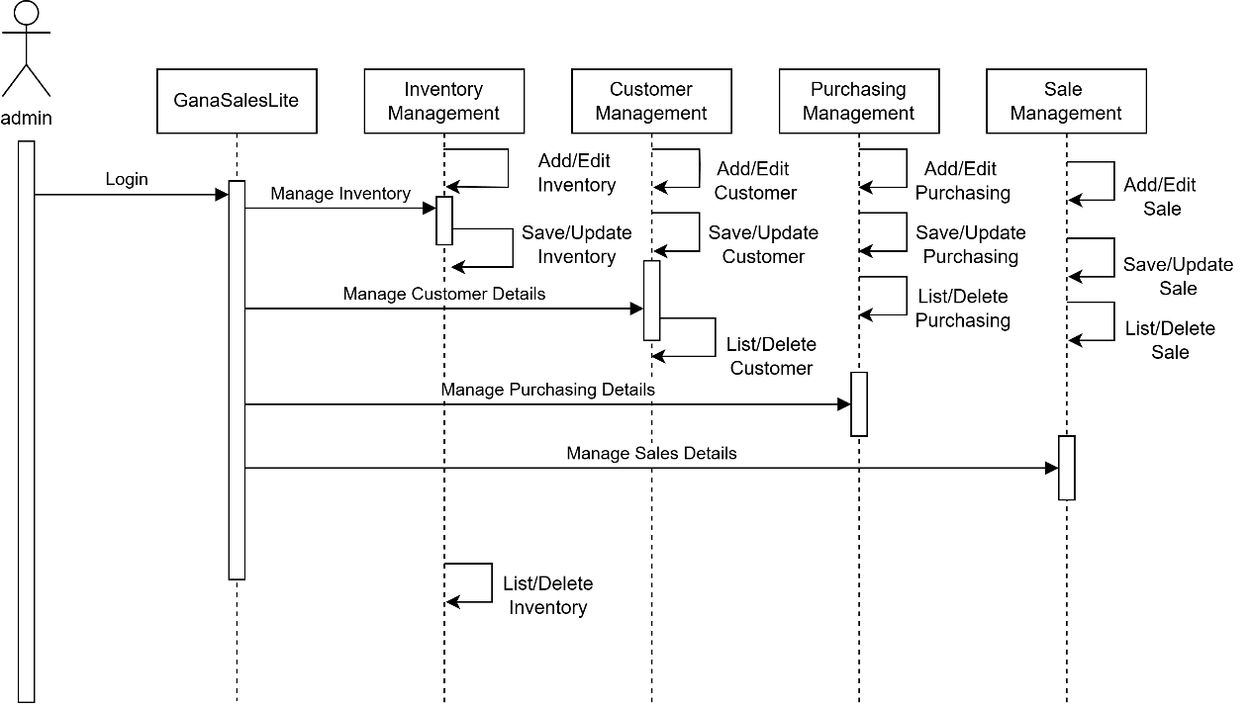The sequence diagram of GanaSalesLite illustrates the step-by-step interactions between the admin and system components, created to visualize the flow of the sales , customer and product management processes.

**Figure 2.4: Sequence Diagram of GanaSalesLite**

## 2.2 Design

The design phase translates the analyzed requirements into a detailed blueprint for constructing "GanaSalesLite", including UI layout, database design and relationship between objects.

### 2.2.1 UI Design

The UI design emphasizes simplicity, consistency, and usability for a single admin user. It uses Bootstrap for responsive design and includes:

* Easy-to-use forms designed for both admin and users to ensure efficient and accurate billing operations.
* Clear navigation sidebar menu for quick access to key features.
* Consistent styling across all pages to maintain familiarity and ease of use.

### 2.2.2 Database Design

#### 2.2.2.1 ER Diagram:

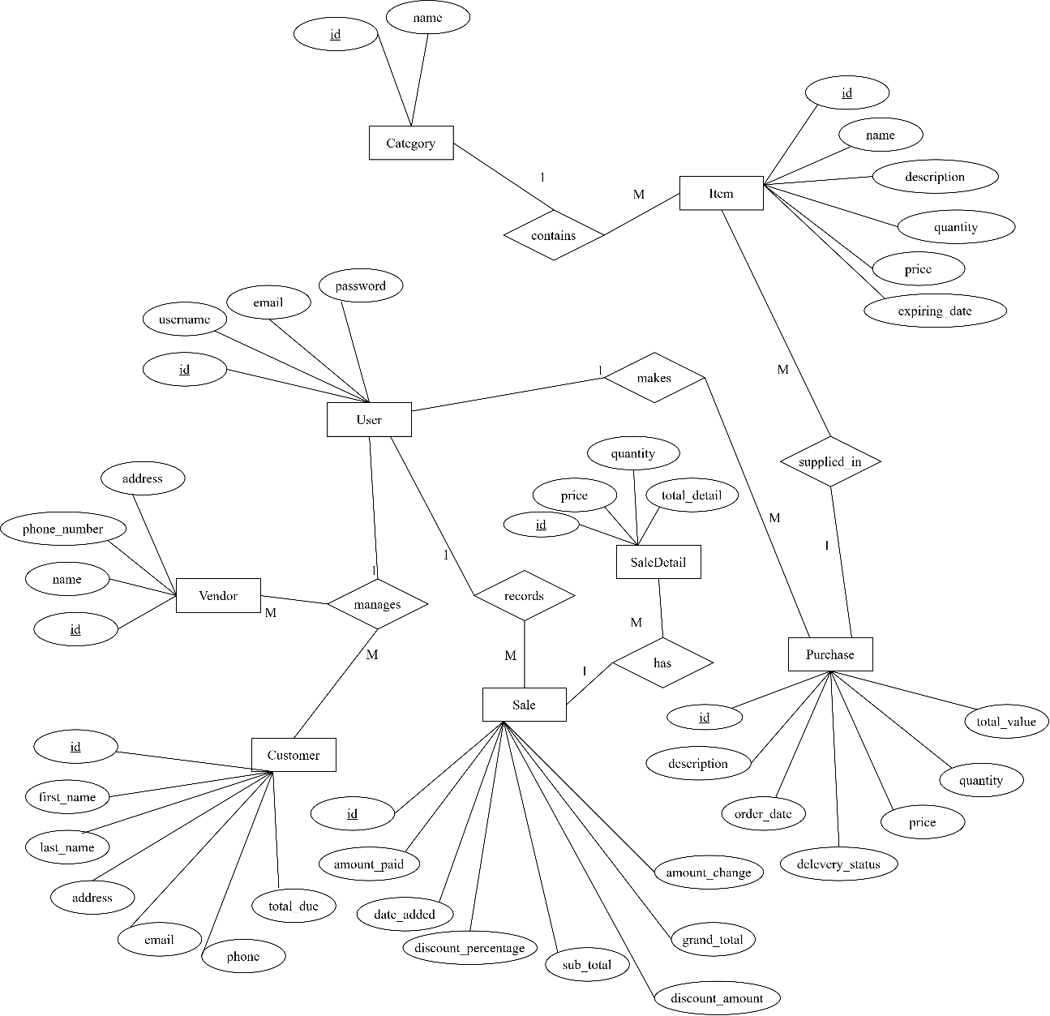

**Figure 2.5: ER Diagram**

## 2.3 Implementation

The "GanaSalesLite" system is developed using Django for the backend, PostgreSQL for the database, and Bootstrap for the frontend design. Core modules like billing, product management, and user interface were implemented based on the design. Testing was performed to ensure the system is functional and reliable.

### 2.3.1 Tools and Technologies Used

The development of "GanaSalesLite" leveraged a combination of modern, open-source tools and technologies chosen for their suitability for web application development, robustness, and the development team's familiarity.

**Table 2. 1: Tools and Technologies Used in GanaSalesLite Development**

|  |  |  |
| --- | --- | --- |
| **Category** | **Tool/Technology** | **Purpose in Project** |
| Backend Language | Python | Core programming language for server-side logic and functionality. |
| Backend Framework | Django | High-level Python web framework for rapid, secure development. |
| Database Management | PostgreSQL | Relational database for persistent storage of all application data. |
| Frontend Technologies | HTML5, CSS3, JavaScript (ES6+) | Standard web technologies for content structure, styling, and interactivity. |
| CSS Framework | Bootstrap | For responsive UI with reusable components. |
| Asynchronous Operations | AJAX (via JavaScript or jQuery) | For dynamic content updates without full page reload. |
| Version Control System | Git | To manage code changes and collaboration. |
| Code Repository | GitHub | For hosting source code and collaboration. |
| Integrated Development Environment | Visual Studio Code (VS Code) | Main development editor with relevant extensions. |
| Web Server (Development) | Django Development Server | For testing and running the application locally. |
| Diagramming Tools | draw.io | Used to draw UML, ERD, and process diagrams. |

### 2.3.2 Module Description

"GanaSalesLite" was developed using a modular approach, breaking down the system into distinct functional units. This enhances organization, simplifies development, and facilitates easier maintenance. The core modules of the system are described below:

#### 2.3.2.1 Admin/User Authentication Module

* Login interface for username/password.
* Credential validation.
* Session management.
* Logout functionality.

#### 2.3.2.2 Product Management Module

* Add/edit/delete products.
* Manage product categories and vendors.
* View/search products.

#### 2.3.2.3 Customer Management Module

* Add/edit customer info.
* View customer list.

#### 2.3.2.4 Sales and Billing Module

* Add products to sale.
* Real-time total calculations.
* Receipt generation.

#### 2.3.2.5 Inventory Overview Module

* Auto-decrement stock on sale.
* Stock level dashboard.
* Reorder level alerts.

#### 2.3.2.6 Reporting Module

* Dashboard summaries.

### 2.3.3 Testing

A thorough testing process was integral to the development of "GanaSalesLite" to identify defects, ensure functionalities align with requirements, and verify the overall quality of the application.

#### 2.3.3.1 Unit Testing

* Objective: Test smallest code units (functions/models) for correctness.
* Tools Used: Django testing framework (unittest).
* Example: Validate product price calculations.

#### 2.3.3.2 Integration Testing

* Objective: Test interactions between modules.
* Example: A sale updates product stock correctly.

#### 2.3.3.3 System Testing

* Objective: Verify full system behavior.
* Environment: Local environment.

#### 2.3.3.5. Test Cases

**Table 2. 2: Test Case Login Module**

|  |  |
| --- | --- |
| **Test Case ID** | TC-LOGIN-001 |
| **Test Type** | Functional |
| **Module** | Authentication |
| **Test Title** | Admin login with correct credentials |
| **Precondition** | Admin account exists |
| **Input Data** | Username: admin Password: correct pw |
| **Expected Result** | Redirect to dashboard page |
| **Actual Result** | Dashboard successfully displayed |
| **Status** | Pass |
| **Comment** | Basic login functionality verified |

**Table 2. 3: Test Case Product Management**

|  |  |
| --- | --- |
| **Test Case ID** | TC-PROD-001 |
| **Test Type** | Functional |
| **Module** | Product Management |
| **Test Title** | Add a new product |
| **Precondition** | Admin is logged in |
| **Input Data** | Product Name: "garnia facewash" Price: Rs.50 Stock: 100 units |
| **Expected Result** | Product added and visible in product list |
| **Status** | Pass |
| **Comment** | Validated input values price > 0, stock recorded properly |

**Table 2. 4: Test Case Reporting Module**

|  |  |
| --- | --- |
| **Test Case ID** | TC-REPORT-001 |
| **Test Type** | Functional |
| **Module** | Reporting |
| **Test Title** | Generate sales report |
| **Precondition** | At least one sale recorded today |
| **Input Data** | - |
| **Expected Result** | Report displays summary of today’s sales |
| **Actual Result** | Report shows 10 transactions, Total Sales: Rs.1500 |
| **Status** | Pass |
| **Comment** | Daily total and transaction count correctly shown |

# CHAPTER THREE: CONCLUSION AND RECOMMENDATION.

## 3.1 Summary

The "GanaSalesLite" project was undertaken with the primary objective of designing and developing a tailored, user-friendly, web-based Sales and Customer Management System for Ganapati Enterprise. The core motivation was to address the inefficiencies and limitations of existing manual or overly complex systems for a single admin operation. The system aimed to automate key business processes including product management, customer record keeping, sales transaction entry, billing, basic inventory overview, and sales reporting.

The project adhered to the iterative waterfall model, progressing through iterative cycles with feedback loops to refine each phase. The development of "GanaSalesLite" was structured as follows:

* **Analysis**: In the initial iteration, requirements (functional and non-functional) were thoroughly gathered and defined, a feasibility study (technical, operational, economic) was conducted to ensure project viability, and initial system models (Use Case Diagrams, Activity Diagrams and Sequence Diagram) were created to conceptualize the system's scope and behavior, with revisions in subsequent iterations based on feedback.
* **Design**: Across iterations, the analyzed requirements were translated into a detailed blueprint. This included designing an intuitive UI suitable for the target user, creating a detailed database design with adjustments made in each cycle to improve the design.
* **Implementation**: The construction of "GanaSalesLite" was carried out iteratively using Django framework for the backend logic, PostgreSQL as the relational database (with SQLite utilized during development), and a frontend built with HTML, CSS (enhanced by Bootstrap), and JavaScript. The system was developed in a modular fashion, with distinct units for admin authentication, product management, customer management, sales and billing, inventory overview, and reporting, each module refined in subsequent iterations.
* **Testing**: A multi-faceted testing strategy was implemented in each iteration, including unit testing for individual components, integration testing to verify module interactions, and system testing for end-to-end functionality to ensure the system met the end-user's needs and expectations, with test results informing refinements in the next cycle.

## 3.2 Conclusion

The "GanaSalesLite" project has successfully achieved its intended goals, delivering a functional system specifically tailored to the operational context and single user requirement of Ganapati Enterprise. The system effectively addresses the core problems associated with manual record-keeping by providing an automated, centralized, and user-friendly platform.

From the development process and the final product, the following key conclusions can be drawn:

1. **Fulfillment of Objectives:** The system successfully implements the specific objectives outlined, including secure admin access, comprehensive CRUD operations for products and customers, an efficient sales and billing process, automatic inventory updates tied to sales, notifications, and the generation of essential sales reports.
2. **Enhanced Operational Efficiency:** "GanaSalesLite" provides Ganapati Enterprise with the means to significantly reduce time spent on manual data entry and retrieval, minimize the potential for human error in calculations and record-keeping, and streamline overall daily workflows.
3. **Improved Data Management and Accessibility:** The centralized PostgreSQL database ensures that all critical business data (products, customers, sales) is stored in an organized, secure, and easily accessible manner for the admin.
4. **User-Centricity and Usability:** The focus on a simple, intuitive UI has resulted in a system that should be readily adoptable by the owner of Ganapati Enterprise, even with limited prior technical expertise.
5. **Effectiveness of Chosen Technology Stack:** The selection of Python/Django, PostgreSQL, and Bootstrap proved to be an effective combination, facilitating relatively rapid development, providing robust built-in features (especially from Django for security and ORM), and enabling the creation of a responsive web interface.
6. **Demonstrated Value for Micro-Enterprises:** This project underscores the significant value that even a relatively simple, custom-developed software solution can bring to micro or small-scale enterprises by providing tools that are directly aligned with their specific needs and operational scale, often being more appropriate than larger, more complex commercial systems.

While "GanaSalesLite" operates within defined limitations (such as its single user design and basic reporting capabilities), these were intentional choices to maintain project focus and align with the immediate requirements of Ganapati Enterprise. The system provides a solid and reliable foundation that successfully digitizes and improves core business processes.

## 3.3 Recommendation

"GanaSalesLite" currently serves as an effective tool for Ganapati Enterprise. However, to further enhance its capabilities, support potential business growth, and broaden its utility, the following recommendations for future enhancements are proposed:

1. **Multi-User System with Role-Based Access Control:**

As the business might expand, an essential upgrade would be to support multiple user accounts (e.g., for a sales assistant, inventory manager). It would allow the primary admin to assign specific permissions to different users, controlling their access to various system modules and functionalities.

1. **Advanced Reporting and Business Intelligence:**

Integrate more sophisticated reporting tools to provide deeper insights. This could include graphical data visualization (charts for sales trends, customer demographics, product performance), customizable report generation by the user, and options to export reports in formats like PDF for external use or record keeping.

1. **Comprehensive Inventory Management:**

Expand the inventory module to include features like purchase order management for restocking from vendors, tracking supplier information more extensively, managing multiple supplier options per product, and tools for periodic stock-taking and variance reconciliation. For businesses dealing with perishable goods and first-in-first-out suggestions would be beneficial.

1. **Automated Data Backup and Cloud Integration:**

Implement an automated data backup schedule and an easy to use restore function. Consider options for cloud-based backup or even deploying the entire application on a secure cloud platform for better data safety and remote accessibility.

1. **Integration with Communication Tools:**

Allow for basic customer communication (e.g., sending out promotional SMS/emails, if consent is obtained) directly from the customer management module.

1. **Barcode Functionality:**

Integrate support for barcode scanners to speed up product selection during sales and for more efficient inventory management tasks like stock receiving and audits.

# REFERENCES

Biggemann, S., & Buttle, F. (2009). Coordinated interaction and paradox in business relationships. *Journal of Business & Industrial Marketing*, *24*(8), 549-560.

Kotler, P., & Lane Keller, K. (2016). A framework for marketing management.

Chaffey, D., & Ellis-Chadwick, F. (2019). *Digital marketing*. Pearson uk.

Laudon, K. C., & Laudon, J. P. (2004). *Management information systems: Managing the digital firm*. Pearson Educación.

# APPENDICES

Appendix 1: Snapshots of the system

