**TRIBHUVAN UNIVERSITY**

Faculty of Management

Kritipur, Kathmandu

An Internship Report

On

**“SOFTWARE DEVELOPMENT IN REDUCT NEPAL PVT.LTD”**

In partial fulfillment of the requirements for the degree of

**Bachelor of Information Management (BIM)**

**Submitted By:**

**Subash Pandey**

Exam Roll Number: 12661/20

TU Registration Number: 7-2-559-29-2020

**Oxford College, Butwal**

June, 2025

# COLLEGE APPROVAL LETTER

# INTERNSHIP CERTIFICATE

# DECLARATION

I hereby declare that the internship report titled **"SOFTWARE DEVELOPMENT IN REDUCT NEPAL PVT.LTD"** is the original outcome of my internship study conducted in 2025 at Reduct Nepal Pvt. Ltd., Sanepa, Lalitpur. This report has been prepared in partial fulfillment of the requirements for the Bachelor of Information Management (BIM) program under the Faculty of Management, Tribhuvan University. It has not been submitted to any other university or institution. I affirm that all sources and assistance have been properly acknowledged, and i take full responsibility for the integrity and authenticity of the contents herein.

.....................................  
Subash Pandey

TU Roll No.: 12661/20

TU Regd. No.: 7-2-559-29-2020

# ACKNOWLEDGEMENT

The successful completion of this internship report would not have been possible without the support, guidance, and encouragement of many individuals. I am sincerely thankful to all who contributed to this journey, both directly and indirectly.

I extend my deepest gratitude to Mr. Punit Jajodia, CEO, and Ms. Rashmita Khatri, HR Manager at **Reduct Nepal Pvt. Ltd.**, for providing me the opportunity to undertake my internship at their esteemed organization. Their commitment to fostering a learning environment enabled me to explore various dimensions of website development, deployment, online compilers, and web socket functionality experiences that greatly enhanced my practical knowledge.

My heartfelt appreciation goes to Mr. Avineak Duwal, Lead Software Engineer and my supervisor at Reduct Nepal, whose expert guidance, constructive feedback, and encouragement played a pivotal role throughout my internship.

I am also thankful to the supportive team at Reduct Nepal. Mr. Biplab Subedi, Scrum Master Facilitator, offered valuable instruction on agile methodologies, while Mr. Yashant Bikram Gyawali, UI/UX Manager, entrusted me with impactful projects that greatly contributed to my personal and professional growth.

I would also like to acknowledge Mr. Aasish Neupane, my academic supervisor and Lecturer at Oxford College, for his consistent support and insightful advice throughout the internship report preparation period.

Finally, i am grateful to my professors, friends, classmates, and family for their constant motivation and belief in me, which has been a continuous source of strength along this path.

**Subash Pandey**

# ABSTRACT

This report, titled **“Software Development in Reduct Nepal Pvt. Ltd.”** highlights the practical experience gained during a three-month internship, focusing on real-world software development tasks across multiple projects. The internship offered exposure to full-stack development, system research, documentation, and internal tool creation within a collaborative and Agile work environment.

One of the key projects involved contributing to a **Challenges Management System**, a web-based platform designed for an educational client to support coding practice through curated challenges in Python and SQL. The system allows administrators to manage problem statements, test cases, difficulty levels, and schema generation for SQL-based problems. Built using **Next.js** and **PostgreSQL**, the platform includes an integrated code editor and focuses on performance, user experience, and secure data handling without storing personal user information.

In addition to this core project, the internship included various other contributions, such as documenting GitHub repositories for **Programiz**, researching ETL tool alternatives (identifying **Dagster** as a potential replacement for Airbyte), automating form submissions with location detection using Google Forms, and actively participating in daily stand-ups and sprint planning. Each activity contributed to strengthening both technical and professional skills, including version control, problem-solving, and team collaboration.

This report outlines the development processes, tools used, challenges encountered, and key learnings gained through this internship experience at **Reduct Nepal Pvt. Ltd.**

TABLE OF CONTENTS

*TITLE PAGE* *i*

*COLLEGE APPROVAL LETTER ii*

*INTERNSHIP CERTIFICATE iii*

*DECLARATION iv*

*ACKNOWLEDGEMENT v*

*ABSTRACT vi*

*TABLE OF CONTENTS vii*

*LIST OF TABLES ix*

*LIST OF FIGURES x*

*LIST OF ABBREVATIONS xi*

CHAPTER I: INTRODUCTION 1

1.1 Background 1

1.2 Focus of Study 1

1.3 Statement of the Problem 2

1.4 Objectives of Study 2

1.4.1 Objectives of Internship 2

1.4.2 Objectives of System 2

1.5 Limitations of the Study 3

CHAPTER II: INTRODUCTION OF INDUSTRY 4

2.1 Introduction to Information Technology 4

2.2 Introduction of Software Industry 4

2.3 Objectives of Information Technology in business 4

2.4 History of IT in Nepal 5

2.5 Opportunities in Nepali IT Sector 5

2.6 Challenges in Nepali IT Sector 6

CHAPTER III: INTRODUCTION TO ORGANIZATION 7

3.1 Introduction of Organization 7

3.2 Organization Core Value 8

3.3 Organization Selection 8

3.4 Internship Details 9

3.5 Organization Structure 9

CHAPTER IV: JOB PROFILE AND ACTIVITIES PERFORMED 11

4.1 Activities Performed 11

4.1.1 Stand-ups and Sprint Planning 11

4.1.2 Documentation of GitHub Repositories 11

4.1.3 Research on ETL Tools 11

4.1.4 Automated Google Form Location Detection 11

4.1.5 Challenges Management System 11

4.1.6 Reliability Testing 12

4.2 Tools and Technology used 12

4.3 Problem Identified and Solved 14

4.4 Experience During the Internship 14

4.5 Observed Gap Between Theory and Practice 15

CHAPTER V: SUMMARY AND CONCLUSION 16

5.1 Conclusion 16

5.2 Recommendation 16

REFERENCES

APPENDIX

WEEKLY INTERNSHIP LOG

# LIST OF TABLES

Table 1.1: Internship duration details 9

Table 2.1: Tools and technology used for Development 12

Table 3.1: Tools and technology used for DevOps and Infrastructure 13

Table 4.1: Tools and technology used for Collaboration and Productivity 13

# LIST OF FIGURES

Figure 1.1: Organizational Structure of Reduct Nepal Pvt. Ltd. 10

# LIST OF ABBREVATIONS

API Application Programming Interface

CI/CD Continuous Integration/Continuous Deployment

CRUD Create, Read, Update, Delete

SQL Structured Query Language

DB Database

IT Information Technology

ROI Return on Investment

HR Human Resources

SDLC Software Development Life Cycle

TU Tribhuvan University

UI User Interface

UX User Experience

PPC Pay Per Click

ETL Extract Transform Load

SEO Search Engine Optimization

# CHAPTER I: INTRODUCTION

## Background

The Bachelor of Information Management (BIM) is a four-year curriculum at Tribhuvan University that consists of 60% IT and 40% Management courses. This curriculum prepares students for IT-focused organizational roles through a semester-based framework of 126 credit hours. A three-month internship is an important component of the program, allowing students to apply theoretical knowledge, obtain industry insights, and build critical skills for future employment in IT and management.

An internship is an invaluable learning opportunity that provides students with practical information and hands-on experience in their field of study. It promotes career exploration, skill development, and professional progress, while also benefiting employers by providing new viewpoints and prospective future employees. The internship, which is part of Tribhuvan University's BIM curriculum, allows students to gain firsthand experience with organizational operations, workplace communication, and project coordination. It closes the gap between academic learning and industry practices, increasing employability by improving technical and managerial abilities. This study is based on a three-month internship at Reduct Nepal Pvt. Ltd., which provided firsthand exposure in a professional work environment and practical insights into industry dynamics.

## Focus of Study

An internship is an important step in a student's transition from an academic to professional career. It gives students hands-on exposure with workplace processes, techniques, and real-world difficulties, allowing them to adjust to a professional environment and build critical skills. The study focuses on the following main areas:

* Practical Experience: Internships allow students to apply classroom knowledge in a real-world situation. It provides a forum for students to develop and demonstrate their skills in addition to theoretical study.
* Career Prospects: Gaining experience in an organization opens the door to new career prospects. The knowledge and abilities gained during the internship can have a significant impact on future professional success.
* Industry Exposure: Working in a professional setting allows students to comprehend organizational routines, deal with job pressure, and make key connections that will aid them in their future employment.

## Statement of the Problem

The client, who operates an online learning platform, identified a need for a dedicated system where learners can apply and test their knowledge through practical coding challenges. Existing solutions lacked the flexibility to create and manage challenges with custom problem statements, difficulty levels, test cases, and support for multiple programming languages like Python and SQL. The absence of such a tailored solution was limiting the effectiveness of the client’s learning ecosystem.

## Objectives of Study

### 1.4.1 Objectives of Internship

An internship's main goal is to introduce students to a real-world workplace, which fosters both professional and personal development. It helps students develop their skills, gain practical experience, and explore career options while growing their professional network. The following are the main goals of the internship program:

* To apply academic knowledge to industry operations to obtain practical experience.
* To improve communication and interpersonal skills, which will boost confidence and teamwork.
* To build professional networks and investigate career options in the information systems industry.

### 1.4.2 Objectives of System

The objectives of the system are listed below:

* To provide a platform where the client can create, manage, and organize coding challenges in Python and SQL for learners.
* To allow users to solve coding problems in a secure, real-time environment without storing personal data, while tracking challenge attempts for performance review.

## Limitations of the Study

It was a great opportunity to be an intern in an IT Company. This report is prepared based on the observations, experience of the internship, formal and informal interview with the staff, and the secondary data available on the internet. However, the internship had some limitations.

The main limitations of internship are listed below:

* Could not meet the client on our own, head of companies were engaged in official meetings with the client.
* Research was done on the surface and not in depth due to security policy.
* Due to privacy policy maintained in an organization there was unavailability of adequate information

# CHAPTER II: INTRODUCTION OF INDUSTRY

## Introduction to Information Technology

The information technology (IT) business in Nepal is still in its early stages, but it has enormous potential for growth, investment, and profitability. With the growing use of computers for both personal and corporate purposes, the need for software and IT services is fast expanding. As a result, software companies are fast growing to fulfill market demand. The IT industry includes computer hardware, software development, electronics, semiconductors, telecommunications, e-commerce, and IT services. Both the software and hardware industries contribute to the development, implementation, and administration of IT systems. The ubiquitous availability of IT products and services has increased demand for technology solutions, transforming IT into a crucial driver of worldwide economic growth and employment (Wikipedia, 2025).

## Introduction of Software Industry

The IT industry contributes significantly to e-governance by facilitating access to information, improving operational efficiency, and fostering openness in the service sector. As the world transitions from analog to digital, IT has become an essential element of daily life, influencing how people communicate, work, and learn new skills. The global IT revolution continues to shape economies by driving innovation and increasing productivity in a variety of industries.

Information technology, which integrates computer and telecommunications technologies, allows businesses to efficiently collect, distribute, and manage information, hence increasing competitiveness and knowledge expansion. The global IT industry is worth around $850 billion, with a 15% annual growth rate. While industrialized countries are primarily responsible for IT, efforts should be made to adapt and deploy these technologies in developing countries such as Nepal, aligning with their specific development needs in order to promote economic growth and national advancement.

## Objectives of Information Technology in business

Some of the objectives of Information Technology in business are listed below:

* Improve efficiency and productivity by automating tasks and processes.
* Enhance the accuracy and reliability of data processing and information management.
* Enable better decision-making by providing access to accurate and timely information.
* Facilitate communication and collaboration through networks and communication technologies.
* Enhance the accessibility of information through web-based systems and mobile technologies.
* Provide better customer services through online self-service systems and customer relationship management tools.
* Enable new business models and opportunities through innovative applications and technologies.

## History of IT in Nepal

The growth of information technology (IT) in Nepal has been steady yet significant over the years. Nepal purchased its first IBM 1401 computer for census data processing in 1971, marking the beginning of its IT journey. IT development gained traction in the 1980s, thanks to the founding of organizations such as the Nepal Telecommunications Corporation (now NTC) and the National Computer Center (Techsansar, n.d.).

The growth of information technology (IT) in Nepal has been moderate yet considerable over the years. Nepal got its first IBM 1401 computer for census data processing in 1971, which marked the start of its IT adventure. IT development took off in the 1980s, mainly to the establishment of organizations like the Nepal Telecommunications Corporation (now NTC) and the National Computer Center.

## Opportunities in Nepali IT Sector

The IT sector in Nepal is rapidly growing, offering numerous opportunities for businesses, professionals, and investors. Key areas of opportunity include:

* Software Development and Outsourcing: Nepal is emerging as a hub for IT outsourcing, with companies providing software development, web solutions, and IT services to international clients.
* E-Governance and Digital Transformation: The government’s push for digital governance creates demand for IT solutions in public services, finance, and infrastructure.
* Growing E-Commerce Industry: With increasing internet penetration and smartphone usage, e-commerce platforms and digital payment systems are expanding rapidly.
* Startup and Innovation Ecosystem: The rise of tech startups in areas like fintech, edtech, and AI-driven solutions presents significant growth opportunities.
* Expanding IT Education and Workforce: More universities and training centers are producing skilled IT professionals, fueling industry expansion.
* Cloud Computing and Cybersecurity: Businesses are increasingly adopting cloud solutions and security measures, creating a demand for experts in these fields.

## Challenges in Nepali IT Sector

The following is a list of some of the goals of business information technology:

* Increase productivity and efficiency by automating procedures and tasks.
* Improve the precision and dependability of information management and data processing.
* Give people access to timely and accurate information to help them make better decisions.
* Using networks and communication technology promotes cooperation and communication.
* Increase information accessibility by utilizing mobile and web-based technologies.
* Use customer relationship management technologies and online self-service platforms to improve customer service.
* Use innovative apps and technologies to open new company options and models.

# CHAPTER III: INTRODUCTION TO ORGANIZATION

## Introduction of Organization

**Reduct Nepal Pvt. Ltd.**, established in 2018, is a forward-thinking technology company dedicated to building global products and services through user-centric design and collaborative innovation. The company focuses on simplifying complex tasks such as transcription, translation, and video editing, significantly contributing to job creation in these areas.

Reduct Nepal operates on a strong foundation of core values including **Self-Leadership, Candor, Collaboration, Impact, and Playfulness**. These principles not only define the company's culture but also foster an environment of empowerment and continuous personal and professional growth for its employees.

A distinguishing feature of Reduct Nepal is its deeply client-centric approach. The company believes in working closely with clients throughout the entire project lifecycle to ensure that solutions are both compassionate and precisely aligned with client needs. This collaborative ethos ensures the delivery of high-impact, customized outcomes.

Reduct offers opportunities across diverse domains such as research, marketing, content creation, human resources, engineering, UI/UX design, and digital advertising (including Google Ads). Its versatile work environment and commitment to learning and development were key factors that influenced my decision to pursue an internship here.

The company also engages in a range of national and international outsourcing projects, specializing in website development, attribution setup, SEO strategy, pay-per-click (PPC) advertising, content writing, custom tool development, and quality assurance. Through these services, Reduct Nepal helps businesses generate high-quality leads by crafting persuasive content and tools that support complex decision-making processes.

## Organization Core Value

Reduct Nepal operates with a strong commitment to fostering a supportive, empowering, and dynamic work environment. Its culture is guided by five core values that shape both individual behavior and organizational practices:

1. **Self-Leadership**  
   Encourages individuals to take initiative, seek feedback, and remain accountable to deliver quality work. *(If individuals grow, the team grows)*
2. **Candor**  
   Promotes psychological safety by enabling open and honest discussions, especially around difficult issues, in a supportive space. *(Speaking up is the first step to solving silent problems)*
3. **Collaboration**  
   Emphasizes mutual understanding and teamwork, where individuals consider each other’s needs, goals, and challenges to grow together. *(Together we can go far)*
4. **Impact**  
   Focuses on creating meaningful, positive outcomes for clients, employees, and the broader community leaving a lasting, valuable footprint. *(We exist to shape the larger society we belong to)*
5. **Playfulness**  
   Cultivates a fun and authentic workplace culture where people feel free to express themselves and enjoy their work environment. *(Productivity and well-being go hand in hand)*

## Organization Selection

The **Bachelor of Information Management (BIM)** program emphasizes the development of self-leaders equipped with both technical expertise and managerial insight. In alignment with this academic vision, pursuing an internship at a forward-thinking, reputable tech start-up became a natural and strategic choice.

I choose **Reduct Nepal Pvt. Ltd.**, a company associated with **Parewa Labs Pvt. Ltd. (Programiz)** and **Reduct.Video**. Its emphasis on **Self-Leadership, Candor, Collaboration, Impact, and Playfulness** aligns closely with the personal and professional values encouraged throughout the BIM program.

At Reduct Nepal, I found an environment that allowed me to apply and expand my knowledge in both information systems and project management. The internship offered a hands-on experience in a real-world setting, enabling me to actively contribute to meaningful projects while learning from skilled professionals in the tech industry.

## Internship Details

Following are the details of the internship period:

Table 1.1: Internship duration details

|  |  |
| --- | --- |
| **Organization** | Reduct Nepal Pvt. Ltd. |
| **Address** | Bijaynagar marg, Sanepa, Lalitpur |
| **Position** | Intern |
| **Department** | Tech Team |
| **Internship Duration** | 9 December 2024 – 8 March 2025 |
| **Work Schedule** | 9:00 AM to 5:00 PM (Mon-Fri) |
| **HR Manager** | Ms. Rashmita Khatri |
| **Contact Details** | +977- 9841890918 (HR) |
| **E-mail** | hr@humanaassisted.ai |
| **Mentor/Supervisor** | Avineak Duwal (Tech Lead) |

## Organization Structure

Reduct Nepal Pvt. Ltd. has a structured organization, **CEO** is responsible for strategic oversight and governance. The **HR Team** handles hiring and employee support with required resources, the **Marketing/Content Team** focuses on brand promotion and content creation of Reduct.Video, and the **Transcription QA Team** ensures quality in audio human transcription services. The **Full Stack Teach Team** leads software development of the inhouse product and associated clients projects. As a **Full Stack Intern**, i support this team by contributing to web development tasks and learning practical skills in both front-end and back-end programming.

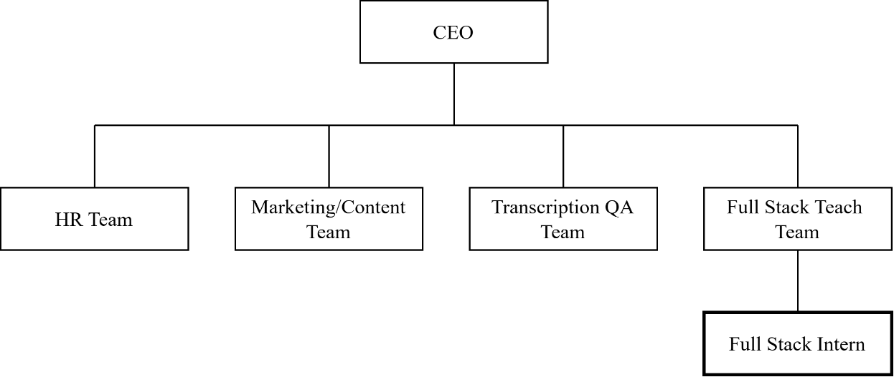

Figure 1.1: Organizational Structure of Reduct Nepal Pvt. Ltd.

# CHAPTER IV: JOB PROFILE AND ACTIVITIES PERFORMED

## 4.1 Activities Performed

During my internship at **Reduct Nepal Pvt. Ltd.**, I was involved in a variety of technical and collaborative tasks that allowed me to apply theoretical knowledge to real-world projects. These activities helped me gain hands-on experience in software development, research, documentation, and project collaboration. Below are the key activities i have performed:

### 4.1.1 Stand-ups and Sprint Planning

Participated regularly in daily stand-up meetings and sprint planning sessions following agile methodology. These meetings helped align team goals and track progress on assigned tasks.

### 4.1.2 Documentation of GitHub Repositories

Contributed to the documentation of more than 6 GitHub repositories of our client **Programiz**, including creating and updating files like **README.md** and **Debugging.md** to improve project understanding and developer onboarding.

### 4.1.3 Research on ETL Tools

Conducted research to find an alternative to **Airbyte**, an open-source ETL tool. Discovered and recommended **Dagster** as a modern and flexible replacement, based on client requirements.

### 4.1.4 Automated Google Form Location Detection

Developed a custom form with automated location detection as part of a **subscription giveaway event**. This was done to enhance user interaction and data accuracy without relying on manual input.

### 4.1.5 Challenges Management System

Worked as part of the tech team to build a **Challenges Management System** that allows administrators to create and manage coding challenges in Python and SQL. Key responsibilities included designing challenge schemas, building front-end components using **Next.js**, integrating a code editor, and handling database operations with **PostgreSQL**.

### 4.1.6 Reliability Testing

I have been actively involved in a project with the IT team working on an online compiler, focusing on improving its reliability, stability, and resistance to potential security threats. As part of the initiative, i supported the team lead in identifying system issues and gained hands-on experience with the implementation details of the compiler.

I have also conducted reliability testing on the online compiler to ensure consistent performance under various conditions. Additionally, i learned how to write and execute test cases and contributed to generating reports based on the test results. I played a key role in making these reports client-ready by organizing and presenting the data in a clear and insightful manner.

## 4.2 Tools and Technology used

During my internship period, I had the opportunity to work with a wide range of tools and technologies across development, DevOps, and collaboration. Below is a breakdown of the key tools I used and their purposes:

### 4.2.1 Development tools

Table 2.1: Tools and technology used for Development

|  |  |
| --- | --- |
| **Tools and Technology** | **Description** |
| Node.js (Express) | Backend JavaScript runtime used for server-side logic. |
| React.js | JavaScript library for building user interfaces. |
| Next.js | React-based framework for server-side rendering and static site generation. |
| Go (Golang) | Programming language used for building high-performance backend services. |
| PostgreSQL | Relational database used for data storage and management. |
| Unix Server | Used for hosting and managing the application development environment. |
| NsJail | Used for sandboxing and securely executing untrusted code, especially important for compiler execution environments. |

### 4.2.2 DevOps and infrastructure

Table 3.1: Tools and technology used for DevOps and Infrastructure

|  |  |
| --- | --- |
| **Tools and Technology** | **Description** |
| GitHub Repository | Used for source code management, version control, and collaboration through pull requests, issue tracking, and integration with CI/CD workflows. |
| Docker | Containerization platform used for environment consistency and deployment scalability. |

### 4.2.3 Collaboration and productivity tools

Table 4.1: Tools and technology used for Collaboration and Productivity

|  |  |
| --- | --- |
| **Tools and Technology** | **Description** |
| Microsoft Teams | Communication and collaboration tool used for meetings, discussions, and updates. |
| Google Workspace (Docs, Sheets, Slides) | For writing and sharing technical documents, managing data, tracking progress, or reporting, preparing and delivering client presentations or internal demos |

## 4.3 Problem Identified and Solved

During my internship, I encountered several key challenges related to project maintainability, testing reliability, and developer onboarding ease. Below are the main problems I identified and the corresponding solutions I implemented:

* Identified the absence of complete README files and repository descriptions, which made project onboarding difficult; addressed this by creating detailed, structured README files for each repository.
* Noticed the lack of standardized test data for compiler validation, leading to inconsistent testing after refactoring; resolved this by designing well-structured test cases with expected output definitions.
* Observed missing expected result cases for online compiler reliability testing; introduced a comprehensive test suite to ensure consistent validation and performance checks.
* Found that deployment processes were undocumented, causing confusion during setup; created step-by-step deployment guides with commands, dependency initialization, and service instructions.
* Realized the system architecture was hard to understand due to missing diagrams or explanations; developed clear visual diagrams outlining the architecture and data flow.
* Overall, the documentation improvements significantly enhanced team collaboration, streamlined onboarding, and increased the reliability and maintainability of future development efforts.

## 4.4 Experience During the Internship

My internship provided a valuable, hands-on experience in a professional software development environment. Key takeaways include:

* Learning to maintain code quality by following proper coding conventions, style guides, and review processes.
* Participating in collaborative decision-making, including discussions on agreements and disagreements among stakeholders to reach a consensus.
* Starting with small, manageable components of the project, and gradually taking on more responsibility.
* Gaining an understanding of professional communication, including async updates, team meetings, and using tools like Microsoft Teams and GitHub for effective collaboration.
* Experiencing the importance of time management—how to break tasks into smaller parts and allocate time efficiently to meet project deadlines without compromising quality

## 4.5 Observed Gap Between Theory and Practice

A key observation during my internship was the significant gap between academic learning and real-world application. Some of the key differences I noticed include:

* In academics, software development is often theoretical and linear, while in practice it involves iterative problem solving, stakeholder communication, and adapting to evolving requirements.
* Decision making in real projects is more complex, requiring technical trade-offs, risk assessment, and often input from multiple teams or clients.
* Time and effort management in the real world is more dynamic, and tasks frequently require context switching, dealing with unexpected issues, and quick prioritization unlike the controlled environment of coursework.
* Documentation, testing, deployment, and team coordination often underemphasized in academic projects are critical components in industry settings.

# CHAPTER V: SUMMARY AND CONCLUSION

## Conclusion

The three month internship at **Reduct Nepal Pvt. Ltd.** was a highly enriching experience that bridged the gap between academic learning and practical software development. By working in a professional Agile environment, i was able to enhance both my technical capabilities and my understanding of real-world development workflows.

Key contributions included working on the **Challenges Management System**, where I gained hands-on experience with full-stack development using **Next.js** and **PostgreSQL**, while also deepening my understanding of browser-based code execution and database schema generation. Beyond this core project, i was involved in cross-functional tasks such as GitHub documentation, internal tool automation, system research, and ETL tool evaluation—each adding valuable dimensions to my skill set.

Through consistent mentorship, code reviews, and collaborative practices like daily stand-ups and sprint planning, i also learned the importance of communication, time management, and iterative development in a team setting. The internship not only sharpened my programming skills but also prepared me for future roles in a software engineering team.

## Recommendation

To build upon this internship experience and further improve similar internship programs, the following recommendations are proposed:

* **For Reduct Nepal:**
  + Continue assigning interns to real, meaningful projects that encourage ownership and accountability.
  + Introduce short learning sessions or workshops on emerging tools and best practices (e.g., DevOps, CI/CD, or software testing).
  + Offer more structured onboarding documentation to help new interns understand project architecture and workflows faster.
* **For Future Interns:**
  + Make the most of the mentorship and actively participate in team discussions.
  + Take initiative in exploring tasks beyond assigned responsibilities to broaden your exposure.
  + Document your learnings regularly to reflect on progress and identify areas for improvement

# REFERENCES

(2025, February 17). Retrieved from Wikipedia: https://en.wikipedia.org/wiki/Information_technology

Smith, J., & Johnson, A. (2019). The impact of project management software on team collaboration and productivity. *Journal of Project Management*, 45-59.

Williams, L., & Carter, M. (2020). *The role of project management systems in task allocation and tracking.* Retrieved from https://www.ijpm.com/task_allocation_tracking

Davis, R., & Moore, H. (2020). Project management systems and risk management. *Risk Management in Projects*.

(n.d.). Retrieved from Techsansar: https://techsansar.com/computer-history-nepal/

# **APPENDIX**

## Screenshots:

Challenges Lists Management  
  
Challenges Create Form

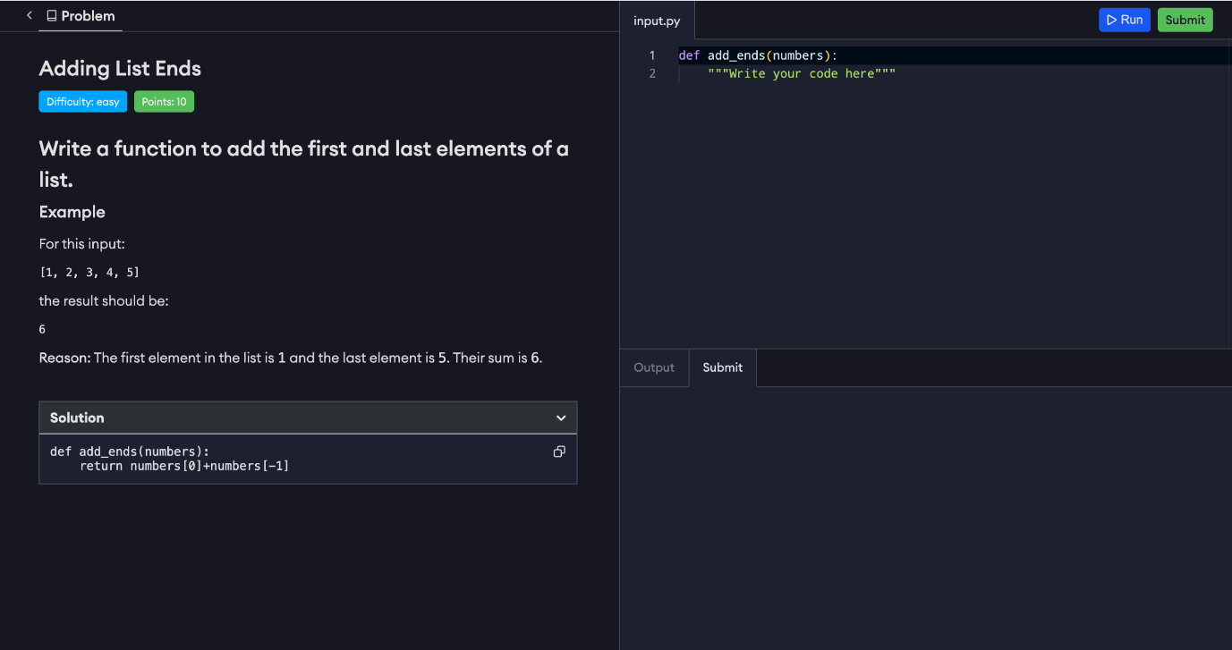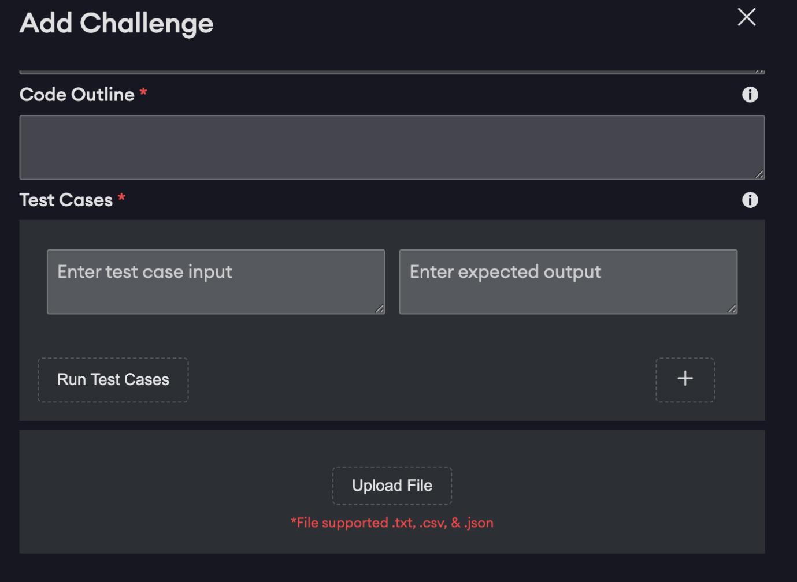  
Challenges Test Cases

Challenges Code Editor

# WEEKLY INTERNSHIP LOG

**Week No. 1**

**Date:** Dec 9 – Dec 13, 2024

**Responsibilities:**

|  |
| --- |
| 1. Onboard to the team and understand company workflows. 2. Familiarize with Git/GitHub and the development environment. 3. Participate in daily stand-ups and sprint planning meetings. |

**Activities:**

|  |
| --- |
| 1. Shadowed mentor to learn team and company processes. 2. Explored internal workflows and tools, including Git/GitHub. 3. Attended daily stand-ups and sprint planning introduction sessions. |

**Next Week Plan:**

|  |
| --- |
| 1. Research and evaluate ETL alternatives to AirByte. |

**Week No. 2**

**Date:** Dec 16 – Dec 20, 2024

**Responsibilities:**

|  |
| --- |
| 1. Investigate ETL tool alternatives. 2. Prepare technical documentation for internal review. 3. Engage in team sprint planning discussions. |

**Activities:**

|  |
| --- |
| 1. Researched alternatives to AirByte and identified Dagster as a strong candidate. 2. Compiled documentation and presented initial findings. 3. Attended sprint planning sessions and team discussions. |

**Next Week Plan:**

|  |
| --- |
| 1. Begin implementation work on automation for event-based forms using Google App Scripts. |

**Week No. 3**

**Date:** Dec 23 – Dec 27, 2024

**Responsibilities:**

|  |
| --- |
| 1. Automate user location detection for a giveaway event form. 2. Ensure technical documentation is thorough and clear. |

**Activities:**

|  |
| --- |
| 1. Created Google App Scripts to fetch real-time user location data. 2. Integrated the script into a subscription giveaway event form. 3. Documented script functionality and implementation steps. |

**Next Week Plan:**

|  |
| --- |
| 1. Attend company retreat and initiate QA testing on Programiz Pro Playground. |

**Week No. 4**

**Date:** Dec 30, 2024 – Jan 3, 2025

**Responsibilities:**

|  |
| --- |
| 1. Participate in company retreat for team-building. 2. Begin QA testing of the Programiz Pro Playground compiler. |

**Activities:**

|  |
| --- |
| 1. Attended the company retreat at Sky Haven Retreat, Chitlang. 2. Started QA testing of the Playground compiler alongside the team. |

**Next Week Plan:**

|  |
| --- |
| 1. Analyze user behavior while using the Learn C Programming course and provide usability feedback. |

**Week No. 5**

**Date:** Jan 6 – Jan 10, 2025

**Responsibilities:**

|  |
| --- |
| 1. Analyze the user experience of the "Learn C Programming" course. 2. Identify usability gaps and provide constructive feedback. 3. Document observations for internal improvements. |

**Activities:**

|  |
| --- |
| 1. Observed non-technical users completing the course. 2. Identified key areas of difficulty and friction points. 3. Documented feedback for both course content and platform UI/UX. |

**Next Week Plan:**

|  |
| --- |
| 1. Begin reviewing and improving documentation of Programiz GitHub repositories. |

**Week No. 6**

**Date:** Jan 13 – Jan 17, 2025

**Responsibilities:**

|  |
| --- |
| 1. Familiarize with Programiz client repositories. 2. Improve project documentation to support better onboarding. |

**Activities:**

|  |
| --- |
| 1. Reviewed Programiz Playground Backend repositories. 2. Created and improved README.md files for enhanced clarity. 3. Gained deeper understanding of the overall codebase and project structure. |

**Next Week Plan:**

|  |
| --- |
| 1. Continue documenting other repositories and create support guides (e.g., for debugging). |

**Week No. 7**

**Date:** Jan 20 – Jan 24, 2025

**Responsibilities:**

|  |
| --- |
| 1. Expand and refine documentation across GitHub repositories. 2. Develop technical guides to support developers. |

**Activities:**

|  |
| --- |
| 1. Continued documentation efforts for additional Programiz repositories. 2. Created Debugging.md files and updated existing documentation. 3. Ensured consistent, clear, and up-to-date information for backend repositories. |

**Next Week Plan:**

|  |
| --- |
| 1. Participate in the initial planning phase for the new Challenges Management System project. |

**Week No. 8**

**Date:** Jan 27 – Jan 31, 2025

**Responsibilities:**

|  |
| --- |
| 1. Support planning for the Challenges Management System. 2. Contribute to technical schema and challenge format design. 3. Maintain existing documentation needs. |

**Activities:**

|  |
| --- |
| 1. Contributed to initial planning and database schema design. 2. Researched technical requirements for managing Python and SQL challenges. 3. Continued repository documentation updates where needed. |

**Next Week Plan:**

|  |
| --- |
| 1. Start front-end development for the Challenges Management System. |

**Week No. 9**

**Date:** Feb 3 – Feb 7, 2025

**Responsibilities:**

|  |
| --- |
| 1. Build front-end components using Next.js. 2. Collaborate with design team on UI/UX for challenge creation. 3. Document component behavior and features. |

**Activities:**

|  |
| --- |
| 1. Developed core front-end components for Challenges Management System. 2. Worked with tech team and designers using Figma mockups. 3. Documented each component's functionality within the repository.. |

**Next Week Plan:**

|  |
| --- |
| 1. Integrate code editor and back-end support for challenge storage. |

**Week No. 10**

**Date:** Feb 10 – Feb 14, 2025

**Responsibilities:**

|  |
| --- |
| 1. Integrate an in-browser code editor. 2. Set up and connect PostgreSQL database operations. 3. Maintain backend documentation. |

**Activities:**

|  |
| --- |
| 1. Integrated code editor into the front-end interface. 2. Implemented database operations for storing and managing challenges. 3. Documented backend logic and database schema. |

**Next Week Plan:**

|  |
| --- |
| 1. Support compiler testing in collaboration with the IT team |

**Week No. 11**

**Date:** Feb 17 – Feb 21, 2025

**Responsibilities:**

|  |
| --- |
| 1. Assist in testing an online compiler for stability and performance. 2. Identify issues and support system improvement analysis. 3. Contribute to reporting findings. |

**Activities:**

|  |
| --- |
| 1. Collaborated with IT team for reliability testing of the online compiler. 2. Helped identify performance bottlenecks and implementation concerns. 3. Contributed to creating a client-facing report on test results. |

**Next Week Plan:**

|  |
| --- |
| 1. Finalize documentation across all assigned repositories and projects. |

**Week No. 12**

**Date:** Feb 24 – Feb 28, 2025

**Responsibilities:**

|  |
| --- |
| 1. Finalize all technical documentation. 2. Participate in knowledge sharing and team review. |

**Activities:**

|  |
| --- |
| 1. Completed documentation for over six Programiz repositories. 2. Finalized documentation contributions for Challenges Management System. 3. Participated in sprint review and knowledge transfer sessions. |

**Next Week Plan:**

|  |
| --- |
| 1. Push final code commits and attend internship wrap-up sessions. |

**Week No. 13**

**Date:** Mar 3 – Mar 7, 2025

**Responsibilities:**

|  |
| --- |
| 1. Push final code and documentation updates. 2. Participate in final review and feedback sessions with the team. |

**Activities:**

|  |
| --- |
| 1. Committed all final changes to GitHub repositories. 2. Took part in final internship review and debrief with mentor and team. |

**Next Week Plan:**

|  |
| --- |
| 1. N/A – Internship concluded. |