PCA Analysis Report - Sleep Quality Dataset

1. Dataset Overview
Original samples: 30000
Cleaned samples: 28329
Features analyzed: 12
Features: Sleep Duration, Stress Level, Physical Activity, Caffeine Cups, Screen Time, SpO2 Before, SpO2 After, Heart Rate Before, Heart Rate After, Age, HR_Change, SpO2_Change

2. Correlation Analysis
Correlation with Sleep Quality (target):
• Sleep Duration: 0.6638
• Physical Activity: 0.0707
• Age: 0.0041
• SpO2 Before: 0.0014
• SpO2 After: -0.0027
• SpO2_Change: -0.0083
• HR_Change: -0.0967
• Heart Rate Before: -0.1545
• Heart Rate After: -0.1799
• Screen Time: -0.2597
• Caffeine Cups: -0.4109
• Stress Level: -0.5208
Highly Correlated Feature Pairs (|r| > 0.8):
• SpO2 Before <-> SpO2 After: 0.8745
• Heart Rate Before <-> Heart Rate After: 0.9021
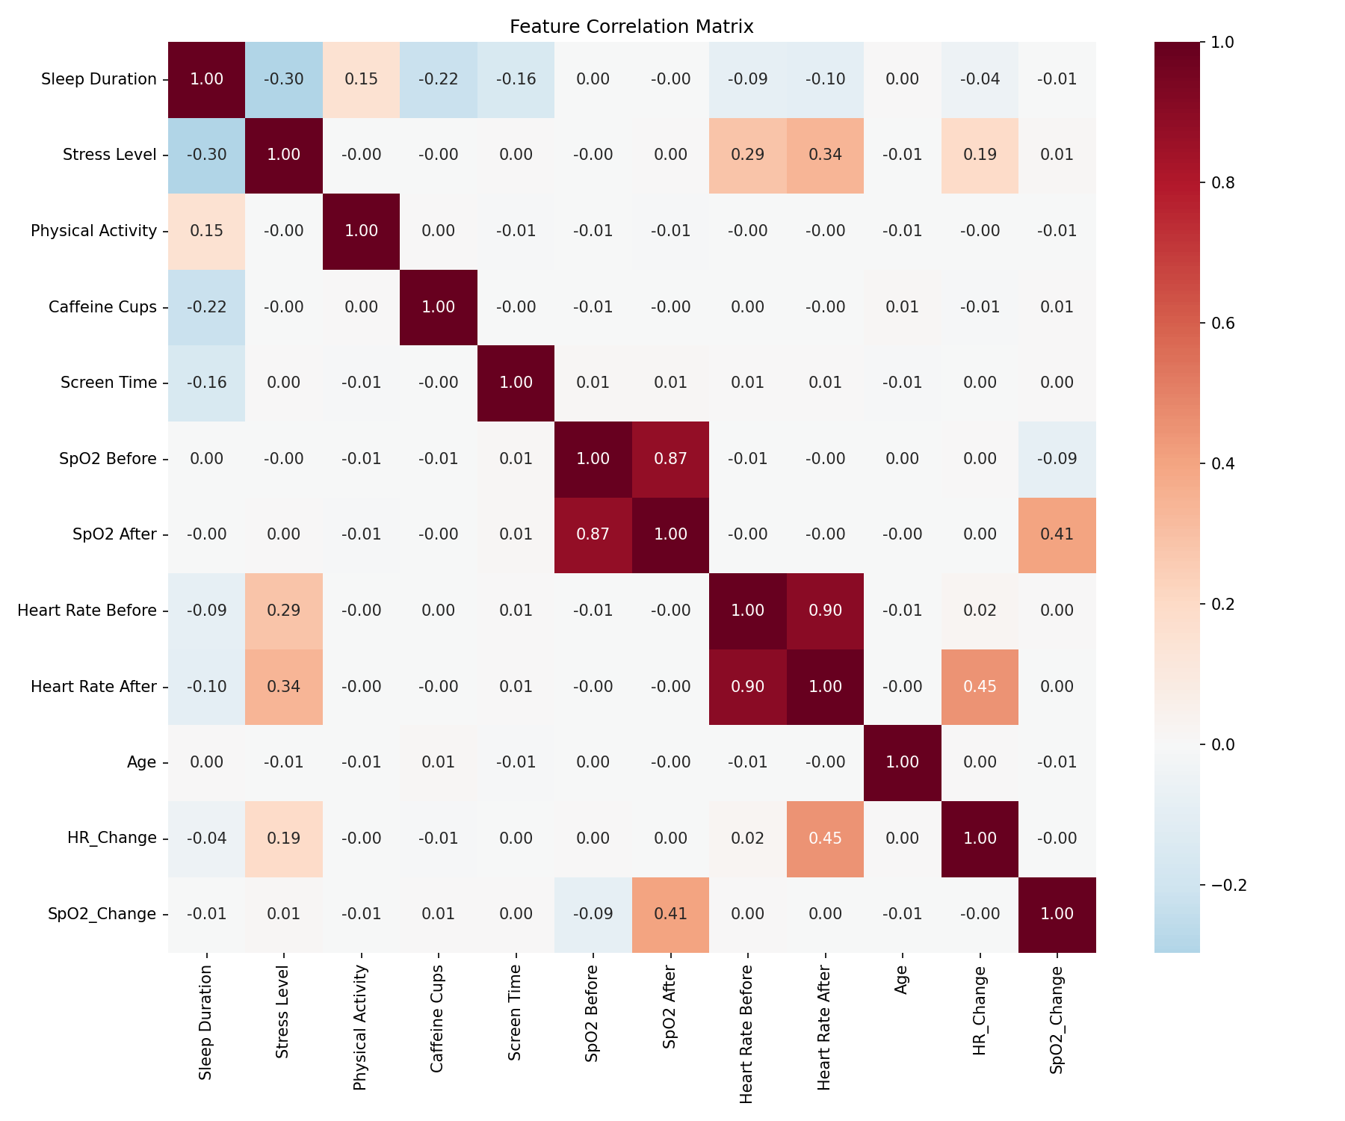

3. PCA Results
Explained Variance by Component:
Component | Variance % | Cumulative % | Key Features
PC1 | 18.80% | 18.80% | Heart Rate After, Heart Rate Before
PC2 | 16.11% | 34.92% | SpO2 After, SpO2 Before
PC3 | 11.07% | 45.99% | Sleep Duration, Caffeine Cups
PC4 | 8.90% | 54.88% | SpO2_Change, SpO2 Before
PC5 | 8.49% | 63.37% | Caffeine Cups, Age
PC6 | 8.38% | 71.75% | Age, Physical Activity
Components for 90% variance: 9
Components for 95% variance: 9
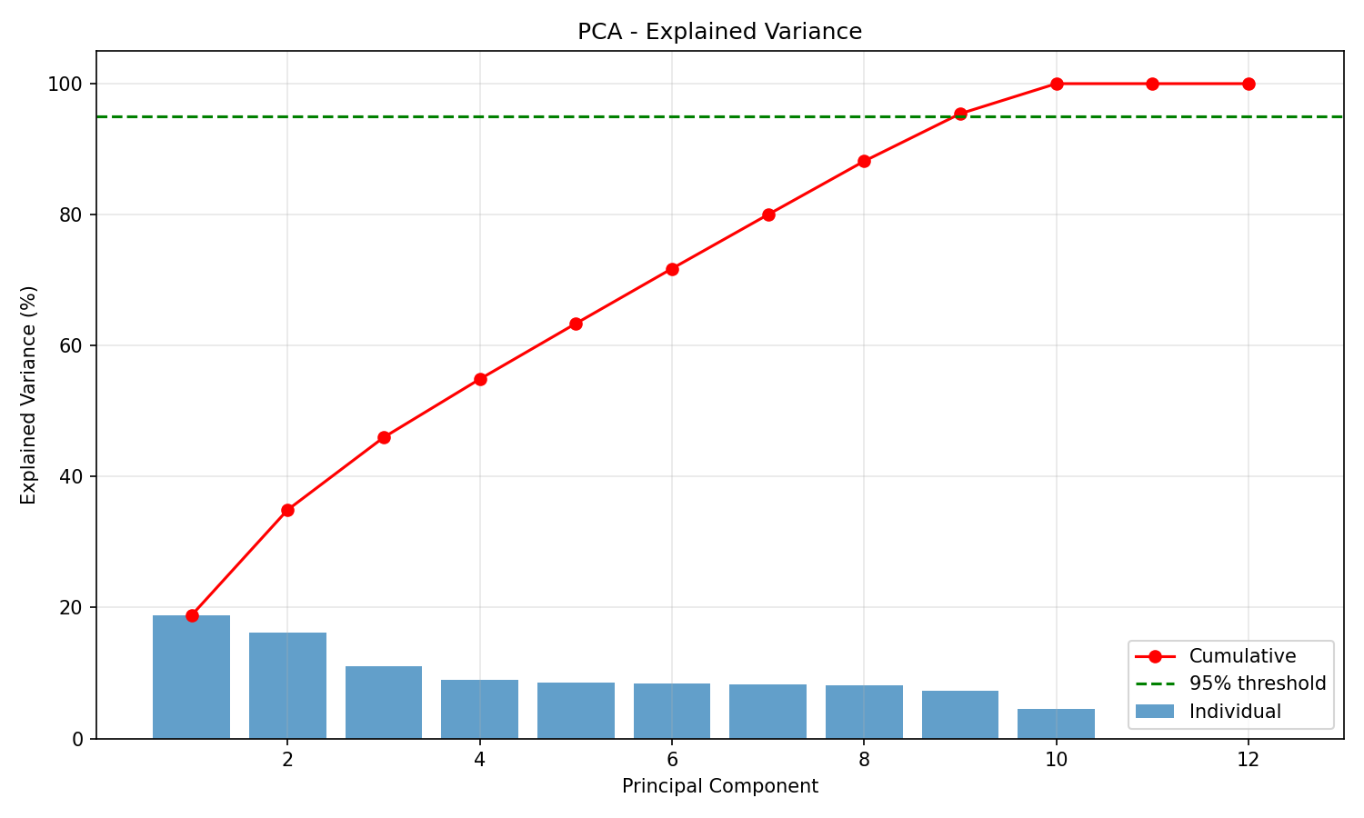

4. Feature Importance (XGBoost)
Feature | Importance
Sleep Duration | 0.4451
Stress Level | 0.1963
Caffeine Cups | 0.1908
Screen Time | 0.0918
Heart Rate After | 0.0115
HR_Change | 0.0107
Age | 0.0099
SpO2_Change | 0.0097
Physical Activity | 0.0096
Heart Rate Before | 0.0092
SpO2 Before | 0.0083
SpO2 After | 0.0073
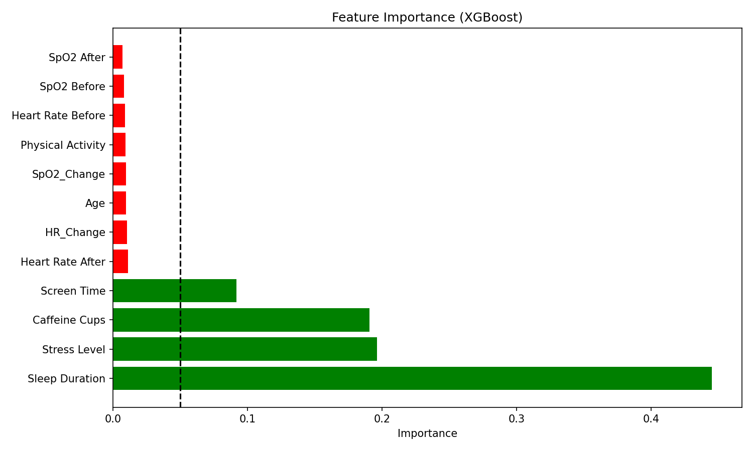

5. Feature Recommendations
Features to REMOVE (low importance or high correlation):
• Physical Activity
• SpO2_Change
• Age
• Heart Rate After
• HR_Change
• Heart Rate Before
• SpO2 Before
• SpO2 After
Features to KEEP:
• Sleep Duration
• Stress Level
• Caffeine Cups
• Screen Time

6. Model Performance Comparison
Original Model (all 12 features): 97.88%
Reduced Model (4 features): 98.02%
Accuracy difference: -0.14%

7. Conclusion
Based on the PCA and feature importance analysis, the dataset can be reduced from 12 to 4 features with minimal accuracy loss. The most important features for sleep quality prediction are: Sleep Duration, Stress Level, Caffeine Cups, Screen Time, Heart Rate After.

