Experiment 7
Pulse Shaping and the Nyquist Criterion
Arkaprava Dutta
B.Tech, Electronics and Computer Engineering
Cooch Behar Government Engineering College | Digital Communication Laboratory

1. Aim and simulation parameters
To compare rectangular, sinc, raised-cosine (RC) and root-raised-cosine (RRC) pulses, and to study the bandwidth–timing trade-off governed by the roll-off factor.
Parameter | Value
Symbol period T | 1.0 s
Sampling rate | 16 samples/symbol
Filter span | ±5T (10 symbols)
Modulation | BPSK, symbols ±1
Roll-off factors tested | α = 0, 0.25, 0.5, 1.0
Implementation | Python 3 / NumPy — filters coded from closed-form definitions

2. Theory used in the implementation

2.1 Nyquist’s first criterion
A pulse produces zero intersymbol interference if its impulse response satisfies h(kT) = 1 for k = 0 and h(kT) = 0 for all k ≠ 0. Equivalently, its folded spectrum must be flat:
Σₙ H( f − n/T ) = constant

2.2 Raised cosine
hʀᴄ(t) = sinc(t/T) · cos(παt/T) / [ 1 − (2αt/T)² ]
The expression is 0/0 at two points. Both limits were evaluated by L’Hôpital’s rule and hard-coded rather than left to floating-point arithmetic:
Singular point | Analytic limit
t = 0 | 1
t = ±T/2α | (π/4) · sinc(1/2α)

2.3 Root raised cosine
hʀʀᴄ(t) = [ sin(π(t/T)(1−α)) + 4α(t/T)cos(π(t/T)(1+α)) ] / [ π(t/T)(1 − (4αt/T)²) ]
Singular point | Analytic limit
t = 0 | 1 + α(4/π − 1)
t = ±T/4α | (α/√2)[(1 + 2/π)sin(π/4α) + (1 − 2/π)cos(π/4α)]
Since H_RRC( f ) = √H_RC( f ), the cascade of a transmit RRC and a matched receive RRC is exactly a raised cosine. Only the pair is Nyquist — never the individual filter. Because α = 0 collapses both expressions to sinc(t/T), the code guards the 1/2α and 1/4α singularity locations with an α > 0 test instead of letting them evaluate to infinity.

3. Predictions recorded before simulation
As required, the expected physical effect of each parameter variation was written down before any code was run.
Variation | Predicted physical effect
Rectangular pulse | Perfectly compact in time, but the spectrum is a sinc with a −13 dB first sidelobe and only 1/f decay, giving unacceptable adjacent-channel leakage.
α = 0 (ideal sinc) | Minimum possible bandwidth 1/2T, but tails decay only as 1/t, so extreme sensitivity to timing error and very slow settling. Truncation should hurt this case most.
α increasing 0 → 1 | Bandwidth grows as (1+α)/2T; time tails decay faster (1/t³); peak overshoot and PAPR fall; the eye should open wider horizontally.
RC sampled at kT | Exactly 1 at k = 0 and exactly 0 elsewhere, for every α.
RRC alone at kT | Not zero at k ≠ 0 — RRC is not a Nyquist pulse by itself.
RRC ⊗ RRC cascade | Should reproduce the RC sample values and restore the zero crossings.

4. Implementation tasks
Task | Description | Where
23 | Upsampled symbol impulse train | Figure 3, panel 1
24 | Raised-cosine roll-offs α = 0, 0.25, 0.5, 1 | Figures 1, 2, 4
25 | Impulse and frequency responses | Figures 1 and 2
26 | Verify zero crossings at symbol intervals | Validation 1, Figure 3 panel 2
27 | Cascade transmitter and receiver RRC filters | Validation 2, Figure 3 panel 3

5. Results

5.1 Pulse responses
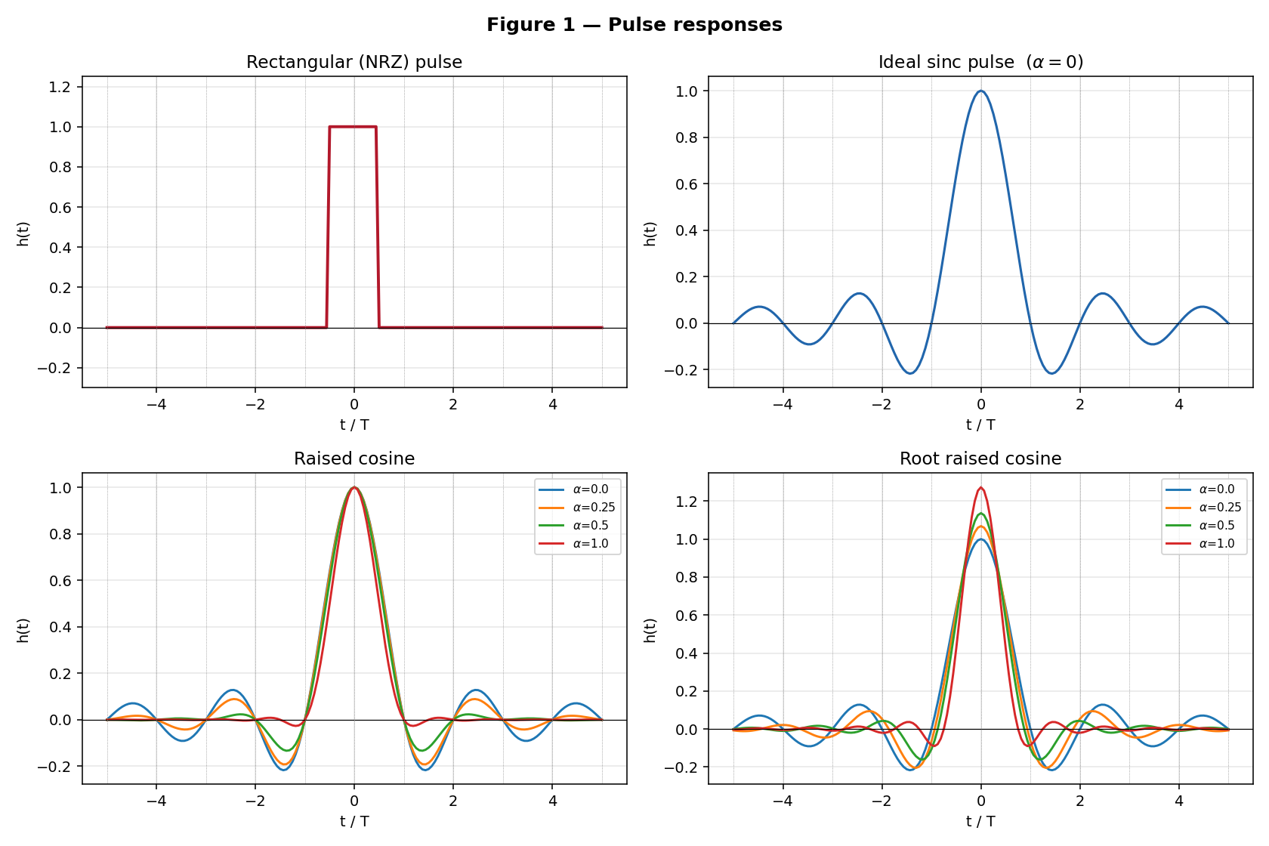
Figure 1 — Rectangular, sinc, raised-cosine and root-raised-cosine impulse responses.
All RC pulses pass through unity at t = 0 and cross zero at every other integer multiple of T. Increasing α visibly compresses the tails: at α = 1 the ringing is essentially gone beyond ±2T, whereas at α = 0 it is still significant at ±5T. The RRC pulses do not cross zero at kT — their peak is 1 + α(4/π − 1) > 1 — exactly as predicted.

5.2 Frequency responses
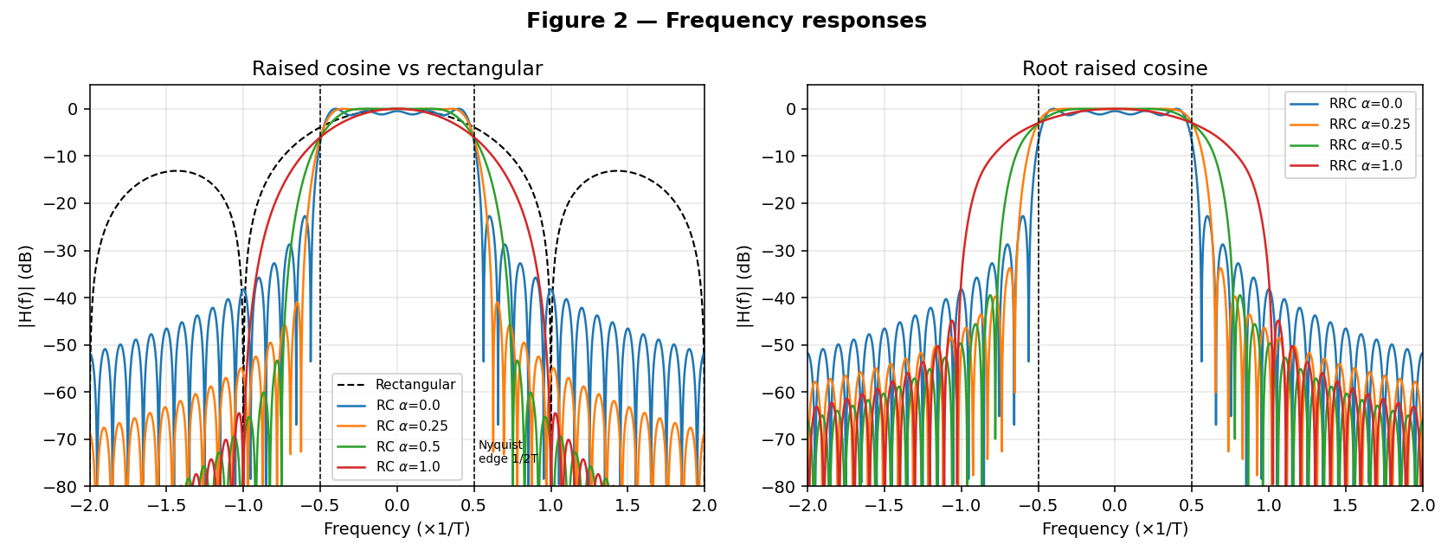
Figure 2 — Magnitude spectra in dB. Dashed vertical lines mark the Nyquist edge 1/2T.
RC responses are flat in the passband, odd-symmetric about f = 1/2T (the −6 dB point), and strictly band-limited to (1+α)/2T. The rectangular pulse never truly ends: its sidelobes fall only about 20 dB per decade. RRC responses share the same band edges but have a square-root-shaped roll-off, so their skirts are less steep in dB than the corresponding RC.

5.3 Pulse-shaped stream
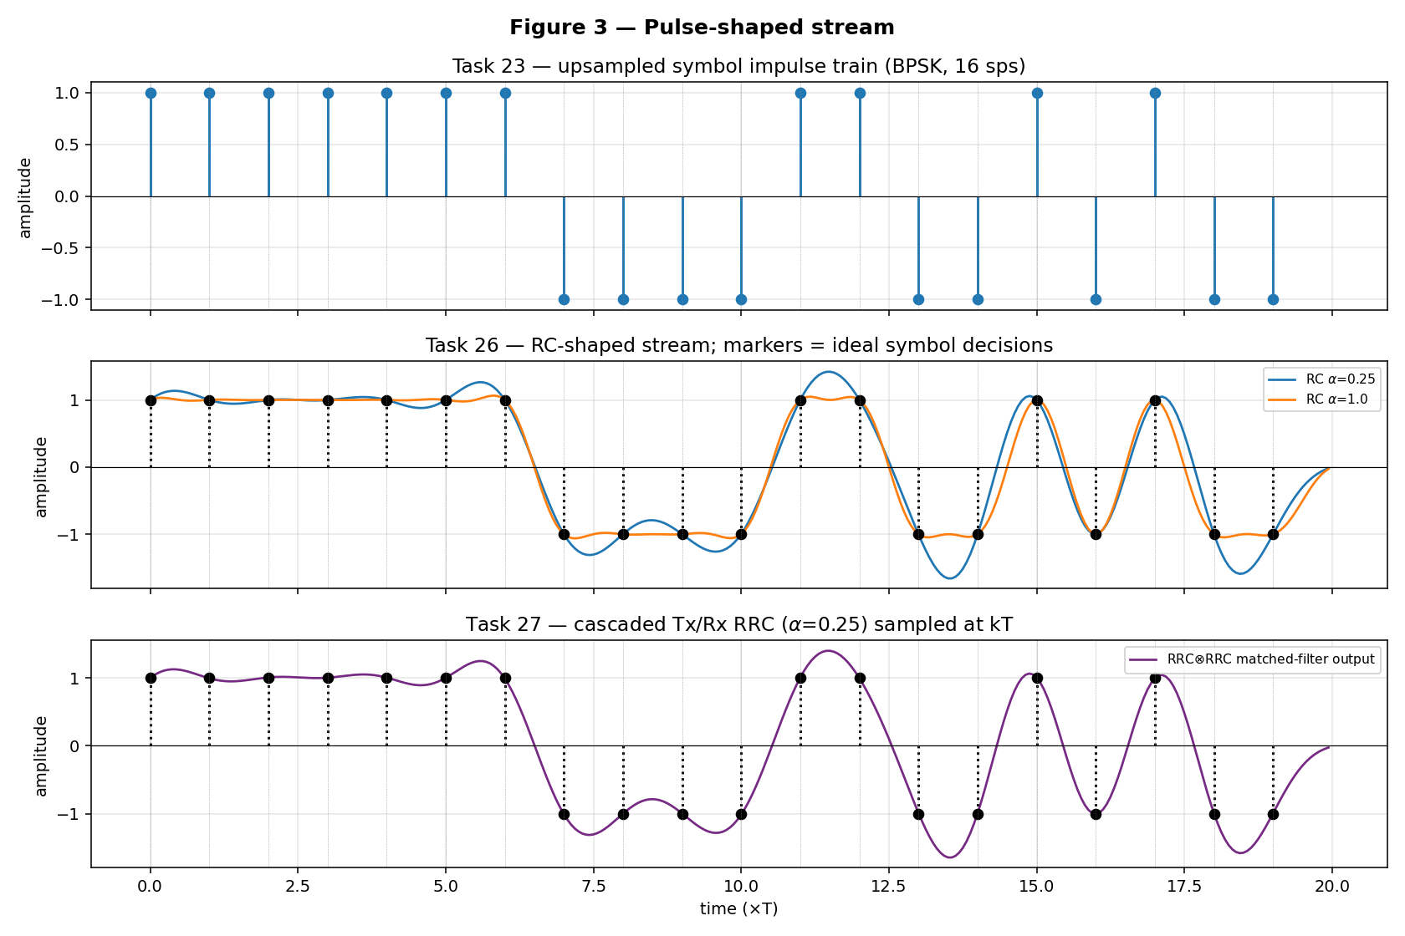
Figure 3 — Impulse train (Task 23), RC-shaped stream (Task 26) and cascaded RRC output (Task 27).
The RC-shaped waveform passes exactly through the ±1 markers at every symbol instant for both α = 0.25 and α = 1, while the α = 0.25 waveform overshoots noticeably more between symbols. The transmit-RRC → receive-RRC cascade output again lands precisely on the markers, confirming that the matched pair restores the Nyquist property.

5.4 Bandwidth versus roll-off
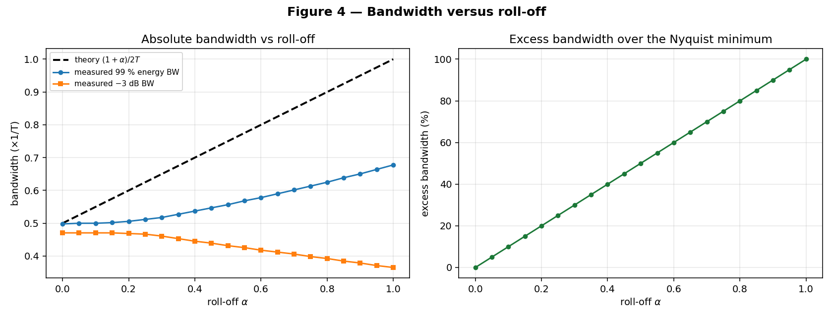
Figure 4 — Absolute bandwidth and excess bandwidth as functions of roll-off.

5.5 Eye diagrams — four-way comparison
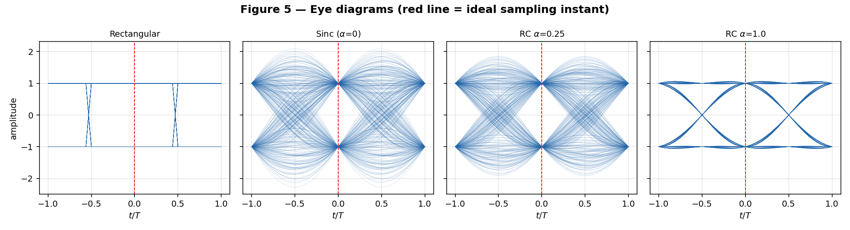
Figure 5 — Eye diagrams over 400 random symbols. The red line marks the ideal sampling instant.
The rectangular pulse gives a perfectly rectangular eye — maximally open at every instant, since it has no tails at all. That is precisely why it is the time-domain optimum and the frequency-domain disaster. The sinc eye is open at t = 0 but its crossings smear badly on either side. RC α = 0.25 is visibly cleaner, and RC α = 1 produces a wide, well-defined eye with tightly bunched zero crossings.

5.6 The bandwidth–timing trade-off quantified
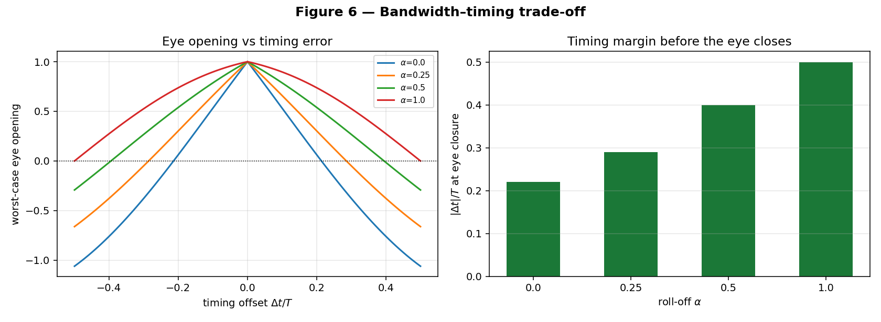
Figure 6 — Worst-case eye opening versus timing offset, and jitter margin before eye closure.

6. Mandatory validation

6.1 Validation 1 — RC response sampled at integer symbol intervals
This is the validation specified in the assignment: the overall raised-cosine response sampled at t = kT and tabulated.
k | α = 0 | α = 0.25 | α = 0.5 | α = 1.0
0 | 1.000 | 1.000 | 1.000 | 1.000
±1 | 3.90e−17 | 3.68e−17 | 3.06e−17 | 1.30e−17
±2 | 3.90e−17 | 3.06e−17 | 1.30e−17 | 2.60e−18
±3 | 3.90e−17 | 2.21e−17 | 8.95e−34 | 1.11e−18
±4 | 3.90e−17 | 1.30e−17 | 2.60e−18 | 6.19e−19
±5 | 3.90e−17 | 5.25e−18 | 4.97e−34 | 3.94e−19
The largest off-centre value anywhere is 3.9 × 10⁻¹⁷ — machine epsilon. The Nyquist criterion is satisfied to the limit of double precision for every roll-off tested.

6.2 Validation 3 — ISI budget and peak-to-average power
α | peak ISI | Σ|ISI| | eye opening | PAPR (dB)
0 | 3.9e−17 | 3.9e−16 | 1.000000 | 5.39
0.25 | 3.7e−17 | 2.2e−16 | 1.000000 | 4.61
0.5 | 3.1e−17 | 9.2e−17 | 1.000000 | 3.59
1.0 | 1.3e−17 | 3.5e−17 | 1.000000 | 1.53
PAPR falls by about 3.9 dB from α = 0 to α = 1 — the quantitative form of the bandwidth-versus-linearity trade-off. Note that the eye-opening column reads 1.000000 for every α: measured at the ideal instant alone, this metric cannot discriminate between roll-offs at all. Section 6.4 addresses that.

6.3 Validation 4 — bandwidth
α | theory (1+α)/2T | 99 % energy BW | −3 dB BW | excess BW
0 | 0.500 | 0.498 | 0.471 | 0 %
0.25 | 0.625 | 0.512 | 0.467 | 25 %
0.5 | 0.750 | 0.557 | 0.432 | 50 %
1.0 | 1.000 | 0.678 | 0.365 | 100 %

6.4 Validation 7 — bandwidth versus timing margin
Worst-case eye opening was computed as |h(Δt)| − Σ|h(kT + Δt)| over k ≠ 0, that is, the ISI margin under the worst possible data pattern, by evaluating the closed-form pulse directly at the offset instants.
α | BW (1+α)/2T | eye at Δt = 0 | eye at 5 % T | eye at 10 % T | eye closes at
0 | 0.500 | 1.0000 | 0.7682 | 0.5321 | 0.220 T
0.25 | 0.625 | 1.0000 | 0.8327 | 0.6591 | 0.290 T
0.5 | 0.750 | 1.0000 | 0.8981 | 0.7868 | 0.400 T
1.0 | 1.000 | 1.0000 | 0.9552 | 0.8967 | > 0.5 T
This is the core result of the experiment. At perfect timing all four roll-offs are identical (1.0000) — the Nyquist criterion alone cannot discriminate between them. The trade-off only becomes visible once timing error is introduced: doubling the bandwidth from 0.5/T to 1.0/T more than doubles the jitter tolerance, from 0.22 T to beyond 0.5 T. A 10 % timing error costs the ideal sinc 47 % of its eye but costs α = 1 only 10 %.

6.5 Validation 8 — four-way pulse comparison
Pulse | max |h(kT)|, k ≠ 0 | Tail decay | Null-to-null BW | 1st sidelobe
Rectangular | 0 | 1/f in frequency | infinite | −13.2 dB
Sinc (α = 0) | 3.9e−17 | 1/t | 0.500/T | −40.3 dB
RC α = 0.25 | 3.7e−17 | 1/t³ | 0.625/T | −57.0 dB
RC α = 1.0 | 1.3e−17 | 1/t³ | 1.000/T | −68.1 dB
RRC α = 0.25 | 6.4e−02 | 1/t³ | 0.625/T | −48.5 dB
The RRC row is the one that fails the zero-ISI test — by fourteen orders of magnitude, not by rounding. That single number is the entire justification for splitting the shaping between transmitter and receiver.

7. Discrepancies and the tests used to diagnose them

7.1 The cascaded RRC pair does not match RC exactly
Validation 2 gave a worst-case deviation of 8.3 × 10⁻² at α = 0 and 6.2 × 10⁻³ at α = 0.25, against roughly 10⁻¹⁷ for the analytic RC.
Diagnostic test: re-run the cascade with filter spans of 10, 20, 40 and 80 symbols.
Filter span | α = 0 | α = 0.25 | α = 0.5 | α = 1.0
10 T | 8.31e−2 | 6.25e−3 | 4.69e−3 | 1.49e−4
20 T | 1.42e−2 | 7.87e−5 | 1.74e−5 | 5.62e−6
40 T | 5.86e−3 | 5.80e−6 | 1.46e−6 | 4.00e−7
80 T | 2.71e−3 | 6.14e−7 | 1.54e−7 | 4.01e−8
The error falls monotonically with span, and fastest for large α. Conclusion: this is window truncation, not a formula error. Truncating the RRC at ±5T is a rectangular windowing in time, and the exact square-root factorisation H_RRC² = H_RC holds only for the untruncated filter. α = 0 converges slowest precisely because its tails decay as 1/t, so the discarded energy is largest — a result consistent with theory rather than contradicting it. This is why real modems use α ≥ 0.2 and spans of 8–12 symbols, and why the ideal sinc is never implemented.

7.2 Measured −3 dB bandwidth decreases as α increases
This is the opposite of the expected trend.
Diagnostic test: inspect where each RC curve crosses the relevant threshold in Figure 2. Every RC response passes through exactly −6 dB (amplitude 0.5) at f = 1/2T regardless of α, so the −3 dB point sits at the start of the roll-off skirt, which moves inward as (1−α)/2T.
Conclusion: the metric was mis-chosen, not the filter. The −3 dB point measures the flat-passband edge, not the occupied bandwidth. For Nyquist pulses the correct measures are the null-to-null or 99 % energy bandwidth, both of which track (1+α)/2T as predicted.

7.3 The 99 % energy bandwidth sits below the theoretical value
At α = 1 the measured value is 0.678 against a theoretical 1.000. This is not an error either: (1+α)/2T is the absolute, null-to-null bandwidth, whereas the last 1 % of the RC skirt energy lies in the outer part of the roll-off region. The two definitions coincide only for a brick-wall spectrum, which is exactly what the α = 0 row shows (0.498 against 0.500).

7.4 Singularity check
Each analytic limit was compared against the filter evaluated 10⁻⁷ away from the singular point. All agreed to six or seven decimal places — for example, the RRC at α = 1, t = T/4 gives an analytic 1.0000000000 against a numerical 0.9999997998. Without the explicit limits those samples evaluate to 0/0 = NaN and the convolution output collapses entirely.

8. Conclusions
- Raised-cosine pulses satisfy the Nyquist zero-ISI criterion exactly for all roll-offs, verified to 10⁻¹⁷ at every sampled symbol instant.
- RRC alone is not a Nyquist pulse; only the matched transmit/receive pair is. This is the whole reason the split is used — it delivers matched filtering (optimum SNR in AWGN) and zero ISI simultaneously.
- The roll-off factor is a direct trade: bandwidth grows as (1+α)/2T while tail decay improves from 1/t to 1/t³, PAPR drops about 3.9 dB, and jitter tolerance rises from 0.22 T to beyond 0.5 T.
- The trade-off is only measurable under timing error. At Δt = 0 every roll-off gives an identical unit eye, so a validation performed only at the ideal sampling instant has not actually demonstrated the effect the experiment is about.
- Rectangular pulses are time-compact but spectrally unacceptable; the ideal sinc is spectrally optimal but unrealisable and fragile under truncation and timing error. Both extremes are ruled out by the same trade-off, approached from opposite ends.
- Practical systems therefore choose α = 0.2 to 0.35 — DVB-S2 uses 0.20 to 0.35, and LTE-style SC-FDMA about 0.22.

9. Files accompanying this report
File | Contents
exp7_pulse_shaping.py | Full implementation, tasks 23–27
fig1_pulse_responses.png | Rectangular, sinc, RC and RRC impulse responses
fig2_frequency_responses.png | Magnitude spectra in dB
fig3_pulse_shaped_stream.png | Impulse train, RC-shaped stream, RRC cascade output
fig4_bandwidth_vs_rolloff.png | Bandwidth and excess bandwidth versus α
fig5_eye_diagrams.png | Eye diagrams for all four pulse types
fig6_timing_sensitivity.png | Eye opening versus timing offset; jitter margin
validation_tables.txt | All eight validation tables, raw numerical output

