

ITEC622: Data Analytics and Visualization

Assessment 3



June 11, 2025

SUBMITTED BY: BISHAL BIDARI

STUDENT ID: S00391799

Contents

Part A: Written Proposal 2

Introduction 2

Project Objectives 2

Data Sources and Collection Tools 3

Data Needs: 3

Data Sources: 3

Tools and Techniques for Data Collection: 4

Data Retention and Management: 5

Analytics and Visualisation Tools/Techniques 5

Data Cleaning & Transformation with Power BI: 5

Data Analysis in Power BI: 5

Data Visualisation in Power BI: 6

Data Visualisation for Preservation of the Common Good: 6

• Raising Awareness 7

• Promoting Accountability and Transparency 7

• Supporting Volunteer Engagement 7

• Encouraging Data-Driven Environmental Actions 7

Part B: Pilot Visualisation 8

Dataset Overview 8

Dataset 1: Global CO₂ Emissions: 8

Dataset 2: Global Energy Mix – Fossil, Renewable, Nuclear 8

Power BI Visualisations 10

Chart 1: Global CO₂ Emissions Over Time (Line Chart) 10

Chart 2: CO₂ Emissions by Country (2022) 11

Chart 3: Top 10 CO₂ Emitting Countries (2022) 11

Chart 4: Global Energy Mix Over Time 12

Dashboard Features 13

Limitations 13

Conclusion 14

References 15

# Part A: Written Proposal

## Introduction

Climate change and other environmental concerns are now more pressing. ABC Environment, a not-for-profit group, works to address these problems - it operates global sustainability projects and recruit’s volunteers from many places. As the group expands, the data it manages also grows. This data includes records of environmental impact, volunteer work along with donations.

ABC Environment plans to put in place data analytics plus display system - this helps the group decide better. It also stays open, follows its progress as well as reports its effects more plainly. That paper describes a way to meet the main information needs of ABC Environment - it centers on methods to gather, study in addition to show their data well. The purpose is to offer facts that direct action, back the group's purpose, and help the public.



## Project Objectives

The project's main purpose is to assist ABC Environment in making better decisions - it builds a plain yet capable data analytics and visualization system. This system shows the organization its performance in important areas. It also reveals where the organization can get better.

The objectives are:

* Track its environmental effect - it monitors indicators such as carbon emissions, waste along with water usage. This shows the organization's environmental footprint.
* Improves volunteer involvement - The organization analyzes volunteer participation data to understand trends. It then increases involvement and improves retention.
* Donor support - The organization analyzes donation trends, sources as well as involvement - this improves fundraising plans.
* Project tracking - it tracks the status plus outcomes of ongoing environmental projects across different areas.
* Promotes transparency and social impact - The organization uses visuals to present information clearly. That builds trust with stakeholders also shows the organization's contribution to environmental sustainability.

By the end of this project, ABC Environment should own a working dashboard and visual reports - these will provide real, useful information; this helps the organization manage its data as well as use it to achieve a greater effect.

## Data Sources and Collection Tools

To construct a useful data analysis and display system for ABC Environment, one must first grasp the kinds of data that matter to the organization. One needs to gather that data well.

### Data Needs:

ABC Environment gathers and handles various data from inside plus outside its organization.

* The environmental footprint data includes carbon emissions, water use, waste output along with how much energy the group consumes.
* Volunteer data consists of registration details, attendance records, hours each person contributes, their specific roles as well as survey feedback.
* Donor and fundraising data show donation sums, information about donors, also the success of fundraising efforts.
* Project data details progress updates, where projects take place, signs of success in addition to how a project affects the community.

### Data Sources:

* **Internal Sources**:

**Volunteer sign-up forms, attendance logs, project reports, donation records, CRM systems.**

* **External Sources**:
  + Open data platforms (e.g. Kaggle, World Bank, UN, data.gov.au)
  + Public APIs for environmental metrics (e.g. CO₂ emission statistics, weather data)
  + Survey tools (e.g. Google Forms, Microsoft Forms)

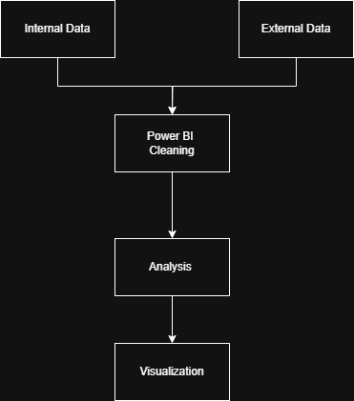

### Tools and Techniques for Data Collection:

* Organizations use online forms and surveys; they collect volunteer feedback, donor surveys along with event signups.
* Web scraping tools, like Python with BeautifulSoup or Scrapy, get real time data. This data comes from environmental plus climate databases.
* APIs gather structured data - this data comes from platforms such as the World Bank, WHO, or government climate data services.
* Databases and spreadsheets, for example, Google Sheets, Excel as well as cloud-based databases like Airtable or MySQL, hold also manage incoming data.
* ETL tools, such as Power Query in Power BI or Python scripts, clean, transform in addition to prepare data for analysis.

### Data Retention and Management:

Regular data backups and safe cloud storage utilizing services like OneDrive, Google Drive, or AWS are recommended. Donor information and other sensitive data should adhere to privacy laws (such as the Australian Privacy Principles and the GDPR). To prevent errors, outdated entries, and duplicates, data cleaning should be done on a regular basis.

ABC Environment may obtain a comprehensive understanding of its performance and potential growth areas by merging structured internal data with extensive external datasets.

## Analytics and Visualisation Tools/Techniques

I plan to use Microsoft Power BI as the main program for this project - it will help me clean, study along with show the data. Power BI is a capable, simple program. People who use it can build dashboards and see important facts; they do not need much coding skill. The program is a good fit for ABC Environment, a non-profit group.

### Data Cleaning & Transformation with Power BI:

Power BI comes with Power Query Editor, which allows easy data preparation:

* Remove duplicates or blanks
* Fix formatting issues (e.g. date or number formats)
* Handle missing data
* Merge data from multiple sources (e.g. CSV, Excel, web)
* Create new calculated columns or measures using DAX (Data Analysis Expressions)

Additionally, Power BI enables the connection to either static or live datasets, allowing for future upgrades to be automated if necessary.

### Data Analysis in Power BI:

The following built-in analytical functions of Power BI will assist in answering the organization's main questions:

* **Descriptive analytics** – Totals, averages, counts for volunteer hours, donations, and environmental indicators.
* **Time series trends** – Track progress over months or years.
* **Filtering and slicing** – Focus on specific projects, regions, or time periods.
* **Interactive visual breakdowns** – Drill-down features to explore data across levels (e.g. global → country → city).

### Data Visualisation in Power BI:

The real power of Power BI lies in its ability to turn numbers into clear, engaging visual stories. I will use:

* Bar/column charts
* Line charts
* KPI cards
* Slicers
* Maps
* Pie/donut charts

All things considered, ABC Environment can transform complicated data into clear, useful insights thanks to Power BI. Telling a story that bolsters decisions and fosters trust with the public, funders, and volunteers is more important than merely displaying numbers.

## Data Visualisation for Preservation of the Common Good:

The capacity of data visualization to make complicated topics understandable to all parties, donors, volunteers, partners, and the public—is one of its greatest advantages. Visualization is crucial in the ABC Environment instance not only for internal decision-making but also for promoting openness, public participation, and long-term effects.  
  
This project will help to maintain the common good in the following ways:

### Raising Awareness

Dashboards display project data. The data appears in real time, and it shows how much CO₂ a project saves - it also indicates how much waste a project lessens. This display raises awareness among the community plus among stakeholders. People who observe the impact clearly often engage; they support the project, or they donate.

### Promoting Accountability and Transparency

Partners and donors frequently want to know the precise use of their funds. Through transparency of project performance data and financing, this project will increase accountability and confidence. Trust in the organization is bolstered by transparent charts that display donations, the allocation of finances, and the effectiveness of environmental efforts.

### Supporting Volunteer Engagement

Volunteers form the centre of ABC Environment. Visual tools show their combined work, as they highlight the total hours people volunteer by region or the number of people who take part in a good project - it is simpler to know and stir them. The tools also help the NGO grasp where it needs more aid.

### Encouraging Data-Driven Environmental Actions

ABC Environment shows clear trends in its environmental numbers. For example, waste goes up, but water use goes down. The company takes these steps to change how it works - it puts its money and time where it does the best. With this, the decisions are better. This helps the environment.

In short, this data visualisation project is not just about charts and numbers — it’s about using technology in a meaningful way to support global environmental goals, foster social responsibility, and create long-term, positive change.

# Part B: Pilot Visualisation

## Dataset Overview

I chose two datasets from Our World in Data; they speak to the ABC Environment's focus on the environment. The datasets show important measures, like worldwide CO₂ emissions and the global energy supply, as they change over time.

### Dataset 1: Global CO₂ Emissions:

* + **Source**: [Our World in Data – CO₂ and Greenhouse Gas Emissions](https://github.com/owid/co2-data)
  + **Collected by**: Global Carbon Project, CDIAC, EDGAR
  + **Published by**: University of Oxford / Our World in Data
  + **Funding**: Oxford Martin Programme on Global Development

#### Description:

This dataset includes annual CO2 emissions statistics for over 200 nations from 1750 to 2022. Emissions per fossil fuel type (oil, gas, and coal), total CO₂ emissions, emissions per capita, and economic variables like GDP and population are important indicators.

#### Include:

* country
* year
* co2 (total emissions)
* co2_per_capita
* coal_co2, oil_co2, gas_co2
* gdp, population

#### Size & Coverage

* + Covers over 100,000 records globally
  + Includes 50+ variables for different sources and breakdowns

#### Relevance to Project:

The data directly helps ABC Environment - it follows how CO₂ emissions change. This shows trends across the globe and in specific areas.

### Dataset 2: Global Energy Mix – Fossil, Renewable, Nuclear

* **Source**: Our World in Data – Energy Mix
* **Collected by**: Energy Institute Statistical Review of World Energy
* **Published by**: Our World in Data
* **Funding**: Oxford Martin School

Description:

This statistic shows how much of each country's total primary energy consumption has come from nuclear, renewable energy, and fossil fuels over time. It provides a useful viewpoint on the global energy transition and covers several decades.

#### Include:

* + year
  + fossil_share_energy
  + renewables_share_energy
  + nuclear_share_energy
  + country

#### Size & Coverage:

* Data for 180+ countries
* Historical data from 1965 to 2023

#### Relevance to Project:

By showing the share of renewables in national energy consumption, this dataset complements the emissions dataset and supports the NGO’s goal of advocating for clean energy solutions.

#### Transform Data

I have Unpivoted the 3 column(Nuclear (% equivalent primary energy), Renewables (% equivalent primary energy) and Fossi Fuel (% equivalent primary energy)) of this dataset into 2 columns (energy_types and Share_percent).

The pivot version and unpivot version of the table are:

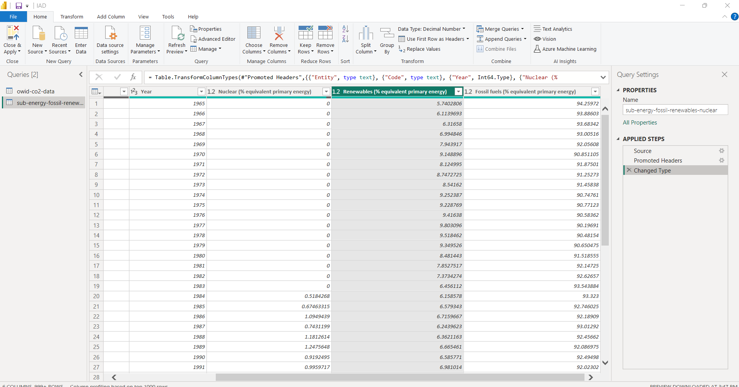

## Power BI Visualisations

To answer important questions that matched the goals of the NGO, I produced four Power BI visualizations. Every chart is intended to be understandable, engaging, and educational.

### Chart 1: Global CO₂ Emissions Over Time (Line Chart)

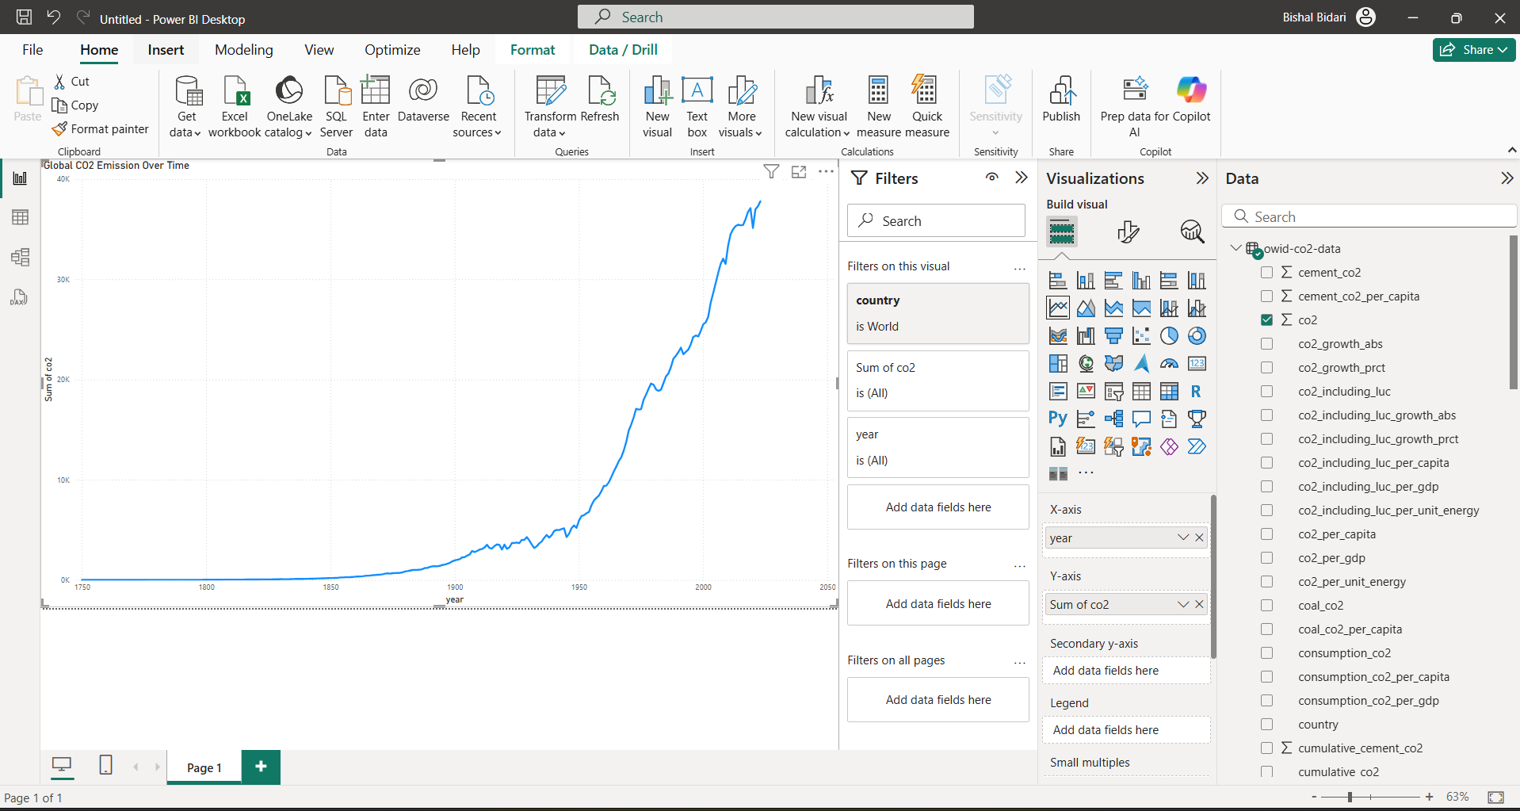

* **Type**: Line Chart
* **Dataset**: Global CO₂ Emissions
* **Fields**: year, co2, filtered to country = World
* **Insight**: Demonstrates a dramatic increase in CO2 emissions since 1950, underscoring the effects of population expansion and industrialization. This pattern emphasizes how urgent environmental action is.

### Chart 2: CO₂ Emissions by Country (2022)

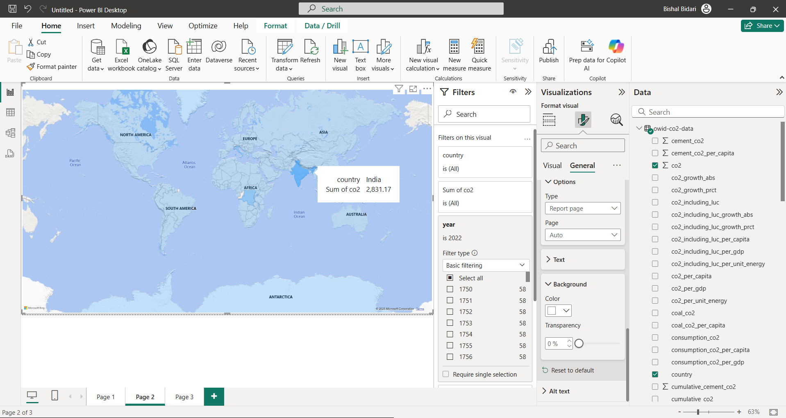

* **Type**: Map Visual
* **Dataset**: Global CO₂ Emissions
* **Fields**: country, co2, year = 2022
* **Insight**: shows emissions in a geographical manner. CO₂ production is dominated by nations like the US, China, and India. helpful in determining areas that could be the focus of policy or awareness.

### Chart 3: Top 10 CO₂ Emitting Countries (2022)

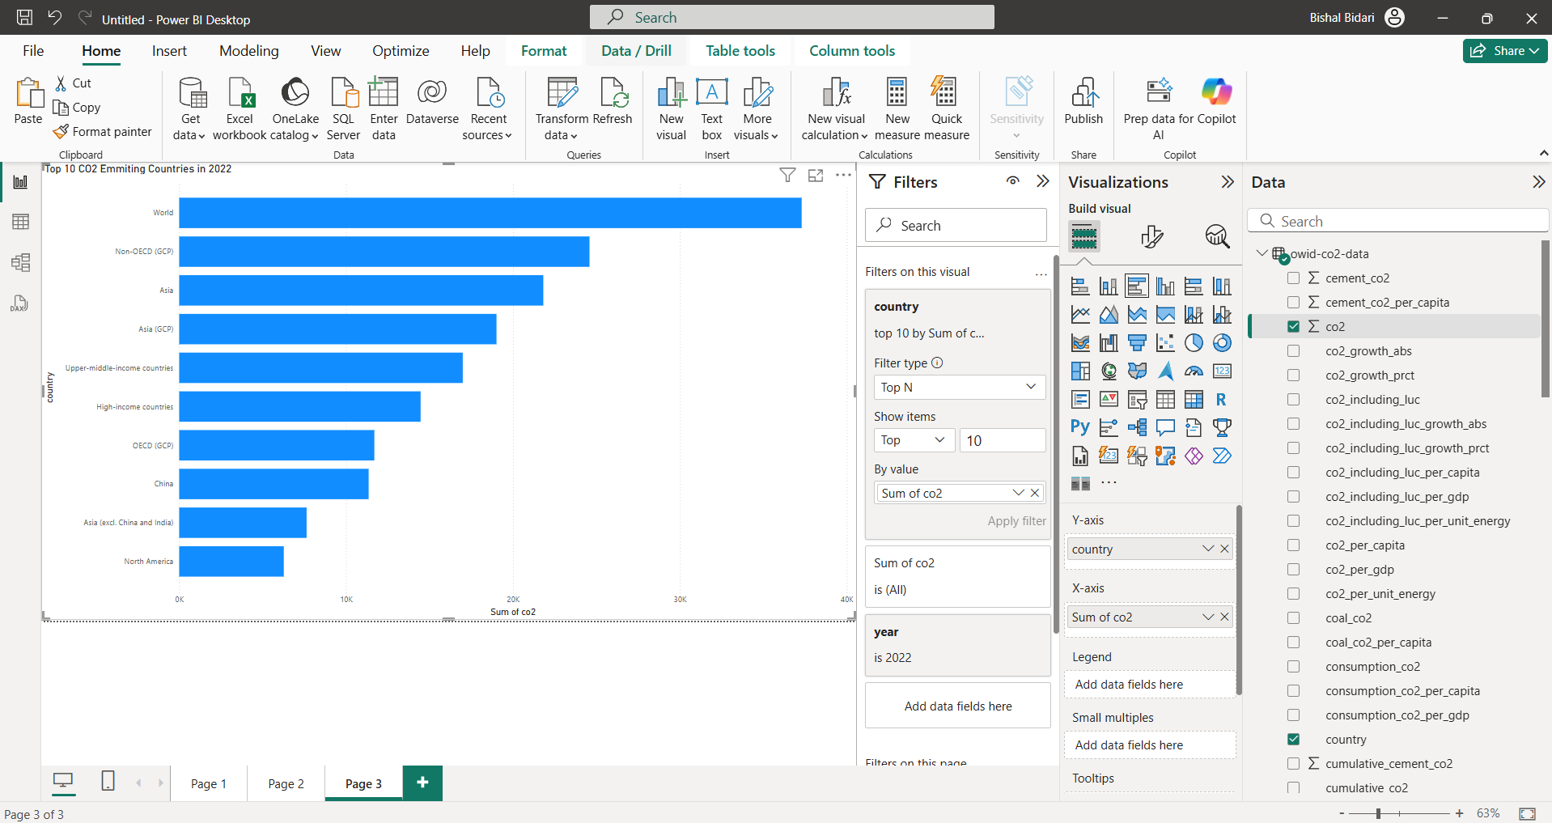

* **Type**: Clustered Bar Chart
* **Dataset**: Global CO₂ Emissions
* **Fields**: country, co2, year = 2022
* **Insight**: A clear ranking of the top 10 emitters. This helps stakeholders target advocacy, awareness, or partnership efforts effectively.

### Chart 4: Global Energy Mix Over Time

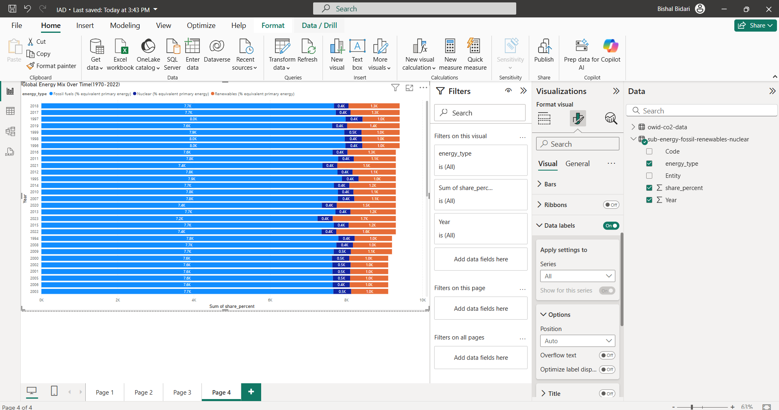

* **Type**: Stacked Area Chart
* **Dataset**: Global Energy Mix
* **Fields**: year, energy_type, share_percent
* **Insight**: Demonstrates the gradual but continuous rise in the use of renewable energy. Although fossil fuels continue to rule the market, the growing renewable energy trend is consistent with ABC Environment's purpose.

### Dashboard Features

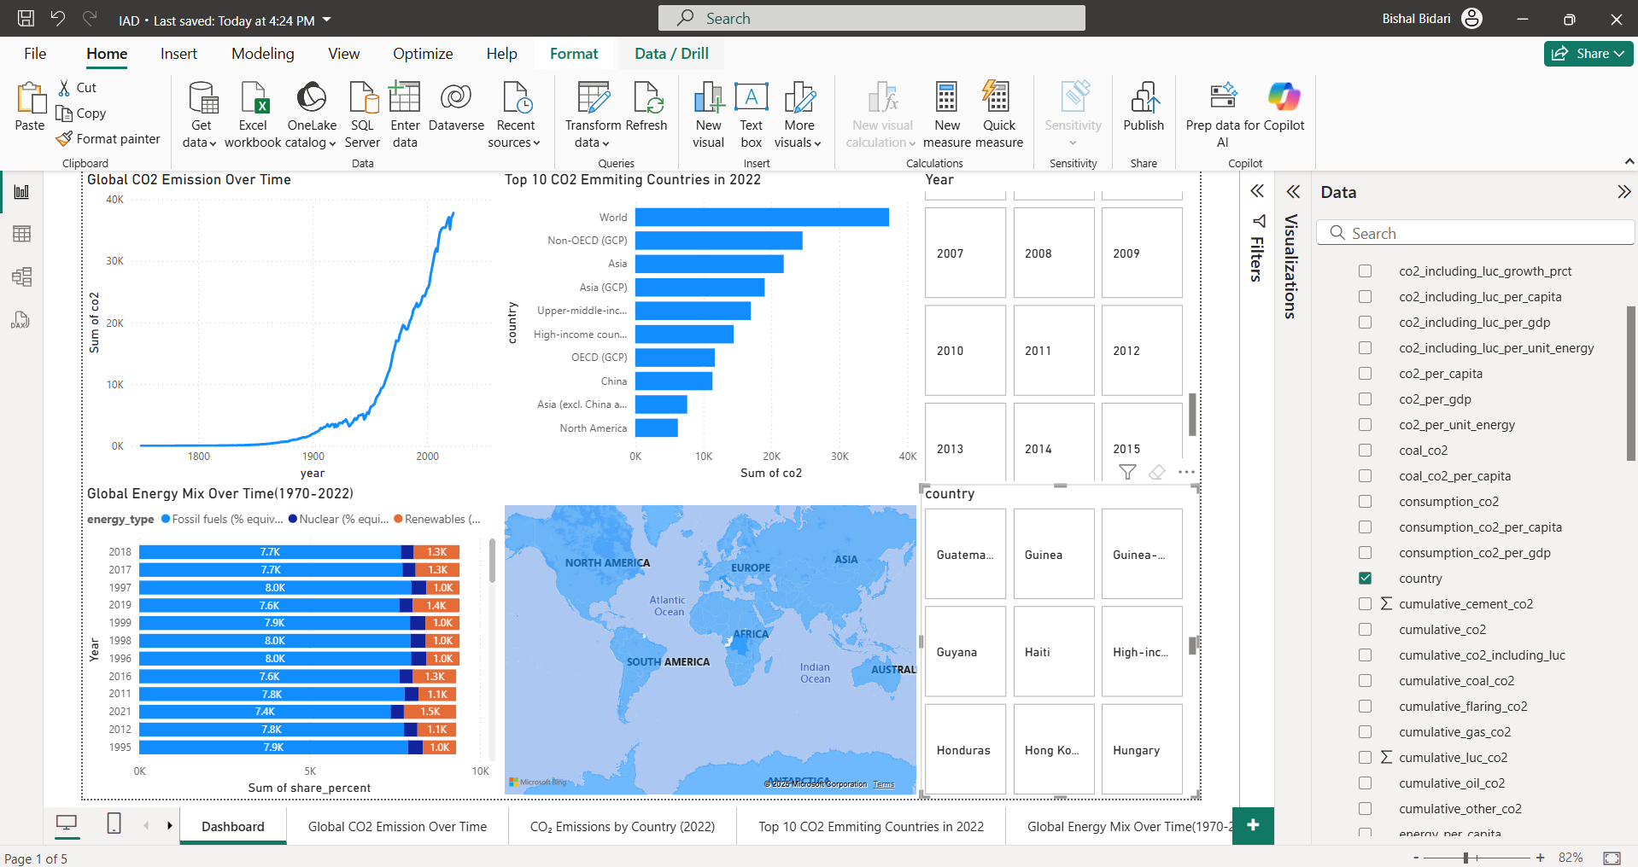

* All 4 visuals were added to the Power BI dashboard.
* Filters applied:
  + Slicer by Year
  + Slicer by Country (optional in visuals)

### Limitations

* Some countries have missed data in earlier years.
* Renewable energy breakdown (e.g., solar vs. wind) isn’t available on Dataset 2.
* The dashboard focuses on global-level insights rather than region-specific NGO data.

# Conclusion

The Power BI project showed how open-source environmental information became visual data. This helped organizations such as ABC Environment reach their goals. With data from Our World in Data, I displayed major global trends in CO₂ emissions. I also showed the changing energy mix in a format that was easy to see.

The dashboard held four visuals:

* Global emissions trends across time,
* Where emissions were on the map,
* A close look at the ten countries that released the most emissions,
* And the global moves away from fossil fuels to renewables and nuclear power.

The visuals helped people find where emissions gathered; they also watched progress towards cleaner energy sources. The visuals supported choices about climate policy and advocacy that came from evidence.

This project confirmed the worth of data visualization - it communicates global issues that are not simple. It also showed how tools like Power BI turn raw data into stories that mean something and lead to action.

# References

*github. “Owid/Co2-Data.” GitHub, 5 Apr. 2021, github.com/owid/co2-data.(github)*

*Our World in Data. (2024). Energy Mix Dataset. [online] Available at:* [*https://ourworldindata.org/energy*](https://ourworldindata.org/energy)

*“Global Carbon Project (GCP).” Globalcarbonproject.org, Global Carbon Project (GCP), 2018, www.globalcarbonproject.org.(“Global Carbon Project (GCP)”)*

*Energy Institute. “Statistical Review of World Energy.” Statistical Review of World Energy, 2024, www.energyinst.org/statistical-review.(Energy Institute)*