What if there is no flutter technology:

1). Maintain each folder for different platform (iOS and Android etc.).

2). If in apps does any update, maintain and debug it needs to push in individual to the app store and play store instead of one.

3). It would be double of work.

4). Due a huge different ecosystem of screen sizes it is hard to handling.

All of these disadvantages so flutter come in to resolve.

What is flutter?

The flutter is framework which is an open-source UI toolkit that is developed by Google. It was officially announced in May 2017 and first stable release, Flutter 1.0, was launched on December 4, 2018.

What are widgets?

In Flutter, a widget is a basic building block of the user interface. Widgets define how a part of the app should look and behave. They can represent anything from a button or a text label to complex layouts or entire screens. Widgets in Flutter are immutable and can be composed together to create more complex UIs.

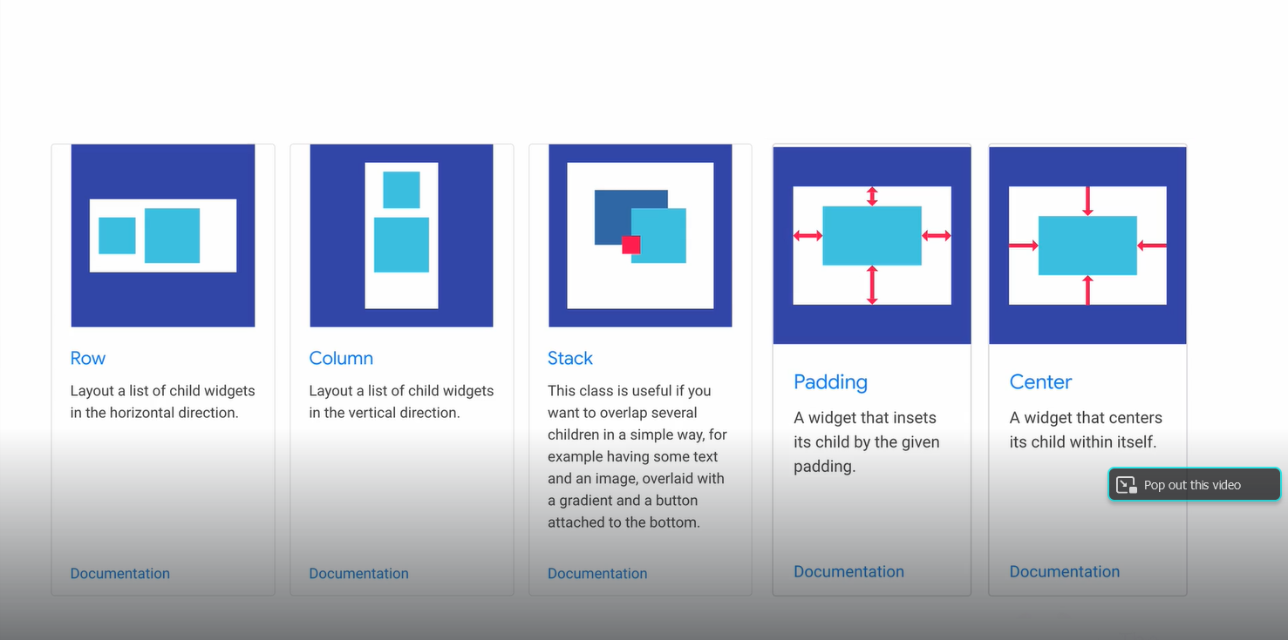

**Note**: Android and iOS it will just provide a blank windows or canvas however all the drawing and design can be done via widgets from the flutter.

**Note:** In flutter, widgets are building block and by plugin together it builds an appealing application.

**Platform and Device independent**

Once an apps is developed in the flutter framework it can deployed everywhere in platform and devices without having rewrite the code or learning new technology or new skill or new programming language.

**Why prefer flutter?**

It prefers because of the reason:

1. One place to debug.
2. One place to maintain.
3. One place to Update.

Which it facilitates to one codebase to rule in all of them but not only of them the flutter facilitate to a simple and flexible layout system.

**Constraints**

Constraints are more complex as the number of elements grow on screen.

We no longer in 3.5-inch screen era anymore.

Constraints each of them in relation to get more complex.

In website there are number that can adjust the user interface like Bootstrap, CSS Grid etc. but in mobile app there come a flutter development.

**Split Second Reload or Hot Reload ( it facilitate to reload super fast)**

Hot Reload in Flutter is a feature that allows you to see changes you make to your code almost instantly without restarting your app. It is designed to speed up the development process by preserving the current state of your app while you update its code.

**access to the original source code**:

In Flutter, access to the original source code means being able to view, edit, and manage the actual Dart files and other resources that make up a Flutter application.

**Anatomy of the flutter App**

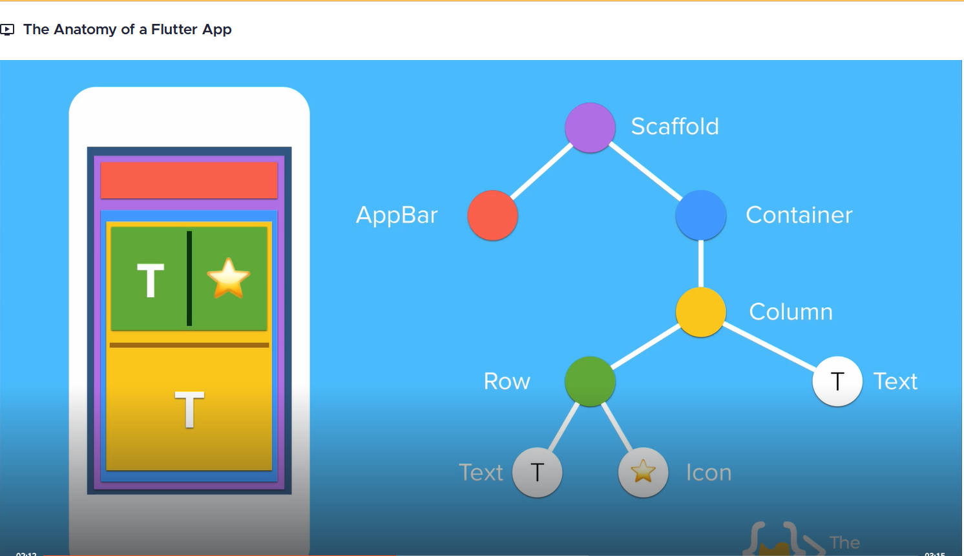

**Perquisites for building app with flutter**

1). Text Editor: Android Studio or Visual Studio (here we prefer Android Studio).

**Notes:**

Testing Android Apps from flutter is easy.

Testing iOS Apps from flutter is difficult because of code signing.

**List of Apps tester tools**

1. Mobile Emulator

* Android Emulator (Platform Android, Android Studio Emulator).
* iOS Emulator (Platform iOS mac).

1. Mobile Simulator

* iOS Simulator (can be considered both a simulator and an emulator Platform: iOS).
* Android Virtual Device (AVD) Platform: Android.

Codemagic: Bult, test and deliver you apps

**Developed Android apps with flutter you can use:**

Android Apps:

* MAC or PC
* Android Studio.
* Android Emulator or Physical Devices.

iOS Apps:

* Mac.
* Android Studio.
* iOS Simulator or Physical Devices.

All practical requirement in developed Android apps

Android Studio.

Flutter SDK (Version 3.22.0)