***4.ReactJS-HOL***

1. Create a new react application using *create-react-app* tool with the name as “blogapp”
2. Open the application using VS Code
3. Create a new file named as **Post.js** in **src folder** with following properties

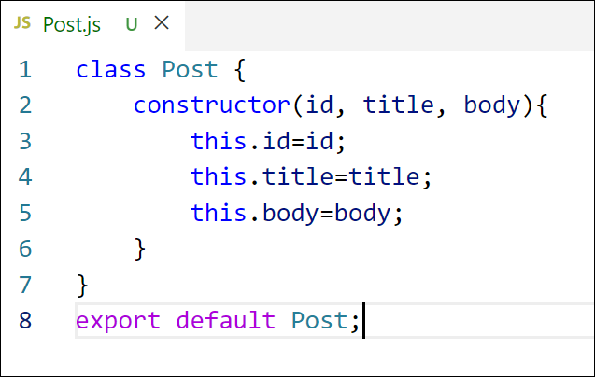

Figure 2: Post class

1. Create a new class based component named as **Posts** inside **Posts.js** file

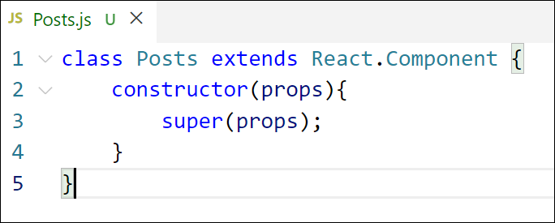

Figure 3: Posts Component

1. Initialize the component with a list of Post in state of the component using the constructor
2. Create a new method in component with the name as **loadPosts()** which will be responsible for using Fetch API and assign it to the component state created earlier. To get the posts use the url (<https://jsonplaceholder.typicode.com/posts>)

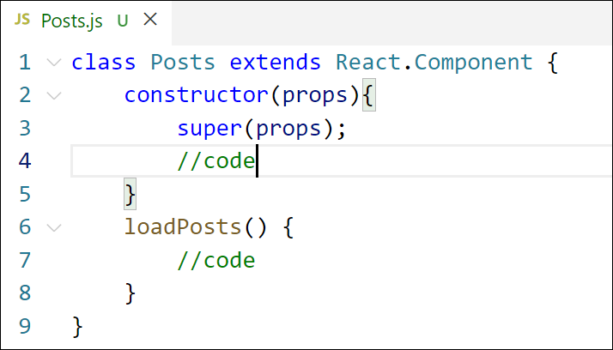

Figure 4: loadPosts() method

1. Implement the **componentDidMount()** hook to make calls to **loadPosts()** which will fetch the posts

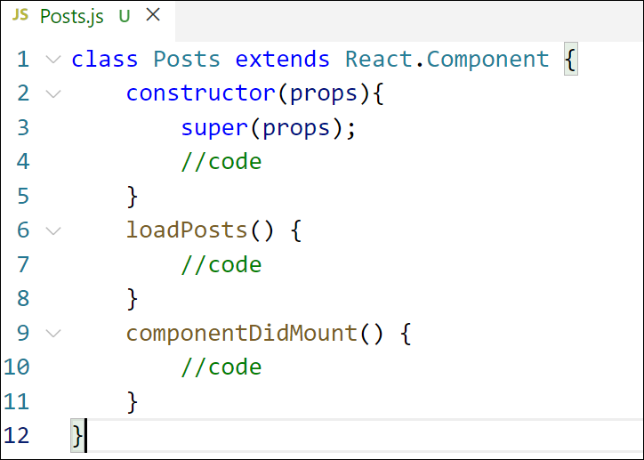

Figure 5: componentDidMount() hook

1. Implement the **render()** which will display the title and post of posts in html page using heading and paragraphs respectively.

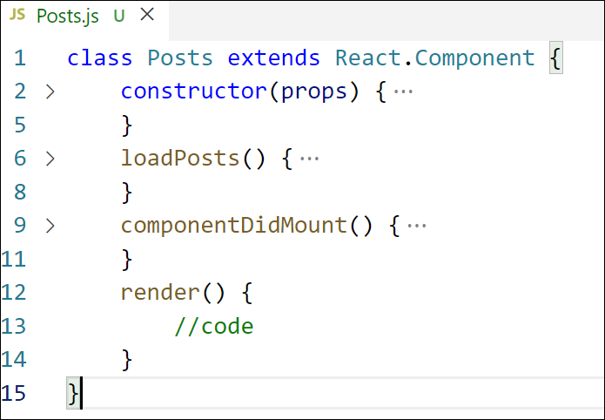

Figure 6: render() method

1. Define a **componentDidCatch()** method which will be responsible for displaying any error happing in the component as alert messages.

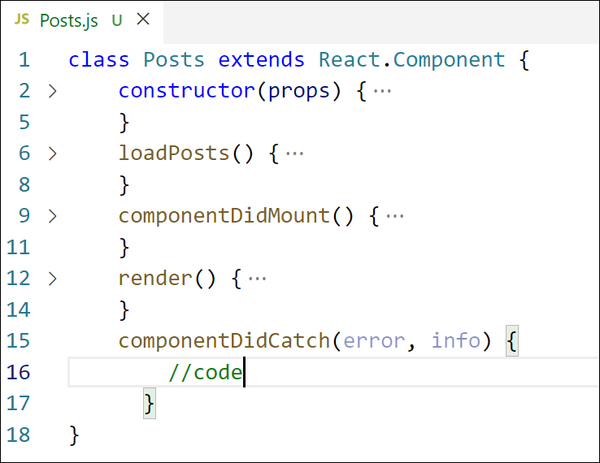

Figure 7: componentDidCatch() hook

1. Add the Posts component to App component.
2. Build and Run the application using *npm start* command.

**Creating -react-app tool with the name as “blogapp”**

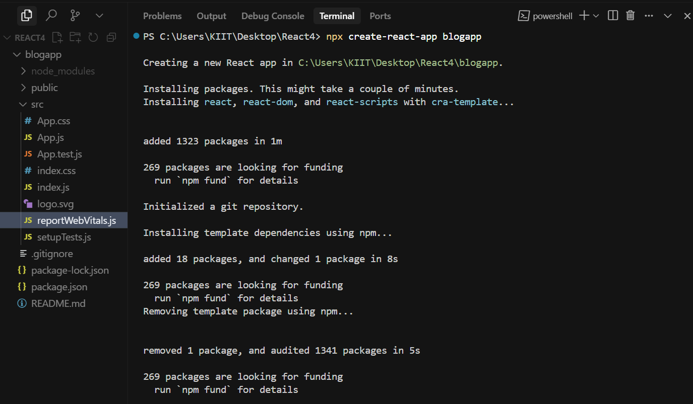

***Post.js***

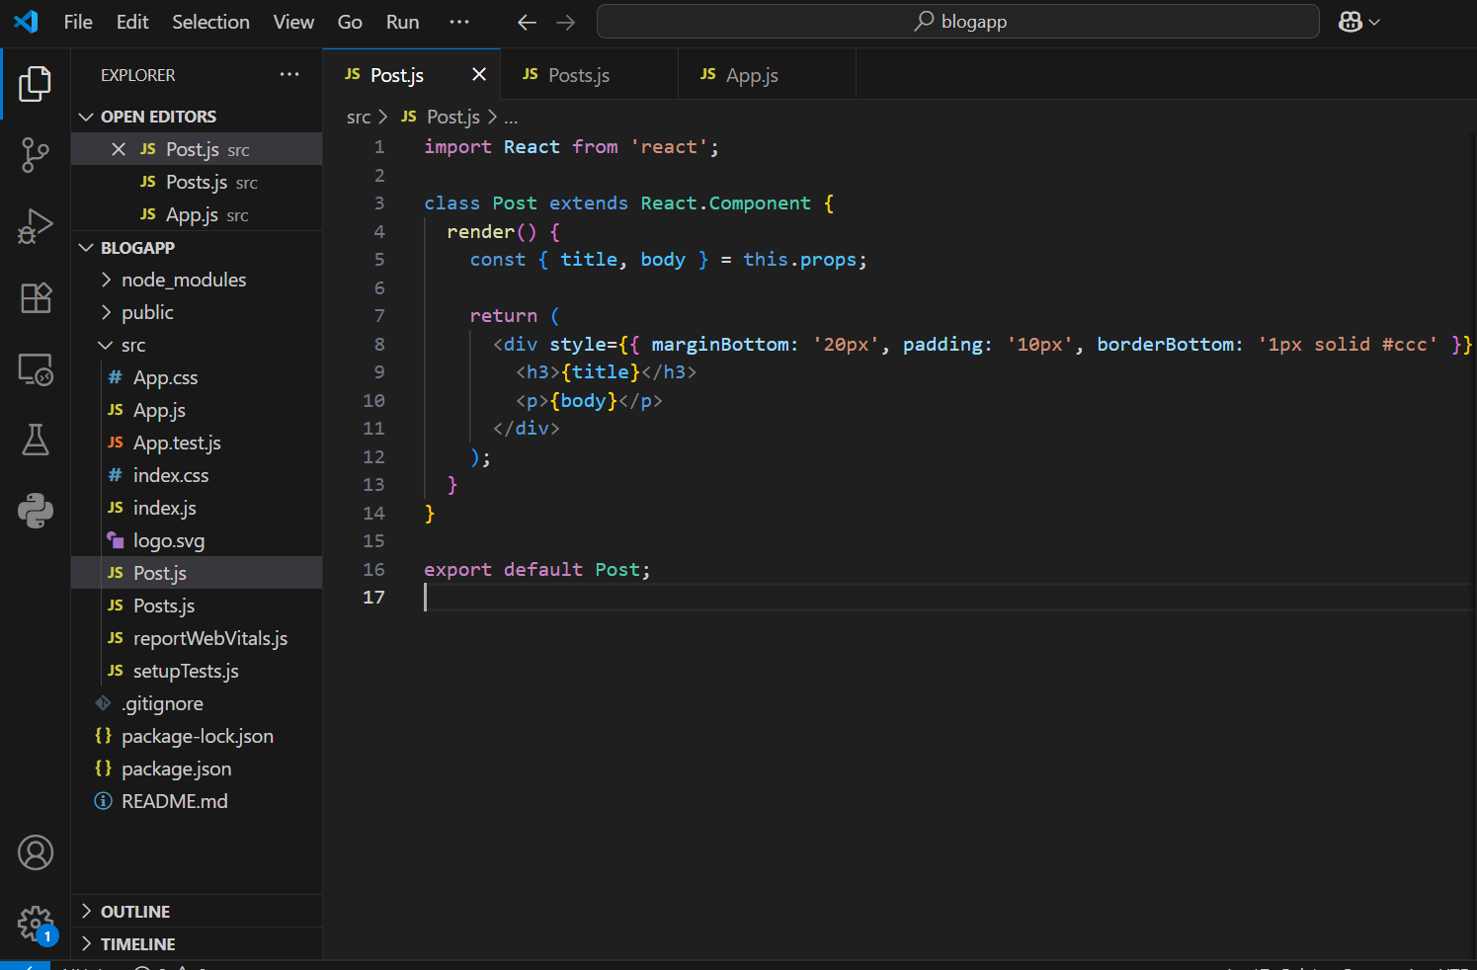

***Posts.js***

import React from 'react';

import Post from './Post';

class Posts extends React.Component {

  constructor(props) {

    super(props);

    this.state = {

      posts: [],

      hasError: false

    };

  }

  loadPosts = () => {

    fetch('https://jsonplaceholder.typicode.com/posts')

      .then(response => response.json())

      .then(data => this.setState({ posts: data }))

      .catch(error => {

        console.error("Error fetching posts:", error);

        this.setState({ hasError: true });

      });

  };

  componentDidMount() {

    this.loadPosts();

  }

  componentDidCatch(error, info) {

    alert("Something went wrong while displaying posts.");

    console.error("Error:", error, info);

  }

  render() {

    if (this.state.hasError) {

      return <p style={{ color: 'red' }}>Unable to display posts.</p>;

    }

    return (

      <div>

        <h2>Blog Posts</h2>

        {this.state.posts.slice(0, 10).map(post => (

          <Post key={post.id} title={post.title} body={post.body} />

        ))}

      </div>

    );

  }

}

export default Posts;

***App.js***

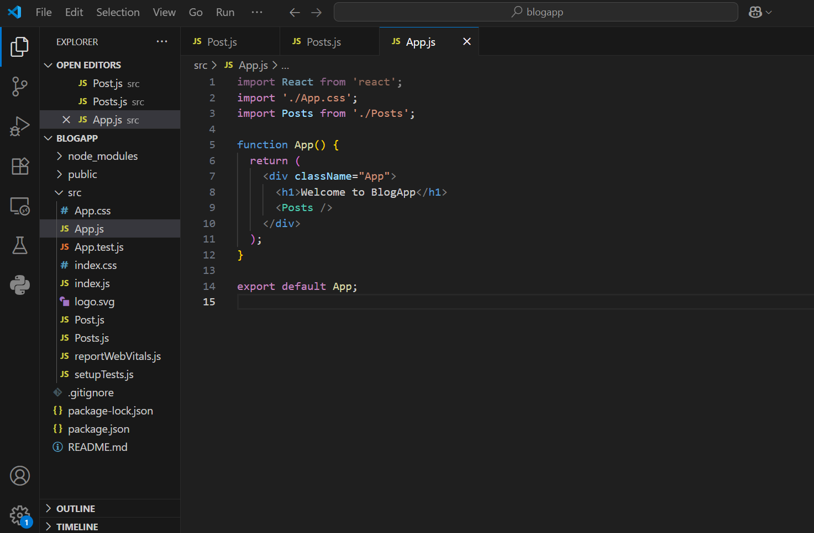

***Final results***



