10ReactJS-HOL

Create a React Application named “officespacerentalapp” which uses React JSX to create elements, attributes and renders DOM to display the page.

Create an element to display the heading of the page.
Attribute to display the image of the office space
Create an object of office to display the details like Name, Rent and Address.
Create a list of Object and loop through the office space item to display more data.
To apply Css, Display the color of the Rent in Red if it’s below 60000 and in Green if it’s above 60000.

Output:
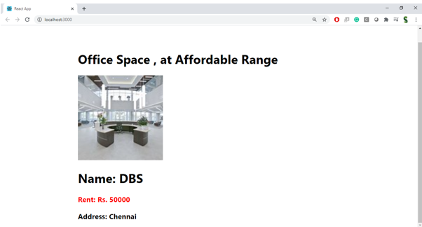

Hint:
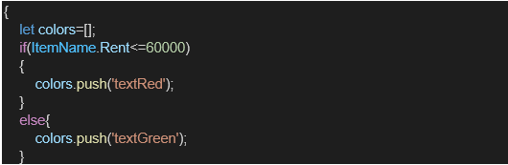
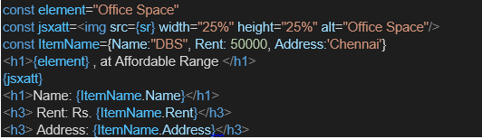
OUTPUT

App.js

import React from 'react';

function App() {
const offices = [
{
name: "WorkNest",
rent: 55000,
address: "123 Main St, Mumbai",
image: "https://tse1.mm.bing.net/th/id/OIP.6_qiksyaXSuIZ8sMD0xpagHaE2?pid=Api&P=0&h=180"
},
{
name: "PrimeHub",
rent: 70000,
address: "456 Business Ave, Delhi",
image: "https://tse3.mm.bing.net/th/id/OIP.JCKoWakhV8r_8XKEKYBX-AHaE9?pid=Api&P=0&h=180"
},
{
name: "TechSpace",
rent: 60000,
address: "789 Startup Blvd, Bangalore",
image: "https://tse1.mm.bing.net/th/id/OIP.PFSK3j90Pd8fKOgowXZAYAHaE8?pid=Api&P=0&h=180"
}
];

return (
<div style={{ textAlign: 'center', fontFamily: 'Arial, sans-serif', padding: '20px' }}>
<h1>Office Space Rentals</h1>

{offices.map((office, index) => (
<div
key={index}
style={{
border: '1px solid #ccc',
borderRadius: '10px',
margin: '20px auto',
padding: '20px',
width: '300px',
boxShadow: '0 0 10px rgba(0,0,0,0.1)'
}}
>
<img
src={office.image}
alt={`${office.name} image`}
style={{
width: '100%',
height: '200px',
objectFit: 'cover',
borderRadius: '8px',
marginBottom: '10px'
}}
/>
<h2>{office.name}</h2>
<p
style={{
color: office.rent < 60000 ? 'red' : 'green',
fontWeight: 'bold'
}}
>
Rent: ₹{office.rent.toLocaleString()}
</p>
<p>Address: {office.address}</p>
</div>
))}
</div>
);
}

export default App;

