12ReactJS-HOL

Create a React Application named “ticketbookingapp” where the guest user can browse the page where the flight details are displayed whereas the logged in user only can book tickets.

The Login and Logout buttons should accordingly display different pages. Once the user is logged in the User page should be displayed. When the user clicks on Logout, the Guest page should be displayed.

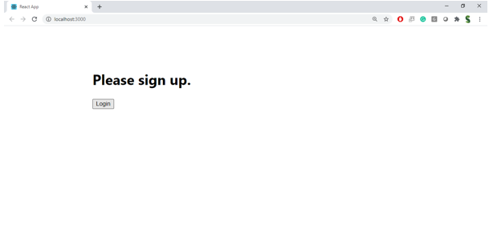

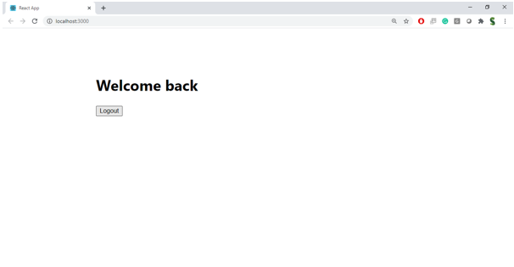

Hint:

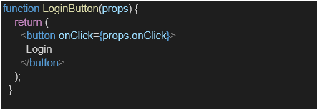
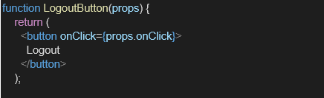

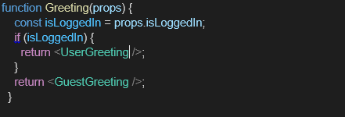

OUTPUT
GuestPage.js

// src/GuestPage.js
import React from 'react';

function GuestPage() {
return <h2>Welcome Guest! Browse flights below.</h2>;
}

export default GuestPage;

UserPage.js
// src/UserPage.js
import React from 'react';

function UserPage() {
return <h2>Welcome User! You can now book tickets.</h2>;
}

export default UserPage;

LoginControl.js

// src/LoginControl.js
import React, { useState } from 'react';
import GuestPage from './GuestPage';
import UserPage from './UserPage';

function LoginControl() {
const [isLoggedIn, setIsLoggedIn] = useState(false);

const handleLogin = () => setIsLoggedIn(true);
const handleLogout = () => setIsLoggedIn(false);

let page = isLoggedIn ? <UserPage /> : <GuestPage />;
let button = isLoggedIn ? (
<button onClick={handleLogout}>Logout</button>
) : (
<button onClick={handleLogin}>Login</button>
);

return (
<div>
{button}
{page}
</div>
);
}

export default LoginControl;

App.js
// src/App.js
import React from 'react';
import LoginControl from './LoginControl';

function App() {
return (
<div className="App">
<h1>Ticket Booking App</h1>
<LoginControl />
</div>
);
}

export default App;

