13ReactJS-HOL

Estimated time to complete this lab: 60 minutes.
Create a React App named “bloggerapp” in with 3 components.

- Book Details
- Blog Details
- Course Details

Implement this with as many ways possible of Conditional Rendering.

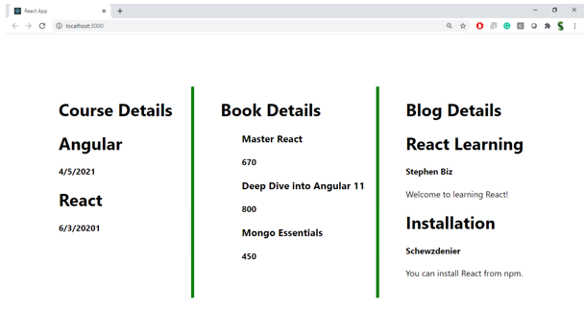

Hint:

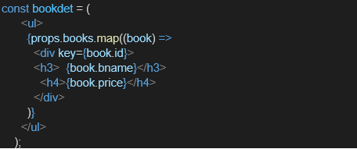

OUTPUT

BookDetails.js

function BookDetails() {
const books = [
{ title: 'Master React', price: 670 },
{ title: 'Deep Dive into Angular 11', price: 800 },
{ title: 'Mongo Essentials', price: 450 },
];

return (
<div>
<h2>Book Details</h2>
{books.map((book, i) => (
<div key={i} className="entry">
<h3>{book.title}</h3>
<p>{book.price}</p>
</div>
))}
</div>
);
}

export default BookDetails;

BlogDetails.js

function BlogDetails() {
const blogs = [
{
title: 'React Learning',
author: 'Stephen Biz',
content: 'Welcome to learning React!',
},
{
title: 'Installation',
author: 'Schwezdenier',
content: 'You can install React from npm.',
},
];

return (
<div>
<h2>Blog Details</h2>
{blogs.map((blog, i) => (
<div key={i} className="entry">
<h3>{blog.title}</h3>
<p><strong>{blog.author}</strong></p>
<p>{blog.content}</p>
</div>
))}
</div>
);
}

export default BlogDetails;

CourseDetails.js
function CourseDetails() {
const courses = [
{ name: 'Angular', date: '4/5/2021' },
{ name: 'React', date: '6/3/2021' },
];

return (
<div>
<h2>Course Details</h2>
{courses.map((course, i) => (
<div key={i} className="entry">
<h3>{course.name}</h3>
<p>{course.date}</p>
</div>
))}
</div>
);
}

export default CourseDetails;

APP.JS
import './App.css';
import CourseDetails from './CourseDetails';
import BookDetails from './BookDetails';
import BlogDetails from './BlogDetails';

function App() {
return (
<div className="app-container">
<div className="section left-section">
<CourseDetails />
</div>
<div className="section middle-section">
<BookDetails />
</div>
<div className="section right-section">
<BlogDetails />
</div>
</div>
);
}

export default App;

App.css
body {
margin: 0;
font-family: 'Segoe UI', Tahoma, Geneva, Verdana, sans-serif;
background-color: white;
}

.app-container {
display: flex;
justify-content: center;
align-items: flex-start;
padding: 50px 100px;
}

.section {
flex: 1;
padding: 0 30px;
}

.middle-section {
border-left: 4px solid green;
border-right: 4px solid green;
}

h2 {
font-size: 24px;
font-weight: 700;
margin-bottom: 20px;
}

h3 {
font-size: 20px;
font-weight: bold;
margin: 10px 0 5px;
}

p {
margin: 5px 0 15px;
font-size: 16px;
}

.entry {
margin-bottom: 20px;
}

