9ReactJS-HOL

Create a React Application named “cricketapp” with the following components:
- ListofPlayers
- Declare an array with 11 players and store details of their names and scores using the map feature of ES6

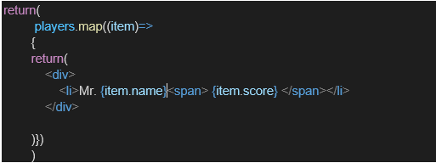

- Filter the players with scores below 70 using arrow functions of ES6.

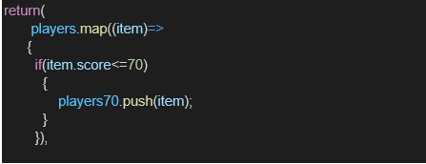

- IndianPlayers

  - Display the Odd Team Player and Even Team players using the Destructuring features of ES6
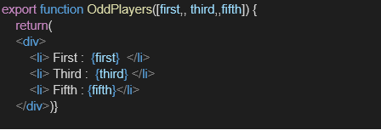

  - Declare two arrays T20players and RanjiTrophy players and merge the two arrays and display them using the Merge feature of ES6
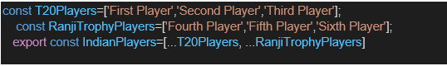

Display these two components in the same home page using a simple if else in the flag variable.
Output:
When Flag=true
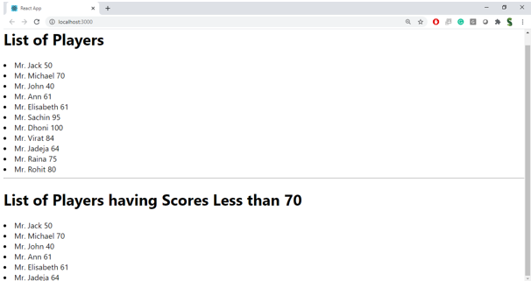

When Flag=false

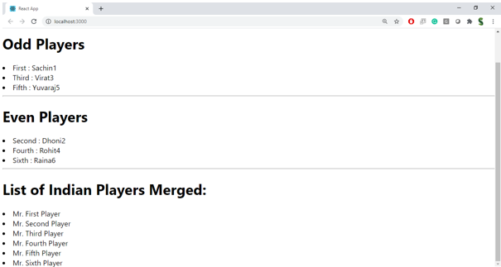

Hint:
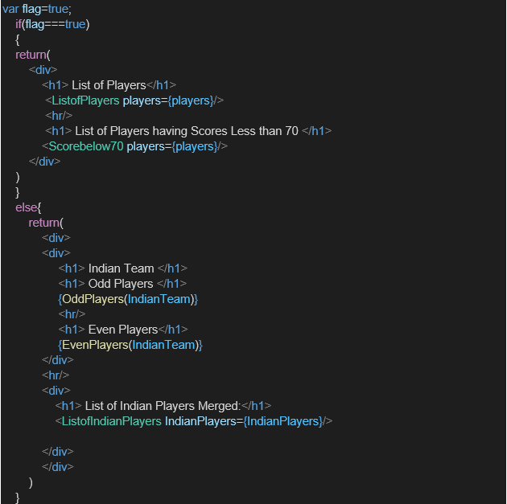

OUTPUT

ListofPlayers.js

import React from 'react';

const ListofPlayers = () => {
const players = [
{ name: 'Mr. Jack', score: 50 },
{ name: 'Mr. Michael', score: 70 },
{ name: 'Mr. John', score: 40 },
{ name: 'Mr. Ann', score: 61 },
{ name: 'Mr. Elisabeth', score: 61 },
{ name: 'Mr. Sachin', score: 95 },
{ name: 'Mr. Dhoni', score: 100 },
{ name: 'Mr. Virat', score: 84 },
{ name: 'Mr. Jadeja', score: 64 },
{ name: 'Mr. Raina', score: 75 },
{ name: 'Mr. Rohit', score: 80 },
];

const lowScoringPlayers = players.filter(player => player.score < 70);

return (
<div>
<h2>List of Players</h2>
<ul>
{players.map((player, index) => (
<li key={index}>{player.name} {player.score}</li>
))}
</ul>

<hr />

<h2>List of Players having Scores Less than 70</h2>
<ul>
{lowScoringPlayers.map((player, index) => (
<li key={index}>{player.name} {player.score}</li>
))}
</ul>
</div>
);
};

export default ListofPlayers;

IndianPlayers.js

import React from 'react';

const IndianPlayers = () => {
const oddPlayers = [
'Sachin1',
'Virat3',
'Yuvaraj5',
];

const evenPlayers = [
'Dhoni2',
'Rohit4',
'Raina6',
];

const mergedPlayers = [
'Mr. First Player',
'Mr. Second Player',
'Mr. Third Player',
'Mr. Fourth Player',
'Mr. Fifth Player',
'Mr. Sixth Player',
];

return (
<div>
<h2>Odd Players</h2>
<ul>
<li>First : {oddPlayers[0]}</li>
<li>Third : {oddPlayers[1]}</li>
<li>Fifth : {oddPlayers[2]}</li>
</ul>

<h2>Even Players</h2>
<ul>
<li>Second : {evenPlayers[0]}</li>
<li>Fourth : {evenPlayers[1]}</li>
<li>Sixth : {evenPlayers[2]}</li>
</ul>

<h2>List of Indian Players Merged:</h2>
<ul>
{mergedPlayers.map((player, index) => (
<li key={index}>{player}</li>
))}
</ul>
</div>
);
};

export default IndianPlayers;

App.js

import React from 'react';
import './App.css';
import ListofPlayers from './ListofPlayers';
import IndianPlayers from './IndianPlayers';

function App() {
const flag = true; // Change to false to see the other view

return (
<div className="App">
<h1>React App</h1>
{flag ? <ListofPlayers /> : <IndianPlayers />}
</div>
);
}

export default App;

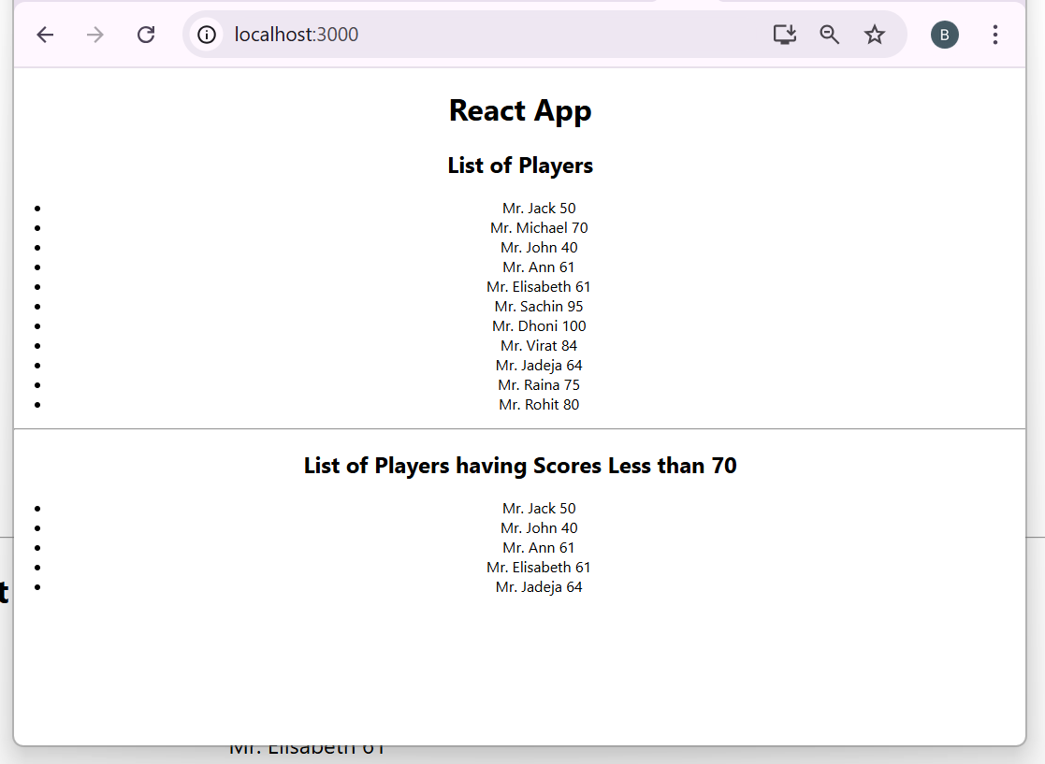

import React from 'react';
import './App.css';
import ListofPlayers from './ListofPlayers';
import IndianPlayers from './IndianPlayers';

function App() {
const flag = false; // Change to true to see the other view

return (
<div className="App">
<h1>React App</h1>
{flag ? <ListofPlayers /> : <IndianPlayers />}
</div>
);
}

export default App;

