Linear Regression To Determing Abalone Age
Bishal Jung Thapa Chhetri, Statistics for Data Science

Abstract— An essential first stage in the data analysis process is exploratory data analysis (EDA), which involves exploring, visualizing, and summarizing data in order to obtain understanding, spot trends, and comprehend the underlying structure. Analysts use exploratory data analysis (EDA) to find patterns, correlations, and anomalies in the information that might guide further modeling and analysis. In EDA, methods including correlation analysis, data visualization, and summary statistics are frequently used to draw conclusions from the data and direct more research. A statistical technique called linear regression is used to describe the connection between one or more independent variables and a dependent variable. It assumes that there is a linear connection between the variables, meaning that variations in the independent variables are always accompanied by variations in the dependent variable. By estimating coefficients, linear regression facilitates inference and prediction, enabling analysts to comprehend the impact of predictors on the dependent variable. Inference, causal link knowledge, and predictive modeling are all frequently accomplished through the application of linear regression.
Keywords—EDA, Regression, Performance metrics, multiple linear regression, Visualization

Introduction (Heading 1)
Abalone are snails like creatures which are small in shape and size. The given data set is comprised of the physical characteristics of abalone like length, sex, diameter, its weight, rings present in it and various other categories which are essential to find the age of abalone. Primitively, the age of abalone is determined by cutting its shell into two halves with the help of sone, and the shell need to be stained and further the process is extended to scientific method to use microscope in a lab to count the number of rings present in it. This steps seems to old, time consuming. But these physical data like length, diameter, its height and weight helps to determine the age in simpler but effective way with the use of different machine learning algorithms.
With the use of different machine learning techniques, Exploratory data analysis, the process of determining abalone age has been simpler. First lets get through Exploratory Data Analysis process and find what we can infer from the data features, data types we have.
EDA process involves in several steps like getting the data, cleaning it, preprocessing it, understanding the features, understanding its correlation, looking for several flaws in our dataset like null values, inconsistency present in data, checking for null values and further visualizing the data we have processed. EDA is very helpful to get data summary, visualization of the data, handling missing values in the dataset, finding the outliers, feature engineering and understanding the relations between the features.

Exploratory Data Analysis
EDA begins with loading our dataset, for that I have used python to perform EDA and Linear regression. First, I have imported the dataset into the respective folder and read it in python using numpy library. After reading the data, the first step of EDA get into charge, where I inspect my data, abalone dataset seems to have 9 feature columns and 4177 sample observations. Since the feature columns in the data set seems to be processed further I transformed all the features column into lowercase and removed the whitespace present between the feature name with “_” which is for better readability and accessibility in future. Further, it is necessary to get the information of our data set, how our data set is comprised of, for that I have used python .info() method which helps me to get the concise summary of data. This method helps me to understand how my data is comprised of what kind of datatypes I am expected to see and work around.
Further process involves in checking if there is null values present in our dataset, it is really important step because null values can change the statistical analysis of data leading to misrepresentation and misinterpretation, can drastically change the model performance. Inorder to prevent from such loss it is important to always check for null values. Since, abalone dataset have 0 null values which we can get by using isna() method from python.
Further next step includes in the process of checking unique value present in our dataset. By spotting any mistakes, discrepancies, and abnormalities, verifying unique values in a dataset is essential for maintaining data quality and integrity. It supports feature engineering, prevents data leakage, evaluates the cardinality of variables, understands the distribution of categorical variables, and validates the data against predetermined criteria. The variety and complexity of the dataset by examining unique values, which helps them make more accurate and trustworthy decisions based on data. After checking the unique values, we can infer that we have 3 unique values in sex which is really important for further analysis.
The statistical summary of each features present in our data can be calculated by using .describe() method which is really important method. As this method helps us to get the statistical summary of data like mean, median, count of data, standard deviation, minimum value present in each feature, maximum value of the feature, it also provides us with the 25%, 50% and 75% of the data. This method helps us to understand the distribution of the feature. Outlier can be detected with the summary we get from the describe method.
The act of turning unstructured data into useful features that machine learning models may utilize as input to perform better is known as feature engineering. To more accurately depict the underlying patterns in the data, it entails adding new features, choosing pertinent characteristics, and altering current features. For this step, I have done one hot encoding of the feature “sex” and further I have derived the birth year of the abalone based on the age and current year.
It is really important to understand the correlation present between each feature of our dataset. Correlation between the data can signify various information like how strongly one feature are correlated with another. The value of correlation ranges from -1 to 1 where -1 means negative correlation and 1 means positive correlation and 0 means no correlation between the data.
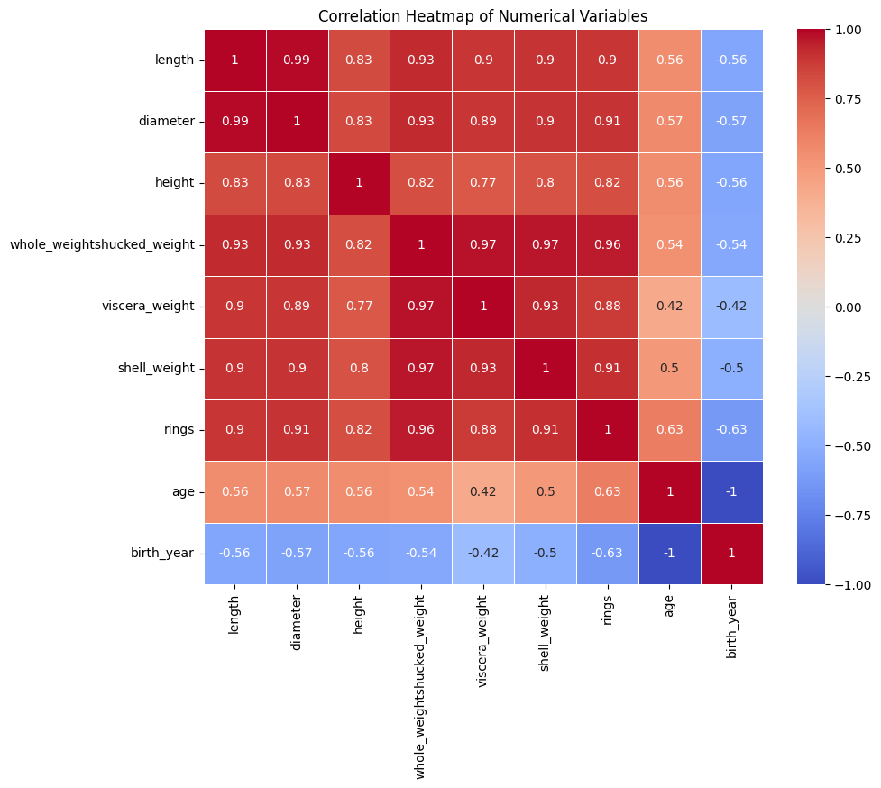
Figure 1: Heat Map of the Abalone feature with correlation.

It is important to separate the quantitative and qualitative feature column because it helps in better EDA process. For this, I have separated my categorical columns into one list and numerical columns into another list. From where I can understand that I have only one categorical column and 8 numerical columns.
The bar graph shown provides us with the information how our sample observation is composed of the number of males, females and infant is shown from where we can infer that the number of Males is greater than Female and infant. But the number of infants is greater than female present in the sample observation.
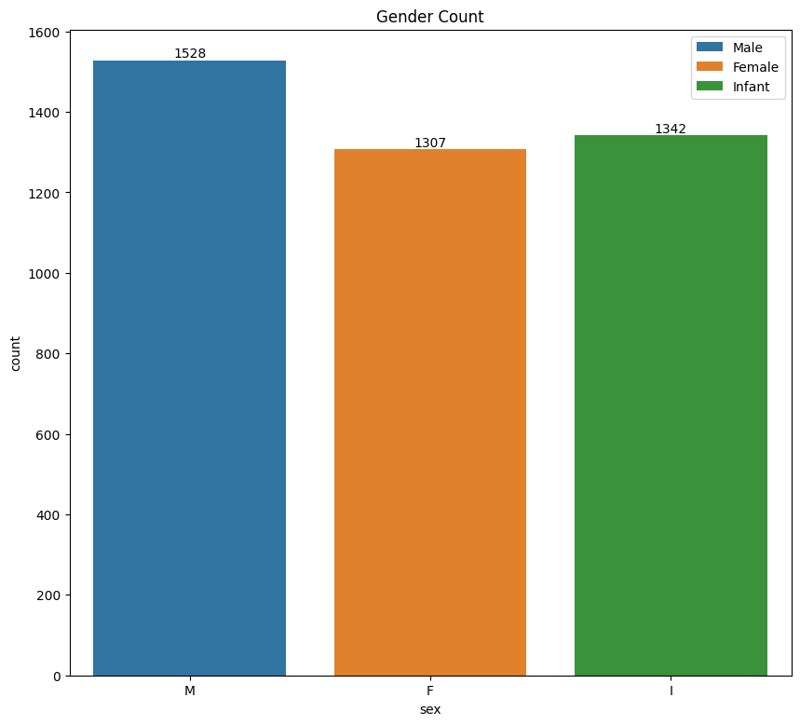
Figure 2: Bar Graph for Gender of Abalone.
Furthermore, the overall quantitative data is plotted in a histogram which explains how our data is spread in the abalone dataset. This histogram explains the spread, skewness of the quantitative variables of abalone such as length, diameter, rings, shell weight. Viscera weight and more.
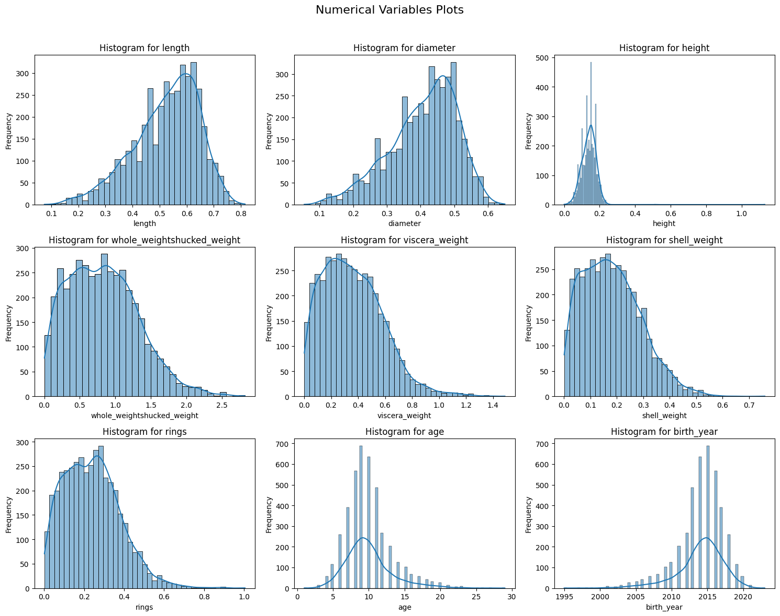
Figure 3: Histogram of Numerical Columns of abalone dataset.
Each histogram that is plotted above is either positive skewed or negative skewed.
The following snapshot helps us to explain the skewness of the data where positive number represent the right side skewness and negative number represent the left side skewness.
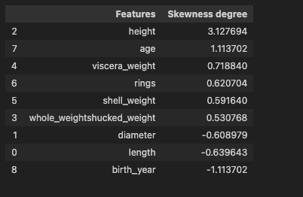
Figure 4: Skewness degree of feature columns

Let's analyze some of the histogram from above plot. First lets get the statistical summary of the histogram plot of the length variable of abalone
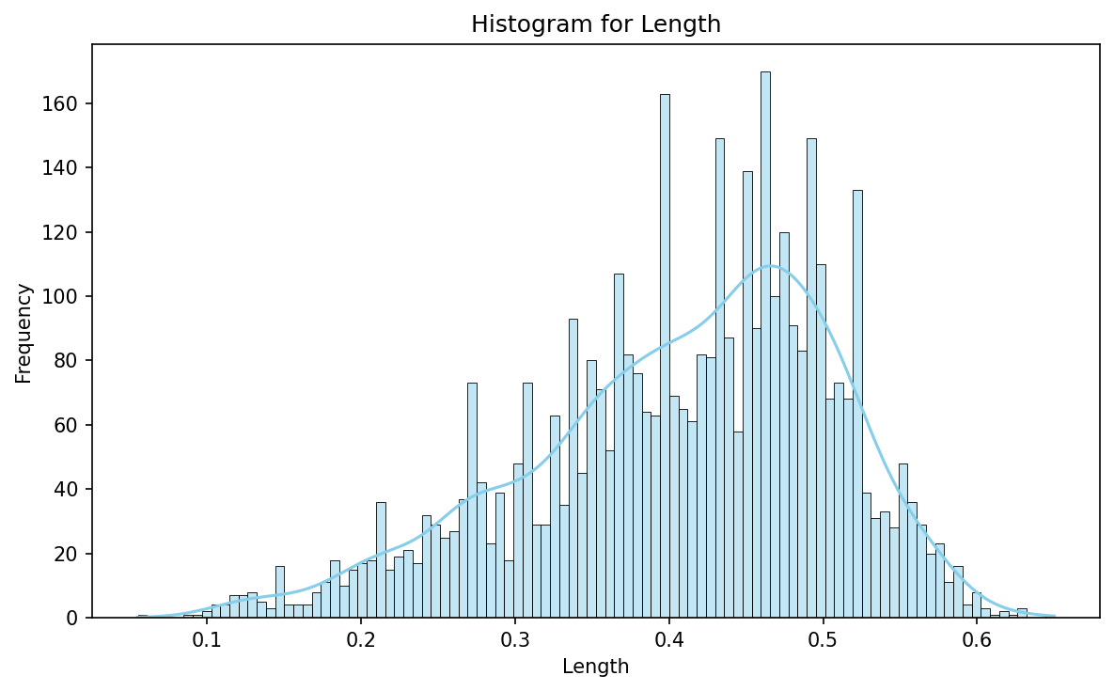
Figure 5: Distribution of Length
The above is the histogram plot of the length variable which is negatively skewed which we can infer from the above skewness graph which has the skewness degree of -0.63. From the graph what we can infer is that the histogram has a tail which is skewed towards the left side indicating that the majority of data points are on the right side of the graph, and it has a mean around 0.47.
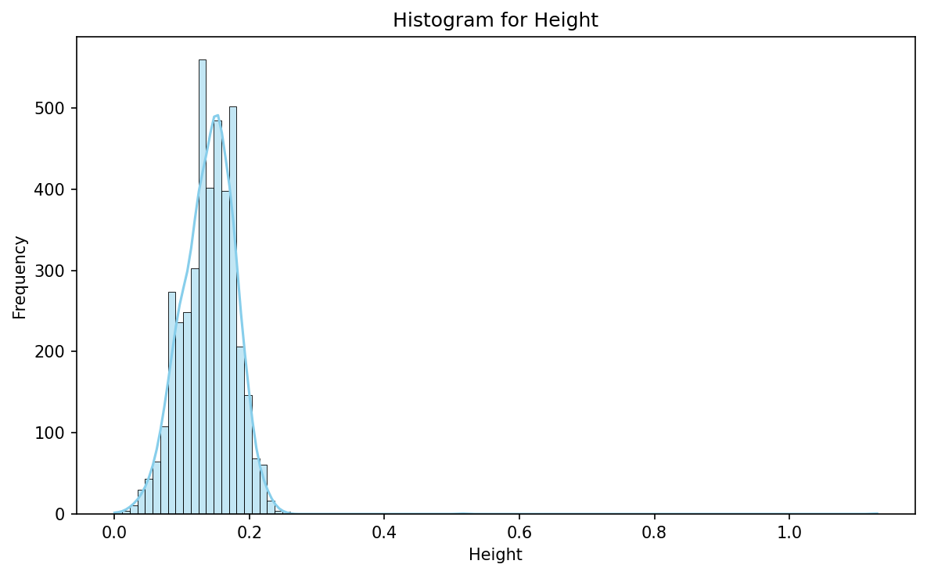
Figure 6: Distribution of Height
If we look closely to the distribution, it is positively skewed meaning that most of the data are concentrated toward right side.

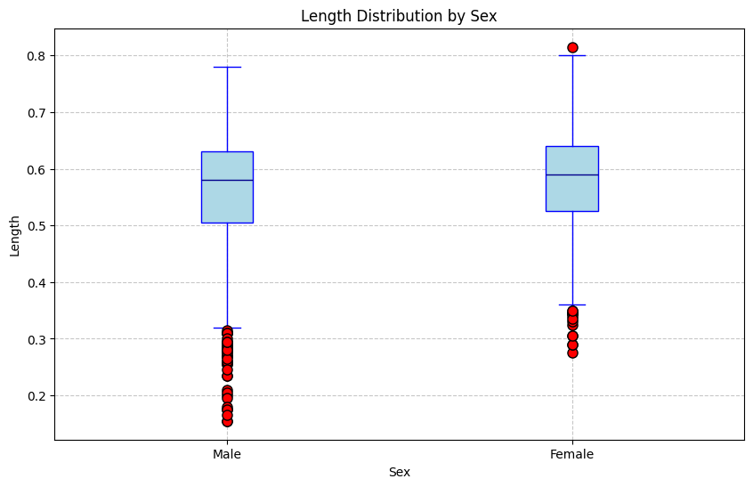
Figure 7: Box plot of length of abalone based on Sex
The above graph is the interpretation of length of abalone based on the gender of the abalone, however the red points are denoted as outliers but actually those are not outliers. Just becaue of the some of the data points that are outside 1.5*IQR does not necessarily means they are outliers which is also known as TUKIS Method. Form the box plot what we can infer is that the length of female is slightly greater than male, but the spread of the male data is larger. The mean length of female is higher than male.
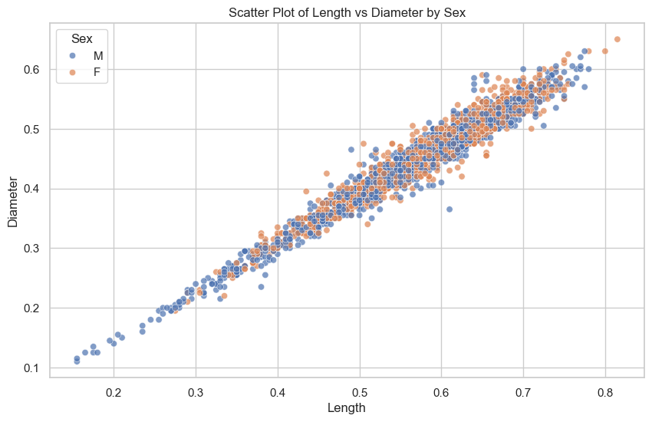
Figure 8: Scatter plot of length Vs Diameter based on sex

The above scatter plot helps is to clearly understand the relation between the length and the diameter variable. It suggests us that they are correlated towards each other and have strong positive correlation. As the length of the abalone tends to increase the diameter of the abalone also increases. Based on the genders if we look closely the diameter of the female tends to increase drastically after certain length lets say 0.57 and the data are heavily concentrated on it.

Following are the findings from the EDA:
- In the dataset, male is more dominant and have higher number.
- The length and the diameter of abalone are highly correlated suggesting that they have a strong linear relation.
- The age factor tends to increase with their length, diameter and height which infers that these physical parameters are more dominant in determining and predicting the age of abalones.
- There is a positive correlation between the number of abalone and the age of the abalone.
- The weight of abalone has strong correlation between the length, diameter and the height of the abalone.

Simple Linear Regression Model

f(x) = 𝑦 = ,𝛽-0.+,𝛽-1. . 𝑥 +𝜖,
A Linear regression is a statistical method which helps to explore the relation between the dependent and independent variable.
From above equation,
y is independent variable,
x is a dependent variable
𝛽-0 is the y-intercept of linear regression line
.. 𝛽-1 is the slope of line meaning change in y for each unit change in x.
What is f(x) good for? With the goof function we can make the prediction of y at new points. We can understand which component of x are important in explaining the y variable. In general, regression function gives us the conditional expectation of y given x at each value of x.
For our dataset, linear regression model can be used to predict the various feature of abalone given the predictor or independent variable. For my case I have consider to take three linear regression model.
A linear regression model performance can be determined by various metrics such as Mean Absolute Error(MAE), Mean Squared Errors(MSE), r-squared, adjusted r-squared. These can be considered as the cost function which is used to measure error or discrepancy between the model prediction and actual values. For the evaluation metrics MAE & MSE are most popular and yet simpler method to explain the cost function.
Mean Absolute Error(MAE):
Mean absolute error is a regression metrics which measures the average magnitude of errors in a group of the predictions without considering the directions. It is basically absolute difference among the predictions and expected values where all individual deviation have even importance. The lower the value of MAE the higher the model predictions are close to the actual values. Which suggest us that the performance of the model is efficient and high.
Mean Squared Errors (MSE):
The mean squared difference between the predictions and expected results gives the MSE. MSE is an alteration of MAE, instead of taking modulus of errors, we basically square them. The metrics can range from 0 to positive infinity and lower value of MSE indicates high performance of the model. MSE is sensitive towards outliers as it penalizes the large errors heavily.
R-squared:
R-square is the percentage of variation explained by the relation between two variables. The more the value of r-square is close to line, it means line is best fitted and r-square less than zero means that the performance of the model is pretty bad.

For this model, my predictor/independent variables the length of the abalone and my response/dependent variable is the rings of the abalone. First, we determine our dependent and independent variable and we separate test and train data and fit the training data in the linear model. A linear redline in the graph below shows the best fit line for the model which means the model performance will be extremely high in that line.
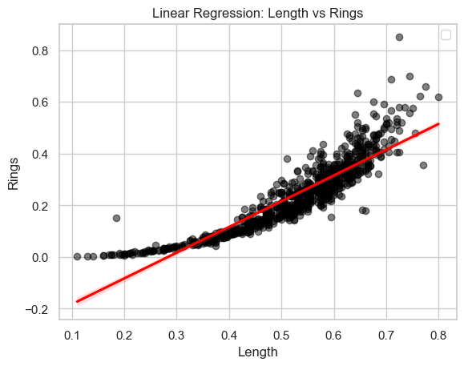
Figure 9: Linear regression Length Vs Rings
The evaluation metrics for the above model are:
Mean Absolute Error | 0.04298473606399985
Mean Squared Error | 0.003424265238579531
R-squared | 0.8153012111236607

The MAE of our model is 0.042 which is extremely well. Which means that on average the predictions made by my linear model is off by 0.042. The model is making relatively better predictions of the number of rings in abalone based on the length of abalone. The MSE of our model is 0.003424265238579531 which suggest that the prediction made by our model is better which indicate good model performance. The r-square of our model is 0.8153012111236607 which means that the relation between the two variables explains 81.53% of variation in the data.
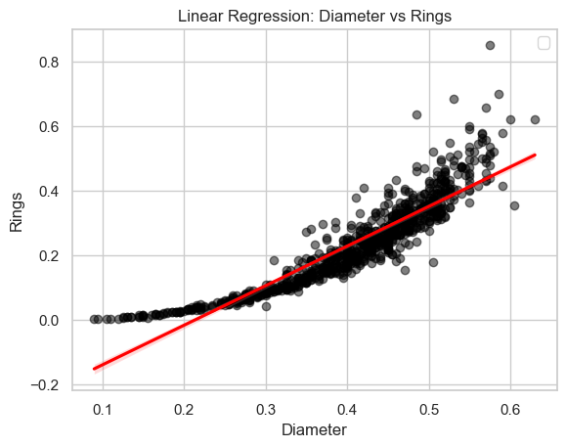
Figure 10: Linear regression Diameter vs Rings
For this model, my predictor/independent variables the diameter of the abalone and my response/dependent variable is the rings of the abalone. The performance metrics of the mode is:
Mean Absolute Error | 0.04088160947941207
Mean Squared Error | 0.0031234256492910085
R-squared | 0.8315279645776937

These above metrics suggest us that the performance of the model is pretty good. The model is making good predictions of rings present on the abalone based on the diameter of the abalone.
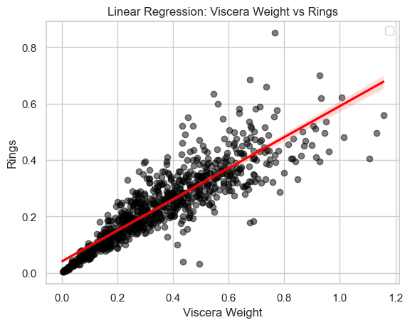
Figure 11: Linear Regression model Viscera weight vs Rings.

For this model, my predictor/independent variables the viscera_weight of the abalone and my response/dependent variable is the rings of the abalone. The performance metrics of the mode is:
Mean Absolute Error | 0.04568359494416806
Mean Squared Error | 0.004174629503131404
R-squared | 0.7748278945950886

These above metrics suggest us that the performance of the model is pretty good. The model is making good predictions of rings present on the abalone based on the viscera_weight of the abalone.

Multiple Linear regression model
Multiple Linear regression model is generally an extension of simple linear regression model where we have multiple independent variable and one dependent variable. The equation for the multiple linear regression model is:
f(x) = 𝑦 = ,𝛽-0.+,𝛽-1. . 𝑥1+,𝛽-2 . 𝑥2 ,+ 𝛽-3. . 𝑥3 ..+ ,𝛽-n . 𝑥n +𝜖,
From above equation,
y is independent variable,
x1,x2,x3,…..xn are a dependent variable
𝛽-0 is the y-intercept of linear regression line
.. 𝛽-1, 𝛽-2, 𝛽-3,…. 𝛽-n are the slope of line meaning change in y for each unit change in x.
Since in simple linear regression one to one variable is being compared and analyzed but in multiple we have multiple dependent variable. For our dataset, our independent variable is Age of abalone and the dependent variables are ‘length', 'diameter', 'height', 'whole_weightshucked_weight', 'viscera_weight', 'shell_weight’ of the abalone which are the physical characteristics of the abalone. Since, we have already identified our feature and target variable, we need to split our data into training and testing dataset. Once this process is completed we can fit our data in the linear regression model. The linear regression method is same for both simple linear and multiple linear regression model. Once the model is fitted we can predict the age of the abalone. There are various model performance metrics to determine the performance of the model, for now I am going to use r-squared and adjusted r-squared. Adjusted r-square actually do have higher accuracy since this metric is developed to perform well when we have large number of predictors.
The r-square indicates the percentage of variance in the dependent variable (abalone age) that can be accounted for by the independent variables (physical attributes).
r-square = 0.5249720723479736, the physical attributes included in the model account for around 52.5% of the variability in the age of abalone. This suggests that the physical attributes taken into consideration in the model have some predictive potential in estimating the age of abalone.
The adjusted r-square is modified version of the plain old r-square but it penalizes unnecessary predictors in our model. Since our adjusted r-square 0.5221104583259735 is not so different than the original r-square we can conclude that we have considered pretty good predictors and none of them are not so unnecessary.

