HTML & CSS FINAL ASSIGNMENT DOCUMENTATION

Student Name: Bishal Rai

Batch : DIN21SP

Email: [rabi00@students.oamk.fi](mailto:rabi00@students.oamk.fi)

Course – HTML & CSS PROGRAMMING

# UI DESIGN IN FIGMA AND DOCUMENTATION:

## UI mockup for mobile and desktop in FIGMA

Here is the link of my website which is designed in FIGMA:

<https://www.figma.com/file/4CBpGDxFcW4qbx9nSzXtSy/html%26cssAssignment?node-id=0%3A1>

## Mobile View of Website:

## Desktop View of Website:

## Logo Designed in Figma:

## Documentation

### Color creating app

Colors for the page is extracted using the from color wheel and color space

### Typography:

* Font type: **SANS-SERIF**

* Font color: for navigation bar through out the website

* For header menu:

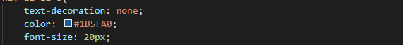

* When the header was hover by the mouse



* For login and sign up background



* Other colors are

 

### Link of the Figma design:

<https://www.figma.com/file/4CBpGDxFcW4qbx9nSzXtSy/html%26cssAssignment?node-id=0%3A1>

### Website Publishing Link:

<https://bishalrai.github.io/HtmlCss_Assignment_Bishal/>