# Chapter 2: Analysis

## 

## 2.1 Introduction to Analysis:

Analysis is the first step in the phases of software development life cycle (SDLC) in which requirement of the clients are gathered and also focuses on the solution of the problem of the client. Requirement Specification is the main goal of analysis. Requirements of the project are collected with the help of user interaction.

In spite of the fact that requirement gathering is the main aim of this stage, analysis focuses on:

* Analysis focuses on the scope of the project.
* It focuses on understanding the problem domain and requirement.
* Some requirements need prioritization and alternatives. Analysis should focus into this aspect.
* Analysis should focus on the feasibility of the project.
* System Requirement Specification (SRS) should be prepared as it helps in functional and non-functional requirements of the project.
* Conceptual System Design should be prepared as it helps in Management Information System.

## 2.2 Analysis Methodology:

It requires a series of structure to develop a system. Analysis, Design, Implementation and Maintenance are the key stages of Software Development Life Cycle. Among these phases Analysis have its own methodologies to help gather requirements and functionalities to develop a system.

Here, for this project I have chosen **Soft Approach Methodology** among other various methodologies like **People Oriented, Process Oriented, Combined Approach, Hard Approach**.

**Soft Approach:**

Both Technical and Human aspects are main parts of Soft Approach to develop a system. Key Technique for soft approach is the interaction between users.

The consideration of human, social activity and technical functional requirements belongs into this approach.

Following are the number of steps undertaken while using this methodology:

1. **Human activity analysis of soft approach involves rich picture, root definition and conceptual model**

**Rich picture:**

The collection of pictures, symbols, text to show relationships, connections between requirement of the users are called rich picture. It is basically a rough sketch diagram to shows the relationships.

**Root definition:**

Root Definition clarifies the processes and problem of the system. There are two types of root-definition i.e.:

Primary task root-definition: focuses on system processes

Issued-based root definition: focuses on problem statement

There are three elements of root definition. i.e. **WHAT, HOW AND WHY**

WHAT: It defines the aim of the system.

HOW: It defines how to achieve the aim.

WHY: It defines why to use the system.

.

**CATWOE**

**CATWOE** stands for

**C Customers/Clients**

**A Actors / Agents**

**T Transformations**

**W World View**

**O Owners**

**E Environment**

**CATWOE** analysis helps to define a root definition

**Customers** are the most important factor for any business or project. They are the one who use system. So without considering the customers, the project will have no meaning. **Actors** are the defined employees, suppliers, agencies and officials. Changes are inevitable. The system must change according to time for the easiness of user, so **Transformation** is changes occurred by the system for the easiness of user. **World Wide** covers the issues related with wide reaching and long lasting effects or relatively contained and short life. **Owner** is the person who owns the problem they must be the parts of its solution or both. **Environment** deals with the budget, resources, laws and regulations of the project.

**Conceptual Diagram**

The conceptual diagram of Online Vehicle Tax Pay System represented as follows:

1. **Social-technical aspects of analysis and design**

Feasibility Study covers the Social and technical aspects of analysis and design of Online Vehicle Tax Pay System and is described in another portion.

1. **Human-Computer Interface design**

To remove duplication of data and diagram human-computer interface design of Online Vehicle Tax Pay System is used.

1. **Design of technical aspects**

Technical aspects of Online Vehicle Tax Pay System cover System Requirement Specification (SRS). System Requirement Specification (SRS) portion of the project is describe in another part.

1. **Cultural aspects**

Cultural aspects represents the cultural beliefs and practices of the society. Beliefs of the society do not effect with the use of this application.

1. **Political aspects**

The application that we will develop does not effects the politics policies of the country. Before to develop this application we have to know the political policies of the country.

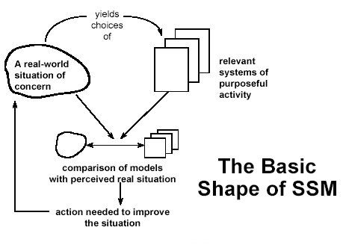**Overview of the Soft System Methodology:**

Above screenshot represents the overview of the soft system methodology. The problem arises due to cultural and social aspects is manage with the use of this methodology. Human interaction is an important factor to control the problem. In addition, human interaction managed the misunderstanding between developer and users. For sustainable running this application and to build trust between users and developer, human interaction plays important role.

**Advantages of Soft Approach over other Methodology and its areas of focus:**

This methodology considers both human and technical factors of the system. This is the main reason I have chosen this Methodology. Following are the reasons to choose soft approach over other approach are:

* It cover human, technical, cultural and political part of the system analysis.
* It increases the understanding level of analyst of a problem during investigation as well as in later stages.
* To solve the problem successfully it relies on the holistic view.
* It doesn’t need any equipment to rely on. Just pen and paper is enough.
* It involves the participation of user during analysis and design phase.

## 2.3 Feasibility Study

The real world scenario in which a proposed system is financially, technically and operationally practical and workable called feasibility study. Feasibility study comes under social and technical aspects of analysis and design and covers description of product, financial data, legal requirements, tax obligation and many more.

Types of feasibility study and their relation with Online Vehicle Tax Pay System are:

|  |  |  |  |
| --- | --- | --- | --- |
| **S.N** | **Types of Feasibility Study** | **Questions (?)** | **Relation with the project** |
| 1 | Operational Feasibility | How this project helps to solve the problems and catch advantages and opportunities? | This project provides an opportunities and advantages to both the users and developers because in the context of our country there is lack of android application to manage our daily expenses. |
| 2 | Technical Feasibility | Do you have the technological resources to undertake the project? Are the processes and procedures conducive to project success? | I have sufficient technological knowledge and skills to develop this project. |
| 3 | Economic Feasibility | Given the financial resources of the company, is the project something that can be completed? | This project used the online payment system. I am trying to use 3rd party application to process this. |
| 4 | Schedule Feasibility | Can the project be completed within the time period? | I have already scheduled the project and made gantt chart and work breakdown structure for this project. |
| 5 | Marketing Feasibility | Is this project useful or applicable for different aged-group users? Who want the system after application has developed? | This project based on all aged-group user for marketing purpose. |
| 6 | Cultural Feasibility | Is this project, well acknowledged by the local people? | This is an android-based application helps to calculate daily expenses and increase effectiveness to manage expenses. |

# 2.4 Requirement Analysis

Requirement analysis is the hardest part of building a software system. The goal of requirement analysis is to understand the requirements of user’s and documented them properly. Requirements of users include functional and non-functional requirements that implemented in a system.

# 2.4.1 Functional Requirements

Functional requirements define all the services or functions required by the users they must have provided by system. Functional requirements are easy to test in comparison to non-functional requirements. It describes “what” the software should do. It related to the individual system features. Failure to meet the individual functional requirement may degrade the system.

Functional requirements of Online Vehicle Tax Pay System described as follows:

|  |  |  |  |  |
| --- | --- | --- | --- | --- |
| **ID** | **Requirements** | **Description** | **Rational** | **Dependencies** |
| FR1 | Registration | To get login access into the system registration is required. | To create new client or user. | N/A |
| FR2 | Login | To get access into the system login is required. | To use system by the registered user. | FR1 |
| FR3 | Add Expenses | Logged user can add their expenses. | To add expenses of logged user. | FR2 |
| FR4 | Add Income | Logged user can add their income. | To add income of logged user. | FR2 |
| FR5 | Add Expenses Category | Logged user can add their expenses category like food, fuel and many more. | To add expenses category of logged user. | FR2,FR3 |
| FR6 | Add Incomes Category | Logged user can add their income categories. | To add income category of logged user. | FR2,FR4 |
| FR7 | Calculate Saving | Logged user can calculate their saving. | To calculate the saving amount of user. | FR2,FR5,FR6 |
| FR8 | Edit Expenses Category | Logged user can edit their expenses category. | To edit the expenses category of logged user. | FR2,FR5 |
| FR9 | Edit Income Category | Logged user can edit their income category. | To edit income category of logged user according to their needs. | FR2,FR6 |
| FR10 | Delete Expenses Category | Logged user can delete their expenses category. | To delete expenses category of logged user. | FR2,FR5 |
| FR11 | Delete Income Category | Logged user can delete their income category. | To delete income category of logged user. | FR2,FR6 |
| FR12 | Edit Profiles | Logged users can edit their own profile and access to modify them done by admin only. | To edit the profile i.e. data of logged user. | FR2 |
| FR13 | Delete Profiles | Logged user delete their own profiles and access to delete them done by admin also. | To delete the profile of logged user. | FR2 |
| FR14 | View Reports | Logged user can view their individual reports. In addition, admin can view the reports of all users. | To view the reports of a logged user and made plan accordingly. | FR2 |
| FR15 | Change Password | Logged user can change password. | For security purposes. | FR2 |
| FR16 | Rating | Rating describes the quality, merit, or amount of a system. | To show the feedback of user. | FR2 |
| FR17 | Logout | Logged user can out from system according to their needs. | To get out from the system. | FR2 |

## 2.4.2 Non-functional Requirements

Non-functional requirements define the system properties and constraints. Non-functional requirements are difficult to test in comparison to functional requirements. . It describes “how” the software will do it. It related to system as a whole. Failure to meet non-functional requirements may make the system unusable.

Non-Functional requirements of Online Vehicle Tax Pay System described as follows:

|  |  |  |  |  |
| --- | --- | --- | --- | --- |
| **ID** | **Requirements** | **Description** | **Rational** | **Dependencies** |
| NFR1 | Authentication | Authorized user only access to system and unauthorized user cannot be access to system. | To maintain network secure by permitting authorized user only. | FR1,FR2 |
| NFR2 | Availability | When the clients need to utilize the system, the system should be accessible and perform the task they need. | To maintain client satisfaction and conveying the requirements in their accommodation. | N/A |
| NFR3 | Documentation | Documentation describes the overall concept of the system i.e. concept, guidance, how to use the system. | Provide learning material to user about how to use the system. | N/A |
| NFR4 | Usability | Design of system should be attractive and easy to use. | To maintain user satisfaction by using this system. | N/A |
| NFR5 | Maintainability | Errors and bugs are easily maintain while using the system. | To maintain sustainable running and to improve the application. | N/A |
| NFR6 | Legal | The application that I have made is legal in the context of law. | To prevent from cybercrime and laws. | N/A |
| NFR7 | User Friendly | The features of the system should be easily understand by the user. | Easy to use and understandable. | N/A |
| NFR8 | Scalability | Scalability includes the RAM, ROM, Database design of system. | To meet user requirements according to the user needs. | N/A |
| NFR9 | Performance | The system that I have made has smooth performance. | To maintain smooth user experience and efficient. | N/A |
| NFR10 | Reliability | Reliability of system includes good performance of hardware, software and firmware. | To deal with misunderstandings and problem of user and to maintain trust. | N/A |
| NRF11 | Confidentiality | Confidentiality defines the privacy of the system. To ensuring confidentiality, data encryption is required. | To control unauthorized access to system. | N/A |
| NRF12 | Integrity | Integrity refers the data that we enter into the system is real and accurate. | To maintain consistency, accuracy and trustworthiness of data. | N/A |
| NRF13 | Security | Here security of user data and security of system occurred. | To maintain security of the user data. | N/A |

# 2.4.3 Hardware/Software Specification

The application that I have been developing requires following hardware/software specification:

|  |  |
| --- | --- |
| Hardware | Software |
| * RAM: 8GB * Processor: Core i5 and above * Hard disk space: 300GB * Good internet connection | * Operating System: Windows 7,8 ,10, Linux * Database: SQL Lite |

## 

## 2.4.4 MoSCoW Prioritization

I have chosen MoSCoW requirement prioritization to prioritize the functional and non-functional requirements of Online Vehicle Tax Pay System among different requirement prioritization like grouping assignment, ranking, bubble sort technique, Analytic Hierarchy Process, hundred dollar method.

Due to the time and budget stakeholders does not meet their requirements. Prioritization of requirement occurs to satisfy stakeholders. MoSCoW stands for Most have (M), Should have (S), Could have (C) and Would have (W).

**Must have (M)** - Vital requirements for the project i.e. system cannot perform without those requirements.

**Should have (S)** - Requirements considered as important but not vital. If we have remaining time it can added in future.

**Could have (C)** – Requirements that considered as desirable but not necessary

**Would have (W)** - A requirement that will not be implemented now, but may be considered in future.

|  |  |  |
| --- | --- | --- |
| **ID** | **Functional Requirements** | **MoSCoW** |
| FR1 | Registration | Must have |
| FR2 | Login | Must have |
| FR3 | Add Expenses | Must have |
| FR4 | Add Income | Must have |
| FR5 | Add Expenses Category | Should have |
| FR6 | Add Incomes Category | Should have |
| FR7 | Calculate Saving | Must have |
| FR8 | Edit Expenses Category | Must have |
| FR9 | Edit Income Category | Must have |
| FR10 | Delete Expenses Category | Should have |
| FR11 | Delete Income Category | Should have |
| FR12 | Edit Profiles | Must have |
| FR13 | Delete Profiles | Should have |
| FR14 | View Reports | Should have |
| FR15 | Change Password | Could have |
| FR16 | Rating | Could have |
| FR17 | Logout | Must have |

|  |  |  |
| --- | --- | --- |
| **ID** | **Non-functional Requirements** | **MoSCoW** |
| NFR1 | Authentication | Must have |
| NFR2 | Availability | Must have |
| NFR3 | Documentation | Should have |
| NFR4 | Usability | Must have |
| NFR5 | Maintainability | Should have |
| NFR6 | Legal | Should have |
| NFR7 | User Friendly | Must have |
| NFR8 | Scalability | Should have |
| NFR9 | Performance | Must have |
| NFR10 | Reliability | Must have |
| NRF11 | Confidentiality | Must have |
| NRF12 | Integrity | Must have |
| NRF13 | Security | Must have |

## 2.5 Use-Case Diagram

In UML, a use-case diagram is also known as dynamic or behavioral diagram. A use-case diagram shows the set of use-cases, actors (special kind of class) and their relationship in graphical way. To manage the system requirements i.e. identify, simplify and organize use-case diagram plays important role during analysis.

In object modeling and real-world system it has own standard notations. They are boundary, actors, use-cases and relationships.

**Advantages of Use-Case Diagram:**

* Functional requirements of the project gather in use case diagram.
* Use-case diagram gather additional behavior of system and improve in system robustness.
* It describes that how the actor connect with system.
* It can provide the summary of the whole system.
* During requirement gathering this diagram is good choice for system analyst because it is easy to draw and easily understandable.

**Disadvantages of Use-Case Diagram:**

* Use-case diagram cannot gather the non-functional requirements of the product.
* Some products and system have complexity to write and understand the diagram for both developers and users.
* It only summarized the relationship between cases, systems and actors.

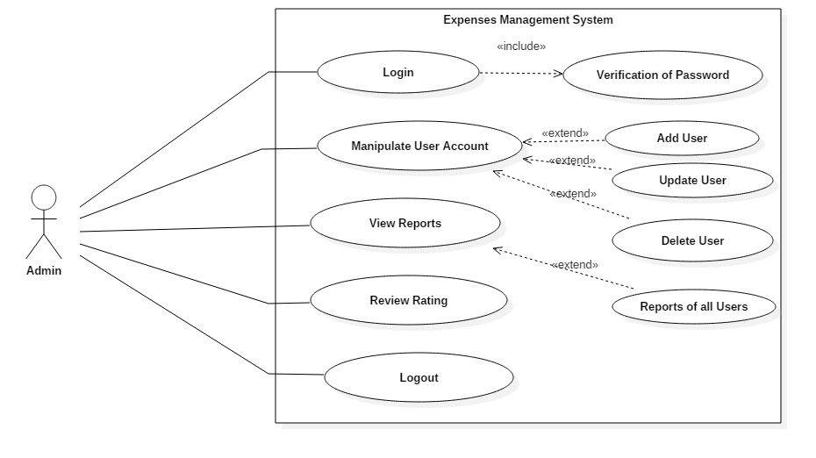

**Scenario Description**

Actor: Actor represents Admin

Admin can access to overall performance of the system. According to the diagram, Admin can perform following things:

* Admin can access to login into system of all user.
* Admin can access to manipulate user account. Manipulation of user account includes Add User, Update User, and Delete User etc.
* Admin can access to view reports, review and rating of all user.
* Admin can logout from system.

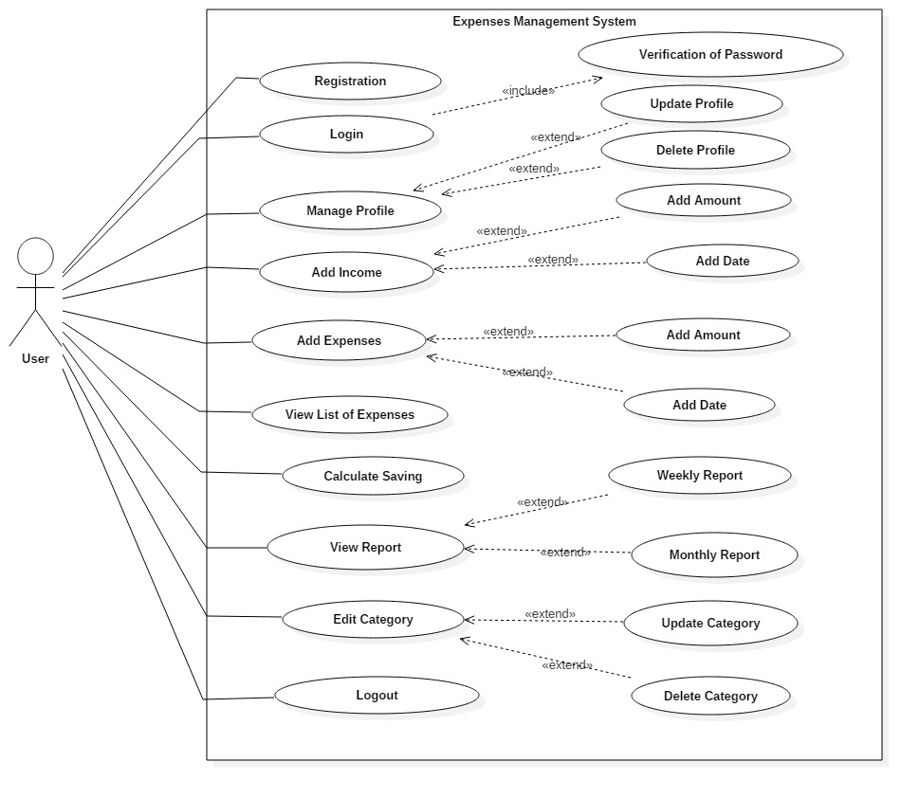

**Scenario Description**

Actor: Actor represents User.

User can access to following things of system:

* User can register to login into the system.
* User can login to use system.
* User can manipulate their own profile. Manipulation of the profile include Update Profile and Delete Profile.
* User can add their income and expenses.
* User can view their list of expenses.
* User can calculate their saving with the use of expenses and income.
* User can view their own report.
* User can edit their own category like food, clothes, hospital etc.
* User can logout from system.