**Dashboard 1**

**Dashboard 2**

View 1: Diabetic/Non-diabetic using Shapes

View 2: Patient summary by Blood Pressure category

View 3: Create a Histogram to show Body Mass Index (BMI) by Age Groups.

View 4: Single Bar showing percent distribution of patients by BMI type

View 5: Bar Chart showing Patient break down by Blood Pressure and Diabetes

View 6: Build a HEAT MAP showing several health factors by Age group

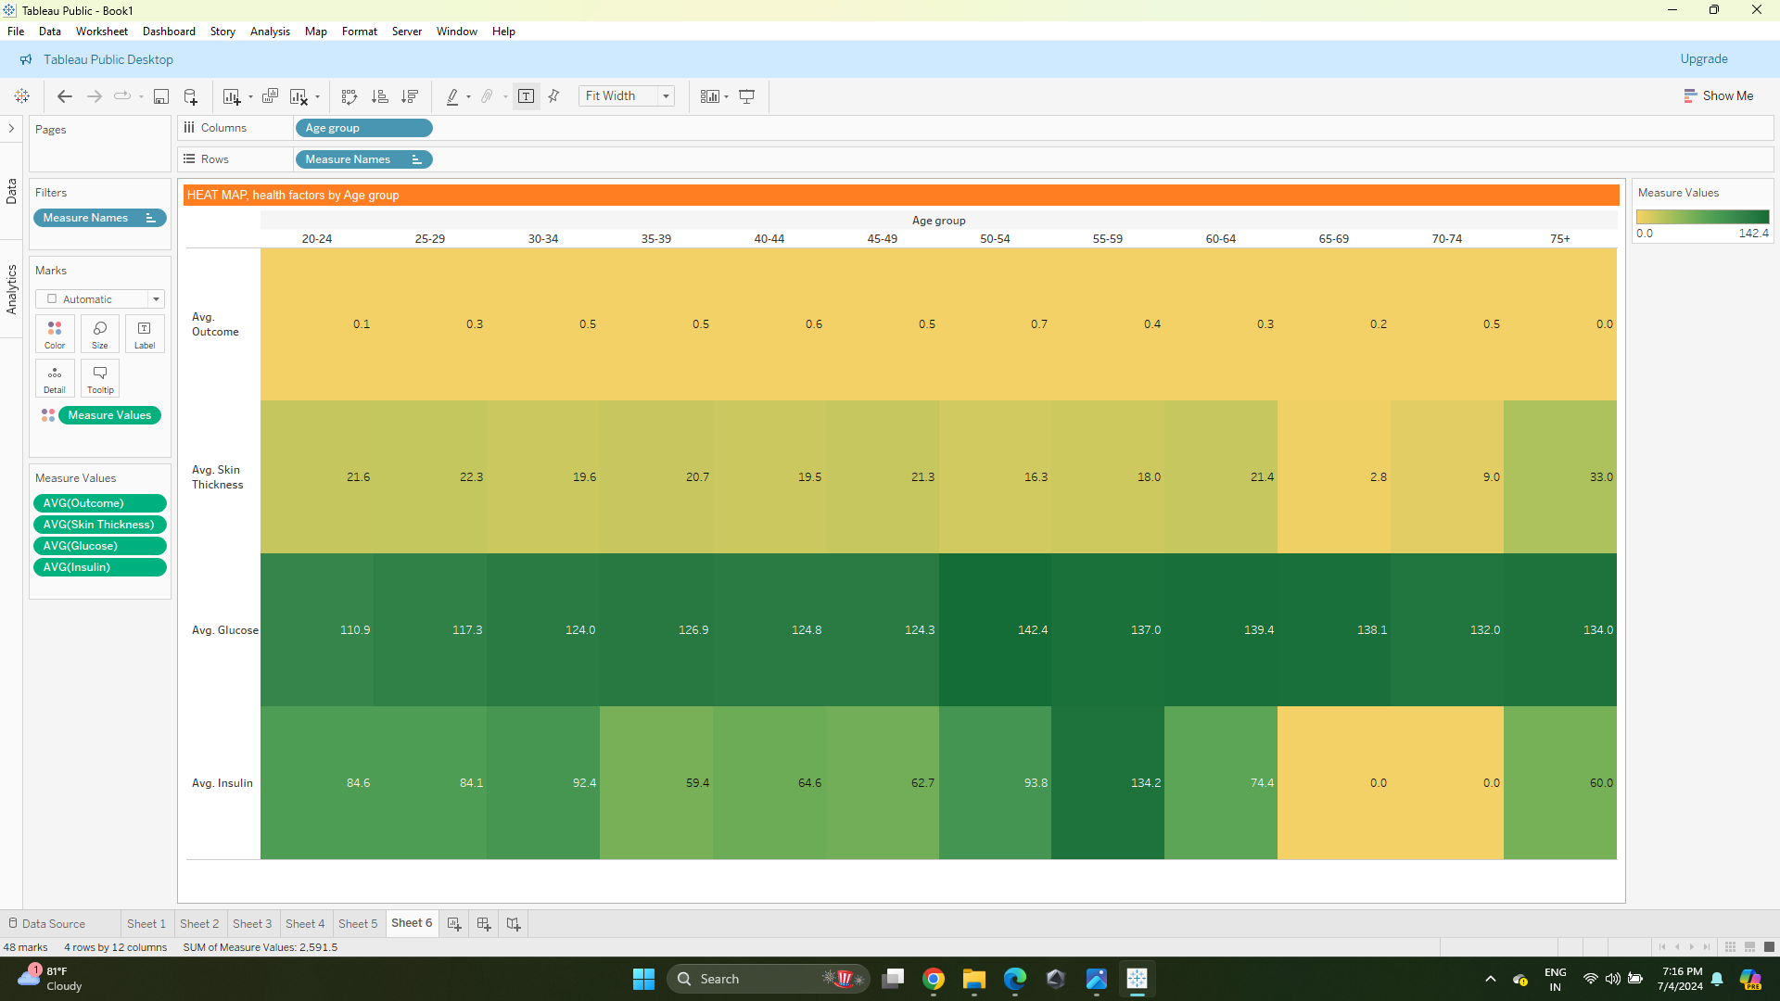

Story Point 1:

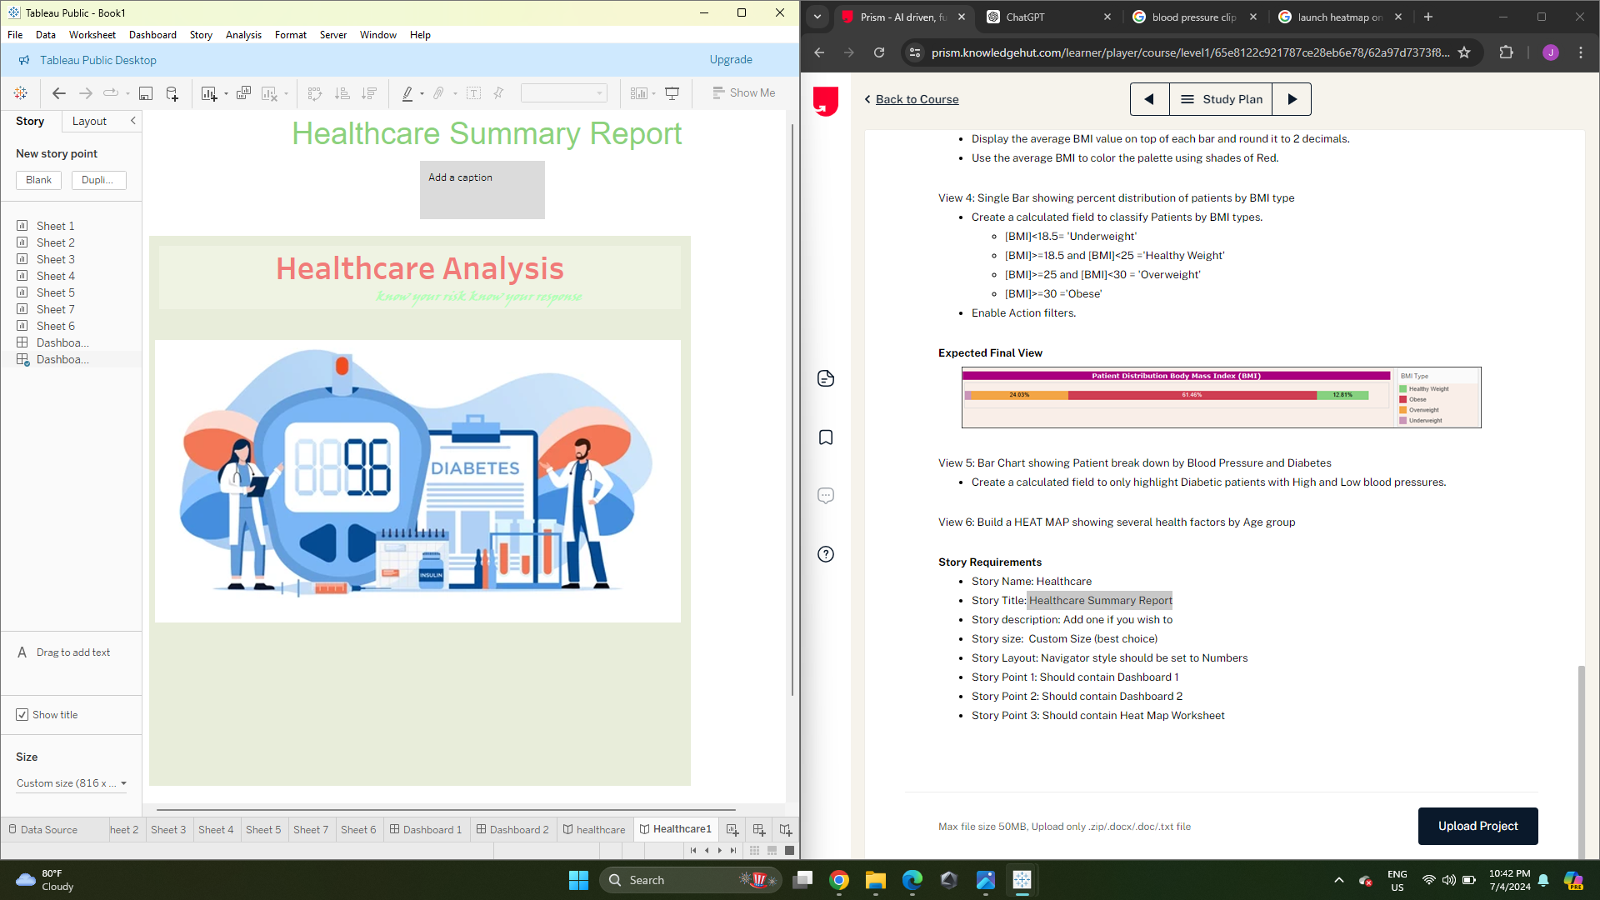

Story Point 2:

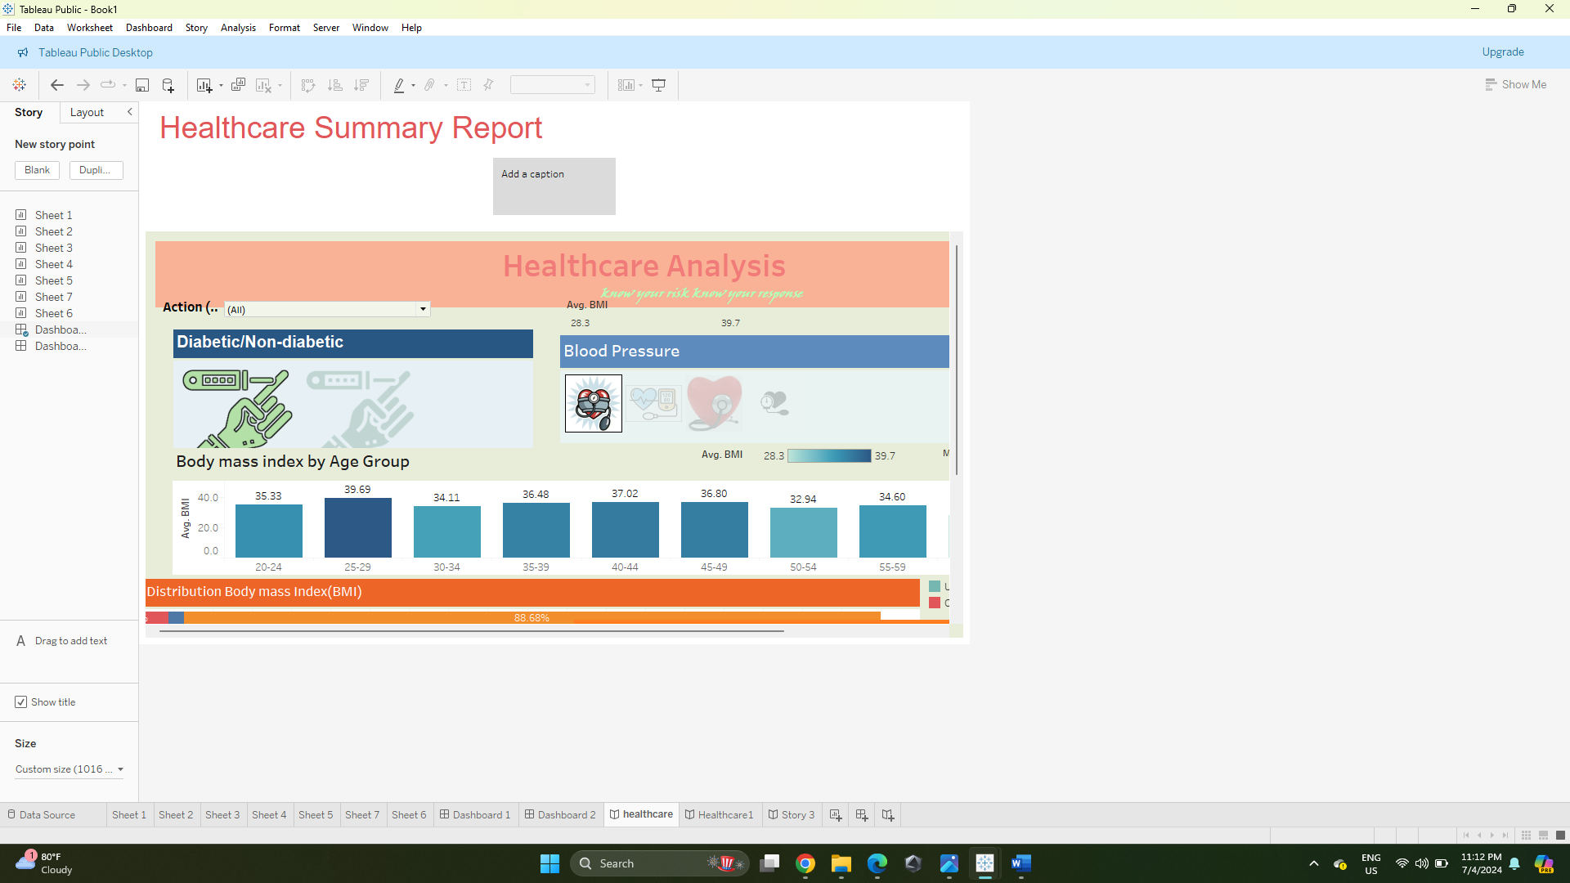

Story Point 3:

