First Official Projects (Friday Nov-14 2025 -December 14 2025)

Seasonal Health Planner

SEASONAL HEALTH PLANNER (NEPAL) — FULL WORKFLOW EXPLANATION

1️⃣ PROJECT GOAL
The Seasonal Health Planner is a smart, dynamic health recommendation tool that helps Nepali people stay healthy based on:
- Month
- Season
- Weather
- Health risks
- Diseases
- Diet
- Exercises
- Local herbal solutions
It provides personalized health guidance for all 12 Nepali months.

2️⃣ FROM WHERE DOES THE DATA COME?

✔ Data comes from your Django Admin Panel.
You (Admin) will enter month-wise seasonal health data from:
/admin
You will enter:
- Month name
- Season
- Temperature range
- Common diseases
- High-risk groups
- Prevention
- Diet recommendations
- Exercises
- Local herbal tips
- Don’ts & cautions
- AQI
- Water contamination risk
- Monthly banner image

👉 This becomes the backend data stored in SQLite database.

✔ The frontend reads data dynamically through Django Views & API.

📌 **No hard-coded data.
No manual file.
No external API.
The admin enters everything.**

3️⃣ WHY THE DATA IS DYNAMIC?
Because all data is stored in the database, not inside Python code.
Dynamic means:
- You can edit any month’s data anytime
- Add new health information
- Change risks
- Update temperature or weather
- Add/removes herbal advice
- Update images
Django automatically updates your frontend with the latest data.

✔ User sees updated content instantly

✔ No need to edit code again

✔ Professional + scalable
This makes your project industry-level.

4️⃣ HOW THE FRONTEND WORKS
The user visits:
/health/
User types: “S”
A JavaScript autocomplete system sends a request to Django:
/api/search-month/?q=S
Django checks database for matching months:
✔ Shrawan
✔ Shrawan can appear
✔ Something starting with S
It returns structured JSON:
{
"results": ["Shrawan"]
}
Frontend displays suggestions.
When user clicks a month →
Frontend loads full seasonal health plan:
- Weather
- Diseases
- Risks
- Preventive measures
- Diet
- Exercise
- Herbs
- Dos / Don’ts
All fetched from the database.

5️⃣ HOW THE BACKEND WORKS (Django)

1. Models (Database Structure)
You will create a model named:
SeasonalHealth
With fields:
- month_name
- season
- temperature_range
- high_risk_groups
- common_diseases
- symptoms
- preventive_measures
- diet
- exercise
- herbal_remedies
- avoid
- weather_description
- air_quality_index
- water_contamination_risk
- image
- created_at
- updated_at
Django automatically stores this in SQLite.

2. Admin Panel
You can add new month data like:
- Shrawan → Monsoon
- Kartik → Pre-winter
- Jestha → Summer
Admin panel also supports:
✔ File upload
✔ Dynamic editing
✔ Full CRUD

3. Views + API
You will build:

📌 Frontend view:
/health/ → shows UI

📌 Detail view:
/health/<month>/ → shows month details

📌 API endpoint:
/api/search-month/?q=A → returns autocomplete results

6️⃣ WHAT DEPENDENCIES DO YOU NEED?
Here is the complete list (simple & small):

✔ Backend Dependencies

1. Django
The main web framework for:
- Models → Database design
- Admin → Data entry
- Views → Logic
- Templates → UI
Install:
pip install django

✔ Frontend Dependencies

2. Vanilla JavaScript
Used for:
- Autocomplete search
- AJAX calls
- Updating UI without reloading page
(No libraries required unless you want React later.)

3. Tailwind CSS (optional but recommended)
For beautiful, modern UI:
pip install django-tailwind
Or you can use Bootstrap instead.

4. Pillow
For image uploads in Django:
pip install pillow

👉 Final dependency list (very small):
django
pillow
django-tailwind (optional)

7️⃣ WHO IS THIS PROJECT FOR?
This is targeted for:
✔ General Nepali people
✔ Students
✔ Farmers
✔ Families
✔ Healthcare awareness programs
✔ Local municipalities
✔ NGOs / INGOs
✔ Community health centers
This is a social impact project.
Extremely powerful for your Portfolio + LinkedIn.

8️⃣ WHY THIS PROJECT IS MARKET-READY?
Because:
- It solves a local health problem
- It has real value
- It uses dynamic data
- It is scalable to mobile app
- It can be used by institutions
- Very strong UI/UX
- Looks like a professional product
- Uses admin panel for data management
Companies love this kind of Django project.

9️⃣ Next Step (you choose)
Now that you fully understand:
✔ workflow
✔ source of data
✔ dynamic nature
✔ dependencies
✔ backend–frontend connection
Your comprehensive guide to staying healthy throughout Nepal's 12 months. Get personalized health recommendations based on season, weather, and local wisdom.

UI:
Landing Page:
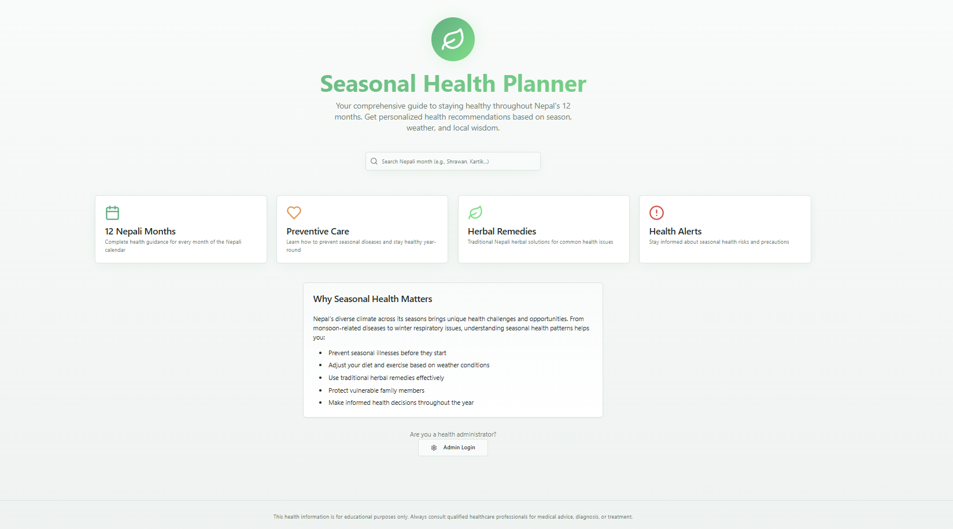

Search as per Nepali Months:
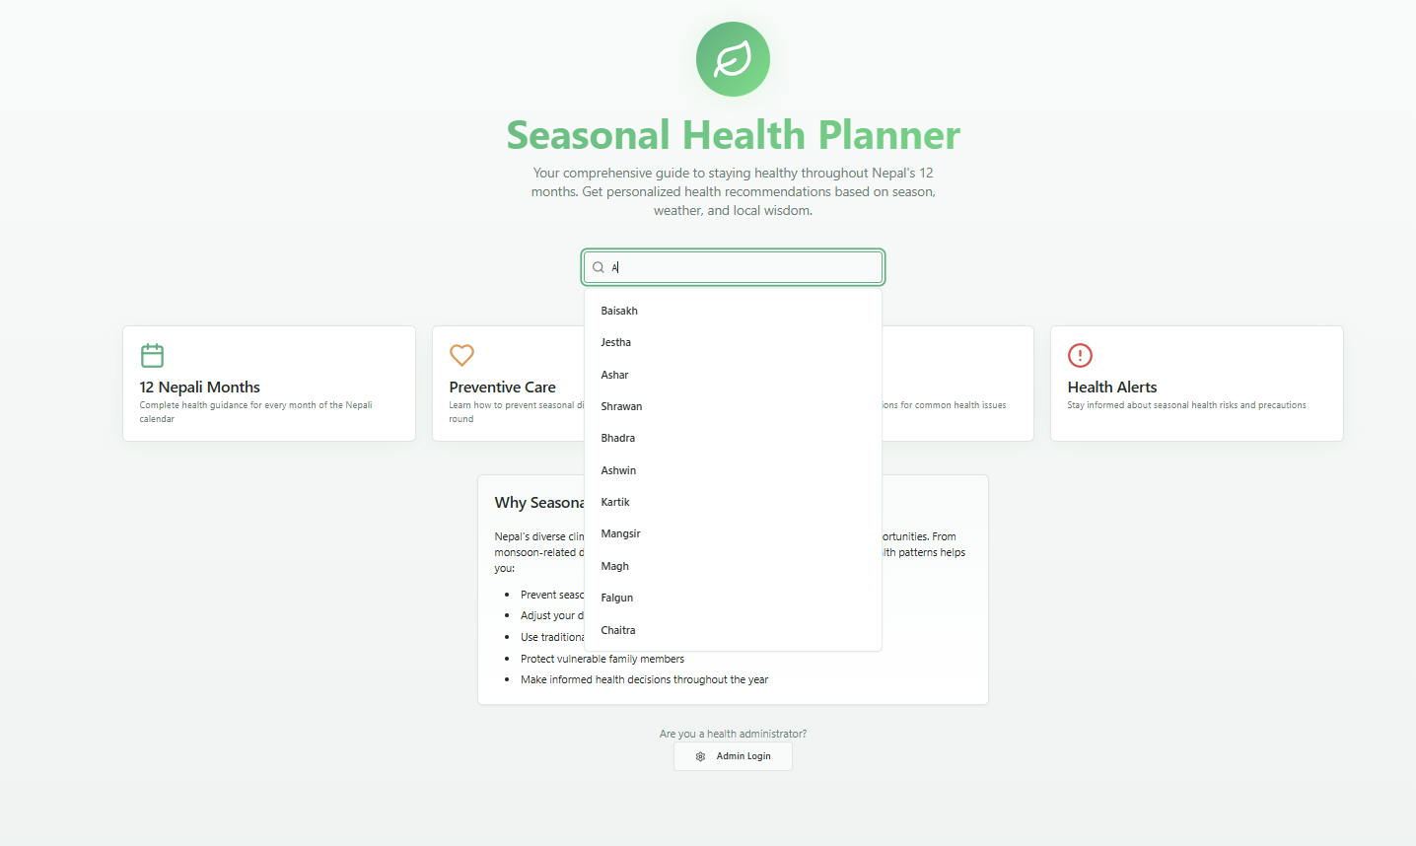

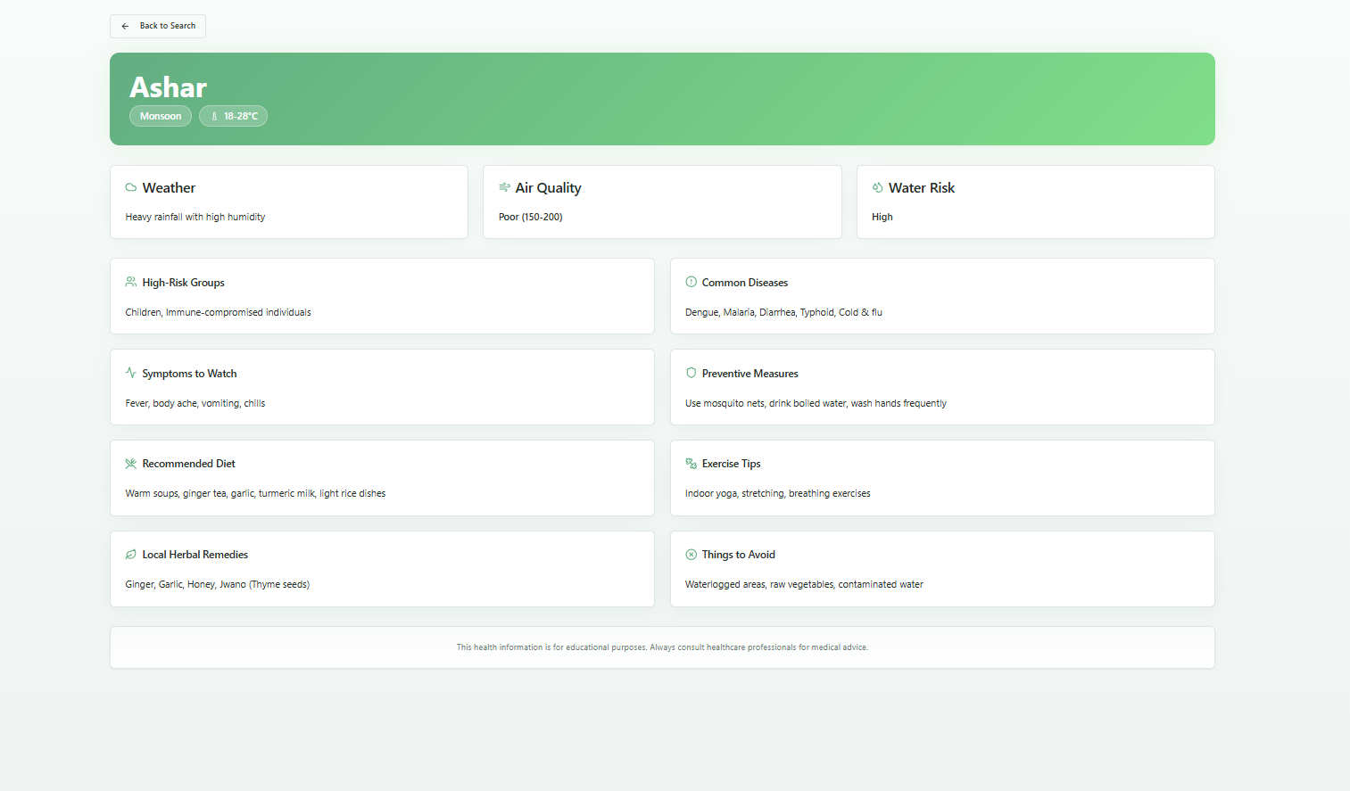

Additional Features:
1, chatbot Assistant in future.
2 daily weather conditions alert and precautions and what to eat, stay hydrated---------.
3. Email/SMS notification, conditions of weather like its heavy rain stay safe, and too cold, too hot today based on conditions
4. Herbal Remedies= Nepali herbal solutions for common issues

