============================================================
INITIAL OVERVIEW
============================================================
Shape: (101766, 50)

Data types:
encounter_id int64
patient_nbr int64
race object
gender object
age object
weight object
admission_type_id int64
discharge_disposition_id int64
admission_source_id int64
time_in_hospital int64
payer_code object
medical_specialty object
num_lab_procedures int64
num_procedures int64
num_medications int64
number_outpatient int64
number_emergency int64
number_inpatient int64
diag_1 object
diag_2 object
diag_3 object
number_diagnoses int64
max_glu_serum object
A1Cresult object
metformin object
repaglinide object
nateglinide object
chlorpropamide object
glimepiride object
acetohexamide object
glipizide object
glyburide object
tolbutamide object
pioglitazone object
rosiglitazone object
acarbose object
miglitol object
troglitazone object
tolazamide object
examide object
citoglipton object
insulin object
glyburide-metformin object
glipizide-metformin object
glimepiride-pioglitazone object
metformin-rosiglitazone object
metformin-pioglitazone object
change object
diabetesMed object
readmitted object
dtype: object

Missing values:
encounter_id 0
patient_nbr 0
race 2273
gender 0
age 0
weight 98569
admission_type_id 0
discharge_disposition_id 0
admission_source_id 0
time_in_hospital 0
payer_code 40256
medical_specialty 49949
num_lab_procedures 0
num_procedures 0
num_medications 0
number_outpatient 0
number_emergency 0
number_inpatient 0
diag_1 21
diag_2 358
diag_3 1423
number_diagnoses 0
max_glu_serum 96420
A1Cresult 84748
metformin 0
repaglinide 0
nateglinide 0
chlorpropamide 0
glimepiride 0
acetohexamide 0
glipizide 0
glyburide 0
tolbutamide 0
pioglitazone 0
rosiglitazone 0
acarbose 0
miglitol 0
troglitazone 0
tolazamide 0
examide 0
citoglipton 0
insulin 0
glyburide-metformin 0
glipizide-metformin 0
glimepiride-pioglitazone 0
metformin-rosiglitazone 0
metformin-pioglitazone 0
change 0
diabetesMed 0
readmitted 0
dtype: int64

Duplicated rows: 0

# Drop remaining object columns that can't be easily encoded
df.drop(columns=['race', 'diag_1', 'diag_2', 'diag_3', 'patient_nbr'],
inplace=True)

print("\nShape after cleaning:", df.shape)
print("Missing values after cleaning:\n", df.isnull().sum())
print("\nData types after cleaning:\n", df.dtypes)
============================================================
STEP 2: DATA CLEANING
============================================================
Dropped: encounter_id, weight, payer_code, medical_specialty
Dropping zero-variance columns: ['examide', 'citoglipton']
Dropping low-variance columns: ['chlorpropamide', 'acetohexamide', 'tolbutamide', 'acarbose', 'miglitol', 'troglitazone', 'tolazamide', 'glipizide-metformin', 'glimepiride-pioglitazone', 'metformin-rosiglitazone', 'metformin-pioglitazone']

Shape after cleaning: (101763, 28)
Missing values after cleaning:
gender 0
age 0
admission_type_id 0
discharge_disposition_id 0
admission_source_id 0
time_in_hospital 0
num_lab_procedures 0
num_procedures 0
num_medications 0
number_outpatient 0
number_emergency 0
number_inpatient 0
number_diagnoses 0
max_glu_serum 0
A1Cresult 0
metformin 0
repaglinide 0
nateglinide 0
glimepiride 0
glipizide 0
glyburide 0
pioglitazone 0
rosiglitazone 0
insulin 0
glyburide-metformin 0
change 0
diabetesMed 0
readmitted 0
dtype: int64

Data types after cleaning:
gender int64
age int64
admission_type_id int64
discharge_disposition_id int64
admission_source_id int64
time_in_hospital int64
num_lab_procedures int64
num_procedures int64
num_medications int64
number_outpatient int64
number_emergency int64
number_inpatient int64
number_diagnoses int64
max_glu_serum int64
A1Cresult int64
metformin int64
repaglinide int64
nateglinide int64
glimepiride int64
glipizide int64
glyburide int64
pioglitazone int64
rosiglitazone int64
insulin int64
glyburide-metformin int64
change int64
diabetesMed int64
readmitted object
dtype: object

# Plot 1: Target variable distribution
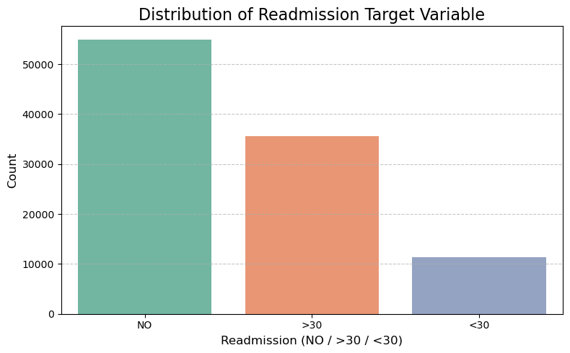
# Plot 2: Age distribution

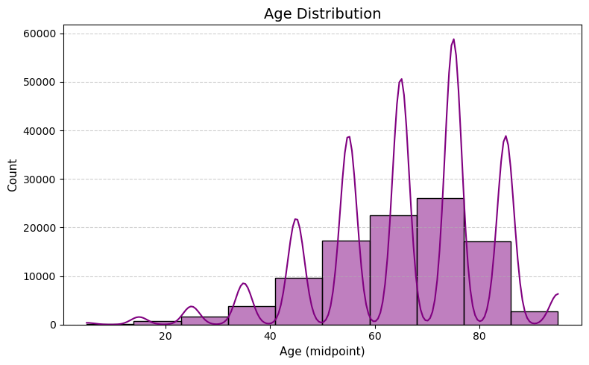

# Plot 3: BMI-equivalent — time_in_hospital by readmission
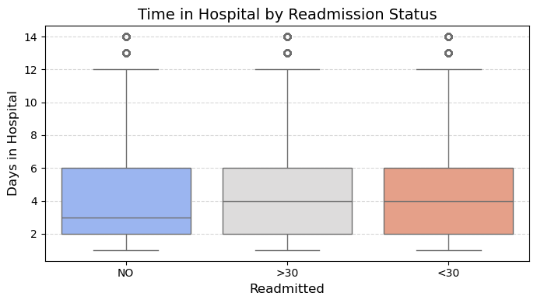

# Plot 4: Correlation heatmap
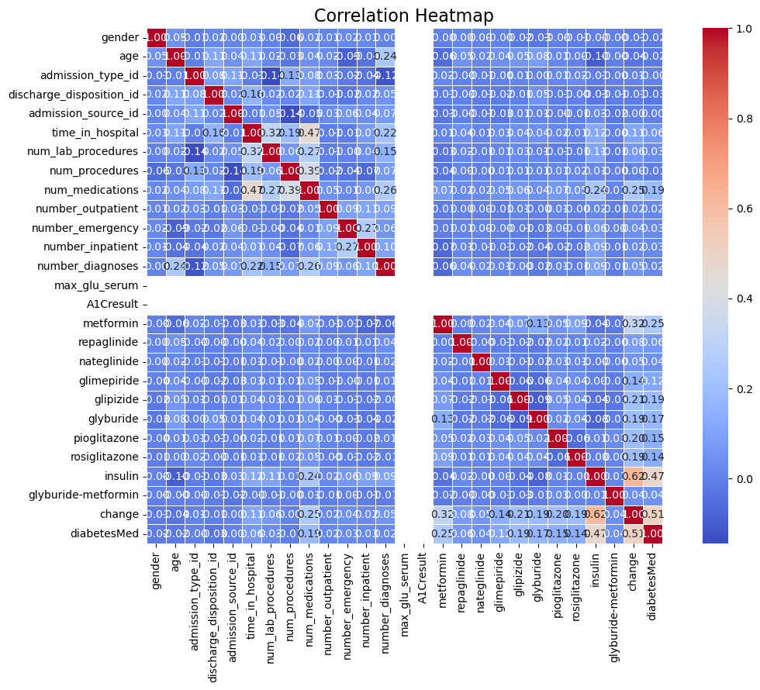

# Plot 5: Violin — num_medications by readmission
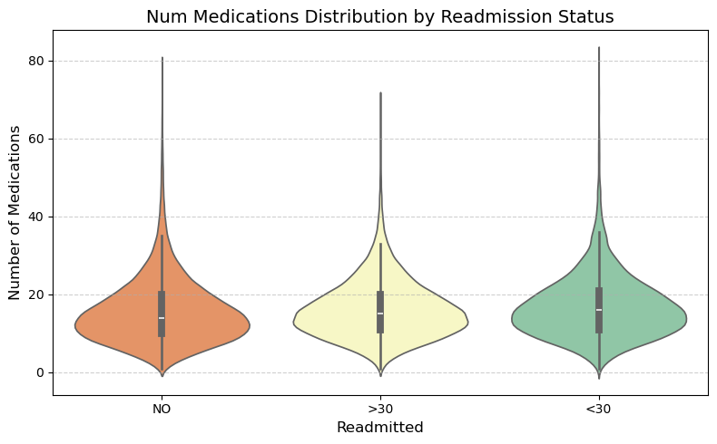

# Plot 6: Violin — num_lab_procedures by readmission
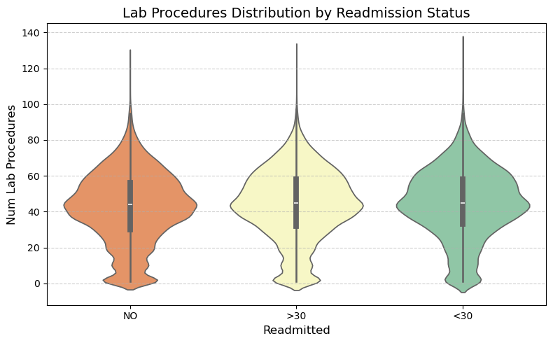

Class distribution:
readmitted
NO 0.539106
>30 0.349292

count mean std min 25% 50% \
gender 101763.0 0.537602 0.498587 0.0 0.0 1.0
age 101763.0 65.966854 15.941022 5.0 55.0 65.0
admission_type_id 101763.0 2.024017 1.445414 1.0 1.0 1.0
discharge_disposition_id 101763.0 3.715515 5.279919 1.0 1.0 1.0
admission_source_id 101763.0 5.754459 4.064110 1.0 1.0 7.0
time_in_hospital 101763.0 4.396018 2.985092 1.0 2.0 4.0
num_lab_procedures 101763.0 43.095909 19.674220 1.0 31.0 44.0
num_procedures 101763.0 1.339691 1.705792 0.0 0.0 1.0
num_medications 101763.0 16.021835 8.127589 1.0 10.0 15.0
number_outpatient 101763.0 0.369368 1.267282 0.0 0.0 0.0
number_emergency 101763.0 0.197842 0.930485 0.0 0.0 0.0
number_inpatient 101763.0 0.635585 1.262877 0.0 0.0 0.0
number_diagnoses 101763.0 7.422649 1.933578 1.0 6.0 8.0
max_glu_serum 101763.0 1.000000 0.000000 1.0 1.0 1.0
A1Cresult 101763.0 1.000000 0.000000 1.0 1.0 1.0
metformin 101763.0 0.218193 0.474826 0.0 0.0 0.0
repaglinide 101763.0 0.017089 0.147010 0.0 0.0 0.0
nateglinide 101763.0 0.007360 0.091795 0.0 0.0 0.0
glimepiride 101763.0 0.058037 0.269322 0.0 0.0 0.0
glipizide 101763.0 0.143225 0.413357 0.0 0.0 0.0
glyburide 101763.0 0.123719 0.397022 0.0 0.0 0.0
pioglitazone 101763.0 0.076619 0.286890 0.0 0.0 0.0
rosiglitazone 101763.0 0.065996 0.265084 0.0 0.0 0.0
insulin 101763.0 0.885735 1.021762 0.0 0.0 1.0
glyburide-metformin 101763.0 0.007134 0.087146 0.0 0.0 0.0
change 101763.0 0.461946 0.498552 0.0 0.0 0.0
diabetesMed 101763.0 0.770034 0.420813 0.0 1.0 1.0

75% max
gender 1.0 1.0
age 75.0 95.0
admission_type_id 3.0 8.0
discharge_disposition_id 4.0 28.0
admission_source_id 7.0 25.0
time_in_hospital 6.0 14.0
num_lab_procedures 57.0 132.0
num_procedures 2.0 6.0
num_medications 20.0 81.0
number_outpatient 0.0 42.0
number_emergency 0.0 76.0
number_inpatient 1.0 21.0
number_diagnoses 9.0 16.0
max_glu_serum 1.0 1.0
A1Cresult 1.0 1.0
metformin 0.0 3.0
repaglinide 0.0 3.0
nateglinide 0.0 3.0
glimepiride 0.0 3.0
glipizide 0.0 3.0
glyburide 0.0 3.0
pioglitazone 0.0 3.0
rosiglitazone 0.0 3.0
insulin 1.0 3.0
glyburide-metformin 0.0 3.0
change 1.0 1.0
diabetesMed 1.0 1.0

Mean num_medications by readmitted:
readmitted
<30 16.903143
>30 16.282768
NO 15.670330
Name: num_medications, dtype: float64

Mean time_in_hospital by readmitted:
readmitted
<30 4.768249
>30 4.495541
NO 4.254480
Name: time_in_hospital, dtype: float64
============================================================
TARGET ENCODING & TRAIN / TEST SPLIT
============================================================
Class counts:
readmitted
0 90406
1 11357
Name: count, dtype: int64

Train size : (81410, 29)
Test size : (20353, 29)

============================================================
FEATURE SELECTION (Embedded — RF Importances)
============================================================
Feature Importances:

num_lab_procedures 0.145551
med_procedure_ratio 0.113848
num_medications 0.102544
time_in_hospital 0.079273
age 0.067163
number_diagnoses 0.053359
discharge_disposition_id 0.048413
num_procedures 0.042667
admission_type_id 0.038850
total_utilization 0.034621
insulin 0.033687
admission_source_id 0.033156
number_inpatient 0.032400
gender 0.026190
number_outpatient 0.017885
metformin 0.017370
glipizide 0.017187
number_emergency 0.015560
change 0.014913
glyburide 0.014492
pioglitazone 0.011547
diabetesMed 0.010933
rosiglitazone 0.009812
glimepiride 0.009361
repaglinide 0.004665
nateglinide 0.002437
glyburide-metformin 0.002116
max_glu_serum 0.000000
A1Cresult 0.000000
dtype: float64
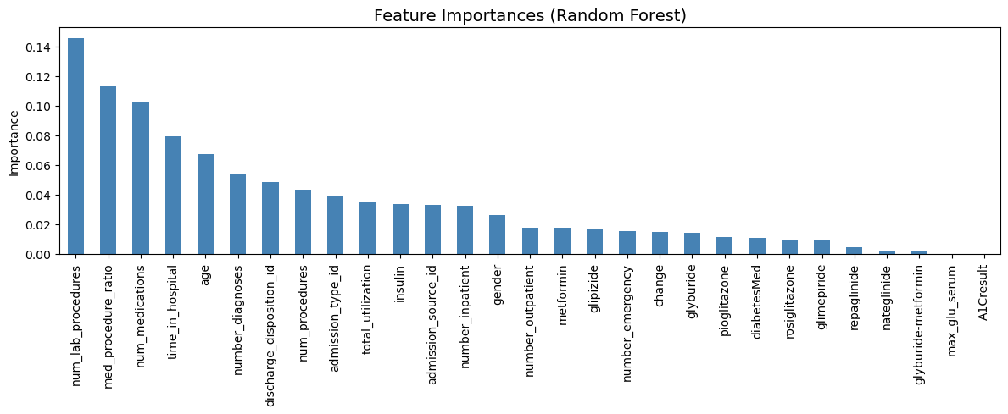

============================================================
STANDARD SCALING
============================================================
MODEL 1: RANDOM FOREST
============================================================

──────────────────────────────────────────────────
Model : Random Forest
──────────────────────────────────────────────────
Accuracy : 0.8852
Precision : 0.2481
Recall : 0.0141
F1 Score : 0.0267

Classification Report:
precision recall f1-score support

0 0.89 0.99 0.94 18082
1 0.25 0.01 0.03 2271

accuracy 0.89 20353
macro avg 0.57 0.50 0.48 20353
weighted avg 0.82 0.89 0.84 20353

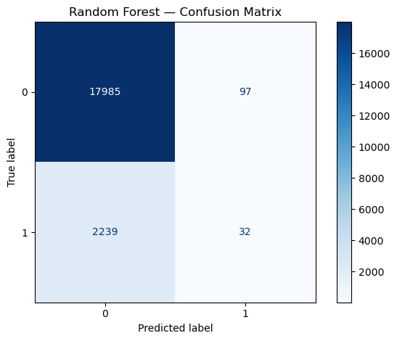
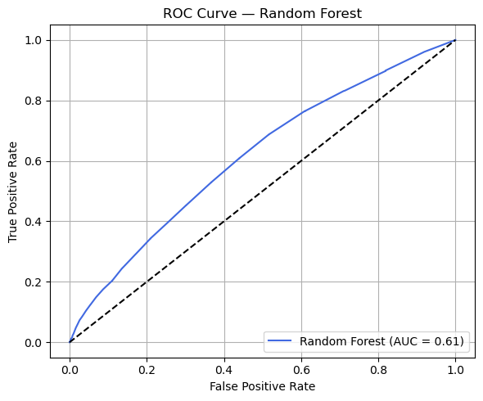
============================================================
MODEL 2: LOGISTIC REGRESSION
============================================================
Accuracy : 0.8878
Precision : 0.2174
Recall : 0.0022
F1 Score : 0.0044

Classification Report:
precision recall f1-score support

0 0.89 1.00 0.94 18082
1 0.22 0.00 0.00 2271

accuracy 0.89 20353
macro avg 0.55 0.50 0.47 20353
weighted avg 0.81 0.89 0.84 20353

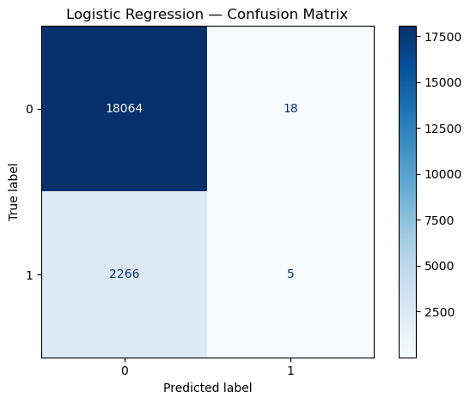
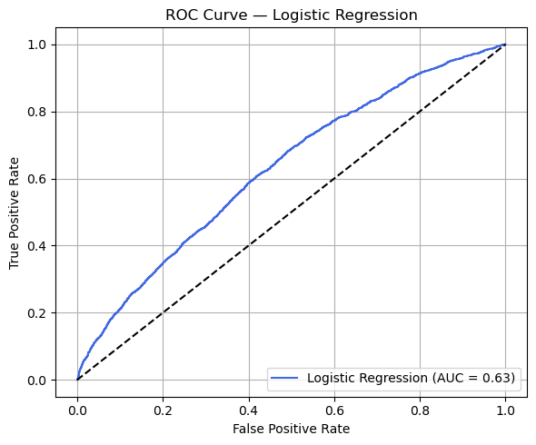
============================================================
MODEL 3: DECISION TREE CLASSIFIER
============================================================
Accuracy : 0.7890
Precision : 0.1535
Recall : 0.1973
F1 Score : 0.1726
Classification Report:
precision recall f1-score support

0 0.90 0.86 0.88 18082
1 0.15 0.20 0.17 2271

accuracy 0.79 20353
macro avg 0.52 0.53 0.53 20353
weighted avg 0.81 0.79 0.80 20353

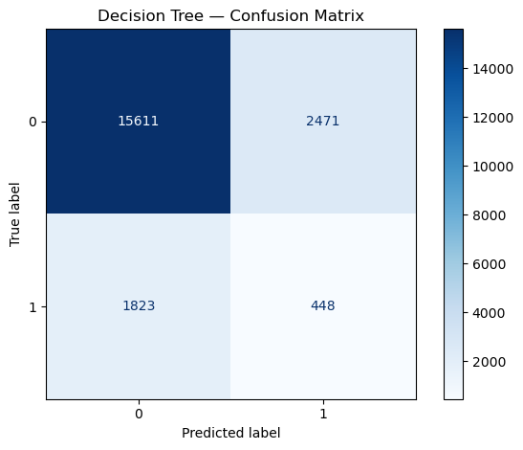
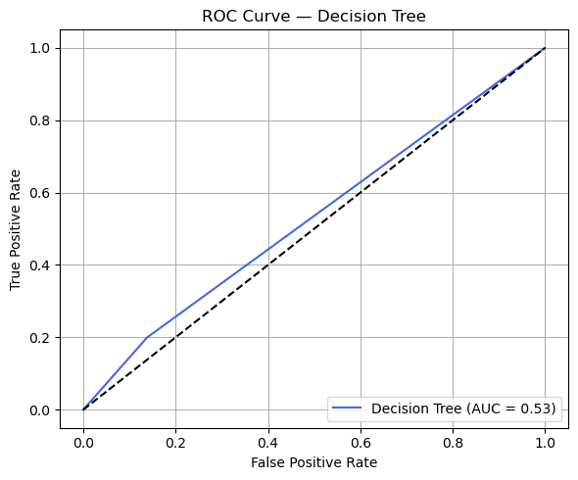

============================================================
PHASE 3: MODEL COMPARISON & FINAL INSIGHTS
============================================================

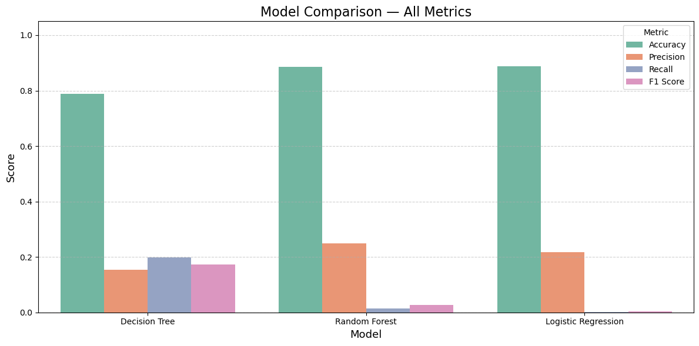
Best model by Recall: Decision Tree
Recall : 0.1973
Precision : 0.1535
F1 Score : 0.1726
AUC : 0.5307
───────────────────────────────────────────
# ── Overlay ROC curves for all three models ───────────────────────────────────
