From College Boards to Dashboards — Submission Document

Author: Pascal Esegemou Ekenya Fonjock

Date: 2025-09-15

# 1. Executive Summary

This story explores how professor effectiveness (EvaluationScore) relates to course costs and enrollment. We identify best practice professors who earn high evaluation scores at moderate or low cost, and low-cost courses with poor evaluations that would benefit most from targeted interventions.

# 2. Dataset Preparation Evidence

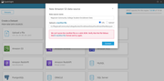

Attempt to create dataset from fictional S3 manifest (expected error). Rubric: Section 1 evidence.

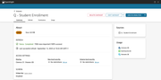

Q - Student Enrollment dataset visible in Datasets. Rubric: Section 1 evidence.



Weekly refresh schedule set to Sunday 12:00 AM (timezone visible). Rubric: Section 1.

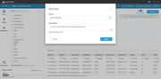

Field HomeOfOrigin renamed to NationalOrigin with description. Rubric: Section 1.

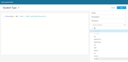

Calculated field Student Type defined. Rubric: Section 1.

# 3. Visuals Created Using Q

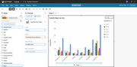

Visual created by Q — Student Majors by Year (initial)

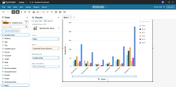

Visual reconfigured to vertical bar chart (formatted, no comma separators)

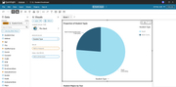

Proportion of Student Types (pie chart)

# 4. Topic & Named Entities

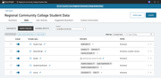

Topic field list includes required fields.

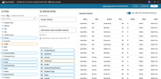

Named Entity: Student Details.

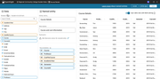

Named Entity: Course Details.

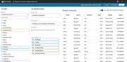

Named Entity: Professor Evaluation.

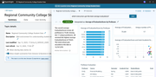

Verified Q answer: Best instructors.

# 5. Dashboard, Scenarios & Thread

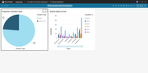

Student Enrollment Dashboard published with Q enabled.

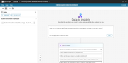

Scenario created with selected visuals.

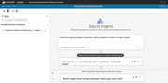

Starter question: How do we improve professor evaluations while avoiding increased cost per course?

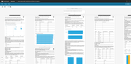

Scenario thread showing iterative Q.

# 6. Data Story



Data Story Visual: Student Majors by Year



Data Story Visual: Proportion of Student Types

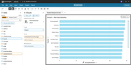

Data Story Visual: Avg EvaluationScore by Course

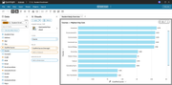

Data Story Visual: Avg CostPerCourse by Course

# 7. File listings and additional artifacts

dataset_fields.md, calculated_fields.md, Q_prompts.md, verified_answers.md, scenario_thread.md, data_story.md, manifest_sample.json, screenshots/ (all screenshot files present)

# 8. Methodology

Steps: sample dataset usage, calculated fields creation, Q prompts, topic creation, scenario & thread, data story creation.

# 9. Originality Statement

I confirm this submission is my original work. Any referenced AWS/Udacity documentation is cited.

# 10. Checklist for Rubric

Map each rubric criterion to the screenshot and file you provided.