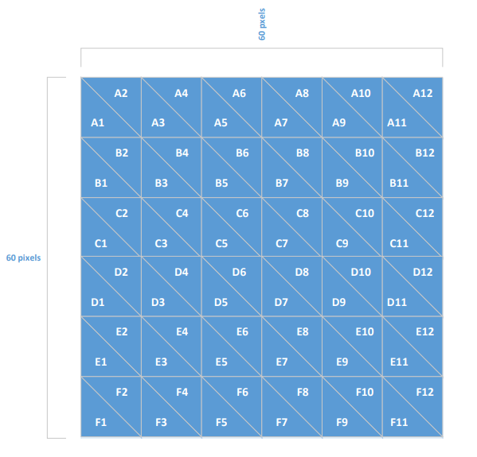

(v+60,v+60) 

(v+50,v+60) 

(v+40,v+60) 

(v+30,v+60) 

(v+20,v+60) 

(v+10,v+60) 

(v,v+60) 

(v,v+50) 

(v,v+40) 

(v,v+30) 

(v,v+20) 

(v,v+10) 

(v+60,v) 

(v+50,v) 

(v+40,v) 

(v+30,v) 

(v+20,v) 

(v+10,v) 

(v,v) 

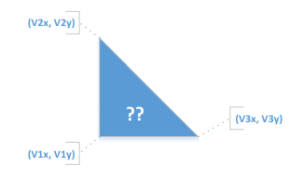

-I’ll be using the value v1x to tell me at which column did the triangle start after I divide it by 5 since the column length in the example above is 5 (since it’s 60 for the 12 columns).

-I’ll be using the value v3x to tell me at which column did the triangle end after I divide it by 5 since the column length in the example above is 5 (since it’s 60 for the 12 columns).

-I’ll be using v2y to tell me at which row did the triangle start after I divide it by 10 since the row length in the example above is 10 (since it’s 12 for the 6 letters).

-I’ll be using v1y to tell me at which row did the triangle end after I divide it by 10 since the row length in the example above is 10 (since it’s 12 for the 6 letters).