**COMP 122/L: Computer Arch. and Assembly Language Summer 2020**

**Instructor:** Mahdi Ebrahimi (mahdi.ebrahimi@csun.edu)

**Office**: Online via Zoom

|  |  |  |  |  |
| --- | --- | --- | --- | --- |
| **Section** | **Class Title** | **Dates & Times** | **Room** | **Class Dates** |
| [COMP 122-01 (10498)](javascript:submitAction_win0(document.win0,'CLASS_TITLE$0');) | COMP ARCH ASSEM (Lecture) | MoTuWeTh  9:00AM - 9:35AM | Online Class  via Zoom | Jul 8, 2020- Aug 18, 2020 |
| [COMP 122L-01 (10499)](javascript:submitAction_win0(document.win0,'CLASS_TITLE$1');) | COMP ARCH ASSEM (Laboratory) | MoTuWeTh  9:45AM - 11:20AM | Online Class  via Zoom | Jul 8, 2020- Aug 18, 2020 |

**Communication:**

Please use email rather than telephone voice mail for messages. Please keep emails short and focused, and use a clear subject line beginning with “COMP 122 Question”. Many technical questions are better handled in person during lecture and lab rather than email since the class as a whole might benefit from the discussion.

You may email me (mahdi.ebrahimi@csun.edu) at any time; I will generally respond within 24 hours (during the academic days). Always include your name, course, and CSUN email address in your messages to me; an email address like meqwik@love.com leaves me clueless about who you are!

**Course Description (from the catalog)**

Introduction to computer architecture, assembly language programming system software, and computer applications. Number systems and data representation. Internal organization of a computer. Primitive instructions and operations. Assembly language.

# Learning Objectives

A successful student will learn basic assembly programming skills, understand the fundamentals of digital logic design, and understand the interface between the two. The ARMv4 instruction set will be used for assembly, though the concepts are broadly applicable. In particular, successful students will be able to:

* Describe how modern computers represent numbers and interconvert between different numeric representations
* Perform common operations over computer-represented numbers, and design circuits which perform these operations
* Write programs in ARM assembly, including conditionals, loops, arrays, and functions
* Design and simplify combinatorial circuits with Boolean algebra and Karnaugh maps
* Design sequential circuits, including those implementing finite state machines
* Design a simplistic processor implementing a restricted assembly language
* Understand, from a high-level, the design of a high-level processor
* ...among many others

**Prerequisite:** Grade of “C” or better in [*COMP 110/L*](https://catalog.csun.edu/academics/comp/courses/comp-110l/); Grade of “C” or better in [*MATH 103*](https://catalog.csun.edu/academics/math/courses/math-103/), [*MATH 104*](https://catalog.csun.edu/academics/math/courses/math-104/), [*MATH 105*](https://catalog.csun.edu/academics/math/courses/math-105/), [*MATH 150A*](https://catalog.csun.edu/academics/math/courses/math-150a/) or [*MATH 255A*](https://catalog.csun.edu/academics/math/courses/math-255a/), or a passing score on the [*Mathematics Placement Test (MPT)*](https://catalog.csun.edu/policies/mathematics-placement-test-mpt/) that satisfies prerequisites for MATH 150A or 255A; Lower division writing requirement.

**Corequisite:** COMP 122L.

**Course Material:**

Course material is available on Canvas (<https://canvas.csun.edu> ). Labs, Assignments, Exams, and grades will be posted on canvas (<https://canvas.csun.edu> ). Any questions about a homework/exam grade should be addressed within **two** days of posting. After two days, all grades are final.

# Textbook

No textbook is required. If you’d like a textbook for further study, two decent supplemental textbooks are:

1. Computer Organization and Design: The Hardware/Software Interface (David A. Patterson and John L. Hennessy); any edition from the past several years
2. Computer Systems Organization and Architecture (John D. Carpinelli)

**Grading**

You will receive a **single combined grade** for the lecture and lab. Your grade is based on the following components:

|  |  |
| --- | --- |
| Lab Assignments | 30% |
| Lab Midterm Exam | 15% |
| Lecture Midterm Exam | 15% |
| Lab Final Exam | 20% |
| Lecture Final Exam | 20% |

The exact number of lab assignments has not been set, as this will depend somewhat on how the class progresses. Lab assignments are submitted through Canvas (https:// canvas.csun.edu/). In the event that there is a problem with Canvas, you may email your assignment to me (mahdi.ebrahimi@csun.edu), though this should be considered a last resort.

**Plus/minus grading is used**, according to the scale below. The left column shows the minimum score necessary to receive the grade in the right column. The highest letter grade possible given the score is chosen; e.g., if you receive an 88.2, you’d receive a ‘B+’ for the course, which corresponds to being >= 86.5.

|  |  |
| --- | --- |
| If your score is >=... | ...you will receive... |
| 96.5 | A+ |
| 92.5 | A |
| 89.5 | A- |
| 86.5 | B+ |
| 82.5 | B |
| 79.5 | B- |
| 76.5 | C+ |
| 72.5 | C |
| 69.5 | C- |
| 66.5 | D+ |
| 62.5 | D |
| 59.5 | D- |
| 0 | F |

* **NOTE: Failure to take the Final Exam will result in a grade of “WU” which is equivalent to a grade of “F”**
* In fairness to all, I don't give make-up for any missed projects, homework, or exams.
* An incomplete (I) grade is given for genuine medical and other certified emergencies only; it is never given to catch up with missed assignments. Furthermore, to receive an Incomplete grade, you must have successfully completed at least two-thirds of the semester with a passing grade.

**Late Policy:**

Late assignments will be accepted without penalty if prior arrangements have been made or there is some sort of legitimate emergency (at my discretion). If an assignment is otherwise submitted late, it will be penalized according to the following scale:

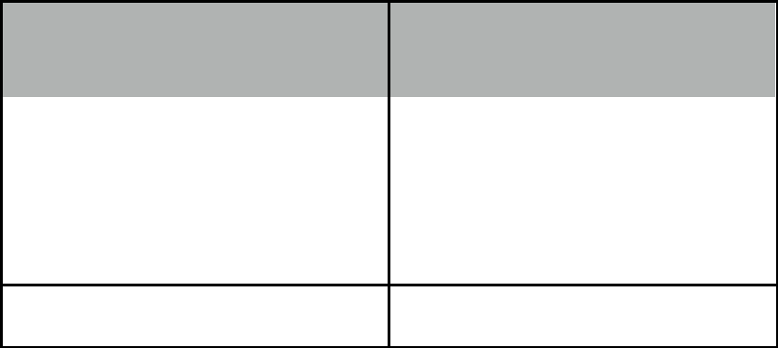

|  |  |
| --- | --- |
| **If your assignment is late** | **...it will be deducted by...** |
| **by <= this many days...** |  |
|  |  |
| 1 | 10% |
|  |  |
| 2 | 30% |
|  |  |
| 3 | 60% |

4+ 100%

To be clear, assignments that are submitted four or more days beyond the deadline will not receive credit.

# Plagiarism and Academic Honesty

While collaboration is allowed on lab assignments, you are responsible for all of your own work. You may **not** take code from online sources and submit it as your own. No discussion whatsoever is allowed during exams, except with the instructor. Any violations can result in a failing grade for the assignment or potentially failing the course for egregious cases. A report will also be made to the Dean of Academic Affairs.

Students who repeatedly violate this policy across multiple courses may be suspended or even expelled.

**Disabled Students**

"If you have a disability and need accommodations, please register with the Disability Resources and Educational Services (DRES) office or the National Center on Deafness (NCOD). The DRES office is located in Bayramian Hall, room 110, and can be reached at (818) 677-2684. NCOD is located on Bertrand Street in Jeanne Chisholm Hall and can be reached at (818) 677-2611. If you would like to discuss your need for accommodations with me, please contact me to set up an appointment."

**Changes to Syllabus**

Changes may be needed to this syllabus and to the course plan. All such changes will be announced in class and will be announced via email. Students are responsible for this information.

# 

# Class Schedule and List of Topics (Subject to Change)

Exactly which topics are covered and when is subject to change.

|  |  |  |
| --- | --- | --- |
| **Week** | **Dates** | **Topics** |
| 1 - 2 | 7/08 - 7/09 | Number representation |
| 2 - 1 | 7/13 - 7/14 | Floating point, operations on binary values |
| 2 - 2 | 7/15 - 7/16 | ARM assembly: introduction and arithmetic |
| 3 - 1 | 7/20 - 7/21 | ARM assembly: conditionals and memory operations |
| 3 - 2 | 7/22 - 7/23 | ARM assembly: loops and arrays |
| 4 - 1 | 7/27 - 7/28 | ARM assembly: functions |
| 4 - 2 | 7/29 - 7/30 | More ARM assembly; review |
| 5 - 1 | 8/03 - 8/04 | **8/4 Lecture Midterm Exam 9:00 AM - 11:20 AM, Online via Canvas** |
| 5 - 2 | 8/05 - 8/06 | Boolean logic and introductory combinatorial circuits |
| 6 - 1 | 8/10 - 8/11 | Simplifying circuits with Boolean algebra and K-maps |
| 6 - 2 | 8/12 - 8/13 | Review |
| 7 - 1 | 8/17 - 8/18 | **8/17 Lab Exam 9:00 AM - 11:20 AM, Online via Canvas**  **8/18 Final Lecture Exam 9:00 AM - 11:20 AM, Online via Canvas** |