Problem Statement 1:

You survey households in your area to find the average rent they are paying. Find the

standard deviation from the following data:

$1550, $1700, $900, $850, $1000, $950.

Solution:

Step 1 = To find the mean = (x1+x2+x3+x4+x5+x6)/N

Mean= ($1550+$1700+$900+$850+$1000+$950)/6 =$1158.333

Sample Variance=

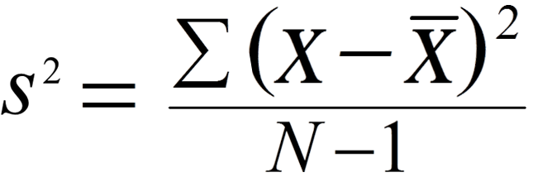

Step 2 = Subtract the mean from each value to find the difference

$1550-$1158.333 = $391.6667

$1700-$1158.333 = $541.6667

$900-$1158.333 = -$258.333

$850-$1158.333 = -$308.333

$1000-$1158.333 = -$158.333

$950-$1158.333 = -$208.333

Step 3 = Square the difference in Step 2

$391.6667 = $153402.8

$541.667 =$293402.8

-$258.333 = $66736.11

-$308.333 =$95069.44

-$158.333 = $25069.44

-$208.333 = $43402.78

Step 4 = Add all the squares in step 3 and divide by 5 = (6-1)

= ($153402.8+$$293402.8+$66736.11+$95069.44+$25069.44+$43402.78)/5 =$135416.7

Step 5 = Find the square root of the number in Step 4 = √$135416.7

Standard deviation = $367.99