1.​ Introduction

This assignment will help you to consolidate the concepts learnt in the session.

2.​ Problem Statement

Problem Statement 1:

Find the variance for the following set of data representing trees in California (heights in

feet):

3, 21, 98, 203, 17, 9

Note: Solution submitted via github must contain all the detailed steps.

**Solution**

**Variance formula**

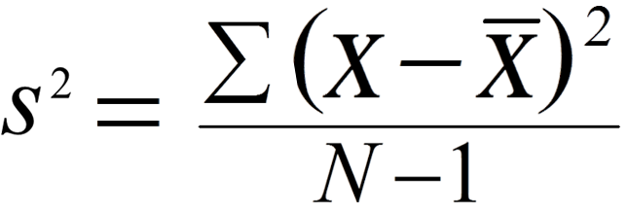

Step 1 = Calculation of Mean: (3+ 21+98+ 203+ 17+ 9)/6= 58.5

Step 2 = Subtract the mean from each value and square it:

( (3-58.5)^2+(21-58.5)^2+(98-58.5)^2+(17-58.5)^2+(9-58.5)^2)=31099.5

Step 3 = Divide the value of step 2 by 5 (N-1)= 6-1=5

Step 4 = Variance =31099.5/5 =6219.9