Week 6 Assignment
Customer Support Intent Classification
AI-Based Smart Queue & Time Management System | TECH 405
Bishwadeep Rai | Westcliff University, California | Professor Aashish Dhakal
Feed-forward Neural Network (MLP) vs. PyTorch LSTM

Executive summary
This classification experiment predicts the service intent of an incoming customer-support request, a practical request-routing component for the Smart Queue project. The executed notebook compares two distinct neural models on identical held-out data: a TF-IDF feed-forward MLP and a token-embedding recurrent LSTM. The target is the dataset's labeled intent.
By held-out macro F1, the stronger model in this run was Feed-forward MLP. Read the full metric table and figures below; macro scores weight each intent equally.

Dataset and ground truth
Dataset: Bitext Customer Service Tagged Training Dataset
Source-reported size is approximately 26,872 request/response examples. The loaded CSV contains 26,872 rows and 27 intent classes. The input is the customer's `instruction`; `intent` is the ground-truth class used for training and validation.
The source metadata declares CDLA-Sharing-1.0. Its dataset card identifies the corpus as hybrid synthetic data produced with NLP/NLG and automated labeling. These labels provide a reference target for this assignment, but they are not independently verified real-world queue outcomes. Review the linked license terms before redistributing source data.
Leakage controls: the response and correlated `category` field are excluded; the vocabulary/vectorizer is fitted only on training instructions; and train/validation/test records are mutually exclusive and stratified.
Partition | Examples
Training | 18,810
Validation | 4,031
Held-out test | 4,031

Models and evaluation method
Model 1 — Feed-forward MLP: training-only TF-IDF unigram/bigram features are passed through two ReLU dense layers (256 and 128 units), dropout, and a 27-class output. Sparse batches are densified only while training.
Model 2 — PyTorch LSTM: a training-only word vocabulary maps the request to token IDs; a 64-dimensional embedding feeds a 64-unit recurrent LSTM, dropout, and a 27-class output. Packed sequences prevent padding from being treated as request content.
Split: 18,810 train / 4,031 validation / 4,031 test, stratified with random seed 42. Validation macro F1 selects the checkpoint. The majority baseline predicts the most common training intent.
Precision, recall, and F1 are macro averages across intent classes. ROC-AUC is macro one-vs-rest multiclass AUC. The test set is used once for final reporting, not for model selection.

Held-out test results
Model | Accuracy | Precision  (macro) | Recall  (macro) | F1  (macro) | ROC-AUC  (OvR macro)
Majority baseline | 0.0372 | 0.0014 | 0.0370 | 0.0027 | N/A
Feed-forward MLP | 0.9943 | 0.9944 | 0.9943 | 0.9943 | 1.0000
PyTorch LSTM | 0.9888 | 0.9891 | 0.9888 | 0.9889 | 1.0000

Result snapshots
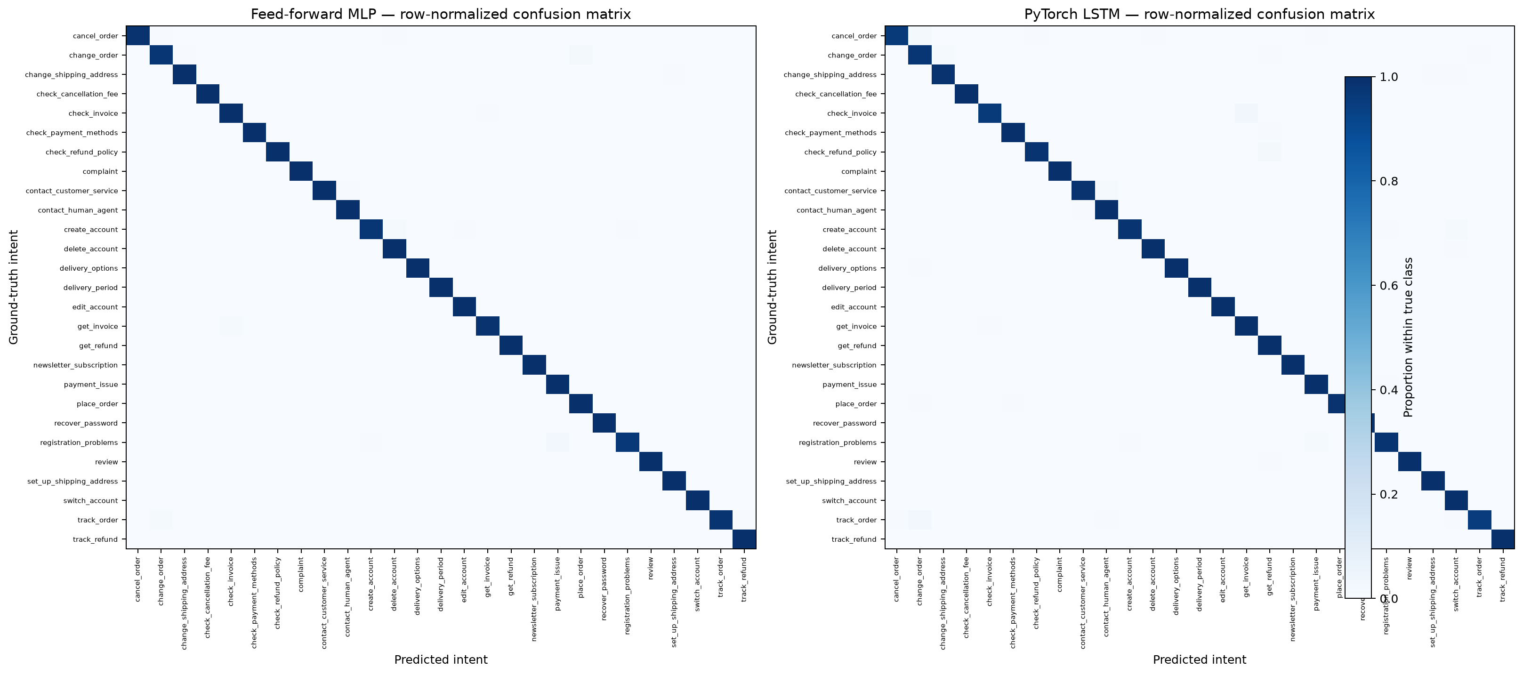
Figure 1. Row-normalized held-out confusion matrices.
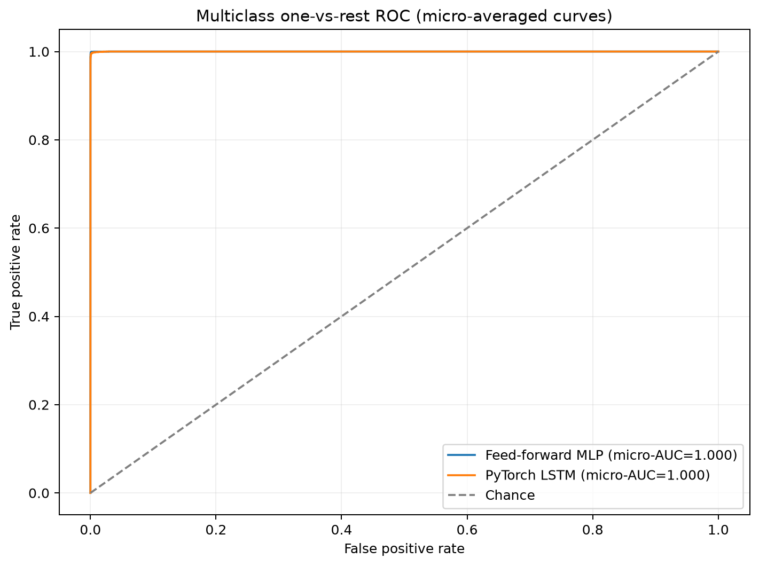
Figure 2. Micro-averaged one-vs-rest ROC curves.
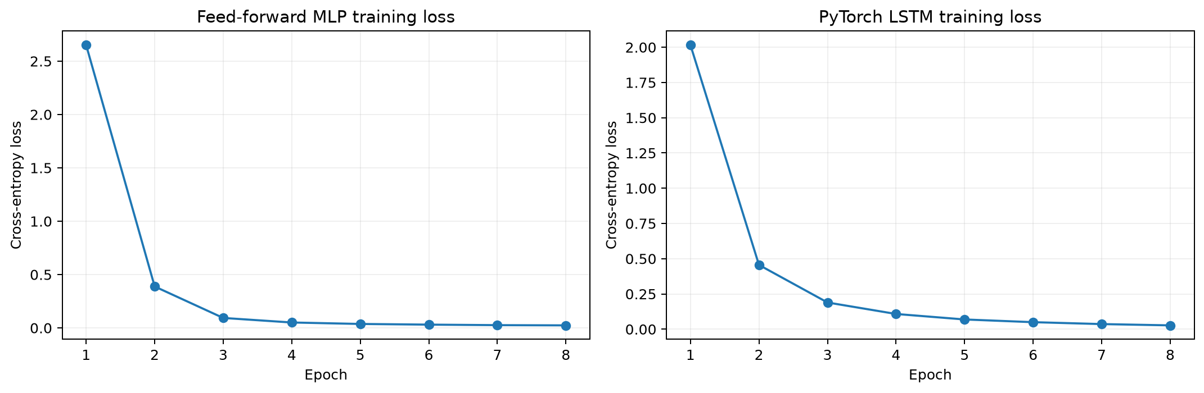
Figure 3. Training cross-entropy by epoch.

Critical code segments
1. The intent label is split before any trainable text transformation. This isolates final testing and fits vocabulary statistics on training text only:
train_idx, holdout_idx = train_test_split(
all_indices, test_size=0.30, random_state=SEED, stratify=y
)
valid_idx, test_idx = train_test_split(
holdout_idx, test_size=0.50, random_state=SEED,
stratify=y[holdout_idx]
)
X_train_tfidf = vectorizer.fit_transform(texts[train_idx])
X_test_tfidf = vectorizer.transform(texts[test_idx])
2. The LSTM processes only each request's real token sequence and maps the final hidden state to intent scores:
embedded = self.embedding(token_ids)
packed = pack_padded_sequence(
embedded, lengths.cpu(), batch_first=True, enforce_sorted=False
)
_, (hidden, _) = self.lstm(packed)
return self.output(self.dropout(hidden[-1]))

Comparison and conclusion
The MLP achieved the higher held-out macro F1 (0.9943); the difference between models was 0.0054. Consider precision/recall trade-offs and the per-intent confusion matrices before selecting a routing model. The baseline helps show whether either neural model is useful beyond predicting the most common class.
This result generalizes only to this fixed synthetic dataset split. Template reuse can make random held-out examples easier than truly new customer phrasing. A real queue deployment requires external validation on human-reviewed, representative requests, monitoring, privacy safeguards, and a safe human-escalation path.

Reproduction and publication
From the repository root, install the assignment dependencies and launch the notebook:
python -m pip install -r week6assignment/requirements.txt
jupyter notebook week6assignment/week6_customer_support_intent_classification.ipynb
python week6assignment/build_report.py
Course repository: BishwadeepRai/Smart-queue-Time-Management-system
Week 6 notebook permalink: week6_customer_support_intent_classification.ipynb
The assignment files must be pushed before the notebook permalink can be submitted as a public GitHub link. Do not add the downloaded data cache to the repository.

