Smart Queue & Time Management System
Project-Wide Week 7 Technical Report
Bishwadeep Rai
Westcliff University
TECH 405: Artificial Neural Network and Deep Learning
October 17, 2026

Abstract
This report documents the project's progression across Weeks 2, 4, 5, and 6. Weeks 2, 4, and 5 use a simulated call-centre queue dataset, moving from exploratory analysis of waiting time to two separate binary service-standard classification experiments. Week 6 is a distinct multiclass customer-support intent-routing experiment using the Bitext dataset. The report preserves these different prediction problems rather than presenting them as one model or one continuous target. It summarizes the datasets, exploratory analysis, preprocessing, model development, held-out evaluation, figures, and methodological limitations based on the project artifacts. The call-centre data is simulated, and the Week 6 data is synthetic/automatically labeled; none of the results establish operational readiness.

Project Scope and Problem Statements
The coursework evolves over several weekly submissions, but its later classification tasks are not interchangeable. Week 2 states the intended system objective as estimating queue waiting time (`wait_length`) to support wait-now-or-return decisions. Week 4 instead predicts whether a call meets the 60-second service standard, and Week 5 predicts the next call's same binary outcome from a recent sequence. Week 6 changes to routing customer text among 27 support intents. These are separately evaluated tasks with their own targets, split strategies, models, and results.
Stage | Dataset and target | Task / model
Week 2 | Simulated call-centre CSV; `wait_length` is the stated future target. | Exploratory analysis; no trained model in this notebook.
Week 4 | Same call-centre CSV; `meets_standard`. | Binary feed-forward neural-network classification.
Week 5 | Same call-centre CSV; next-call `meets_standard`. | Binary sequence classification with a PyTorch LSTM.
Week 6 | Bitext support requests; `intent`. | 27-class text classification with TF-IDF MLP and PyTorch LSTM.

Datasets and Provenance
Weeks 2, 4, and 5 use the repository's 51,708-row, nine-column `simulated_call_centre.csv` dataset. The Week 2 dataset card records 2021-01-01 through 2021-12-31, 261 Monday-to-Friday operating days, and identifies the data as generated by a discrete-event simulation. Source: https://www.kaggle.com/datasets/jpmiller/call-centre-queue-simulation. The CSV is shared within this repository.
Week 6 uses the Bitext Customer Service Tagged Training Dataset, with 26,872 labeled requests across 27 intents. Its documented source is https://huggingface.co/datasets/bitext/Bitext-customer-support-llm-chatbot-training-dataset. The raw file is downloaded to a local cache by the Week 6 workflow rather than stored in the repository.
Repository: https://github.com/BishwadeepRai/Smart-queue-Time-Management-system. Dataset source pages and repository links are recorded for reproducibility; redistribution remains subject to the respective dataset terms.

Exploratory Data Analysis
Week 2 audited data types, missingness, distributions, the target, and temporal patterns. The majority of records have zero waiting time, so `wait_length` is zero-inflated and right-skewed. The dataset is chronologically ordered and temporal patterns motivated respecting time order in the later call-centre experiments. For the classification target used in Weeks 4 and 5, 4,227 of 51,708 calls (8.17%) missed the standard, making class imbalance an important evaluation consideration.
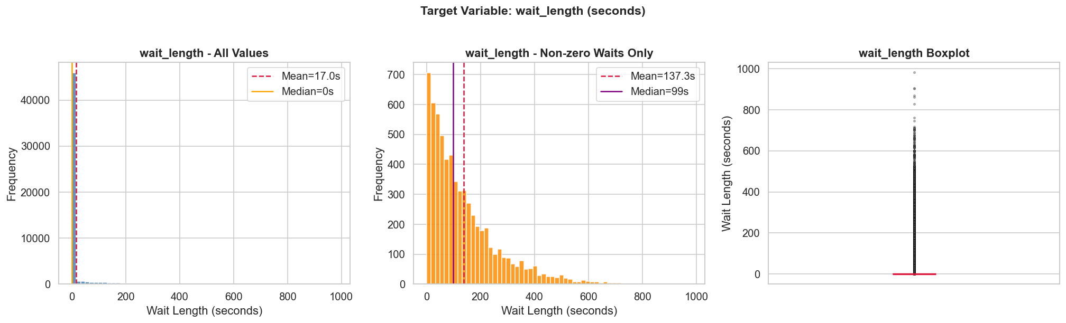
Week 2: call-centre target distribution as saved in the executed EDA notebook.
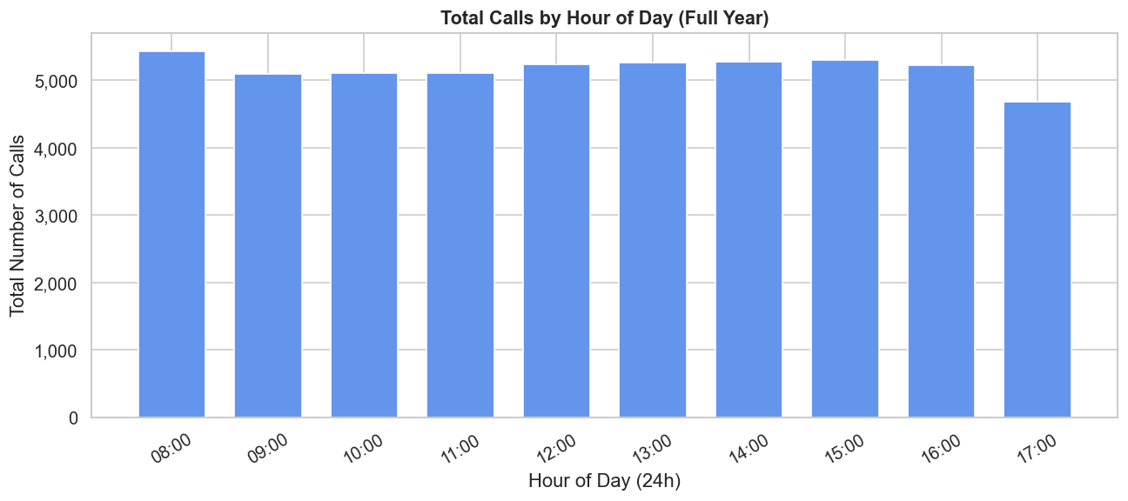
Week 2: temporal EDA figure from the executed notebook.
Week 4's recorded EDA includes class distribution, queue position by outcome, temporal service-standard rates, and feature correlations. Week 6's audit found no missing or blank values in its five source fields; intent counts range from 950 to 1,000 examples. Case- and whitespace-normalization identified 1,187 repeated-request groups (2,598 additional rows), and all normalized duplicates had consistent intent labels.
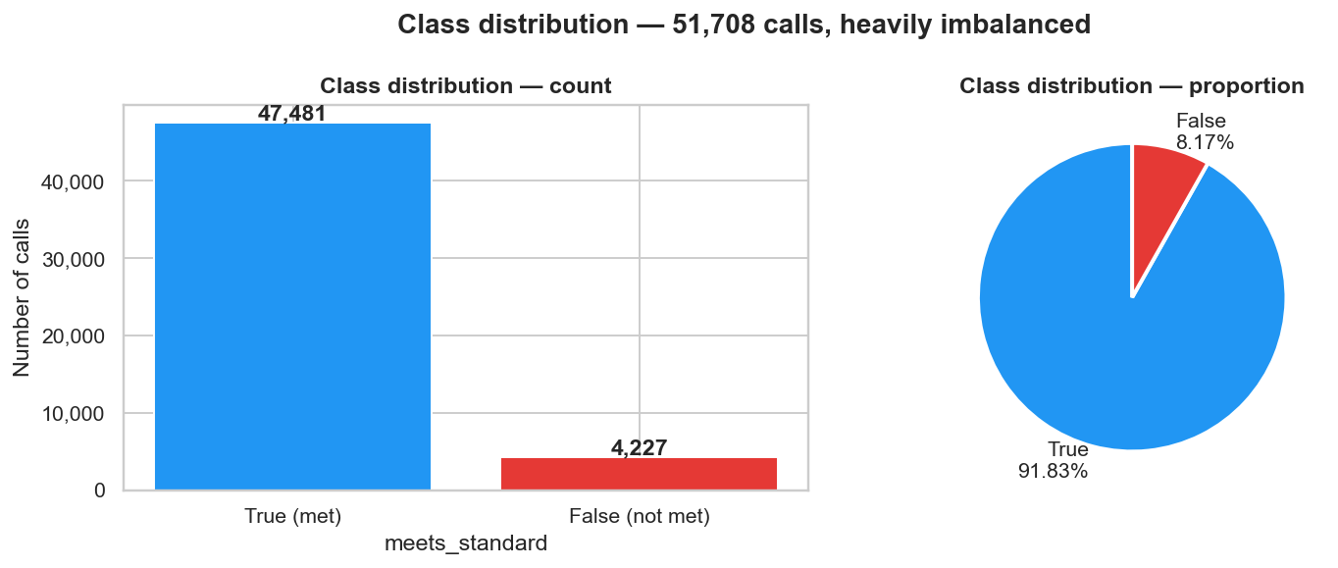
Week 4: imbalance in the binary service-standard outcome.
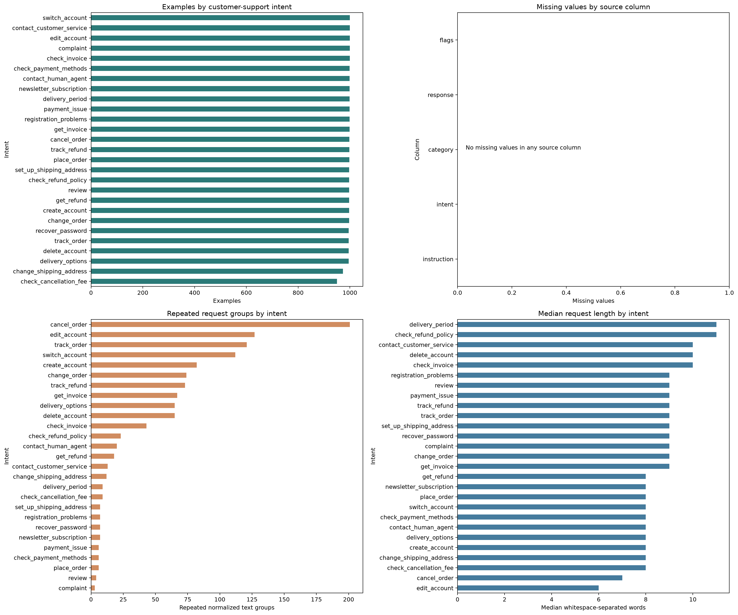
Week 6: intent-class counts and normalized duplicate-request analysis.

Model Development and Methodology

Week 4: Feed-Forward Neural Network
The binary target is `meets_standard` (False = missed, True = met). The runner sorts records by call start time and makes a chronological 70/15/15 train/validation/test split. Eight arrival/calendar features are used. `call_id`, `wait_length`, `call_answered`, `call_ended`, and `service_length` are excluded; in particular, `wait_length <= 60` determines the label and would directly leak the target. Four Keras feed-forward configurations are compared. The selected configuration is chosen on validation missed-class F1, then validation macro F1; the test set is used only for final metrics.
The selected run used hidden layers [64, 32], learning rate 0.001, batch size 32, and dropout 0.0. Training-set class weights address imbalance; the chronological test set is kept separate from model selection.
best = max(experiment_results, key=lambda r: (r["val_metrics"]["f1_false"], r["val_metrics"]["f1_macro"]))

Week 5: Sequential LSTM
The LSTM task uses the prior 20 calls within the same operating day to classify the next call. No sequence crosses a date boundary. A chronological future-period test is reserved; the scaler is fitted only on training-window features. The notebook compares six settings using validation balanced accuracy, followed by validation accuracy and loss. It uses a weighted binary loss to emphasize missed-standard examples. `wait_length` and fields known only after answering or finishing a call are excluded.
The validation-selected setting used hidden size 32, 1 LSTM layer, learning rate 0.001, dropout 0.0, and missed-class loss weight 8.0.
best_experiment_name = max(experiment_results, key=lambda name: (experiment_results[name]['validation_balanced_accuracy'], experiment_results[name]['best_val_accuracy'], -experiment_results[name]['best_val_loss']))
self.lstm = nn.LSTM(input_size=input_size, hidden_size=hidden_size, num_layers=num_layers, batch_first=True)
_, (hidden_state, _) = self.lstm(inputs)
last_hidden_state = hidden_state[-1]
logits = self.linear(self.dropout(last_hidden_state))
return logits.squeeze(-1)

Week 6: Duplicate-Aware Multiclass Intent Models
The input is the customer's `instruction`; the target is `intent` among 27 classes. Instructions are case-folded, whitespace-normalized, and grouped before a seeded, stratified 70/15/15 split. This keeps normalized duplicate requests from appearing in both train and held-out sets. The TF-IDF vocabulary is learned from training data only. The two existing neural models are a feed-forward MLP over TF-IDF features and a PyTorch LSTM over token sequences. Macro precision, recall, F1, one-vs-rest macro ROC-AUC, confusion matrices, and per-intent results are saved.
The TF-IDF representation uses unigrams and bigrams with a maximum vocabulary of 12,000 terms. The MLP has 256- and 128-unit hidden layers. The separate token LSTM uses a 64-dimensional embedding, 64-unit hidden state, and dropout 0.30.
normalized_instructions = (df["instruction"].astype(str).str.casefold().str.replace(r"\s+", " ", regex=True).str.strip())
train_groups, holdout_groups = train_test_split(
all_group_ids, test_size=0.30, random_state=SEED, stratify=group_y
)
valid_groups, test_groups = train_test_split(
holdout_groups, test_size=0.50, random_state=SEED,
stratify=group_y[holdout_groups]
)
X_train_tfidf = vectorizer.fit_transform(texts[train_idx])
X_valid_tfidf = vectorizer.transform(texts[valid_idx])
X_test_tfidf = vectorizer.transform(texts[test_idx])
self.network = nn.Sequential(
nn.Linear(input_size, 256), nn.ReLU(), nn.Dropout(0.35),
nn.Linear(256, 128), nn.ReLU(), nn.Dropout(0.25),
nn.Linear(128, number_of_classes),
)
return self.network(features)
self.embedding = nn.Embedding(vocab_size, embedding_size, padding_idx=0)
self.lstm = nn.LSTM(embedding_size, hidden_size, batch_first=True)
self.dropout = nn.Dropout(0.30)
self.output = nn.Linear(hidden_size, number_of_classes)
return self.output(self.dropout(hidden[-1]))
The code excerpts above represent the existing model-selection and duplicate-normalization logic; full implementations and execution details remain in the linked notebooks and experiment runner.

Held-Out Evaluation Results
Precision, recall, F1, and AUC are reported with macro averaging for class-comparable summaries. For the binary call-centre tasks, ROC-AUC is for the positive class `meets_standard=True`. Week 6 reports one-vs-rest macro ROC-AUC. The datasets, targets, and splits differ, so cross-stage scores should not be interpreted as a direct model competition.
Experiment | Accuracy | Macro precision | Macro recall | Macro F1 | ROC-AUC
Week 4 selected Exp 2 — Increased capacity | 0.3753 | 0.5159 | 0.5246 | 0.3635 | 0.54042
Week 5 selected LSTM | 0.7434 | 0.4939 | 0.4945 | 0.4938 | 0.48727
Week 6 TF-IDF MLP | 0.9921 | 0.9922 | 0.9922 | 0.9921 | 0.99996
Week 6 PyTorch LSTM | 0.9883 | 0.9885 | 0.9883 | 0.9883 | 0.99991

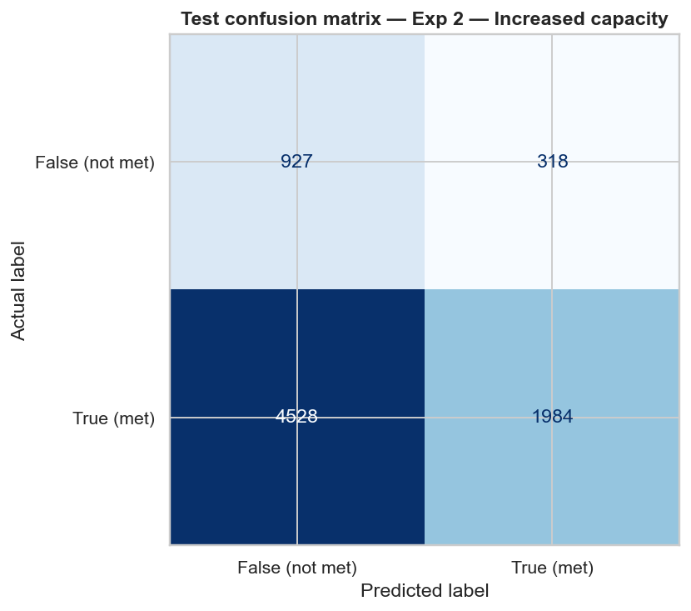
Week 4: selected model's chronological held-out confusion matrix.
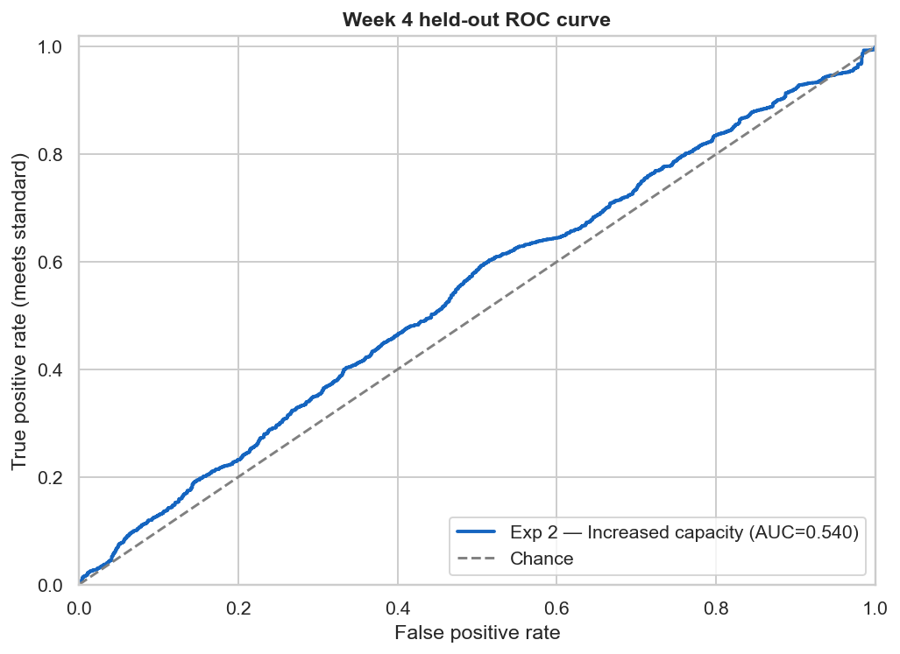
Week 4: ROC curve for the held-out positive class.
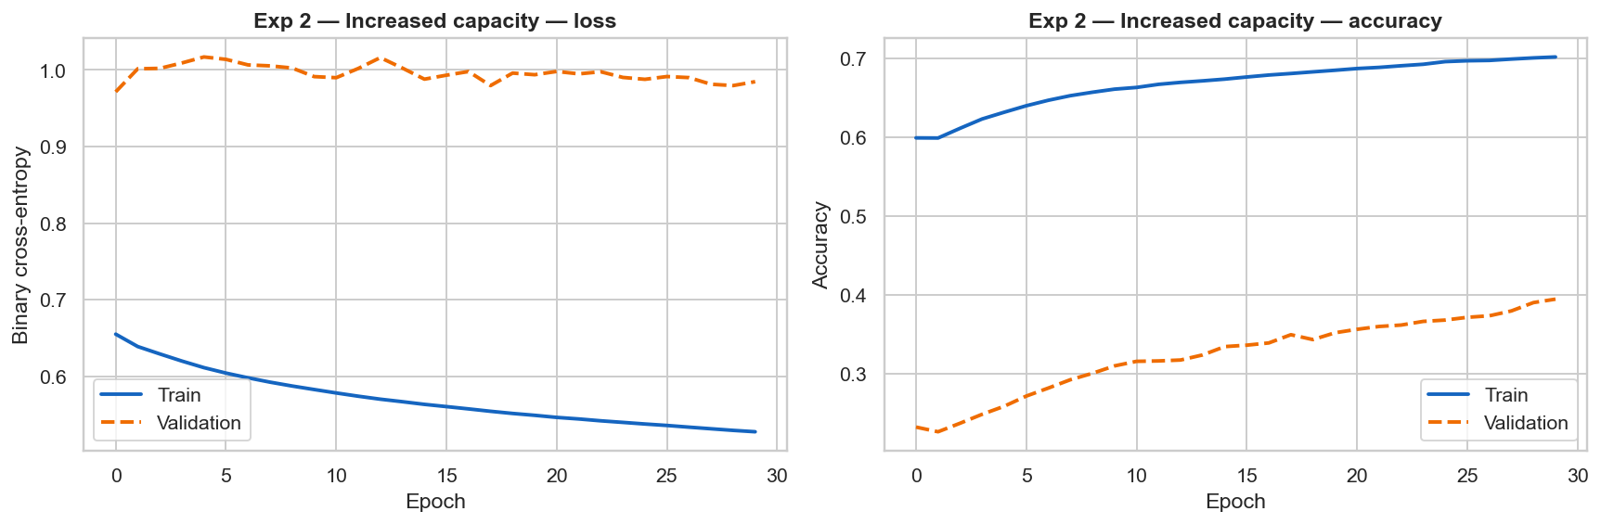
Week 4: selected capacity experiment's training and validation history.
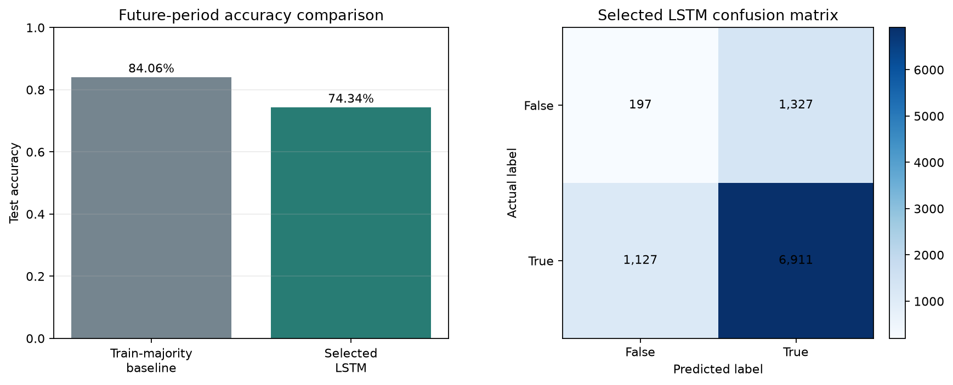
Week 5: future-period accuracy comparison and LSTM confusion matrix.
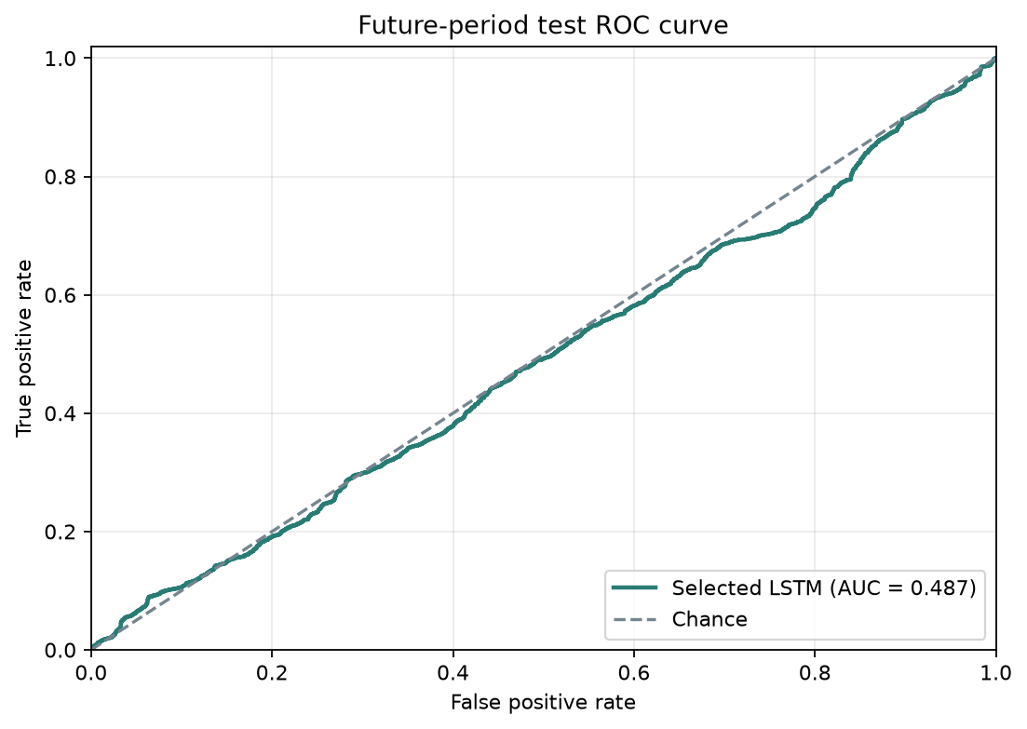
Week 5: ROC curve for the future-period test set.
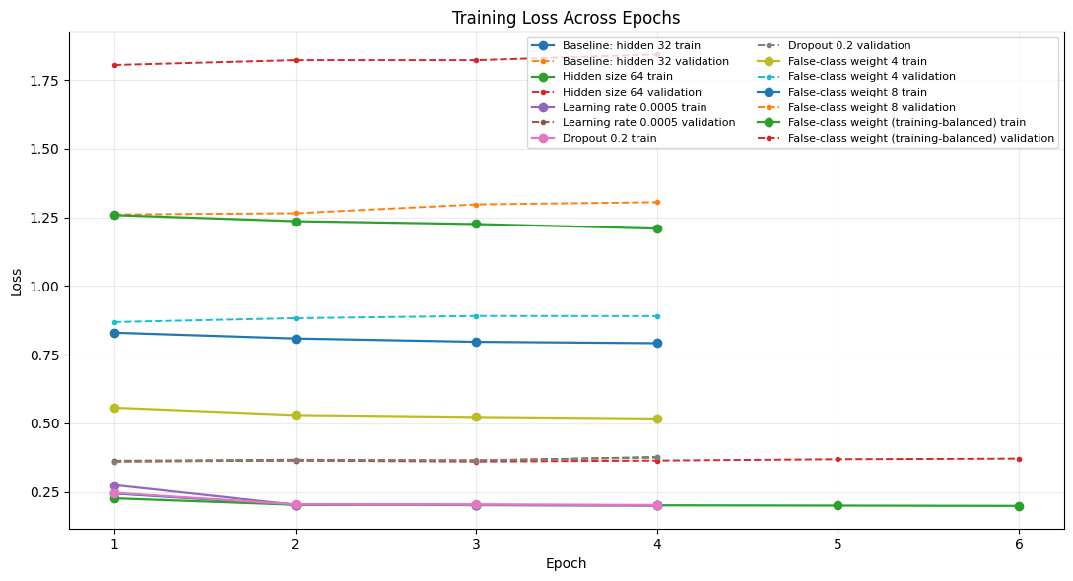
Week 5: training and validation loss histories for the compared LSTM configurations.
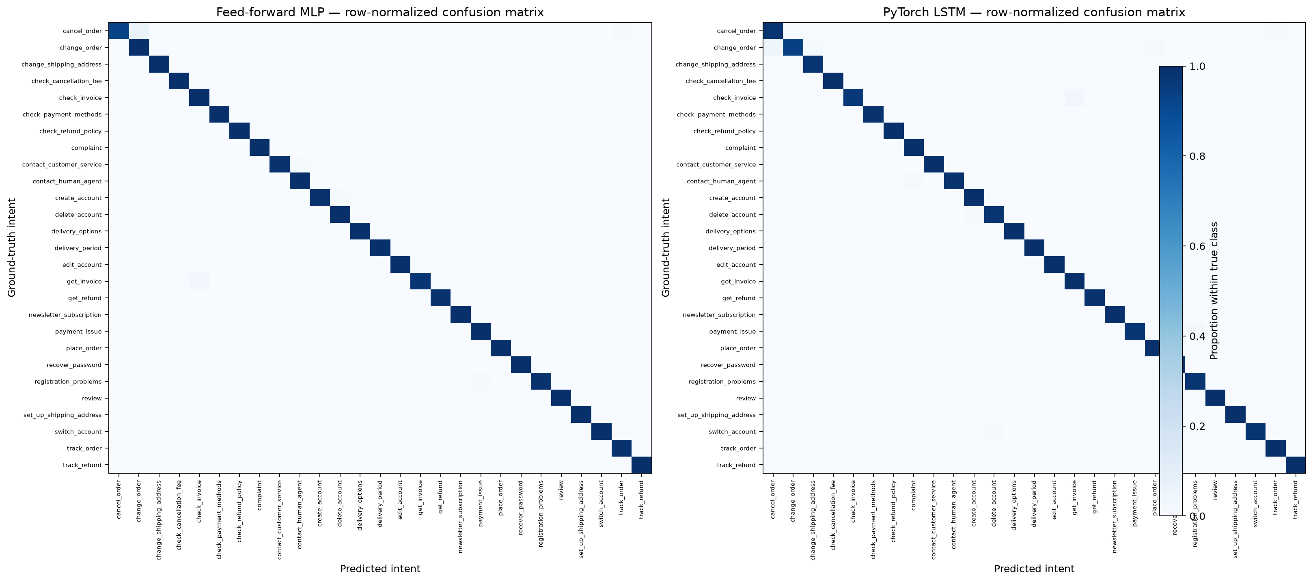
Week 6: held-out confusion matrices for the MLP and LSTM.
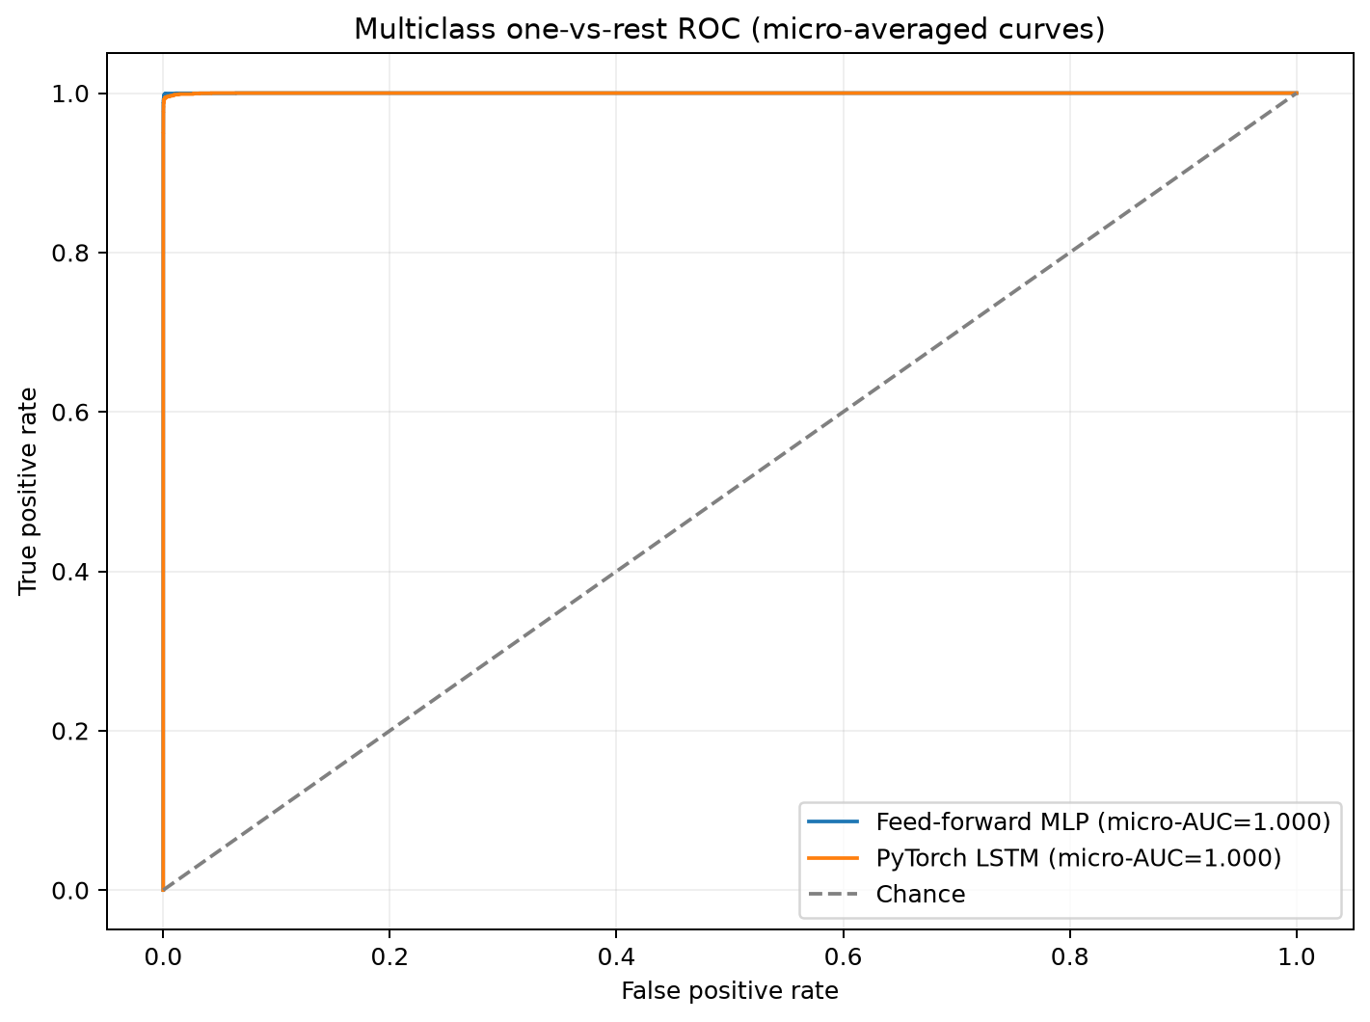
Week 6: one-vs-rest ROC curves across the 27 intent classes.

Performance Analysis and Limitations
Week 4's selected model (Exp 2 — Increased capacity) achieved 37.5% accuracy, macro F1 0.363, and positive-class ROC-AUC 0.540. For missed-standard calls, precision, recall, and F1 were 0.170, 0.745, and 0.277; for calls meeting the standard, these were 0.862, 0.305, and 0.450. The test period has a different missed-class prevalence from the training period, and its low accuracy and near-chance AUC indicate weak generalization; this should not be treated as an operational predictor.
Week 5's selected LSTM achieved 74.3% test accuracy versus 84.1% for the training-majority baseline and ROC-AUC 0.487. Its missed-standard precision, recall, and F1 were 0.149, 0.129, and 0.138. The model therefore did not beat the baseline accuracy and captured few missed-standard calls. This is a substantive negative finding, not a success claim.
Week 6's majority-class baseline accuracy was 0.033; the MLP achieved macro F1 0.992 and 0.988 (LSTM), with high one-vs-rest AUC. Those results are based on a duplicate-aware split, but remain specific to a synthetic, automatically labeled dataset. Similar templated language, dataset construction, and domain coverage can make these scores substantially more favorable than real deployment performance.
Further limitations include simulation-specific call patterns, temporal distribution shift, the use of a single held-out period in the call-centre experiments, and the absence of external validation. A future operational study would require realistic prospective data, calibration and threshold analysis, and monitoring of changing queue conditions. The Week 2 stated wait-time regression objective remains a distinct future model-development task; Weeks 4 and 5 do not evaluate regression error.

Reproducibility and Project Artifacts
The Week 4 experiment runner records seed 42 and writes its metrics and plots to `week 4/results.json` and `week 4/images/`. Week 5 records seed 42, selected settings, test metrics, confusion matrix, and classification report in `week 5/outputs/week5_results.json`; the notebook saves the evaluation figures in `week 5/images/`. Week 6 records its split metadata, metrics, confusion matrices, and per-intent results in `week 6/outputs/week6_results.json`. Run instructions and dependencies are maintained in the respective READMEs and requirements files.
To complete the previously missing Week 7 evaluation outputs, the existing Week 4 experiment runner and Week 5 notebook were executed without changing their dataset, target, split strategy, or model design; the runs generated the saved test AUC values, ROC plots, and machine-readable Week 5 results. Week 6 metrics are read from its existing duplicate-aware results artifact. The report presents the saved artifacts rather than estimating or fabricating scores.
GitHub repository: https://github.com/BishwadeepRai/Smart-queue-Time-Management-system
Call-centre dataset: https://www.kaggle.com/datasets/jpmiller/call-centre-queue-simulation
Bitext dataset: https://huggingface.co/datasets/bitext/Bitext-customer-support-llm-chatbot-training-dataset

