Routing Customer Requests by Intent:
A Technical Report on Duplicate-Aware Neural Model Evaluation
Bishwadeep Rai
Westcliff University
TECH 405: Artificial Neural Network and Deep Learning
Professor Aashish Dhakal
October 17, 2026

Abstract
This project studies whether an English customer-support instruction can be assigned to one of 27 service intents for downstream queue routing. The Bitext Customer Service Tagged Training Dataset contains 26,872 examples. A TF-IDF feed-forward multilayer perceptron (MLP) and a PyTorch long short-term memory (LSTM) network are compared with a majority-class baseline. An initial audit found repeated customer instructions, so case- and whitespace-normalized duplicates were grouped before a stratified 70/15/15 train/validation/test split. The preprocessing vocabulary is learned from training data only, and the test partition is reserved for final evaluation. The report documents the dataset, exploratory analysis, implementation pipeline, code excerpts, held-out metrics, and saved result figures. Results are specific to this synthetic, automatically labeled dataset and do not establish real-world customer-service performance.
Keywords: intent classification, neural networks, LSTM, TF-IDF, duplicate-aware evaluation

Problem Statement
The task is multiclass text classification: given only a customer's incoming request (`instruction`), predict its labeled service intent (`intent`) among 27 classes. The intended project use is to route a request to an appropriate service queue. This is not a prediction of waiting time, service duration, or whether a call meets a service-level target. The experiment compares an order-insensitive TF-IDF MLP with a sequence-based LSTM while holding the source dataset and evaluation partitions constant.

Dataset and Exploratory Data Analysis
Dataset: Bitext Customer Service Tagged Training Dataset, a hybrid synthetic customer-service corpus with automated labels (Bitext, n.d.). Hugging Face dataset page
The source contains 26,872 English requests and 27 intents. Each record also contains response/category/metadata fields, but only `instruction` is used as `X` and `intent` as `y`. The response is not available at routing time; the coarse `category` is a correlated label shortcut. The raw text source is downloaded from Hugging Face into a user cache and is not committed to the repository. The dataset metadata declares the CDLA-Sharing-1.0 license; its terms should be reviewed before redistribution.
The five dataset columns were checked for both null and blank values: flags: 0 null, 0 blank; instruction: 0 null, 0 blank; category: 0 null, 0 blank; intent: 0 null, 0 blank; response: 0 null, 0 blank. No rows required imputation or deletion. Intent counts range from 950 to 1,000 examples, so the source labels are near-balanced rather than dominated by a single class.
Request length averaged 8.69 whitespace-separated words (median 9; interquartile range 7–11; observed range 1–16). Median request length varied from 6 words for `edit_account` to 11 words for `check_refund_policy`. This is descriptive analysis and does not establish text length as a causal or sufficient predictor.
The EDA found 24,274 distinct case- and whitespace-normalized instruction groups. 1,187 groups contain repeated rows, representing 2,598 additional copies beyond the first occurrence of each request. Repeated normalized requests had consistent intent labels. This finding motivated the group-disjoint partitioning described below.
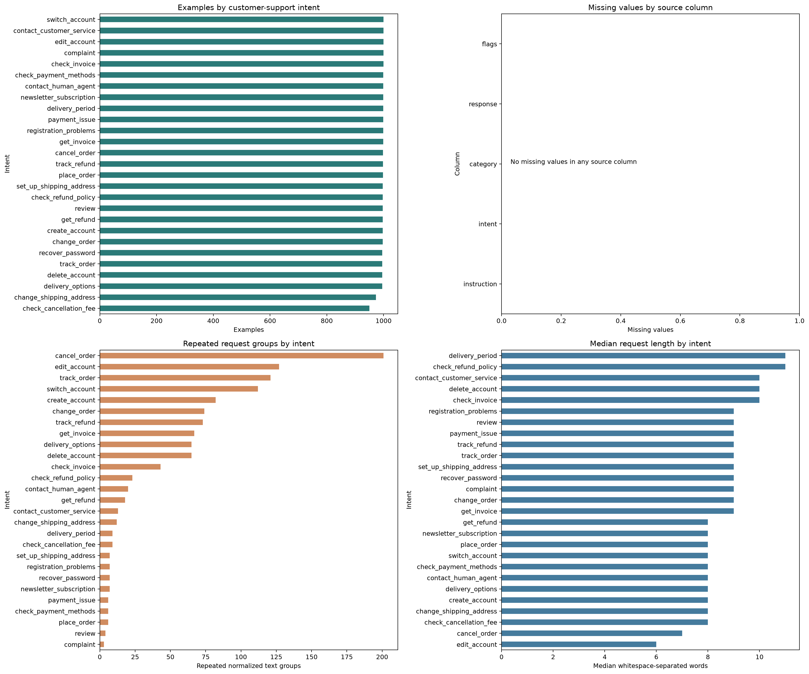
Figure 1. Four-panel EDA: intent counts, missing values, repeated normalized request groups, and median request length by intent.

Model Development Pipeline
The executed notebook follows these stages: (a) validate the required columns and non-empty input/target values; (b) normalize instruction case and whitespace for grouping; (c) stratify unique instruction groups by intent into development and held-out partitions; (d) split the development groups into training and validation; (e) fit each representation using training rows only; (f) select checkpoints using validation macro F1; and (g) evaluate each selected model once on the same held-out test rows.
The split is stratified at the normalized-request-group level and is implemented as a 70% training / 30% holdout split followed by an even validation/test split of the holdout. Each normalized request group belongs to exactly one partition. Since duplicate groups have different sizes, percentages of original rows are approximate; all 27 classes are present in each partition.
Partition | Rows | Request groups | Share of rows
Training | 18,831 | 16,991 | 70.08%
Validation | 4,010 | 3,641 | 14.92%
Held-out test | 4,031 | 3,642 | 15.00%

The normalized grouping is an exact-text control after case-folding and collapsing whitespace. It does not group paraphrases or all semantically similar templates; those forms of near-duplicate overlap were not measured and remain a limitation.

Important Implementation Excerpts
The following excerpts are taken directly from the executed notebook and show the duplicate-aware split and the training-only feature fit.

Normalized request grouping and stratified split
normalized_instructions = (
df["instruction"].astype(str).str.casefold().str.replace(r"\s+", " ", regex=True).str.strip()
)
instruction_groups, unique_instructions = pd.factorize(normalized_instructions, sort=False)
group_summary = (
df.assign(instruction_group=instruction_groups)
.groupby("instruction_group", sort=False)
.agg(intent=("intent", "first"), label_count=("intent", "nunique"), rows=("intent", "size"))
)
if (group_summary["label_count"] != 1).any():
raise ValueError("A normalized customer instruction maps to multiple intent labels.")
all_group_ids = np.arange(len(unique_instructions))
train_groups, holdout_groups = train_test_split(
all_group_ids, test_size=0.30, random_state=SEED, stratify=group_y
)
valid_groups, test_groups = train_test_split(
holdout_groups, test_size=0.50, random_state=SEED, stratify=group_y[holdout_groups]
)
train_idx = np.flatnonzero(np.isin(instruction_groups, train_groups))
valid_idx = np.flatnonzero(np.isin(instruction_groups, valid_groups))
test_idx = np.flatnonzero(np.isin(instruction_groups, test_groups))
y_train, y_valid, y_test = y[train_idx], y[valid_idx], y[test_idx]

Training-only TF-IDF representation
vectorizer = TfidfVectorizer(
lowercase=True, ngram_range=(1, 2), max_features=12_000,
min_df=2, sublinear_tf=True, dtype=np.float32
)
X_train_tfidf = vectorizer.fit_transform(texts[train_idx])
X_valid_tfidf = vectorizer.transform(texts[valid_idx])
X_test_tfidf = vectorizer.transform(texts[test_idx])
print(f"Training-only TF-IDF vocabulary: {X_train_tfidf.shape[1]:,} features")

Recurrent model architecture
class IntentLSTM(nn.Module):
def __init__(self, vocab_size, number_of_classes, embedding_size=64, hidden_size=64):
super().__init__()
self.embedding = nn.Embedding(vocab_size, embedding_size, padding_idx=0)
self.lstm = nn.LSTM(embedding_size, hidden_size, batch_first=True)
self.dropout = nn.Dropout(0.30)
self.output = nn.Linear(hidden_size, number_of_classes)
def forward(self, token_ids, lengths):
embedded = self.embedding(token_ids)
packed = pack_padded_sequence(
embedded, lengths.cpu(), batch_first=True, enforce_sorted=False
)
_, (hidden, _) = self.lstm(packed)
return self.output(self.dropout(hidden[-1]))

Models and Training Procedure
The majority baseline always predicts the most frequent training intent. The feed-forward MLP uses lowercased TF-IDF unigrams and bigrams, two ReLU hidden layers (256 and 128 units), dropout (0.35 and 0.25), and a 27-class output. It is optimized with Adam (learning rate .001, weight decay .0001) and cross-entropy. The vocabulary is fitted only on training instructions; sparse batches are densified for the network.
The PyTorch LSTM uses a training-only token vocabulary, sequences truncated/padded to 48 tokens, a 64-dimensional embedding, a 64-unit LSTM, 0.30 dropout, and a 27-class output. It is optimized with Adam (learning rate .001) and cross-entropy. Both neural models select the checkpoint with the highest validation macro F1; test data is not used for model or epoch selection.
Model | Input representation | Architecture | Selection
Feed-forward MLP | Training-only TF-IDF unigrams/bigrams | 256 → 128 ReLU; dropout; 27 outputs | Validation macro F1; best epoch 4
PyTorch LSTM | Training-only token IDs; max length 48 | 64-d embedding; 64-unit LSTM; dropout; 27 outputs | Validation macro F1; best epoch 8

Model Evaluation and Performance Analysis
The table reports held-out accuracy and macro-averaged precision, recall, F1, and one-vs-rest ROC-AUC. Macro averages give each intent equal weight. The baseline ROC-AUC is not calculated because it produces constant class predictions.
Model | Accuracy | Macro precision | Macro recall | Macro F1 | Macro OVR AUC
Majority baseline | 0.0335 | 0.0012 | 0.0370 | 0.0024 | Not calculated
Feed-forward MLP | 0.9921 | 0.9922 | 0.9922 | 0.9921 | 1.0000
PyTorch LSTM | 0.9883 | 0.9885 | 0.9883 | 0.9883 | 0.9999

On this held-out partition, the Feed-forward MLP has the higher macro F1 (0.9921 versus 0.9883). The MLP misclassified 32 of 4,031 test rows, and the LSTM misclassified 47. The majority baseline is included as a reference floor, not as a competitive model.
The five lowest per-intent MLP F1 values on this test run were: cancel_order (0.954, n=158); change_order (0.968, n=151); check_invoice (0.979, n=144); get_invoice (0.983, n=147); track_order (0.985, n=135). This class-level view complements the macro average.
Figure 3 plots micro-averaged one-vs-rest ROC curves, whereas the table reports macro one-vs-rest ROC-AUC. These are different averaging conventions and are labeled separately. The ROC-AUC values near one indicate strong ranking on this dataset split; they do not remove the synthetic-data or duplicate-similarity limitations.

Visual Results and Training Evidence
The following figures are the actual PNG outputs saved by the executed notebook. They provide visual evidence of the held-out confusion matrices, ROC curves, and training-loss histories.
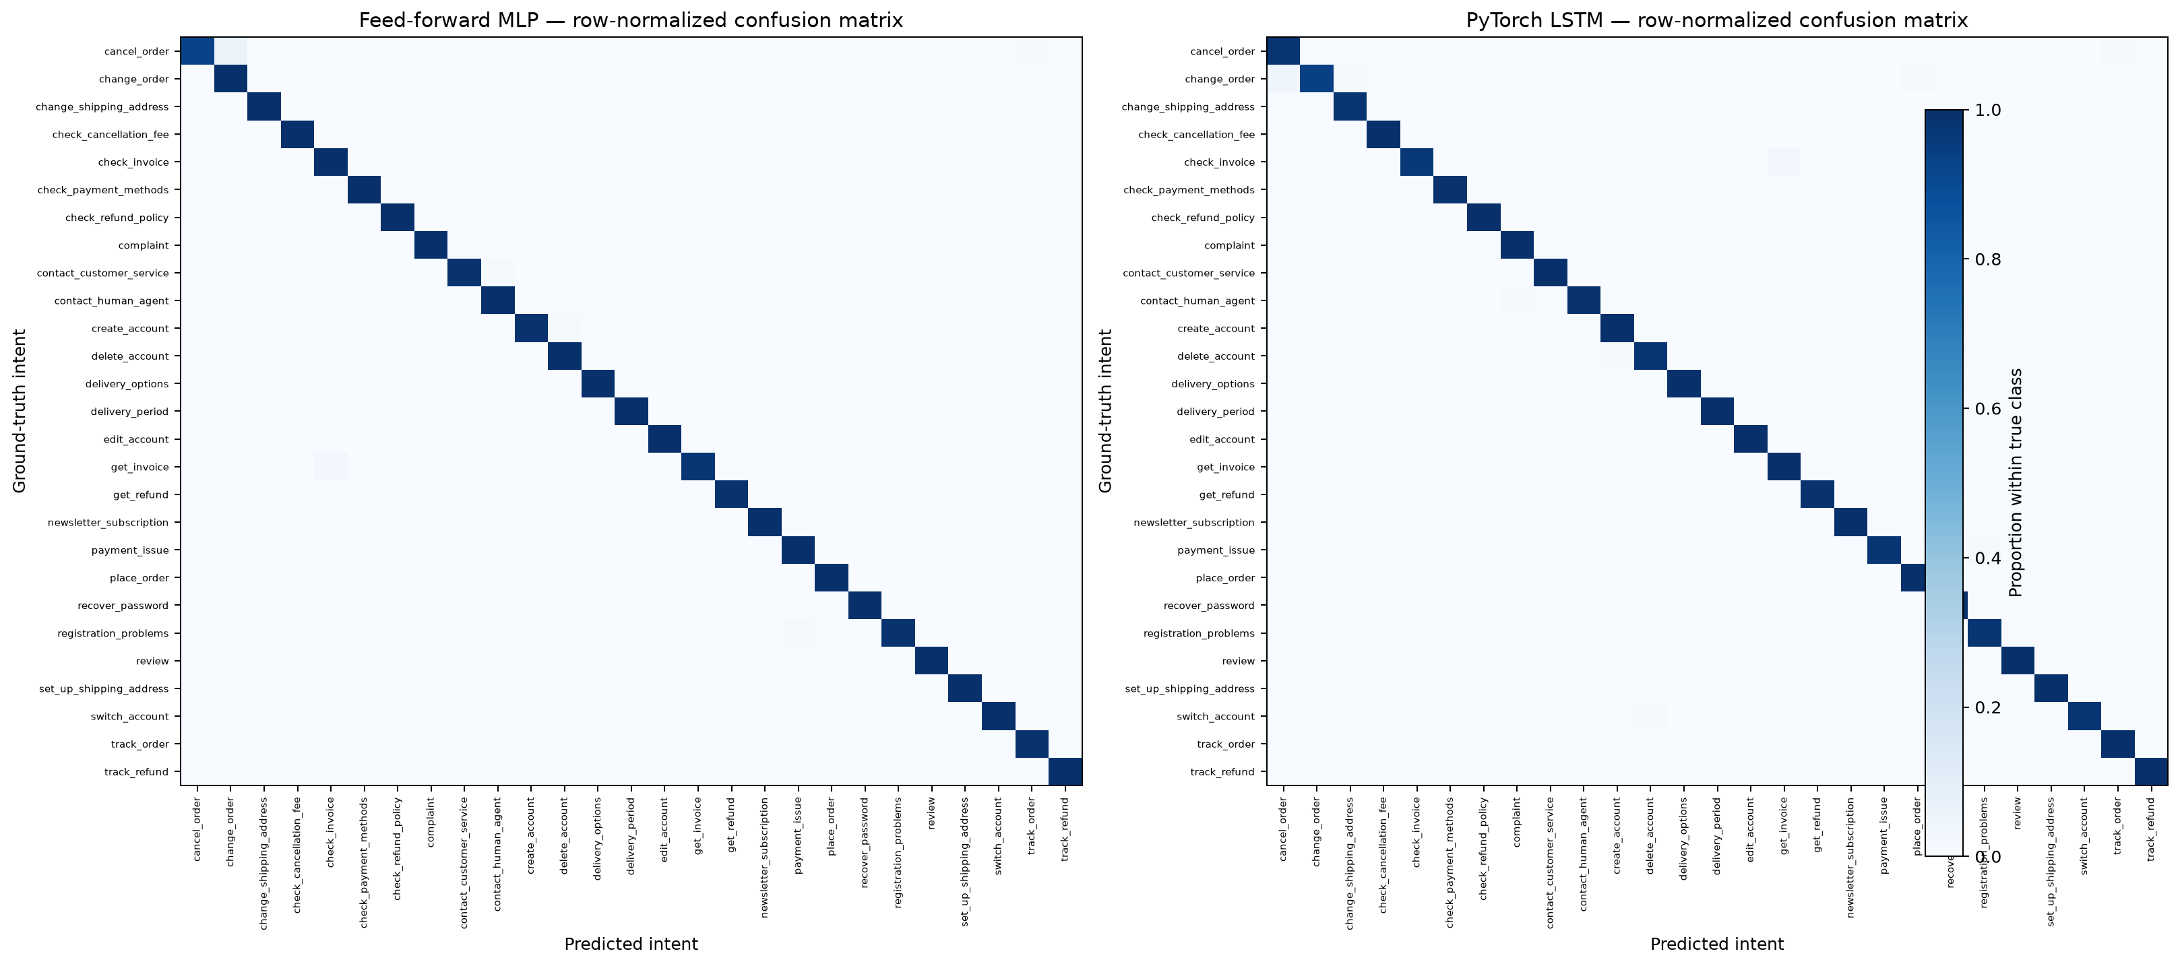
Figure 2. Row-normalized MLP and LSTM confusion matrices on the held-out test partition.
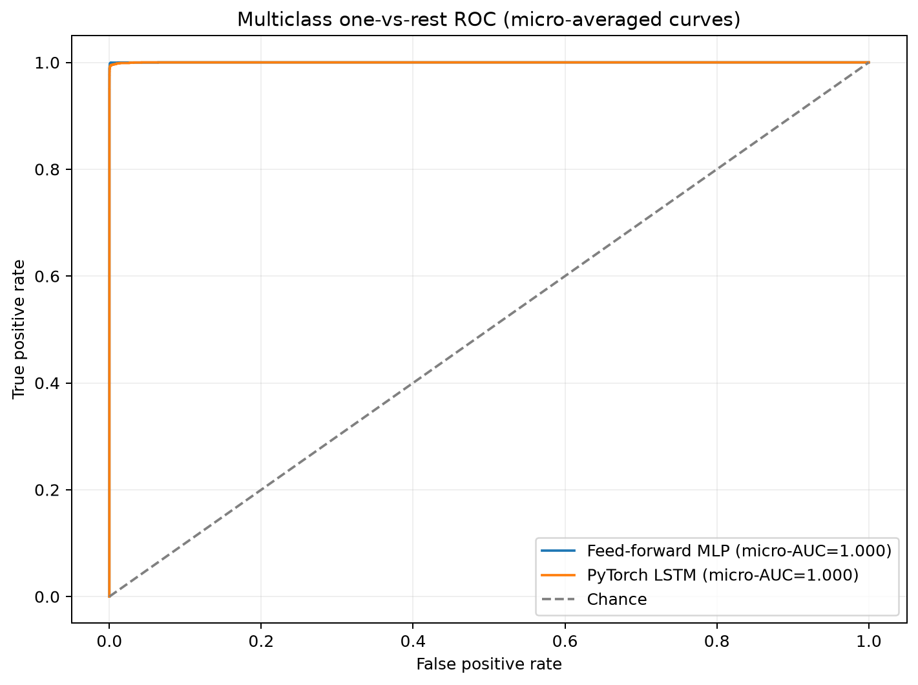
Figure 3. Micro-averaged one-vs-rest ROC curves on the held-out test partition.
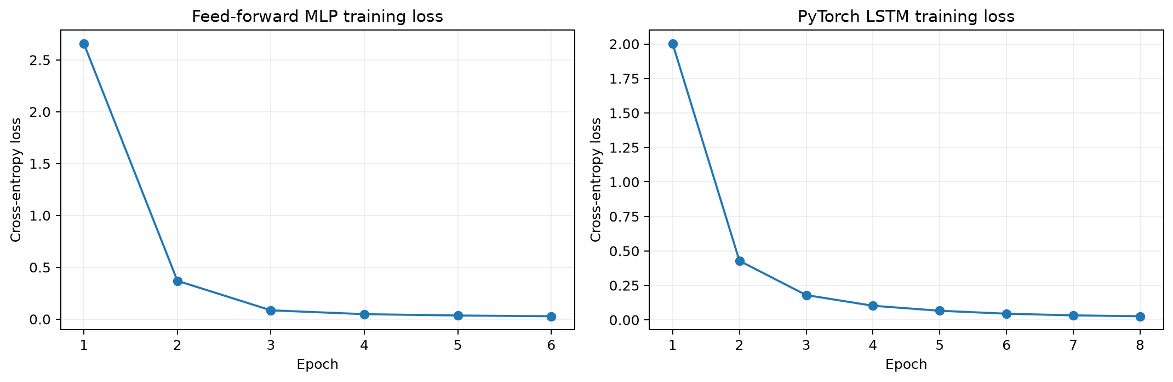
Figure 4. Training cross-entropy loss by epoch for the MLP and LSTM.
Validation macro F1 selected epoch 4 of 6 for the MLP and epoch 8 of 8 for the LSTM. The saved loss plots show training loss; validation macro-F1 histories are retained in the JSON results.

Limitations and Conclusion
The source dataset is synthetic/hybrid and automatically labeled. A stratified group split prevents the same case- and whitespace-normalized request from appearing in multiple partitions, but does not rule out overlap among paraphrases or generated templates. The test results therefore measure performance on this held-out portion of the source corpus, not on independently collected customer traffic. No operational claims about routing accuracy, queue performance, or service quality should be inferred without external validation.
The project preserves the existing Bitext dataset, 27-intent target, TF-IDF MLP, and PyTorch LSTM. It corrects the evaluation procedure for repeated request text, records the resulting test metrics, and provides the analysis and visual evidence needed to interpret the models.

Repository and Reproducibility
GitHub repository: https://github.com/BishwadeepRai/Smart-queue-Time-Management-system
The executed notebook, saved metrics, report builder, and figure PNGs are in the repository's `week 6/` directory. From the repository root, install the Week 6 requirements and open the notebook with that folder as the working directory. Re-running the notebook downloads the published dataset if it is not already present in the user's cache, trains both models, and regenerates the figures and JSON metrics.
To rebuild this report after executing the notebook, run `python "week 6/build_week7_report.py"` from the repository root.

References
Bitext. (n.d.). *Bitext customer support LLM chatbot training dataset* [Data set]. Hugging Face. https://huggingface.co/datasets/bitext/Bitext-customer-support-llm-chatbot-training-dataset
Fawcett, T. (2006). An introduction to ROC analysis. *Pattern Recognition Letters, 27*(8), 861–874. https://doi.org/10.1016/j.patrec.2005.10.010
Hochreiter, S., & Schmidhuber, J. (1997). Long short-term memory. *Neural Computation, 9*(8), 1735–1780. https://doi.org/10.1162/neco.1997.9.8.1735
Salton, G., & Buckley, C. (1988). Term-weighting approaches in automatic text retrieval. *Information Processing & Management, 24*(5), 513–523. https://doi.org/10.1016/0306-4573(88)90021-0
Sokolova, M., & Lapalme, G. (2009). A systematic analysis of performance measures for classification tasks. *Information Processing & Management, 45*(4), 427–437. https://doi.org/10.1016/j.ipm.2009.03.002

