**2 stroke engine cycle:**



In two-stroke engines, there is **one** power stroke **every revolution.**

The two-stroke cycle eliminates the separate induction and exhaust strokes, so that between the expansion and compression processes, a scavenging process occurs.

**1 . The compression stroke (Fig. 2.2a).**

* The piston travels up the cylinder, compressing the

trapped charge.

* If the fuel is not pre-mixed, the fuel is injected toward the end of the

compression stroke(in case of 2 stroke CI engine).

* ignition should again occur before top dead center.
* Simultaneously, the underside of the piston is drawing in a charge through a reed valve.

2. **The power stroke.**

* The burning mixture raises the temperature and pressure in the cylinder

and forces the piston downward.

* The downward motion of the piston also compresses the charge in the crankcase.
* As the piston approaches the end of its stroke, the exhaust port is uncovered (Fig. 2.2b), and blow-down occurs.
* When the piston is even closer to bottom dead center (Fig. 2.2c), the transfer port also is uncovered, and the compressed charge in the crankcase expands into the cylinder.
* As the piston travels up the cylinder, first the transfer port is

closed by the piston, and then the exhaust port is closed.

**4 stroke engine cycle:**

In four stroke engines, there is **one power stroke every two revolution**. The four-stroke cycle sometimes is summarized as "suck, squeeze, bang, and blow."

1. **The induction stroke.** The inlet valve is open, and the piston travels down the cylinder, drawing in a charge of air. In the case of a spark ignition engine, the fuel usually is premixed with the air.
2. **The compression stroke.** Both valves are closed, and the piston travels up the cylinder. In the case of compression ignition engines, the fuel is injected toward the end of the compression stroke. As the piston approaches top dead center (tdc), ignition occurs either by means of a spark or by auto-ignition.
3. **The expansion, power, or working stroke.** Combustion propagates throughout the charge, raising the pressure and temperature, and forcing the piston downward. At the end of the power stroke, as the piston approaches bottom dead center (bdc), the exhaust valve opens.
4. **The exhaust stroke.** The exhaust valve remains open, and the piston travels up the cylinder and expels most of the remaining gases. At the end of the exhaust stroke, when the exhaust valve closes, some exhaust gas residuals will remain. These will dilute the next charge.

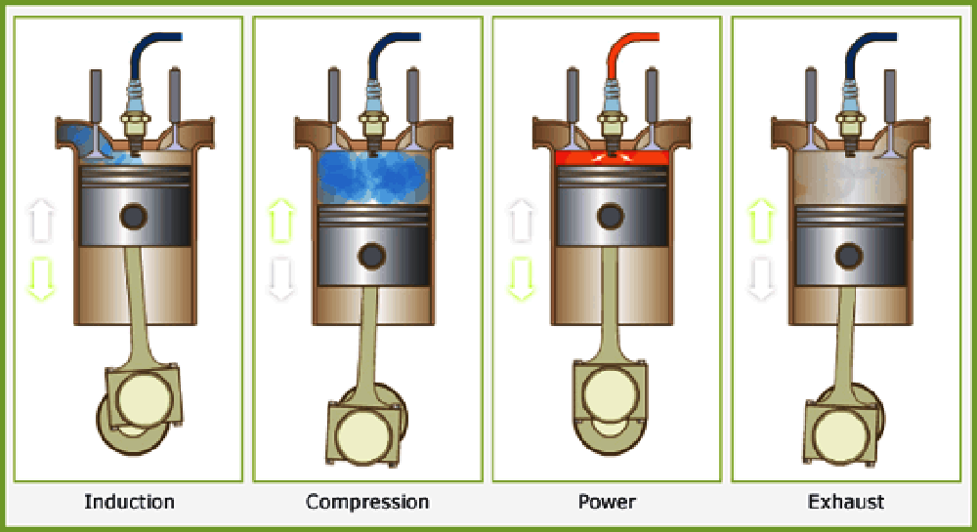

References:

* Google
* Automotive Engineering Fundamentals; by Richard Stone and Jeffrey K. Ball