**EIGRP:**

Enhanced Interior Gateway Routing Protocol (EIGRP) is a network protocol that enables routers to exchange information more efficiently than earlier network protocols, such as Interior Gateway Routing Protocol (IGRP) or Border Gateway Protocol (BGP).

Enhanced Interior Gateway Routing Protocol (EIGRP) is a dynamic routing protocol that is used to find the best path between any two-layer 3 devices to deliver the packet. EIGRP works on network layer Protocol of OSI model and uses protocol number 88. It uses metrics to find out the best path between two layer 3 devices (router or layer 3 switches) operating EIGRP.

**Network Design:**

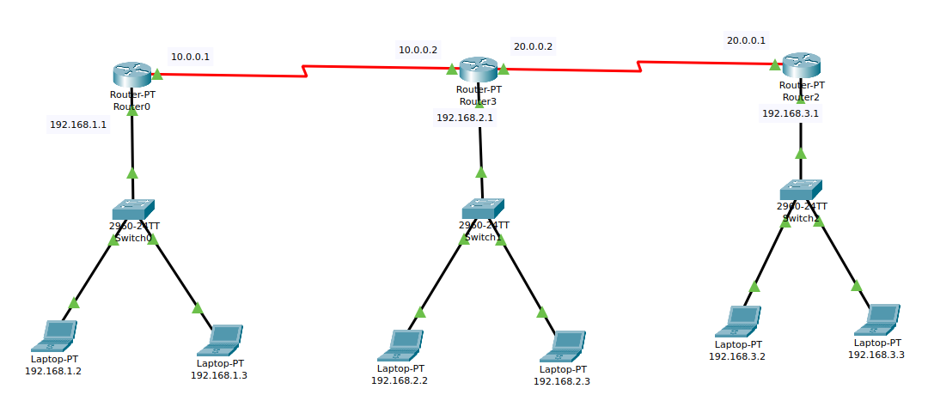

**Configuration Step :**

1. Assign IP address and subnet mask to each PC’s of the network
2. Configure each router using router’s command-line interface (CLI)
3. Firstly configure the router’s for the interface networks
4. Then configure the router’s for the EIGRP network configuration
5. We verify the route with show ip route to ensure it's active and correctly set up.

PC IP configuration

|  |  |  |  |
| --- | --- | --- | --- |
| Device | IP | Subnet Mask | Default gateway |
| Laptop 1 | 192.168.1.2 | 255.255.255.0 | 192.168.1.0 |
| Laptop 2 | 192.168.1.3 | 255.255.255.0 | 192.168.1.0 |
| Laptop 3 | 192.168.2.2 | 255.255.255.0 | 192.168.2.0 |
| Laptop 4 | 192.168.2.3 | 255.255.255.0 | 192.168.2.0 |
| Laptop 5 | 192.168.3.2 | 255.255.255.0 | 192.168.3.0 |
| Laptop 6 | 192.168.3.3 | 255.255.255.0 | 192.168.3.0 |

**Router Configuration Command :**

**router 0**

en

conf t

int fa0/0

ip add 192.168.1.1 255.255.255.0

no shut

int se2/0

ip add 10.0.0.1 255.0.0.0

no shut

exit

router EIGRP 1

network 10.0.0.0

network 192.168.1.0

exit

**router 1**

en

conf t

int fa0/0

ip add 192.168.2.1 255.255.255.0

no shut

int se2/0

ip add 10.0.0.2 255.0.0.0

no shut

int se3/0

ip add 20.0.0.2 255.0.0.0

no shut

exit

router EIGRP 1

network 10.0.0.0

network 20.0.0.0

network 192.168.2.0

exit

**router 2**

en

conf t

int fa0/0

ip add 192.168.3.1 255.255.255.0

no shut

int se2/0

ip add 20.0.0.1 255.0.0.0

no shut

exit

router EIGRP 1

network 20.0.0.0

network 192.168.3.0

exit

**Output:**

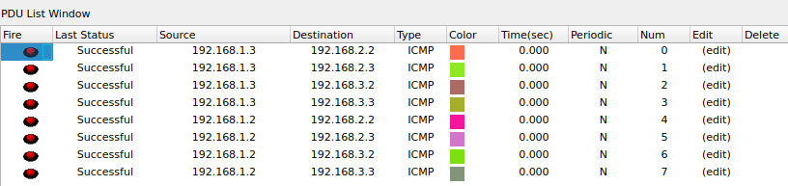

**Packet Tracer File :**