**University Campus Network**

### Submitted By

|  |  |
| --- | --- |
| **Student Name** | **Student ID** |
| Bishwajit Chakraborty | 0242220005101414 |
| Arafat. | 0242220005101415 |
| Md. Shah Alam | 0242220005101409 |

**MINI LAB PROJECT REPORT**

This Report Presented in Partial Fulfillment of the course **CSE314:**

**Computer Networks Lab in Computer Science and Engineering**

**Department**



### DAFFODIL INTERNATIONAL UNIVERSITY

**Dhaka, Bangladesh**

**December 14, 2024**

## DECLARATION

We hereby declare that this lab project has been done by us under the supervision of **Z N M Zarif Mahmud, Lecturer**, Department of Computer Science and Engineering, Daffodil International University. We also declare that neither this project nor any part of this project has been submitted elsewhere as lab projects.

**Submitted To:**

**Z N M Zarif Mahmud**

**Lecturer**

Department of Computer Science and Engineering Daffodil International University

**Submitted by**

|  |  |
| --- | --- |
| Bishwajit Chakraborty ID:0242220005101414  Dept. of CSE, DIU | |
| Arafat.  ID:0242220005101415  Dept. of CSE, DIU | Md.Shah Alam ID:0242220005101409  Dept. of CSE, DIU |

## COURSE & PROGRAM OUTCOME

The following course have course outcomes as following:.

Table 1: Course Outcome Statements

|  |  |
| --- | --- |
| **CO’s** | **Statements** |
| CO1 | Able to identify the fundamental technologies for the hardware and software of the  internet and their addressing mechanism. |
| CO2 | Able to analyze the conceptual and implementation aspects of network applications and its use in most of the application, Transport and Data link layer protocols for  implementing enterprise network for different organization. |
| CO3 | Able to apply the knowledge of basic binary system to solve sub-netting problems and can identify and make evaluation on the underlying principles of routing algorithms and its related protocols being applied to the Internet. |
| CO4 | Able to describe the components, services, principle and protocol provided in wireless network and can categorized between different wireless architecture. |

Table 2: Mapping of CO, PO, Blooms, KP and CEP

|  |  |  |  |  |
| --- | --- | --- | --- | --- |
| **CO** | **PO** | **Blooms** | **KP** | **CEP** |
| CO1 | PO1 | C1, C2 | KP3 | EP1, EP3 |
| CO2 | PO2 | C2 | KP3 | EP1, EP3 |
| CO3 | PO3 | C4, A1 | KP3 | EP1, EP2 |
| CO4 | PO3 | C3, C6, A3,  P3 | KP4 | EP1, EP3 |

The mapping justification of this table is provided in section **4.3.1**, **4.3.2** and **4.3.3**.

# Table of Contents

**Declaration** **i**

Course & Program Outcome ii

1. Introduction 1
   1. Introduction 1
   2. Motivation 1
   3. Objectives 1
   4. Feasibility Study 1
   5. Gap Analysis 2
   6. Project Outcome 2
2. Proposed Methodology/Architecture 3
   1. Requirement Analysis & Design Specification 3
      1. Overview 3
      2. Proposed Methodology/ System Design 3
      3. UI Design 4
   2. Overall Project Plan 4
3. Implementation and Results 5
   1. Implementation 5
   2. Performance Analysis 5
   3. Results and Discussion 6
4. Engineering Standards and Mapping 9
   1. Impact on Society, Environment and Sustainability 9
      1. Impact on Life 9
      2. Impact on Society & Environment 9
      3. Ethical Aspects 9
      4. Sustainability Plan 9
   2. Project Management and Team Work 9
   3. Complex Engineering Problem 9
      1. Mapping of Program Outcome 10
      2. Complex Problem Solving 10
      3. Engineering Activities 11

Table of Contents Table of Contents

1. Conclusion 13
   1. Summary 13
   2. Limitation 13
   3. Future Work 13

References 14

**Chapter 1**

# Introduction

**This part will cover Problem statement, motivation, objectives, feasibility, gap analysis, an**

**expected outcomes etc.**

### Introduction

The following project involves the design and implementation of a robust and efficient network infrastructure for a university campus, using Cisco Packet Tracer. This involves the scaling up of a secure, high-performance network that will be able to handle different university academic, administrative, and operational requirements. The network will have integrated routing, switching, wireless access, and network security, enabling easy connectivity and communication on campus.

### Motivation

It is the increasing dependence on digital media for teaching, research, and administration that gave rise to the need for a secure and up-to-date campus network. Apart from hampering productivity, network downtime, insufficient bandwidth, and security vulnerabilities work against the general user experience. This project was informed by the need to address such challenges and further develop a network that will serve both technological growth and improvement in the learning environment for students and staff.

### Objectives

* To design a scalable network topology that would suit the current and future needs of the university.
* The use of secure and efficient routing and switching protocols shall be done.
* To implement seamless wireless connectivity across campuses.
* The security of the network shall be ensured via firewalls, VLANs, and access control mechanisms.
* For speedy internet and low latency, network performance shall be optimized.
* Network monitoring integration for proactive maintenance/troubleshooting.

### Feasibility Study

The feasibility study evaluates the technical, economic, and operational viability of the project:

**Technical Feasibility:** Cisco Packet Tracer is available for simulation and access to the required networking knowledge and resources.

**Economic Feasibility:** Cost-effectiveness of using simulation tools to test the network design before actual implementation, reducing potential waste.

**Operational Feasibility:** Whether the proposed network design can meet the operational demands like high user-density, rich application requirements of the university

### Gap Analysis

A detailed gap analysis of the current network infrastructure in most university campuses reveals a number of deficiencies. This includes:

* Lack of redundancy, failover mechanisms to common failure conditions - regular downtime
* Inadequate wireless coverage in strategic areas, negatively impacting user mobility
* Older-generation network equipment and protocols leading to poor performance.
* Poor security practices, leaving the network open to cyber threats.
* Poor bandwidth distribution resulting in congestion at peak times.

The project will fill these gaps with advanced networking solutions and best practices using Cisco Packet Tracer.

### Project Outcome

The successful implementation of this project will bring the following:

* A scalable, efficient network infrastructure designed specifically for university needs.
* Reliable, high uptime network due to redundancy and failover mechanisms.
* Seamless wireless connectivity across all campus zones.
* Enhanced security to handle cyber threats effectively in the network.
* Optimized academic and research-related activities, as well as administrative activities, through better network performance.
* One comprehensive simulation model for future training and upgrades.

**Chapter 2**

# Proposed Methodology/Architecture

**This part will includes System design, requirement analysis, and design specifications etc.**

### Requirement Analysis & Design Specification

#### Overview

#### From the requirement analysis, critical needs were established concerning the university network infrastructure, such as high-speed access to the internet, security measures, wireless connectivity, and scalability for future expansion. It describes the details necessary to specify the various component/configurations that are necessary for meeting these requirements, as will be simulated using Cisco Packet Tracer to verify.

#### Proposed Methodology/ System Design

The design shall be supported by the following system designs:

**Network Topology**: A hierarchical design that includes core, distribution, and access layers for efficient traffic management.

**Routing and Switching:** Dynamic routing protocols such as OSPF and VLANs will be implemented to segment the network and enhance performance.

**Wireless Access Points:** Access points will be installed to provide wireless connectivity throughout the campus.

**Security Features:** Firewalls, ACLs, and encryption protocols will be integrated to secure the network.

#### UI Design

#### The UI design focuses on network monitoring and management interfaces that provide administrators with intuitive tools for real-time performance tracking, configuration, and troubleshooting.

### Overall Project Plan

### The project plan consists of the following phases:

### Requirement Gathering: Data collection based on network needs and constraints.

### Design and Simulation: Designing the network and testing it on Cisco Packet Tracer.

### Implementation: Network infrastructure rollout based on the approved design.

### Testing and Validation: Performance and security benchmarking of the network.

### Maintenance and Documentation: Giving guidelines for ongoing support and upgrades in the future.

### Img: Project Diagram and Structure

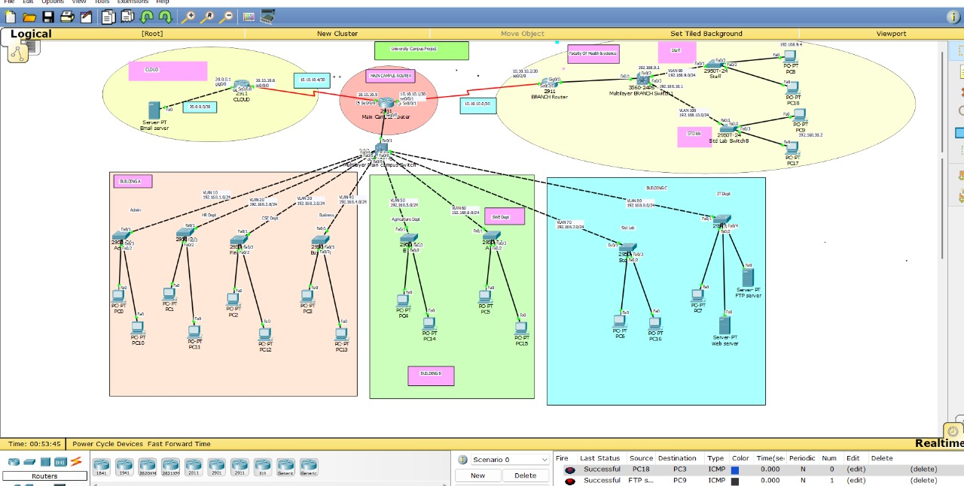

**Chapter 3**

# Implementation and Results

Every chapter should start with 1-2 sentences on the outline of the chapter.

### Implementation

### This involves the actual implementation of the network, using the approved design. Configuration of routers, switches, and wireless access points in Cisco Packet Tracer will be done, along with implementing security features like firewalls, VLANs, and ACLs in order to secure the network.



### Let’s go through the console code:

### **For Branch campus Router:**

### en

### conf t

### int gig0/0

### no shut

### int se0/2/0

### no shut

### do wr

### **StdLab Switch :**

### en

### conf t

### int range fa0/1-24

### switchport mode access

### switchport access vlan 90

### do wr

### **Staff Switch:**

### en

### conf t

### int range fa0/1-24

### switchport mode access

### switchport access vlan 100

### do wr

### **MultylYER SWICTH:**

### en

### conf t

### int fa0/2

### switchport mode access

### switchport access vlan 90

### do wr

### en

### conf t

### int range fa0/3

### switchport mode access

### switchport access vlan 100

### do wr

### **Switch to switch trunk:**

### int fa0/1

### switchport trunk encapsulation dot1q

### switchport mode trunk

### exit

### do wr

### **creating a sub interface**

### **first click router**

### int se0/2/0

### ip add 10.10.10.2 255.255.255.252

### exit

### **Router er interface se0/2/0 to VLAN 90 or 100 for response**

### int gig0/0.90

### encapsulation dot1Q 90

### ip add 192.168.9.1 255.255.255.0

### exit

### int gig0/0.100

### encapsulation dot1Q 100

### ip add 192.168.10.1 255.255.255.0

### exit

### **Now connecting DHCP server**

### service dhcp

### ip dhcp pool staff-pool

### network 192.168.9.0 255.255.255.0

### default-router 192.168.9.1

### dns-server 192.168.9.1

### exi**t**

### ip dhcp pool stdlab-pool

### network 192.168.10.0 255.255.255.0

### default-router 192.168.10.1

### dns-server 192.168.10.1

### exit

### **Rip version 2**

### en

### conf t

### router rip

### version 2

### network 192.168.9.0

### network 192.168.10.0

### network 10.10.10.0

### exit

### **For Cloud Router:**

### en

### conf t

### int gig0/0

### no shut

### int se0/0/0

### no shut

### do wr

### **for cloud**

### en

### conf t

### int se0/0/0

### ip add 10.10.10.6 255.255.255.252

### exit

### int gig0/0

### ip add 20.0.0.1 255.255.255.252

### exit

### router rip

### version 2

### network 20.0.0.0

### network 10.10.10.4

### exit

### Performance Analysis

### Performance analysis will involve the testing of the network on reliability, speed, and security. Key metrics will include throughput, latency, and packet loss that will be evaluated using simulation tools such as Cisco Packet Tracer. Additionally, it will be determined if the network is capable of supporting high user density and diverse application requirements.

### Results and Discussion

### The results will summarize the performance of the network against the set objectives. Discussions will emphasize strengths in the design, problems during implementation, and areas for potential improvement. This section will also cover the scalability and future adaptability of the network.

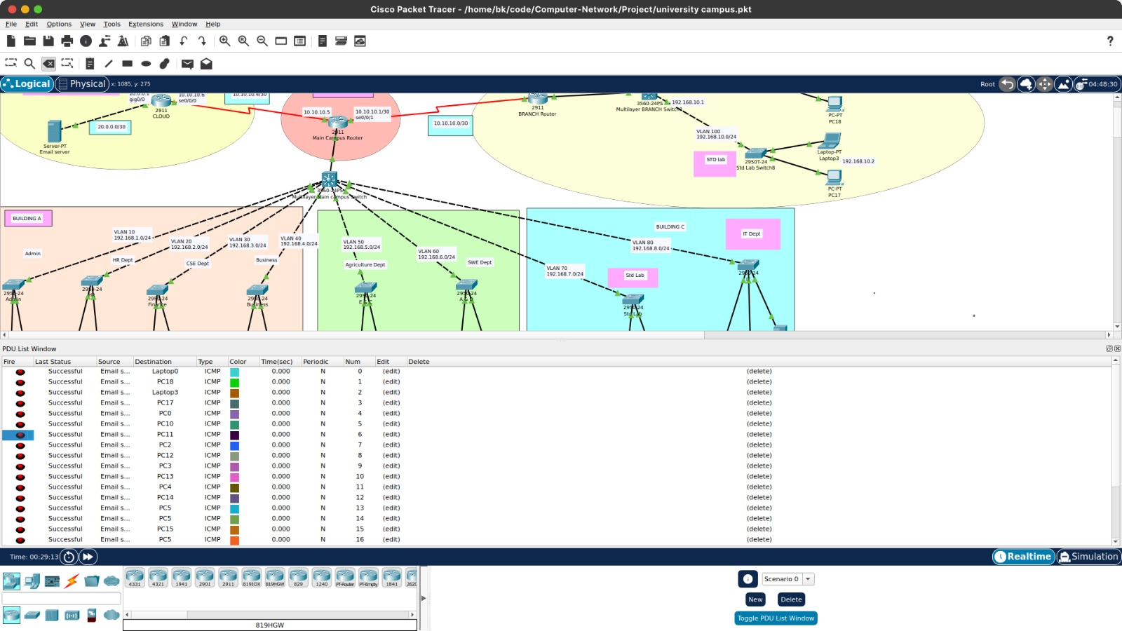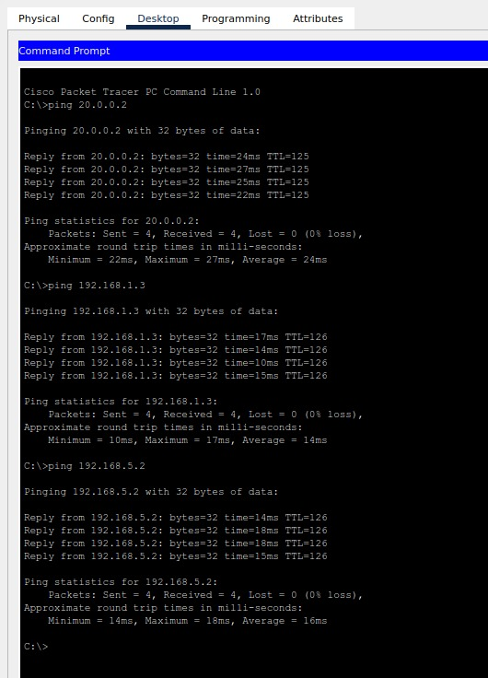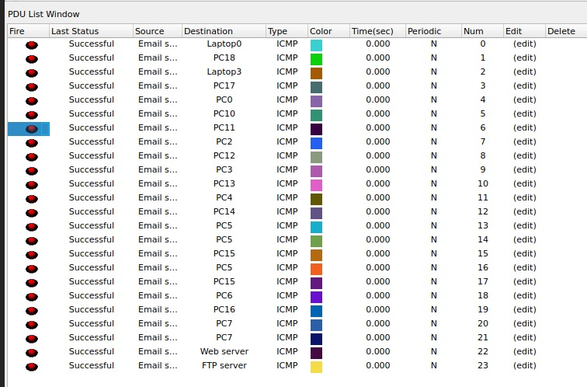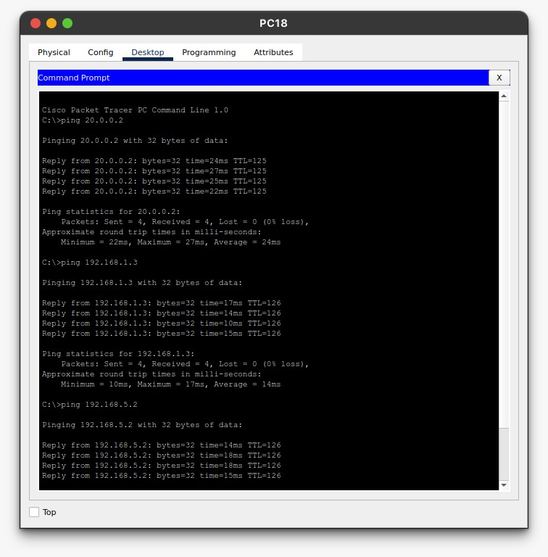

**Chapter 4**

# Engineering Standards and Mapping

**This part included social, environmental, and ethical impacts.**

### Impact on Society, Environment and Sustainability

### A modern campus network will improve the quality of education and research by facilitating fast and reliable access to online resources. Students and staff will have better connectivity, which will make communication and collaboration easier and faster. This will lead to a more interactive and dynamic learning environment.

#### Impact on Life

#### A modern campus network will improve the quality of education and research by facilitating fast and reliable access to online resources. Students and staff will have better connectivity, which will make communication and collaboration easier and faster. This will lead to a more interactive and dynamic learning environment.

#### Impact on Society & Environment

#### The project advocates for digital inclusion in terms of access to information and technology by all members of the university community. Environmentally, the design of the network incorporates energy-efficient devices and configurations to minimize power consumption, reducing the campus's carbon footprint.

#### Ethical Aspects

#### The project ensures the ethical use of technology by considering robust security measures that can protect the users' privacy and data. Fair principles are also ensured to provide equal access to all network resources.

#### Sustainability Plan

#### The sustainability plan is designed to maintain regular upkeep and updates that will ensure the network remains functional, safe, and secure. Scalability for the future is planned by using a flexible infrastructure that can adjust to new technologies and increased users without major overhauls. Training programs for the IT staff ensure the long-term sustainability of the network.

#### \

### Project Management and Team Work

Provide a cost analysis in terms of budget required and revenue model. In case of budget, you must show an alternate budget and rationales.

### Complex Engineering Problem

### The project addressed complex engineering problems such as managing inter-VLAN communication, routing between branches, and optimizing network resources.

#### Mapping of Program Outcome

#### The project maps to the following program outcomes:

Table 4.1: Justification of Program Outcomes

|  |  |
| --- | --- |
| **PO’s** | **Justification** |
| PO1 | The project utilizes engineering principles to design a functional and efficient university campus layout that meets infrastructural requirements. |
| PO2 | Addressed challenges like space optimization, infrastructure accessibility, and sustainability through systematic analysis and solutions. |
| PO3 | Designed an effective campus infrastructure that includes classrooms, labs, and facilities while considering user requirements, environmental impact, and aesthetics. |

#### Complex Problem Solving

This project solves complex networking problems by integrating multiple concepts, including inter VLAN routing, DHCP configuration, and multibranch connectivity using RIP.

Chapter 4. Engineering Standards and Mapping 4.3. Complex Engineering Problem

Knowledge profile and rational thereof.

Table 4.2: Mapping with complex problem solving.

|  |  |  |  |  |  |  |
| --- | --- | --- | --- | --- | --- | --- |
| **EP1**  Dept of Knowledge | **EP2**  Range of Conflicting Requirement | **EP3**  Depth of Analysis | **EP4**  Familiarity of Issues | **EP5**  Extent of Applicable Codes | **EP6**  Extent  Of Stakeholder Involvement | **EP7**  Inter- dependence |
| Applied networking concepts like VLAN, DHCP, and RIP to design an optimized and scalable campus network. | Resolved conflicting needs such as network performance, security, and resource allocation through proper VLAN segmentation and IP address management. | Conducted detailed analysis of network traffic flow and IP management to ensure efficient communication and reduced congestion. | Addressed challenges like IP conflicts, security vulnerabilities, and data loss by implementing DHCP for dynamic allocation and RIP for routing optimization. | Followed industry standards and protocols (IEEE 802.1Q for VLANs, RFCs for DHCP and RIP) to ensure compliance and reliability. | Collaborated with stakeholders like IT staff, faculty, and students to identify network requirements and test performance. | Ensured seamless integration between VLANs, DHCP servers, and RIP routing to create a cohesive, efficient, and secure campus network system. |

#### Engineering Activities

This subsection outlines the core engineering activities involved in the project, including:

Table 4.3: Mapping with complex engineering activities.

|  |  |  |  |  |
| --- | --- | --- | --- | --- |
| **EA1**  Range of resources | **EA2**  Level of Interaction | **EA3**  Innovation | **EA4**  Consequences for society and  environment | **EA5**  Familiarity |
| Configuring VLAN, DHCP, and RIP in a university campus network requires diverse resources, including physical devices (switches, routers, servers), software (network configuration tools), and human expertise (network engineers). | These technologies involve significant interaction between hardware, software, and users. VLANs require proper switch configurations and coordination with DHCP servers to ensure IP management. RIP interacts dynamically with routers for routing table updates. | Implementing VLAN, DHCP, and RIP together represents an innovative approach to designing a cost-effective, efficient, and scalable network for a university campus. | The proper use of these protocols ensures a reliable network, which positively impacts students, faculty, and staff by supporting uninterrupted learning, research, and administrative processes. | These technologies are well-known and widely used in networking. Network engineers are typically trained in configuring VLAN, DHCP, and RIP. |

**Chapter 5**

# Conclusion

**This part includes summary, limitations, and future work.**

### Summary

### The project successfully designed and simulated a scalable, secure, and efficient university campus network using Cisco Packet Tracer. Key objectives of the project included providing robust wireless connectivity, enhanced security, and optimized performance. The feasibility study and gap analysis were performed to ensure that the network addressed the critical deficiencies in the current systems.

### Limitation

Although the project was able to successfully implement most of the goals in simulation through Cisco Packet Tracer, there are many realities on actual grounds that could not be simulated with all certainty. Additionally, the design testing only accounted for scalability for a predefined number of users and could have been stress-tested further.

### Future Work

### In this respect, future works can be done on:

### Extending the simulation by including IoT devices and their impact on network performance.

### Implementing the design in a live environment for real-world validation.

### Exploring advanced network features like software-defined networking that will offer greater flexibility.

### Conducting user feedback studies to refine the network design based on actual usage patterns.

# References

1. Cisco Systems, "Cisco Packet Tracer 8.1 User Guide," Cisco Networking Academy, 2023.
2. Oppenheimer, P., "Top-Down Network Design," 4th Edition, Cisco Press, 2020.
3. Tanenbaum, A. S., & Wetherall, D., "Computer Networks," 5th Edition, Pearson, 2011.
4. Kurose, J. F., & Ross, K. W., "Computer Networking: A Top-Down Approach," 8th Edition, Pearson, 2021.
5. IEEE, "802.11 Wireless Standards Overview," IEEE Standards Association, 2022.

Project link: https://github.com/Bishwajit-2810/Computer-Network/tree/master/Project