**RIP:**

Routing Information Protocol (RIP) is a routing protocol that uses hop count as a routing metric to find the best path between the source and the destination network.

The Routing Information Protocol is a distance vector routing protocol that helps routers determine the best path to transfer data packets across the network. RIP works on the Network layer of the OSI model. It uses hop count as its metric for determining the best path, but the maximum hop count allowed in the RIP is 15. Routing Information Protocol is mostly used in small to medium-sized networks.

**Network Design:**

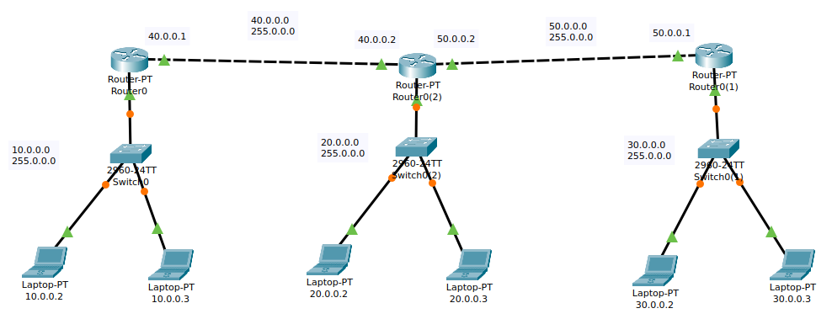

**Configuration Step:**

1. Assign IP addresses to all the connected PC’s respected to their network as the Network Design shows
2. Go to the router’s command-line interface (CLI).
3. Configure router with IP address and Subnet mask.
4. After configuring all of the devices we need to assign the routes to the routers.

**PC IP configuration:**

|  |  |  |  |
| --- | --- | --- | --- |
| Device | IP | Subnet Mask | Default gateway |
| Laptop 1 | 10.0.0.2 | 255.0.0.0 | 10.0.0.1 |
| Laptop 2 | 10.0.0.3 | 255.0.0.0 | 10.0.0.1 |
| Laptop 3 | 20.0.0.2 | 255.0.0.0 | 20.0.0.1 |
| Laptop 4 | 20.0.0.3 | 255.0.0.0 | 20.0.0.1 |
| Laptop 5 | 30.0.0.2 | 255.0.0.0 | 30.0.0.1 |
| Laptop 6 | 30.0.0.3 | 255.0.0.0 | 30.0.0.1 |

**Router Configuration Command:**

**Router 1**

en

conf t

int fa0/0

ip address 10.0.0.1 255.0.0.0

no shut

exit

int fa1/0

ip address 40.0.0.1 255.0.0.0

no shut

exit

router rip

network 10.0.0.0

network 40.0.0.0

no auto summary

exit

**Router 2**

en

conf t

int fa0/0

ip address 20.0.0.1 255.0.0.0

no shut

exit

int fa1/0

ip address 40.0.0.2 255.0.0.0

no shut

int fa2/0

ip address 50.0.0.2 255.0.0.0

no shut

exit

router rip

network 20.0.0.0

network 40.0.0.0

network 50.0.0.0

no auto summary

exit

**Router 3**

en

conf t

int fa0/0

ip address 30.0.0.1 255.0.0.0

no shut

exit

int fa1/0

ip address 50.0.0.1 255.0.0.0

no shut

exit

router rip

network 30.0.0.0

network 50.0.0.0

no auto summary

exit

**Output:**

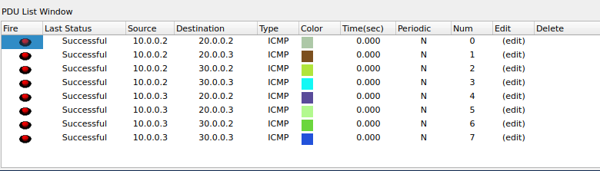

**Packet Tracer File:** [**RIP**](https://github.com/Bishwajit-2810/Computer-Network/tree/master/RIP)