**Computer Network Lab Report 01**

**Designing a Hybrid Network Topology with Mesh and any other Configurations**

**Name: Bishwajit Chakraborty**

**Id: 0242220005101414**

**Section: 63_I**

**Designing a Hybrid Network Topology with Mesh and any other Configurations**

**Abstract:**

This lab report aims to evaluate the performance and effectiveness of network devices using Cisco Packet Tracer (CPT) as a simulation tool. CPT is a widely utilized network simulation software, commonly employed for designing and testing network configurations prior to real-world implementation. This report investigates various hybrid network topologies to assess the performance of devices such as routers, switches, and end devices. The report methodology encompasses the design of network scenarios, device configuration, and testing of various network protocols. The analysis reveals that CPT is capable of accurately replicating most functions and behaviors of network devices, providing a clear depiction of network performance under different conditions. This report is expected to offer valuable insights for professionals and academics in understanding and optimizing network design before deployment in real-world environments.

**Objective:**

Design and implement a hybrid network topology using 10 PCs or end nodes, incorporating both a mesh topology and another topology (star, bus, or ring). This assignment aims to provide practical experience in configuring complex network topologies and understanding their respective advantages and challenges.

**1. Topology Design:**

For fulfilling the objective I have take 10 computers where I have connected 5 computers in mesh topology and 5 computers in ring topology and 5 computers in ring topology and interconnected the switches for further packet transfer.

**2. Network Implementation:**

**Physical Layout:**

To establish an effective and efficient computer laboratory for network testing and experimentation, three different network topologies were designed and evaluated. These topologies—Mesh, and Ring—were selected to determine which best suits the laboratory's requirements based on various performance criteria.

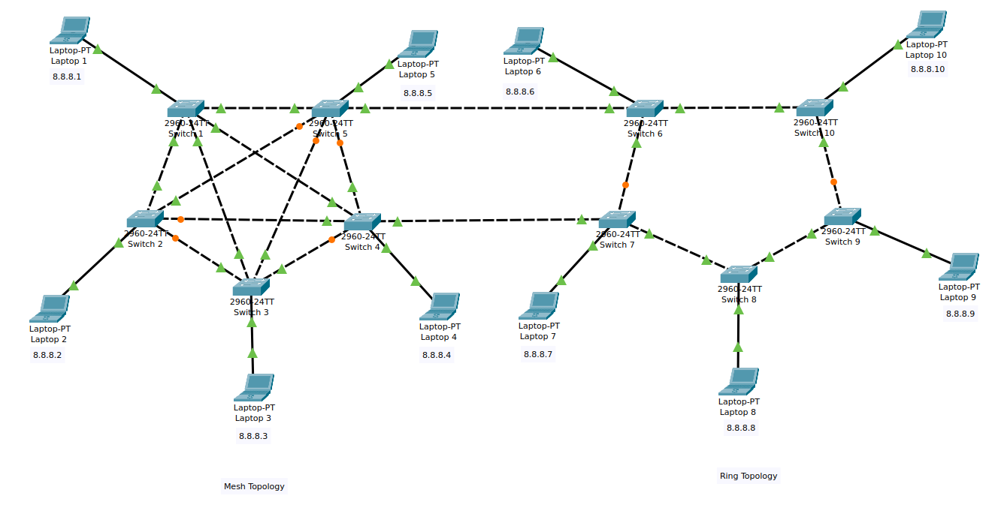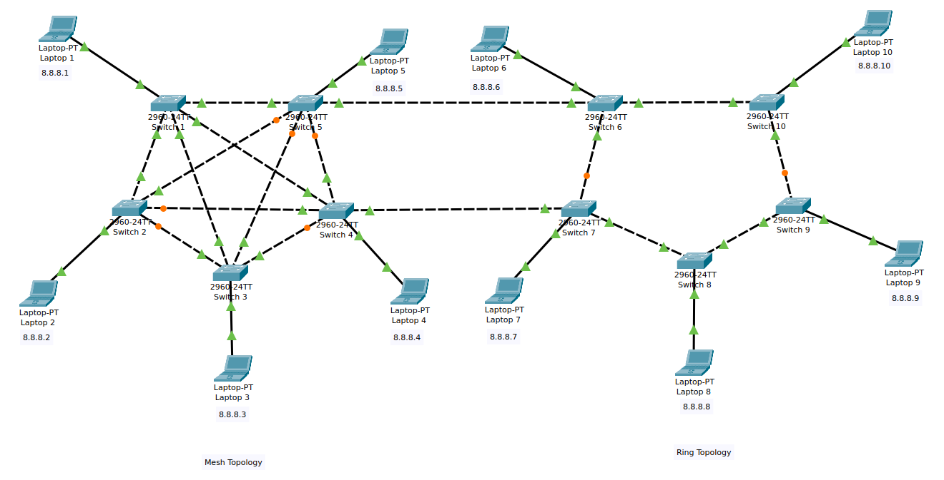

Figure: Hybrid Topology

**Configuration:**

Following the design phase, the network devices were configured based on the scenarios previously outlined. This involved configuring essential elements such as IP addressing, routing protocols, VLANs, and other necessary network settings to ensure optimal performance.

**For mesh topology :**

The Laptops are Laptop 1, Laptop 2, Laptop 3, Laptop 4, Laptop 5

**For ring topology :**

The Laptops are Laptop 6, Laptop 7, Laptop 8, Laptop 9, Laptop 10

**IPv4 , Subnet Mask of Host Devices:**

|  |  |  |  |
| --- | --- | --- | --- |
| **Host Device** | **IPv4 Address** | **Subnet Mask** | **Network Device** |
| Laptop 1 | 8.8.8.1 | 255.0.0.0 | Switch 1 |
| Laptop 2 | 8.8.8.2 | 255.0.0.0 | Switch 2 |
| Laptop 3 | 8.8.8.3 | 255.0.0.0 | Switch 3 |
| Laptop 4 | 8.8.8.4 | 255.0.0.0 | Switch 4 |
| Laptop 5 | 8.8.8.5 | 255.0.0.0 | Switch 5 |
| Laptop 6 | 8.8.8.6 | 255.0.0.0 | Switch 6 |
| Laptop 7 | 8.8.8.7 | 255.0.0.0 | Switch 7 |
| Laptop 8 | 8.8.8.8 | 255.0.0.0 | Switch 8 |
| Laptop 9 | 8.8.8.9 | 255.0.0.0 | Switch 9 |
| Laptop 10 | 8.8.8.10 | 255.0.0.0 | Switch 10 |

**Connections of the switches :**

There are 24 ports in switch so it doesn't do any difference in which port devices are connected. But the interconnection is important and documentation is important for further works and troubleshooting.

**With One Network Devices Connected Host and Another Network Devices:**

|  |  |  |
| --- | --- | --- |
| **Network Device** | **Connected Host** | **Total Connected Devices** |
| Switch 1 | Laptop 1 | Switch 2, Switch 3,Switch 4,Switch 5 |
| Switch 2 | Laptop 2 | Switch 1, Switch 3, Switch 4, Switch 5 |
| Switch 3 | Laptop 3 | Switch 1, Switch 2, Switch 4, Switch 5 |
| Switch 4 | Laptop 4 | Switch 1, Switch 2, Switch 3, Switch 5 |
| Switch 5 | Laptop 5 | Switch 1, Switch 2, Switch 3, Switch 4 |
| Switch 6 | Laptop 6 | Switch 5, Switch 7, Switch 10 |
| Switch 7 | Laptop 7 | Switch 4, Switch 6, Switch 8 |
| Switch 8 | Laptop 8 | Switch 7, Switch 9 |
| Switch 9 | Laptop 9 | Switch 8, Switch 10 |
| Switch 10 | Laptop 10 | Switch 6, Switch 9 |

**Network Devices and Host Devices Connected Ports:**

|  |  |  |  |
| --- | --- | --- | --- |
| **Device 1** | **Device 1 Port** | **Device 2** | **Device 2 Port** |
| Switch 1 | FastEthernet0/3 | Laptop 1 | FastEthernet0 |
| Switch 2 | FastEthernet0/3 | Laptop 2 | FastEthernet0 |
| Switch 3 | FastEthernet0/3 | Laptop 3 | FastEthernet0 |
| Switch 4 | FastEthernet0/3 | Laptop 4 | FastEthernet0 |
| Switch 5 | FastEthernet0/3 | Laptop 5 | FastEthernet0 |
| Switch 6 | FastEthernet0/3 | Laptop 6 | FastEthernet0 |
| Switch 7 | FastEthernet0/3 | Laptop 7 | FastEthernet0 |
| Switch 8 | FastEthernet0/3 | Laptop 8 | FastEthernet0 |
| Switch 9 | FastEthernet0/3 | Laptop 9 | FastEthernet0 |
| Switch 10 | FastEthernet0/3 | Laptop 10 | FastEthernet0 |

**Network Devices Connected Ports:**

|  |  |  |  |
| --- | --- | --- | --- |
| **Device 1** | **Device 1 Port** | **Device 2** | **Device 2 Port** |
| Switch 1 | FastEthernet0/2,  FastEthernet0/4,  FastEthernet0/5,  FastEthernet0/1 | Switch 2,  Switch 3,  Switch 4,  Switch 5, | FastEthernet0/1,  FastEthernet0/1,  FastEthernet0/1,  FastEthernet0/1 |
| Switch 2 | FastEthernet0/1,  FastEthernet0/2,  FastEthernet0/4,  FastEthernet0/5 | Switch 1,  Switch 3,  Switch 4,  Switch 5 | FastEthernet0/2,  FastEthernet0/2,  FastEthernet0/2,  FastEthernet0/2 |
| Switch 3 | FastEthernet0/1,  FastEthernet0/2,  FastEthernet0/4,  FastEthernet0/5 | Switch 1,  Switch 2,  Switch 4,  Switch 5 | FastEthernet0/4,  FastEthernet0/2,  FastEthernet0/4,  FastEthernet0/4 |
| Switch 4 | FastEthernet0/1,  FastEthernet0/2,  FastEthernet0/4,  FastEthernet0/5 | Switch 1,  Switch 2,  Switch 3,  Switch 5 | FastEthernet0/5,  FastEthernet0/4,  FastEthernet0/4,  FastEthernet0/5 |
| Switch 5 | FastEthernet0/1,  FastEthernet0/2,  FastEthernet0/4,  FastEthernet0/5 | Switch 1,  Switch 2,  Switch 3,  Switch 4 | FastEthernet0/1,  FastEthernet0/5,  FastEthernet0/5,  FastEthernet0/5 |
| Switch 6 | FastEthernet0/1,  FastEthernet0/2 | Switch 7,  Switch 10 | FastEthernet0/1,  FastEthernet0/1 |
| Switch 7 | FastEthernet0/1,  FastEthernet0/2 | Switch 6,  Switch 8 | FastEthernet0/1,  FastEthernet0/1 |
| Switch 8 | FastEthernet0/1,  FastEthernet0/2 | Switch 7,  Switch 9 | FastEthernet0/2,  FastEthernet0/1 |
| Switch 9 | FastEthernet0/1,  FastEthernet0/2 | Switch 8,  Switch 10 | FastEthernet0/2,  FastEthernet0/2 |
| Switch 10 | FastEthernet0/1,  FastEthernet0/2 | Switch 6,  Switch 9 | FastEthernet0/2,  FastEthernet0/2 |

**Configuration of Laptop 1 (all configured in same way):**

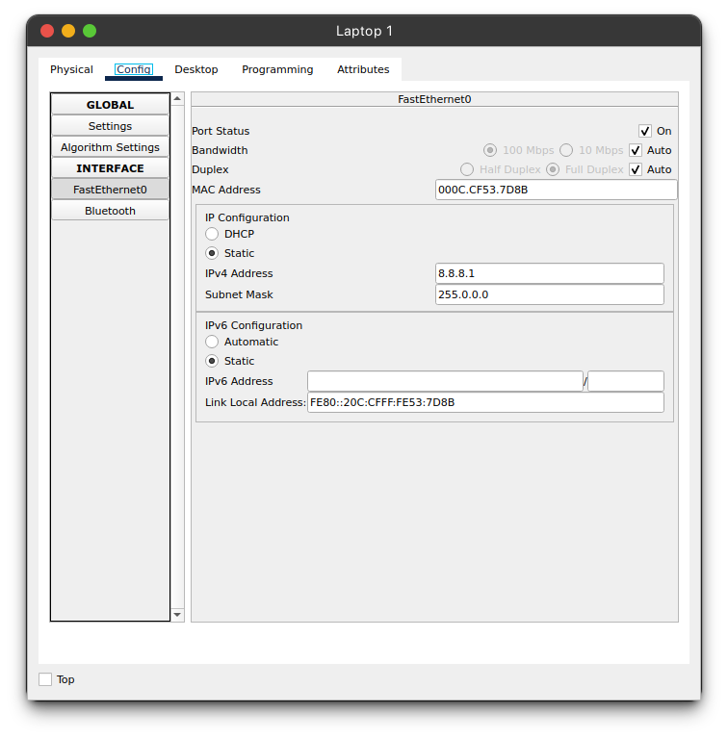

**3. Testing and Validation:**

After configuring the network devices, the next step was to test various network protocols within the simulated environment to assess their performance and behavior under different conditions. The protocols tested included sending messages between devices and conducting ping tests to measure response times and data integrity.

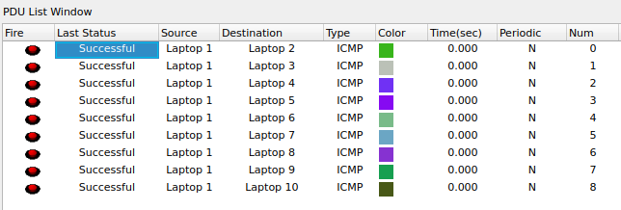

In the Hybrid topology, testing revealed that while the network could handle basic communication tasks effectively, an increase in the number of devices or data load significantly impacted performance, resulting in increased latency and potential data loss. This finding confirmed the Ring topology's susceptibility to performance degradation as network demands grow. The Mesh topology demonstrated high reliability and consistent performance, even under heavy data loads. The redundancy inherent in the topology allowed for continuous communication despite simulated failures in individual connections. However, this reliability comes with increased complexity and required robust management tools to handle the numerous connections.

Testing of the Ring topology showed that it offered a good balance between reliability and simplicity. The network maintained stable communications, and failures in individual connections did affect overall network performance. However, the tests highlighted the network's critical dependence on the Connection with two mesh hub, which, if compromised, would lead to total network failure.

**Ping Testing:**

The ping tests conducted on the hybrid topology further illustrate the differences in response times and data transmission efficiency across the three topologies.

**Command :**

**ping ip-address**

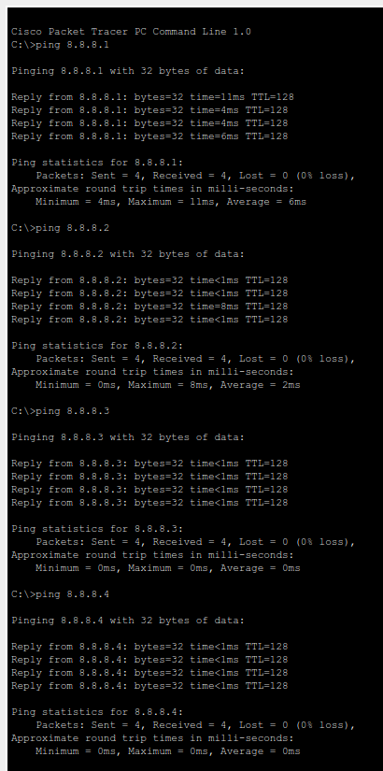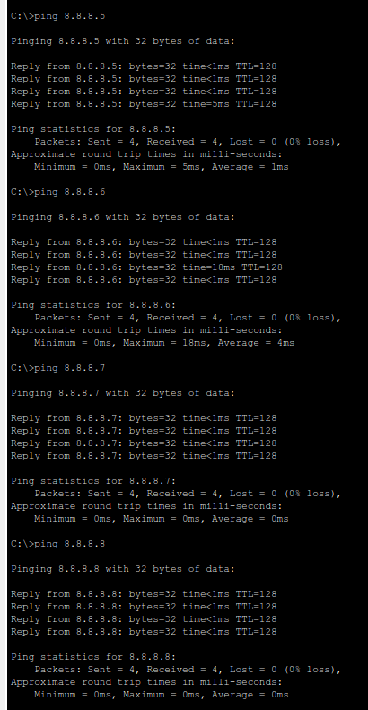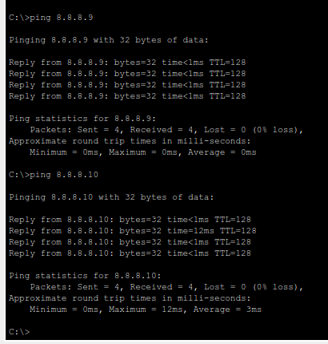

**Performance Analysis:**

The final step involved a comprehensive performance analysis of the configured network devices within the simulated environment. Key performance metrics such as latency, throughput, and packet loss were monitored and analyzed. The analysis of the Ring topology indicated that it is best suited for smaller networks with a limited number of devices. Its simplicity and low cost make it an economical choice for environments with minimal network demands. However, the Ring topology's vulnerability to connection point of failure and limited scalability were significant drawbacks, especially in larger or more dynamic network environments. The Mesh topology outperformed the other topology in terms of reliability and fault tolerance. The ability to reroute traffic in case of a failure makes it ideal for networks requiring high availability and performance. Nevertheless, the complexity of implementing and managing a Mesh topology, along with the higher costs associated with its deployment, make it more suitable for environments where these factors are justified by the network's critical role. This analysis underscores the importance of selecting the appropriate topology based on specific network requirements, including cost, complexity, scalability, and reliability. Each topology has distinct advantages and limitations that must be carefully considered to ensure optimal network performance in various scenarios.

**5. Conclusion:**

Hybrid topologies offer significant benefits in performance and reliability, and targeted improvements can make them even more resilient.

**Impact on Network Performance:** A hybrid topology (ring + mesh) improves bandwidth utilization, reduces latency by providing multiple paths for data flow, and enhances scalability without increasing complexity. The ring provides efficient, predictable routing, while the mesh offers dynamic, adaptive routing for better overall performance.

**Impact on Network Reliability:** Hybrid topology increases fault tolerance and redundancy. If a failure occurs in the ring, traffic can be rerouted through the mesh, ensuring minimal disruption. Recovery is faster in hybrid systems, as the mesh provides alternative paths during failures.

**Comparison with Single Topologies:** A ring topology is simple but vulnerable to single failures, and mesh offers better redundancy but is complex and costly. The hybrid topology combines the simplicity of ring with the resilience and availability of mesh, making it ideal for larger networks.

**Improvements to Network Design:** Dynamic load balancing, enhanced redundancy with more links, automated monitoring, cost efficiency through software-defined networking (SDN), and better security practices can further enhance hybrid network design, making it more reliable and efficient.

In conclusion, a hybrid topology combining ring and mesh offers significant advantages in both performance and reliability compared to using a single topology. However, strategic improvements in dynamic load balancing, redundancy, automation, and security can further enhance the design, leading to a more resilient and efficient network.

**CPT file link :** [**Computer-Network-Lab_Link**](https://github.com/Bishwajit-2810/Computer-Network)