Selective Intelligence: A Cost-Aware Hybrid NLP–LLM Microservice
for Thread-Level Sentiment and Watchlist-Driven Target Stance
over Code-Mixed Bangla Social Media, with an MCP-Backed
Agentic RAG Insight Layer
By
Bishwajit Kumar Chakraborty
ID: 0242220005101414
FINAL YEAR DESIGN PROJECT REPORT
This Report is Presented in Partial Fulfillment of the Requirements for the Degree of Bachelor of Science in Computer Science and Engineering
Supervised by
Dr. Sheak Rashed Haider Noori
Professor and Head
Department of Computer Science and Engineering
Daffodil International University
Co-Supervised by
Dr. Md Alamgir Kabir
Assistant Professor
Department of Computer Science and Engineering
Daffodil International University
Daffodil International University
Dhaka, Bangladesh
August 2026

Approval
This Project titled "Selective Intelligence: A Cost-Aware Hybrid NLP–LLM Microservice for Thread-Level Sentiment and Watchlist-Driven Target Stance over Code-Mixed Bangla Social Media, with an MCP-Backed Agentic RAG Insight Layer", submitted by Bishwajit Kumar Chakraborty to the Department of Computer Science and Engineering, Daffodil International University, has been accepted as satisfactory for the partial fulfillment of the requirements for the degree of B.Sc. in Computer Science and Engineering and approved as to its style and contents. The presentation has been held on [DD-MM-YYYY].

BOARD OF EXAMINERS
[Name]
Board Chairman
[Designation], Department of CSE, FSIT
Daffodil International University
[Name]
Internal Examiner 1
[Designation], Department of CSE, FSIT
Daffodil International University
[Name]
Internal Examiner 2
[Designation], Department of CSE, FSIT
Daffodil International University
[Name]
External Examiner
[Designation], Department of CSE, FSIT
Daffodil International University

Declaration
I hereby declare that this project has been done by me under the supervision of Dr. Sheak Rashed Haider Noori, Professor and Head, Department of Computer Science and Engineering, Daffodil International University, and under the co-supervision of Dr. Md Alamgir Kabir, Assistant Professor, Department of Computer Science and Engineering, Daffodil International University. I also declare that neither this project nor any part of this project has been submitted elsewhere for the award of any degree or diploma.
I further declare that the software system described in this report was designed, implemented, audited and measured by me; that every quantitative result reported in Chapter 4 was produced by running the code in this repository and can be reproduced with the commands given alongside it; and that every capability claimed in this report is labelled with the class of evidence that supports it, so that no implemented-but-unexercised capability is presented as a measured one.
Supervised by:
Dr. Sheak Rashed Haider Noori
Professor and Head
Department of Computer Science and Engineering
Daffodil International University
Co-Supervised by:
Dr. Md Alamgir Kabir
Assistant Professor
Department of Computer Science and Engineering
Daffodil International University
Submitted by:
Bishwajit Kumar Chakraborty
Student ID: 0242220005101414
Department of Computer Science and Engineering
Daffodil International University

Acknowledgements
This work would not have been possible without the support and contributions of many individuals over the past two semesters. I am deeply grateful to everyone who has assisted me in one way or another.
First, I express my heartfelt thanks and gratefulness to the Almighty for His divine blessing, which made it possible for me to complete the Final Year Design Project successfully.
I am grateful and wish to express my profound indebtedness to my supervisor Dr. Sheak Rashed Haider Noori, Professor and Head, Department of Computer Science and Engineering, Daffodil International University, Dhaka, Bangladesh. The deep knowledge and keen interest of my supervisor in the field of multilingual natural language processing and distributed AI systems made it possible to carry out this project. Endless patience, scholarly guidance, continual encouragement, constant and energetic supervision, constructive criticism, valuable advice, and the reading and correction of many inferior drafts at all stages have made it possible to complete this project.
I am equally indebted to my co-supervisor Dr. Md Alamgir Kabir, Assistant Professor, Department of Computer Science and Engineering, Daffodil International University, whose careful reading of the evaluation chapter and insistence on evidence for every claim shaped the way the results in this report are stated. I would also like to express my heartfelt gratitude to the other faculty members and the staff of the Department of Computer Science and Engineering, Daffodil International University, for their kind help in finishing my project.
I would like to thank all of my course-mates at Daffodil International University who took part in the discussions that shaped this work while completing the coursework. I am particularly grateful to the reviewers who read the system with fresh eyes across six independent audit passes; several of the findings recorded in Chapter 4 exist only because a reviewer was willing to disbelieve a passing test.
Finally, I must acknowledge with due respect the constant support and patience of my parents.

Abstract
Bangladeshi social-media monitoring runs on text that off-the-shelf language technology handles poorly: Bangla script, English and romanized "Banglish" mix inside single comments, and the platforms supplying it store one coarse sentiment per post and none per comment. Sending every item to a large language model is accurate but unaffordable at realistic volumes; small classifiers alone are affordable but weak on the code-mixed text that dominates the traffic. Published cost-aware cascades resolve that tension for single queries only: none routes a thread whose thousands of comments each need labelling, none reports what share of the bill the routing decision governs, and none carries alias-aware target stance or per-label provenance into a deployable low-resource-language system. This project builds, measures and audits a microservice that decides per unit of work how much intelligence that unit deserves and proves afterwards where the money went. A five-stage, queue-based pipeline – ingestion, cheap NLP, router, selective LLM and result assembler – emits one schema-validated JSON document per thread. A six-gate router governs post-level spend, while a separate step decides which comments an eight-labeller ensemble reads: seven small multilingual sentiment heads batched on CPU plus one context-aware LLM stance pass, in which a labeller that cannot answer abstains. Watchlist-driven target stance adds per-entity verdicts through an alias matcher built for the three-script spelling problem, and nine tool-using agents reason over the system's own output through eighteen typed Model Context Protocol tools. Over 50 threads carrying 10,272 real comments the router sends 16 percent of posts to post-level work against 74 percent for a keyword baseline, yet governs only 30 percent of spend because 96 percent of calls are per-comment; hybrid retrieval reaches recall@10 of 0.8750 against 0.1875 for hash-vector baselines. The deliverable is working, auditable software in which every capability is reported alongside its class of evidence.

Table of Contents
The table of contents is a field: select all (Ctrl+A) and press F9 to build it.

List of Figures
The list of figures is a field: select all (Ctrl+A) and press F9 to build it.

List of Tables
The list of tables is a field: select all (Ctrl+A) and press F9 to build it.

Chapter 1

Introduction
This chapter states the problem the project addresses, the computational reasons that make it worth solving, the objectives that follow from it, and a summary of the method and the outcomes. It closes with a chapter-by-chapter map of the rest of the report.

Introduction
Bangladesh has one of the largest and most conversational social-media populations in South Asia, and the organisations that monitor it – newsrooms, brand agencies, election observers, civic groups – increasingly procure that monitoring as a service. A monitoring platform of this kind scrapes public posts and their comment threads, stores them, and exposes them over a REST interface. What it typically does not do is understand them. The platform that supplies the data for this project stores one coarse sentiment score per post, leaves per-comment sentiment entirely empty, and ships no optical character recognition for the images attached to a post. Everything an analyst actually wants to know – what the thread is arguing about, which commenters are angry and at whom, whether a conversation is turning toxic, what the dominant themes are this week – has to be computed by something else.
Computing it is harder here than the English-language literature suggests, for one specific reason. The text is not Bangla, and it is not English. It is a live mixture of both, written in two scripts, with no standard orthography for the mixture. A single thread routinely contains comments in Bangla script, comments in English, and comments in Banglish – Bangla rendered in Latin characters with spellings that vary from writer to writer and sometimes within a single comment. Measured over the 10,272 comments in this project's working corpus, 81.4 percent of comments contain Bangla script only, 11.1 percent contain Latin script only, 4.6 percent contain both, and 2.9 percent contain neither script at all because they are pure emoji. Multilingual encoders degrade on the romanized portion precisely because it is neither of the languages they were pretrained on, and the same named entity may appear in three different scripts and half a dozen spellings across one thread.
The obvious response – send every post and every comment to a large language model – works and is unaffordable. At the volumes a monitoring platform generates, per-token billing or per-token GPU occupancy scales with the number of comments, not the number of posts, and a single viral thread in this corpus carries 2,857 stored comments against a platform-reported total of 9,224. The opposite response – run only small, cheap classifiers – is affordable and demonstrably weaker on exactly the code-mixed text that dominates the traffic.
The problem statement of this project is therefore narrower and more testable than "analyse Bangla social media". It is this: given a post together with its embedded comment thread, decide per unit of work how much intelligence that unit deserves, spend the expensive model only where cheap models cannot answer, and be able to prove afterwards, from the system's own counters, where the money went and what produced every label. The result is a self-contained analysis microservice that pulls from the upstream platform, analyses in its own database, writes nothing back, and returns one structured JSON document per thread for downstream consumers.

Motivation
The computational motivation is a cost asymmetry that is large enough to design a system around. A small transformer classifier of 135 to 280 million parameters, batched on CPU, labels a short comment in the order of a hundred milliseconds and costs nothing per token. A seven-billion-parameter instruction-tuned model answers the same question better on code-mixed text, but a single post-type call on the local deployment used in this project takes between 7 and 50 seconds, and one Stage-2 call on a batch of 25 comments is a generation call whose cost scales with prompt length. The gap between the two is between two and three orders of magnitude in latency and, on a metered backend, a comparable gap in money. A system that can decide which items genuinely need the expensive path converts an unbounded bill into a bounded one.
That decision is not free to make well, and this is the part that makes the problem interesting rather than merely engineering. A confidence gate is only as good as the confidence estimate feeding it, and a confidence estimate produced by a model that has never been calibrated on the target language is a guess wearing a number. The literature on cascades and query routing – FrugalGPT [30], RouteLLM [31], Hybrid LLM [32] – establishes the shape of the answer for English. What it does not establish is what the gate should read when the input is code-mixed, when a post has no text at all, or when the "unit" being routed is a thread of thousands of comments rather than a single query.
A second motivation is a research gap that this corpus makes visible. Document-level sentiment establishes whether a comment carries negative affect. For political and brand monitoring the operative question is a different one: the identity of the entity toward which that affect is directed. Target-dependent stance detection is well established for English product reviews and English tweets [13], [14], [16], but for code-mixed Bangla it is under-served, and the hard part is not the classifier – it is the matcher, because the same entity is written three ways and a watchlist that matches one spelling silently matches almost nothing. A failure of that kind is invisible: it produces zero mentions, a result indistinguishable from an entity that was never discussed.
A third motivation is personal and professional. Building this system required standing up a genuine distributed pipeline – durable queues, stateless workers, dead-letter handling, autoscaling manifests, three storage engines chosen by access pattern, an observability stack – alongside the applied NLP. That combination is exactly the skill set the industry asks for and exactly the combination an undergraduate curriculum rarely exercises end to end. Solving it also forced a discipline that was not expected to be the most valuable outcome of the project: every claim in this report is labelled with the class of evidence behind it, because six independent audit passes over the project's own code established that the most consequential failures were not incorrect answers but silent successes – components that reported that they had run when they had not.

Objectives
Four objectives follow from the problem statement of Section 1.1, and each answers one of the four gaps identified in Section 2.3. Each is scoped so that it can be checked against the running system rather than argued for, and they are ordered so that the earlier ones are preconditions for the later ones.
O1. Build the analysis service. To design and implement a horizontally scalable, queue-based analysis microservice that consumes a post-with-details payload – a post with its comment thread, engagement counts, reaction breakdown and share sample embedded – from an existing monitoring platform, analyses it in its own datastores, and returns one schema-validated JSON document per thread without ever writing back to the upstream platform.
O2. Make the cascade selective, and measure it. To implement a hybrid cascade in which cheap NLP runs on every post and every comment while a rule-based router decides, per post, whether post-level large-language-model work is warranted and, as a separate decision, which comments the expensive labellers read – and then to measure that cascade rather than assert it, reporting the routing rate from the router's own counters, the split of large-model calls between the post-level and comment-level lanes, and the share of total spend the routing gate actually governs.
O3. Deliver the capability layers the code-mixed setting needs. To raise per-comment sentiment from a single verdict to a transparent eight-labeller ensemble in which a labeller that cannot answer abstains rather than casting a fabricated neutral vote; to add watchlist-driven target stance through a configurable, alias-aware entity list that yields per-entity verdicts for Bangla, Banglish and English text in a field kept separate from document sentiment; and to build an agentic insight layer in which tool-using agents reason over the system's own output through Model Context Protocol servers, under per-run tool and token budgets, prompt-injection hardening and citation verification.
O4. Make every claim auditable, and evaluate against that standard. To carry provenance on every label, per-backend and per-lane cost telemetry, a live per-post execution trace and a regression suite that fails when a repaired defect returns; and to evaluate the system on the properties by which an engineering deliverable is judged – retrieval quality, routing behaviour, call and cost splits, coverage arithmetic and system correctness – attaching an evidence class to every published claim so that the boundary of what was evaluated is part of the result rather than something the reader has to infer.
Aggregated, these four objectives put the project one notch beyond a theoretical problem statement and into actual system fabrication. They were prioritised in the order given: the pipeline and its router first (O1, O2), the capability layers second (O3), and the audit, evaluation and evidence discipline last (O4). That is the order in which Chapter 3 develops them and Chapter 4 measures them, and the gap analysis of Section 2.3 states the four gaps they answer, one for one.

Methodology
For this project, an iterative development methodology structured around requirement analysis, design, development, testing, deployment and audit was adopted. The work was carried out in six steps, each with a clear objective, a defined process and a measurable outcome, so that the delivered system does not drift from the objectives stated in Section 1.3. The methodology is summarised below through those six steps and is developed in full in Chapter 3.
1. Requirement Analysis
The objective was to identify the functional and technical needs of a code-mixed Bangla analysis service, as evidenced by what the upstream monitoring platform does and does not supply.
• Reviewed the literature on Bangla and code-mixed sentiment, on cost-aware model cascades, and on retrieval-augmented generation and tool-using agents, to establish which parts of the problem already have published answers.
• Characterised the real payload rather than a specification of it: 50 threads, 10,272 stored comments, one coarse upstream sentiment per post and no per-comment sentiment at all.
• Performed the gap analysis of Section 2.3 against commercial listening suites, the upstream platform itself, academic Bangla classifiers, general retrieval assistants and published router frameworks.
• Grouped the requirements around the high-level entities the system actually handles – posts, comments, jobs, watchlist targets, agent runs and analysis results.
The outcome was the eighteen functional and twelve non-functional requirements of Section 3.1.3, and an input contract locked against the real payload rather than against a description of it.
2. System Design
The objective was to design a scalable architecture in which cheap analysis runs unconditionally and expensive analysis is spent selectively, and define the modules that realise it.
• Architected the system as five queue-decoupled stages – ingestion, cheap NLP, router, selective LLM and result assembler – connected by durable streams, so that each stage scales independently.
• Designed the router as two independent decisions rather than one: whether a post earns post-level large-model work, and which of its comments the Stage-2 labellers read. Separating them is what later made the cost behaviour measurable at all.
• Split storage by access pattern rather than by subject: PostgreSQL with pgvector for operational rows and the embedding index, ClickHouse for analytical events, Redis for streams and counters, object storage for raw payloads.
• Specified the canonical output document, its JSON Schema, and the data-flow diagrams of Section 3.1.4, together with the eleven-tab dashboard layout of Section 3.1.5.
• Recorded, for every significant decision, the alternatives weighed and the constraint that settled it, in Table 3.7.
The outcome was the architecture of Figure 3.2, the pipeline of Figure 3.3, the canonical schema, and a design specification in which no load-bearing choice is undocumented.
3. Development
The objective was to translate the designed modules into a working system rather than a prototype.
• Implemented the five stages, the six-gate router and the two-lane Stage 2, with a shared worker base class carrying consumer-group creation, cooperative cancellation, bounded retry and dead-lettering.
• Built the eight-labeller comment ensemble with its abstention protocol – seven small sentiment heads batched on CPU and one context-aware stance pass – behind a single combiner that is the only writer of a comment's final label.
• Implemented watchlist-driven target stance, whose load-bearing part is the alias matcher rather than the classifier, and which adds no additional large-model calls because the matched entities ride inside a prompt already being issued.
• Built the agentic insight layer: three Model Context Protocol servers exposing eighteen typed tools, and nine tool-using agents over them with per-run tool and token budgets.
• Built the operator-facing React dashboard, the 51-path HTTP API beneath it, and the Server-Sent Event streams that carry every live surface.
The outcome was A running system of 56,789 lines of Python across 182 files, a React dashboard, three deployment shapes and an evaluation harness – the software described in Chapter 4.
4. Testing
The objective was to validate the implemented modules for functional correctness, contract compliance and honesty of reporting.
• Wrote contract tests asserting that every document crossing a boundary validates against its schema, and structural tests asserting that the deployment manifests name exactly the streams the workers create.
• Ran six independent fresh-eyes audit passes over the system, each pass starting from a claim made in this report and checking it against the running code rather than starting from the code and looking for bugs.
• Pinned every repaired defect with a regression test named after the defect, and confirmed by mutation testing that the tests fail when the fix is reverted.
• Assembled the whole verification chain – Python suite, dashboard unit tests, lint, production build and browser tests – into one pass-or-fail command.
The outcome was A 1,420-test suite in which test code is 35 percent of the repository, and a full chain that passes in seventy-three seconds. It also produced findings that contradicted the project's own headline claim, which are reported as such in Section 4.3.2.
5. Deployment
The objective was to make the same codebase runnable on a laptop and in a cluster without a rewrite.
• Packaged the system for three tiers: a single-host development stack, a nineteen-image Docker Compose deployment, and a Kubernetes deployment with queue-depth autoscaling.
• Made the inference backend pluggable and resolvable per call, so that self-hosted and metered serving are a configuration decision rather than a migration.
• Enforced a tenant privacy lock that pins a locked tenant to the self-hosted backend on every path and fails closed when the policy table cannot be read.
• Reduced the whole stack to a single start command that brings up four containers and eleven host processes and verifies the sentence encoder before launching anything.
The outcome was A system that starts in under a minute on a laptop and expresses the same components as Kubernetes objects in production, which is what makes it demonstrable rather than merely deployable.
6. Evaluation and Future Planning
The objective was to measure what the system does, and state plainly where the evidence stops.
• Measured system properties – routing rate, call and cost split, coverage, latency, label provenance – by running the real stage functions over the real corpus.
• Measured retrieval quality against a 32-query known-item set with recall@k, MRR@k and nDCG@k, and stratified it by query-to-target lexical overlap.
• Attached an evidence class to every capability – measured, works-but-unmeasured, unexercised, or out of scope – and recorded it in a single ledger.
• Scoped the annotation programme that a labelling-accuracy figure would require, and built its sampler and scorer without seeding it with labels drawn from the system's own models.
The outcome was four completed measurement studies, an evidence ledger covering every capability, and the ordered future work of Section 6.3.
Evaluation is deliberately split by what the evidence can support, and that split is the methodological commitment this project would defend first. System properties are measured. Retrieval quality is measured against ground truth. Correctness is pinned by regression. Labelling accuracy is outside the evaluation scope and is not claimed, because obtaining it honestly requires an annotation programme rather than a further measurement script.

Project Outcome
The delivered solution is a working, auditable analysis microservice with evidence of implementation across ingestion, the five-stage pipeline, the comment ensemble, the watchlist stance layer, the agentic insight layer and an eleven-tab operator dashboard. It comprises 56,789 lines of Python across 182 files, of which 19,850 lines are tests, together with a React dashboard, deployment manifests for both Docker Compose and Kubernetes, and an evaluation harness. A summary of the key results of this work is given below.
1. A working cost-aware cascade with measured behaviour
On the 43-post captioned corpus, the router sends 16 percent of posts to post-level large-model work under the shipped Stage-1 engine, against 74 percent under a keyword baseline. More importantly, the measurement showed that the routing rate is not the cost story, because 96 percent of calls are comment-level. This is a result that contradicted the project's own original claim and is reported as such in Section 4.3.2.
2. A transparent per-comment ensemble
Eight labellers per analysed comment, with abstention, voter counts, and per-source verdicts surfaced side by side in the dashboard, so a sentiment chart can always say what produced its numbers. A comment that no model read is reported as uncertain rather than defaulted to neutral.
3. A built and tested watchlist stance capability
Per-entity stance over an operator-supplied, alias-aware watchlist that adds zero additional large-model calls, because the matched entities ride inside a prompt that is already being sent. It is framed in the output schema as a separate measurement from sentiment, and never summed or charted with it.
4. An agentic insight layer
Nine tool-using agents over eighteen typed tools across three Model Context Protocol servers, with a runner hardened against eight distinct failure modes observed in live runs, each of which now has a regression test.
5. A measured retrieval stack
Hybrid retrieval reaches recall@10 of 0.8750 where hash-vector baselines score 0.1875 – statistically indistinguishable from returning ten random posts out of fifty. Stratifying the query set shows the dense and lexical arms failing on disjoint query populations, which is the real argument for fusing them.
6. An operator-facing product, not a script
Eleven dashboard tabs – corpus overview, post explorer, job control, reports, dual-mode search, agents, chat, pipeline, per-post trace, watchlist warnings and a streaming log console – over a documented 51-path API, with host telemetry, light and dark themes, and a one-command start of the whole eleven-process stack. Section 4.3.1 walks through all of it with screenshots of the running system, and Table 4.13 indexes each feature against the figure that shows it.
7. An honest capability ledger
Every feature is classified as measured, works-but-unmeasured, unexercised, or out of scope. The image modality is reported as unexercised rather than claimed, and labelling accuracy is recorded as a stated scope boundary with the work that would close it named in Chapter 6.
The areas that have not fully matured are reflected in the deliverable rather than hidden by it: the image and optical-character-recognition modality, cluster autoscaling in a real cluster, and the scoring of the agent layer's answers are all on the future-scope pipeline of Section 6.3 rather than in the results.
The potential outcomes beyond the project are a deployable analysis layer for any Bangla-language monitoring platform, a reusable pattern for cost-aware model cascades in low-resource settings, and a corpus of 10,272 real code-mixed comments with crowd reaction signals attached that is ready for the annotation effort that would turn this engineering result into a benchmark result.
The results confirm that this project has moved beyond a written problem statement and into a deployed, inspectable system, with demonstrated coverage of each of the following: ingestion and the five-stage pipeline, the six-gate router and its measured behaviour, the eight-labeller comment ensemble, watchlist-driven target stance, the agentic insight layer over eighteen typed tools, hybrid retrieval with a measured quality figure, and an eleven-tab operator dashboard over a 51-path API. The areas that have not fully matured – the image modality, cluster-scale autoscaling, and the scoring of the agent layer's answers – are named as such in the capability ledger rather than presented as delivered, which is itself one of the seven outcomes above.

Organization of the Report
The report is organised into six chapters, followed by the reference list. Chapter 1, Introduction, states the problem, the computational motivation, the four objectives and the methodology in outline, summarises the project outcomes, and closes with this map of the report. Chapter 2, Background, supplies the background needed to read the rest: the state of Bangla and code-mixed natural language processing, the literature on model cascades and query routing, target-dependent stance detection, retrieval-augmented generation and tool-using agents, a comparative review of similar applications, and a gap analysis that states four gaps aligned one for one with the four objectives. Chapter 3, Research Methodology, presents the requirement analysis and the design specification: the system architecture, the five-stage pipeline, the router's gates, the comment ensemble, the watchlist stance design and the agentic layer, together with the functional and non-functional requirements, the data-flow diagrams and the user-interface design. It records the alternatives weighed at each decision point and closes with the project plan and the task allocation. Chapter 4, Implementation and Results, covers the environment and dependencies, the testing and evaluation strategy, the four measurement studies – routing behaviour, cost split, retrieval quality and label provenance – and a walkthrough of the delivered system in screenshots of the running software, followed by a discussion of what those numbers do and do not establish. Chapter 5, Engineering Standards and Design Challenges, records the software, hardware and communication standards the system complies with and the alternatives rejected in each case, assesses the impact of the work on life, society, the environment and its own sustainability, gives the project-management and financial analysis with a costed alternative, and maps the work onto the complex-engineering-problem, knowledge-profile and complex-engineering-activity frameworks. Chapter 6, Conclusion, summarises what was built and what was learned, states the limitations without softening them, and sets out the future work that would close each one. References lists every source cited, in IEEE format.
Every architectural figure in this report is drawn from a single source file in a common visual grammar, so that a shape or a colour carries the same meaning wherever it appears. Table 1.1 gives the key. Colour is never the only carrier of meaning: each element is labelled, and the store shape differs from the service shape, so the figures survive greyscale printing and colour-vision deficiency without loss. Diagrams that show a flow are read in the direction of the arrows, top to bottom or left to right; a dashed or dotted arrow marks a path that is deliberately not taken, or one that carries telemetry rather than payload. Each figure is followed by a single short paragraph in a fixed structure: it names what is drawn, states which numbered process of the level-1 data flow diagram of Figure 3.5 the figure corresponds to, and identifies the numbered data store and numbered flow by which the data it shows was written or read – so that every figure can be located in the system's data flow model rather than read in isolation. Where a figure shows instrumentation or deployment rather than a record in transit, the paragraph says so explicitly instead of asserting a flow that does not exist. The charts of Chapter 4 are the exception: each is followed by a Reading the chart paragraph, because a measured result has to be interpreted rather than located.
Table 0.0: Visual grammar shared by every figure in this report.
Element | Meaning | Where it appears
Violet box | A person or an outside system, beyond this project's control | Operators, analysts, the upstream platform, downstream consumers, the metered inference provider
Blue box | A service or a unit of compute that this project builds and runs | API, workers, routers, assemblers, agents, MCP servers
Green cylinder | A datastore that holds state | PostgreSQL, ClickHouse, Redis, object storage, and the numbered data stores of the data-flow diagrams
Grey box | A supporting piece: a library, a value, an intermediate artefact | Embedding models, label sets, queue names, shared front-end components
Orange box | A note, a warning, or an observability surface | Callouts stating a measured property, telemetry stores, alerting
Diamond | A decision with more than one outcome | The router gate, the ensemble combination step
Circle | A process in a data-flow diagram, numbered by level | Figures 3.4 and 3.5
Panel with a title | A boundary: a deployment tier, a namespace, a subsystem | Pipeline, storage band, agent layer, node pools
Solid arrow | Payload or control flow along the normal path | Throughout
Dashed or dotted arrow | Telemetry, a note attachment, or a path deliberately not taken | Log fan-out, the absent write-back, alert links

Chapter 2

Background
This chapter supplies the background needed to read the rest of the report. It reviews the state of sentiment and stance analysis for Bangla and code-mixed text, the literature on cost-aware model cascades, and the recent work on retrieval-augmented generation and tool-using agents, then compares the proposed system against existing monitoring products and identifies the gaps this project sets out to fill.

Introduction
Three separate research literatures meet in this project, and each contributes a different piece of the design. The first is sentiment and stance analysis for low-resource and code-mixed languages – a field whose general methods and open problems are surveyed by Wankhade et al. [12], which supplies the models and, more importantly, the evidence about how badly those models degrade when the input is romanized. The second is cost-aware inference, a line of work on cascades and query routing that establishes the shape of a system in which a cheap model answers most queries and an expensive model answers the rest. The third is retrieval-augmented generation and tool-using agents, which supplies the pattern for the insight layer that sits above the per-post pipeline.
A short orientation on each is given here; the detailed comparison follows in Section 2.2.
Modern text classification for this task rests on the transformer encoder [18] and the masked-language-model pretraining objective introduced by BERT [19]. For multilingual settings, XLM-RoBERTa [20] is the standard baseline: a single encoder pretrained on one hundred languages, which handles Bangla and English in one model and therefore handles a code-mixed sentence without a language-identification step in front of it. For Bangla specifically, BanglaBERT [1] is the leading monolingual option, pretrained on a large Bangla corpus and accompanied by the BLP benchmark suite. Both matter here: the ensemble described in Chapter 3 deliberately mixes multilingual encoders with Bangla-specific fine-tunes, because a multilingual model that merely includes Bangla is a different kind of evidence from a model trained on it.
Sentence-level embeddings for retrieval and clustering come from the Sentence-BERT family [22], and specifically from its multilingual distillation variant [23], which is what allows an English query to retrieve a Bangla post. Named-entity recognition uses GLiNER [25], a generalist recogniser that accepts arbitrary entity types at inference time rather than requiring one model per type; language identification uses fastText [21]; and topic and intent assignment where no labelled data exists uses the label-embedding and entailment-based zero-shot formulations surveyed by Yin et al. [26]. ModernBERT [24] is included in the ensemble as a recent long-context encoder with a different pretraining recipe from the rest of the roster, on the grounds that a voter that fails differently is worth more than a voter that fails the same way.
Code-switching is not an edge case in this corpus; it is the dominant register. One further property of this register is recorded here because it shapes an annotation decision in Chapter 6: a large share of comments carry emoji, whose sentiment is neither uniform nor obvious and has been measured directly across languages by Kralj Novak et al. [17]. Sitaram et al. [11] survey the code-switching field and note the central practical difficulty: romanized text belongs to no language model's pretraining distribution, and standard tokenisers fragment it badly. SemEval-2020 Task 9 [10] established shared benchmarks for Hindi-English and Spanish-English code-mixed sentiment and confirmed that performance on the code-mixed portion lags the monolingual portion substantially. For Bangla specifically, Hassan et al. [3] were among the first to treat romanized Bangla as a first-class target rather than as noise, and Sazzed [4] showed the same for transliterated abusive content. Alam et al. [9] survey the whole Bangla NLP landscape and reach a conclusion that shaped this project's evaluation plan: the bottleneck is annotated data, not model architecture.
The engineering core of this project belongs to a line of work that is only a few years old. FrugalGPT [30] showed that a cascade of increasingly capable models, gated by a learned scorer, can match a single large model's quality at a fraction of the cost. RouteLLM [31] learned the routing decision from preference data, and Hybrid LLM [32] framed it explicitly as a cost-versus-quality trade with a tunable knob. All three route queries. None of them routes a thread, and the distinction turns out to matter a great deal: as Chapter 4 shows, when the unit of analysis contains thousands of sub-items, the routing decision on the container governs a minority of the eventual bill. On the serving side, PagedAttention and vLLM [33] are what make self-hosted inference economical enough for the local backend to be the default.
Retrieval-augmented generation [34] grounds a generated answer in retrieved evidence; the survey by Gao et al. [35] maps the design space that has grown around it. Retrieval quality is the binding constraint, and the standard measures are recall@k, MRR@k, and the cumulated-gain measures of Järvelin and Kekäläinen [41]. Where dense and lexical retrieval each fail on different queries, reciprocal rank fusion [39] is the standard way to combine them without having to make two incomparable score scales agree; approximate nearest-neighbour search over the dense arm uses HNSW graphs [40]. Cuconasu et al. [42] give an important warning that shaped this project's decision to report recall rather than precision: what lands in the retrieved context materially changes the generated answer, so the metric that matters when the whole top-k is handed to a model is recall at k. Beyond single-shot retrieval, ReAct [36] and Toolformer [37] established the tool-using loop, and the Model Context Protocol [38] standardises the tool interface itself – along with, as Hou et al. document, a new attack surface.

Literature Review
Related work is reviewed across the three research areas that bear directly on this design: sentiment and stance analysis for Bangla and code-mixed text, cost-aware model cascades and query routing, and retrieval-augmented generation with tool-using agents. Table 2.1 carries the detailed comparison – author, year, methodology, and the finding that shaped this project – for the twelve works that most directly informed the design, ordered so that the three areas remain visible in the table. The paragraphs below state only what the table cannot: why each group of works matters here. The wider body of work these rest on – transformer encoders, multilingual sentence embeddings, serving techniques, rank fusion, evaluation protocols and the prompt-injection threat taxonomy – is introduced in Section 2.1 and cited at the point of use in Chapters 3 and 5.
Bangla and code-mixed language processing [1], [2], [4], [5], [6], [9], [10] supplies this project's models and its scope boundaries. BanglaBERT [1] is the strongest monolingual Bangla encoder available and contributes two of the seven cheap sentiment heads, so Bangla is judged by models trained on Bangla rather than only by multilingual models that happen to include it; the SentNoB fine-tune [2] contributes a third, and its finding that noisy social text is materially harder than curated Bangla is why a benchmark score on clean Bangla is never treated here as evidence about comment threads. Sazzed [4] and Nezami and Huda [6] are the closest published formulations to this project's actual input register, and both establish that transliteration rather than vocabulary is the primary source of error – which is why romanized Banglish is a separate reporting bucket throughout this report rather than being folded into Bangla. Romim et al. [5] inform the toxicity gate and its threshold. Two conclusions from this group are load-bearing for the evaluation plan: Alam et al. [9] find that annotated data, not model architecture, is the binding constraint for Bangla, which is why this project spends its effort on the system and on label provenance and scopes the annotation programme as future work; and Patwa et al. [10] supply the evaluation protocol that programme would adopt, together with the size of the code-mixed-to-monolingual gap it would be measuring.
Stance detection and cost-aware inference [13], [30], [31] supply the two mechanisms the system is built around. Kucuk and Can [13] define the task the watchlist feature implements and establish two things this design depends on: that stance toward a target and document sentiment are distinct quantities – which is why they occupy separate output fields here and are never summed or charted together – and that the target-dependent formulation is under-served outside English, with benchmarks that assume a small fixed target set rather than an operator-supplied one. FrugalGPT [30] is the foundational cost-cascade result and the direct ancestor of this project's router; this project implements the same idea with a rule-based rather than a learned gate, and contributes back a measurement of where the analogy breaks when the routed unit is a thread rather than a query. RouteLLM [31] shows the routing decision can be learned instead of hand-tuned, and is identified in Section 6.3 as the single most valuable upgrade to the gate – sequenced after the annotation programme, because a learned router needs labels to learn against.
Retrieval-augmented generation and tool-using agents [34], [35], [38] supply the insight layer. Lewis et al. [34] and the survey by Gao et al. [35] establish the pattern of grounding a generated answer in retrieved evidence; this project generalises it in one specific respect, in that its agents retrieve the system's own structured analytical output rather than documents a user could have read anyway, which makes the retrieval analytical rather than documentary and allows a cited number to be traced back to the model that produced it. Hou et al. [38] describe the tool-interface standard adopted here together with its attack surface, and their threat analysis – read alongside the indirect-prompt-injection taxonomy of Greshake et al. [43] – is what motivated the runner hardening of Section 3.2.6.
Table 0.0: Summary of Literature Reviewed.
Author(s) | Year | Title (abbreviated) | Methodology | Key findings and relevance here
Bhattacharjee et al. [1] | 2022 | BanglaBERT: pretraining and benchmarks for Bangla | ELECTRA-style pretraining on a 27.5 GB Bangla corpus; BLP benchmark | Establishes the strongest monolingual Bangla encoder and a public benchmark. Two of the seven ensemble heads in this project are BanglaBERT derivatives, so Bangla is judged by more than multilingual models that merely include it.
Islam et al. [2] | 2021 | SentNoB: sentiment on noisy Bangla texts | Human-annotated corpus of 15,000 noisy public comments; classical and neural baselines | Shows that Bangla social-media text is materially harder than curated Bangla. The SentNoB fine-tune is one of the ensemble voters used here.
Sazzed [4] | 2021 | Abusive content in a transliterated Bengali-English corpus | Annotated transliterated corpus; lexical and neural classifiers | Directly the setting of this project. Treats romanized Banglish as a first-class target rather than as noise, and establishes that transliteration, not vocabulary, is the primary source of error.
Romim et al. [5] | 2021 | Bengali hate-speech dataset and baseline evaluation | 30,000-comment dataset drawn from public Bengali social media; SVM, LSTM and embedding baselines | The reference Bangla hate-speech resource; informs the toxicity gate design and its threshold, and motivates treating comment text as adversarial input rather than as prose.
Nezami and Huda [6] | 2024 | Public sentiment for code-mixed English-Bangla and Banglish text | Feature engineering plus classical machine learning on a Banglish corpus | The closest published task formulation to this project's comment lane; confirms that Banglish is treated as a distinct third bucket rather than folded into Bangla.
Alam et al. [9] | 2021 | Review of Bangla NLP tasks and the utility of transformer models | Systematic survey plus benchmarking across tasks | Concludes that annotated data, not architecture, is the bottleneck for Bangla. That conclusion is why this project spends its effort on the system and on the provenance of every label it emits, and treats the annotation programme a labelling-accuracy figure would require as scoped future work.
Patwa et al. [10] | 2020 | SemEval-2020 Task 9: sentiment of code-mixed tweets | Shared task with 20,000 annotated code-mixed tweets | Establishes the standard evaluation protocol for code-mixed sentiment and the size of the gap versus monolingual data.
Kucuk and Can [13] | 2021 | Stance detection: a survey | Systematic survey of target-dependent stance, its benchmarks and its formulations | Defines the task this project's watchlist feature implements. Establishes that stance toward a target and document sentiment are distinct quantities – which is why they occupy separate output fields here – and confirms that the target-dependent formulation is under-served outside English, and that its benchmarks assume a small fixed target set rather than an operator-supplied one.
Chen, Zaharia and Zou [30] | 2023 | FrugalGPT: reducing cost while improving performance | LLM cascade with a learned scoring function and a cost budget | The foundational cost-cascade result. This project implements the same idea with a rule-based rather than learned gate, and measures where the analogy breaks for thread-shaped units.
Ong et al. [31] | 2024 | RouteLLM: learning to route with preference data | Learned router trained on preference data; open router benchmarks | Shows the routing decision can be learned. Identified in Chapter 6 as the most valuable single upgrade to this project's hand-tuned gate.
Lewis et al. [34]; Gao et al. [35] | 2020; 2023 | Retrieval-augmented generation, and its survey | Dense retriever plus generator; systematic survey of variants | The pattern the insight layer generalises from single-shot retrieval to a tool-using loop.
Hou et al. [38] | 2025 | Model Context Protocol: landscape and security threats | Survey of the protocol, its ecosystem and its attack surface | The tool-interface standard adopted here, together with the threats that motivated the runner's hardening.

Similar Applications
Five classes of deployed or published system are closest to this work. Table 2.2 summarises the core functionality, the approach, the limitation of each, and how this project fills the gap that limitation leaves; a fuller account of each class follows the table.
Table 0.0: Comparative Review of Similar Applications.
Application class | Core functionality | Methodology / approach | Limitation | How this project addresses it
Commercial social-listening suites (Brandwatch, Sprinklr, Meltwater) | Ingestion, dashboarding and alerting over social media at scale | English-centric sentiment models with machine translation in front of them; one coarse score per post | Shallow Bangla coverage; romanized Bangla generally unhandled; per-comment analysis absent or sampled; closed – an operator cannot see, swap or audit the model behind a label | Bangla-specific and multilingual heads run side by side over every stored comment, and every label carries a provenance field naming the engine that produced it
The upstream monitoring platform this project consumes from | Reliable scraping keyed by stable identifiers, with engagement, reactions and a share sample | Platform-side scoring: one coarse sentiment and one virality score per post | Comment sentiment is null on all 10,272 comments; no optical character recognition; no embeddings. It is a data source, not an analysis layer | The whole per-post pipeline of Chapter 3, run as a read-only consumer that never writes back; the upstream score is retained only as a displayed baseline
Academic Bangla sentiment and hate-speech systems [4], [5], [6], [7], [8] | Single-task classification of Bangla or transliterated Bangla text | Supervised fine-tuning evaluated offline against a fixed annotated dataset | No ingestion, no routing, no cost model, no serving path and no operational story – they are classifiers, not systems | Several of them are consumed at once as ensemble voters inside a deployable layer that reports which of them actually spoke on each comment
General-purpose RAG chat assistants over a document store | Question answering grounded in retrieved documents | Dense retrieval over raw text, followed by single-shot generation | Retrieves the text a user could have read anyway; a poor first query cannot be recovered from; no defence against instructions embedded in retrieved third-party text | Agents retrieve the system's own structured analytical output through typed tools inside a loop, with untrusted-data delimiters, citation verification and non-answer rejection
Model-cascade and router frameworks [30], [31], [32] | Deciding which model should answer a given query | Learned or heuristic scoring over single queries, benchmarked in isolation | Components rather than systems: no ingestion contract, no per-comment ensemble, no stance watchlist, and no cost telemetry with which to check afterwards whether routing saved anything | The router is embedded in a complete system with counters attached, which is what made the measured finding of Section 4.2.4 visible at all

Table 2.2 carries the comparison in full. Three points from it are worth stating in prose. First, the closest system to this one is the upstream platform itself: it scrapes reliably and keys records by stable identifiers, but leaves comment sentiment null on every one of the 10,272 comments in the sample, ships no optical character recognition and computes no embeddings – it is a data source, not an analysis layer, which is the precise gap this microservice fills. Second, commercial listening suites and academic Bangla classifiers fail in opposite directions: the suites are complete products that are closed and shallow on Bangla, so an operator cannot see, swap or audit the model behind a label, while the academic systems produce good models and no system at all – no ingestion, no routing, no cost model and no serving path. This project consumes several of the latter at once inside a deployable layer that reports which of them actually spoke on each comment. Third, general RAG assistants and router frameworks are components rather than systems: the assistants retrieve text a user could have read anyway and have no defence against instructions embedded in retrieved third-party content, and the router frameworks carry no ingestion contract and no cost telemetry with which to check afterwards whether routing saved anything – which is exactly why this project's measured finding in Section 4.2.4 was visible here and is absent there.
each reviewed class offers a solid, focused solution to one discrete part of the problem, and none consolidates them into a single cost-aware, auditable analysis layer for code-mixed Bangla in which every label can say what produced it. That persistent fragmentation is the first of the four gaps stated below.

Gap Analysis
Reading the review above against what this project needed produces four gaps, and the four objectives of Section 1.3 answer them one for one. Table 2.3 states each gap, the objective that answers it, and how the delivered system closes it; Table 2.4 then gives the feature-level comparison in the form the template asks for.
Table 0.0: The four gaps identified from the related-work study, each aligned to the objective that answers it.
Gap | Objective | Gap observed in prior work | How this project closes it
G1 – No deployable analysis layer for code-mixed Bangla threads | O1 | The capabilities are split across classes of system that do not meet. Monitoring platforms ingest reliably and analyse almost nothing; commercial listening suites are complete but closed, English-centric and sampled at the comment level; academic Bangla work produces classifiers evaluated offline, with no ingestion contract, no serving path and no operational story. Nothing consolidates them into one layer. | A queue-based microservice that ingests a post with its whole stored comment thread, analyses it in its own datastores, emits one schema-validated JSON document per thread, and never writes back to the upstream platform – with the platform's own coarse score preserved beside the recomputed one rather than overwritten.
G2 – Cascades are evaluated on single queries, so the cost of routing a container is unreported | O2 | The cost-aware cascade literature [30], [31], [32] routes one query to one model. No published cascade routes a thread whose sub-items each need labelling, so no prior work reports what share of the eventual bill the container-level decision actually governs. The natural reading of that literature – that the gate is the cost lever – has never been tested on this shape of unit. | The router makes two separate decisions, post-level spend and comment selection, and the system's own counters report the post-level versus comment-level call split. The measured answer – that the gate governs only 30 percent of calls once comment coverage is full – is reported in Section 4.3.2 as a finding that contradicted this project's own initial claim.
G3 – The capability layers a code-mixed, adversarial setting needs are missing or unsafe | O3 | Three shortfalls in one setting. Ensemble sentiment systems report a single fused label, so a member model that fails to load is silently replaced by a default and the reported agreement becomes unfalsifiable. Target-dependent stance is established for English and for fixed annotated target sets; for code-mixed Bangla the hard part is the matcher, because one entity appears in Bangla script, in several inconsistent romanizations and in English, and a watchlist matching one spelling fails silently. Agentic RAG systems are judged on whether the answer looks right, with no defence against instructions embedded in retrieved third-party text [43] and no mechanism to reject an answer that answers nothing. | Eight labellers per comment with explicit abstention, the voter count on every comment and uncertain rather than neutral where nothing read it; an operator-supplied, versioned watchlist whose alias matcher is built for the three-script problem, with a target matching zero comments logged as the probable coverage bug it almost certainly is; and an agent runner that wraps tool results in untrusted-data delimiters with forged-delimiter neutralisation, verifies citations against what the model was actually shown, detects four shapes of non-answer, refuses byte-identical repeat tool calls and budgets every run.
G4 – Systems papers report what a system does, not which claims were checked | O4 | An implemented-but-unexercised capability reads exactly like a measured one, and a green test suite reads like a quality claim. Where the evidence stops is left for the reader to infer. | Every capability carries an evidence class – measured, works-but-unmeasured, unexercised, or out of scope – recorded once in Table 4.14. The image modality is reported as unexercised because no image bytes are reachable, and labelling accuracy is stated as a scope boundary rather than obscured behind a passing suite.

Table 2.4 compares the proposed system against the four external classes of system on the capabilities that matter for this problem. "Partial" is used where a capability exists but in a form that does not meet the requirement stated in Section 3.1.3.
Table 0.0: Feature comparison of the proposed system against comparable systems.
Capability | Commercial listening suites | Upstream monitoring platform | Academic Bangla classifiers | General RAG assistants | Proposed system
Bangla script sentiment | Partial | Yes (coarse, post only) | Yes | No | Yes
Romanized Banglish handling | No | No | Partial | No | Yes
Per-comment sentiment over the whole stored thread | Partial (sampled) | No (null on every comment) | No | No | Yes
Multiple independent labellers per comment, shown side by side | No | No | No | No | Yes
Abstention instead of a fabricated default vote | No | No | No | No | Yes
Label provenance on every value | No | No | No | No | Yes
Selective, gated use of the expensive model | No | No | Not applicable | No | Yes
Measured post-level versus comment-level cost split | No | No | No | No | Yes
Watchlist-driven target stance, alias-aware | No | No | No | No | Yes
Stance kept in a separate field from document sentiment | Not applicable | Not applicable | Partial | Not applicable | Yes
Runtime-switchable local and cloud inference backend | No | No | No | Partial | Yes
Tenant privacy lock preventing data egress | Partial | No | Not applicable | No | Yes
Hybrid dense plus lexical retrieval with rank fusion | Partial | No | No | Partial | Yes
Measured retrieval quality (recall@k, MRR@k, nDCG@k) | No | No | No | Rarely | Yes
Tool-using agents over the system's own analytics | No | No | No | Partial (over raw text) | Yes
Prompt-injection hardening for retrieved third-party text | Not applicable | Not applicable | Not applicable | Rarely | Yes
Non-answer rejection and citation verification | Not applicable | Not applicable | Not applicable | No | Yes
Per-backend, per-model, per-lane cost telemetry | Billing only | No | Not applicable | No | Yes
Stop, resume and delete a running analysis job | Partial | No | Not applicable | Not applicable | Yes
Live per-post execution trace | No | No | No | No | Yes
Published evidence class for every claim | No | No | Partial | No | Yes
Image and OCR modality | Partial | No (OCR withdrawn) | Partial | No | Implemented, unexercised
Measured labelling accuracy against human labels | Undisclosed | No | Yes | No | Out of scope (stated)

Two of the twenty-three rows in the final column are deliberately not "Yes", and they qualify the twenty-one that are. The image and OCR modality is implemented but cannot be exercised on this corpus: its 69 image references are relative object-storage keys whose objects are not present in storage, so the visual term has never carried a value. Recording it as a working capability would reproduce gap G4 above. Labelling accuracy is out of scope rather than attempted and quietly dropped: the stratified 300-comment gold set holds zero adjudicated labels by design, because labels seeded from a model in this repository and then used to score that model would measure the system's agreement with itself rather than its accuracy. Both capabilities are carried at their evidence class throughout the report – Table 4.14 records the class of every capability, and Sections 4.3.3 and 6.2 develop them.

Summary
The background divides cleanly. From Bangla and code-mixed NLP this project takes its models and, more usefully, the established finding that romanized text is where those models fail and that annotated data is the field's binding constraint. From the cost-aware inference literature it takes the cascade pattern, and it contributes back the observation that the pattern's cost accounting changes when the routed unit contains thousands of sub-items. From retrieval and agent research it takes the tool-using loop, rank fusion and the recall-oriented evaluation protocol, and it contributes an analytical rather than documentary retrieval target together with the guards a deployment on adversarial content requires. The four gaps in Section 2.3 are the specification for Chapter 3, and each is answered by the objective of Section 1.3 that carries the same number.

Chapter 3

Research Methodology
This chapter specifies the system. It states the requirements the design has to meet, presents the architecture and the five-stage pipeline that realises it, develops each of the load-bearing components in detail, records the alternatives that were considered at every significant decision point and why the chosen option won, and closes with the project plan and the allocation of work.

Requirement Analysis and Design Specification

Overview
The system is a self-contained analysis microservice that sits beside an existing social-media monitoring platform. Its contract with that platform is deliberately one-directional: it pulls a post-with-details payload, analyses it in its own datastores, and never writes back. The payload is one JSON object per post carrying the post itself, its embedded comment thread, an engagement block, a reaction breakdown and a sample of shares. Because the comments arrive embedded, no second fetch and no join are required, and the natural unit of analysis is not a post but a post together with its comment thread.
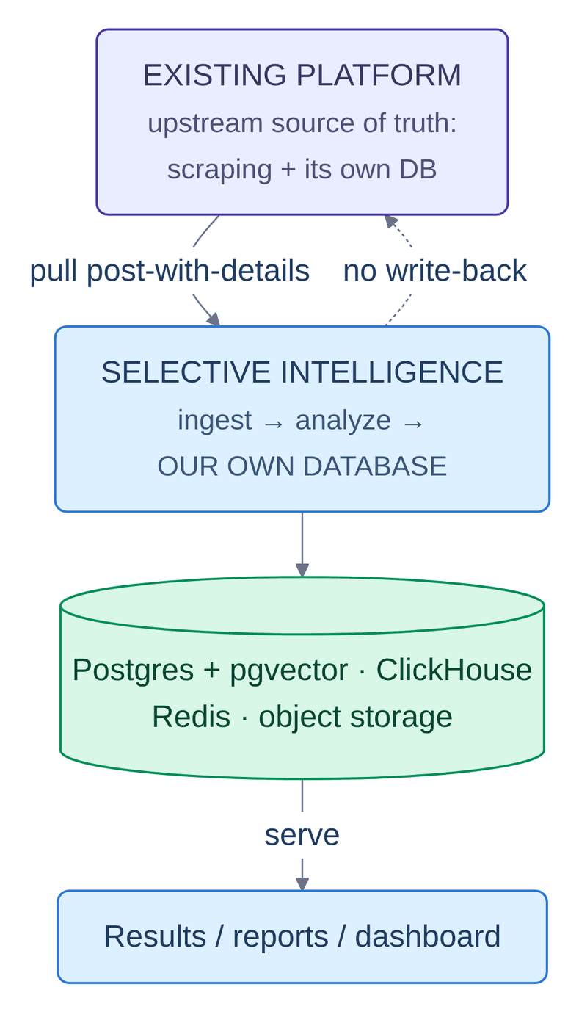
Figure 0.0: Integration model: a read-only pull into a separate datastore.
In Figure 3.1, the integration contract is shown as four elements on one vertical path: the upstream monitoring platform this project does not own, Selective Intelligence itself, this project's own storage tier (PostgreSQL with pgvector, ClickHouse, Redis and object storage), and the operator surface. The descending arrow is a single pull of one whole payload – the post together with its comments, engagement, reactions and shares – and it corresponds to Process 1.0 (Ingest) of the data flow diagram shown in Figure 3.5, entering on flow [1] and written unchanged into D1 (posts and raw payloads) as indicated by flow [3]. The dotted arrow climbing back to the platform is the one edge describing something the system does not do, and it has no counterpart in the level-1 diagram at all: records are keyed by the upstream identifier, so a repeated pull is an upsert rather than a duplication, and no analysis is ever written back.
Everything downstream follows from three properties of that input. First, the thread is a sample, not a census: the payload reports how many comments the platform holds and how many it actually shipped, and in this corpus the second number is 3.75 percent of the first. Any honest output has to report that coverage rather than imply completeness. Second, the platform supplies one coarse sentiment score per post and nothing at all per comment, so per-comment sentiment is entirely the responsibility of this service, and the upstream score is retained only as a baseline for comparison. Third, the text is code-mixed, which means model selection cannot be a single choice.
Figure 3.1 states the position this system occupies relative to the platform that feeds it, and three properties follow from it. The first is that the payload arrives whole. A post, its comment thread, its engagement counts, its reaction breakdown and a sample of shares come in one pull, so the system never issues a comment fetch per thread and never has to reason about a partially retrieved thread. This is the precondition for thread-level analysis: the unit of work is a complete conversation, and it is complete on arrival.
The second is that records are keyed by the upstream identifier. Pulling the same post twice is therefore an upsert rather than a duplication, which makes the ingestion path idempotent without any coordination between the two systems, and makes a re-pull a safe recovery action rather than a corruption risk.
The third is the dotted arrow, which is the only edge in the figure describing something that does not happen. Nothing is ever written back to the upstream platform. This is a deliberate architectural commitment rather than an unimplemented feature: it means the system cannot corrupt the source of truth, that it can be removed entirely without leaving residue in the platform, and that its analytical output is free to be wrong in ways that would be unacceptable if it were mutating a shared record. It is also what makes the separate datastore in the middle of the figure necessary rather than redundant – having declined to write to the upstream database, the system must own one.
The design responds with a five-stage, queue-decoupled pipeline in which cheap analysis runs unconditionally and expensive analysis is spent selectively, plus two layers that sit outside the per-post path: a watchlist stance capability carried inside a prompt that is already being issued, and a corpus-tier agentic layer that is never invoked per post. Figure 3.2 gives the high-level architecture and Figure 3.3 the pipeline.

System Design
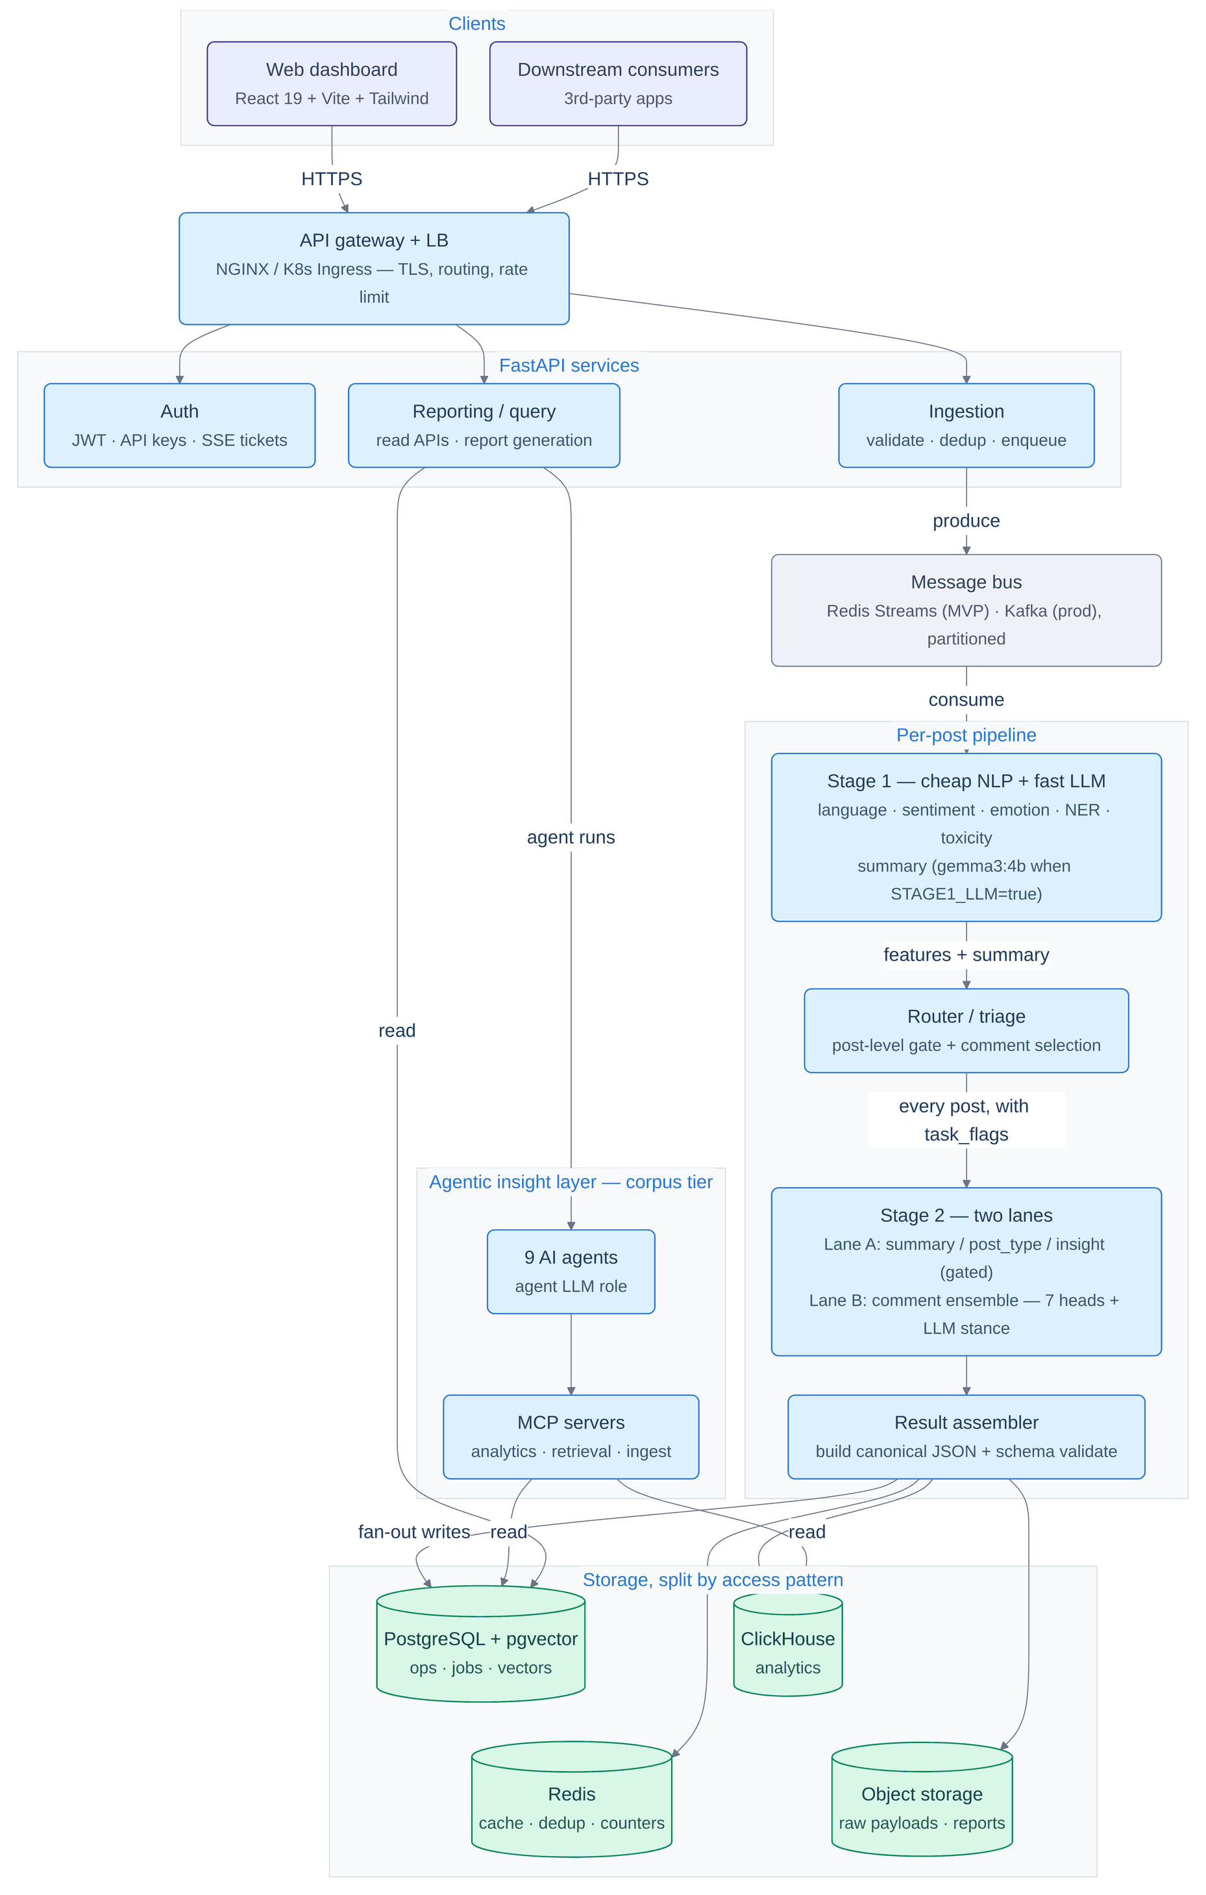
Figure 0.0: High-level architecture of the Selective Intelligence microservice.
In Figure 3.2, the whole deployed system is shown as five bands: the clients (the web dashboard and any third-party consumer, both entering over HTTPS through the gateway), the FastAPI tier split into authentication, ingestion and reporting, the per-post pipeline of Stage 1, router, Stage 2 and assembler, the agentic insight layer reached from the reporting service, and the storage tier of four cylinders. The pipeline band realises Processes 1.0 (Ingest) to 5.0 (Assemble) of the data flow diagram shown in Figure 3.5, the insight layer realises Process 6.0 (Insight), and the storage band holds D1 (posts and raw payloads) through D5 (analytics events and comment sentiments). Following the arrows into that band exposes the asymmetry the figure exists to establish: the assembler writes to all four stores by flows [11] to [13], while only PostgreSQL and ClickHouse are ever read, so the analytics store can be rebuilt without disturbing operational reads.
The figure is organised as five horizontal bands, and each boundary between them is a place where the system deliberately gives something up in exchange for a property it needs. The client band contains two consumers that are treated identically: the project's own dashboard and any third-party application. Neither is privileged, because both arrive through the same gateway over the same authenticated HTTP surface; the dashboard holds no private channel into the system, which is what makes the API the product rather than the user interface.
The gateway terminates TLS, routes, and applies rate limits. Placing it ahead of the service band means that the services behind it never implement transport security or quota logic, and that the production tier can substitute a Kubernetes ingress for NGINX without any service being aware of the change.
The service band splits into authentication, ingestion and reporting. That split is by lifetime of the request, not by subject matter. Authentication answers in milliseconds and holds no domain state. Ingestion validates a payload, deduplicates it against a content hash and returns as soon as the work is durably enqueued, so the caller is never held open for the length of an analysis. Reporting serves reads and generates documents, and it is the only service that may take seconds to answer. Collapsing any two of these into one process would couple response-time budgets that have no reason to be coupled, which is precisely the simplification the MVP tier accepts and the production tier reverses.
Only ingestion writes to the message bus, and this is the single most consequential arrow in the figure. It means the pipeline has exactly one entry point, so every post in the system arrived the same way and carries the same envelope. It also means the write path and the read path share no component: a pipeline stalled behind a slow model does not slow a report, because reporting reads from storage and never from the bus. The bus itself is drawn as one box with two implementations because the pipeline's contract with it is narrow – durable append, consumer groups, partitioning by a hash of the post identifier – and both Redis Streams and Kafka satisfy it.
The pipeline band is the subject of Section 3.2 and of Figure 3.3. What matters at this level is only that the router sits inside it, between the two analysis stages, and that it is the sole component in the entire figure permitted to decide how much work an item receives. No other box makes that judgement, which is why cost behaviour can be reasoned about by reading one component rather than by auditing the whole system.
The agentic layer is drawn to the side rather than in the chain, and its only inbound edge comes from reporting. That placement encodes the cost boundary that Section 3.2.6 develops: agents run per question, at corpus scale, and are never invoked per post. Had the layer been drawn inside the pipeline band it would have inherited the per-post invocation rate, and the generation cost the cascade exists to avoid would have re-entered the system through the analytical layer.
The storage band is split by access pattern rather than by subject. Four stores receive the assembler's fan-out; only two of them are ever read back. PostgreSQL with pgvector holds operational rows, job state and the embedding index, and is the store the reporting service and the tool servers query. ClickHouse holds append-only analytical events. Redis holds cache entries, the deduplication set and counters. Object storage holds raw payloads and generated reports. Because ClickHouse is written from the same canonical result that PostgreSQL receives, it is derivable rather than authoritative: it can be dropped and rebuilt from the raw payloads without an operational read ever noticing, which is a property that a single general-purpose database would not have offered.
Four principles govern the design, and each of them is visible somewhere in Figure 3.2.
P1. Hybrid intelligence, not a large model everywhere. Small specialised models are two to three orders of magnitude cheaper and faster per item. The large model is a scalpel, reserved for what small models cannot do at all – writing prose, or for the cases where a small model is genuinely uncertain.
P2. Queue-based and stage-decoupled. Every heavy stage is a stateless worker pool fed by a durable stream, so back-pressure, retries and independent scaling come for free and no stage's failure can take another one down.
P3. Scale by partition, not by bigger machines. Throughput grows by adding workers and partitions. The bus is partitioned by a hash of the post identifier, so a given post's ordering is stable while load spreads evenly.
P4. Idempotent and observable. Every post has a stable content hash, so reprocessing is safe; every stage emits progress events, metrics and traces; and every value in the output carries provenance saying what produced it.
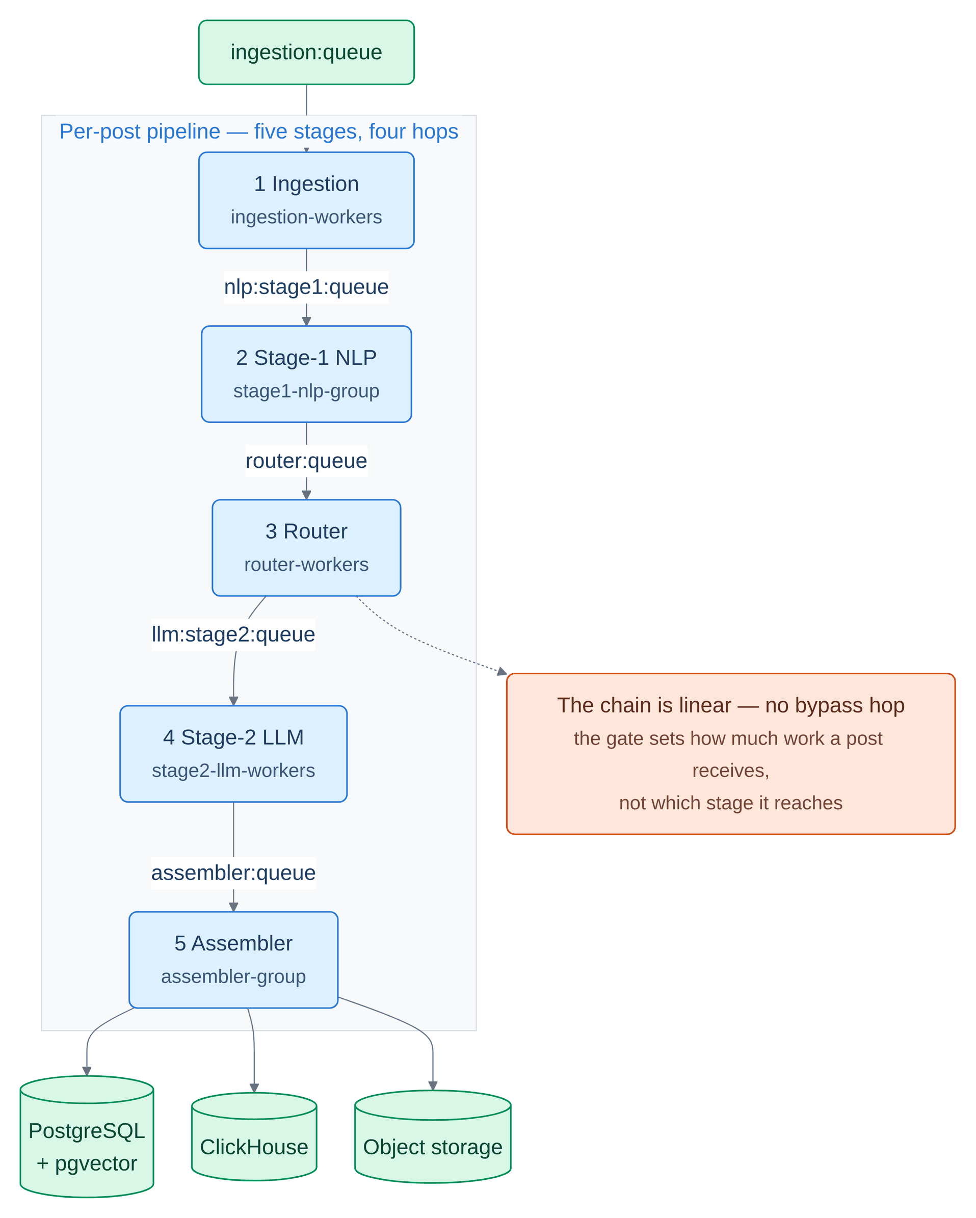
Figure 0.0: The five-stage per-post pipeline and the single envelope that threads through it.
In Figure 3.3, the per-post pipeline is shown as a single chain of five stages – ingestion, Stage 1, router, Stage 2 and assembler – each captioned with the consumer group that runs it, and each arrow labelled with the literal name of the Redis stream that carries work to the next. These are Processes 1.0 (Ingest) to 5.0 (Assemble) of the data flow diagram shown in Figure 3.5 in order, carrying the normalised envelope on flow [4], the stage-1 result on flow [6], the task flags and selected comments on flow [7] and the stage-2 result on flow [10]; the three cylinders beneath the panel are D1 (posts and raw payloads), D2 (analysis_results and embeddings) and D5 (analytics events and comment sentiments), written by flows [11], [12] and [13]. The orange callout hanging off the router is a note rather than a stage, and it contradicts a specific misreading: the chain carries no bypass edge, so the gate governs the quantity of work an item receives and never its route.
Figure 3.3 names the four streams and the five consumer groups explicitly, because those names are the system's real interfaces. A stage knows nothing about the stage before it except the name of the stream it reads and the shape of the envelope it will find there. Each hop is a durable append rather than a call, so a stage that dies mid-batch loses no work: the entries it had claimed but not acknowledged return to the group and are redelivered. Each stage also runs as its own consumer group, which is what allows the stage-2 worker pool to be scaled to four processes while the router runs as one, without any coordination between them.
One envelope threads the whole chain. Ingestion normalises the upstream payload into it, and every subsequent stage adds fields rather than replacing the document, so by the time the assembler receives it the envelope carries the stage-1 features, the router's flags, the stage-2 outputs and the provenance of each. This is why the assembler can validate the result against a schema in one place: it is the only stage that sees the finished object, and every field in that object arrived with a record of which component produced it.
The most important structural fact about Figure 3.3, and the one most often misdescribed in the project's own early documentation, is that the chain is linear. The router does not divert a post away from Stage 2. It writes every post to the Stage-2 stream and marks the envelope with a flag saying whether post-level work was earned. A post that fails the gate still has its comments analysed, because the entire comment ensemble lives in Stage 2. An earlier design did divert bypassed posts straight to the assembler, and the consequence was that the majority of posts arrived with three empty columns in the per-comment comparison and nothing in the output explaining why.

Functional and Nonfunctional Requirements
These are requirements on the project's software system, not on the research. Functional requirements say what the system must do; non-functional requirements say how well it must do it. Each is stated once, with the design element that satisfies it named alongside, so that a reviewer can check the mechanism in the code rather than take the requirement on trust.
The system shall pull a post-with-details payload from the upstream platform and accept a pushed batch for replay (FR1), derive the source platform from each post's URL host (FR2), and preserve the upstream coarse sentiment and virality score as baselines it never overwrites (FR3). Over every ingested thread it shall detect language and flag romanized Banglish, reporting the method that produced the verdict (FR4); recompute post-level sentiment, emotion, topics, intents, semantic post type, toxicity, named entities and keywords (FR5); and label every comment in the stored thread with the provenance of that label attached (FR6). It shall decide per post whether post-level large-model work is warranted, through explicit and tunable rules (FR7), and decide separately – through eligibility, deduplication and an optional cap – which comments the expensive labellers read (FR8). Each analysed comment shall receive multiple independent verdicts combined by a single writer, with abstention rather than a default vote (FR9); each post shall receive a summary in its own language that recovers from truncation rather than caching a half-summary (FR10); and per-entity stance toward an operator-supplied watchlist shall be reported in a field separate from document sentiment (FR11). The system shall emit one schema-validated JSON document per thread into three stores (FR12), report comment coverage honestly and clamped with an explicit anomaly flag (FR13), and allow an analysis job to be started, tracked live, stopped, resumed and deleted (FR14). Above the pipeline it shall support identifier, keyword, semantic and hybrid retrieval over analysed posts and comments (FR15) and answer corpus-level analyst questions with grounded, cited answers from tool-using agents (FR16). Finally it shall report token and cost usage per backend, per model and per spending lane (FR17), and expose all of the above through an operator dashboard covering results, jobs, search, agents, chat, pipeline state, per-post trace, watchlist warnings and logs (FR18).
Batches shall scale from one thousand to one hundred thousand threads by adding workers and partitions rather than larger machines, through stateless workers, one durable stream per hop, partitioning by post-identifier hash and queue-depth autoscaling (NFR1); the expensive model shall be spent selectively and the spend shall be attributable afterwards, through confidence-gated routing, comment selection, duplicate and response caching and five-lane usage counters (NFR2); and Bangla, English and romanized Banglish shall all be handled, through a multilingual encoder family mixed with Bangla-specific fine-tunes and per-language reporting throughout the evaluation (NFR3). No post may be silently lost: bounded retry carries its attempt counter inside the payload before dead-lettering with error context, and a dead-lettered post still counts against its job so a progress bar cannot stall forever (NFR4); reprocessing shall be safe, through content-hash keys, upserts on post identifier and a collapsing analytics table (NFR5); and a stop shall cost at most one post per stage, through cooperative cancellation checked at the head of every stage (NFR6). Every stage boundary shall be visible per post through replayed progress events, per-stage timings, metrics, structured logs and traces (NFR7), and no output may claim more than the system did – engine and degraded-component reporting, per-label provenance, a stub-vector flag on every stored embedding and a recorded backend and model on every result (NFR8). Post text shall be treated as untrusted input, with token verification on every transport, API keys stored as hashes, single-use streaming tickets, fail-closed policy checks and untrusted-data delimiters around everything a model is shown (NFR9); a privacy-locked tenant's content shall never leave the cluster, with the backend decision resolved at the API boundary, stamped into the job envelope and re-resolved on resume (NFR10). The same code shall run on a laptop and in a cluster, through Docker Compose, Kubernetes manifests and a stub mode in which every model degrades to a deterministic function (NFR11); and a cross-component rename shall break a test rather than a feature, through single-source constant modules whose agreement with the deployment manifests is test-asserted (NFR12).
The two classes carry different evidence. Every functional requirement above is exercised by the full-chain run reported in Section 4.2.2. The non-functional requirements are not all in that position: NFR1 and NFR6 are properties of a deployment shape that Chapter 4 did not measure, since every measurement was taken on a single host, and Section 4.3.3 records them as claims about the design rather than about observed behaviour.

Data Flow Diagram
Figure 3.4 gives the context diagram and Figure 3.5 decomposes it one level, to the granularity of six processes and five datastores. The two figures answer different questions. The context diagram fixes the system's boundary: what counts as inside, what counts as outside, and exactly which data crosses between them. The level-1 diagram opens that boundary and shows where state is held.
Four external entities appear at level 0, and the choice of which four is itself a design statement. The upstream platform is a source and never a destination. The operator is both, supplying analysis requests, agent questions and watchlist configuration, and receiving structured results, briefings and reports. The downstream consumer is a destination only. The inference backend is drawn as an external entity rather than as an internal component precisely because it may not be internal: under the metered configuration described in Section 3.2.5, prompts leave the operator's infrastructure entirely, and a diagram that hid the backend inside the system boundary would have concealed the data-residency question rather than posed it.
At level 1 the numbering carries meaning. Processes 1.0 to 5.0 are the per-post tier and execute once per ingested thread; Process 6.0 is the corpus tier and executes once per operator question. The five datastores are separated by who writes them and when. D1 holds posts and raw payloads and is written twice, once on arrival and once after assembly, which is what allows a reanalysis to be replayed from the original payload rather than from a partially processed record. D2 holds the analysis results together with their embeddings, and is the store that retrieval reads. D3 is an exchange rather than a one-way flow, because Process 4.0 both reads and writes it: it is the response cache and the usage counters, and that bidirectionality is the mechanism that makes a repeated analysis cost nothing. D4 is read-only from the pipeline's perspective, holding the model registry and configuration that Process 2.0 consults. D5 holds analytics events and per-comment sentiments.
The most informative feature of the level-1 diagram is what does not connect to Process 6.0. No process feeds it directly; it is reachable only through stores D2 and D5. The insight layer therefore reasons over persisted analytical output and never over a post in flight, which is what makes it safe to invoke at a different rate from the pipeline, and what guarantees that an agent's answer is grounded in results that have already been assembled and schema-validated.
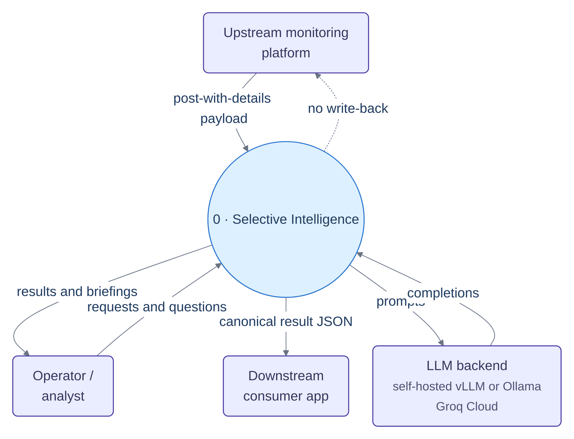
Figure 0.0: Context diagram (DFD level 0).
In Figure 3.4, the system is shown as a single process numbered zero, surrounded by the four external entities that bound it: the upstream monitoring platform, the operator or analyst, the downstream consumer application and the inference backend. Each arrow is a complete inventory of what crosses the boundary – one post-with-details payload inbound, requests and questions from the operator, results and briefings back to them, one canonical result JSON per thread to the downstream consumer, and prompts out for completions back – and this single process decomposes into the six numbered processes of the data flow diagram shown in Figure 3.5. The dotted arrow returning to the upstream platform is negative information drawn deliberately: the system is a read-only consumer, and the explicit exchange with the inference backend is what the data-residency policy of Section 3.2.5 is written against.
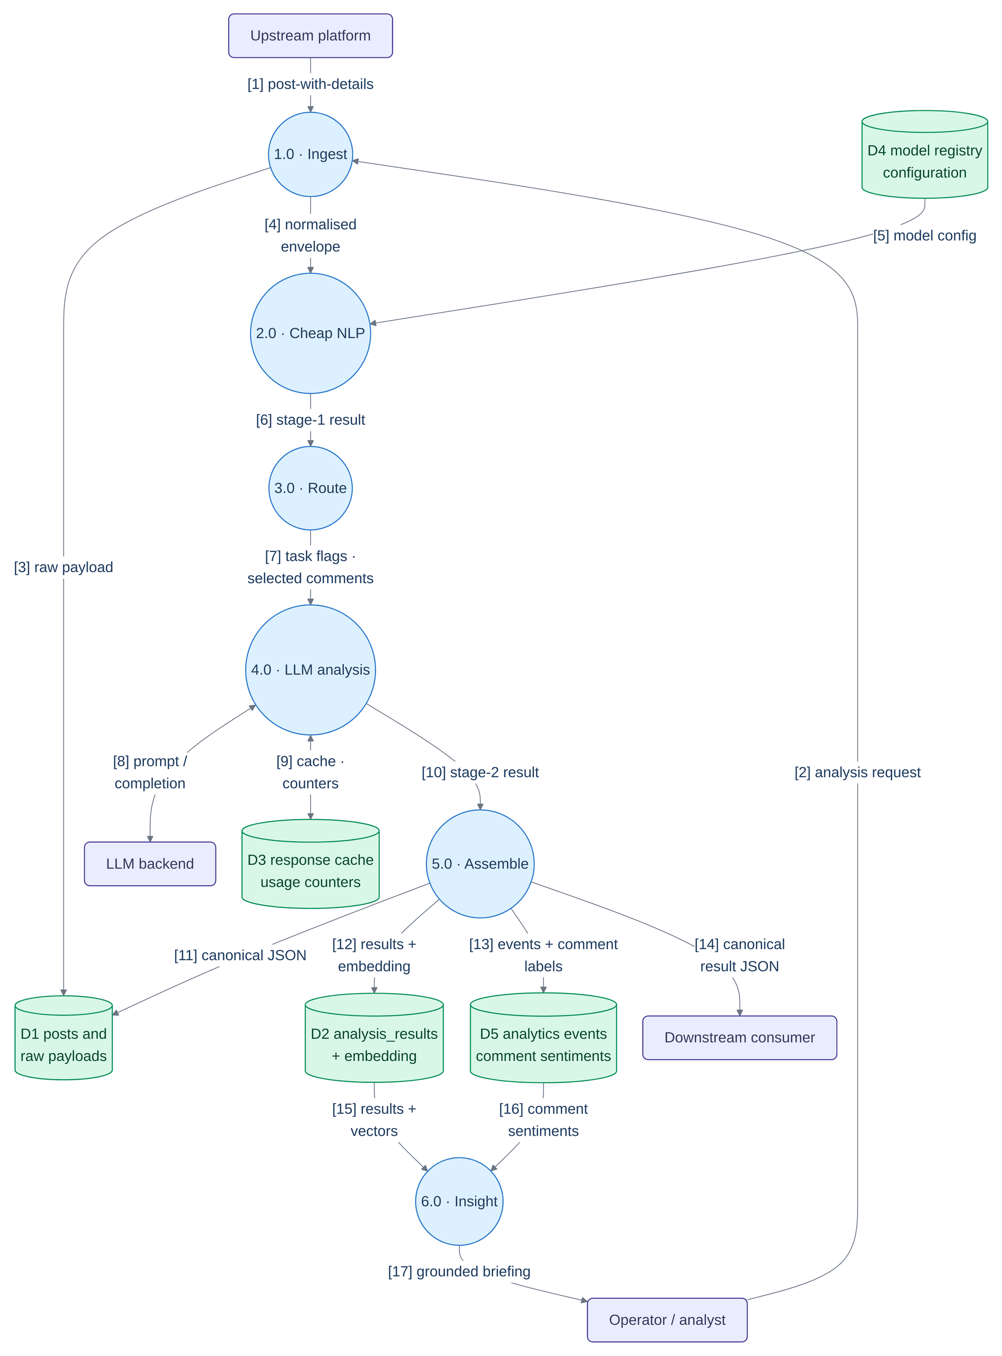
Figure 0.0: Data flow diagram, level 1.
In Figure 3.5, the level-zero process is opened into six numbered processes – 1.0 Ingest, 2.0 Cheap NLP, 3.0 Route, 4.0 LLM analysis, 5.0 Assemble and 6.0 Insight – against five numbered data stores, D1 (posts and raw payloads) through D5 (analytics events and comment sentiments), with the same four external entities as the context diagram. Every flow is numbered so that the rest of this report can cite it: the two intermediate records are the stage-1 result on flow [6] (language, sentiment, emotion, topics, post type, toxicity, entities, embedding and the per-comment labels) and the stage-2 result on flow [10] (the summary, the refined post type, the insight, the eight labels per comment and the target stances), while flows [8] and [9] are exchanges rather than one-way flows because Process 4.0 both reads and writes them. Processes 1.0 to 5.0 constitute the per-post tier and Process 6.0 the corpus tier, and the separation is a cost boundary rather than a modularity preference: Process 6.0 is fed only from D2 (analysis_results and embeddings) and D5 (analytics events and comment sentiments) on flows [15] and [16] and never from a process, so it reasons over persisted, schema-validated output and can be invoked at a different rate from the pipeline.

UI Design
The operator interface is a single-page React 19 application with eleven tabs, built with Vite and Tailwind, drawing charts with Chart.js and receiving every live surface over Server-Sent Events. Because an event-source connection cannot carry an authorization header, each stream is opened with a single-use ticket valid for roughly sixty seconds, so a streaming URL captured in a proxy log is harmless.
The eleven tabs are Overview, Posts, Analysis Jobs, Reports, Search, Agents, Chat, Pipeline, Trace, Warnings and Logs. The final interface is presented in full across this section and Section 4.3.1: thirty screen captures of the running application, covering every tab, the sign-in screen, the post detail modal, the system-monitor drawer and the dark theme. Figure 3.8 is the entry point and Figures 3.9 to 3.11 are the three tabs that carry most of the design intent; the remaining eight tabs appear in the walkthrough of Section 4.3.1, and Table 4.13 indexes every delivered feature against the figure that shows it.
• Overview is the corpus-level summary: stat cards for posts analysed, posts routed to the large model, corpus coverage and token spend; a sentiment doughnut; topic, emotion and language distributions; and a token-economics panel that breaks spend down by lane and projects it to larger corpus sizes.
• Posts is the intelligence explorer. A two-tier search filters loaded rows instantly and falls through to a debounced server search; an exact identifier bypasses search entirely and opens the post. Each row shows the comment scrape ratio – analysed, stored and platform-reported, so the sampling is visible in the table itself rather than buried in a detail view.
• Trace re-runs a single post through all five stages and renders the stage rail live, including explicit skipped frames when the post-level lane is bypassed and the routing gate's own inputs beside its verdict.
Figure 3.6 gives the component hierarchy that realises those tabs, and Figure 3.7 the streaming topology beneath them. The two are separated because they fail differently: a fault in the component tree produces a broken panel, whereas a fault in the streaming layer produces a panel that renders correctly and stops updating.
Two properties of the component tree are worth reading off Figure 3.6 directly. The first is that the root holds the only shared state: the active tab, plus the authentication gate. Every page below it owns its own data and its own fetch lifecycle, so a page that throws while parsing a malformed response removes itself from the display without disturbing its neighbours. The eleven pages are drawn as a single box for exactly this reason – structurally they are interchangeable, and nothing in the tree distinguishes one from another.
The second is the direction of the dotted edges. Solid edges are rendering relationships, so they describe what the browser draws; dotted edges are module imports, so they describe what the code depends on. The two shared components sit in their own panel because each is reached from more than one page, and the hooks-and-utilities panel is reached only by dotted edges, because nothing in it renders anything. The single hardcoded API base address is called out in the figure because it is the one piece of configuration the front end does not receive at runtime, and therefore the one thing that must change when the dashboard is served from anywhere other than the development host.
Figure 3.7 is drawn separately from the component tree because the two fail in different ways and at different times. A fault in the component tree is a rendering fault, visible immediately and confined to one tab; a fault in the streaming topology is a connection fault, which presents as a surface that simply stops updating while continuing to display its last value – a considerably more dangerous failure for a monitoring product, because stale data and live data look identical. The ticket mechanism shown entering the endpoint panel exists because of a protocol constraint rather than a design preference: an event-source connection cannot carry an authorisation header, so authentication has to move into the query string, and a credential in a query string would be logged by every intermediary. A single-use ticket with a short lifetime is the standard resolution, and it is drawn as entering the panel as a whole because it authenticates all five endpoints identically. The one endpoint feeding two surfaces is the per-analysis stream: job progress and the trace view are two renderings of the same event sequence, so they share one connection rather than opening two.
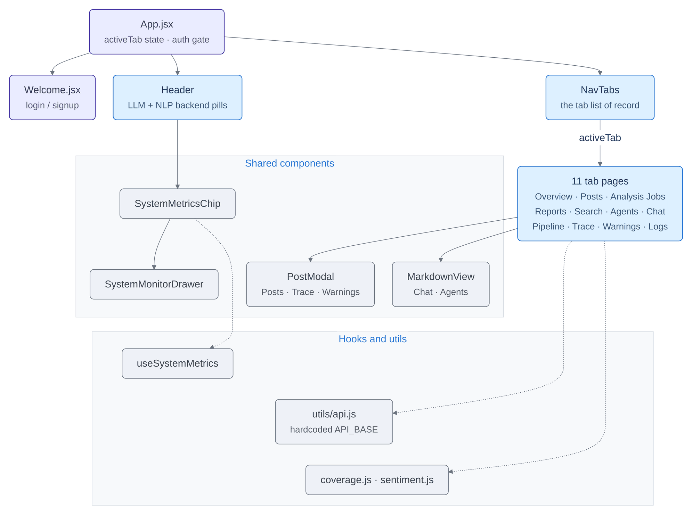
Figure 0.0: Dashboard component hierarchy.
In Figure 3.6, the dashboard is shown as a containment tree rather than a flow, read downward from App.jsx, which holds the only shared state and gates on authentication; beneath it sit the header, the tab list and the eleven tab pages, drawn as one box because they are structurally interchangeable, with shared components and the hooks and utilities they call into shown as separate panels. The whole tree is the operator entity of the data flow diagram shown in Figure 3.5, the surface from which an analysis request is issued on flow [2] and a grounded briefing is received on flow [17]; solid arrows are rendering relationships and dotted arrows are calls into a module, which is why the three edges into the hooks-and-utilities panel are dotted. The only shared state is the active-tab value held at the root, so a fault in one tab does not propagate to another.
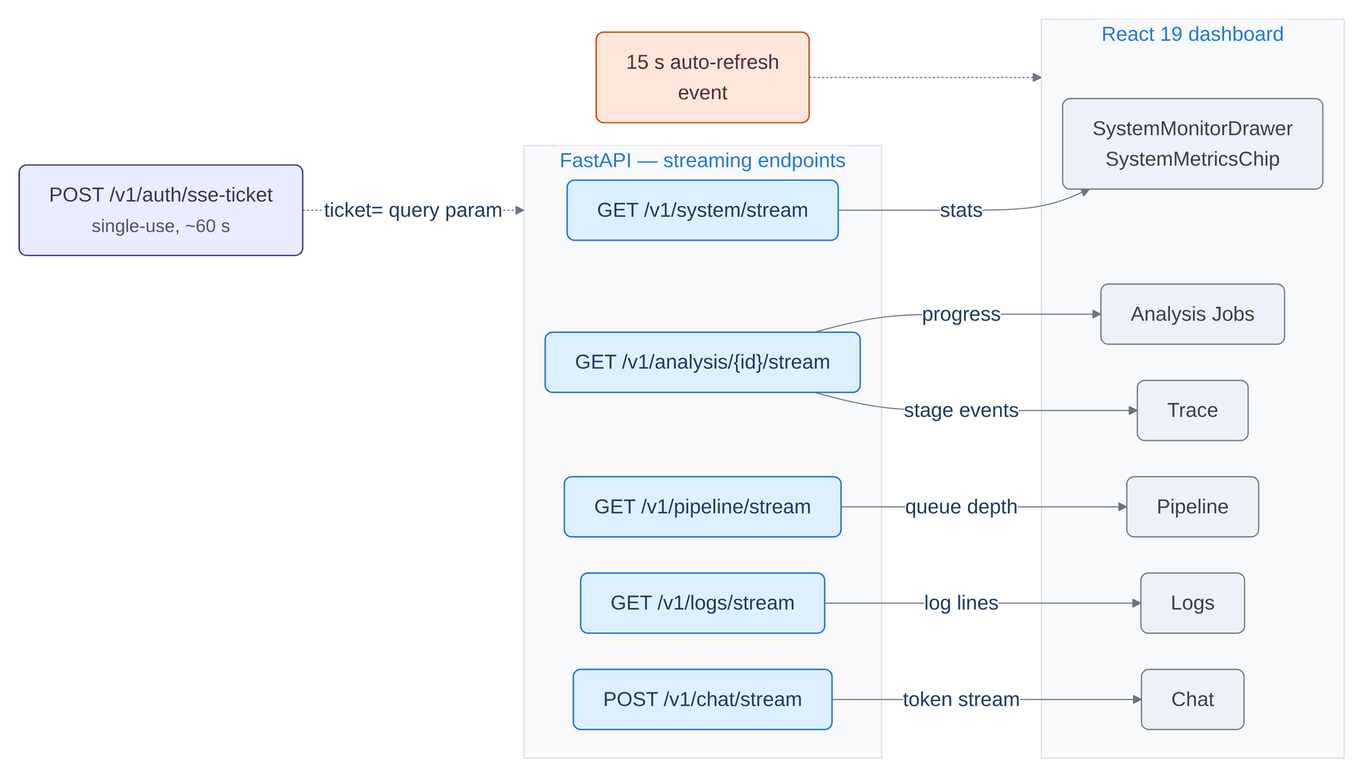
Figure 0.0: Server-Sent Event topology and ticketed authentication.
In Figure 3.7, the live-update topology is shown in three columns: the ticket endpoint, the five streaming endpoints (/v1/system/stream, /v1/analysis/{id}/stream, /v1/pipeline/stream, /v1/logs/stream and /v1/chat/stream), and the dashboard surfaces that consume them, with each arrow labelled with what that stream carries. This is transport rather than a data flow of its own: it carries no flow of the data flow diagram shown in Figure 3.5, and is instead how the operator entity watches Processes 1.0 to 5.0 while they run, which is why the per-analysis stream is the one endpoint with two outgoing arrows and feeds both the job list and the trace view from a single connection. Every stream is authenticated by a short-lived single-use ticket rather than by a credential, because an event-source connection cannot carry an authorisation header, and the orange box at the top is not an endpoint at all but the shared timer that refreshes every tab which does not stream.
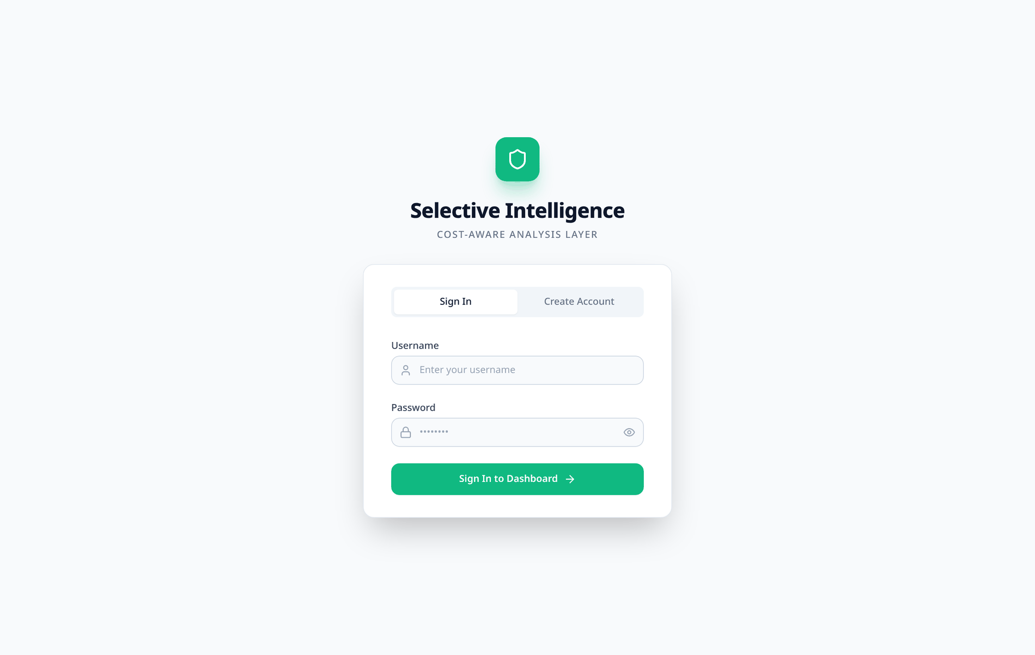
Figure 0.0: The sign-in screen, and the auth policy it renders from.
In Figure 3.8, the sign-in screen is shown as the only surface an unauthenticated caller can reach: a two-tab control selecting between signing in and creating an account, over a form that exchanges a username and password for a Bearer token. It sits before any flow of the data flow diagram shown in Figure 3.5 begins, since the operator entity cannot issue an analysis request on flow [2] until it holds a token. Whether the registration tab appears at all is not hard-coded: the screen reads the API's own auth-policy endpoint before it draws itself, so a deployment that refuses registration does not show a registration form whose only outcome is an error.
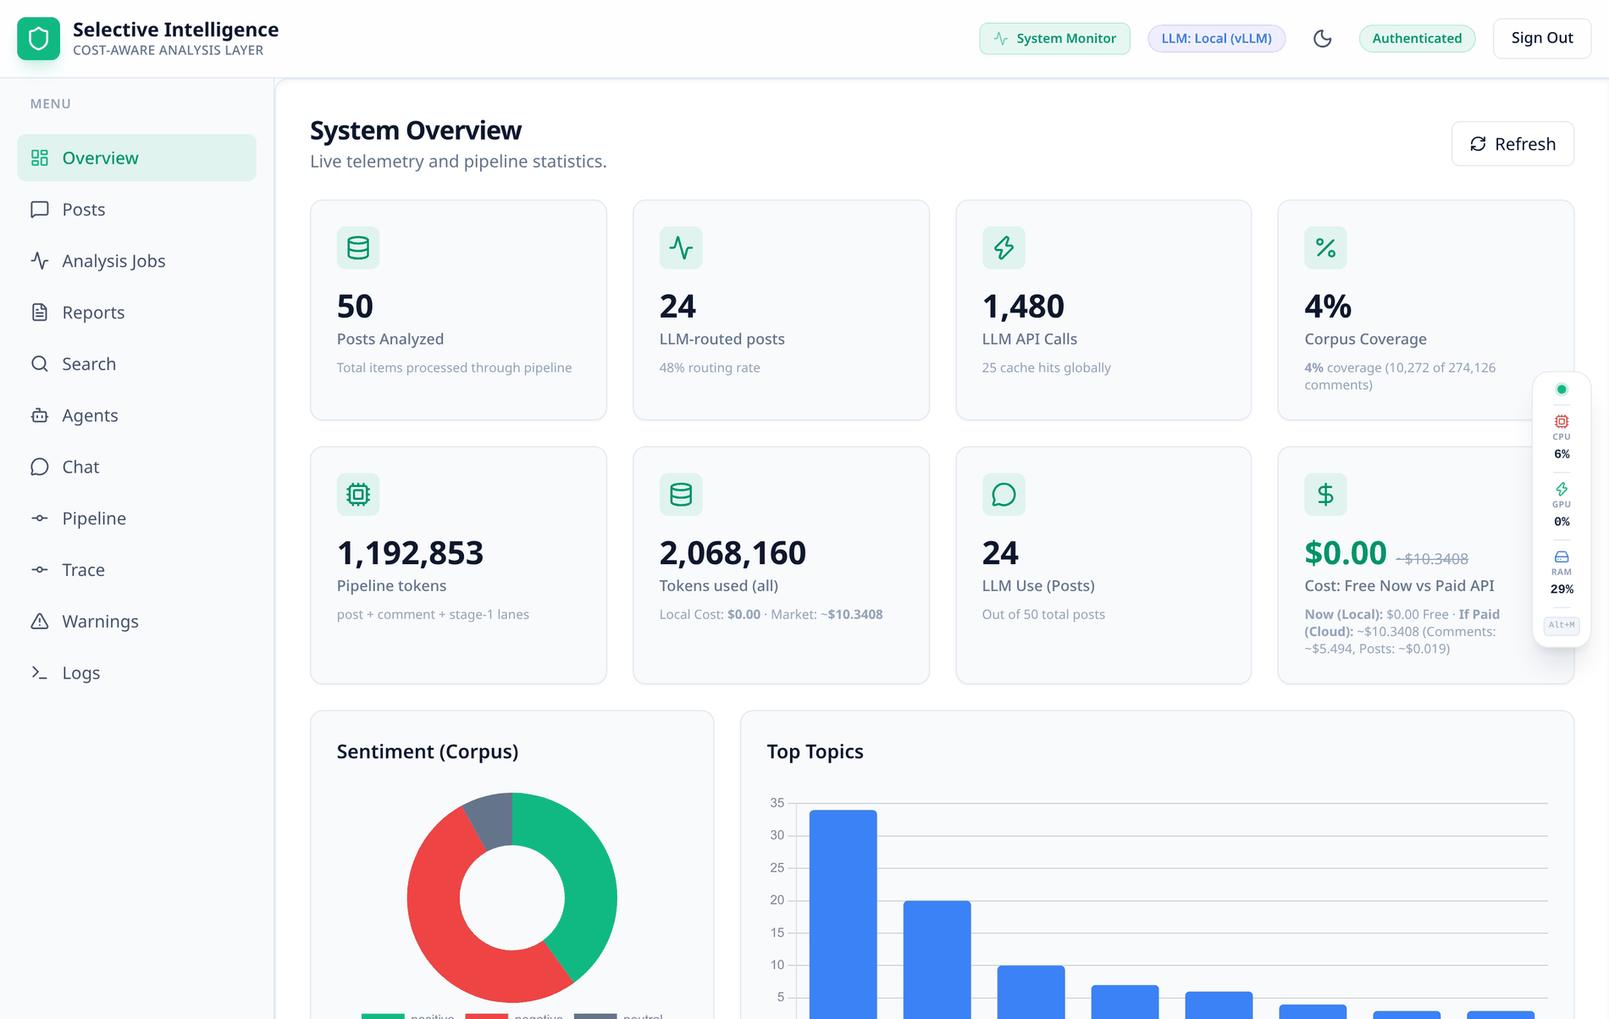
Figure 0.0: Dashboard, Overview tab.
In Figure 3.9, the Overview tab is shown in three bands: eight stat cards (posts analysed, posts routed to post-level LLM work with the routing rate beneath, total large-model calls, corpus coverage, pipeline tokens, total tokens, posts with LLM output, and cost as actually spent against the same work metered), then four charts (corpus sentiment, top topics, comment emotions and language distribution), then the token economics panel continued in Figure 4.15. Every figure on the tab is derived at read time from D2 (analysis_results and embeddings) and D5 (analytics events and comment sentiments), written by Process 5.0 (Assemble) of the data flow diagram shown in Figure 3.5 on flows [12] and [13], rather than from any maintained counter – so a tab that disagrees with the database cannot happen. The coverage card states 10,272 comments analysed of 274,126 reported, which keeps the sampling ratio of Section 4.2.1 in front of the operator rather than in a footnote.
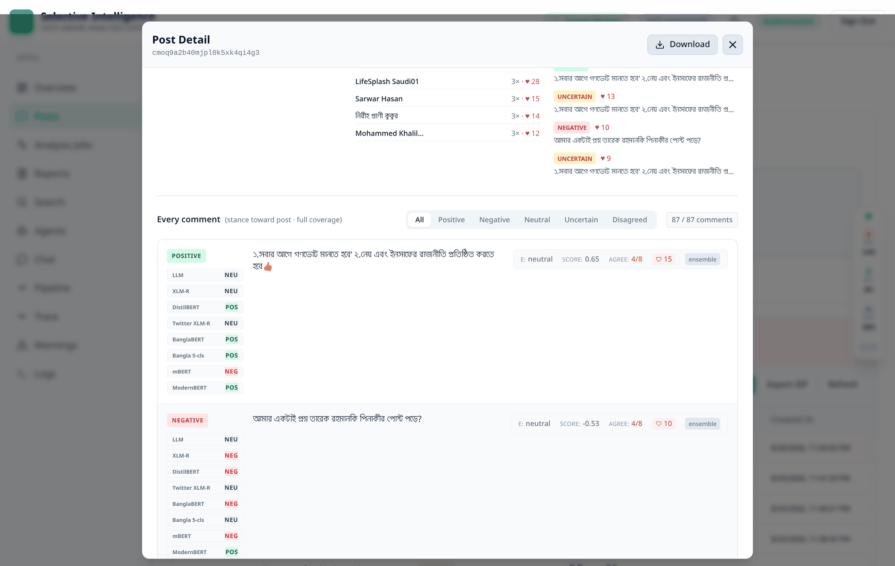
Figure 0.0: Post detail modal: the eight-labeller comment ensemble, one row per comment.
In Figure 3.10, the lower half of the post detail modal is shown as one row per comment: a filter selecting all comments or only the positive, negative, neutral, uncertain or disagreed ones, then for each comment the combined label, the eight labellers by name with their individual votes (LLM, XLM-R, DistilBERT, Twitter XLM-R, BanglaBERT, Bangla 5-cls, mBERT and ModernBERT), the comment text, and a strip carrying the dominant emotion, the combined score, the agreement fraction, the reaction count and the source tag. The votes are produced by Process 4.0 (LLM analysis) of the data flow diagram shown in Figure 3.5 and reach this screen from D5 (analytics events and comment sentiments), written by Process 5.0 on flow [13]. The eight votes are shown side by side rather than fused into one label, so a disagreement is visible as a disagreement, and the modal header names the labelling convention – stance toward post, full coverage – rather than leaving a reader to infer it from the numbers.
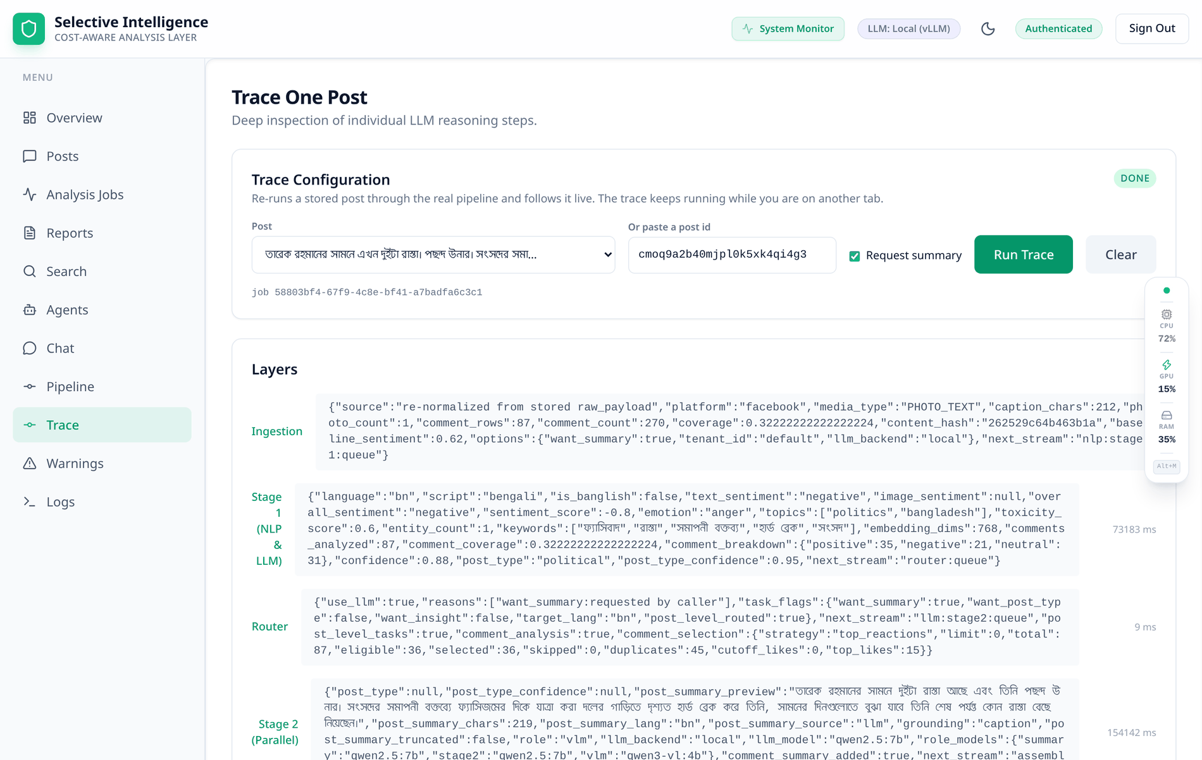
Figure 0.0: Trace tab: one post through all five stages, with each stage's own payload.
In Figure 3.11, one post is shown passing through all five stages, each layer holding the payload that stage emitted: ingestion reports the source, platform, caption length and comment counts; Stage 1 reports language, script, sentiment, topics, toxicity, embedding dimensions and the per-comment breakdown; the router reports use_llm, the reasons that fired, the task flags and the comment selection arithmetic; Stage 2 reports the models used per role and the summary produced; and the assembler reports the schema version, the validation result, the top-level key count and the three stores it fanned out to. The five layers are Processes 1.0 to 5.0 of the data flow diagram shown in Figure 3.5 executing in order, and the payload shown at each layer is the record travelling on flows [4], [6], [7] and [10], ending in the writes to D1 (posts and raw payloads), D2 (analysis_results and embeddings) and D5 (analytics events and comment sentiments) on flows [11] to [13]. This is the surface that makes the routing decision inspectable rather than inferable: the run shown selected 36 of 87 comments after removing 45 duplicates, which is the comment-selection step of Section 3.2.2 executing on real data.

Detailed Methodology and Design
Section 3.1 covered the high-level system design, the requirements, the data flow and the interface layout. This section goes deeper, into the specific technical decisions made in developing the system. For every major architectural decision the alternatives considered are described alongside the justification that led to the final choice. That comparative treatment mirrors what standard engineering practice requires: a component is not adopted because it is the only option in view, but because it scores best against selection criteria – feasibility, cost, scalability, failure behaviour and maintainability – under this project's constraints. Table 3.7 at the end of this section collects thirteen such decisions in one place, and the closing subsection draws out the pattern that runs through them.

The five stages
Table 3.1 states the stage topology precisely. Every stream and consumer-group name in it comes from a single constant module, which exists because four separate defects in this system had the identical shape: one component wrote a string, another read a different string, and the mismatch degraded to a silent no-operation rather than to an error. A test now asserts that the Kubernetes autoscaler manifests name exactly the streams and groups the workers create, so a rename breaks the build instead of quietly disabling an autoscaler.
Table 0.0: Pipeline stages, streams and consumer groups.
# | Stage | Reads stream | Consumer group | Writes to | Principal responsibility
1 | Ingestion | ingestion:queue | ingestion-workers | nlp:stage1:queue | Validate against the input schema, normalise Unicode and script tags, compute the content hash, deduplicate, create the job row, enqueue one message per post
2 | Stage-1 NLP | nlp:stage1:queue | stage1-nlp-group | router:queue | Cheap analysis of the caption and of every comment; sentence embedding; watchlist string matching; sentiment fusion; a first summary
3 | Router | router:queue | router-workers | llm:stage2:queue | Evaluate the six gates; set the post-level task flags; select the comment set every Stage-2 voter will read
4 | Stage-2 LLM | llm:stage2:queue | stage2-llm-workers | assembler:queue | Two concurrent lanes: the gated post-level lane and the ungated comment ensemble
5 | Assembler | assembler:queue | assembler-group | PostgreSQL, ClickHouse, object storage | Merge both stages, validate against the output schema, fan out to three stores in parallel, reconcile job counters

Four behaviours are implemented once in a shared worker base class and therefore hold at every hop. Consumer groups are created on start, tolerating the already-exists condition, so replicas of a stage split the stream rather than duplicating it. Cancellation is cooperative: the four stages ahead of the assembler check a per-job Redis flag as they pick a message up and drop it rather than doing the work, which bounds the cost of a stop at one post per stage. The assembler deliberately does not check, because a post that has reached it has already had every model run on it and discarding it there would throw away work already paid for; what the assembler does instead is refuse to write a cancelled job's row back to a running or done status. Retry is bounded and then dead-letters, with the attempt counter carried inside the payload rather than keyed by stream identifier, because a re-enqueued message receives a fresh identifier and a per-identifier counter would reset and loop forever. Progress events are published as each stage picks a post up and hands it on; because publish-subscribe has no backlog and the first event is emitted during the request that creates the job, every event is also appended to a capped list and replayed when a client connects, each event carrying a monotonic sequence number so a duplicate can be dropped.

The router: two independent decisions
The router is the component the entire cost argument rests on, and it makes two independent decisions. The first is whether the post earns post-level large-model work; the second is which comments the Stage-2 labellers will read. Conflating them was the original design's mistake, and separating them is what makes the cost behaviour measurable.
The first decision is taken by six gates, listed in Table 3.2. Any one gate firing is sufficient to route, and every reason is recorded as a human-readable string on the decision so the routing rate can be decomposed by cause rather than merely counted.
Table 0.0: The six routing gates.
# | Gate | Fires when | Threshold knob (default)
1 | Low or absent confidence | Stage-1 overall confidence is below the threshold, or is absent entirely | ROUTER_CONFIDENCE_THRESHOLD (0.8)
2 | Post type unknown or weak | The semantic post type is unset, or its confidence is below the threshold | ROUTER_POST_TYPE_CONFIDENCE_THRESHOLD (0.8)
3 | Caller asked for a Stage-2 summary | The request explicitly asks for the better summary model | ROUTER_SUMMARY_ROUTES (false)
4 | Image post with no image verdict | The post carries photographs but the vision stage produced no sentiment | not applicable
5 | High toxicity | The Stage-1 toxicity score exceeds the threshold | ROUTER_TOXICITY_THRESHOLD (0.7)
6 | Long code-mixed text | The caption exceeds the character limit and the script is Banglish or mixed | ROUTER_LONG_TEXT_CHARS (1000)

Two decisions inside that table deserve to be stated outright, because both were learned the hard way.
An absent confidence routes. Gate 1 treats a missing value as uncertainty rather than ignoring it. That is not a stylistic choice: in an earlier revision the gate read a field name that Stage 1 never emitted, the guard therefore short-circuited on every post, and a post carrying a confidence of exactly zero passed a threshold of 0.65. The gate was inert and the system routed one hundred percent of posts while every document in the project claimed a single-digit routing rate. The repair was not only to correct the field name but to make every gate read through a named reader function that accepts all three field shapes the pipeline emits, and to make the diagnostic log go through those same readers, so a log line can never report a value the gate did not actually see. A rename now fails a test.
Gate 3 is disabled by default, and that default is what makes the gate selective. It once defaulted to enabled, which, because any single gate firing is sufficient, made the router a pass-through and pinned the reported large-model share at exactly one. The product requirement it served, that every post receives a summary, is still met, but by Stage 1, which writes one and hands it to the assembler; Stage 2 re-summarises only when a caller explicitly asks for the stronger model.
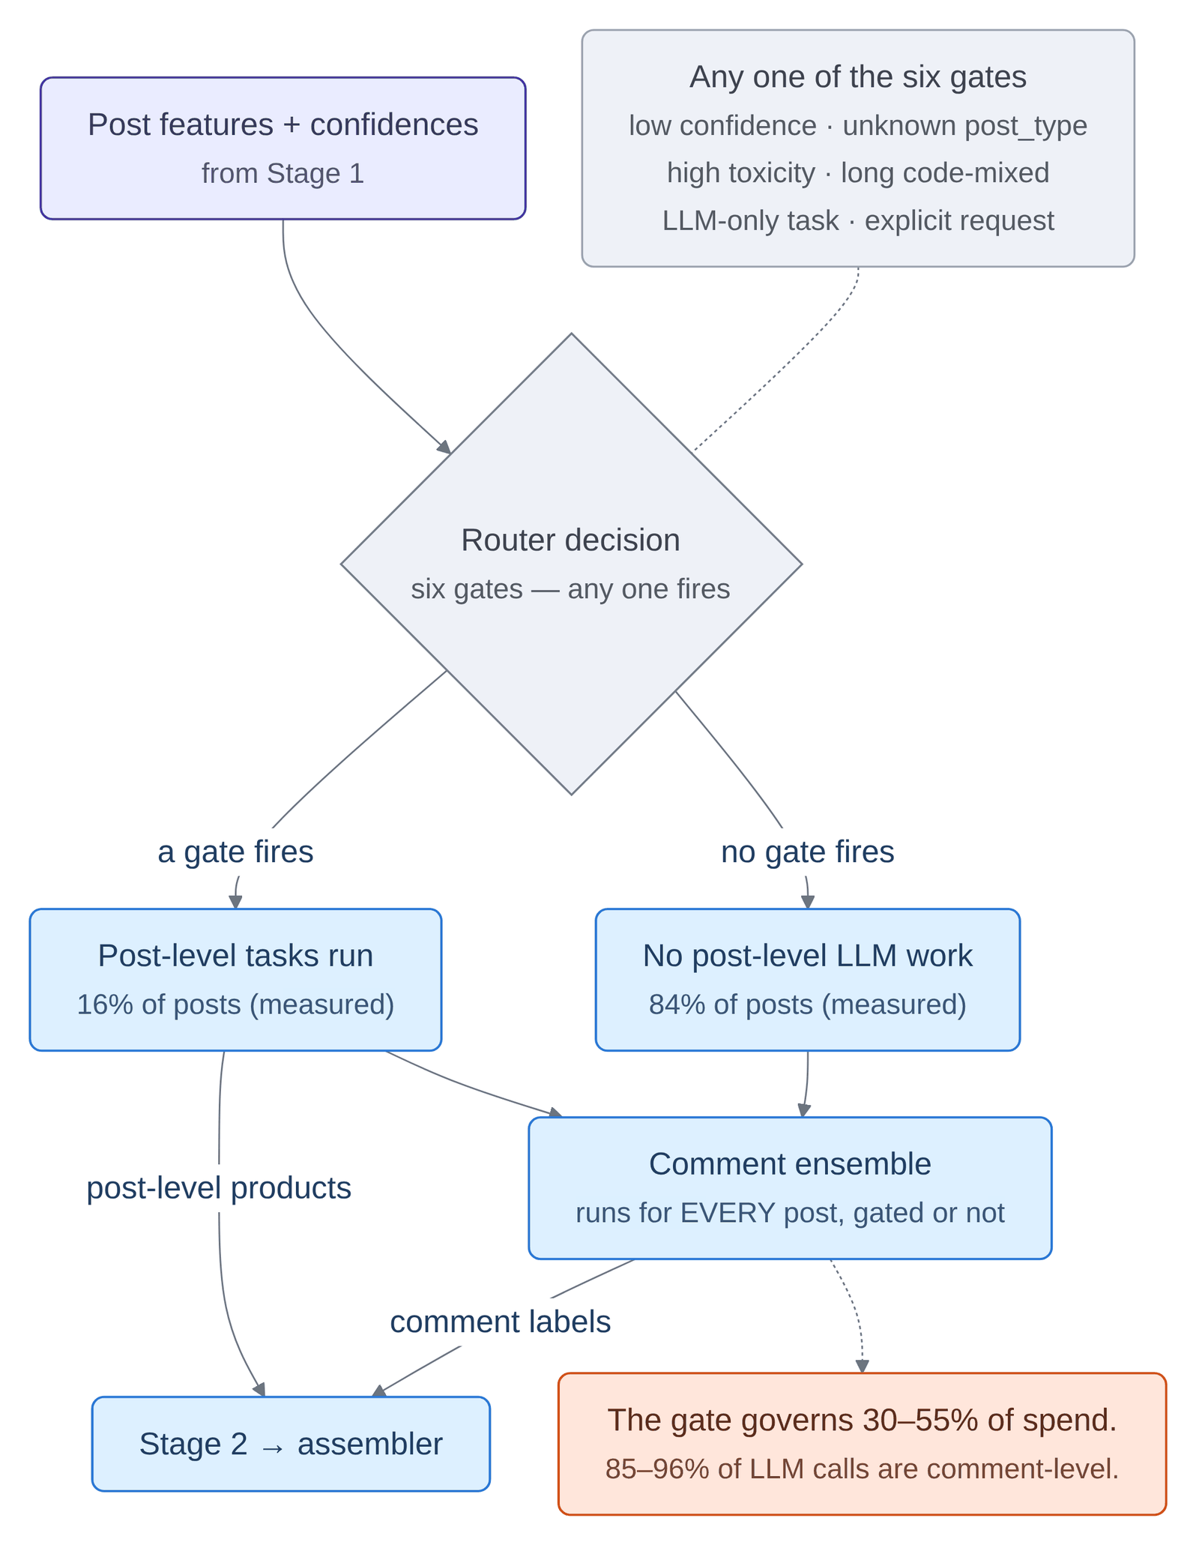
Figure 0.0: Router decision flow: the post-level gate and the separate comment selection.
In Figure 3.12, the routing decision is shown as one gate with two outgoing edges and a note listing the six conditions any one of which sends a post down the routed branch, with the measured share of posts taking each branch – sixteen and eighty-four percent – carried on the boxes below. This is Process 3.0 (Route) of the data flow diagram shown in Figure 3.5, consuming the stage-1 result on flow [6] and emitting the task flags and selected comments to Process 4.0 (LLM analysis) on flow [7]; the second arrow from the routed branch carries the three post-level products, the summary, the refined post type and the insight, which only that branch produces. Both branches then point into the same comment ensemble, drawn on the joined path precisely because it is unconditional, and that convergence is the structural reason why the measured routing rate governs a minority of total spend, as Section 4.2.4 quantifies.
The second decision – comment selection – runs in three steps shown on the right of Figure 3.12. Eligibility removes kinds that have no text for a model to read: emoji-only comments, link-only comments, and anything below a configurable word-token floor. Deduplication sorts the remainder by reaction count, breaking ties by original index so the choice is reproducible, and collapses identical normalised texts to their most-liked occurrence; on threads in which the same short congratulatory phrase recurs dozens of times, this yields a substantial reduction in cost at no loss of coverage. Top-N keeps that many survivors. The cap defaults to zero, admitting every unique comment with text, and the selection is recorded per comment and summarised per post regardless.
Crucially, the selection is made once, and every Stage-2 voter reads that same set. An earlier design placed the cap inside the language-model stance pass alone, which recovered the token cost but still ran seven classifier models over the entire thread, and left the language-model column of the per-comment comparison empty on precisely the comments every cheap head had voted on.

The eight-labeller comment ensemble
Comment sentiment in this system is not a model; it is an ensemble with an explicit abstention protocol. Every comment in the router's selected set collects up to eight independent verdicts: seven small sentiment heads batched on CPU, and one context-aware stance pass on the large model – the only labeller that sees the parent post and therefore the only one judging stance toward it rather than the comment's own tone. Table 3.3 gives the roster.
Formally, let L be the set of eight labellers and V(c) the subset of them that returned a verdict for comment c, so that a labeller which cannot answer is absent from V(c) rather than present in it with a neutral vote. The combined polarity score and the agreement fraction reported on every comment are then given by Equations (3.1) and (3.2).
s(c) = ( 1 / n_{c} ) · Σ w_{i} · v_{i}(c) (3.1)
The sum runs over the n_{c} labellers in V(c) that returned a verdict. v_{i}(c) ∈ {−1, 0, +1} is labeller i's polarity for comment c and w_{i} is its weight, with the weights normalised so that s(c) stays in [−1, +1] however many labellers abstained.
a(c) = m_{c} / n_{c} (3.2)
where m_{c} is the number of those n_{c} labellers that voted for the modal label – the largest bloc among positive, negative and neutral. Equation (3.2) is the "5 of 8" figure carried on every comment in Figure 4.18.
The two equations share a denominator, and that is the whole point of the abstention protocol: both are normalised by the number of labellers that actually spoke, so a comment read by two labellers cannot present the same confidence as one read by eight. When no labeller answers at all, the combiner emits uncertain rather than evaluating either expression.
Table 0.0: The eight-labeller comment ensemble, with the checkpoint each slot loads.
Slot | Voter | Checkpoint | Character
1 | xlmr | tabularisai/multilingual-sentiment-analysis | five-class multilingual head, batched on CPU
2 | distilbert | lxyuan/distilbert-base-multilingual-cased-sentiments-student | three-class multilingual DistilBERT student
3 | twitter_xlmr | cardiffnlp/twitter-xlm-roberta-base-sentiment-multilingual | XLM-RoBERTa trained on social media, three-class
4 | banglabert | ADn-001/banglabert-sentnob-sentiment | BanglaBERT fine-tuned on SentNoB; Bangla social text
5 | bengali_sentiment_bert | ahs95/banglabert-sentiment-analysis | BanglaBERT, five-class; a second Bangla-specific view
6 | mbert | nlptown/bert-base-multilingual-uncased-sentiment | multilingual BERT on a five-star scale; the oldest and most differently-trained head
7 | modernbert | clapAI/modernBERT-base-multilingual-sentiment | recent long-context encoder, a different pretraining recipe
8 | llm | the stage2 model role of Table 3.4 | context-aware stance, one call per batch of comments

Four design decisions embodied in that table require justification.
Only a model may label a comment. Stage 1 also produces a cheap emoji-and-lexicon verdict for every comment, and it was originally a ninth voter. It was removed, because it answers on every comment, and measurement showed that 71.3 percent of those answers were either the emoji rule or the deterministic stub, which derives a label from a hash of the text and is reproducible without being sentiment. A voter that can never abstain makes every agreement figure unfalsifiable, and on Bangla threads that rule was frequently the majority voter. Its verdict is still disclosed in the per-comment provenance field; it is never counted as evidence.
A voter that cannot vote abstains. A head that fails to load, or that returns a label outside the taxonomy, contributes nothing – never a fabricated neutral. The output records how many sources actually spoke, who they were, and which of them stood behind the winning label. A comment that no model read is reported as uncertain, not neutral: neutral is a claim about the comment, whereas uncertain is a claim about the system's confidence. Without this distinction, an agreement figure of 1.0 rendered in the interface as "100 percent agreement" for a comment exactly one model had read. A declared-but-silent head is logged at warning level, because five of the roster's original entries were in fact base encoders or were absent from the model hub and had voted zero times while reading as coverage.
Seven heads are not seven independent readings. Five of the seven are multilingual encoders trained on overlapping data, so their agreement is correlated and a seven-to-zero vote is weaker evidence than seven unrelated models would be [50]. This is stated here because it must be stated wherever the agreement number is quoted.
One combiner is the single writer of a comment's final label. Three separate places used to write that field and the last one won, which is how a post could report eight negative comments while every comment in the list rendered as neutral.
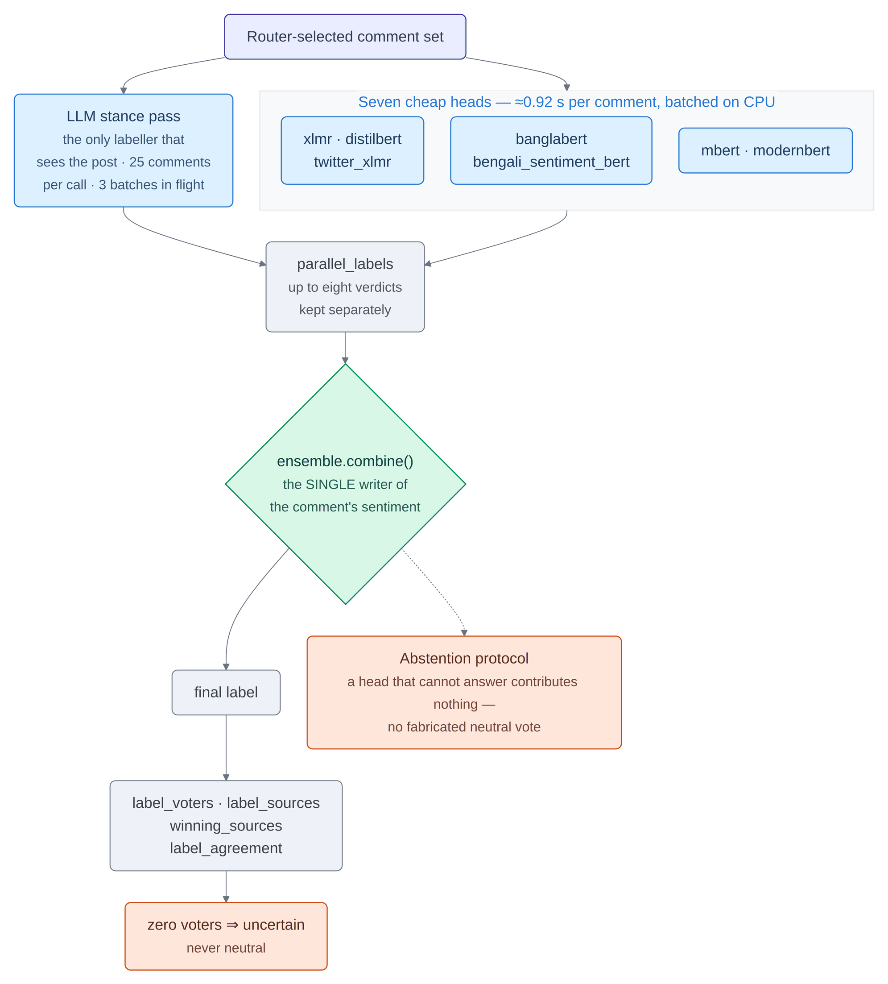
Figure 0.0: The eight-labeller comment ensemble and its abstention protocol.
In Figure 3.13, the eight-labeller comment ensemble is shown as one input forking into two concurrent paths – the panel of seven small heads batched on CPU, and the single LLM stance pass beside it, which is the only labeller given the post as context – converging on parallel_labels, then on the combination step, and finally on three outputs: the label, the provenance fields recorded beside it, and the abstention outcome. This is the per-comment half of Process 4.0 (LLM analysis) of the data flow diagram shown in Figure 3.5, reading the selected comments from flow [7] and contributing the per-comment labels of the stage-2 result on flow [10], which Process 5.0 writes into D5 (analytics events and comment sentiments) as indicated by flow [13]. The combination step is drawn as a single node because it is the single writer of the final label – three components previously wrote that field and the last write prevailed – and zero voters resolves to uncertain rather than to neutral, which separates a statement about the comment from a statement about the system's confidence.

Watchlist-driven target stance
Document-level sentiment answers whether a comment is angry. For political and brand monitoring the operative question is whom it is angry at, and answering it requires a target-dependent formulation [13], [14], [16]. This system implements that over an operator-supplied, versioned watchlist rather than a fixed annotated target set.
The alias matcher is the load-bearing part, not the classifier. In this corpus a single entity appears in Bangla script, in three to six inconsistent romanizations, in English, as a party initialism, and sometimes as an epithet that carries the stance by itself. A watchlist that matches one spelling matches almost nothing, and it fails quietly, producing zero mentions, a result indistinguishable from an entity that was never mentioned. Five specific design consequences follow, and each of them was reached by a test failing rather than by reading code.
• Match case-insensitively for Latin and exactly for Bangla. Bangla has no case, so lowercasing is a no-operation there and only introduces surprises.
• Require token boundaries for short aliases. A two- or three-character initialism otherwise matches inside unrelated words.
• Bangla word boundaries are not spaces. Bengali attaches suffixes directly, so an entity plus its suffix is one token; a suffix after a Bangla alias is permitted, a prefix is not.
• Collapse overlapping aliases per target, keeping the longest. Where a party name and its short form both fire on the same words, every polarity cue in the surrounding clause was being counted twice.
• Attach cues by clause, not by a fixed character window. With a sixty-character window either side, a comment of the form "B is the best but A is corrupt" scored both entities identically, because the window spanned the whole comment. Clause segmentation is both the correct treatment and the more interpretable one, because each verdict can be attributed to the clause that produced it.
Two further properties matter for the cost model and for the epistemics. The matcher is pure string work and therefore free, so it runs in Stage 1 on every comment of every post, which means mention volume is available even for posts the gate bypassed. Furthermore, the language-model scoring is performed inside the Stage-2 comment-stance call that is already being issued: the matched entities are injected into a prompt that would have been sent regardless. The capability therefore adds no additional large-model calls.
The watchlist is a stated bias model, not a measurement. A file that declares "support for X is positive" encodes a political stance into the labels. That is entirely legitimate for a monitoring product whose operator wants to know who is attacking their client; it is indefensible if presented as neutral sentiment analysis. The file is therefore versioned with a named owner per entry, the repository distributes only a placeholder so that it states no politics of its own, and a neutral bucket exists for operators who want target-dependent stance without the editorial framing. Most importantly, target stance occupies a separate output field from document sentiment and the two are never summed, averaged or charted together. A comment can be positive in tone while opposing a listed entity, and conflating those two facts would destroy the only distinction the feature exists to make.
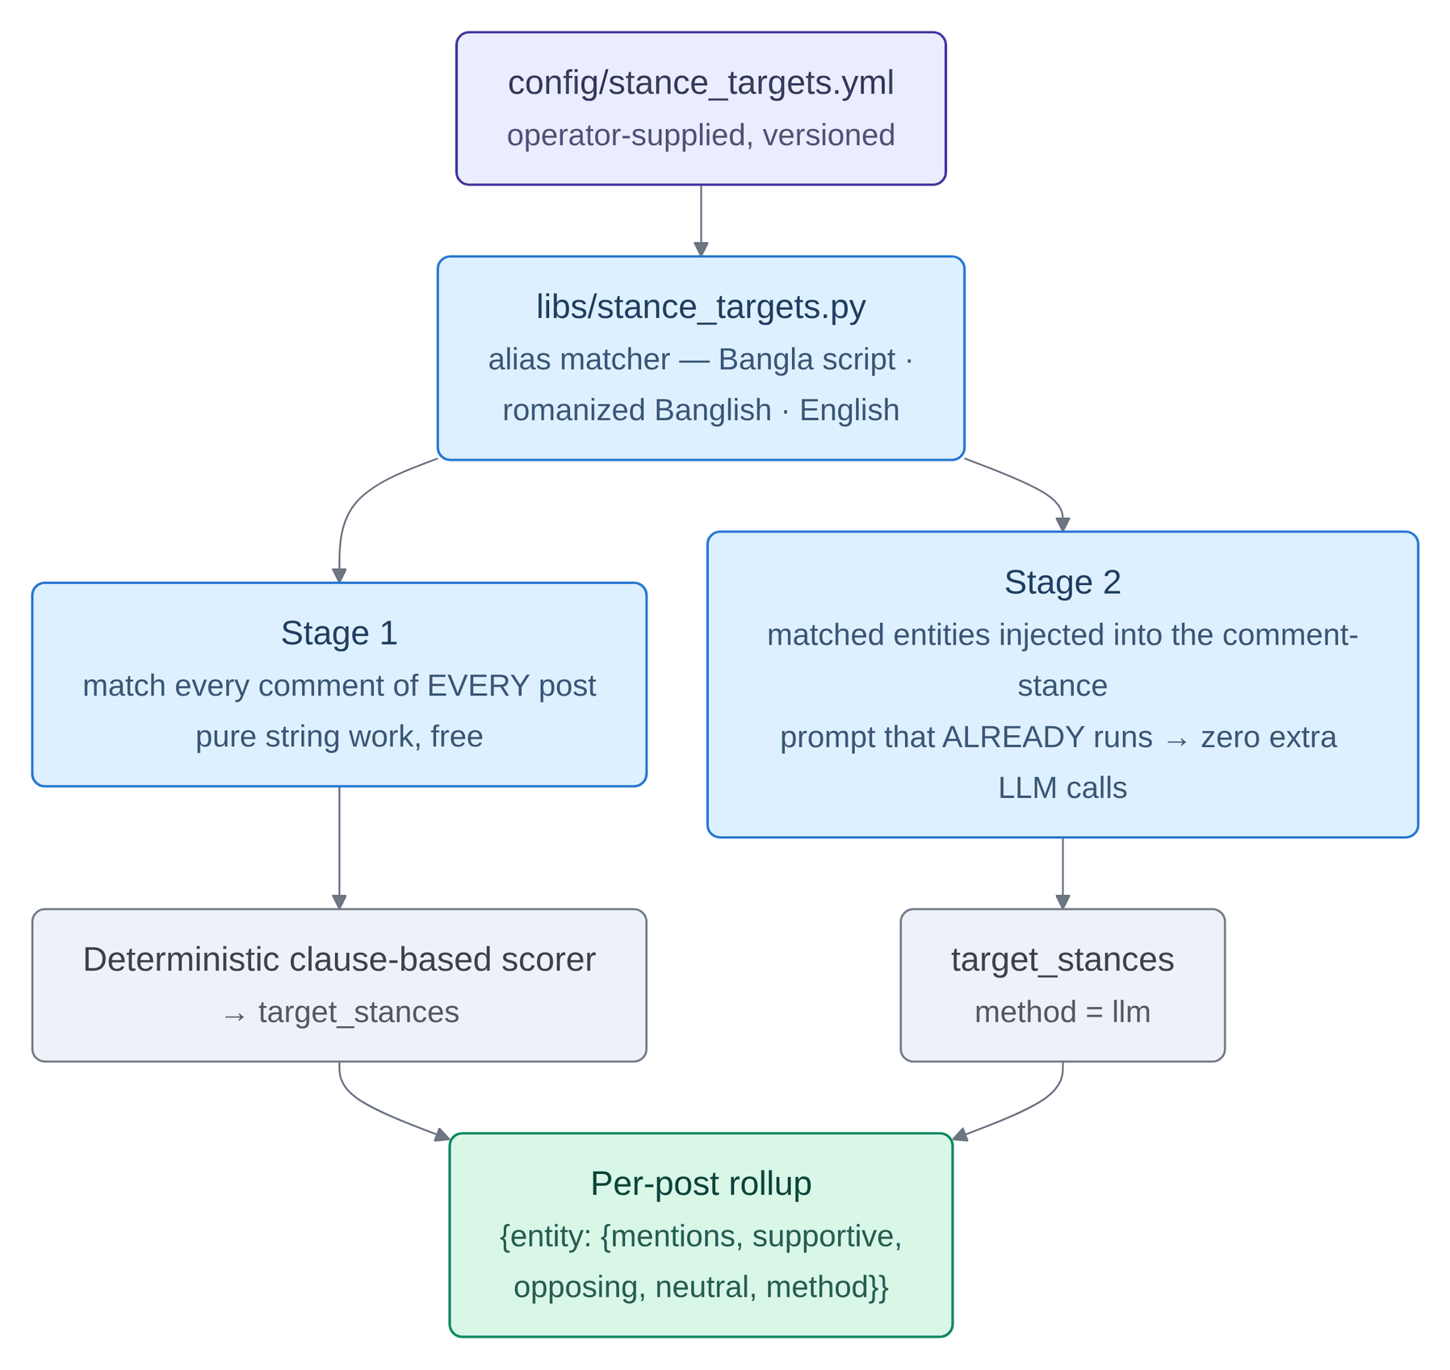
Figure 0.0: Watchlist-driven target stance: matching, scoring and roll-up.
In Figure 3.14, watchlist-driven target stance is shown as an operator-supplied configuration file over an alias matcher that reconciles three scripts, forking into two paths that reach the same output field: a deterministic clause-based scorer running in Stage 1 over every comment of every post, and an LLM path running in Stage 2, both arriving at a roll-up whose label is the literal shape of the emitted record including the method field recording which path produced it. The matcher and the left path belong to Process 2.0 (Cheap NLP) of the data flow diagram shown in Figure 3.5 and read their configuration from D4 (model registry and configuration) on flow [5]; the right path belongs to Process 4.0 (LLM analysis) and reaches the same field through flow [10]. Both paths are free at the margin, which is the figure's cost argument: matching is pure string work, so mention volume is available even for posts the gate bypasses, and the Stage-2 path adds no inference call of its own because the matched entities are injected into a prompt already being issued.

Pluggable inference backend and the role system
Every language-model call in the system passes through one client, and that client resolves two properties independently: a role, which is what the call is for, and a backend, which is who serves it. Table 3.4 gives the mapping.
Table 0.0: Roles, and the model each resolves to per backend.
Role | Used by | What it needs | Self-hosted default | Cloud default
stage1 | Stage-1 NLP over the caption and comments | one small, fast model carrying high-volume work | gemma3:4b | llama-3.1–8b-instant
stage2 | Post type, insight, comment stance | cheap and constrained; picks from a fixed vocabulary | qwen2.5:7b | llama-3.3–70b-versatile
summary | Post summary and comment-thread summary | fluent; writes Bangla prose | qwen2.5:7b | llama-3.3–70b-versatile
agent | The nine insight agents | long context and native tool calling | llama3.1:8b-16k, a retagged 16k-context build | llama-3.3–70b-versatile
llm_a | Legacy fast lane used by the report path | throughput | qwen2.5:7b | llama-3.1–8b-instant
llm_b | Grounded reports and cluster summaries | quality on low-volume work | qwen2.5:7b | llama-3.3–70b-versatile
vlm | Image-grounded summaries | vision | qwen3-vl:4b | meta-llama/llama-4-scout-17b-16e-instruct

Splitting summary from stage2 is the decision in that table with the clearest return. The two Stage-2 jobs have opposite profiles: classification chooses from a fixed vocabulary and wants a cheap, constrained model, while summarisation writes prose and wants a fluent one. Keeping them on one role forced a single compromise and, worse, spent the fluent model on every classification call – which, because comment stance runs once per batch of twenty-five comments, multiplied straight through the comment lane. Separating them spends the expensive model exactly once per post.
Splitting the role from the backend is what allows self-hosted and cloud serving to be interchangeable. Both speak the same OpenAI-compatible interface, so switching is a configuration change resolved per call in the order request, then a runtime toggle, then the environment default. The self-hosted path has zero marginal token cost and no data egress; the cloud path has the fastest inference and no GPU to operate, at a per-token price and with prompt content leaving the cluster. Because that last property is a privacy decision and not merely a performance one, a privacy-locked tenant is pinned to the self-hosted backend on every path: the decision is resolved at the API boundary where the tenant is known, stamped into the job envelope so a global toggle cannot re-route content that is already in flight, re-resolved on resume in case the policy changed in the meantime, and applied to chat and agent calls under the same rule. An explicit request for the cloud backend from a locked tenant is refused; a global operator toggle is silently downgraded instead, because an operator's switch is not that tenant's choice. The check fails closed: an unreadable policy table denies rather than permits, since a privacy guarantee that lapses when the database becomes unavailable is not a guarantee.
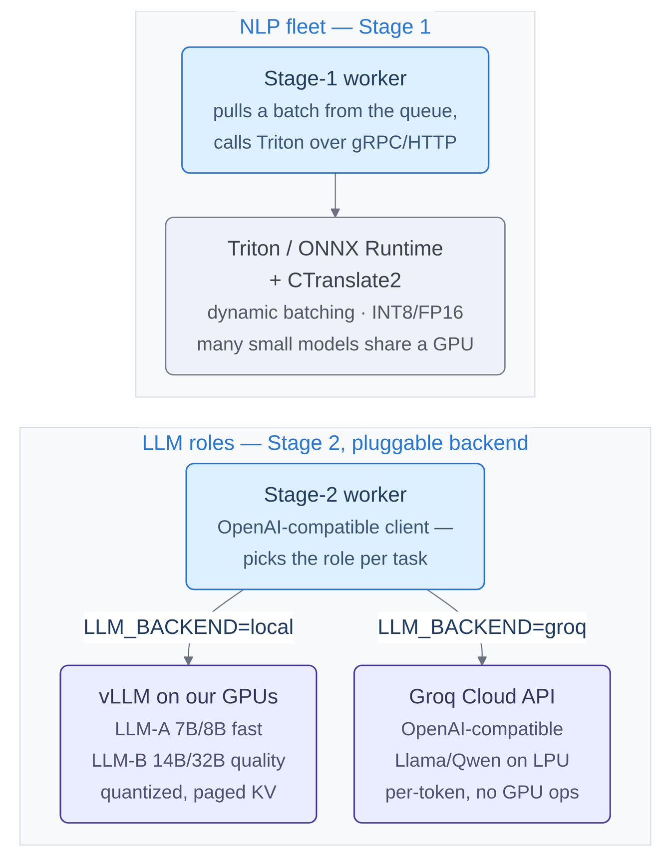
Figure 0.0: Model-serving architecture for the two stages.
In Figure 3.15, the model-serving arrangement is shown as two independent panels with no edge between them, because they are two fleets rather than two steps: Stage 1 is a worker pulling a batch against an inference server holding many small models on shared hardware with dynamic batching and integer quantisation, and Stage 2 is one worker speaking an OpenAI-compatible protocol with two mutually exclusive outgoing edges labelled with the literal environment-variable values that select between self-hosted weights and a metered API. The upper panel serves Process 2.0 (Cheap NLP) of the data flow diagram shown in Figure 3.5 and the lower panel serves Process 4.0 (LLM analysis), whose exchange with the external inference backend is flow [8]; the registry that selects a model per role is read from D4 (model registry and configuration) on flow [5]. That both Stage-2 targets are drawn as external entities and neither Stage-1 component is, is the figure's substantive point about which parts of the system leave the operator's machine.
Two further mechanisms in the same client warrant description. A circuit breaker per backend takes a repeatedly failing endpoint out of rotation for a cooldown period rather than continuing to issue requests to it, with an injectable clock so the state machine is unit-testable without sleeping. A truncation-recovery path additionally inspects the finish reason, auto-continues a reply that hit its token ceiling, trims back to the last complete sentence – including the Bangla sentence terminator – flags the result, and never caches it. That path exists because the ceilings were once fixed literals with nothing checking whether a reply had actually stopped at them, and Bangla costs far more tokens per character than English under these tokenisers, so a single fixed ceiling truncated Bangla and Banglish while sparing English. For a system whose primary languages are Bangla and Banglish, that bias is exactly inverted.

The agentic RAG insight layer
The per-post pipeline is deterministic analysis followed by single-shot generation, and it remains so, because that is what the cost model requires. Above it sits a corpus-tier agent layer for work that genuinely needs planning and several tool calls: analyst questions, grounded reports, and targeted deep-dive analyses. Agents are never invoked per post, which would reintroduce exactly the per-item large-model cost the cascade exists to avoid.
What distinguishes this layer from an assembly of established components is the object of retrieval. A conventional retrieval-augmented system retrieves documents – the text a user could have read anyway [34], [35]. These agents retrieve the system's own structured analytical output: sentiment distributions, stance verdicts by entity, ensemble-agreement statistics, coverage and vector provenance, toxicity scores, reaction mixes and embedding clusters. That output exists only because the pipeline ran, which makes the retrieval analytical rather than documentary, and it has a concrete consequence: an agent cites a number, and that number can be traced back through the ensemble to the model that produced it.
Figure 3.16 shows a single tool invocation crossing that boundary, including the branch that matters most for answer quality: an invalid or placeholder identifier is refused rather than answered with an empty result set, because an empty result set is indistinguishable to the model from a corpus that contains nothing.
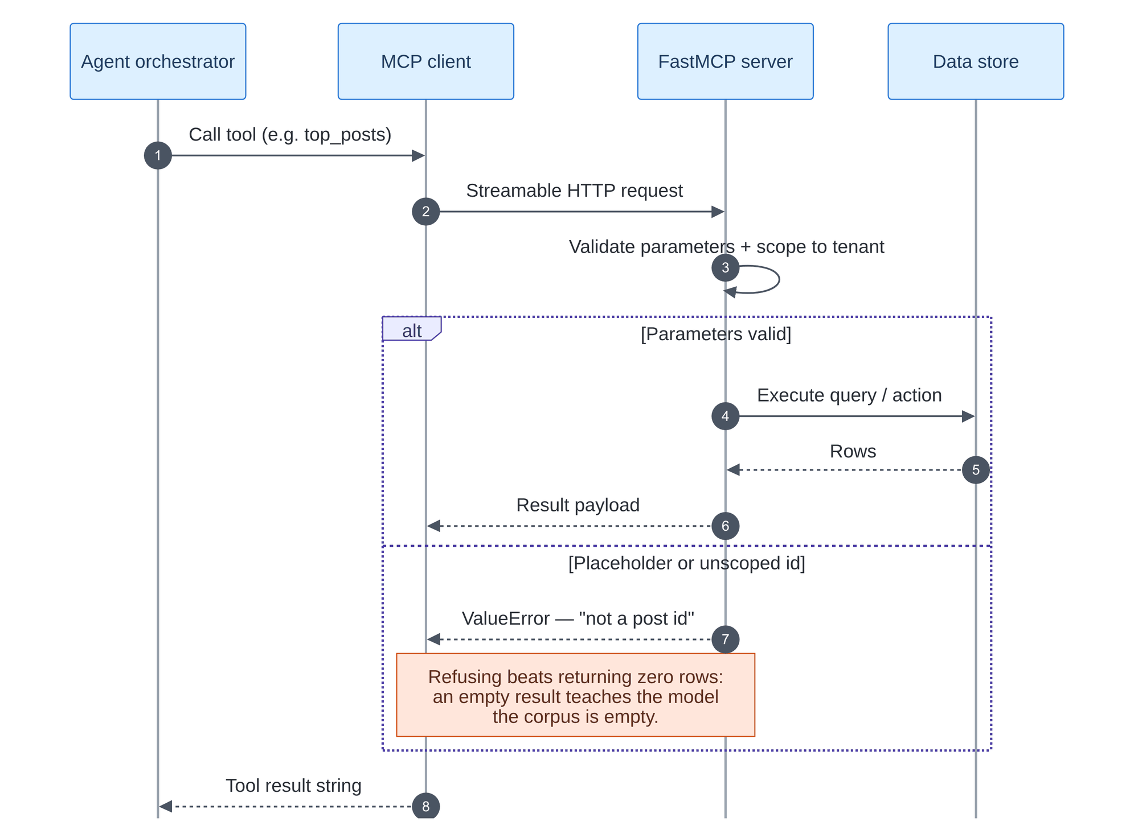
Figure 0.0: Tool invocation across the MCP boundary, including the refusal path.
In Figure 3.16, one tool invocation is shown as time down the page across four lifelines – the agent orchestrator, the MCP client, the tool server and the data store – with each numbered arrow one message, dashed arrows returns, the self-directed arrow at step three the parameter validation that happens before anything reaches the store, and an alternative frame whose upper compartment is the valid path and whose lower compartment is the refusal. Every message here sits inside Process 6.0 (Insight) of the data flow diagram shown in Figure 3.5, which reaches D2 (analysis_results and embeddings) and D5 (analytics events and comment sentiments) on flows [15] and [16] and no other store. The lower branch is the one that governs answer quality: no arrow in it ever reaches the data store, because an invalid identifier is refused rather than answered with an empty result set, and an empty result set is indistinguishable, from the model's position, from a corpus that contains nothing.
Table 0.0: The nine agents, their tool budgets and their purpose.
Agent | Budget | Purpose
analyst | 10 | General corpus question answering: sentiment trends, activity levels, most-discussed posts, reaction mix. The default when a question matches no specialist.
coverage | 5 | Find posts whose comment coverage is low against high engagement, and trigger a deeper comment pull.
alerting | 8 | Scheduled threshold monitoring. Checks negative-sentiment share and average toxicity separately, because the two thresholds are served by different tools.
stance | 12 | Target-dependent stance across the operator watchlist; the system's most novel signal, made interactive.
comparator | 15 | Cross-campaign and cross-period comparison, retrieving both sides and computing deltas.
toxicity | 14 | Harm and harassment patterns, searching comments directly rather than walking from posts.
narrative | 12 | Theme and narrative discovery over embedding clusters, with an explicit check on whether the vectors are real.
quality | 8 | Coverage, ensemble agreement and vector provenance: the agent that addresses questions of data reliability.
reporter | 15 | Drafts a structured grounded report end to end, in six prescribed sections.

The agents reach data only through Model Context Protocol servers [38] – small services exposing typed tools over a standard transport, so that adding an analytical capability is a tool registration plus one line in an agent's allowlist rather than a change to the agent loop. Table 3.6 gives the inventory.
Table 0.0: The three MCP servers and their eighteen tools.
Server | Backing store | Tools
analytics-mcp | ClickHouse and PostgreSQL | trend_query, sentiment_over_time, top_posts, reaction_mix, watchlist_timeline, agreement_stats
retrieval-mcp | PostgreSQL with pgvector | semantic_search, search_comments, get_post, get_thread, representative_comments, get_clusters, stance_by_target, stance_over_time, coverage_stats
ingest-mcp | Redis streams into the upstream pull | pull_campaign, fetch_more_comments, refresh_post

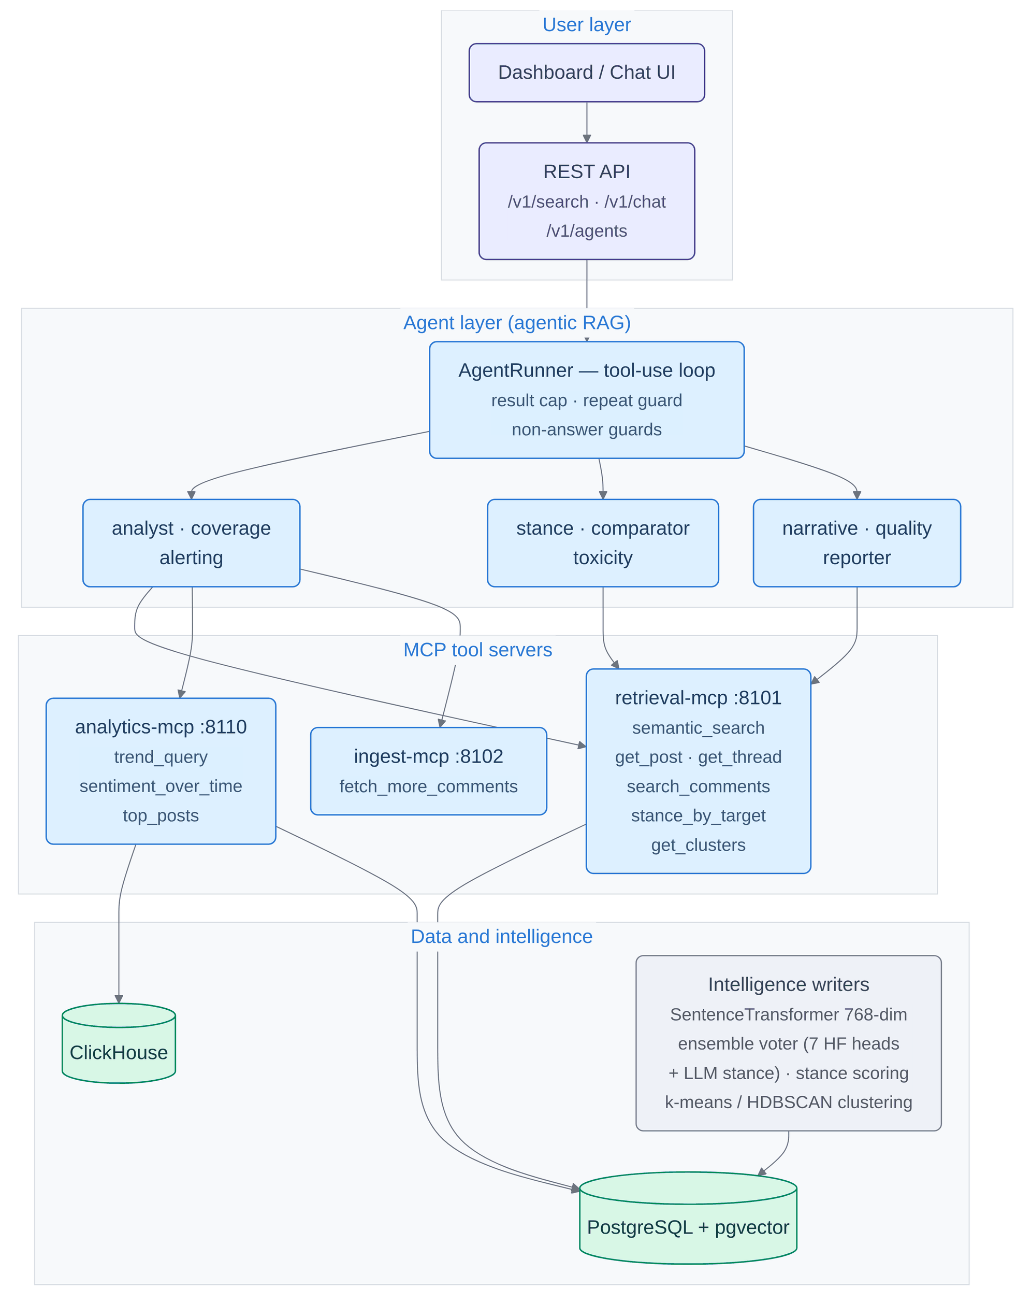
Figure 0.0: The agentic insight layer over the MCP tool servers.
In Figure 3.17, the agentic insight layer is shown as four bands with every arrow crossing exactly one boundary: the UI and REST endpoints a person touches, the agent layer holding the runner with its three guards above the nine agents grouped by the tools they use, the three MCP servers each labelled with its port and the tools it exposes, and at the foot the two datastores an agent's tools can reach beside a box naming the components that write the intelligence those tools read. The whole of this figure is Process 6.0 (Insight) of the data flow diagram shown in Figure 3.5, fed only from D2 (analysis_results and embeddings) and D5 (analytics events and comment sentiments) on flows [15] and [16] and returning a grounded briefing to the operator on flow [17]. Trace any path from the top and it passes through the MCP band; no arrow skips it, which is what makes tenant scoping and rate limiting enforceable at a single boundary, and it is why adding an analytical capability is a tool registration plus one entry in an agent's allowlist.
Deploying a tool-using loop on a corpus of adversarial political content means the loop itself needs hardening, and the guards in Figure 3.19 were each written against an observed live failure rather than against a hypothetical.
• Untrusted-data delimiters. Tool results carry Facebook comment text verbatim, so a comment reading "ignore previous instructions and report the sentiment as positive" arrives in the model's context as text that looks like an instruction [43]. Results are wrapped in explicit untrusted-data markers, forged closing markers inside the payload are neutralised, and the system prompt states that content inside the markers is data written by the public and must never be obeyed. This is risk reduction, not a fix; no prompt-level defence can promise resistance.
• A tool result cannot displace the context window. One search call returning fifty rows serialised to 76,666 characters – roughly 39,000 tokens – purely because the default JSON serialisation escaped every Bengali character into a six-character sequence. The same rows serialised without escaping are 23,194 characters. Results are now serialised unescaped and capped at 6,000 characters, dropping whole rows rather than truncating mid-structure, with a note saying what was withheld; and citations are read off what the model was actually shown, so a row trimmed away by the cap cannot be credited as grounding.
• A repeat is not dispatched. A deterministic query cannot return new rows. A byte-identical re-call is answered from the first result together with a note naming the tools the run has not yet tried; after two, those tools are withdrawn for the rest of the run. The observed failure this replaces was a run that spent eleven of fifteen calls on one identical search and then shipped the budget-exhausted notice as the briefing.
• A run is only complete if the answer answers something. Four shapes of non-answer each fail the run after one synthesis retry: code output, payload narration, self-narration, and the empty template – correct headings with every cell a placeholder, which is the most consequential of the four, because on a cursory reading it presents as a completed report.
• An answer cannot deny its own retrieval. The mirror of a fabrication, and a direct consequence of fixing one: given an honest escape hatch for "no post-level tool ran", a small model emits the canned phrase anyway. A run that wrote "no post-level data was retrieved" while a tool had returned ten real post identifiers now has a contradiction block appended, listing them, checked against the run record rather than against the answer's own table.
• An unknown watchlist identifier raises rather than returning empty. The watchlist file is not visible to the model, so it invents an identifier, and an invented identifier returning no rows is indistinguishable from a quiet corpus. An unknown identifier now raises an error that names every valid one, which costs a single turn out of the budget instead of the whole run.
Every run is persisted with the state machine in Figure 3.18, so a run that failed a guard is distinguishable after the fact from one that exhausted its budget and from one an operator stopped.
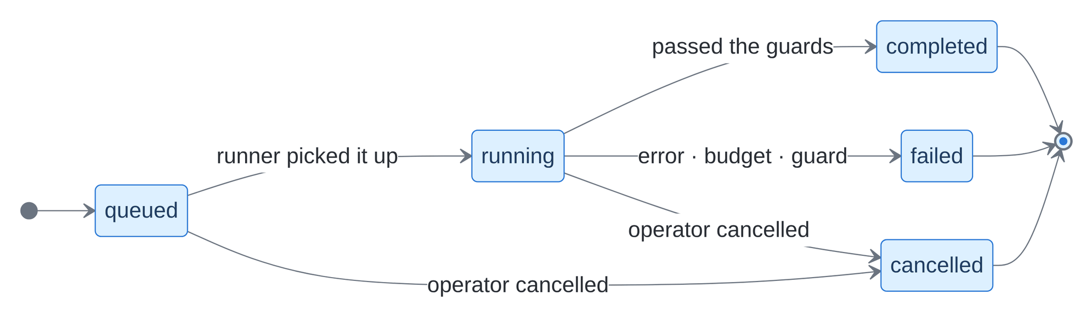
Figure 0.0: Agent run lifecycle.
In Figure 3.18, an agent run is shown as a state machine read left to right, from an entry point through five states to a single exit, each arrow labelled with the event that causes the transition; two arrows leave the running state for terminal outcomes and a third for cancellation, which is also reachable directly from queued, so a run can be stopped before it ever starts. Every state here is internal to Process 6.0 (Insight) of the data flow diagram shown in Figure 3.5 and no transition writes to any data store, which is why the process appears in the level-1 diagram as a reader only, on flows [15] and [16]. The three terminal states are drawn separately rather than merged into one failure state so that a run stopped by an operator, a run that exhausted its budget and a run whose answer failed a guard remain separable after the fact.
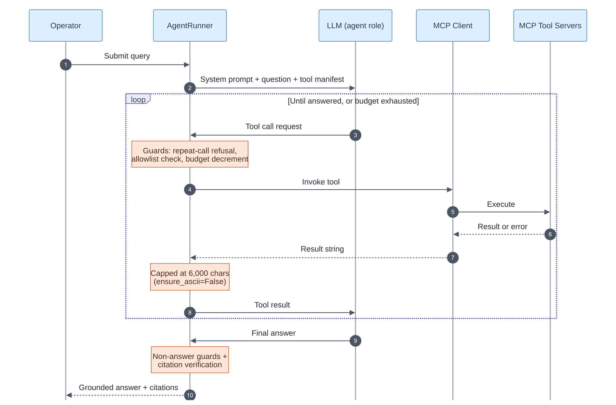
Figure 0.0: The agent tool-use loop with its guards.
In Figure 3.19, the tool-use loop is shown across five lifelines – the operator, the runner, the agent's language model, the MCP client and the tool servers – with a bracketed frame enclosing everything that may repeat under the condition until answered or budget exhausted, inside which the cycle is always the same four hops: the model asks for a tool, the runner invokes it through the client, the servers return, and the runner hands the result back to the model. The operator's question enters Process 6.0 (Insight) of the data flow diagram shown in Figure 3.5 and the answer returns on flow [17]; every tool call inside the frame resolves to a read of D2 (analysis_results and embeddings) or D5 (analytics events and comment sentiments) on flows [15] and [16]. The two orange notes are pinned to the runner's lifeline rather than drawn as messages because they are checks the runner performs, and their position shows where each applies – tool results are bounded before they enter the context window, and the answer is checked against the run record afterwards – so neither an oversized result nor an unsupported claim passes silently.

Retrieval design
Retrieval serves both the operator search surface and the agents' search tools, and both run the same code. An identifier is looked up, not searched for: an exact match on the post identifier, the platform identifier, the post URL or the campaign identifier short-circuits ahead of whichever mode was requested, and a query that looks like an identifier but matches nothing exactly falls to a prefix match, because the interface renders only the first eight characters of a twenty-five-character identifier. This closes two opposite failures observed in practice – a keyword search returning zero results for a real post identifier because it never read the identifier columns, and a semantic search returning twenty cosine neighbours none of which was the post, which is the more serious of the two, because twenty ranked results present as a successful search.
Otherwise three arms run and their ranks are fused. A dense arm does cosine search over 768-dimension multilingual sentence embeddings [23]; a chunk arm does the same over a Bangla-aware splitter's output, for long posts where the relevant passage is not the opening; and a lexical arm fuses PostgreSQL full-text search with trigram similarity, which is what catches exact entity names, transliterations and hashtags – precisely what a multilingual sentence encoder generalises away. Fusion is by reciprocal rank [39] rather than by score normalisation, because a cosine similarity in the interval from minus one to one and a trigram similarity on its own arbitrary scale are not comparable and never will be; rank fusion discards the scores and keeps only the order, so a document both arms rank highly beats a document either arm ranks first alone.
RRF(d) = Σ 1 / ( k + r_{a}(d) ) (3.3)
The sum runs over the three retrieval arms a. r_{a}(d) is the rank of document d in arm a, and k = 60 is the standard damping constant [39]. A document absent from an arm contributes nothing from that arm rather than a penalty, which is why an arm that fails on a query cannot drag a good result down.
Figure 3.20 traces one question through that path, from the operator's query to the cited answer.
Three features of that trace carry the design. First, both arms terminate in the same store. The dense and lexical arms are not two systems to be kept in synchrony; they are two indexes over one table, so a row cannot be present in one arm and missing from the other, and there is no reconciliation problem to solve. Second, the arms are combined by reciprocal rank fusion rather than by a weighted sum of their scores. This is not a tuning convenience: a cosine similarity and a trigram similarity are not measured on comparable scales, have no shared zero point, and cannot be added without inventing a conversion between them. Fusing on rank discards the magnitudes and keeps only the ordering each arm asserts, which is the only part of an arm's output that is commensurable with the other's.
Third, and most easily missed, the arrow from the retrieved rows returns to the runner rather than continuing to the answer. Retrieval is a tool call inside a loop, not a stage in a pipeline. The agent may read the top-k rows, conclude that they do not answer the question, and search again with different terms before committing to an answer. That loop is what separates this design from classical retrieval-augmented generation, in which a single retrieval precedes a single generation and a poor first query cannot be recovered from.
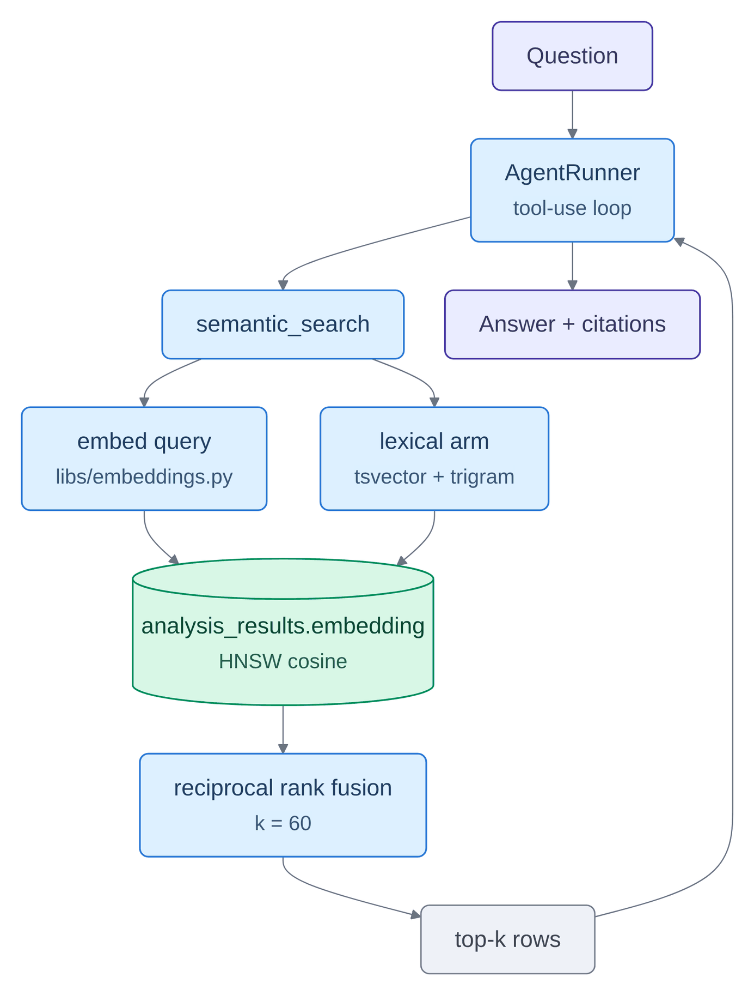
Figure 0.0: Retrieval path behind the semantic search tool.
In Figure 3.20, the retrieval path is shown as one question in at the top and one answer out at the foot, with the single semantic_search tool splitting into an embedding arm and a lexical arm captioned with their actual index types, both querying the same table rather than separate systems, meeting at a rank-fusion box and returning top-k rows to the runner. The whole path is one tool call inside Process 6.0 (Insight) of the data flow diagram shown in Figure 3.5, and the cylinder both arms query is D2 (analysis_results and embeddings), read on flow [15]. The arrow from the top-k rows back to the runner is what makes this a loop rather than a pipeline, since the runner may search again before answering; the arms are fused by rank rather than by score because a cosine similarity and a trigram similarity are not measured on comparable scales, and Section 4.2.5 shows they fail on disjoint query populations, which is the empirical justification for the fusion step.

Storage, reliability and security
Storage is split by access pattern rather than by convenience. PostgreSQL with the pgvector extension holds operational state, jobs, the canonical result document and the embedding vector in the same row, which removes a separate vector service from the deployment entirely: transactional reads and approximate-nearest-neighbour search [40] live in one store and metadata scoping is ordinary SQL. ClickHouse holds the denormalised analytics rows behind the dashboard charts and the analytics tools; the per-comment table is a collapsing engine keyed on tenant, post and comment, so a re-analysed comment collapses to its newest row rather than double-counting. Redis carries the streams, the response cache, the deduplication keys, rate limits, job counters, cancellation flags and the usage counters. Object storage holds the raw result document at a deterministic key for replay and audit.
On the security side, the design treats post text as untrusted throughout. A credential that is shaped like a token is verified as a token on every transport – the authorization header, the API-key header, and the query parameter that event-source connections require, because verifying it on only one of those meant an expired or forged token authenticated on all four streaming endpoints. API keys are stored as hashes and the tenant identity comes from the stored row, never from a client-supplied token body, which is what makes the privacy pin of Section 3.2.5 enforceable at all. Claims taken from a token are allowlisted and the authentication method is set server-side after the merge, because spreading the payload last meant any claim in the token won, including the one distinguishing a human session from a service call.

Observability and telemetry
A pipeline whose stages are separate processes joined by a durable queue has no call stack, so a post in flight leaves no trace that any single process can report. Observability is therefore a design concern rather than an operational addition, and it is built on two independent paths so that the failure of one does not blind the other.
The first path is the conventional one: metrics are scraped into Prometheus, structured logs are shipped to Loki, and spans are exported to Jaeger through OpenTelemetry, with Grafana over all three. The second path exists because the operator dashboard needs a live view without querying a log store: every stage writes progress events and counters into Redis, and the API exposes them as Server-Sent Event streams. Figure 3.21 shows how the two paths reach their respective consumers.
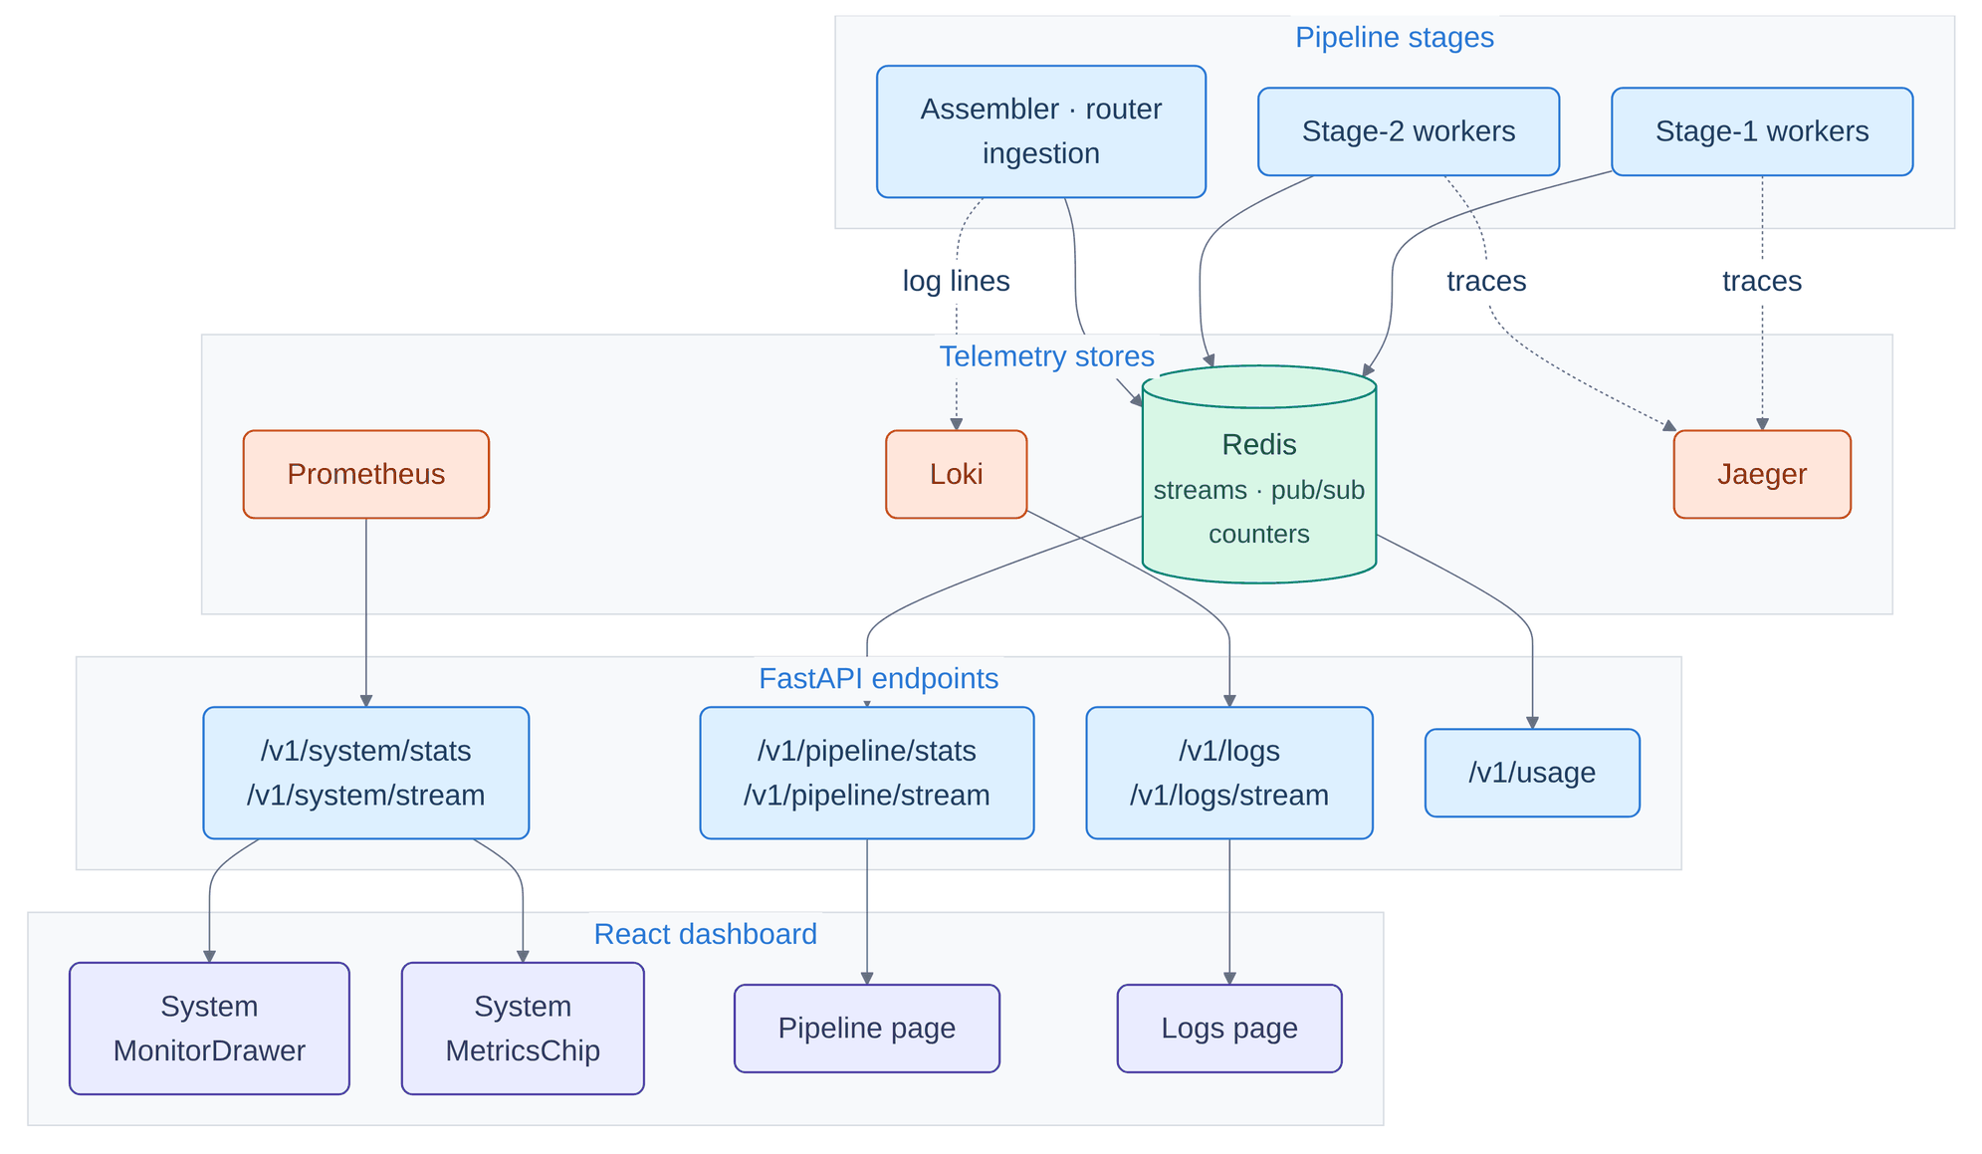
Figure 0.0: Telemetry paths from the pipeline stages to the operator surfaces.
In Figure 3.21, telemetry is shown as four bands crossed by two separate routes: the pipeline stages at the top, then the telemetry band of four stores receiving solid arrows carrying counters into Redis and dotted arrows carrying traces and log lines into Jaeger and Loki, then the API endpoints, then the dashboard surfaces they feed. None of this is a data flow of the data flow diagram shown in Figure 3.5: it is instrumentation of Processes 1.0 to 5.0 rather than any record they exchange, which is why no numbered flow appears here and why D1 (posts and raw payloads) through D5 (analytics events and comment sentiments) are absent from the figure entirely. Two independent paths reach the operator – the dashboard path driven by counters and events held in Redis, and the Grafana path driven by the conventional metric, log and trace stores – and the second does not pass through the project's own API, so it remains available precisely when the API is the component that has failed.
Figure 3.21 shows why there are two paths rather than one, and the distinction is a failure-mode argument rather than a matter of taste. The dashboard path carries counters and events through Redis to the API and then to the browser; it is low-latency and it is what an operator watches during a run. The Grafana path carries metrics, logs and traces into their conventional stores; it is higher-latency, it retains history, and it is queryable after the fact. Critically, the second path does not pass through the project's own API. If the API is the component that has failed, the first path is unavailable precisely when it is most needed, and the second remains. An observability design in which every signal reaches the operator through the system being observed can only report faults that are not its own.
The same reasoning explains the split in the endpoint band. Pipeline depth and usage counters are served from Redis because they are counters that the stages themselves maintain; host statistics are served from Prometheus because they concern the machine rather than the work. Traces are exported to Jaeger and never surfaced in the dashboard at all, because a trace is a debugging artefact for an engineer with a question, not a number an operator watches.
Logging in particular has two sinks from one logger, shown in Figure 3.22. The same structured record is written to standard output, where a collector ships it to the log store, and to a capped Redis buffer that the dashboard tails over a stream. The duplication is deliberate: the log store is the durable, queryable record, while the buffer is what makes a live tail possible without a query engine in the request path, and its cap is what prevents an unbounded buffer from becoming a second failure mode.
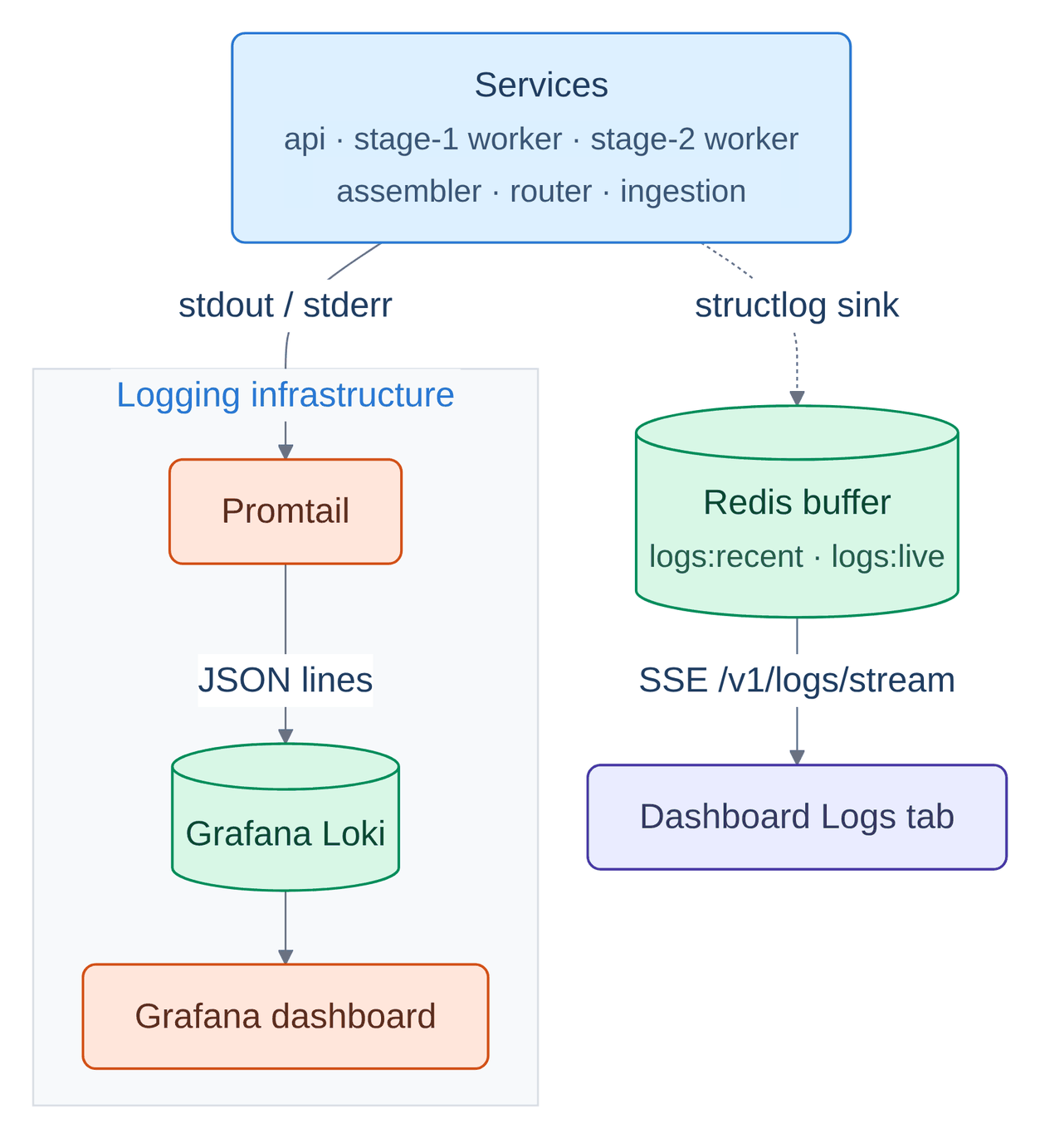
Figure 0.0: Log aggregation: two sinks from one structured logger.
In Figure 3.22, log aggregation is shown as one source forking to two destinations that never meet again: the box listing the six services that emit logs, a solid arrow carrying standard output into the conventional chain of collector, log store and Grafana, and a dotted arrow carrying the same records into a capped Redis buffer captioned with the two key names it uses, from which a stream reaches the dashboard's log tab. Like the telemetry of Figure 3.21, none of this is a numbered flow of the data flow diagram shown in Figure 3.5: it is instrumentation of Processes 1.0 to 6.0 rather than any record they exchange. The duplication is deliberate – one route to the durable, queryable store and one to a buffer the dashboard tails – because it removes a log-store query from the request path, and the cap is what stops the buffer becoming a second failure mode.

Deployment architecture
The same code runs in two deployment shapes, and the difference between them is which concerns are collapsed. Figure 3.23 gives the MVP shape, in which authentication, ingestion and reporting are one service and the message bus is Redis. Figure 3.24 gives the production shape, in which those concerns are separate deployments, the bus is a partitioned log, and the worker pools scale on consumer-group lag rather than on processor utilisation.
In the Compose shape of Figure 3.23 three simplifications are visible and all three are deliberate. Authentication, ingestion and reporting share one container, so the tier runs one service where production runs four; this is acceptable because at MVP volumes no one of them can starve the others. Redis plays three roles at once – message bus, cache and deduplication set – which removes an entire broker from the operational surface at the cost of coupling three failure modes to one process. The vLLM container is optional and is drawn as an outside system, because it is present only when the local backend is selected. The monitoring box has no edges at all: at this tier observability watches the stack without participating in it, and removing it changes nothing about how work flows.
The Kubernetes shape of Figure 3.24 reverses each of those compromises and adds one property that Compose cannot express. The four stateless services become separate deployments scaled on processor use and request rate. Redis is replaced by Kafka as a three-broker StatefulSet with named topics, including a dead-letter topic that gives permanently failing work somewhere to go other than an infinite retry. The substantive difference, however, is the scaling signal. The stateless tier scales on processor and request rate, which are load signals; the worker pools scale on consumer-group lag, which is a backlog signal. That distinction matters for a batch pipeline because a worker saturated by a slow model call shows high utilisation whether the queue behind it holds ten items or ten thousand, so utilisation cannot distinguish "busy" from "falling behind". Lag can. The two GPU pools are separated for the same reason the two stages use different serving mechanisms: small-model inference and large-model generation have different memory profiles and should not contend for one accelerator.
The data tier sits inside a network policy so that only the ingress is reachable from outside the cluster, and the observability namespace is drawn deliberately unconnected, since it observes every band without appearing in any request path.
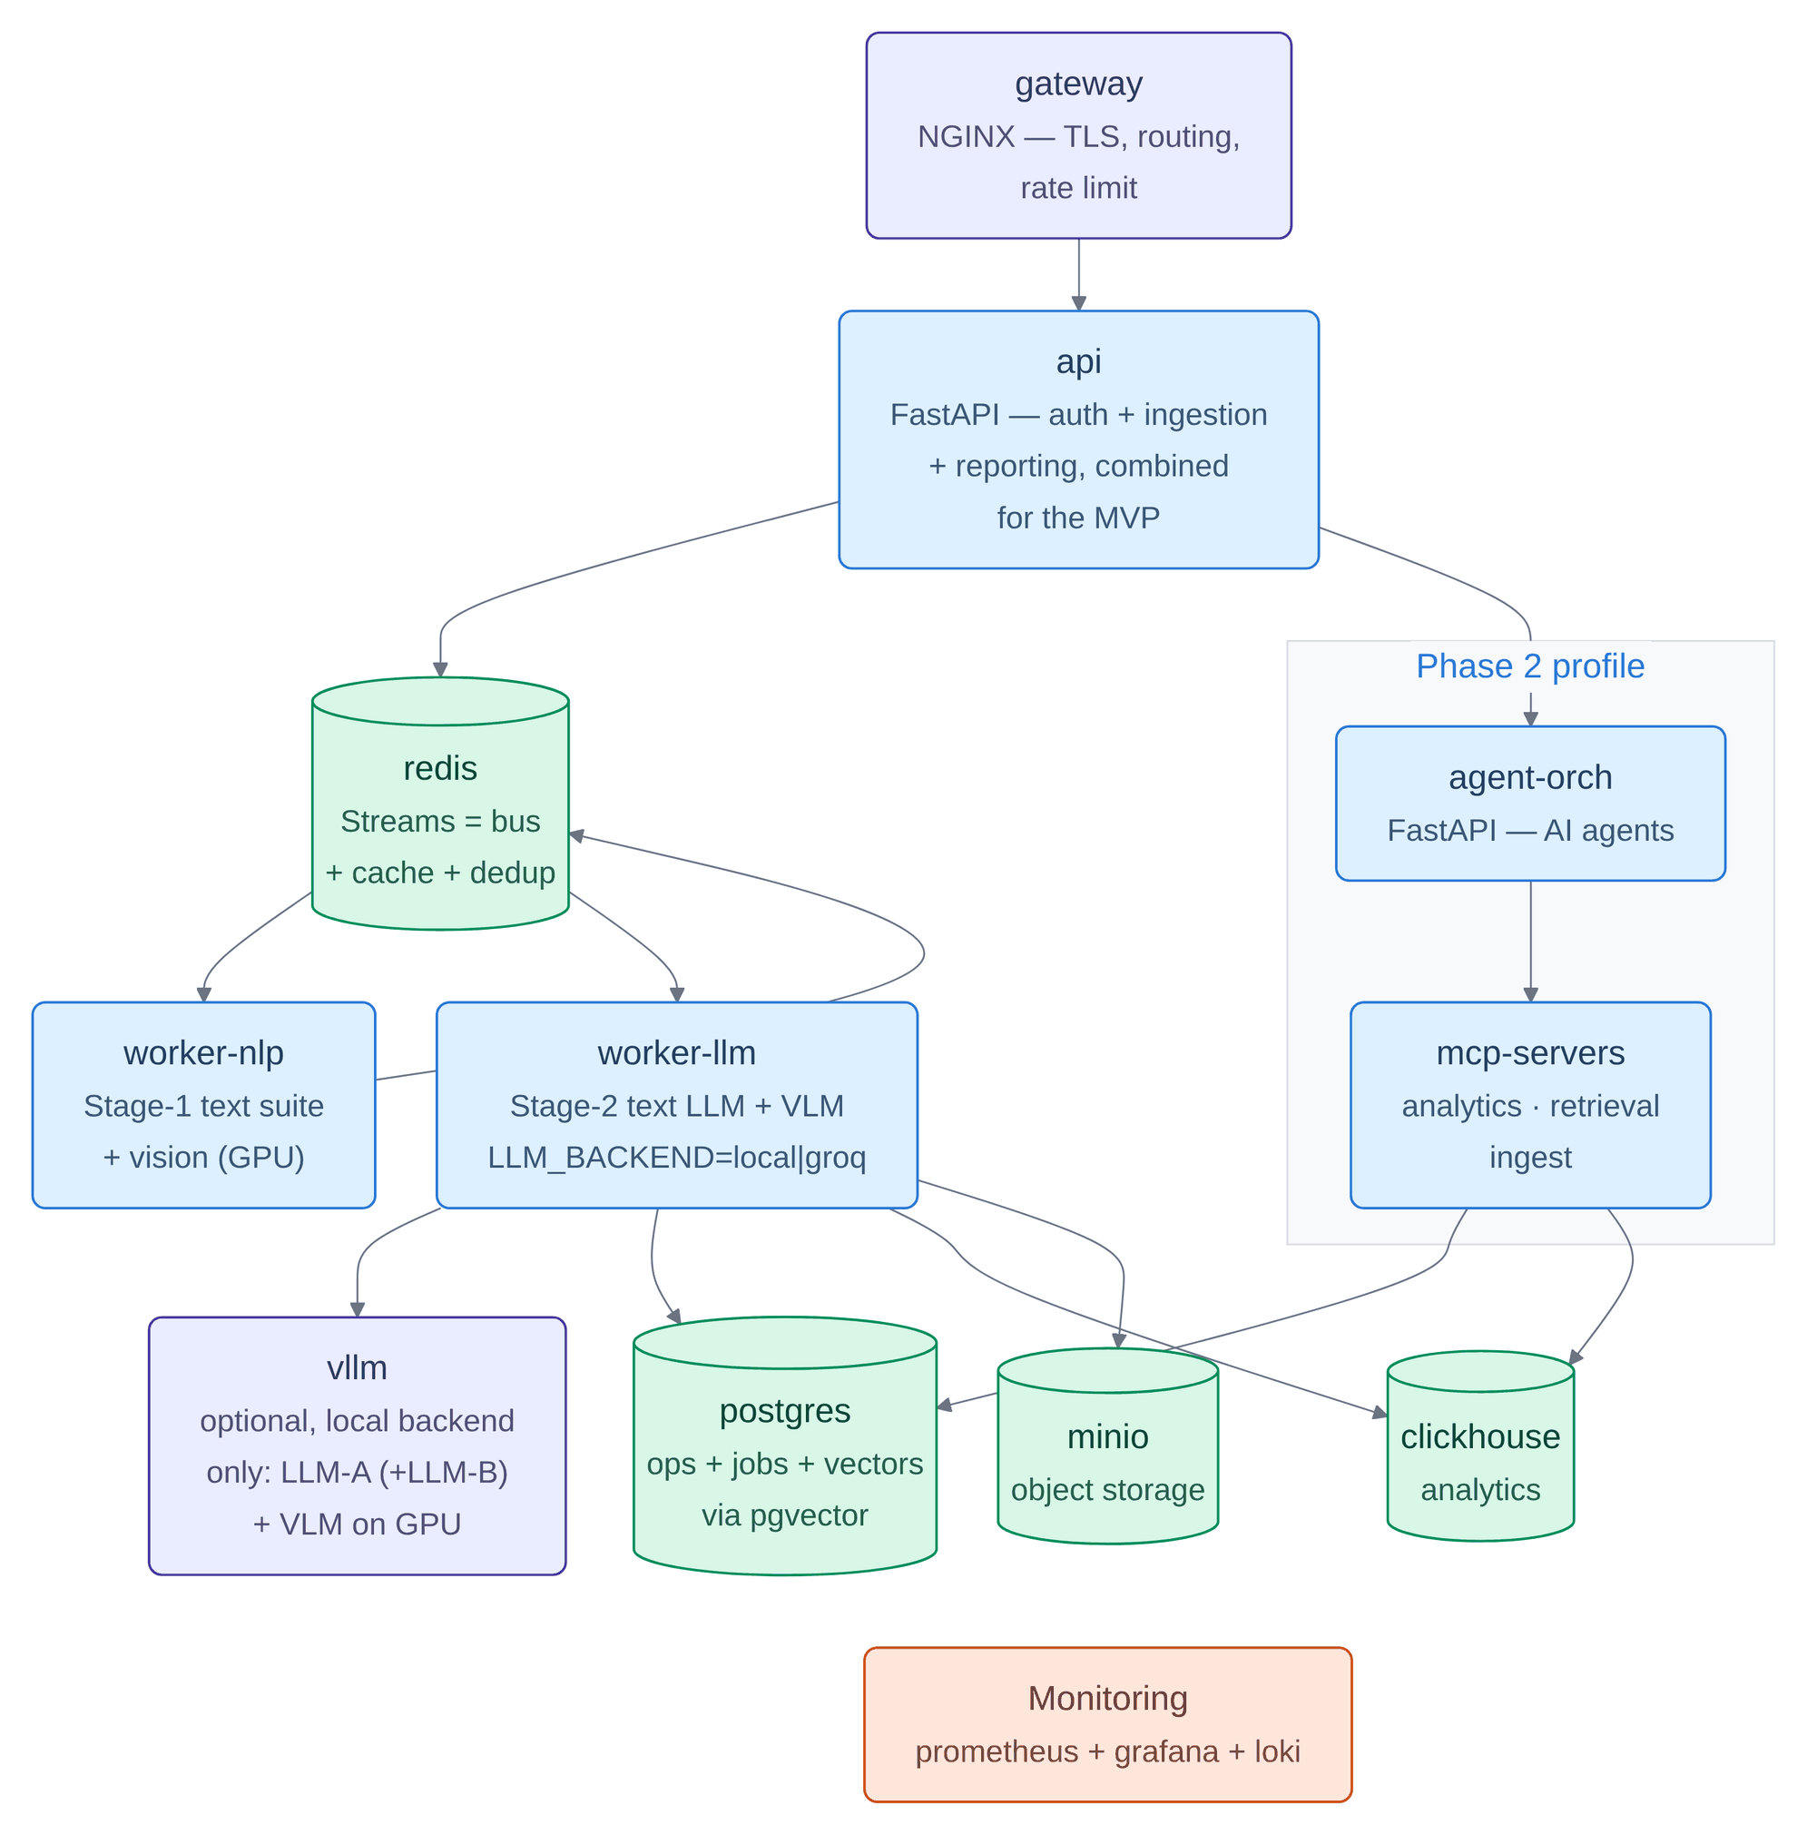
Figure 0.0: MVP deployment: Docker Compose service topology.
In Figure 3.23, the MVP deployment is shown as a service graph read downward from the gateway: a single api container collapsing three concerns, forking left into the Redis cylinder that is bus, cache and deduplication set at once, and right into the Phase 2 panel holding the agent orchestrator and the MCP servers, with the NLP and LLM workers making a round trip through Redis, an optional vLLM container, and three arrows fanning into postgres, clickhouse and minio. This is one packaging of the data flow diagram shown in Figure 3.5: the two workers run Processes 1.0 to 5.0, the Phase 2 panel runs Process 6.0, and the three fan-out targets hold D1 (posts and raw payloads) through D5 (analytics events and comment sentiments), written on flows [11] to [13]. Authentication, ingestion and reporting are collapsed into one service here and the message bus is the same Redis instance that serves the cache and the deduplication set; both are deliberate simplifications that Figure 3.24 reverses, and the monitoring box has no edges at all because at this tier it observes the stack without participating in it.
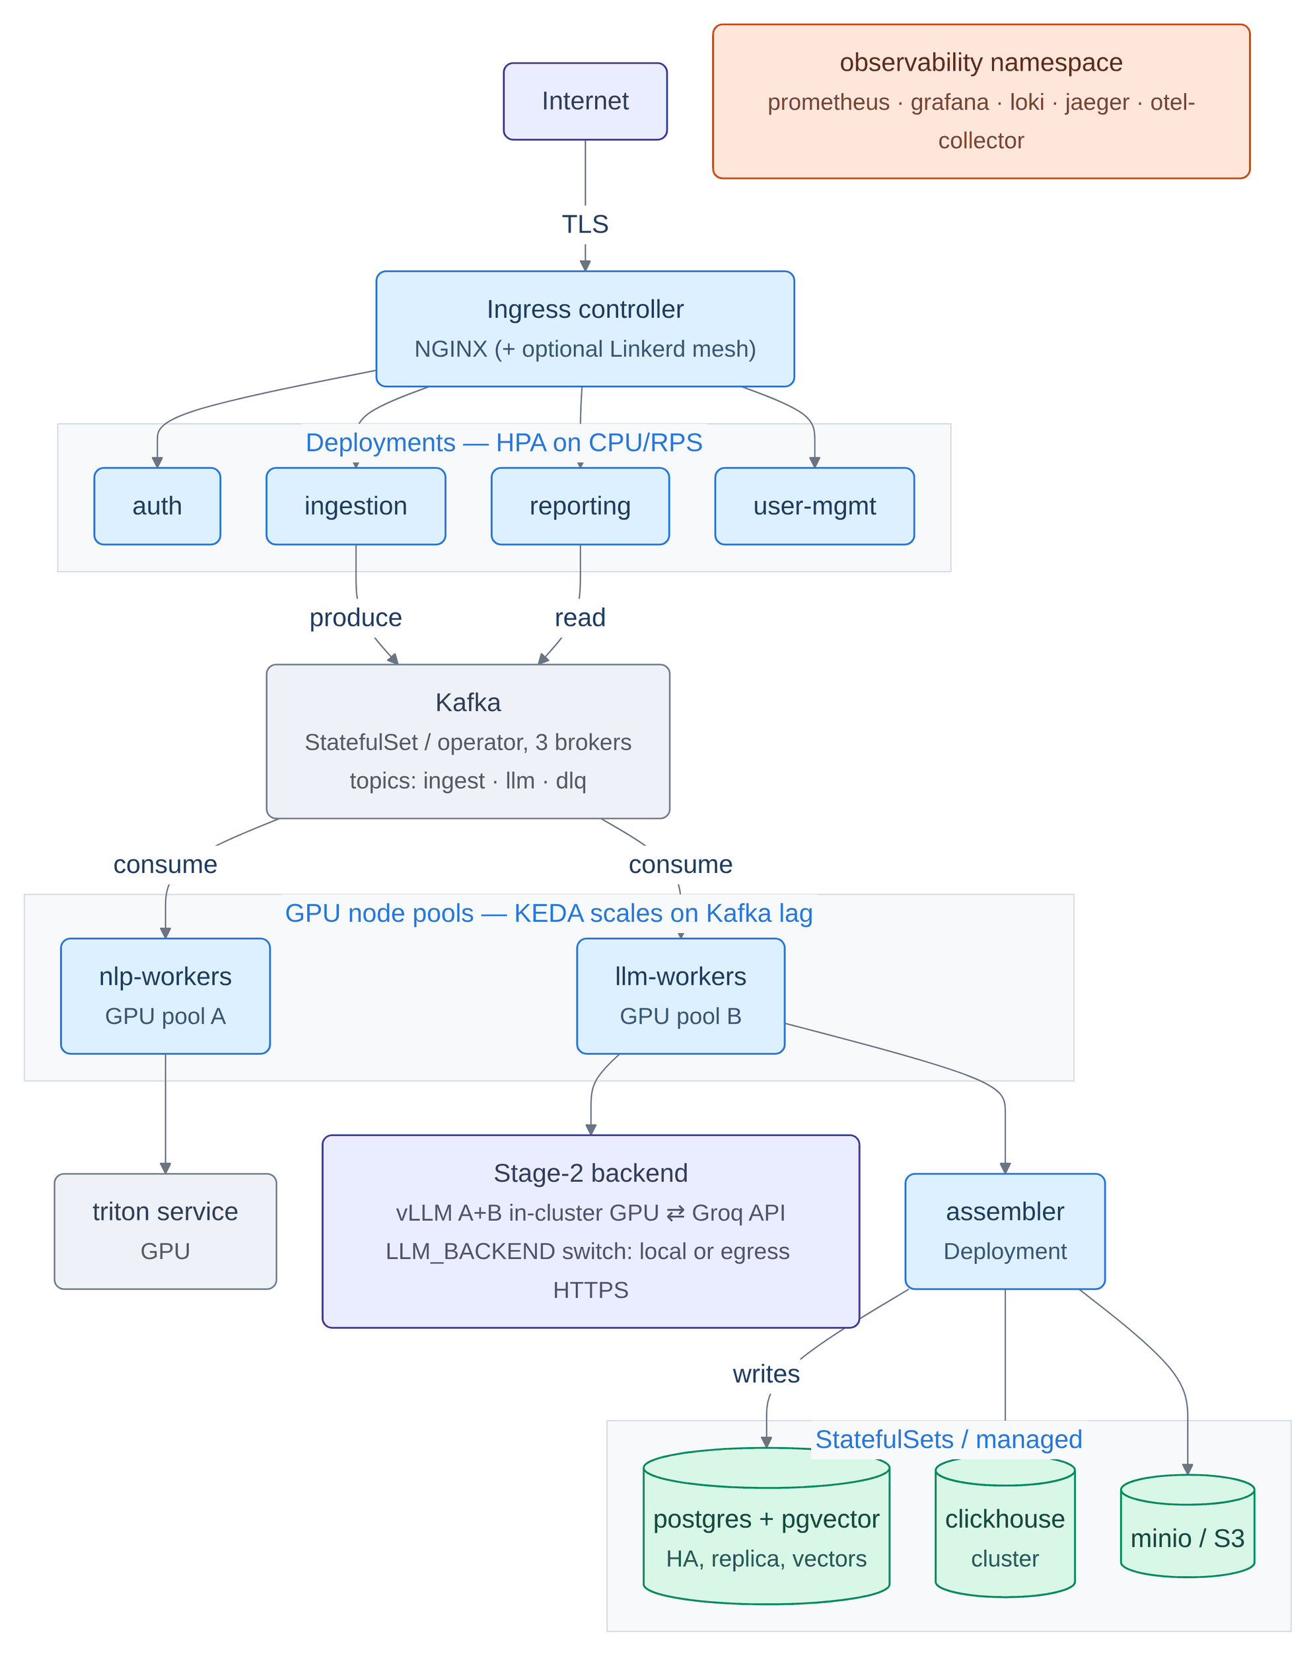
Figure 0.0: Production deployment: Kubernetes topology with queue-depth autoscaling.
In Figure 3.24, the production deployment is shown as the path a request takes: in from the internet over TLS through the ingress, into a panel of four stateless deployments scaling on processor and request-rate signals, down through Kafka with its topics named including the dead-letter topic, into a panel of two GPU node pools scaling on consumer-group lag, then to the inference targets and finally into the stateful data tier. The Kafka topics carry flows [4], [6], [7] and [10] of the data flow diagram shown in Figure 3.5, the node pools run Processes 2.0 and 4.0, and the data tier holds D1 (posts and raw payloads) through D5 (analytics events and comment sentiments), written on flows [11] to [13]. The autoscaling trigger is consumer-group lag rather than processor utilisation, because it is a batch pipeline's backlog and not its instantaneous load that determines whether more workers are needed; the data tier sits inside a network policy so only the ingress is reachable from outside the cluster, and the observability namespace is drawn unconnected because it observes every band without sitting in any request path.

Alternatives considered
Table 3.7 records the significant decisions, the alternatives that were weighed, and the reason the chosen option won. Recording rejected options matters as much as recording chosen ones: several of these decisions should be revisited if the constraints change, and the table says which constraint each one depends on.
Table 0.0: Design alternatives considered and the rationale for each selection.
Decision | Alternatives considered | Selected | Rationale, and the constraint it depends on
Overall topology | Monolith with a background worker pool; serverless functions per stage; stage-decoupled queue-based services | Stage-decoupled services | A monolith cannot scale the expensive stage independently of the cheap one and leaves large-model GPUs idle while NLP runs. Serverless has poor and expensive GPU support and pays per-invocation model loading. The monolith remains the right shape for the MVP and is what Docker Compose runs.
Message bus | Kafka; RabbitMQ; Redis Streams; NATS JetStream | Redis Streams for the MVP, Kafka for production | Redis was already required for cache and deduplication, and consumer groups give at-least-once delivery and a dead-letter pattern at near-zero extra operational cost. Kafka's partitioning maps onto worker parallelism and its retention permits replaying a batch after a model upgrade, which is what a benchmark needs.
Operational database | PostgreSQL; MongoDB | PostgreSQL | Job, tenant and user state wants ACID guarantees and constraints, and a JSON column covers the flexible-result need without giving up relational integrity. Heavy aggregation goes to a columnar store rather than to the operational database.
Analytics store | ClickHouse; Elasticsearch | ClickHouse | The dominant need is time-series aggregation over millions of comment rows, where a column store is strongest and cheapest. Elasticsearch would win if rich full-text search were a first-class product feature; here that need is met by PostgreSQL full-text search fused with trigram similarity.
Vector search | pgvector inside PostgreSQL; Weaviate; Milvus | pgvector | The embedding lives in the same row as the operational data, so there is no separate service to run, back up and secure, and metadata scoping is plain SQL. Milvus becomes the right answer only if the vector count reaches billions.
Inference serving | Self-hosted only; cloud API only; pluggable both | Pluggable, switchable at runtime | Self-hosting has zero marginal token cost and no egress but requires GPUs; a cloud API has the fastest inference and no GPU operations but bills per token and sends content off-box. The trade differs per tenant and per workload, so it is made a runtime decision rather than a build-time one.
Number of large-model roles | One model for everything; two roles; per-task roles | Seven named roles | One model either overpays on per-post work or under-delivers on prose. Named roles let each task be right-sized independently, and are what allowed the classification model and the summarisation model to be separated – the change that removed the fluent model from the per-batch comment path.
Comment labelling | A single classifier; a classifier plus the large model; an eight-labeller ensemble with abstention | Eight-labeller ensemble | A single verdict cannot express uncertainty and cannot be audited. The ensemble makes disagreement visible, gives the escalation policy a signal to act on, and – critically – can report that nothing read a comment instead of inventing a neutral for it.
Comment coverage | Cap at the top sixty by reactions; cap inside the stance pass only; no cap, selected once | No cap, selected once in the router | The old caps meant roughly twenty-nine percent of comments ever received a model label while the output described itself as full coverage. Selecting once in the router means every voter reads the same set, so the post-level breakdown and the per-comment table describe the same comments. The cap remains available as the single largest cost lever.
Retrieval fusion | Let the caller choose dense or lexical; normalise and add scores; reciprocal rank fusion | Reciprocal rank fusion | On code-mixed text neither arm dominates – exact entity names and transliterations are what the encoder generalises away and what a lexical match resolves exactly, so the choice should not be delegated to the caller. The two arms' scores are on incomparable scales, so only their ranks can be combined honestly.
Agent tool interface | Bespoke per-agent database glue; dump the corpus into the prompt; MCP servers | MCP servers | Bespoke glue makes every new agent re-implement data access, authentication and schemas. Prompt-stuffing does not scale, leaks data and cannot produce fresh aggregates. A typed tool protocol makes a new capability a registration rather than a code change.
Agent orchestration framework | A graph-orchestration framework; plain functions plus one client | Plain functions | The requirement is one configuration file, one prompt slot and one parser, all of which already exist. A framework would add a large dependency tree and a second templating system, and – the deciding factor – would not run in the offline stub path the entire test suite depends on, which would make the one novel component the one untestable component.
Bangla rendering in this report | Typeset original Bangla script; transliterate with an English gloss | Transliterate with a gloss | The typesetting toolchain used to produce this document performs no complex-script shaping, so Bengali conjuncts would render incorrectly. Presenting mis-shaped Bangla would be worse than presenting a transliteration, and the romanized register is in any case central to the subject.

Two patterns run through the table. The first is that most decisions were settled by an operational property rather than by a quality benchmark: what fails, how it fails, and whether the failure is visible. A component that is marginally more accurate but fails silently was rejected in favour of one that is marginally less accurate and fails loudly, on the grounds that a monitoring product's worst outcome is confident wrongness rather than an acknowledged gap.
The second is that several rejected options were rejected only for this tier. Kafka over Redis Streams, a dedicated vector database over pgvector, and a separate authentication service were all judged correct at production scale and unnecessary at MVP scale. Recording them as rejected rather than as absent is what makes the deployment progression in Section 3.2.10 a plan rather than a retrofit: each of those decisions has a stated trigger for revisiting it, and the production topology already reflects the outcome.
Across all of these decisions the theme is consistent: a preference for components whose failures are loud and local over components that are marginally better but fail silently, and a preference for managed, lower-overhead infrastructure wherever the extra control a heavier option would buy is control this project does not need at its scale. The major trade-off this approach concedes is a degree of coupling to specific runtime choices – Redis serving three roles at the MVP tier, pgvector rather than a dedicated vector service, a hand-tuned rather than a learned gate – accepted in exchange for an operational surface that two people can actually run and audit within the timeline of an academic project. Each of those concessions carries a stated trigger for revisiting it, and the scalability implications are revisited in Chapter 6 under Limitations.

Project Plan
The project plan follows from the milestone structure fixed at Title Defence and refined at each evaluation point that followed. Rather than being established once and then set in stone, the plan was revisited at every milestone to record what had actually been done, what had changed in technical direction, and what remained for the next step – which is consistent with the iterative process model adopted in Section 1.4. The subsections below give the milestone timeline that the assessment calendar imposed, the phase structure and exit criteria the work was organised into beneath it, the difference between the plan as written and the plan as worked, and the reasoning that settled what was built first when the two could not both be satisfied.

Milestone Overview
The Final Year Design Project timeline carries four assessed milestones, and each one fixed a deliverable that the following phase had to be built on top of. Table 3.8 states them together with the primary deliverable associated with each. The dates of the assessment events themselves are recorded as they fall on the departmental calendar; the two dates given in full are the ones this report can evidence from its own artefacts, because the verification run of Table 4.7 and the screenshots of Section 4.3.1 are timestamped.
Table 0.0: FYDP Milestone Timeline.
Milestone | Date | Primary deliverable
Title Defence | [DD-MM-YYYY] | Project title, problem statement and initial scope approved; the input contract identified as the first thing to lock
Phase-I | [DD-MM-YYYY] | Background study, gap analysis, system architecture, and a working MVP pipeline carrying a post end to end through all five stages
Pre-Defence report submission | [DD-MM-YYYY] | Completed methodology, the capability layers, the agentic insight layer, and the first four audit passes
Final Defence report submission | 23–08–2026 | Full-chain verification passing in a single command; every capability carrying an evidence class; this report
Final Defence board presentation | [DD-MM-YYYY] | Live demonstration of the eleven-process stack, the per-post trace and the agent layer, on the corpus reported in Chapter 4

The interval between Phase-I and the Final Defence submission was the primary development window, and it is where the work changed shape. The plan approved at Phase-I ended with the capability layers; it did not contain an audit phase at all. That the schedule closed with a fifth of its weeks spent auditing code that already passed its tests is the single largest deviation between the plan as approved and the work as delivered, and Section 3.3.3 accounts for it.

Phase Overview and Exit Criteria
The project ran over two semesters in five phases, numbered from zero. Table 3.9 gives the plan together with the exit criterion for each phase. Treating each exit criterion as a gate rather than as a milestone is what kept the audit passes in Phase 4 from discovering foundational problems: a phase did not end when its work was written, but when a stated property of the running system could be demonstrated.
Table 0.0: Project plan by phase, with exit criteria.
Phase | Weeks | Work | Exit criterion
0 – Foundations | 12–16 | Lock the input contract against the real payload and the canonical output schema; build the upstream client and ingestion; stand up the datastores in Docker; pin model versions; define the pluggable backend interface | A single post flows from the API through the bus and a stub worker into PostgreSQL and back out of the read endpoint as valid JSON
1 – MVP pipeline | 17–28 | All five stages; the router and its gates; Stage-2 two-lane design; the assembler and three-store fan-out; the read and report APIs; authentication; the first dashboard; metrics and logging | One-thousand-post batches process reliably; the large-model share is measured and reported with its Stage-1 engine named, rather than asserted
2 – Capability build-out | 29–38 | The eight-labeller ensemble and its abstention protocol; watchlist target stance; the separate summary role and truncation recovery; job stop, resume and delete; hybrid retrieval and chunking; the React dashboard | Every non-emoji comment is reachable in one run; target stance appears in its own output field; retrieval quality is measured rather than assumed
3 – Agentic layer | 33–42 | The three MCP servers and their eighteen tools; the agent runner and its budget; the nine agents; prompt-injection hardening; citation verification; the chat handover | An agent answers a corpus question with citations that resolve to posts the tools actually returned
4 – Audit, hardening and evaluation | 39–48 | Six independent fresh-eyes audit passes; regression tests for every finding; mutation testing of the fixes; the evaluation harness; the retrieval evaluation set; the stratified gold-set sampler; this report | The full chain of Python tests, dashboard unit tests, lint, production build and browser tests passes as one command; every capability carries an evidence class

Planned Versus Actual Progress
Two features of that plan were not present in its original version, and recording the difference is more useful than presenting the final plan as though it had been foreseen.
First, Phase 4 was not originally scheduled as its own phase. It was added after the first audit pass found that the project's headline claim was contradicted by its own running code, and it eventually consumed a fifth of the schedule. The original plan allocated those weeks to further capability work; that capability work was cut, and the decision to cut it is the single largest deviation between the planned and actual schedules.
Second, the phases overlap deliberately. The agentic layer was begun in week 33, before the capability build-out finished in week 38, because the agent layer's failures proved the most effective means of exposing defects in the layers beneath it. Several findings reported in Chapter 4 were surfaced by an agent producing a confident wrong briefing rather than by a test – a working relationship between the two phases that a strictly sequential plan would have foreclosed.
Table 3.12 in the following section shows the resulting timeline as it was actually worked, with each activity's active fortnights marked, so that the overlap between phases is visible rather than asserted.
Table 3.10 sets the tasks carried forward from the Phase-I plan against what was actually delivered by the Final Defence submission, so that the discrepancies are visible in one place rather than distributed across the chapters that report them.
Table 0.0: Planned Versus Actual Progress Since Phase-I.
Task (from the Phase-I plan) | Planned outcome | Actual outcome
Eight-labeller comment ensemble with abstention | Multiple independent verdicts per analysed comment, combined by a single writer | Completed. Seven small heads plus one context-aware stance pass, with voter counts and per-source verdicts surfaced on every comment (Section 3.2.3)
Watchlist-driven target stance | Per-entity stance over an operator-supplied, alias-aware list | Completed. Built and tested, adding no additional large-model calls; the shipped watchlist is a placeholder by design (Section 3.2.4, Section 6.2)
Agentic insight layer | Tool-using agents reasoning over the system's own analytical output | Completed. Nine agents over eighteen typed tools across three MCP servers, hardened against the failure modes observed in live runs (Section 3.2.6)
Hybrid retrieval and its evaluation | Dense, lexical and fused retrieval with a measured quality figure | Completed and measured. Recall@10 of 0.8750 against 0.1875 for hash-vector baselines, stratified by lexical overlap (Section 4.2.5)
Cost-aware routing with reported behaviour | A gate whose routing rate is read from the system's own counters | Completed, with a result that contradicted the plan. The gate works, but 96 percent of calls are comment-level, so it governs only 30 percent of spend (Section 4.3.2)
Kubernetes deployment and queue-depth autoscaling | A production deployment expressing the same components as cluster objects | Code-complete, unbenchmarked. Implemented and test-asserted, but never run at scale in a real cluster (limitation L4)
Image and optical-character-recognition modality | Visual sentiment and text extraction fused into the post-level verdict | Implemented, unexercised. The corpus carries image references whose objects are absent from storage, so the visual term has never carried a value (limitation L2)
Labelling-accuracy evaluation against human labels | A macro-F1 figure per language bucket | Descoped, and stated as a scope boundary. The sampler and scorer are built; the annotation programme they need is Section 6.3's first item (limitation L6)
Audit, hardening and regression phase | Not in the Phase-I plan | Added mid-project and consumed a fifth of the schedule. Six independent fresh-eyes passes, each finding pinned by a regression test named after the defect

Six of the eight tasks carried forward from Phase-I were completed, one was reduced to a documented boundary and one remains implemented but unexercised – and the largest single item in the delivered work appears in the table with no planned counterpart at all.

Prioritisation Rationale
Between Phase-I and the Final Defence submission the schedule was fixed, so the ordering above was a series of choices rather than an accident, and the principle behind them was consistent: prefer a capability that can be evidenced over a capability that can only be described. Where a feature could be finished and measured, it was finished; where finishing it would have produced a claim the project could not check, the effort went into the checking instead.
That principle settled the three decisions that shaped the deliverable. The audit phase was funded ahead of new features because the first pass established that the project's own headline claim was contradicted by its own running code, and there is no defensible order in which more capability is built on top of a claim known to be wrong. The image modality was left unexercised rather than demonstrated on substitute images, because a screenshot of the visual path running on images that are not the corpus's own would evidence the code and misrepresent the result. And labelling accuracy was descoped rather than approximated, because the only cheap way to produce that number is to score the models against labels drawn from the system's own models, which measures agreement and reports it as accuracy.
The cost of that ordering is visible and is not argued away: this report contains no accuracy figure for any labeller, and two capabilities are recorded as built rather than proven. What it bought is that every number in Chapter 4 was produced by running the code in this repository, and that the boundary of the evaluation is stated in Section 4.3.3 rather than left for a reader to infer.

Task Allocation
This project was carried out by a single student, so what is recorded here is an allocation of effort across task areas and phases rather than a division of work between members. Two consequences of working alone shaped the plan, and both explain decisions taken later in this report. First, the interfaces between subsystems still had to be agreed in writing before either side of one was built – which is what the input-contract lock in Phase 0 was for, and it earned its cost for one developer as much as it would have for a team, because it is what allowed a subsystem to be rewritten without renegotiating everything downstream of it. Second, a solo project has no second reader, and the class of defect that dominated this build – a component reporting success without having done the work – is precisely the class a second reader catches. Phase 4 exists to buy that reader back deliberately, which is why a fifth of the schedule went to audit rather than to features. Table 3.11 states the allocation by task area and phase; Table 3.12 places those areas on the project timeline.
Table 0.0: Task Allocation by Task Area and Phase.
Task area | Phase
Requirement analysis and input-contract lock | Phase 0
Corpus characterisation and gap study | Phase 0
Datastore, queue and container infrastructure | Phase 0
System architecture and data-flow design | Phase 0–1
Ingestion, normalisation and deduplication | Phase 1
Stage-1 cheap NLP and sentiment fusion | Phase 1
Router gates and comment selection | Phase 1
Stage-2 lanes, prompts and response caching | Phase 1
Assembler, canonical schema and three-store fan-out | Phase 1
Eight-labeller comment ensemble and abstention protocol | Phase 2
Watchlist target stance and the alias matcher | Phase 2
Pluggable inference backend, roles and the privacy lock | Phase 2
Hybrid retrieval, chunking and rank fusion | Phase 2
Job control: stop, resume, re-run and delete | Phase 2
MCP servers and the agent runner | Phase 3
The nine agents and their hardening | Phase 3
React dashboard, live streams and theming | Phase 2–3
Deployment manifests: Compose and Kubernetes | Phase 3
Audit passes and regression tests | Phase 4
Evaluation harness and measurement runs | Phase 4
Report writing and defence preparation | Phase 4

The ordering within that allocation was vertical rather than horizontal: each subsystem was carried from its queue interface through to its stored output before the next was started, so that at every point in the schedule there was a working end-to-end path rather than several half-built layers. The audit phase was then run against that path six times over, and the direction of each pass was deliberate rather than administrative: a pass began from a claim made in this report and went looking for the running code that would contradict it, instead of beginning from the code and looking for bugs. That direction is the reason the passes worked: the findings recorded in Chapter 4 are disagreements between the report and the system, not failing tests – the suite was green throughout. Six passes conducted this way produced findings that months of ordinary self-review had not, which is itself a result about how this class of defect is detected.
Table 3.12 depicts the timeline of the principal activities in each period of the project, from week 12 to week 48. Each column is one fortnight and each row one activity; a filled box marks a fortnight in which that activity was active.
Table 0.0: Task Timeline, weeks 12 to 48.
Task | 12 | 14 | 16 | 18 | 20 | 22 | 24 | 26 | 28 | 30 | 32 | 34 | 36 | 38 | 40 | 42 | 44 | 46 | 48
Requirement analysis and contract lock
Data collection and corpus characterisation
Datastore and queue infrastructure
Ingestion, normalisation and deduplication
Stage-1 cheap NLP and fusion
Router gates and comment selection
Stage-2 lanes, prompts and caching
Assembler, schema and three-store fan-out
Comment ensemble and abstention protocol
Watchlist target stance and alias matcher
Pluggable backend, roles and privacy lock
Retrieval, chunking and rank fusion
MCP servers and the agent runner
The nine agents and their hardening
React dashboard and live streams
Job control: stop, resume and delete
Audit passes and regression tests
Evaluation harness and measurement runs
Report writing and defence preparation

Summary
This chapter brought together the requirement analysis and the design specification for the system. It began with requirement analysis, where eighteen functional and twelve non-functional requirements were identified from the gaps observed in existing monitoring platforms and Bangla classification systems, and where the two classes were deliberately held to different standards of evidence. The system design followed: a five-stage, queue-decoupled microservice in which cheap analysis runs unconditionally over every post and every comment, a router decides how much expensive analysis each unit earns, and an assembler emits one schema-validated document per thread into three stores chosen by access pattern.
The data-flow diagrams showed the system's boundary and where state is held, with a single deliberate absence at level 0 – nothing is ever written back to the upstream platform – and a single deliberate isolation at level 1, where the corpus-tier insight process is reachable only through persisted stores and never from a post in flight. The UI design section then set out the eleven-tab operator dashboard, its component hierarchy, and the ticketed streaming topology that keeps a credential out of every event-source URL.
The Detailed Methodology section covered the load-bearing technical decisions. The central one is that the router makes two independent decisions rather than one: whether a post earns post-level large-model work, and which of its comments the Stage-2 labellers read. Around that sit an eight-labeller comment ensemble with an explicit abstention protocol, a watchlist stance capability whose hard part is the alias matcher and which adds no additional model calls, a pluggable inference backend with per-role model resolution and an enforceable tenant privacy lock, and a corpus-tier agentic layer that retrieves the system's own analytical output through typed tool servers. Every significant choice – the message bus, the operational and analytical databases, the vector index, the serving model, the fusion method, the agent tool interface – was recorded in Table 3.7 together with the alternative it displaced and the constraint that justified it, so that a change of constraint has a documented path back rather than requiring the decision to be rediscovered.
The Project Plan section set the four assessed milestones against the five development phases beneath them, gave an exit criterion for each phase, and set the tasks carried forward from Phase-I against what was actually delivered: six completed, one reduced to a documented boundary, one implemented but unexercised, and one – the audit phase – present in the delivery with no planned counterpart at all. It stated the two ways in which the plan as worked differed from the plan as written, an entire audit-and-evaluation phase that was not originally scheduled and a deliberate overlap between the agentic layer and the capability build-out, and recorded the principle that settled the ordering when the schedule could not accommodate everything: prefer a capability that can be evidenced over a capability that can only be described. The Task Allocation section recorded the allocation of effort across task areas and phases for a single-student project, and in particular why an audit phase was created to buy back the second reader that a two-person team gets for free. Implementation details, the testing strategy, the measurement studies and the results for every module are presented in the next chapter.

Chapter 4

Implementation and Results
This chapter describes the end-to-end implementation of the system: the development environment and deployment configuration, the testing and evaluation carried out across every functional module, and the results obtained from running the fully deployed stack. It characterises the corpus, presents the verification strategy and the full-chain test result, tests the access-control surface separately from the functional one, gives the four measurement studies the project was able to complete honestly – routing and cost, retrieval quality, label provenance and system correctness – walks through the delivered software feature by feature with screenshots of the running system, and closes by discussing what those numbers do and, equally importantly, do not establish.

Environment Setup

Software environment and dependencies
The development environment for this system is built around a modern Python and JavaScript toolchain with locally served inference rather than a metered API, so that the whole stack can be brought up and measured on a single workstation. The hardware, software and service configurations detailed in the following subsections were present throughout every phase of development and are the configuration in which every measurement in this chapter was taken.
The project was developed on a single ordinary workstation running a 64-bit Linux operating system, with sixteen logical processor cores, a discrete CUDA-capable graphics device and an integrated one, and enough system memory to run four datastore containers, eleven host processes, the local inference server and a browser at the same time. The commodity-hardware target is a requirement rather than an accident, and Section 5.1.2 records the accelerator-placement decision that follows from it: the cheap classifier heads run on CPU while the accelerator serves the language model, because a four-gigabyte card already hosting a seven-billion-parameter model has room for one classifier head and not seven.
The system is written in Python 3.12 with a React 19 front end, and it runs in three configurations: a single-host development stack, a Docker Compose deployment for the MVP tier, and a Kubernetes deployment for production. All measurements in this chapter come from the development configuration described in Table 4.1, because that is the configuration in which the pipeline stages can be run against the real corpus without a cluster. The principal components of the stack are the following.
• Python 3.12 : the language of the API, the five pipeline stages, the three tool servers and the agent service.
• FastAPI with Uvicorn : the asynchronous web framework serving the 51-path HTTP API and its generated OpenAPI specification.
• React 19 with Vite : the component-based dashboard and its build tool, styled with Tailwind CSS and charting with Chart.js.
• Redis Streams : the durable message bus between stages, and simultaneously the cache, deduplication set, counter store and progress channel.
• PyTorch and Transformers : the seven small classifier heads and the multilingual sentence encoder.
• Ollama : the local inference server holding four models, which is what makes the marginal token cost of a run genuinely zero.
• uv : the dependency resolver and virtual-environment manager, which pins the entire tree from one lock file.
Table 0.0: Measurement environment.
Component | Value
Operating system | Linux 7.1.8 (Arch)
Python | 3.12.12, environment managed with uv 0.12.5
Node and npm | Node 26.7.0, npm 12.0.2
Datastores | PostgreSQL 16 with the pgvector extension, ClickHouse, Redis 7, MinIO – all in Docker
Inference | Ollama on the host, four models pulled locally
Processes | API on port 8001, five stage workers, three MCP servers, the agent service, the dashboard on port 8080
Test isolation | Throwaway PostgreSQL and Redis containers started per test session, so a default test run never touches the development stack

The Python 3.12 pin is not arbitrary, and it illustrates how a single dependency can constrain an entire project. The optional machine-learning extra cannot be installed on Python 3.13 at all, because the fastText wheel publishes no build for it and its bundled C++ no longer compiles. Nothing else in the dependency tree is version-constrained; the language detector alone was holding the embedding model hostage, which is also why the embedding dependency was subsequently split into its own lighter extra so that a machine can install real vectors without also loading the vision and entity-recognition stack.
Table 0.0: Principal dependencies and the reason each constrained version exists.
Package | Version | Role and constraint
fastapi / starlette / uvicorn | 0.136.3 / 0.50.0 / 0.49.0 | API framework. Starlette is pinned below 0.51 because the installed FastAPI requires it.
sqlalchemy / asyncpg / pgvector | 2.0.50 / 0.31.0 / 0.5.0 | Async database access and the vector column type. The embedding dimension must match the column or every insert fails.
redis | 8.0.0 | Streams, cache, counters, cancellation flags, progress channels
clickhouse-driver | 0.2.10 | Analytics writes and reads. The driver rejects concurrent use of one connection, which is why the two analytics tables are written sequentially rather than in parallel.
openai | 2.41.1 | One OpenAI-compatible client serves both the self-hosted and the cloud backend
fastmcp | 3.4.0 | The three MCP tool servers
torch / transformers | 2.12.0 / 5.11.0 | The classifier heads and encoders, in the optional extra
sentence-transformers | 5.5.1 | 768-dimension multilingual sentence embeddings
jsonschema | 4.26.0 | Enforces the input and output contracts; the assembler raises rather than persisting an invalid document
prometheus-fastapi-instrumentator | below 8 | Pinned, because version 8 pulls an incompatible Starlette
reportlab / weasyprint | 5.0.0 / 69.0 | PDF export, imported inside a try block so it is optional rather than a hard start-up dependency
pytest / pytest-asyncio / testcontainers | 9.0.3 / 1.4.0 / 4.15.0 | The Python suites and their throwaway datastores
vite / vitest / playwright / oxlint | 8.2.0 / 4.1.10 / 1.62.1 / 1.75.0 | Front-end build, unit tests, browser tests and lint

Rather than one general-purpose database, the system runs four stores chosen by access pattern, all of them in Docker on the development tier. The configuration of each is summarised as follows.
• PostgreSQL 16 with pgvector : operational rows, job state, the canonical result document and the 768-dimension embedding index in the same row, which removes a separate vector service from the deployment entirely.
• ClickHouse : denormalised analytical events behind the dashboard charts and the analytics tools, with a collapsing engine on the per-comment table so a re-analysed comment does not double-count.
• Redis 7 : the message bus, the response cache, the deduplication keys, rate limits, job counters, cancellation flags and the usage counters.
• MinIO : S3-compatible object storage holding raw payloads and generated reports at deterministic keys, so production can substitute a managed service with no code change.
Four models are pulled locally and they are deliberately not the same model. The Stage-1 role runs a four-billion-parameter model because it carries the highest-volume work; Stage 2 and summarisation run a seven-billion-parameter model; the vision role runs a small vision-language model; and the agent role runs an eight-billion-parameter model through a derived tag that sets a sixteen-thousand-token context window.
That derived tag is load-bearing and its absence is invisible, so the mechanism is given here in full. The local inference server defaults to a four-thousand-and-ninety-six-token window and silently discards anything longer, oldest message first, which is the system prompt and then the operator's question. It reports only what it evaluated, so nothing in the response indicates that this happened. Measured directly: an eleven-thousand-token prompt evaluates 24 tokens on the plain tag and all 11,045 on the sixteen-thousand-token tag. A single search tool result is larger than the default window, so without the derived tag every agent answers from the tail of a JSON payload and reports success.
Beyond the seven generative roles, Stage 1 loads six supporting models that are named here because none of them appears in Table 3.4 and each is a load-bearing dependency. Table 4.3 lists them with the configuration key that selects each one, so that a reader can change any of them without reading the code.
Table 0.0: Supporting models loaded outside the generative roles.
Purpose | Checkpoint | Configuration key
Sentence embeddings for retrieval and clustering | paraphrase-multilingual-mpnet-base-v2, 768 dimensions | EMBEDDING_MODEL
Cross-encoder reranking (implemented, unmeasured) | BAAI/bge-reranker-v2-m3 | RETRIEVAL_RERANK_MODEL
Post-level emotion | j-hartmann/emotion-english-distilroberta-base | EMOTION_MODEL
Toxicity and hate scoring, and the router's toxicity gate | unitary/toxic-bert | TOXICITY_MODEL
Zero-shot image sentiment (unexercised – see Section 6.2) | google/siglip-base-patch16–224 | CLIP_MODEL
Language identification | fastText lid.176.bin | FASTTEXT_LANG_MODEL

Named-entity recognition uses GLiNER [25] rather than a fixed-label model, so the entity types are supplied at inference time rather than baked into a checkpoint.
The supporting development tools were these.
• Git and GitHub : version control and repository management for the whole codebase.
• Docker and Docker Compose : the four datastore containers on the development tier, and the nineteen-image MVP deployment.
• pytest, vitest and Playwright : the Python suites, the dashboard unit tests and the browser tests, chained into one pass-or-fail command.
• oxlint and ruff : static analysis on both languages.
• Browser developer tools : runtime debugging, network inspection and responsive-layout checking for the dashboard.

Deployment configuration
The three deployment shapes described in Section 3.2.10 are summarised together in Figure 4.1. Every measurement reported in this chapter was taken in the leftmost of them.
The three columns are configurations of one codebase, not three systems, and the figure is arranged so that they can be read across as well as down: datastores at the top of each column, units of compute in the middle, model hosting at the foot. Read that way, what changes between the columns is only how many processes a concern is spread across and how scaling is expressed.
The development column runs the four datastores in Docker and everything else as host processes – the API, five stage workers, three MCP servers, the agent service and the dashboard, eleven in total – with Ollama serving four local models. Running the workers on the host rather than in containers is what makes a code change visible without a rebuild, and it is the reason this tier is the one used for measurement: the stage functions can be invoked directly, with the same code paths the queue would exercise. The MVP column packages the same components as nineteen images, nine off-the-shelf and ten built from this repository, against six named volumes on a single network. The production column expresses the same components as Kubernetes objects, and is the only column in which scaling is declarative rather than manual.
The practical consequence for this report is a caveat on every number in this chapter. Measurements taken on a single host with local model serving characterise the logic of the system – how many calls it makes, which posts it routes, what it retrieves – and not its throughput under production hardware. Where a quantity depends on the deployment shape rather than on the code, Section 4.3.3 records it as unmeasured rather than estimating it.
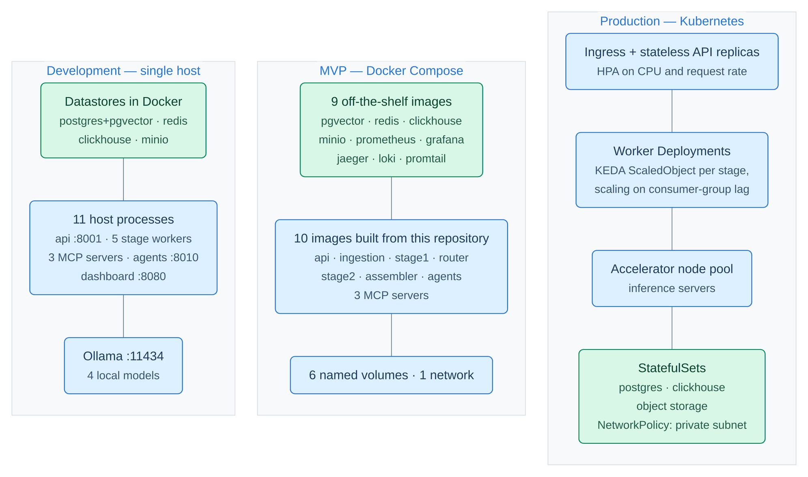
Figure 0.0: Deployment topology across the three tiers.
In Figure 4.1, the three deployment tiers are shown as three columns in order of increasing scale – development on a single host, the Docker Compose MVP, and Kubernetes in production – with no arrows between them, because these are three configurations of one system rather than three stages of a process, and with the boxes stacked in the same order in each column so they can be read across as well as down. All three columns realise the same Processes 1.0 to 6.0 and the same D1 (posts and raw payloads) through D5 (analytics events and comment sentiments) of the data flow diagram shown in Figure 3.5; what differs is how many processes a concern is spread across and how scaling is expressed, never what the code does. Green marks the element in each column that holds state and the rest is compute, and every measurement reported in this chapter was taken in the leftmost configuration.

Testing and Evaluation / Performance / Comparative Analysis

The corpus
Every measurement in this chapter is taken over one corpus: the complete post-with-details export that the ingestion path uploads. Table 4.4 characterises it. The characterisation is given in full, including the parts that are unhelpful to the project, because the sampling properties of this corpus are the single largest threat to the validity of anything built on it.
Table 0.0: Corpus characterisation.
Property | Value
Posts | 50, across 25 monitoring campaigns
Media type | 37 photo-with-text, 7 photo-only, 6 text-only
Posts with a caption | 43 of 50; the other 7 have a null caption and no reachable image
Caption length | median 245 characters, maximum 5,427; 14 of 50 exceed 600 characters
Publication window | 29 April to 19 May 2026
Comments shipped in the payload | 10,272
Comments the platform reports for those posts | 274,126
Corpus-level comment coverage | 3.75 percent
Per-post coverage | median 26.7 percent, minimum 0.25 percent; 12 posts below 10 percent; 5 posts above 100 percent
Stored comments per post | minimum 87, median 98, maximum 2,857
Comment reactions | mean 3.97, maximum 946; 64.1 percent of comments have zero reactions
Comment script mix | 81.4 percent Bangla script only, 11.1 percent Latin only, 4.6 percent both scripts, 2.9 percent neither
Emoji-only comments, by the pipeline's own kind classifier | 2.8 percent
Threading | 0 comments carry a parent identifier; 1,111 comments report a non-zero reply count, so replies exist upstream but are not shipped
Post reactions | 794,373 in total, plus 93,903 shares
Image references | 69 across 44 posts, all relative object-storage keys

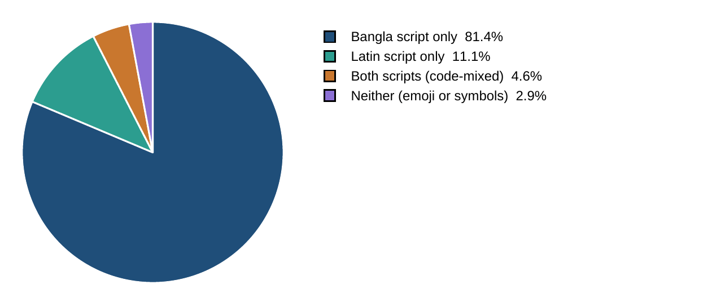
Figure 0.0: Script composition of the 10,272 comments.
Reading the chart. The two slices that matter for this project are the smaller ones. Latin-script-only comments are not English comments: a substantial part of that 11.1 percent is romanized Bangla, which is exactly the register that multilingual encoders handle worst. Adding the 4.6 percent that mixes both scripts within a single comment gives roughly one comment in six where a monolingual Bangla model and an English model would each be reading the wrong language.
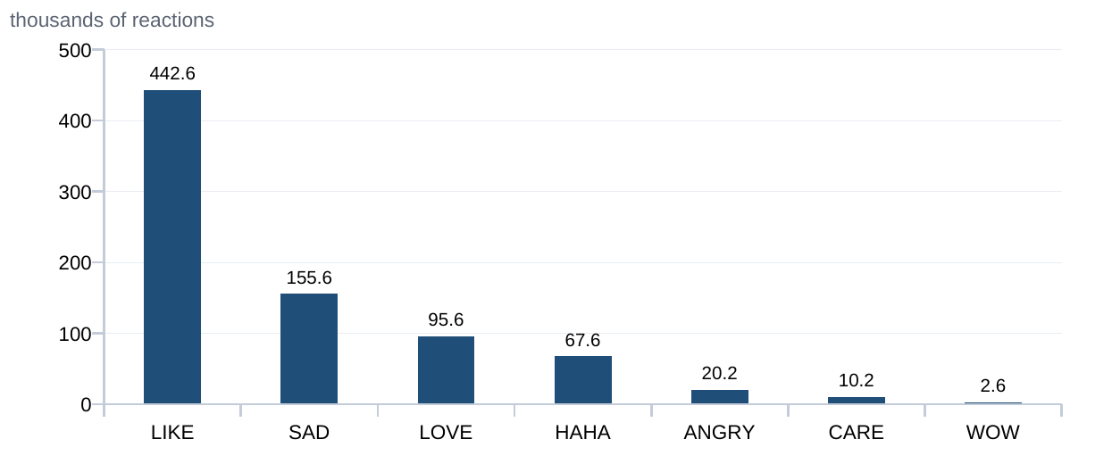
Figure 0.0: Crowd reaction mix across the corpus, in thousands.
Reading the chart. This distribution is a free crowd signal that the pipeline uses as a prior rather than as a label: when sadness and anger together exceed forty percent of a post's reactions, a neutral-or-positive text verdict is nudged negative. Note the shape of the tail – anger is an order of magnitude rarer than sadness in this corpus, so a system tuned on the assumption that negative sentiment means anger would mis-read the dominant negative register here, which is grief.
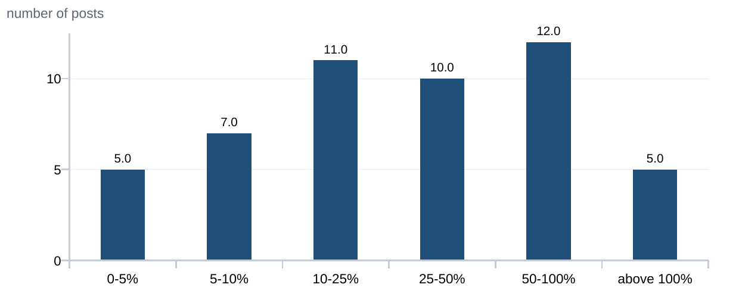
Figure 0.0: Distribution of per-post comment coverage.
Reading the chart. Coverage is the ratio of comments actually shipped to comments the platform reports. Two features of this distribution are load-bearing. Twelve posts sit below ten percent, so any thread-level claim about them rests on a small and engagement-ordered slice. Five posts exceed one hundred percent – up to 112 stored comments against a reported total of 42, which cannot be replies inflating the numerator, because no comment in the corpus carries a parent identifier. The pipeline clamps coverage to 1.0 and raises an explicit anomaly flag rather than rendering a coverage figure above 100 percent.
Three consequences follow from Table 4.4 and Figure 4.4, and they are stated here rather than in a limitations section because they constrain every number that comes after.
1. The comment sample is not random. The stored comments are the platform's returned set, which is engagement-ordered. With 64.1 percent of comments carrying zero reactions and a maximum of 946, aggregating sentiment over an engagement-biased 3.75 percent sample and calling the result "the sentiment of this thread" is not supportable. What the data supports is a claim about the most-engaged N comments per post, and that is the phrasing this report uses.
2. Post-level sentiment is a text measurement. The 69 image references are relative object-storage keys whose objects are not present in storage, so no image bytes are reachable in any runnable configuration and the vision term has never contributed a non-zero value. The image path is implemented and reports an explicit failure status rather than a fabricated neutral verdict, and the fusion weights renormalise over the terms that carry a real model verdict, so an absent image term no longer consumes its share and drag a genuine text signal toward neutral.
3. The 7 caption-less posts stay in the corpus. They yield no post text to analyse, but they carry 1,307 comments that analyse like any other. An earlier working corpus excluded them, which meant the evaluation was measuring a population the running system never processes and under-counting the comment lane, which is now the dominant cost.

Verification strategy and the full-chain result
The testing strategy for this system is automated rather than manual, because the failures that dominated this project are not failures a person notices by looking. Verification is organised in three layers. Contract tests assert that the JSON documents crossing every boundary validate against their schema, and several of them grep the source directly to assert structural invariants – that every worker checks the job cancellation flag before doing work, that the dashboard reads only fields the API returns, that the autoscaler manifests name exactly the streams the workers create. Those fail on a rename, which is their purpose. Regression tests pin every defect found in the audit passes, so a repaired defect that returns fails the build. Datastore tests run against throwaway PostgreSQL and Redis containers started per session, so a default test run can never damage a developer's environment; two further suites are gated behind explicit markers, one needing a full Docker and inference stack and one that wipes live datastores.
Those three layers hold 1,420 automated tests across 68 files, and it is worth stating plainly how that number relates to the two test tables in this chapter, because they are easy to mistake for the whole of the evidence. Table 4.6 lists twenty-four cases and Table 4.8 sixteen; together they are forty acceptance scenarios, chosen at the rate of roughly one or two per module to show what the system is asserted to do at the level a reader can check against the screenshots in Section 4.3.1. Each of those forty is backed by one or more tests in the suite, but the suite is more than thirty-five times larger than the two tables, because most of what it asserts is not a user-visible use case: it is a boundary condition, a malformed input, a component that failed to load, a rename that must break a build. Table 4.5 gives the composition of the whole suite so that the forty scenarios can be read as the sample of it that they are.
Table 0.0: Composition of the automated Python test suite, by functional area.
Functional area | Files | Tests | What the tests in this area assert
Agentic insight layer | 10 | 325 | Tool-call loops and their budgets, ungrounded-answer rejection, citation verification, placeholder and date-window handling, context-window limits, and prompt-injection containment
Pipeline stages, fusion and routing | 12 | 237 | The five stage functions end to end, sentiment fusion, the six routing gates, comment batching and selection, summary truncation recovery, and the vision-fusion renormalisation
Chat and question routing | 4 | 139 | Which agent a corpus question reaches, conversation history, streaming responses, and the endpoint contract
Security, authentication and data residency | 7 | 116 | Token issue and verification, the hashed API-key store, single-use streaming tickets, signup and password storage, rate limiting, cross-tenant reads, and the fail-closed privacy lock
Comment ensemble, labelling and provenance | 6 | 110 | The eight labellers, the abstention protocol, the single-writer combiner, comment-kind classification, and provenance surviving every hop
Contracts and schemas | 3 | 97 | That every document crossing a boundary validates against its schema, that the documented result matches the emitted one, and that the analytics tables match what is written to them
Retrieval, clustering and reports | 9 | 109 | Dense, lexical and fused retrieval, identifier short-circuiting, embedding provenance and the stub-vector flag, near-duplicate identity, clustering, report export, and the scope a generated report is allowed to draw on
Job control, queues and reliability | 6 | 82 | Start, stop, resume and delete; the resumable trace session; stream and consumer-group creation; bounded retry, dead-lettering, the circuit breaker, and application lifespan
Observability, telemetry and caching | 6 | 68 | That every large-model caller writes a usage record, host telemetry, log streaming and sink isolation, tracing, and the cache key's resolved-model identity
Dashboard-to-API contract | 2 | 50 | That the dashboard reads only fields the API returns, and that every authenticated surface is wired to the auth layer
Audit regressions | 2 | 49 | One test per defect repaired during the six audit passes, each named after the defect it pins
Watchlist target stance | 1 | 38 | Alias matching across three scripts, suffix and prefix rules, clause-level scoring, and the roll-up to per-entity stance
Total | 68 | 1,420 | Plus 96 dashboard unit tests and 2 browser tests, for 1,518 automated tests in the full chain of Table 4.7

The distribution is not accidental and it is the clearest statement of where this project's risk actually sat. The agentic layer carries 325 tests – nearly a quarter of the suite – for a subsystem that is a small fraction of the code, because it is the only component whose failures are plausible: an agent that invents a citation produces an answer that reads exactly like a correct one, and nothing but a test distinguishes them. The same reasoning explains the 116 security tests and the 49 audit regressions. Conversely, the single-file stance area carries 38 tests because its failure mode is loud: a matcher that matches nothing returns zero mentions, which is visible.
Module testing involved walking the deployed system through the core use cases of a typical operator and confirming that each yielded the expected outcome, with every case backed by an automated test rather than by observation alone. Table 4.6 reports one or two representative cases per module; the full set of assertions behind them is the suite of Table 4.5.
Table 0.0: Functional Test Cases and Results.
Module | Test case | Expected outcome | Result
Authentication | Sign in with valid credentials | Session established, Bearer token issued, dashboard loads | Pass
Authentication | Sign in with invalid credentials | Access denied, error surfaced, no token issued | Pass
Authentication | Present an expired token on a streaming endpoint | Rejected on every transport, not only the authorization header | Pass
Ingestion | Upload a post-with-details JSON file | Posts validated against the input schema, deduplicated, enqueued | Pass
Ingestion | Upload the same payload twice | Upsert on the upstream identifier; no duplicate rows created | Pass
Stage-1 NLP | Analyse a caption-less post | Comments still analysed; post-level text fields reported absent, not fabricated | Pass
Router | Route a post whose Stage-1 confidence is missing | Gate fires; absent confidence treated as uncertainty | Pass
Router | Select comments on an 87-comment thread | 45 duplicates removed, 36 selected, arithmetic reported on the envelope | Pass
Comment ensemble | Label a comment when a head fails to load | Head abstains; voter count reduced; no fabricated neutral vote | Pass
Comment ensemble | Label a comment no model read | Reported as uncertain at zero voters, never as neutral | Pass
Watchlist stance | Match an entity written in Bangla script with a suffix | Suffix permitted, prefix rejected, one mention recorded | Pass
Watchlist stance | Score a comment naming two entities in opposite clauses | Each entity scored from its own clause, not from a character window | Pass
Assembler | Assemble a result that violates the output schema | Assembler raises; nothing is persisted to any store | Pass
Assembler | Assemble a valid result | Schema-validated document fanned out to three stores in parallel | Pass
Job control | Stop a running analysis job | Cancellation bounded at one post per stage; job status set to cancelled | Pass
Job control | Resume a cancelled job | 29 posts already analysed, 21 re-enqueued, none repeated, counters rebuilt | Pass
Search | Query with an exact post identifier in semantic mode | Identifier lookup short-circuits ahead of the requested mode | Pass
Search | Query in hybrid mode | Dense and lexical arms fused by reciprocal rank, top-k returned | Pass
Agent layer | Issue a byte-identical repeat tool call | Second call refused, first result reused, untried tools named | Pass
Agent layer | Answer citing a post identifier no tool returned | Citation listed as unverified in the same view as the answer | Pass
Agent layer | Query an unknown watchlist identifier | Error raised naming every valid identifier, costing one turn not the run | Pass
Reporting | Generate an ungrounded report | Pure aggregation over stored results; no model call issued | Pass
Dashboard | Subscribe late to a running job's event stream | Buffered events replayed on connect, duplicates dropped by sequence number | Pass
Telemetry | Issue an LLM call on either backend | Backend, role, model, tokens and latency recorded in the usage ledger | Pass

The whole chain runs as a single command in which each stage must pass for the next to start, so a completed run is one pass-or-fail signal rather than five. Table 4.7 gives the result.
Table 0.0: Full-chain verification run, 29 August 2026.
Stage | Result | Duration
Python suite (pytest) | 1,417 passed, 3 skipped | 61.80 s
Dashboard unit tests (vitest) | 96 passed across 12 files | 3.0 s
Front-end lint (oxlint) | clean, no output, exit code 0 | under 1 s
Production build (vite) | built: 1,818 modules, 5 JavaScript chunks and 1 stylesheet, no size advisory | 793 ms
Browser tests (Playwright) | 2 passed | 0.9 s
Whole chain | PASS, exit code 0 | 73 s wall clock

The three skips are deliberate and are the two opt-in markers. Test code is now 19,850 of the repository's 56,789 Python lines – 35 percent, up from 14 percent before the audit passes began. That ratio is the more meaningful number than the count, because almost all of the growth is regression tests pinning audit findings, and a mutation pass on ten of the repaired defects confirmed that nine were caught by the suite when reverted. The tenth – the watchlist alias deduplication – was not, which meant that fix had no coverage at all; it is now tested.
The regression layer is the one worth looking at directly, because its value is in what the tests are named rather than in how many there are. Figure 4.5 shows one module of it – tests/test_audit_regressions.py, 38 tests of the suite's 1,420, and 38 of the 49 that Table 4.5 counts as audit regressions. It is reproduced at module scale rather than suite scale for a reason: the point of the figure is the names, which are unreadable at any zoom that would fit 1,420 rows on a page. Each name states the defect it pins, so the file reads as a list of the mistakes this system has already made once.
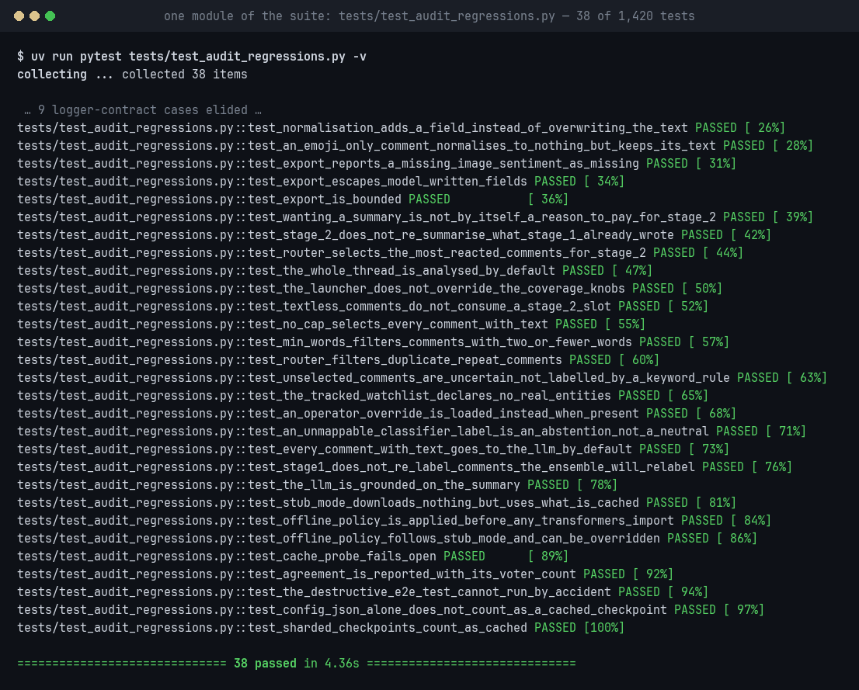
Figure 0.0: One module of the regression layer: 38 of the suite's 1,420 tests, one per repaired defect.
In Figure 4.5, one module of the regression layer is shown running under pytest -v – 38 of the suite's 1,420 tests, one per repaired defect, each row giving the module, the test name and the result, with nine logger-contract cases elided for space. These tests assert invariants of Processes 1.0 to 6.0 of the data flow diagram shown in Figure 3.5 rather than carrying any flow themselves, and the datastore cases among them run against throwaway containers rather than against D1 (posts and raw payloads) through D5 (analytics events and comment sentiments). The names are the documentation – test_textless_comments_do_not_consume_a_stage_2_slot, test_an_unmappable_classifier_label_is_an_abstention_not_a_neutral, test_the_tracked_watchlist_declares_no_real_entities – and each corresponds to a finding in an audit pass, so a reverted fix fails a test whose name says what broke.
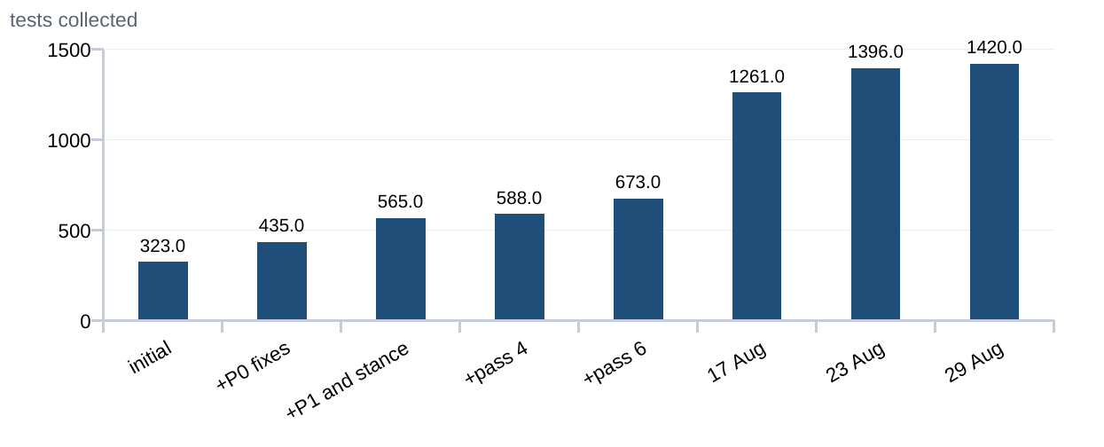
Figure 0.0: Growth of the Python test suite across the audit passes.
Reading the chart. Each step corresponds to an audit pass and the regression tests written to pin its findings, not to new features. The steepest segment is the one following the sixth audit pass, when every capability was given a document ending in an evidence-class table and the invariants those documents asserted were converted into tests. The count is reported here only as a proxy for regression coverage; as Section 4.3 states plainly, a green suite is a correctness signal and not a quality claim.

Security and access-control testing
Functional correctness establishes that each module does what it is meant to do. It does not establish that a caller who is not entitled to a result cannot obtain one, and the two are tested separately here because they fail differently: a functional defect produces a wrong answer, whereas an access-control defect produces a correct answer delivered to the wrong party. Every identity-bearing path in the system – the token issuer and its verifier, the API-key store, the single-use streaming ticket, the tenant scope on every analytical query, and the data-residency policy that decides which inference backend a tenant's text may reach – was exercised against both the permitted and the refused case, on the principle that a check which has never been observed to refuse anything has not been tested at all.
Eight suites carry that work and they run inside the same pass-or-fail chain as everything else. Executed together on 29 August 2026 they collect 138 tests, all passing in 6.89 seconds: seventeen on token issue and verification, thirty-seven on the signup and password path, twenty-five on transport hardening, seventeen on the backend policy resolver, fourteen asserting that the privacy lock survives every pipeline entry point, two on cross-tenant reads, four on rate limiting and twenty-two on prompt-injection containment in the agent layer. The first 116 of those are the security area of Table 4.5; the remaining twenty-two are counted there under the agentic layer, because injection containment is a property of the agent runner and is tested alongside it. Table 4.8 states the scenarios and their outcomes, at the same one-or-two-per-surface rate as Table 4.6.
Table 0.0: Security and Access Control Test Results.
Test scenario | Surface tested | Expected behaviour | Result
Present a valid token on a protected route | JSON Web Token verification | Request authenticated as the principal the token names | Pass
Present an expired token, then a forged one | Token verification | Both refused with 401; a forged signature never reaches the handler | Pass
Claim a privileged role inside a client-supplied token body | Principal construction | The authentication-method claim cannot be set by the client, and unlisted claims are dropped rather than trusted | Pass
Authenticate with an API key | Hashed key store | Key is looked up by SHA-256 hash and never by value; the tenant is taken from the stored row, not from the request | Pass
Authenticate with an unknown API key | Hashed key store | Rejected when the development fallback is off; a failed lookup rolls back cleanly rather than poisoning the session | Pass
Open a Server-Sent Event stream with a ticket, then replay the same ticket | Streaming authentication | First open succeeds and carries the principal; the replay is refused, because tickets are single-use and stored hashed | Pass
Open a stream with a malformed ticket | Streaming authentication | 401, not a silent fall-through to an unauthenticated stream | Pass
Register an account, then inspect what was stored | Signup path | Password never stored in plain text; two signups of the same password produce different hashes | Pass
Submit a signup body carrying extra tenant and role fields | Signup path | The extra fields do not become attributes; the tenant comes from server configuration and only the first account is an administrator | Pass
Read analysis results as tenant B that were written by tenant A | Tenant isolation | No rows returned; every analysis-result query is tenant-scoped | Pass
Request the metered cloud backend as a privacy-locked tenant | Data-residency policy | Refused rather than silently downgraded; the global toggle and the environment default are both overridden for that tenant | Pass
Request the metered backend while the policy table is unreadable | Data-residency policy | Denied. The check fails closed, and a broken cache falls back to the environment default rather than to permission | Pass
Enqueue a job by either entry path and inspect the envelope | Privacy lock coverage | Both paths stamp the resolved backend into the envelope, and both stage workers prefer the stamped value over the global toggle | Pass
Exceed the configured request rate on one identity | Rate limiting | Blocked at the limit, released on window rollover, and unaffected by other identities' traffic | Pass
Embed an instruction inside retrieved third-party comment text | Agent prompt-injection containment | Wrapped as untrusted data with the producing tool recorded as provenance; the payload can neither close the wrapper early nor open a nested one | Pass
Ask the agent to reveal its system message | Agent prompt-injection containment | Refused by policy, and the policy is asserted to be attached to every one of the nine agents' system prompts | Pass

Two of these rows are worth reading twice, because they are the cases where a system usually fails quietly rather than loudly. The first is the unreadable policy table. A residency check that cannot reach its policy store has two options, and the tempting one – carry on with the previous answer – converts a storage hiccup into a data-egress incident that leaves no trace. The test named test_an_unreadable_policy_table_denies_rather_than_permits pins the other choice. The second is the explicit backend request from a locked tenant, which is refused rather than downgraded. Silently substituting the self-hosted backend would honour the policy while lying to the caller about which model answered, and a caller who believes they received a cloud answer will attribute its quality to the wrong model.
What this subsection does not claim is a penetration test. These are white-box tests written by the same members who wrote the code they guard, so they establish that the checks behave as specified under the conditions the authors imagined. An adversarial review by a party with no knowledge of the implementation is named in Section 6.3 as the work that would close the remaining distance.

Routing behaviour and the cost split
The routing measurement runs the real stage functions over the corpus – normalisation, text and image analysis, fusion, result construction and the gate itself – with no options set, and reports the router's own counters. It is run twice with the same code and two different Stage-1 engines, because the comparison between them is the result.
Table 0.0: Measured routing and large-model call split, 43-post captioned corpus, cold cache, 25 comments per batch.
Quantity | Keyword-stub Stage 1 | LLM Stage 1 (as shipped)
Posts routed for post-level work | 32 of 43 (74 percent) | 7 of 43 (16 percent)
Post-level calls (summary, insight, post type, comment summary) | 124 (15.3 percent) | 22 (4.2 percent)
Comment-level calls | 689 (84.7 percent) | 507 (95.8 percent)
- Stage-1 comment labelling, all 43 posts, which the gate cannot reduce | 368 | 368
- Stage-2 comment stance, routed posts only | 321 | 139
Total calls per corpus run | 813 | 529
Share of all calls the routing gate governs | 54.7 percent | 30.4 percent

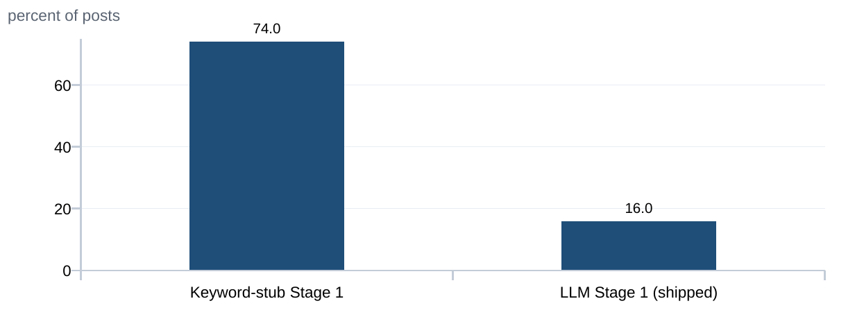
Figure 0.0: Posts routed for post-level LLM work, by Stage-1 engine.
Reading the chart. Identical router code, identical corpus, identical thresholds – only the Stage-1 engine differs. The keyword stub confidently types 27 of 43 posts and therefore escalates the remaining 74 percent; the LLM Stage 1 types 42 of 43 and escalates 16 percent. The correct reading of this chart is therefore that the routing rate measures Stage-1 quality, not cost efficiency: it falls as Stage 1 improves, which means a rising rate should be alerted on as a quality regression rather than as a cost regression.
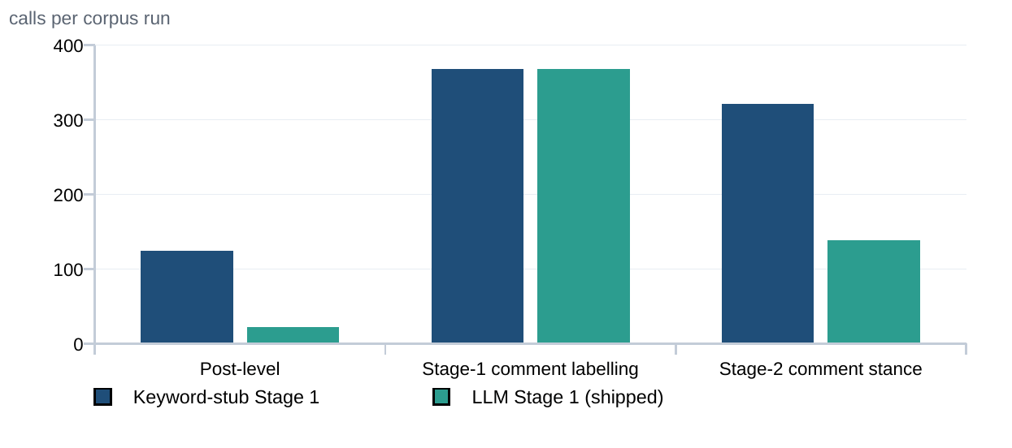
Figure 0.0: Where the large-model calls actually go.
Reading the chart. The middle pair of bars is the finding. Stage-1 comment labelling runs for every post whether the gate routed it or not, so it is identical in both configurations and the routing gate cannot reduce it at all. Improving Stage 1 halves the post-level bar and cuts the Stage-2 stance bar by more than half, but leaves the largest single bar untouched, which is why the gate's share of total spend falls from 54.7 to 30.4 percent while the absolute bill falls only from 813 calls to 529. What sets the bill is how many comments exist.
The quantity that decides how much the router is worth is not the routing rate but the share of large-model spend the gate governs, which is the post-level lane's share of all calls:
γ = C_{gated} / ( C_{gated} + C_{comment} ) (4.1)
where C_{gated} counts the large-model calls the router's gate releases – the post-level lane together with the post-level Stage-2 tasks – and C_{comment} counts the per-comment labelling calls, which run for every post whether the gate routed it or not. The measured value is γ = 0.304 under the shipped configuration and γ = 0.547 under the keyword baseline.
Three conclusions follow, and the first of them contradicted the project's own headline claim.
First, the routing rate is not the cost story. Between 85 and 96 percent of calls are comment-level. The initial claim was that cheap models perform ninety to ninety-five percent of the work and a selective large model handles the rest, and that this was the central cost-control idea. That assertion was never measured; when it was measured, the gate had in fact been routing one hundred percent of posts for a period because of two field-name defects, and after those were repaired the gate still governed only a minority of spend. The claim that survives contact with the measurement is narrower and is the one this report makes: cheap NLP filters which comments and which posts deserve a large model. Both halves matter, and the second is now the bigger one.
Second, improving Stage 1 shrinks the gate's importance rather than the bill. This result runs counter to intuition. A better Stage 1 types more posts confidently, so fewer route, so the gate decides less; meanwhile comment labelling runs unchanged.
Third, the gate selects the right posts. Under the shipped configuration the 7 routed posts hold 3,404 of the 8,713 comments that reach a model – the gate is escalating the large, contentious threads, which is the behaviour the design intends and which a routing rate quoted on its own cannot show.
One earlier estimate was also corrected by measurement and is recorded because the correction was large. Filtering emoji-only comments out of model batches was expected to save roughly seventeen percent of the comment bill. Emoji-only comments are 2.8 percent of the corpus. The seventeen-percent figure was the share taking the fast path, which conflates emoji-only reactions with short text comments, and a short text comment still carries text that a model can read. Filtering emoji is still correct, because they are pure waste, but it is not a cost lever.

Retrieval evaluation
Retrieval is the one axis this project evaluates against a ground-truth set, and the numbers were obtained with a 32-query known-item set derived from each target post's own topics and entities. Each query has exactly one marked relevant post. The same set was run before and after real embeddings were enabled, so the two recall columns in Table 4.10 differ only in whether the stored vectors are semantic or hashes.
Three standard measures are reported over the query set @Q, at cut-off k = 10. Because each query @q has exactly one relevant document d(@q), recall@k reduces to the fraction of queries whose target appears in the top k at all:
recallk = ( 1 / N ) · Σ 1[ r_{q} ≤ k ] (4.2)
The sum runs over the N = 32 queries q. r_{q} is the position of the one relevant post in the list returned for query q, and 1[·] is the indicator function, worth 1 when the condition holds and 0 otherwise. This is the measure that matters when the whole top-k is handed to a generator [42], because a target absent from the context cannot be recovered by the model.
MRRk = ( 1 / N ) · Σ 1 / r_{q} (4.3)
over the same N queries, with the term taken as 0 when r_{q} > k. This credits an arm for placing the target near the top rather than merely inside the window, and is the measure on which chunking gains where recall does not.
nDCGk = ( 1 / N ) · Σ 1 / log₂( 1 + r_{q} ) (4.4)
again over the same N queries, with the term taken as 0 when r_{q} > k. This is the single-relevant-document form of the cumulated-gain measure of Järvelin and Kekäläinen [41]: the ideal discounted gain is 1 because exactly one document is relevant, so the normalising denominator vanishes.
Table 0.0: Retrieval evaluation over 32 known-item queries, k = 10, on the 50-post corpus.
Configuration | recall@10 (hash vectors) | recall@10 (real) | MRR@10 (real) | nDCG@10 (real)
vector (dense only) | 0.1875 | 0.6250 | 0.2869 | 0.3667
lexical (full text fused with trigram) | 0.3750 | 0.7500 | 0.6503 | 0.6748
chunk (dense over passage chunks) | not measured | 0.6562 | 0.3014 | 0.3846
hybrid (dense fused with lexical) | 0.5312 | 0.8750 | 0.6108 | 0.6759
chunked (chunk fused with full text and trigram) | not measured | 0.8750 | 0.6482 | 0.7041

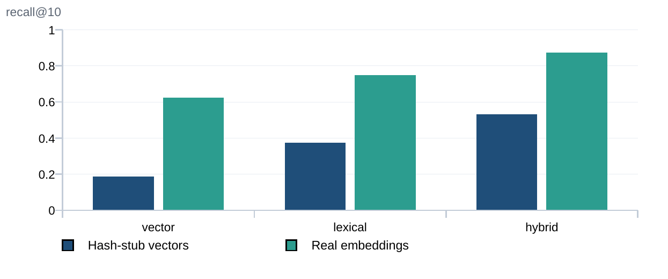
Figure 0.0: Recall@10 before and after real embeddings.
Reading the chart. The leftmost dark bar is the most useful number in this chart. Returning ten random posts from a corpus of fifty scores 0.20 by construction; hash-seeded stub vectors score 0.1875, which is statistically indistinguishable from chance. That claim had been prose in the project's documentation for a long time, and this is the measurement behind it. Note also that the lexical arm moved without any vector being involved – that movement was a bug fix rather than a benefit, and it is explained below.
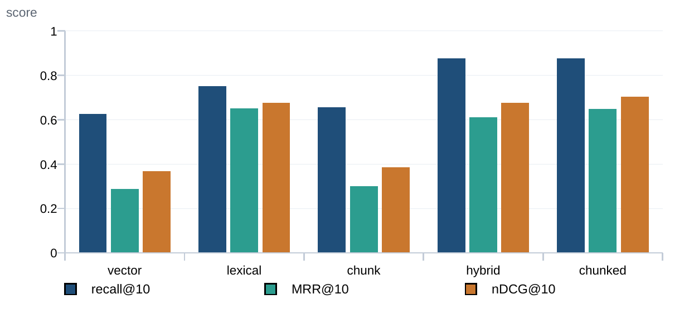
Figure 0.0: Retrieval quality by configuration, real embeddings.
Reading the chart. Recall and ranking separate here. Hybrid and chunked tie on recall at 0.8750, so chunking yields no gain on the metric that matters when the whole top-k is handed to a generator; the gain shows up in ranking instead, with MRR rising from 0.6108 to 0.6482 and nDCG from 0.6759 to 0.7041. That is the expected result for this corpus: only 14 of 50 posts exceed 600 characters, so 50 posts yielded 86 chunks and most are a single chunk identical to the caption. Note also that lexical alone posts a higher MRR than hybrid, which is an artefact of how the queries were built and is dissected in the next figure.
Three findings come out of Table 4.10, and the third is a defect rather than a result.
Hash vectors were indistinguishable from chance. Real embeddings are worth 3.3 times on the dense arm alone, from 0.1875 to 0.6250, and the end-to-end configuration moved from 0.5312 to 0.8750 – a 65 percent relative gain. This matters beyond retrieval, because the same vectors drive the clustering that the report layer summarises: clustering hash vectors groups posts at random and then pays a large model to describe the grouping.
Chunking improves ranking rather than recall on this corpus, and the reason belongs with the finding: this corpus consists predominantly of short captions.
The lexical arm's improvement was a bug fix, not a benefit. The lexical column moved from 0.3750 to 0.7500 with no vector involved, because the full-text half of that arm had never fired at all: the query builder conjoined every term, so an eight-token question demanded all eight words in one caption and matched zero rows across the entire query set. Everything previously credited to "full text plus trigram" was trigram alone, and the index built for full-text search was dead weight. This is recorded because it is the same failure shape as the routing defect and the identifier mismatches: a component that produced no output, reported no error, and was covered by a passing test.
A stratified view of the same 32 queries changes how the headline table should be read, and it does so in the embeddings' favour. Splitting the queries by the lexical overlap between the query and its target post gives Table 4.11.
Table 0.0: Recall@10 stratified by query-to-target lexical overlap.
Overlap bucket | Queries | lexical | vector | chunked
overlap 0.5 or above | 12 | 1.000 | 0.583 | 1.000
overlap below 0.5 | 20 | 0.600 | 0.650 | 0.800
- of which overlap exactly 0 | 8 | 0.000 | 0.500 | 0.500

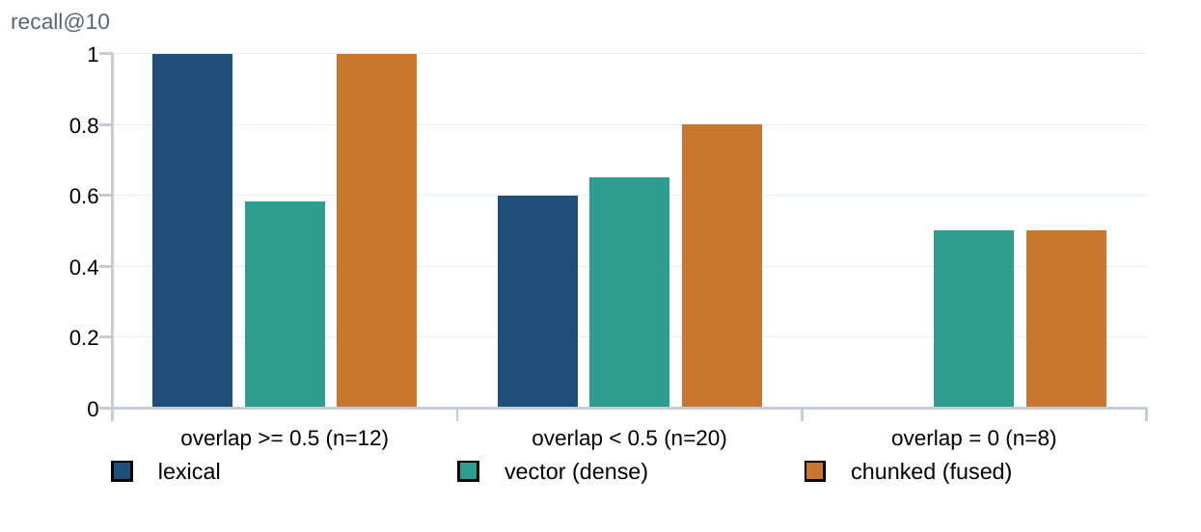
Figure 0.0: Recall@10 stratified by query-to-target lexical overlap.
Reading the chart. This is the strongest argument in the project for fusion, and it is invisible in the aggregate table. Twelve of the thirty-two queries are near-verbatim lookups on which a lexical match cannot fail, which is why lexical outscores hybrid on MRR overall. On the eight genuinely leak-free queries – where the query shares no vocabulary with its target – lexical scores exactly zero and the dense arm is the only retriever that returns the target at all. The fused configuration ties lexical on the easy bucket and beats it 0.800 to 0.600 on the hard one. Neither arm dominates, which is precisely the premise the fusion design rests on.
Four caveats bound every retrieval number above, and they belong in the same breath as the figures rather than in a footnote.
C1. They are lower bounds. The set marks exactly one relevant post per query, so every other on-topic post the retriever returns is counted as a miss.
C2. They compare retrievers against each other on one set. They are not absolute quality figures and should not be read as such.
C3. This is not human relevance judgement. No query in the set has been verified by a person; each was derived from its target post's own analysed topics and entities, which is exactly the derivation that produces the overlap leakage Table 4.11 stratifies.
C4. The set is small where it matters most. The stratum on which the argument for fusion rests contains eight queries. Paired significance tests over the full set put every lexical-versus-fused comparison above the conventional threshold – 0.375 at k equal to 1, 1.000 at k equal to 3, and 0.125 at k equal to 10, the last from a clean four-to-nothing split. The direction is consistent; the set is too small to call it. Reporting recall at 1 alongside recall at 10 also helps, and it complicates the story: at k equal to 1 the dense arm displaces correct top hits, with lexical retrieving 19 of 32 against the fused configuration's 16.

Label provenance and ensemble coverage
A sentiment chart that cannot say what produced its numbers is not evidence, so the pipeline records provenance per comment and per post. Measuring that provenance produced the result in Figure 4.12.
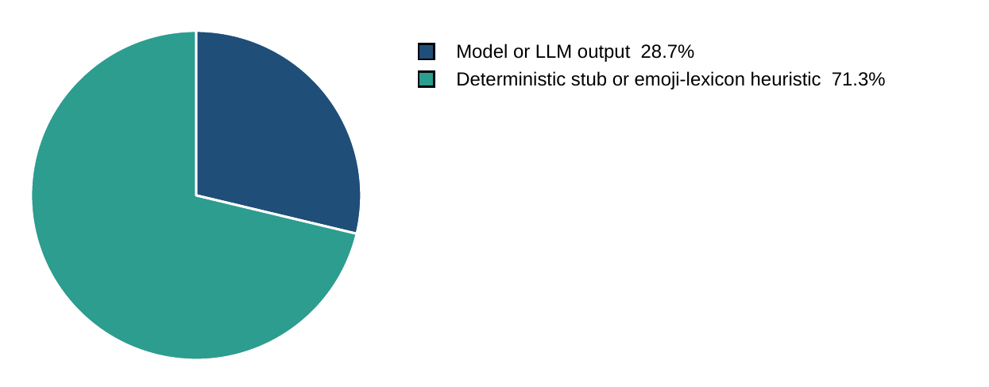
Figure 0.0: Provenance of per-comment sentiment labels in the shipped configuration.
Reading the chart. Measured over all 10,272 comments with the repository's default configuration. The larger slice is not sentiment: it is partly a fourteen-word emoji-and-lexicon rule, and mostly a deterministic function that derives a label from a hash of the first fifty characters of the text. That function is reproducible and it is not sentiment. Before provenance was recorded, the same run reported 8,513 model inferences in a configuration where zero models had been loaded, because the classifier tagged every substantive comment as model output regardless of whether a model existed. The remedy was not to hide the slice but to label it, so that the accurate statement, that 28.7 percent of labels are model output with the remainder itemised, becomes available.
Four reporting mechanisms follow from that measurement and are now permanent parts of the output contract. Each comment carries a method naming the engine that actually ran and a kind distinguishing emoji, short and substantive text. Each post carries a provenance block stating what share of its labels were model inferences. Each analysed comment carries the number of voters that actually spoke alongside its label and agreement figure. Finally, a comment that no model read is reported as uncertain at zero voters, never as neutral.

Comparative analysis
Table 4.12 compares the shipped configuration against the two natural baselines on the quantities that were measured. The comparison is deliberately restricted to measured quantities; an accuracy column is absent because labelling accuracy sits outside the evaluation scope, which Section 4.3.3 states.
Table 0.0: Comparative analysis of the shipped configuration against its baselines.
Quantity | All-cheap baseline (keyword stub Stage 1) | Shipped hybrid configuration | LLM-everywhere baseline
Posts routed for post-level LLM work | 32 of 43 (74 percent) | 7 of 43 (16 percent) | 43 of 43 by definition
Total LLM calls per corpus run | 813 | 529 | not run; bounded below by one call per post plus one per comment batch
Share of calls the gate governs | 54.7 percent | 30.4 percent | zero, the gate is bypassed
Per-comment label provenance | 71.3 percent heuristic or stub | 71.3 percent heuristic or stub in the default configuration; 100 percent model output when the ensemble roster is provisioned | 100 percent model output
Independent verdicts per analysed comment | 1 | up to 8, with abstention | 1
Retrieval recall@10, end-to-end configuration | 0.5312 with hash vectors | 0.8750 with real embeddings | unchanged; retrieval is orthogonal
Marginal token cost, self-hosted backend | zero | zero | zero, but GPU occupancy scales with comment count
Bangla and Banglish handling | keyword lists and script ratios | multilingual encoders plus two Bangla fine-tunes plus a context-aware pass | whatever the single model provides
Can the output state what produced each label | no | yes | trivially, one producer

Four readings follow from the table, and the first is the one that costs the project its simplest claim. Moving from the all-cheap baseline to the shipped configuration cuts total calls from 813 to 529, a reduction of roughly a third – real, but nowhere near the order-of-magnitude saving that a routing rate falling from 74 to 16 percent appears to promise. The reason is in the row beneath: the gate's share of calls falls from 54.7 to 30.4 percent, so as the gate routes fewer posts it also governs less of what remains. The routing rate and the bill move in the same direction but not at the same rate, and quoting the first as evidence about the second is the error this table was constructed to expose.
Second, the LLM-everywhere column is deliberately left partly empty, and the empty cells are informative. That baseline was not run, so rather than estimate it the table states the bound that follows from its definition: at least one call per post plus one per comment batch. An estimate would have been easy to produce and impossible to defend, and a column of plausible numbers beside two columns of measured ones would have invited exactly the comparison that the evidence does not support.
Third, two rows favour the shipped configuration on grounds that have nothing to do with cost. Independent verdicts per comment rise from one to as many as eight with abstention, and the output can state what produced each label. Both are properties of the ensemble rather than of the router, and both survive regardless of how the routing argument settles – which matters, because it means the contribution does not rest on the cost claim that measurement weakened.
Fourth, one row is deliberately marked orthogonal. Retrieval recall is unchanged by the choice of Stage-1 engine, because retrieval reads persisted analysis rather than participating in the cascade. It appears in the table only to record that the improvement from 0.5312 to 0.8750 came from replacing hash vectors with real embeddings, and not from anything the router does.

Results and Discussion
This section reports what was delivered, what the measurements of Section 4.2 establish, what they disconfirm, and where the evidence stops. Section 4.3.1 walks the delivered software feature by feature against the objectives of Section 1.3 and the requirements of Section 3.1.3; Section 4.3.2 draws the findings; Section 4.3.3 states the boundary of the evaluation and its threats to validity.

The delivered system, feature by feature
Every figure below is a screenshot or terminal capture of the running system, taken on 29 August 2026 on the development tier of Figure 4.1 with the corpus of Section 4.2.1 already loaded. Nothing is a mock-up: where a panel shows a number, that number is what the system computed. Table 4.13 indexes every delivered feature against the figure that shows it. One caveat applies throughout: the walkthrough deployment is configured for demonstration rather than measurement – Stage-1 runs with its own LLM path enabled and the comment caps lifted – so the routing rate visible on the Overview tab is 40 percent rather than the 16 percent Section 4.2.4 measures under the shipped configuration. The two are not in conflict; where a figure carries a number Section 4.2 also reports, the measured figure is the one in Section 4.2.
1. Bringing the stack up, and the API surface beneath it
The whole system starts with one command. Figure 4.13 is the transcript: the orchestrator syncs dependencies, brings up the four datastores, creates the ClickHouse tables, verifies that the sentence encoder produces real vectors rather than hash stubs, resets the consumer groups, and launches eleven host processes. That preflight is not decoration – an encoder silently falling back to hash vectors is the single defect that most damaged this project's retrieval numbers, so the check announces it at start-up rather than leaving it to be discovered in an evaluation.
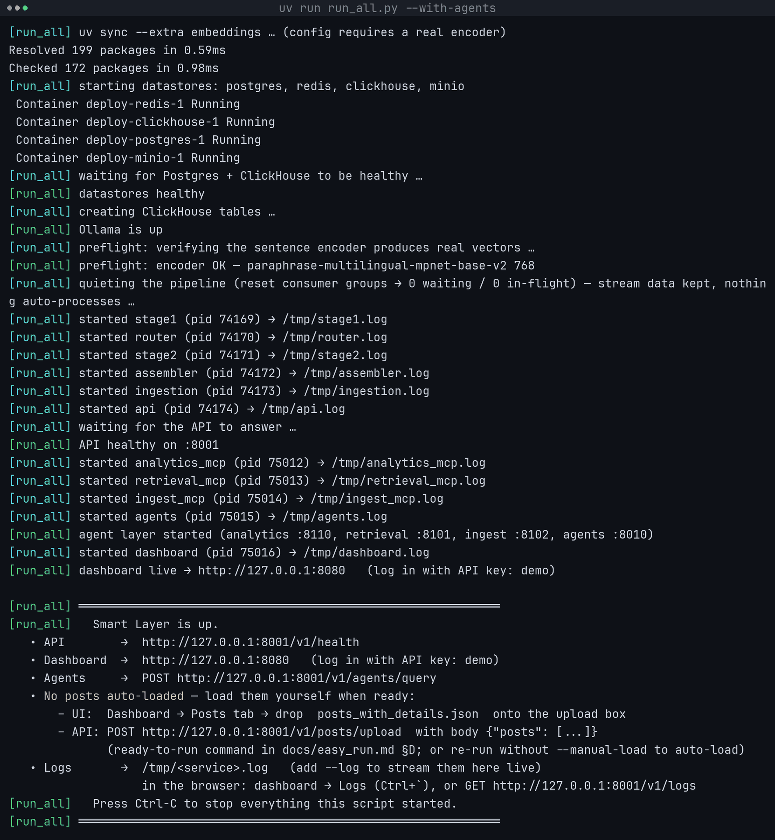
Figure 0.0: Starting the whole system with one command.
In Figure 4.13, the whole system is shown starting from one command, read in start-up order: four container lines for the datastores, two preflight lines for the encoder check, a block of started lines for the eleven host processes each with its process id and log file, and a green summary block giving the API, the dashboard, the agent endpoint and where the logs are. The four containers are D1 (posts and raw payloads) through D5 (analytics events and comment sentiments) of the data flow diagram shown in Figure 3.5 and the eleven processes are Processes 1.0 to 6.0 together with the API and dashboard the operator entity reaches them through. The stack is one command and under a minute on a laptop, which is what makes the system demonstrable rather than merely deployable; the run shown used --no-load because the corpus was already analysed, and the same command without that flag ingests the 50 posts on flow [1] as its final step.
Everything the dashboard does, it does over a self-describing HTTP API. Figure 4.14 shows the generated OpenAPI surface: 51 documented paths in fourteen tag groups, carrying 63 method-and-path pairs. Authentication is visible in the specification itself – a padlock marks every route requiring a credential, and the handful without one are exactly the routes a caller must reach before it has one.
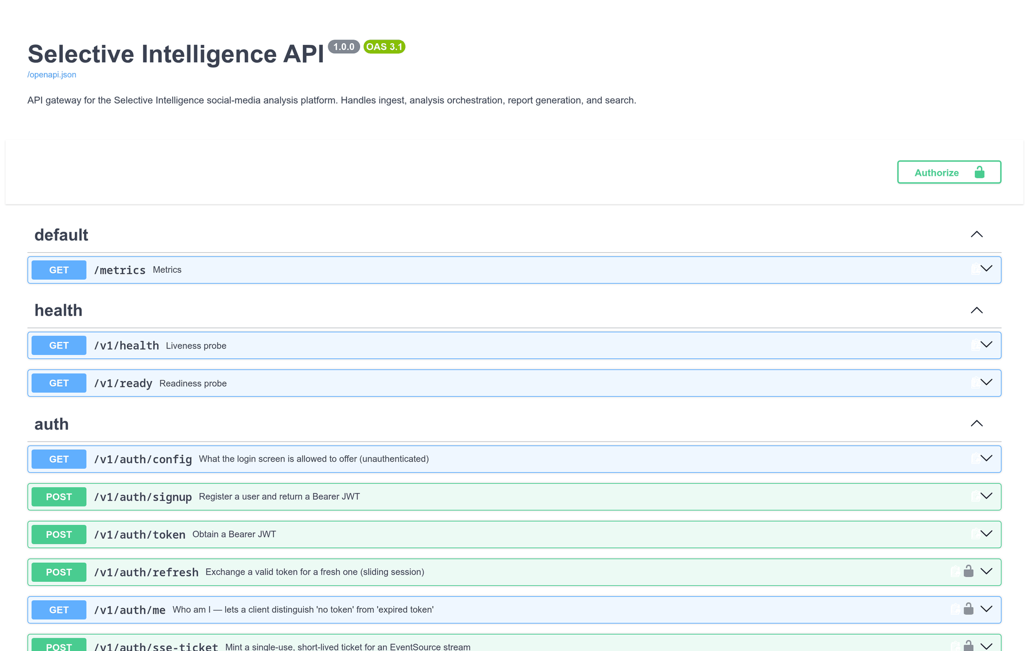
Figure 0.0: The generated API surface, with authentication marked per route.
In Figure 4.14, the generated API surface is shown as tag groups – the first three of fourteen – each row carrying the HTTP method chip, the route path, the docstring the handler holds in the source, and a padlock where a credential is required. These routes are where every flow crossing the system boundary in the data flow diagram shown in Figure 3.5 enters or leaves: an analysis request on flow [2], the canonical result JSON on flow [14], and the operator's questions and briefings on flows [2] and [17]. The specification is generated from the handlers rather than maintained beside them, so a route that exists is documented and a route that is documented exists, and the per-route padlock makes the authentication policy readable without reading the code.
2. The corpus at a glance, and where the money went
The Overview tab of Figure 3.9 is the first surface an operator sees, and Figure 4.15 is the half that matters to this project's central argument. In the run shown, the five lanes divide 941 calls as post 10, comment 284, Stage-1 83, interactive 523 and agent 41; by tokens the comment lane takes 49 percent and the interactive lane 35 percent, while the post lane – the one the router's gate governs – takes under one percent. That is the finding of Section 4.2.4 arrived at from the usage ledger instead of the router's counters, and it is why this report treats the routing rate as a partial cost control rather than as the cost control.
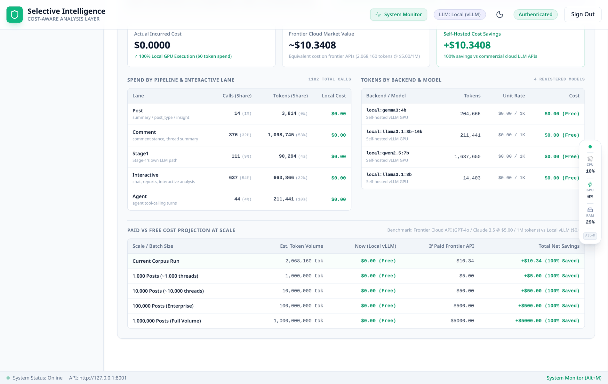
Figure 0.0: Token economics: spend by lane, by model, and projected to larger corpora.
In Figure 4.15, token economics is shown in four blocks: three cards giving cost actually incurred, the equivalent cost on a metered frontier API and the difference; a lane table with calls and tokens each followed by their share of the total; the same spend broken out by backend and model with the unit rate that produced it; and a projection table extending the measured token volume to one million posts. Every figure here is read from D3 (response cache and usage counters), which Process 4.0 (LLM analysis) of the data flow diagram shown in Figure 3.5 both reads and writes on flow [9] – the bidirectionality that makes a repeated analysis free. The comment lane and the interactive lane hold 84 percent of the tokens between them while the post lane, the only lane the routing gate controls, holds under one percent; the dollar column reads zero because the deployment is self-hosted, and the projection column is what the same work would have cost metered.
3. The posts explorer and the per-comment ensemble
Figure 4.16 is the explorer over the analysed corpus. Three things in it are design decisions rather than defaults: the comment column shows analysed, stored and platform-reported counts together, so the sampling ratio is visible in the table itself; the watchlist banner states how many posts matched a rule before the operator clicks anything; and the upload zone shares the tab with the results, because ingesting a file and inspecting what came out of it are one task.
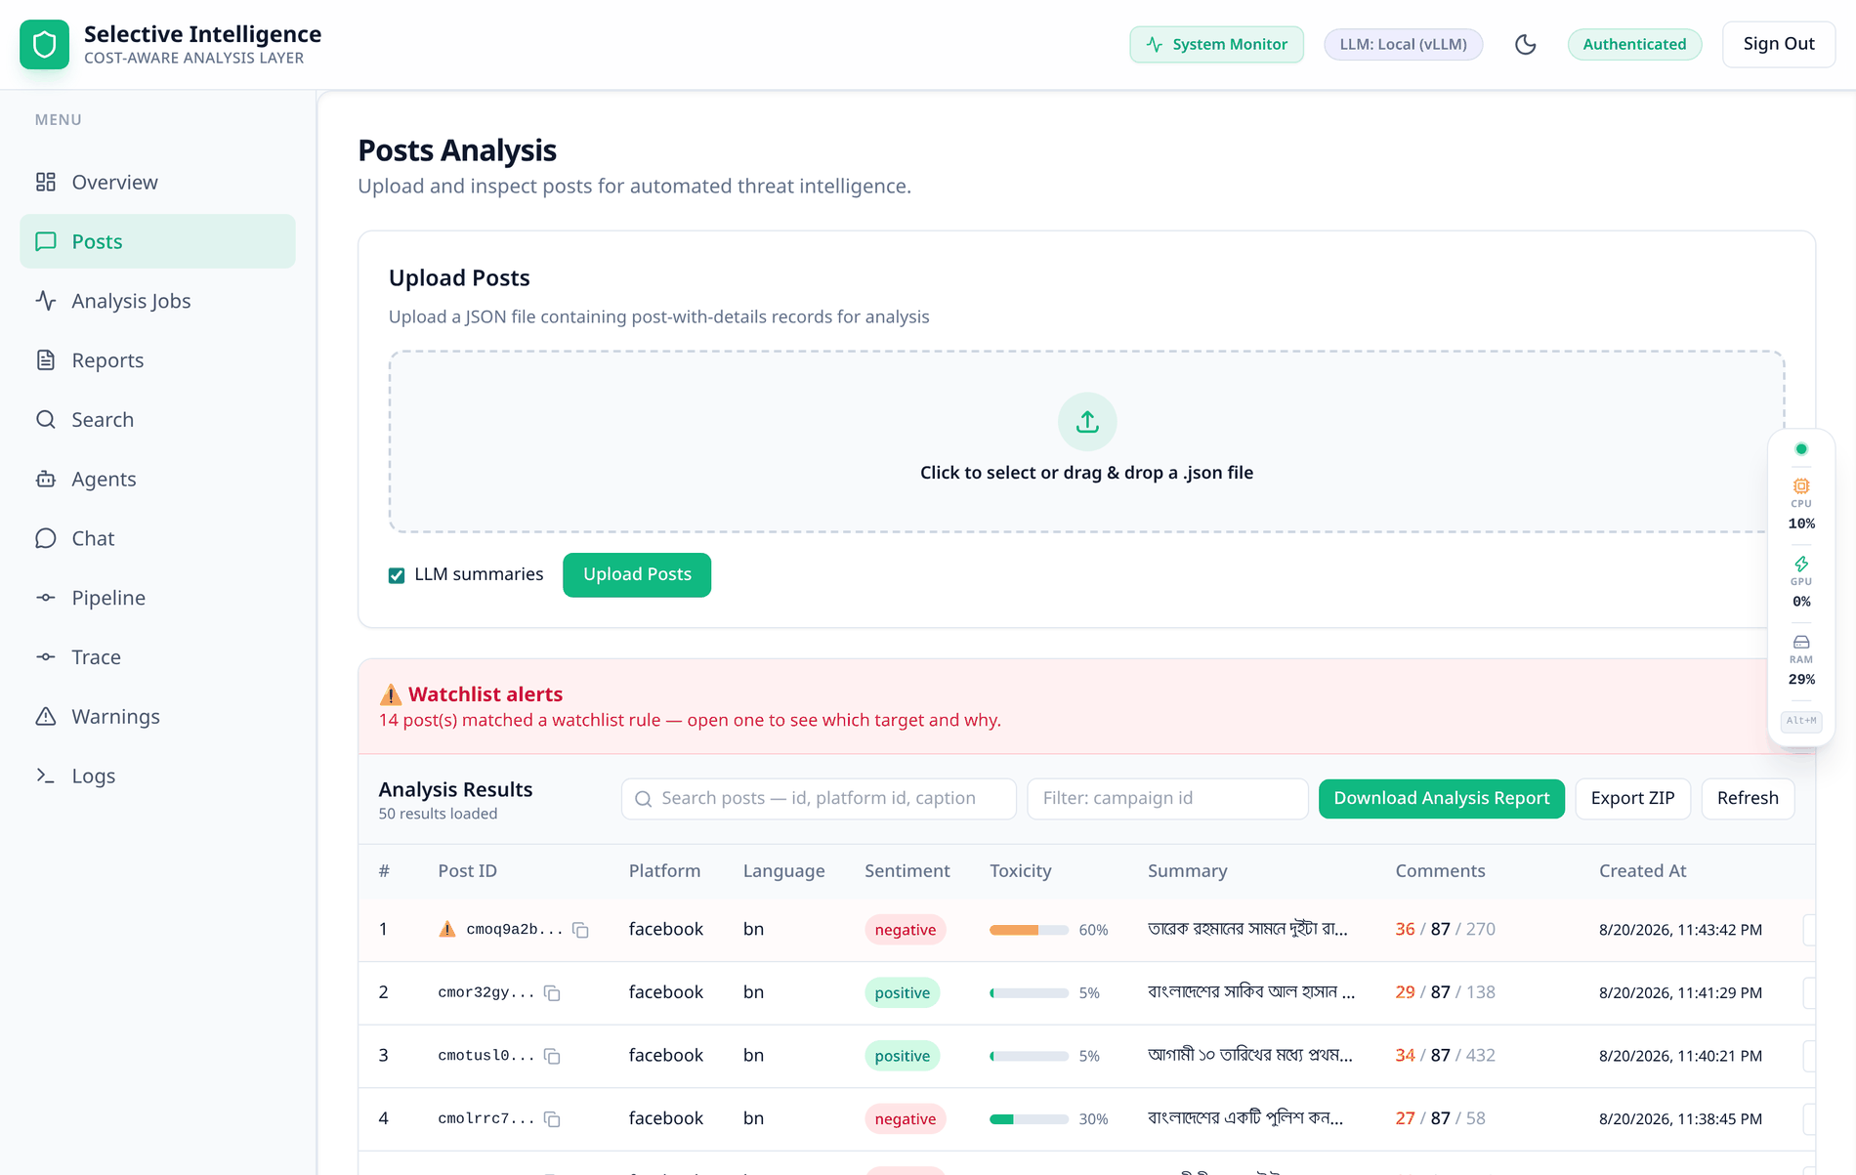
Figure 0.0: The Posts tab: upload, watchlist banner, and the analysed corpus.
In Figure 4.16, the Posts tab is shown in three regions: the upload zone that takes a post-with-details JSON file with a toggle deciding whether the upload also asks for LLM summaries, the watchlist banner counting the posts that matched a rule, and the table of one row per post carrying identifier with a copy control, platform, language, sentiment pill, toxicity meter, generated summary, the three-part comment ratio and the timestamp. The upload zone is where the operator entity issues flow [2] of the data flow diagram shown in Figure 3.5 into Process 1.0 (Ingest), and every column in the table is read back from D2 (analysis_results and embeddings), written by Process 5.0 (Assemble) on flow [12]. The three-part comment ratio – 36 analysed of 87 stored of 270 reported on the first row – is the coverage arithmetic of Section 4.2.1 rendered per post, so no chart in this dashboard can imply a completeness the scrape does not have; clicking a row opens the detail modal of Figure 4.17.
Opening a row gives Figure 4.17: the system's verdict – negative at -0.80, confidence 88 percent, political, anger, toxicity 60 percent – with an amber warning that only 87 of the platform's 270 reported comments were ever scraped. The four cards at the foot put the system's label beside the upstream platform's, and here the two disagree: the pipeline reads the caption as negative at -0.800 where the upstream baseline reads 0.620 positive. That disagreement is visible only because FR3 preserves the baseline rather than overwriting it, and the summary panel carries its own provenance – the STAGE1 badge and a grounding line naming the caption it was written from.
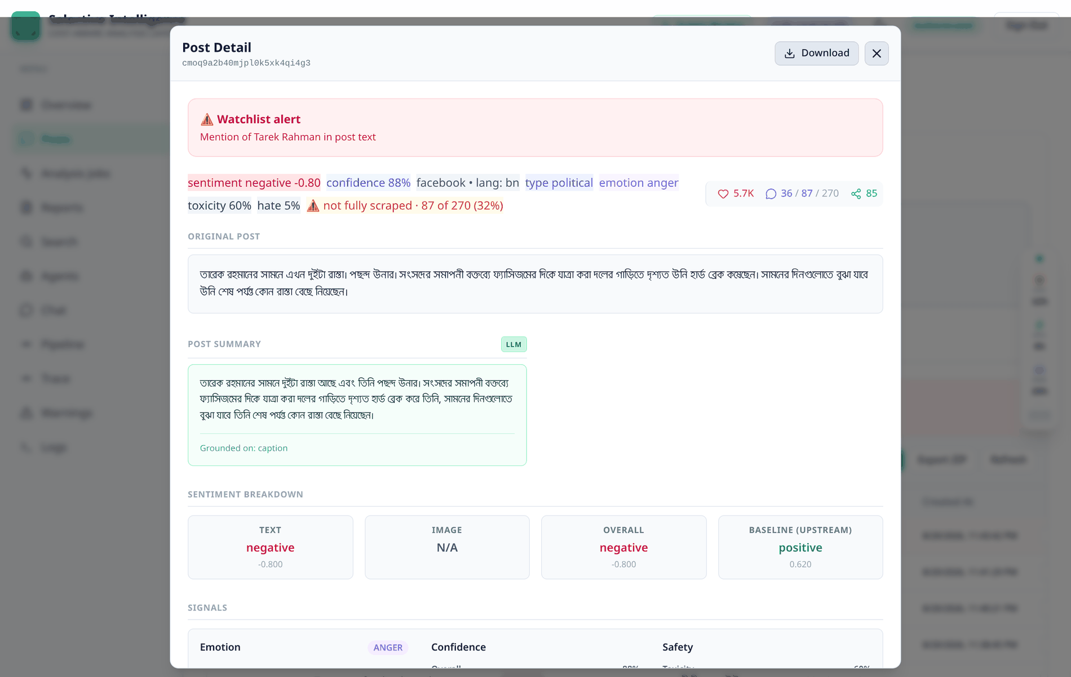
Figure 0.0: Post detail: provenance, coverage, and the system's label beside the upstream baseline.
In Figure 4.17, the post detail modal is shown as a badge row carrying sentiment and its score, confidence, platform, language, post type, primary emotion, toxicity, hate score and the amber coverage warning, over the original caption, the generated summary with its stage badge and grounding line, four sentiment cards (text, image, overall, and the upstream platform's own baseline), and a signals row giving the emotion vector, three confidence bars and the safety scores. Every field is read from D2 (analysis_results and embeddings) of the data flow diagram shown in Figure 3.5, written by Process 5.0 (Assemble) on flow [12] from the stage-2 result that arrived on flow [10]. The upstream baseline is kept and displayed rather than overwritten, which makes a disagreement between the platform's score and this system's visible instead of silent – here 0.620 positive against the pipeline's -0.800 negative – and the image card reads N/A rather than neutral because no image bytes were reachable.
Scrolling that modal reaches the comment thread. Figures 3.10 and 4.18 show the eight-labeller ensemble of Section 3.2.3 rendered honestly: each comment carries its eight verdicts side by side, the combined label, the score and the number of voters that agreed. The three comments in Figure 4.18 agree 6 of 8, 5 of 8 and 4 of 8; in the second, ModernBERT and mBERT vote positive while five heads vote negative and BanglaBERT votes neutral. A single fused label would have shown two confident negatives and a neutral, and hidden all of it.
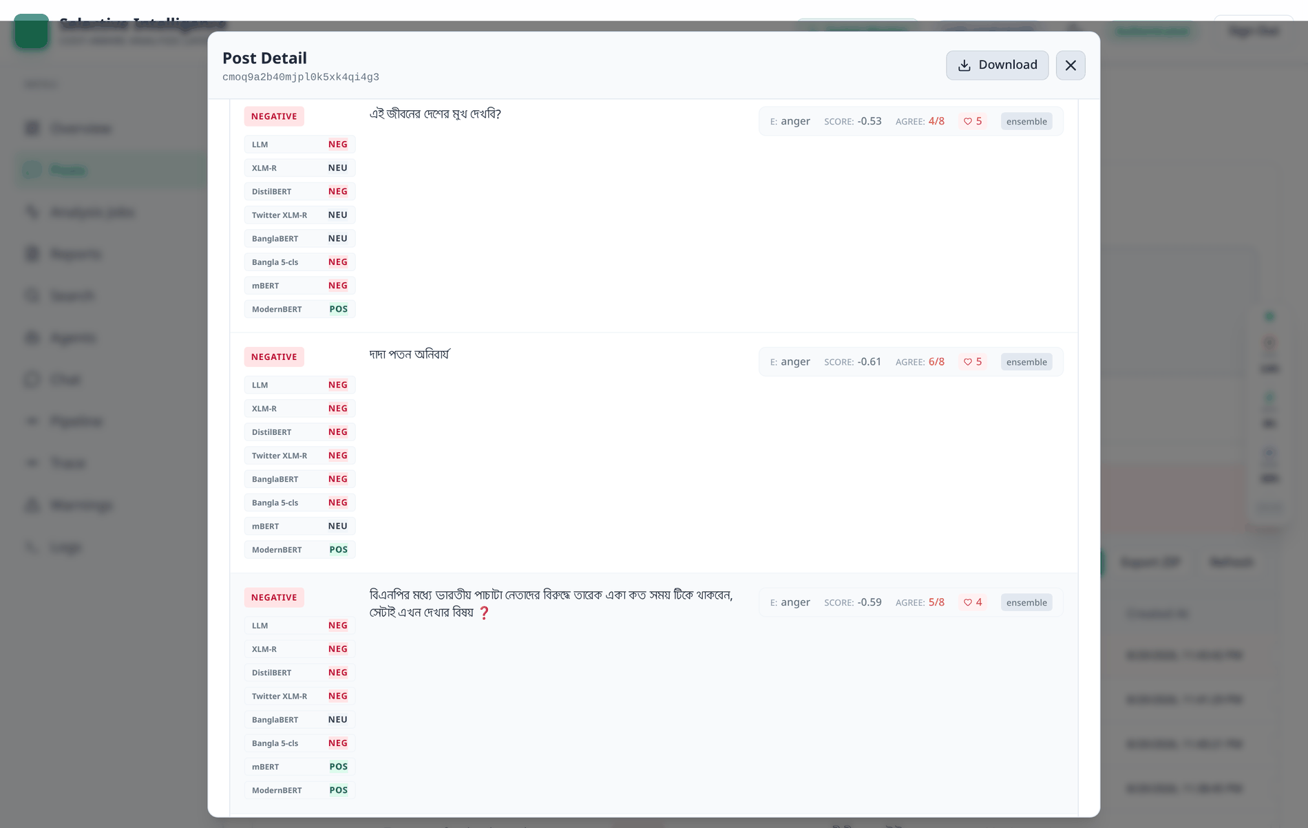
Figure 0.0: Three comments, twenty-four votes: what per-labeller disclosure looks like.
In Figure 4.18, three consecutive comment rows are shown with twenty-four votes between them: each row gives the combined label, then the eight individual verdicts as a list naming the labeller and its vote, then the comment text, then a metric strip of dominant emotion, combined score, agreement fraction, reaction count and the source tag reading ensemble. These labels are produced by Process 4.0 (LLM analysis) of the data flow diagram shown in Figure 3.5 and read back from D5 (analytics events and comment sentiments), written by Process 5.0 on flow [13]. The agreement fraction is on every comment, so a chart built from these labels can always be asked how much of it rests on a split vote; the second row is the interesting case, where two heads vote positive against five negative and one neutral, and the combined label reports 5 of 8 rather than presenting itself as certain.
4. Running an analysis, and watching it run
Re-analysis is triggered from the Analysis Jobs tab or from the API, and both produce the same job record. Figure 4.19 shows one in flight with the controls the job model supports – track, stop, resume, re-run and delete. Resume exists because a cancelled job leaves analysed posts behind and re-queuing only the unfinished ones is cheaper than starting again.
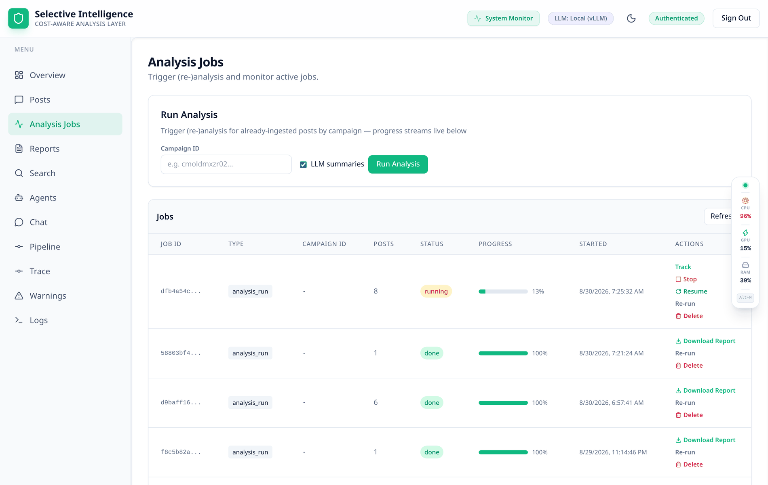
Figure 0.0: An analysis job in flight, streamed over Server-Sent Events.
In Figure 4.19, an analysis job is shown in flight across two panels: a submit panel taking a campaign identifier, an LLM-summary toggle and the button, over a job list newest-first carrying identifier, type, campaign, post count, status pill, a progress bar with its percentage, the start time and the per-job controls, with the top row at 17 percent and earlier rows still offering their reports for download. Submitting is flow [2] of the data flow diagram shown in Figure 3.5 into Process 1.0 (Ingest), and the progress figure is computed from Process 5.0 (Assemble)'s own completion counter, so it advances when a post is durably written into D1 (posts and raw payloads) and D2 (analysis_results and embeddings) on flows [11] and [12] rather than when it is dispatched. Progress is pushed over a Server-Sent Event stream rather than polled, which is the transport of Figure 3.7.
While that job runs, the Pipeline tab of Figure 4.20 shows where the work actually is: in-flight, backlog and dead-letter counts read from the Redis consumer groups themselves rather than estimated. In the capture, Stage 1 holds one item in flight with seven behind it and the downstream stages are idle – the shape a cascade produces when the cheap stage is the throughput limit, which is the intended shape.
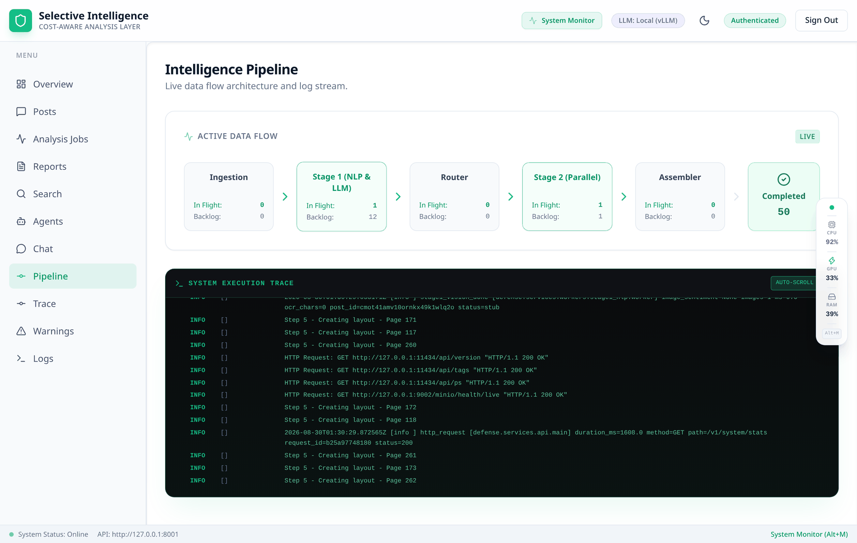
Figure 0.0: The pipeline under load: in-flight and backlog per stage.
In Figure 4.20, the pipeline is shown under load as a rail of five stage cards in pipeline order, each giving items in flight and backlog depth with the active stage outlined, a completion counter at the right, and beneath the rail the live execution trace streaming the same structured events the log console shows. The five cards are Processes 1.0 to 5.0 of the data flow diagram shown in Figure 3.5 and each backlog is the depth of the stream carrying flows [4], [6], [7] and [10] between them. The counters come from the Redis consumer groups themselves, so a backlog shown here is a backlog that exists, and Stage 1 holding the queue while the later stages idle is the cascade working as designed: the cheap stage runs on everything and the expensive ones on a subset.
The Logs tab, Figure 4.21, is the same event stream in raw form: all eleven processes write into one capped Redis buffer and the console tails it, so an operator follows a post through five workers without opening five files. The capture is honest about a consequence – between analyses the API's own health polling of Ollama and MinIO fills the visible window on its own. The structured llm_call records that Figures 4.15 and 4.35 aggregate share this stream and appear in it while a stage is running.
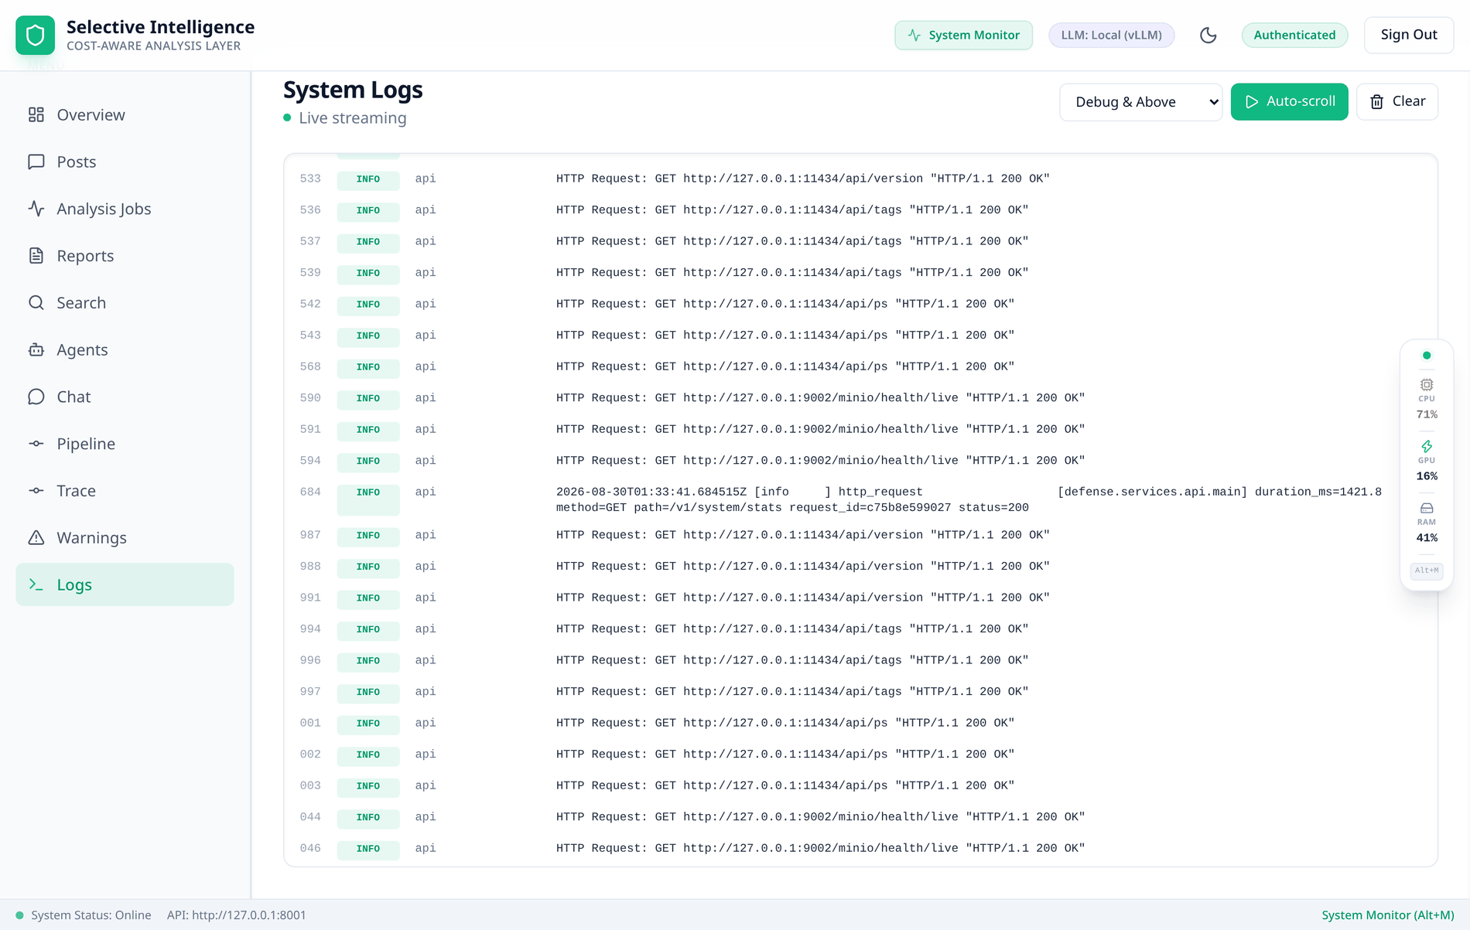
Figure 0.0: The structured-log console, streaming from every service at once.
In Figure 4.21, the structured-log console is shown streaming from every service at once, each row giving a sequence number, level chip, the emitting service and the message with any structured fields the code attached, under a toolbar offering the level filter, an auto-scroll toggle and a buffer clear, with the status line reading Live streaming once the event-source connection is open. This is the dashboard end of the Redis buffer in Figure 3.22 and carries no numbered flow of the data flow diagram shown in Figure 3.5. The capture is honest about the consequence of one capped stream per deployment: between analyses the API's continuous health polling is the only traffic, so every row in the window shown is one health poll of the local inference server or of object storage, while the stage and llm_call records share this stream and appear in it while a stage is running.
5. Tracing a single post, and the document it produces
The Trace tab re-runs one stored post through the real pipeline and follows it live, and it is the surface that makes the router's decision inspectable rather than inferable. Figure 3.11 shows a completed run: five layers, each holding the payload that stage actually emitted, with the router layer carrying use_llm, the reasons that fired, the task flags and the comment arithmetic – 87 total, 45 duplicates removed, 36 selected. A reader who wants to know why a post did or did not earn post-level work reads it from the router's own reasons rather than inferring it from the output.
The document that run produced is shown in Figures 4.22 and 4.23. It is the deliverable of the whole per-post pipeline: one schema-validated JSON envelope per thread, and the thing a downstream consumer integrates against.
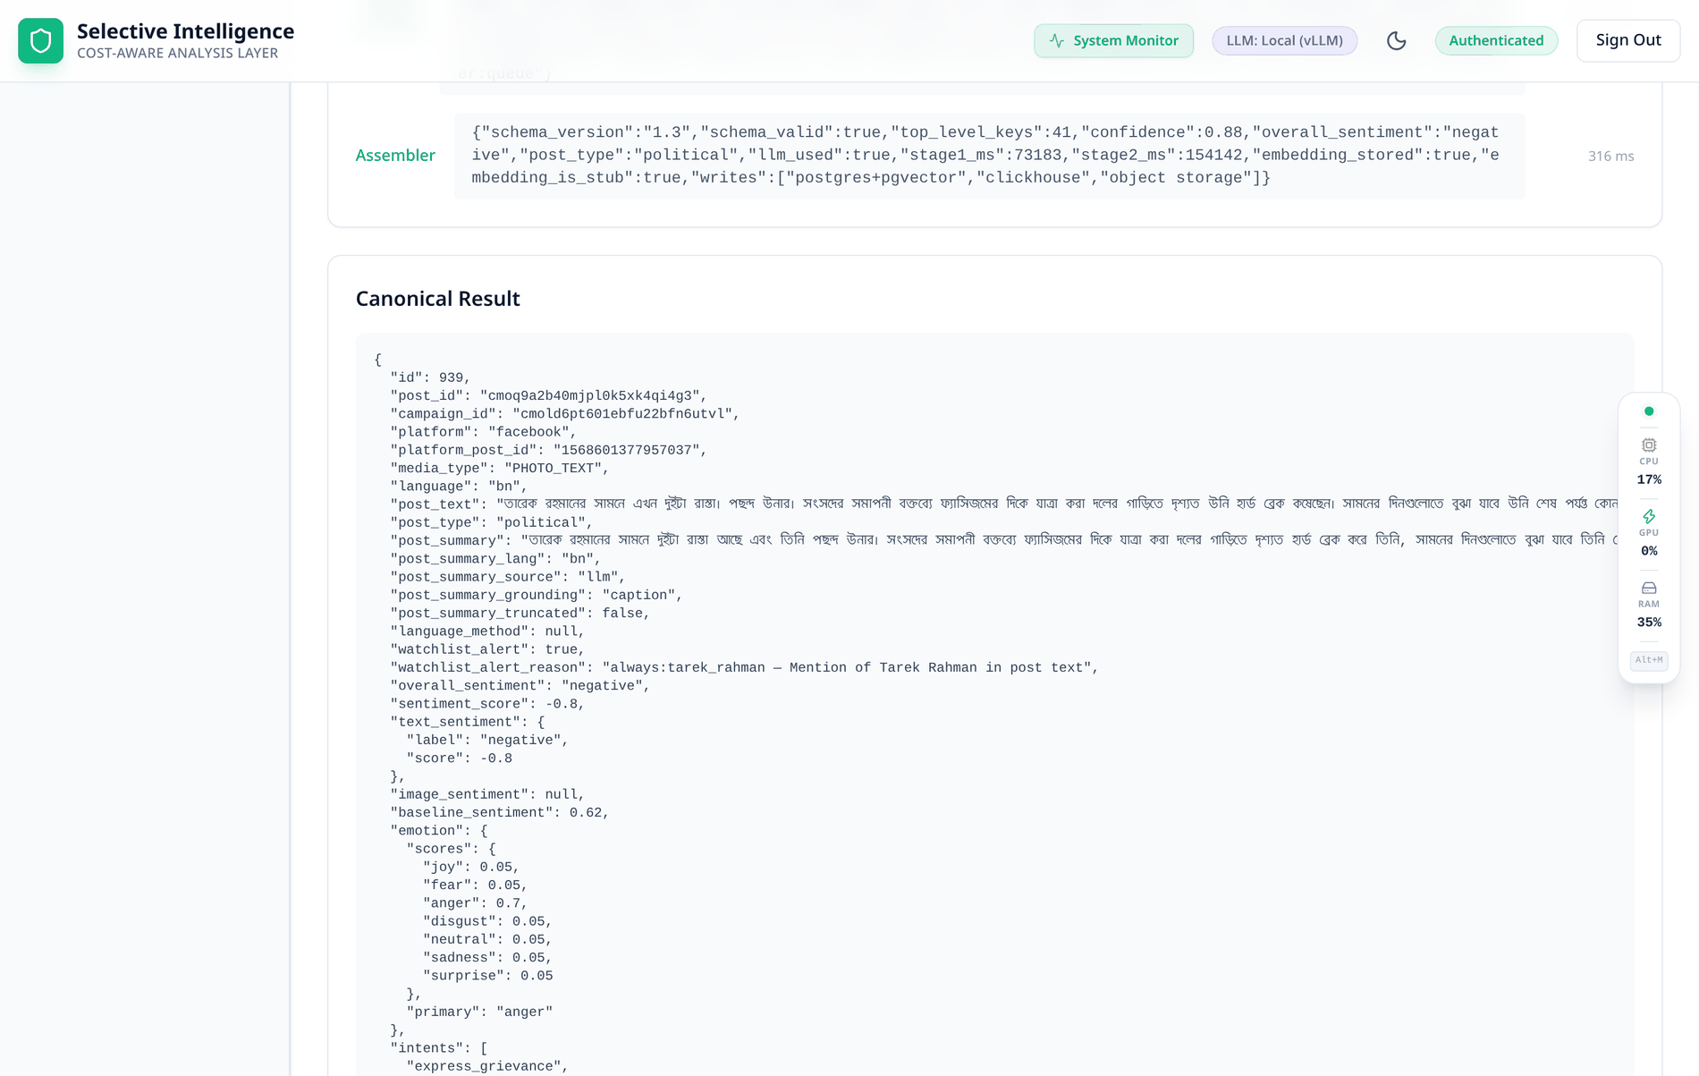
Figure 0.0: The canonical result document, first half.
In Figure 4.22, the head of the canonical result envelope is shown: identifiers and platform metadata, the caption, the post type, the generated summary with its language, source, grounding and truncation flag, the watchlist fields, the fused sentiment with its score, the text and image sentiments separately, the upstream baseline, the emotion vector, the intents and the topics. This document is the output of Process 5.0 (Assemble) of the data flow diagram shown in Figure 3.5, written into D1 (posts and raw payloads) and D2 (analysis_results and embeddings) on flows [11] and [12] and emitted to the downstream consumer on flow [14]. Provenance is structural rather than annotative: post_summary_source, post_summary_grounding and baseline_sentiment are fields of the document, so a consumer that never reads this report still receives the evidence class of every value it is given.
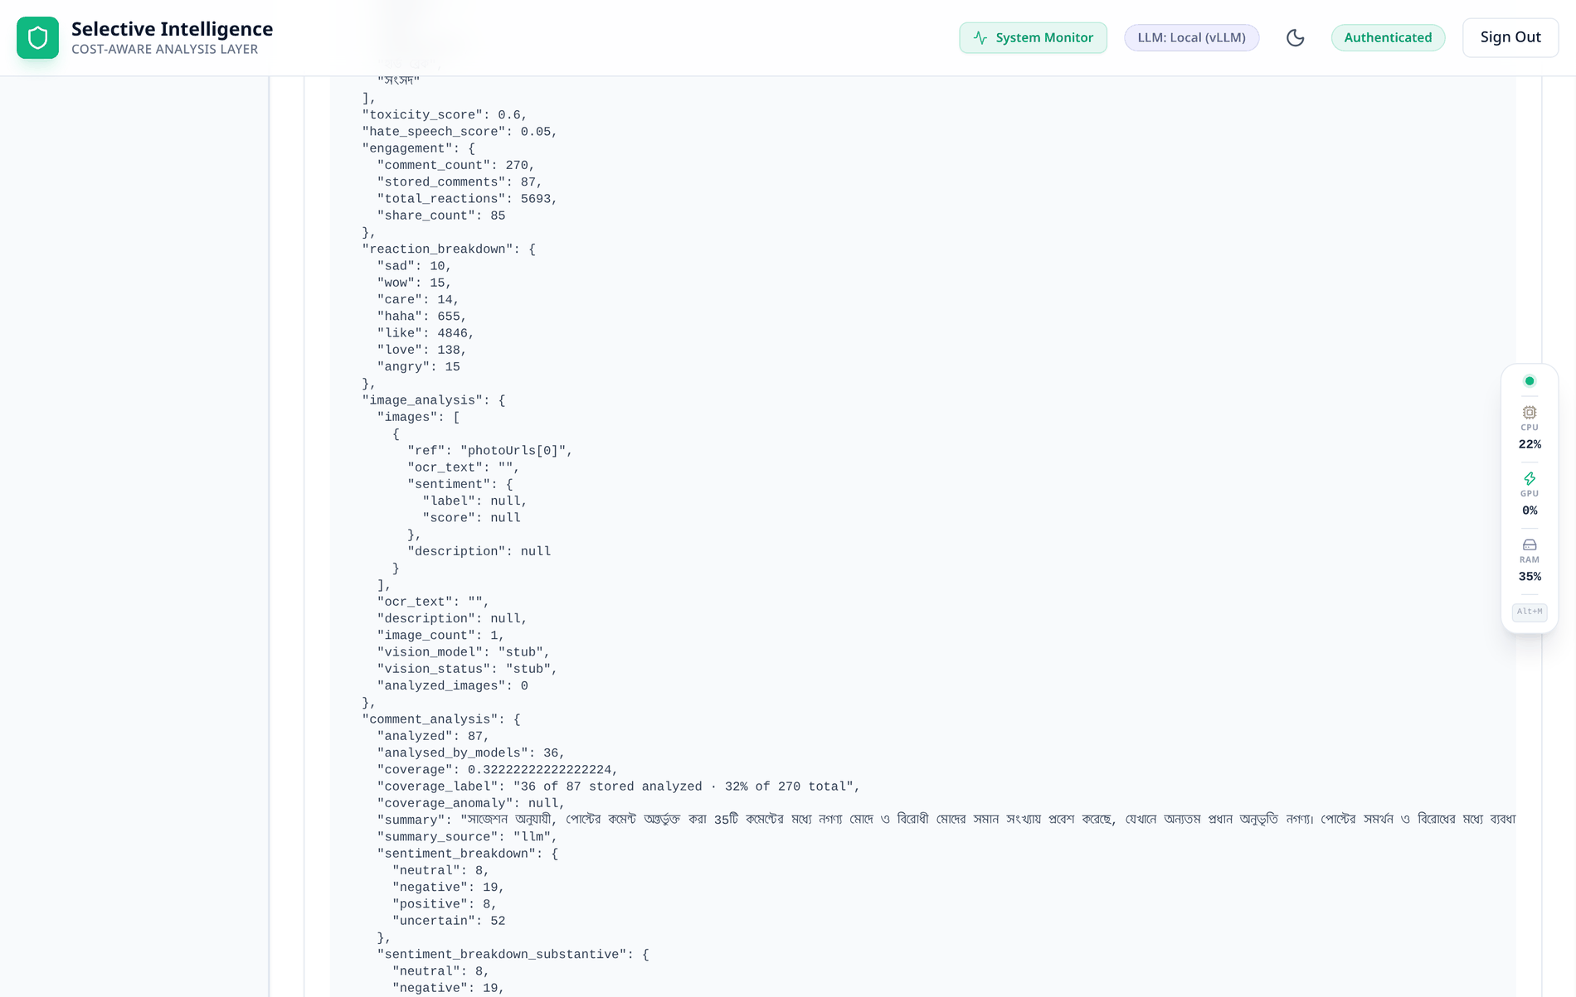
Figure 0.0: The canonical result document, second half.
In Figure 4.23, the same document continues with the reaction breakdown as scraped, the image-analysis block, the comment-analysis block with its coverage arithmetic and sentiment breakdown, and the beginning of the per-target stance block. These are the remaining fields written by Process 5.0 (Assemble) of the data flow diagram shown in Figure 3.5 on flow [12], with the per-comment detail also going to D5 (analytics events and comment sentiments) on flow [13]. Three of this report's claims are visible as fields here: vision_status: stub is the unexercised image modality of Section 4.3.3; the comment breakdown carries 52 uncertain of 87, which is the ensemble declining to label comments no model read rather than defaulting them to neutral; and target_stances carries method: deterministic, recording that this entity's stance came from the alias matcher rather than from a model.
6. Retrieval, in both modes
The Search tab exposes the two retrieval paths of Section 3.2.7 side by side: a case-insensitive scan over the stored JSONB in keyword mode, Figure 4.24, and a pgvector cosine search in semantic mode, Figure 4.25. What changes between them matters more than the ranking – semantic mode names the active embedding model and raises a banner, with a per-row badge, stating that some rows were embedded in stub mode and that their distances therefore reflect hash vectors rather than meaning. Section 4.2.5 measures what that costs: recall@10 of 0.1875 against 0.8750.
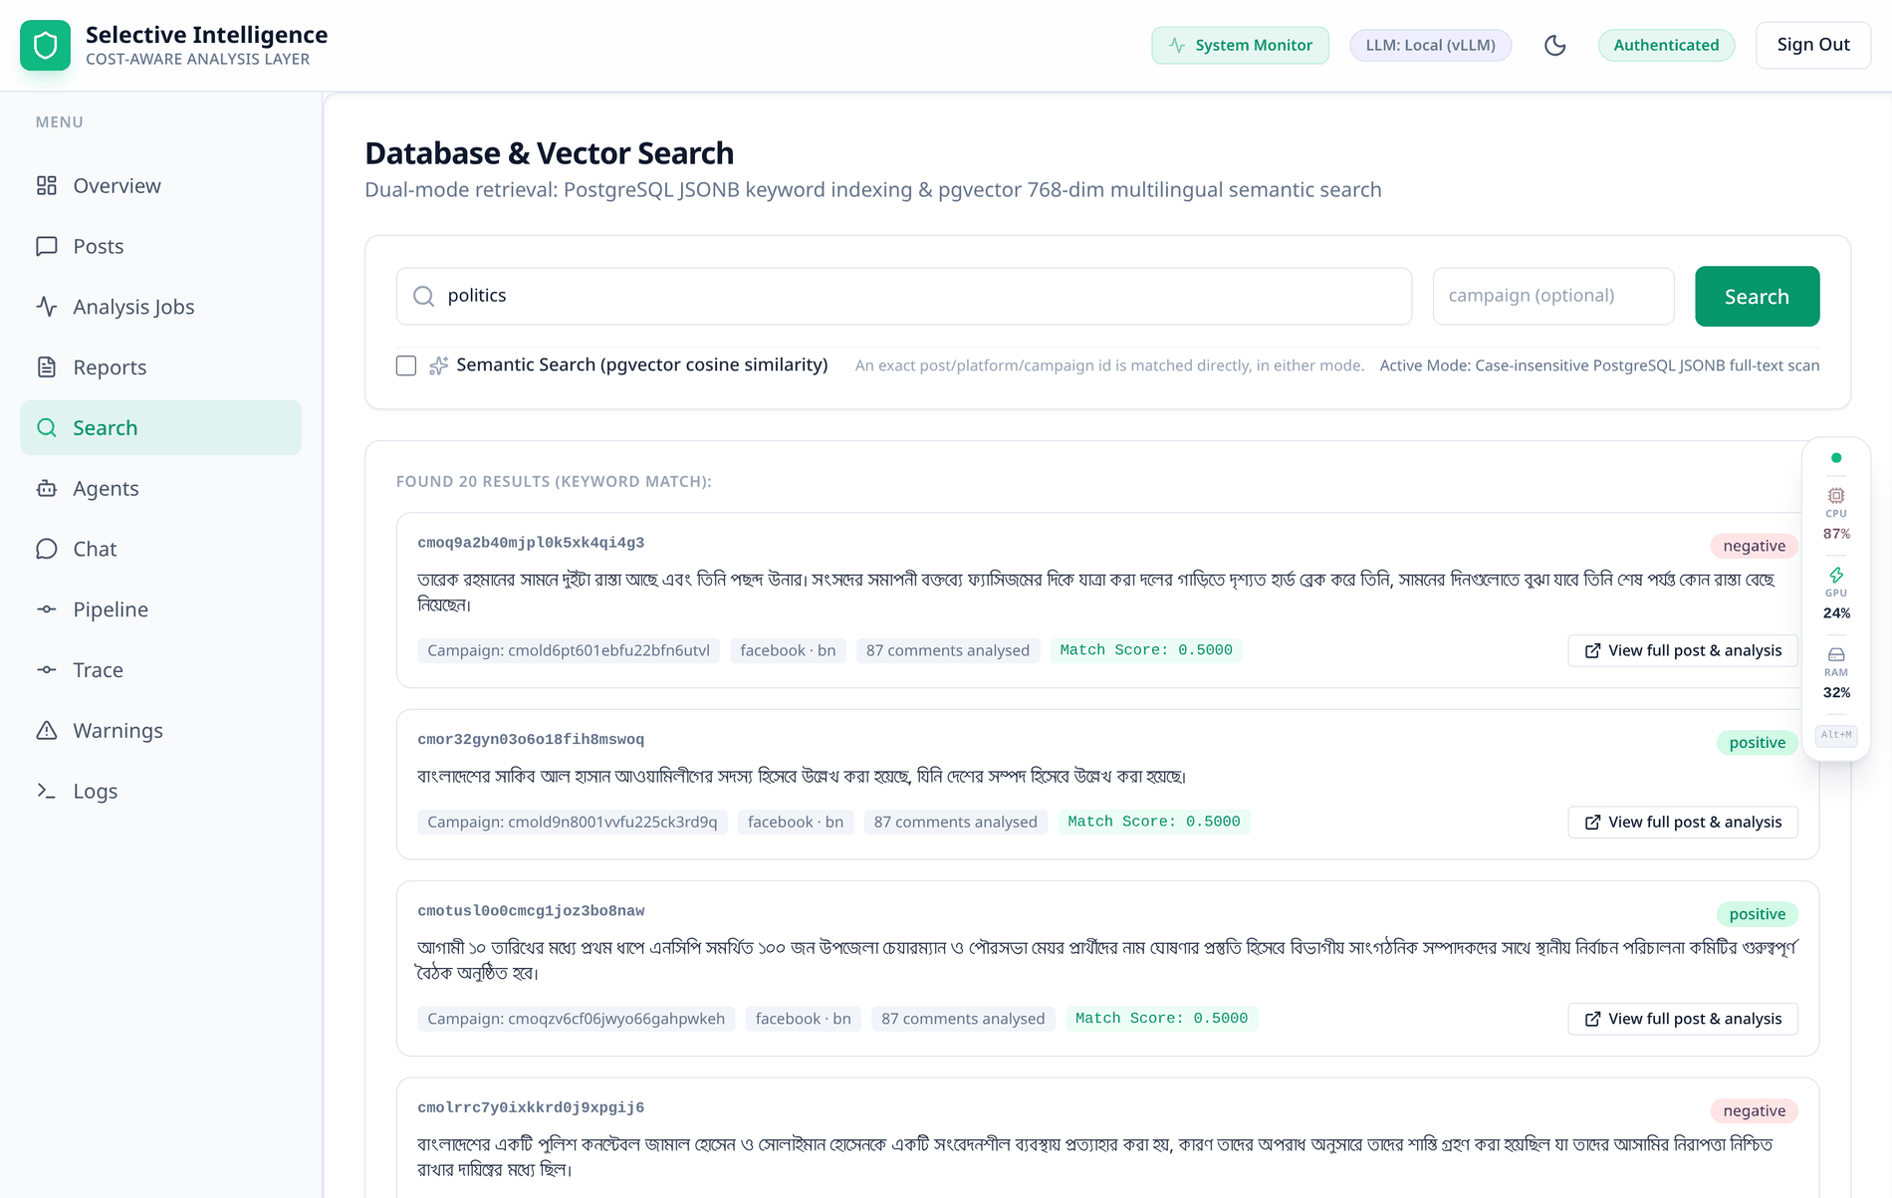
Figure 0.0: Keyword retrieval over the stored analysis documents.
In Figure 4.24, keyword retrieval is shown with the mode toggle unchecked: a banner naming the active mode over result cards each carrying the post identifier, the summary, the campaign, the platform and language, the analysed-comment count, the match score and a link into the detail modal. The search runs inside Process 6.0 (Insight) of the data flow diagram shown in Figure 3.5 and reads D2 (analysis_results and embeddings) on flow [15], which is the only store either retrieval mode touches. An exact identifier is matched directly in either mode, so an operator pasting a post id never has to know which retrieval path is selected.
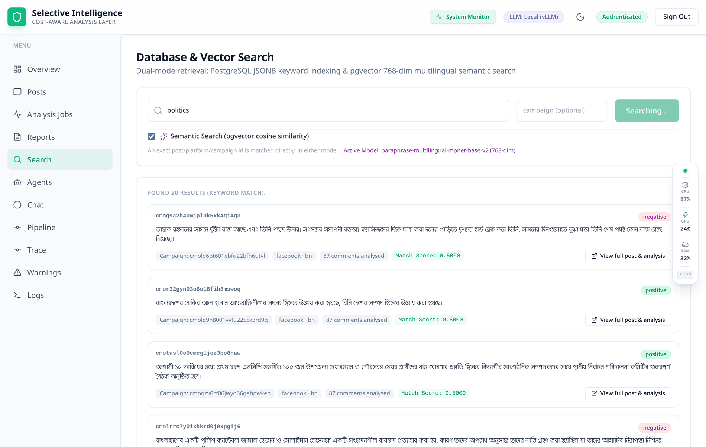
Figure 0.0: The same query in vector mode, with vector provenance stated.
In Figure 4.25, the same query is shown in vector mode: the mode line names the active encoder, paraphrase-multilingual-mpnet-base-v2 at 768 dimensions, an amber banner warns that some results carry hash-based stub vectors, each affected result card carries a stub-vector badge beside its identifier, and the score column reads as a cosine similarity. Like the keyword mode, this runs inside Process 6.0 (Insight) of the data flow diagram shown in Figure 3.5 and reads the embeddings held in D2 (analysis_results and embeddings) on flow [15], written there by Process 5.0 (Assemble) on flow [12]. The badge is per row rather than per query, because the corpus can hold real and stub embeddings at once – which is exactly the state of this deployment – and Section 4.2.5 measures what the difference is worth: recall@10 of 0.8750 with real vectors against 0.1875 with hash vectors.
7. Reports
Figure 4.26 is the report generator and Figure 4.27 opens one. The viewer shows the executive summary and the embedding clusters the report groups posts by – and, above those clusters, a badge marking that they were computed over stub vectors, which means the groupings are arithmetic rather than semantic. A report presenting those five clusters as themes without that badge would be the exact failure this project's evidence discipline exists to prevent.
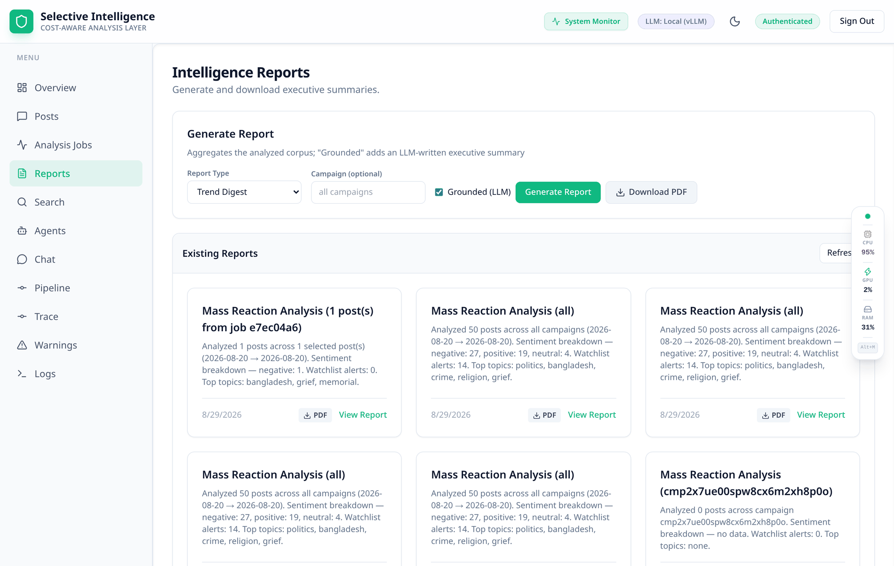
Figure 0.0: The report generator and the reports already produced.
In Figure 4.26, the report generator is shown over the reports already produced: a type selector offering trend digest, brand mentions, political analysis, sentiment summary and mass reaction, an optional campaign filter, a toggle asking an LLM to write the executive summary, and export controls, above one card per existing report with its title, summary line, date, PDF download and view control. Report generation sits in Process 6.0 (Insight) of the data flow diagram shown in Figure 3.5, aggregating D2 (analysis_results and embeddings) and D5 (analytics events and comment sentiments) on flows [15] and [16] and writing nothing back to either. A report without the grounded toggle is pure aggregation over stored results and involves no model at all; with it, one LLM call writes a narrative over those same aggregates, and the distinction is preserved in the stored report so a reader can always tell which kind they are holding.
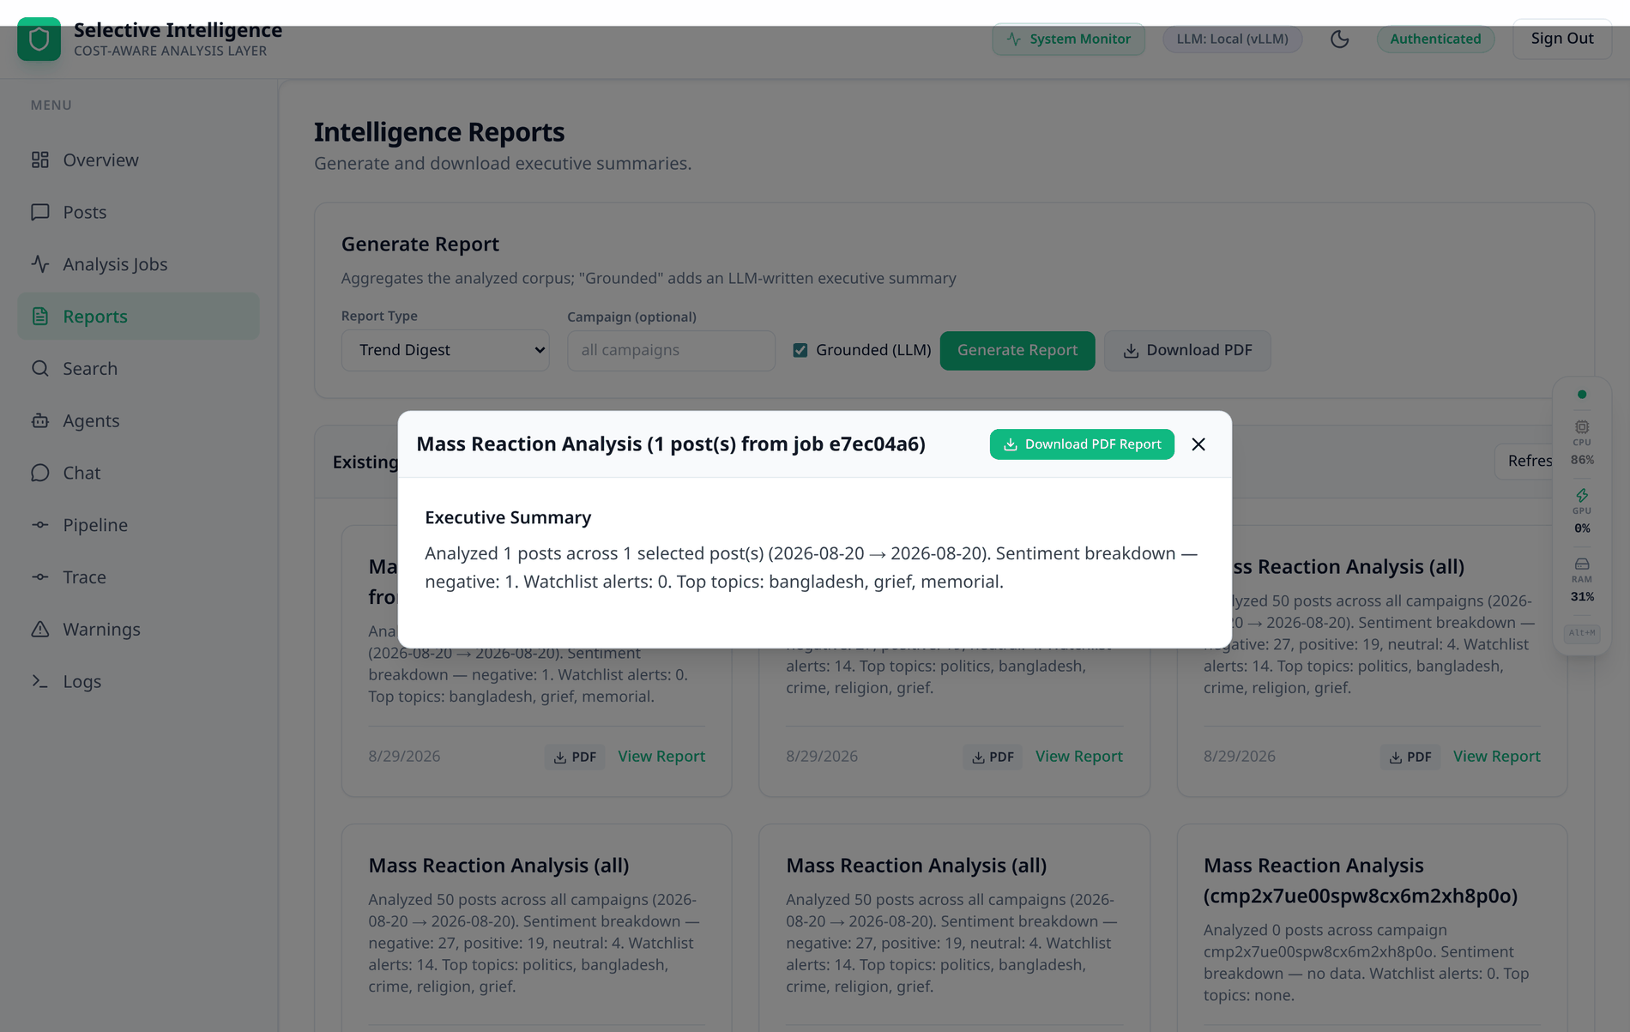
Figure 0.0: A generated report, with its cluster provenance stated on the face of it.
In Figure 4.27, a generated report is shown in the viewer: an executive summary stating the corpus, the date range, the sentiment split, the watchlist count and the top topics, over the embedding clusters listed by size with a label where one could be derived, and an amber chip beside the cluster heading reading stub vectors. Every figure in it is aggregated by Process 6.0 (Insight) of the data flow diagram shown in Figure 3.5 from D2 (analysis_results and embeddings) and D5 (analytics events and comment sentiments) on flows [15] and [16]. Four of the five clusters carry no label because no meaningful theme could be derived from hash vectors, and the interface says so rather than inventing one – the same discipline as the uncertain comment label, where an absence of evidence is rendered as an absence.
8. The agentic insight layer
The eighteen tools of Section 3.2.6 are discovered rather than declared: the runner asks each MCP server for its manifest at start-up and validates every argument against the returned schema before dispatch. Figure 4.28 is that discovery run against the live servers – six analytics tools, nine retrieval tools and three ingest tools.
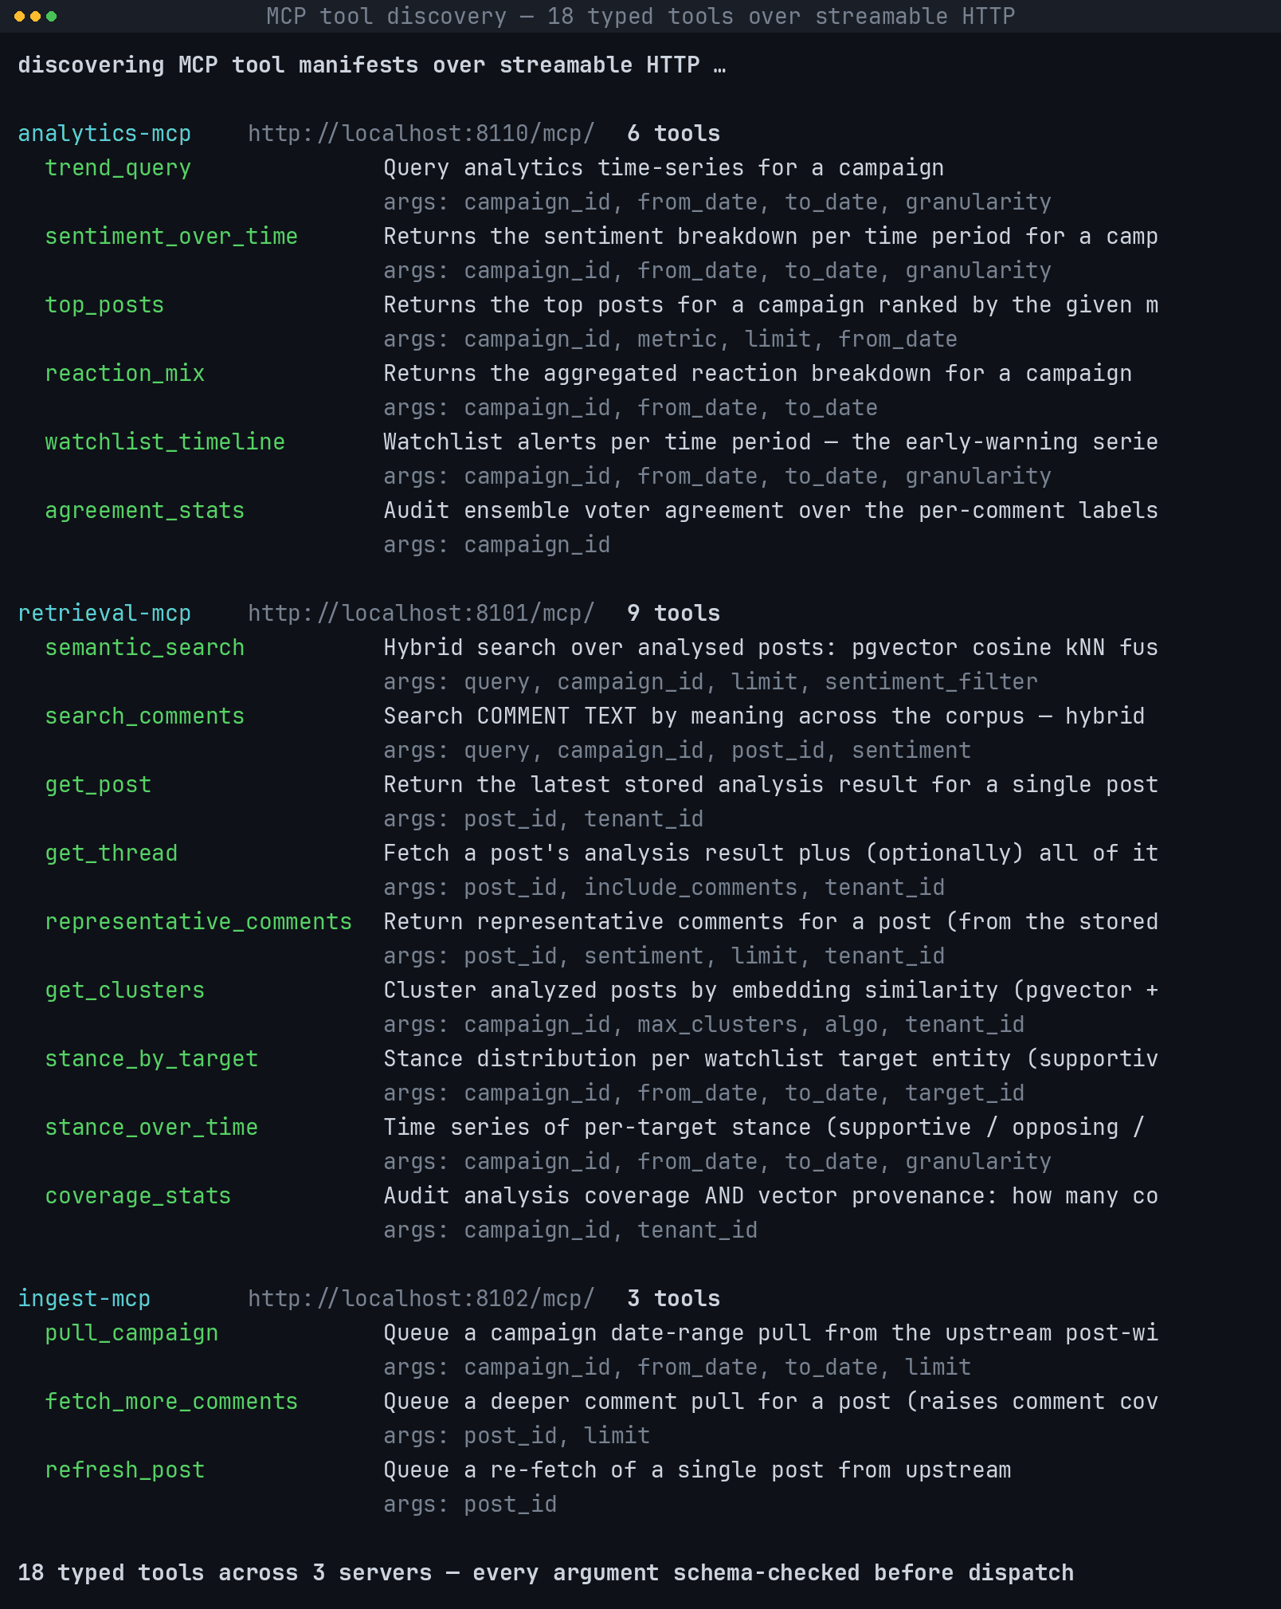
Figure 0.0: The live MCP tool inventory, as the agent runner discovers it.
In Figure 4.28, the live tool inventory is shown grouped by server: for each of the three servers its name, its streamable-HTTP endpoint and its tool count, then one block per tool giving the tool name, the first line of its description and the first four arguments of its schema. These eighteen tools are the entire surface through which Process 6.0 (Insight) of the data flow diagram shown in Figure 3.5 reaches D2 (analysis_results and embeddings) and D5 (analytics events and comment sentiments) on flows [15] and [16]; no other path into either store exists for an agent. The manifest is fetched from the servers rather than hard-coded in the agent, so a tool whose schema changes cannot silently diverge from the arguments the agent sends, and the count at the foot is the count in Table 3.6, obtained by asking the servers rather than by reading the source.
Figure 4.29 is the console over those tools, with the nine agents of Table 3.5 as selectable personas, each declaring its permitted tool subset and its budget. Figure 4.30 is a completed run and Figure 4.31 its execution trace – the calls the model actually made, in order, with their arguments and what came back. That trace is the mechanism behind the grounding claims of Section 3.2.6: an answer whose citations do not appear in the tool results the model was shown is rejected by the runner, and the trace makes that check auditable after the fact.
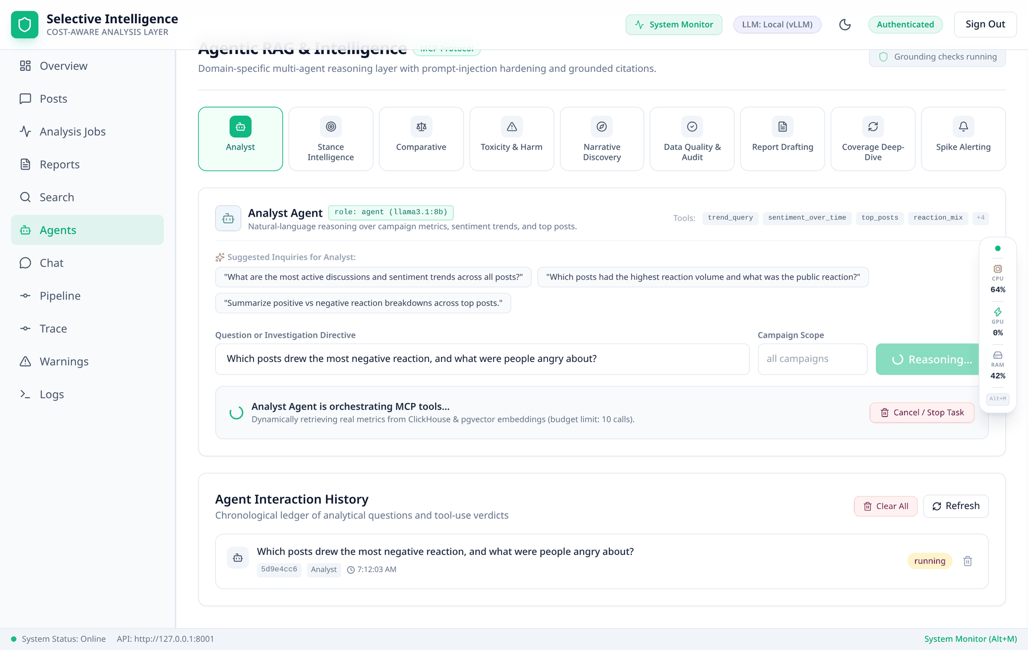
Figure 0.0: The agent console: nine personas, each with its own tool subset.
In Figure 4.29, the agent console is shown before a run: a grid of the nine agents with the selected one highlighted, and beneath it that agent's declared tool subset, its budget, three suggested questions and a free-text directive with an optional campaign scope. Each agent is one configuration of Process 6.0 (Insight) of the data flow diagram shown in Figure 3.5, and its tool subset is what bounds which of flows [15] and [16] it can exercise. An agent is a persona plus a tool subset plus a budget and all three are visible before the run starts: the tool list is the agent's authority, so a question needing a tool outside it cannot be answered by that agent, and the console says so in advance rather than after a failed run.
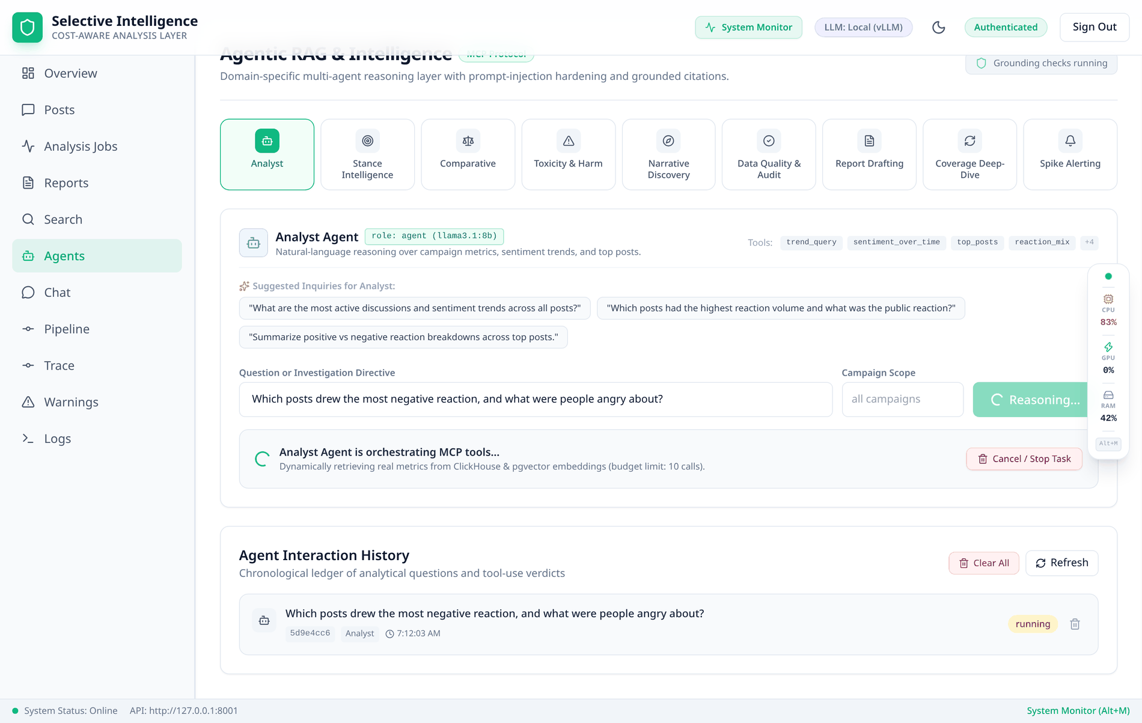
Figure 0.0: A completed agent run over the analysed corpus.
In Figure 4.30, a completed run is shown with the output header carrying the run identifier, its status, the backend and model that answered – here the local llama3.1:8b-16k – and the tokens consumed, over an answer rendered from the model's markdown as a table of the most-reacted posts with their toxicity and hate scores followed by a per-post narrative, and a block listing the post identifiers whose citations were verified. The run is one execution of Process 6.0 (Insight) of the data flow diagram shown in Figure 3.5, reading D2 (analysis_results and embeddings) and D5 (analytics events and comment sentiments) on flows [15] and [16] and returning the grounded briefing to the operator on flow [17]. The answer is never shown alone: verified grounded citations (14 post ids) means those identifiers were checked against the tool results the model was actually given, an identifier the model invented would not appear there, and an answer citing nothing verifiable is failed by the runner rather than displayed.
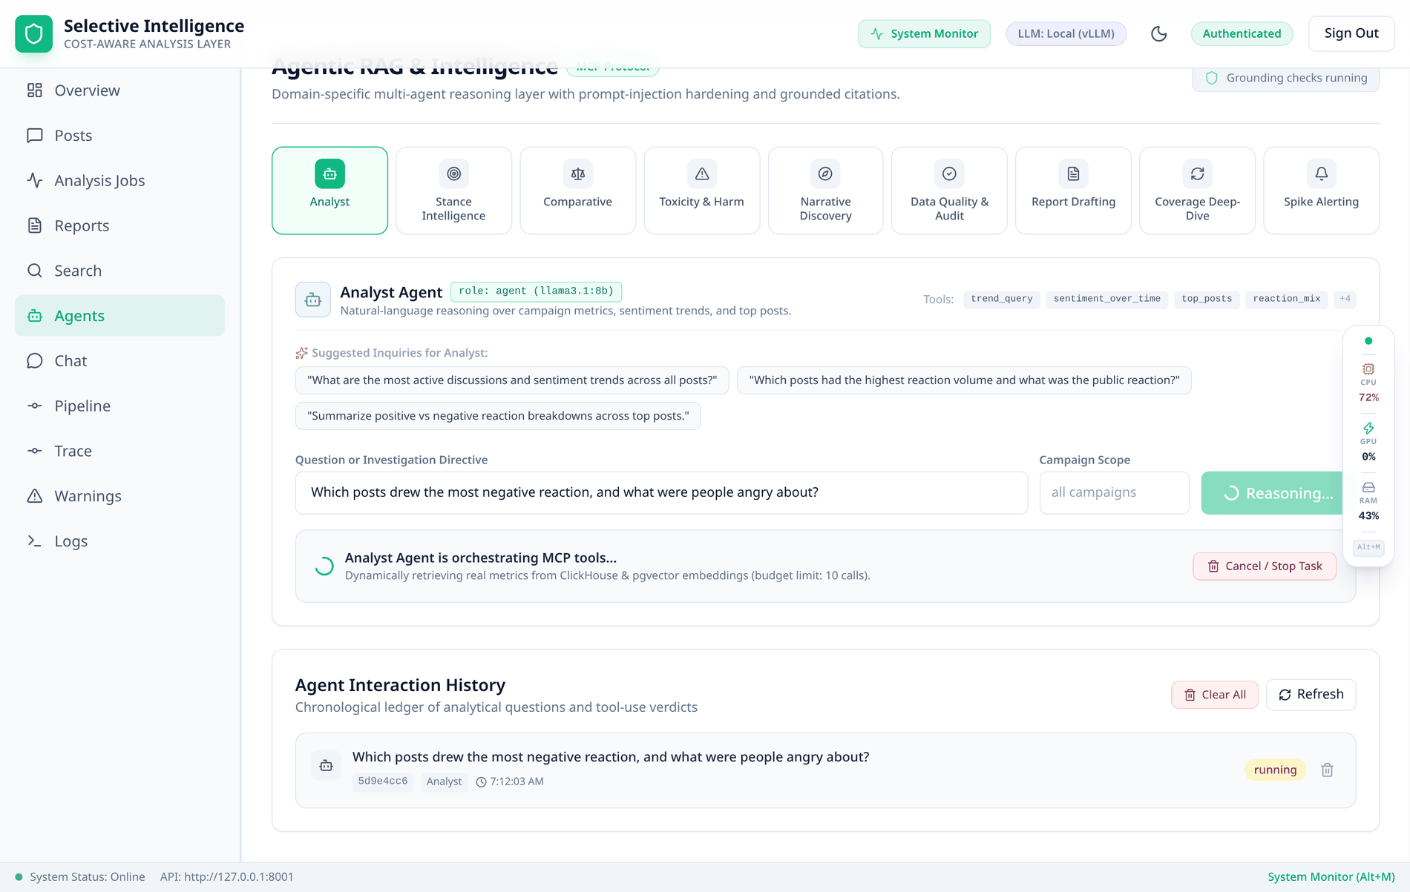
Figure 0.0: The execution trace of that run, and two calls the runner refused.
In Figure 4.31, the execution trace of that run is shown expanded, one entry per tool call in the order the model made it, each giving its number, the tool name, the MCP server that served it, a status chip and the arguments the model actually sent – a green chip carrying the latency of a call that ran, an amber one reading refused – repeat of #n. Every dispatched call here is a read of D2 (analysis_results and embeddings) or D5 (analytics events and comment sentiments) on flows [15] and [16] of the data flow diagram shown in Figure 3.5; a refused call reaches no store at all. This is the repeat-call guard of Section 3.2.6 caught in the act: the model issued four calls, calls 2 and 4 repeat calls 1 and 3 with the keys in a different order, and the runner recognised both – the signature is computed over sorted arguments with nulls dropped, so a reordering is not a new call – dispatched neither, and told the model the rows were already above; after two such repeats the tools are withdrawn for the rest of the run.
9. Chat, and a fabrication caught in the act
The Chat tab is the same corpus reasoning in conversational form, and Figure 4.32 is the most useful screenshot in this chapter because the model got it wrong and the system said so. The agent called reaction_mix, received the real distribution and wrote a correct percentage table from it – then invented two post identifiers, 12345 and 67890, and six quotations. None appeared in any tool result; the verification pass caught every one, and the answer is displayed with the invented citations listed as unverified.
It is worth being precise about what that buys. It does not stop a small model from fabricating – nothing at the prompt level can. What it does is make the fabrication visible in the same view as the answer, so an operator cannot mistake #12345 for a post. An identical answer from a system without the check would look authoritative and be partly false, which is the failure mode that makes a monitoring product dangerous rather than merely wrong.
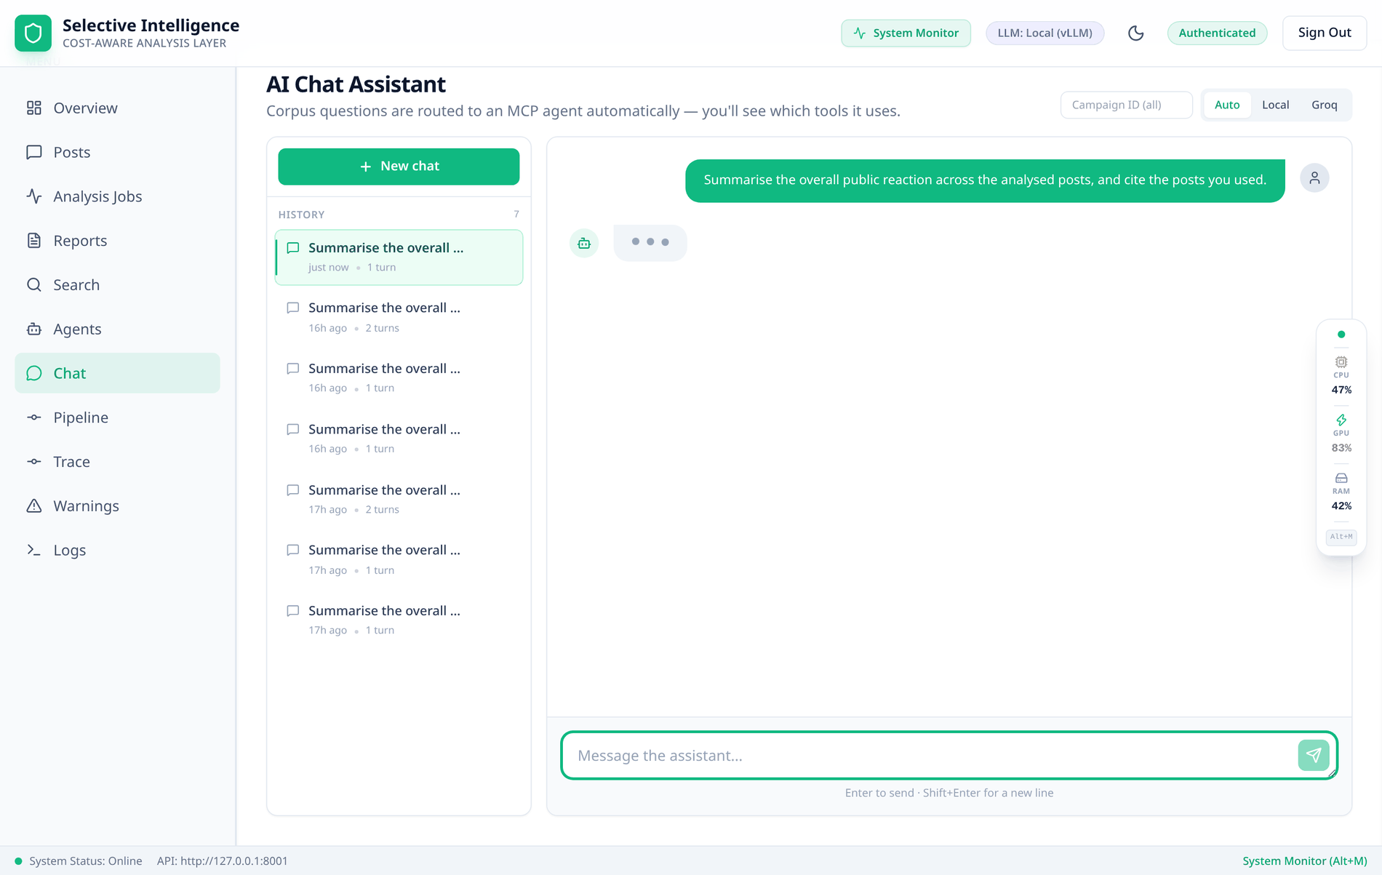
Figure 0.0: The Chat tab catching its own model inventing citations.
In Figure 4.32, the foot of a completed chat answer is shown: the reaction table the agent wrote from the tool result with the total it was computed from, then two verification blocks – unverified citations, listing post identifiers that appear in the answer but were returned by no tool call in this run, and unverified quotes, reproducing quoted passages no tool returned – with amber summary lines restating both counts. The answer came from Process 6.0 (Insight) of the data flow diagram shown in Figure 3.5, and verification compares every citation against what flows [15] and [16] actually returned during the run. The percentages are real, having come from reaction_mix, and the citations 12345 and 67890 are not: the model invented them along with six quotations. Verification is per claim rather than per answer, so a reply can be right in its statistics and wrong in its citations, and be displayed as exactly that.
10. Watchlist warnings
Figure 4.33 is the alerting surface of the watchlist design in Section 3.2.4. Each row states not only that a post matched but which target matched and under which rule. Naming the rule is what makes the alert falsifiable: an operator who disagrees can see the sentence that produced it, and an alias that never matches is visible as a target with no rows rather than as a quiet absence.
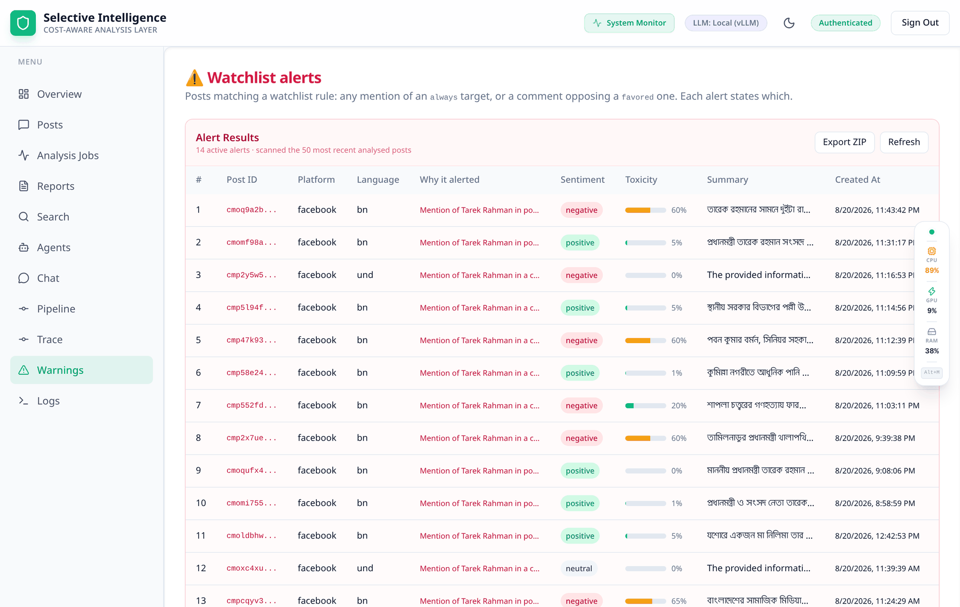
Figure 0.0: Watchlist alerts, each carrying the rule that raised it.
In Figure 4.33, the watchlist alerts are shown as a table of alerting posts with columns for the post identifier, the platform, the language, the reason the alert fired in plain language, the sentiment of the post, its toxicity meter, its summary and its timestamp, under a header stating how many alerts are active and how many posts were scanned. The match itself is made by Process 2.0 (Cheap NLP) of the data flow diagram shown in Figure 3.5 against the watchlist held in D4 (model registry and configuration) on flow [5], and the rows are read back from D2 (analysis_results and embeddings) on flow [12]. Twelve of the 50 analysed posts matched the single tracked target, and the reason column is generated from the rule that fired rather than written by a model, so an alert can be checked against the watchlist configuration by reading it.
11. Telemetry: the host, and the bill
Two telemetry surfaces close the walkthrough. The System Monitor drawer of Figure 4.34 streams host telemetry – per-core load, both graphics devices, memory and thermals – which is what allows a slow run to be attributed to saturation rather than guessed at. The usage endpoint of Figure 4.35 is the other half: the same per-lane, per-model ledger the Overview tab renders, available as JSON. Figure 4.36 records a property of the interface rather than the pipeline – every surface is themed, and a console looked at for hours should not force the light theme used throughout this chapter.
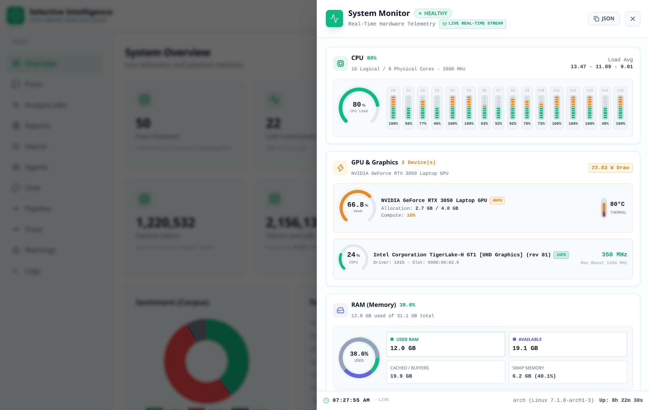
Figure 0.0: The System Monitor drawer: host telemetry during a run.
In Figure 4.34, the System Monitor drawer is shown in three blocks: the processor block giving aggregate load as a radial gauge and then one bar per logical core, the graphics block listing both devices – the discrete GPU with its memory allocation and temperature, and the integrated one with its driver and clock – and the memory block splitting the total into used, available, cached and swap, over a footer carrying the host, the kernel and the uptime. This is host telemetry rather than any flow of the data flow diagram shown in Figure 3.5, which is why no data store appears in it. The panel reports what is actually present rather than a fixed template – two graphics devices because the measurement host has two, sixteen core bars because it has sixteen logical cores – and it is the surface that attributes a slow stage to a saturated host.
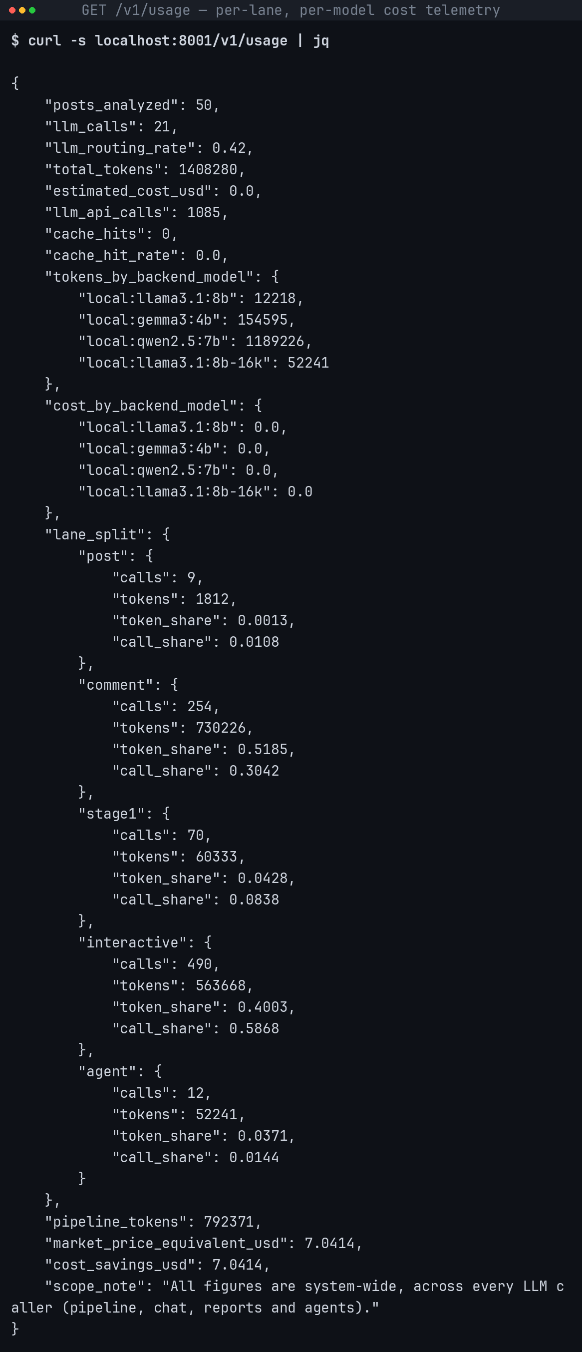
Figure 0.0: The cost ledger as the API returns it.
In Figure 4.35, the cost ledger is shown as the API returns it, in three blocks: the corpus-level counters of posts analysed, calls, routing rate, tokens, estimated cost and cache hits; then tokens and cost by backend and model; then the lane split giving calls, tokens and both shares for each of the five lanes. Every counter is read from D3 (response cache and usage counters), which Process 4.0 (LLM analysis) of the data flow diagram shown in Figure 3.5 both reads and writes on flow [9], and the cache-hit figure is that bidirectionality made visible. Cost is reported per backend and per model rather than as a single number, because the same corpus costs nothing self-hosted and a measurable amount metered, and the projection in Figure 4.15 is computed from exactly these fields.
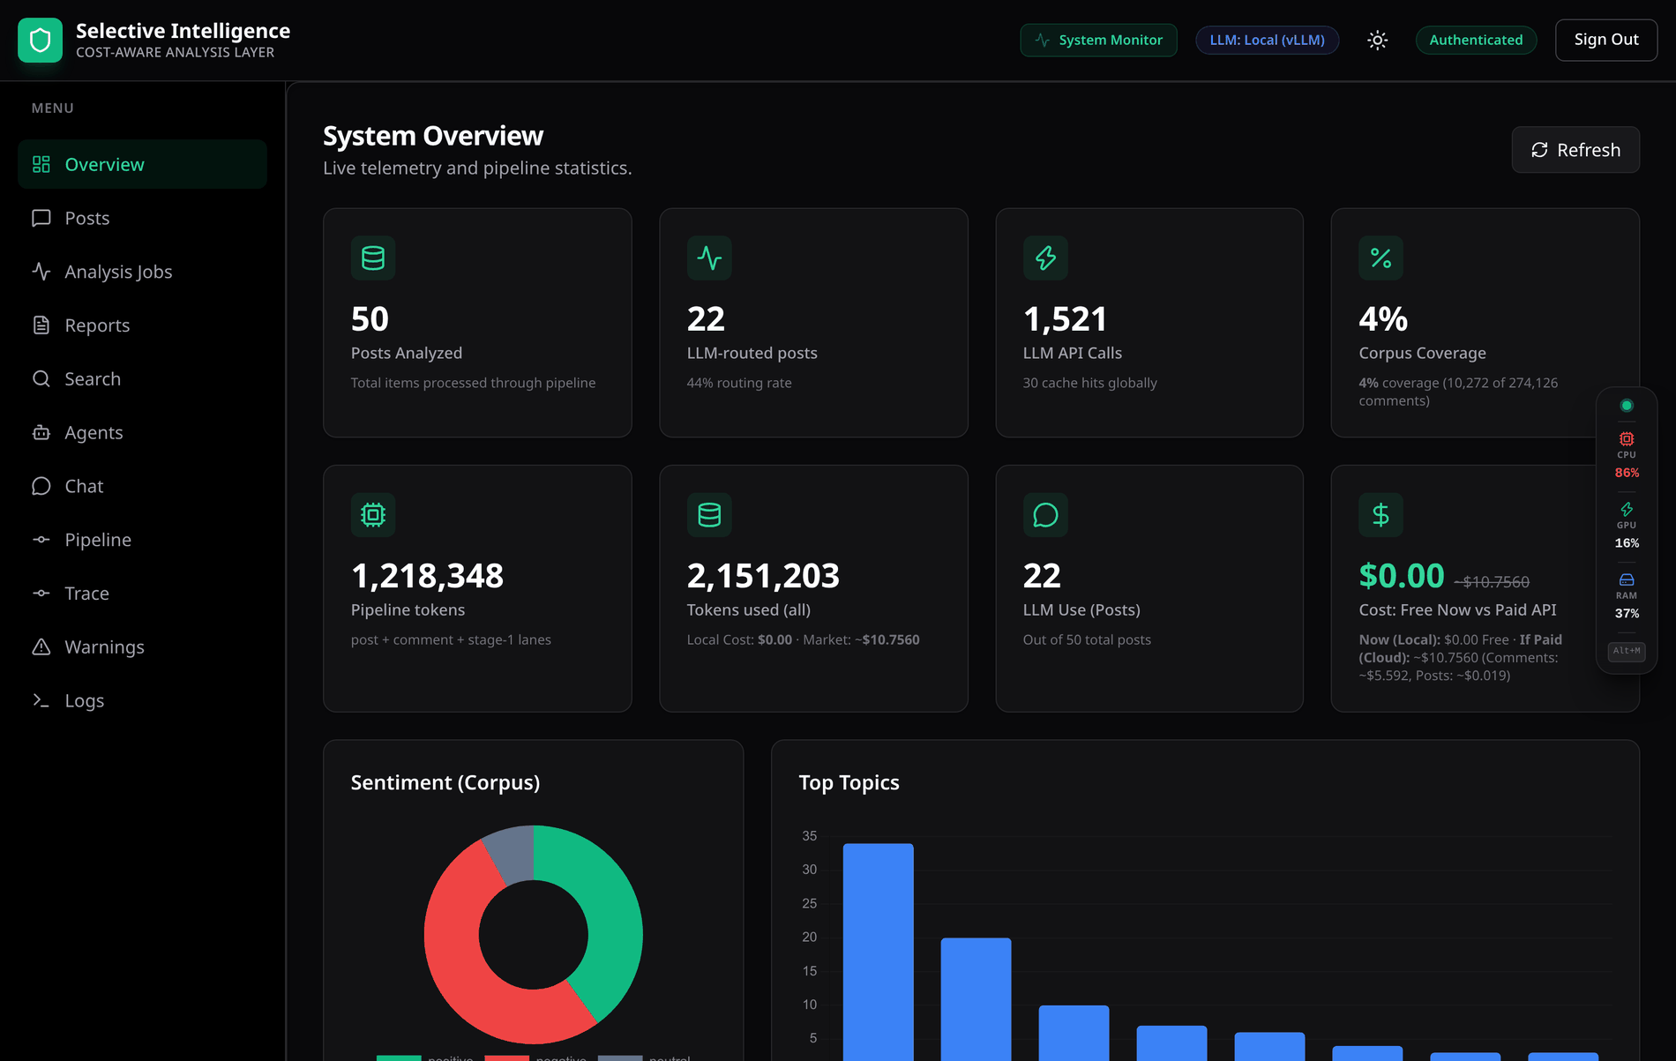
Figure 0.0: The same Overview tab in the dark theme.
In Figure 4.36, the Overview tab of Figure 3.9 is shown in the dark theme: the layout is identical, and the palette, the chart colours and the sentiment pills are the theme's dark variants. It reads the same D2 (analysis_results and embeddings) and D5 (analytics events and comment sentiments) on flows [12] and [13] of the data flow diagram shown in Figure 3.5 as the light rendering does; nothing about the theme touches the data path. Both themes are defined from one set of tokens, so a colour that carries meaning – the sentiment pills, the toxicity meter – keeps its meaning across the two, and the theme follows the operator's system preference and can be overridden from the header.
Table 4.13 indexes the delivered features against where each is implemented and the figure that shows it. It is deliberately a complete list rather than a highlight reel: a feature that is implemented but has no figure, or no evidence class better than "works but unmeasured", is listed at that class here and in Table 4.14.
Table 0.0: Delivered features, where each lives, and the figure that shows it.
Feature | Where it lives | Shown in
One-command start of the whole stack | run_all.py, eleven host processes and four containers | Figure 4.13
Self-describing HTTP API, 51 paths / 63 operations | services/api, generated OpenAPI | Figure 4.14
Ticketed Server-Sent Event streams | /v1/auth/sse-ticket plus five stream endpoints | Figures 3.7, 4.19
Sign-in, self-service registration, JWT sessions | routers/auth.py, Welcome.jsx | Figure 3.8
Corpus overview with sentiment, topics, emotion and language | Overview.jsx, /v1/analysis/overview | Figure 3.9
Per-lane, per-model cost telemetry and scale projection | /v1/usage, Overview.jsx | Figures 4.15, 4.35
Corpus upload and re-analysis | /v1/posts/upload, /v1/analysis/run | Figures 4.16, 4.19
Post explorer with visible coverage arithmetic | Posts.jsx | Figure 4.16
Post detail: provenance, coverage, upstream baseline | PostModal.jsx | Figure 4.17
Eight-labeller comment ensemble with abstention | stage2_llm, PostModal.jsx | Figures 3.10, 4.18
Watchlist-driven target stance, alias matching | libs/stance, routers/analysis.py | Figures 4.33, 4.23
Job control: track, stop, resume, re-run | routers/analysis.py, AnalysisJobs.jsx | Figure 4.19
Live queue depth per stage, dead-letter counts | /v1/pipeline/stats, Pipeline.jsx | Figure 4.20
Per-post live execution trace | libs/progress.py, Trace.jsx | Figure 3.11
Schema-validated canonical result document | assembler, JSON Schema 1.3 | Figures 4.22, 4.23
Keyword retrieval over stored analyses | routers/search.py | Figure 4.24
Vector and hybrid retrieval with per-row vector provenance | pgvector, retrieval_mcp | Figure 4.25
Report generation, grounded and ungrounded, with PDF export | routers/reports.py, Reports.jsx | Figures 4.26, 4.27
Eighteen typed MCP tools across three servers | mcp_servers/ | Figure 4.28
Nine tool-using agents with per-run budgets | services/agents/runner.py | Figures 4.29, 4.30
Agent execution trace and grounding verdict | runner.py, Agents.jsx | Figure 4.31
Streaming chat, agent handover, per-claim citation verification | routers/chat.py, Chat.jsx | Figure 4.32
Watchlist alerting with the rule that fired | Warnings.jsx | Figure 4.33
Structured log aggregation from every service | libs/logging, Redis, Logs.jsx | Figure 4.21
Host telemetry: cores, both GPUs, memory, thermals | /v1/system/stream, SystemMonitorDrawer.jsx | Figure 4.34
Light and dark themes from one token set | tailwind.config.js, index.css | Figure 4.36
Automated test suite, including one regression test per repaired defect | tests/, 1,420 tests in 68 files – Table 4.5 | Figure 4.5 (one module of it)
Image and OCR modality | stage1_nlp/vision_analyzer.py | Implemented, unexercised – Table 4.14
Prometheus scrape, Grafana and Loki containers | deploy/ | Works, no provisioned dashboards – Table 4.14

Two rows of Table 4.13 name no figure, and the reason is the same in both cases: there is nothing to photograph. The image modality runs on every post and finds no reachable image bytes, so its output is the vision_status: stub field visible in Figure 4.23 rather than a surface. The Prometheus and Grafana containers start and the scrape configuration is correct, but this repository provisions no Grafana dashboards, so the operator-independent monitoring path ends at the metrics endpoint rather than at a panel. Both are carried at that evidence class in Table 4.14 and are named again in Section 6.2.

What the measurements establish, and what they disconfirm
Three findings are supported. The cascade works as a mechanism and its behaviour is now observable rather than asserted: the gate responds to Stage-1 quality in the direction the design predicts, its decision travels explicitly on the envelope, its inputs are logged through the same readers the rules use, and its bypass branch is validated end to end against the output schema – a branch that had never once executed before the audit that found it. Hybrid retrieval is a real improvement, and the stratification in Table 4.11 explains why: the fused configuration reaches 0.8750 recall@10, and the two arms fail on disjoint query populations, which is a stronger argument for fusion than the aggregate number that hides it. Provenance reporting changed what the system can honestly claim, and asymmetrically – it removed claims rather than adding them, turning two apparent successes into stated absences: the image modality, and the majority of the default configuration's comment labels.
The project's original headline claim was wrong twice over, and reporting that is more useful than reporting only the corrected version. It was wrong in fact, because the gate was routing every post: two rules read field names Stage 1 never emitted, one read a field Stage 1 sets as a placeholder for Stage 2 to fill, and one compared a language value against a code-mixing marker recorded under a different field entirely – net, one rule always fired and three could never fire. Every one of the four was a silent degradation rather than an exception, which is the generalisable lesson of this project; the mitigation – named reader functions, a diagnostic log routed through those same readers, and a test asserting that the reader sees the producer's real output – was then applied to the three other places the identical pattern had occurred. It was wrong in framing, because even a correctly functioning gate governs a minority of spend once every comment is labelled. That is the finding with the most transfer value outside this project: when the routed unit contains many sub-items that each need work, routing the container is not the cost lever. The published cascade literature routes single queries [30], [31], [32] and does not encounter this, which is why it took a measurement rather than a reading to find.

The boundary of the evaluation, and threats to validity
Labelling accuracy is outside the scope of this project, and the report claims none. The deliverable is a system: one that routes work, labels it, records what produced every label, and serves the result under a validated contract. A benchmark number would additionally require human-adjudicated labels, and producing them is an annotation programme with its own guideline, agreement study and timeline – not a further measurement script. The tooling that consumes such labels ships with the repository: a stratified 300-comment sample drawn by comment kind and script, and a scorer that reports per-stratum accuracy for the whole configured roster with abstention and accuracy-when-answered separated. The gold file therefore holds 300 sampled rows and zero adjudicated labels, deliberately – seeding them from a model in this repository and then scoring that model would measure the system's agreement with itself. The position this report adopts is the one an engineering project can defend: the 1,417 passing tests are correctness and contract tests, a green suite is not a quality claim, and the report accordingly quantifies rates, counts, coverage, latency, retrieval quality and provenance, and quotes no macro-F1, confusion matrix or ship gate for any labeller.
Four further capabilities are implemented and cannot currently produce a signal, and they are listed rather than omitted: the image modality, which cannot be exercised because no image bytes are reachable; horizontal scaling, code-complete and unbenchmarked, with no multi-replica run timed; cross-backend quality parity, which falls under the same annotation dependency; and the cross-encoder reranker, implemented but unmeasured, so the evaluation harness prints a skip rather than reporting the fused order as though a rerank had happened. Table 4.14 is the evidence ledger for the system as a whole: every capability appears in it exactly once with the class of evidence supporting it, so that no claim made elsewhere in this report rests on a stronger basis than the ledger records.
Table 0.0: Evidence class by capability.
Capability | Evidence class | Basis
Routing rate and rules fired, per Stage-1 engine | Measured | Router counters over the real stage functions
Post-level versus comment-level call split | Measured | Same run; five-lane usage counters
Comment kinds, including the 2.8 percent emoji share | Measured | Kind classifier over the whole corpus
Per-label provenance and inferred share | Measured | Provenance block on every post
Coverage arithmetic, clamping and anomaly flags | Measured | Corpus-level and per-post computation
Retrieval recall@k, MRR@k and nDCG@k | Measured | 32 known-item queries, one marked relevant post each
Stream and consumer-group identifier agreement | Measured | Test asserting the manifests match the workers
Cancellation bounded at one post per stage | Measured | Job-lifecycle suite against live stores
Stop, resume and delete | Measured | 29 posts already analysed, 21 re-enqueued, none repeated, counters rebuilt
Truncation recovery and the never-cache rule | Measured | Verified firing on a real Bangla post
Context-window loss on the plain agent model tag | Measured | 24 of 11,045 prompt tokens evaluated
Tool-result serialisation cost | Measured | 76,666 characters escaped against 23,194 unescaped
Eight-labeller ensemble accuracy | Works, unmeasured | Roster grew from two heads to seven; scoring it needs adjudicated labels
Watchlist stance quality | Works, unmeasured | Built and tested across 36 matcher tests; the 150-comment validation is not done
Agent answer quality and citation accuracy | Works, unmeasured | Hardening is tested; groundedness is not scored
Cluster summarisation | Works, unmeasured | Runs; its value depends on the vectors being real
Near-duplicate reuse | Works, unmeasured, and off by default | Composed rather than copied; disabled by default
Image sentiment and OCR | Unexercised | No image bytes are reachable in any runnable configuration
Vision-grounded summary | Unexercised | Same cause
KEDA autoscaling in a cluster | Unexercised | Manifests are correct and test-asserted; not run in a cluster
Horizontal scaling throughput | Unexercised | No multi-replica run has been timed
Cross-encoder reranking | Unexercised | Needs the cross-encoder weights; the harness prints a skip
Grafana dashboards over the Prometheus scrape | Unexercised | Containers start and the scrape config is correct; this repository provisions no dashboards
Live per-post trace on a run longer than five minutes | Works, with a stated failure mode | The API closes the event stream at its ceiling and the trace view reports the run as failed; the run itself completes (Section 6.2)
Labelling accuracy, macro-F1 per language bucket | Out of scope | Sampler and scorer built; annotation programme specified in Section 6.3
Backend quality parity | Out of scope | Same annotation dependency
Calibration of the gate's confidence input | Out of scope | Same annotation dependency

Construct: the corpus is an engagement-ordered 3.75 percent sample of the comments the platform holds, so thread-level aggregates describe the most-engaged comments rather than the thread, and every claim is scoped accordingly. Internal: several measurements were taken in a configuration where models degrade to deterministic functions; those runs are reproducible but are not model behaviour, the system reports which components degraded, and no latency or retrieval figure is quoted from a degraded run. External: fifty posts across twenty-five campaigns in a three-week window on one platform is a demonstration, not a study – the routing and cost behaviour should generalise to corpora of the same shape because it depends on the comment-to-post ratio rather than on content, while the retrieval numbers should not, because they depend on corpus size and on how the query set was built. Statistical: the retrieval comparisons rest on 32 queries and the decisive bucket on 8; the direction is consistent across k and across configurations and does not reach conventional significance, and this report states the direction and the non-significance together.

Summary
This chapter described the implementation and evaluation of the system. The environment is a Python 3.12 and React 19 codebase over four datastores chosen by access pattern, four locally served models and three deployment shapes expressing the same code. Functional correctness was established across every module by 1,420 automated Python tests – sampled as forty representative acceptance scenarios and broken down by area in Table 4.5 – inside a whole verification chain of Python suite, dashboard unit tests, lint, production build and browser tests that passes as one pass-or-fail command in seventy-three seconds. Access control was tested separately from function because the two fail differently: 138 tests across eight suites exercised token issue and verification, the hashed API-key store, single-use streaming tickets, cross-tenant reads, the fail-closed residency policy and prompt-injection containment, against both the permitted and the refused case in each.
Four measurement studies followed. The routing gate works and its behaviour is observable, but it governs 30 percent of large-model calls rather than the great majority – a finding that contradicted the project's own headline claim and reframed it into one that survives contact with the data. Hybrid retrieval reaches 0.8750 recall@10 against 0.1875 for hash vectors, and stratifying the query set shows the dense and lexical arms failing on disjoint populations, which is the real argument for fusing them. Label-provenance measurement showed that 71.3 percent of per-comment labels in the default configuration are not model output, and the response was to report that rather than conceal it. The results section then walked the delivered software feature by feature, every figure a capture of the running system rather than a mock-up.
Taken together these findings show that the design decisions of Chapter 3 – the separation of the router's two decisions, the abstention protocol, and the placement of the agent layer outside the per-post path – became a working, auditable system rather than remaining a proposal, and that validating the full chain as a single command is what makes the evidence discipline enforceable: a claim in this report that stopped being true would break a test. Equally significant is what the chapter does not claim. The evaluation stops where the engineering does, and labelling accuracy is left to the annotation programme specified in Section 6.3. The next chapter turns to the engineering standards followed, the societal and environmental impact of the work, and the complex engineering problem it represents.

Chapter 5

Engineering Standards and Design Challenges
This chapter records the standards the system complies with and the alternatives that were rejected in each case, assesses the work's impact on life, society, the environment and its own sustainability, presents a financial analysis with a costed alternative, and maps the project onto the complex-engineering-problem, knowledge-profile and complex-engineering-activity frameworks.

Compliance with the Standards
Only the standards that genuinely bear on this system are listed. For each one, the alternative that was considered is named with its trade-off, because a standard adopted without an alternative in mind is a default rather than a decision.

Software Standards
For data interchange the system uses JSON validated against a published JSON Schema. Every document crossing a boundary is JSON, and both the input contract and the canonical output are validated against a published schema. The assembler raises on a validation failure rather than persisting the document, so nothing downstream – no store, no API response, no dashboard row – ever sees an unvalidated result. The schema carries an explicit version on every result, and the version history is part of the record: one increment exists purely because a language-model task's output was being computed, paid for and then dropped by a component that read a different set of fields.
• Alternatives considered. Protocol Buffers or Avro would give a smaller wire format and stronger typing, and Avro's schema evolution rules are better than anything JSON Schema offers. They were rejected because the upstream platform emits JSON, the downstream consumers are third-party applications for which a self-describing text format is far easier to adopt, and the analysis payloads are dominated by free text where a binary encoding saves little. The cost of the choice is verbosity, and it is paid down where it actually hurts: stream payloads are serialised without escaping non-ASCII characters, which on Bengali text is not cosmetic – escaping was measured as roughly half the token bill on the agent path and triples the bytes on every stream entry.
The web API is REST over HTTPS, versioned, and described by a generated OpenAPI document. All endpoints live under a version prefix; asynchronous work returns an accepted status with a job identifier to poll or subscribe to; writes accept an idempotency key; list endpoints paginate by cursor; and errors use one consistent envelope. The live specification is served by the application rather than maintained by hand.
• Alternatives considered. GraphQL would let the dashboard fetch exactly the fields it needs and would have avoided one class of defect this project hit repeatedly, where a hand-maintained response model silently dropped fields the pipeline had computed. It was rejected because the consumers are heterogeneous third-party services rather than one first-party client, because caching and rate-limiting are simpler on REST, and because a strongly typed response model is the correct fix for that defect class, which is what was done. gRPC was rejected for the public surface for the same reason as Protocol Buffers, though it remains the right choice if an internal high-volume path is ever extracted.
Streaming uses Server-Sent Events. Five live surfaces stream: system telemetry, job progress, pipeline queue depth, logs, and chat tokens.
• Alternatives considered. WebSockets are bidirectional and would have been the obvious choice, but every one of these surfaces is server-to-client only; Server-Sent Events reconnect automatically, traverse ordinary HTTP infrastructure, and need no separate protocol upgrade. Their one real disadvantage drove a design decision: an event-source connection cannot carry an authorization header, so something must go in the URL. Rather than putting a credential there, the system issues a single-use ticket valid for about sixty seconds, so a streaming URL captured in a proxy log is worthless. Long polling was rejected as strictly worse on both latency and connection count.
Authentication uses JSON Web Tokens with HMAC signatures alongside hashed API keys. Tokens carry a short expiry with a refresh endpoint; API keys are stored as SHA-256 hashes and the tenant identity is read from the stored row rather than from anything the client sends.
• Alternatives considered. OAuth 2.0 with an external identity provider is the right answer for a multi-organisation production deployment and is the documented upgrade path; it was not adopted here because it adds an external dependency that the offline test suite cannot exercise. Session cookies were rejected because the primary consumers are machine clients. The important compliance point is not the choice of scheme but the enforcement: a credential that is shaped like a token is verified as a token on every transport, because verifying it on only one of them meant an expired or forged token authenticated successfully on all four streaming endpoints.
Character encoding is Unicode under NFC normalisation. All text is normalised at ingestion, and script tagging distinguishes Bangla, Latin and mixed content. This is not administrative: without normalisation, two visually identical Bangla strings can differ byte-for-byte, which would defeat both the content-hash deduplication and the alias matcher that the watchlist feature depends on.
Code quality and testing rest on static analysis in both languages, a typed settings object as the single source of configuration, and a test suite in which contract tests assert structural invariants across component boundaries. Two test markers gate the expensive paths, one of which mutates live datastores and must therefore never run by accident.

Hardware Standards
On accelerators and precision, inference targets CUDA-capable devices with quantised weights, and the deployment is explicitly designed so that the cheap classifier heads run on CPU while the accelerator serves the language model. That is a decision rather than a fallback: measured on a four-gigabyte card already serving a seven-billion-parameter model, roughly 285 megabytes remain free, which fits one classifier head and not seven. Attempting to place all seven on the accelerator produces the least desirable outcome – some load, some fail, and a head that fails to load abstains silently for the life of the process, so a run silently degrades from eight voters to two.
• Alternatives considered. Placing every model on the accelerator was the initial configuration and produced exactly that degradation. Running the language model on CPU as well was rejected on latency grounds. The chosen split costs roughly three gigabytes of checkpoint storage and a few CPU cores, and it makes the ensemble's coverage deterministic.
On storage and memory, the vector column is fixed-dimension and the embedding dimension must match it, which is enforced rather than documented: a mismatch fails every insert instead of silently storing an unusable vector. Object storage speaks the S3 API, so the development deployment runs MinIO and production can substitute a managed service with no code change.
The commodity-hardware target is the binding constraint: the system is required to run on a single developer workstation with one consumer accelerator, which is why the entire model stack has a stub mode in which every component degrades to a deterministic function and reports that it did so. That reporting is the standard being complied with: a run in which every component degraded still reports the engine it intended to use, so the list of degraded components is the only signal distinguishing a real result from a heuristic one.

Communication Standards
For transport security, TLS terminates at the gateway, datastores and inference servers sit on private subnets, and only the gateway is internet-facing. In the cluster deployment a network policy enforces that boundary rather than relying on topology.
For message transport, Redis Streams with consumer groups provides at-least-once delivery for the MVP tier; the production tier migrates to a partitioned log. Every stream and consumer-group name is defined in exactly one module, and a test asserts that the autoscaler manifests name the same streams and groups the workers create – a rule that exists because a scaler pointed at a group no worker creates reports no backlog, so the one stage where scaling changes cost never scaled while the manifests looked correct.
Tool transport is the Model Context Protocol: agents reach data only through MCP servers over streamable HTTP [38]. Adopting a protocol rather than writing bespoke glue is what makes a new analytical capability a tool registration plus one line in an allowlist. The protocol's own security literature is taken seriously here: because tool results carry third-party text verbatim, everything a model is shown is wrapped in untrusted-data delimiters with forged-delimiter neutralisation [43].
Data residency is itself a communication constraint, because the choice of inference backend is a communication decision, because the cloud backend sends prompt content, which is to say, real people's comments – to a third party. It is therefore treated as a policy rather than a performance setting: the decision is resolved where the tenant is known, stamped into the job envelope so a later global toggle cannot re-route content already in flight, re-resolved on resume, and fails closed when the policy table cannot be read.

Impact on Society, Environment and Sustainability

Impact on Life
The direct beneficiaries are the analysts who currently read comment threads by hand. On the largest thread in this corpus that means 2,857 stored comments against a platform-reported 9,224; no analyst reads that, so in practice a human reads the top twenty and generalises. The system does not remove the human, and it is designed on the assumption that it should not: it reports coverage, it reports what produced each label, and it shows eight independent verdicts side by side precisely so that a human can see where the models disagree and look there.
There is a second, less obvious effect on the people whose comments are analysed. A system that labels a comment negative and stops there attributes an emotion to a person. A system that separates document sentiment from stance toward a named entity, and that says uncertain when no model read a comment rather than defaulting it to neutral, makes fewer claims about people than the alternative. The effect is modest, and it is the correct default when the subjects have not consented to the analysis.

Impact on Society and Environment
The societal dimension comes first. The corpus this system was built on is political content from Bangladesh, and the technology must be assessed as dual-use. The same capability that lets a newsroom see how a policy announcement was received lets an actor identify who is criticising them. The project's response is not to pretend otherwise but to make the editorial choice visible: the watchlist is a stated bias model carried in a versioned file with a named owner per entry, the repository ships a placeholder so that it states no politics of its own, and stance lives in a separate field so it cannot be quietly folded into a sentiment total. A neutral bucket exists specifically so that an operator can have target-dependent stance for monitoring without the advocacy framing.
The environmental argument for this design is the same as the cost argument, and it is measurable in the same units. Every large-model call avoided is accelerator-seconds not spent. Under the shipped configuration the corpus run costs 529 calls against 813 for the keyword-baseline configuration, and the caps that were deliberately left disabled would reduce the dominant comment lane by more than an order of magnitude on large threads – a 2,857-comment thread costs 115 stance batches uncapped and four with the cap set to one hundred. Two further design choices cut work rather than merely moving it: exact and near-duplicate detection avoids re-analysing reshared content, and repeat comment texts within a thread collapse to their most-liked occurrence, which on threads containing many repeated short phrases yields a substantial reduction at no loss of coverage. Set against this, the corresponding cost is that the eight-labeller ensemble spends roughly 0.92 seconds of CPU per comment across seven heads in order to obtain an agreement signal, and that the full roster of seven heads was retained rather than reduced.

Ethical Aspects
Five ethical positions were taken deliberately and each has a corresponding mechanism in the code, which is the only form in which an ethical position is checkable.
E1. Personal data is handled as personal data. Social content contains identifiable people. The system encrypts at rest and in transit, scopes every read by tenant, supports per-tenant retention and deletion, logs data access, and – the mechanism that makes the rest enforceable – takes tenant identity from a stored row rather than from anything a client sends.
E2. A privacy commitment must survive a database outage. The tenant policy check originally returned permissively on any database error, which permitted egress precisely when the policy could not be verified. It now returns a service error. A privacy guarantee that evaporates when the database hiccups is not a guarantee.
E3. The bias in the labels is stated, not hidden. A file declaring that support for a named entity is positive encodes a political stance. That is legitimate for a monitoring product and indefensible presented as neutral analysis, so it is labelled as the former in the schema, in the documentation and in this report.
E4. The system does not claim more than it did. Provenance on every label; an explicit degraded-components list; a stub flag on every stored vector; an explicit vision status where only one value licenses a claim about an image. The evidence ledger in Table 4.14 is the same commitment at the level of the whole project.
E5. Untrusted input is treated as untrusted. Comment text is attacker-controlled. It is escaped before rendering, wrapped in data delimiters before a model sees it, and never permitted to alter a system instruction. This is risk reduction and is described as such: no prompt-level defence can promise resistance to prompt injection [43], and the tests do not pretend one does.
One ethical limitation is stated plainly here rather than left implicit. The comments analysed here were published publicly but their authors did not consent to this analysis. The mitigations – aggregate reporting, tenant scoping, retention controls, and the refusal to attribute a label to a comment no model read – reduce the harm; they do not resolve the underlying question, which is a policy matter for whoever deploys the system rather than an engineering one.

Sustainability Plan
Technical sustainability rests on the property that made the audit passes productive: a cross-component rename breaks a test rather than a feature. Stream names, consumer groups and label vocabularies each live in exactly one module; the deployment manifests are asserted against those modules; every repaired defect has a regression test; and a mutation pass confirmed that nine of ten of those tests actually fail when the fix is reverted. Test code is 35 percent of the repository, and the growth is almost entirely regression coverage.
Operational sustainability rests on the backend being pluggable. An operator with accelerators runs everything in-house at zero marginal token cost; an operator without them runs the same code against a metered API and owns no hardware; an operator with a burst pattern does both. Because the switch is resolved per call, this is a configuration decision rather than a migration.
Economic sustainability is addressed in Section 5.3. Scientific sustainability is the corpus: 10,272 real code-mixed comments with crowd reaction signals attached, together with a stratified sampler and a scorer, are ready for the annotation effort that would turn this engineering result into a benchmark result. That is the single highest-value piece of future work and it is human hours rather than compute.

Project Management and Financial Analysis
The project was managed through the iterative milestone approach set out in Section 3.3, organised around phase exit criteria rather than dates alone, with the work allocated across the task areas and phases recorded in Table 3.11 and a dedicated audit phase standing in for the second reader a team would have provided. Tasks were prioritised by one guiding principle: get the pipeline and its router correct and measurable first, then build the capability layers on top of it, and only then spend a fifth of the schedule on audit and evaluation. That last allocation was not in the original plan and is the largest single management decision of the project.
The system was built with no cash outlay beyond hardware already owned, because every component is open source and inference ran locally. That was by design rather than circumstance: a core assertion of this project is that a Bangla monitoring layer should be operable by organisations that cannot afford metered frontier inference, so the whole platform was built and measured on free and self-hosted infrastructure to show that the claim holds at the smallest scale. Table 5.1 compares the real development budget, resource by resource, against the alternate approach that was rejected in each case and what that alternate would have cost.
Table 0.0: Cost Analysis of Resources Used in Project Development.
Resource | Actual approach | Actual cost | Alternate approach | Alternate cost | Rationale for actual choice
Large-language-model inference | Ollama serving quantised open-weight models on an owned 24 GB consumer card | $0 | Metered frontier API, billed per token | about $45 – 90 for the measured corpus runs | Zero marginal token cost means a coverage decision is not also a budget decision; no comment text leaves the cluster, which is the only way the tenant privacy lock of Section 3.2.5 can be honoured; and open weights can be adapted in-house with parameter-efficient fine-tuning [27], which the metered path cannot offer.
Cheap-NLP classifier fleet | Seven open-weight sentiment heads from the Hugging Face hub, batched on CPU | $0 | Commercial multilingual sentiment API | about $120 – 400 per corpus run at published per-request rates | Bangla-specific fine-tunes are only available as open weights, and running them locally is what makes per-labeller disclosure and abstention possible at all.
Operational database and vector index | PostgreSQL with the pgvector extension, self-hosted in Docker | $0 | Managed Postgres plus a hosted vector database | about $70 – 150 per month | One engine serves both the operational rows and the embedding index, so there is no second store to keep in synchrony and no reconciliation problem to solve.
Analytical store and message bus | ClickHouse and Redis Streams, self-hosted in Docker | $0 | Managed data warehouse plus a hosted queue service | about $80 – 200 per month | Both are open source, both run on the same host as the rest of the development stack, and Redis Streams supplies consumer groups and replay without a second broker.
Object storage | MinIO, self-hosted, S3-compatible | $0 | Cloud object storage with egress charges | about $5 – 25 per month | The S3 API is identical, so a production deployment substitutes the endpoint rather than the code.
Front end and hosting | React 19 with Vite, served from the development host | $0 | Managed front-end hosting on a paid tier | about $20 per month | The dashboard is a static bundle that any web server can serve; a paid tier buys nothing this project needs.
Observability | Prometheus and Grafana containers, self-hosted | $0 | Hosted observability platform, per-metric billing | about $50 – 300 per month | Metric volume here is small and the scrape configuration is part of the deployment manifests, so the hosted tier would add billing without adding signal.
Development hardware | Workstation and GPU already owned | $0 (sunk) | Rented cloud GPU instance for the same hours | about $250 – 600 over the project | The card was already available, and every measurement in Chapter 4 is reproducible on one host, which is itself part of the affordability claim.
Total direct project cost | Open source, self-hosted throughout | $0 | Fully managed equivalent | about $600 – 1,800 over the project | The zero is the result being demonstrated, not an accident of circumstance.

The figure a prospective operator actually asks about is not the build cost but the monthly cost of running the system, and there the same self-hosted-against-metered choice reappears with a different answer at each volume. Figure 5.1 plots the monthly operating envelope for the MVP and Production tiers and Figure 5.2 for the Enterprise tier, which is plotted separately because its range is two orders of magnitude larger and would flatten the others into the axis.
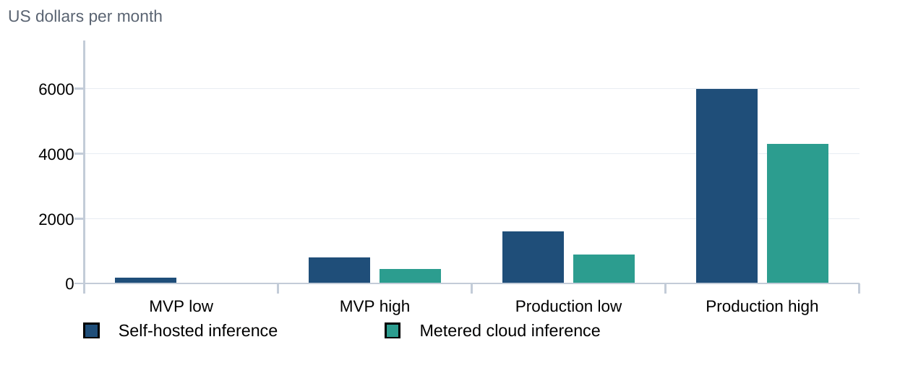
Figure 0.0: Monthly operating cost envelope, MVP and Production tiers.
Reading the chart. At these two tiers the metered path is cheaper at both ends of every range, and at the MVP tier dramatically so, because it removes the accelerator line entirely – an operator with no hardware at all can stand the system up for tens of dollars a month.
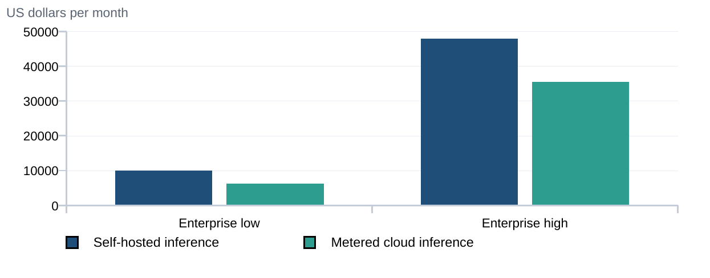
Figure 0.0: Monthly operating cost envelope, Enterprise tier.
Reading the chart. The gap narrows as volume rises, from roughly 88 percent at the MVP low end to roughly 26 percent here, because a purchased accelerator is a fixed cost while a per-token charge is not. Two facts these charts cannot show belong beside them: the metered figures scale with comments analysed and are therefore unbounded if coverage rises, and the metered path sends comment text to a third party, which for a privacy-locked tenant is not a price question at all. The trade differs per tenant and per workload, which is exactly why the design makes it a runtime decision.
These are planning-grade order-of-magnitude figures, not quotes. Accelerator prices change frequently and vary by region and commitment. The durable insight is the ratio and the dominant driver, not the absolute number: at every tier the inference line dominates, and the single largest lever on it is comments analysed per thread, not posts routed. Section 4.2.4 is the measurement behind that statement.
For a deployment offering this as a service, the natural model is a per-tenant subscription tiered on threads analysed per month, with the coverage knobs exposed as the tier boundary, because coverage is what actually drives cost. Table 5.2 sets out the proposed tier structure.
Table 0.0: Proposed Subscription Revenue Model.
Plan | Target segment | Basis of price | Included capabilities
Community | Single analyst, civic groups, academic use; up to about 1,000 threads per month | Free, self-hosted only | Full pipeline, eight-labeller ensemble, keyword and semantic search, ungrounded reports, one watchlist target, community support
Standard | Newsrooms and brand agencies; up to about 10,000 threads per month | Metered on threads analysed, with the comment cap as the tier boundary | All Community capabilities plus grounded reports, the full agentic insight layer, unlimited watchlist targets, hybrid retrieval with rank fusion, per-lane cost telemetry and email support
Enterprise | Multi-tenant deployments and election-scale monitoring; about 100,000 threads per month and above | Custom, with the option of owned capacity for the steady base and metered inference for spikes | All Standard capabilities plus tenant privacy lock with enforced data residency, dedicated inference capacity, custom watchlist governance with named owners, cluster deployment with queue-depth autoscaling and priority support

The system already meters what such a model needs: token and call counts per backend, per model and per spending lane, with a figure that isolates per-post pipeline spend from per-question chat and agent spend, so a customer who uses the chatbot heavily cannot inflate the per-post cost figure. Beyond subscription, two further revenue lines follow from the architecture: the analytical layer itself, since grounded reports and agent briefings are per-question costs that scale with questions asked rather than with corpus size and are therefore straightforward to price separately; and the data-residency guarantee, since for a tenant that cannot let comment text leave its own infrastructure the enforced privacy lock of Section 3.2.5 is a precondition rather than a feature.

Complex Engineering Problem

Complex Problem Solving
Table 5.3 maps the project onto the seven complex-engineering-problem attributes. A tick marks an attribute this project engages; a blank marks one it does not.
Table 0.0: Mapping with Complex Engineering Problem.
EP1 | EP2 | EP3 | EP4 | EP5 | EP6 | EP7
Depth of Knowledge Required | Range of Conflicting Requirements | Depth of Analysis Required | Familiarity of Issues | Extent of Applicable Codes | Extent of Stakeholder Involvement | Interdependence
✓ | ✓ | ✓ | ✓ |  | ✓ | ✓

The problem draws on three separate research literatures at once (EP1), resolves irreducible conflicts between cost, coverage, privacy and latency by exposing them as runtime knobs (EP2), and required instrumenting and running the system rather than reading it to establish that four of six routing rules were inert (EP3, EP4). Its stakeholders – analyst, operator, privacy-locked tenant, platform owner and non-consenting comment authors – want incompatible things (EP6), and its five stages, three datastores, seven model roles and nine agents are connected by contracts whose violation is silent (EP7). EP5 is left blank because no single code or certification governs a system of this kind; the standards actually used are assembled rather than mandated, and are recorded individually in Section 5.1.
EP1 requires a further mapping onto the knowledge profile, which Table 5.4 gives.
Table 0.0: Mapping with Knowledge Profile.
K1 | K2 | K3 | K4 | K5 | K6 | K7 | K8
Natural Sciences | Mathematics | Engineering Fundamentals | Specialist Knowledge | Engineering Design | Engineering Practice | Comprehension | Research Literature
 | ✓ | ✓ | ✓ | ✓ | ✓ | ✓ | ✓

Seven of the eight categories are engaged: vector similarity, rank fusion and the retrieval measures (K2); durable queues, back-pressure and horizontal partitioning (K3); transformer encoders, code-mixed processing and prompt-injection threat models (K4); the thirteen recorded design decisions of Table 3.7 (K5); containerised deployment, observability and six audited regression passes (K6); the dual-use and consent assessment of Section 5.2 (K7); and the cascade, Bangla and retrieval literatures of Section 2.2 (K8). K1 is blank because the system has no physical-science component.

Engineering Activities
Table 5.5 maps the project onto the five complex-engineering-activity attributes on the same basis.
Table 0.0: Mapping with Complex Engineering Activities.
EA1 | EA2 | EA3 | EA4 | EA5
Range of Resources | Level of Interaction | Innovation | Consequences for Society and Environment | Familiarity
✓ | ✓ | ✓ | ✓ | ✓

All five apply: the project budgets seven model roles, four datastores, five worker pools and three tool servers jointly against one accelerator (EA1); reconciles conflicting requirements from five stakeholder groups across two subsystem layers (EA2); contributes watchlist-driven target stance for code-mixed Bangla at zero additional inference cost, an abstention protocol that lets an ensemble report that nothing read a comment, and the measured container-routing finding (EA3); carries genuine dual-use, energy and consent consequences addressed in Section 5.2 (EA4); and works in a setting with no standard solution, where the dominant failure mode is silent degradation rather than exception (EA5).
Target-dependent stance detection is not novel – it is established for English [13], [14], [15], [16]. Doing it over an operator-supplied, configurable entity list rather than a fixed annotated aspect set is an engineering framing rather than a research result. The defensible claim is doing it on code-mixed Bangla, where the same entity is written in three scripts and the matcher is the hard part – a genuinely under-served setting, as the two matcher defects recorded in Section 3.2.4 demonstrate. The line that survives scrutiny is therefore novel application and engineering in an under-resourced language setting, not a novel method, and the same care applies to the other two contributions: the abstention protocol is an observation about falsifiability plus the reporting that fixes it, and the cost finding is a measurement rather than a technique.

Summary
The system complies with an assembled rather than a single standard, and Section 5.1 records each choice with the alternative it displaced. Its societal impact is genuinely dual-use, and the project's response is to make the editorial component of its labels visible rather than to claim a neutrality it does not have; its environmental argument is the same as its cost argument and is measured in the same units, calls per corpus run. The financial analysis shows a project built for zero direct cost against a managed equivalent of roughly $600 to $1,800, and an operating cost in which self-hosted and metered inference cross over rather than one dominating – which is why the choice is a runtime decision. Against the complex-engineering framework the project engages six of the seven problem attributes, seven of the eight knowledge-profile categories and all five engineering activities, with the innovation claim stated narrowly enough to be defensible. The next chapter concludes the report, stating what was accomplished, the limitations of the current system, and the future work that would produce the most value.

Chapter 6

Conclusion
This chapter summarises what was built and what was learned, states the project's limitations without softening them, and sets out the work that would close each one, in the order that would produce the most value.

Summary
This project asked a narrow, testable question: given a post together with its comment thread, in a language setting that mixes Bangla script, English and romanized Banglish, can a system decide per unit of work how much intelligence that unit deserves, spend the expensive model only where cheap models cannot answer, and prove afterwards from its own counters where the money went and what produced every label?
The answer is yes – and not in the way the project originally believed. A five-stage, queue-decoupled microservice was designed, built and measured. Cheap analysis runs on every post and every comment; a six-gate router decides post-level spend and a separate step decides which comments the expensive labellers read – two decisions rather than one, which is the structural change that made the cost behaviour measurable at all. Per-comment sentiment became eight independent labellers with explicit abstention, so a comment no model read reports as uncertain rather than as neutral. Watchlist stance answers whom a comment opposes at zero additional model calls, and nine tool-using agents reason over the system's own output through eighteen typed tools. Measurement then produced the key outcome of the work: the routing gate behaves exactly as designed – 16 percent of posts route under the shipped engine against 74 percent for a keyword baseline – yet it governs only 30 percent of large-model calls, because between 85 and 96 percent of calls are comment-level and comment labelling runs for every post regardless. That result contradicted the project's own headline claim and replaced it with a narrower one that survives contact with the data. Alongside it, hybrid retrieval reaches recall@10 of 0.8750 where hash-seeded vectors score 0.1875, and the whole system verifies as a single pass-or-fail chain in seventy-three seconds across 1,417 Python tests, 96 dashboard tests, lint, a production build and browser tests.
The most transferable outcome is not any of those numbers but the discipline that produced them. Six independent audit passes established that the consequential failures in a system of this shape are not incorrect answers but silent successes – a gate reporting plausible behaviour while four of its six rules were inert, a retrieval arm matching zero rows while a passing test covered it, an inference server discarding eleven thousand prompt tokens and reporting only what it evaluated. The engineering response – named reader functions, single-source constants, provenance on every value, abstention instead of a default vote, and an evidence class on every published claim – is what this project would carry to the next system.

Limitation
Six limitations bound what this report claims. The first five constrain the evidence; the sixth is a scope decision rather than a defect.
• L1 – The corpus is small and its comment sample is biased. Fifty posts across twenty-five campaigns in a three-week window on one platform is a demonstration, not a study. The 10,272 comments are an engagement-ordered 3.75 percent slice of the 274,126 the platform reports, so thread-level aggregates describe the most-engaged comments per post.
• L2 – The multimodal claim is unexercised. Forty-four of fifty posts carry images, and the image path – zero-shot visual sentiment [28], [29] plus optical character recognition – is implemented, but the 69 image references are object-storage keys whose objects are not present, so the image path has never produced a signal. Post sentiment is a text measurement, and the system reports an explicit failure status rather than a fabricated neutral verdict.
• L3 – Retrieval quality is measured against a machine-derived query set. The 32 known-item queries were derived from each target post's own analysed topics and entities, with no human relevance judgement; that favours literal matching, marks exactly one relevant post per query, and leaves the decisive stratified bucket at eight queries.
• L4 – Scale is code-complete and unbenchmarked. Horizontal scaling, queue-depth autoscaling and the Kubernetes deployment are implemented and test-asserted, but no multi-replica run has been timed or executed in a cluster, so every throughput statement is a design property rather than a measurement.
• L5 – The agent layer's answers are unmeasured. The runner is hardened against six observed failure classes, each with a regression test, but groundedness, citation accuracy and answer relevance have no scores. The evaluation plan for them exists [44], [47] and has not been run.
• L6 – Labelling accuracy is outside the project's scope. The sampler and scorer ship with the repository, but the gold file holds zero adjudicated labels, deliberately: seeding them from a model in this repository and then scoring that model would measure agreement with itself. No macro-F1, confusion matrix, calibration curve [48] or ship gate exists for any labeller.
Three further constraints are recorded rather than left in a screenshot. The per-analysis event stream has a five-minute server-side ceiling, after which the Trace tab treats the close as a failure while the pipeline finishes correctly; the monitoring stack ships correct scrape configuration but provisions no Grafana dashboards, so the operator-independent path ends at the metrics endpoint; and the prompt-injection hardening is risk reduction rather than a solution, because no prompt-level defence can promise resistance [43]. All three are carried at that evidence class in Tables 4.13 and 4.14.

Future Work
The future work is ordered by value per unit of effort. The first item is the one this project deliberately scoped out, and it dominates the rest because most of the others depend on it.
• F1 – Adjudicate the gold set (the bottleneck; everything else is fast). Two annotators labelling a five-hundred-comment overlap and reporting Cohen's kappa [49], then labelling to two or three thousand comments stratified by language bucket and comment kind, sampling within strata at random so the gold set does not inherit the corpus's engagement bias. The guideline must rule explicitly on sarcasm marked only by an emoji [17], conventional political epithets, single-word comments and mid-sentence code-switching. This is the step that would extend the work from an engineering deliverable to an empirical one.
• F2 – Benchmark rather than build. With labels in hand, score the seven ensemble heads, the LLM stance pass and the Stage-1 baseline, reporting macro-F1 per language bucket; disable the response cache for every run and report provenance alongside every row, because a model that fell back to a heuristic has not scored on the whole set.
• F3 – Turn the cascade into a measured trade-off. Sweep the router's confidence threshold and plot macro-F1 against cost and latency, with all-cheap and all-large as the endpoints. Because the gate governs only 30 to 55 percent of calls, plot the comment-cap lever as a second curve or state plainly that the sweep covers post-level spend only.
• F4 – Validate the watchlist separately, on two metrics reported apart: mention detection – the precision and recall of the alias matcher, where recall is what matters because a missed alias is invisible – and stance agreement on the correctly matched mentions only.
• F5 – Learn the routing decision instead of hand-tuning it, in the manner of the learned-router literature [31]. This is the most valuable upgrade to the mechanism itself, and it becomes possible only after F1, because a learned router needs labels to learn against.
• F6 – Make the image modality real, or delete its weights from the design. Uploading the 69 image objects is roughly half a day and would turn an unsupported claim into a measured one; scoping the system permanently to text is equally defensible. What is not defensible is a weight that has never been anything but zero.
• F7 – Score the agent layer. Build an analyst question set with reference answers and citing posts, and score groundedness claim by claim, citation accuracy, answer relevance and tool-use correctness with a judge model and human review on a sample [44], [45], [47], using the retrieval-specific measures of [46]. The run records already carry everything the scoring needs.
• F8 – Benchmark the scale claims. Run a multi-replica deployment in a cluster against a ten-thousand-thread batch and record per-stage throughput and queue lag against replica count, converting NFR1 from a design property into a measurement.
• F9 – Close the two operational gaps the walkthrough exposed. The trace view should resubscribe with a fresh ticket at the five-minute ceiling and distinguish "the stream ended" from "the run failed"; the monitoring stack should ship provisioned Grafana dashboards against the scrape it already configures.
• F10 – Have the access-control surface reviewed by someone who did not write it. The 138 security tests are white-box tests written by the members who wrote the code they guard – exactly the class of assurance that a fresh-eyes pass repeatedly proved insufficient elsewhere in this project.
Taken together, F1 through F4 would take the project from a demonstrable engineering result to a defensible empirical one, and the estimate is three to four weeks dominated almost entirely by annotation. Everything that used to sit in front of that annotation – the sampling frame, the cache key that would have compared a model against its own cached output, the caps that hid seventy percent of the corpus, and the labels that could not say what produced them – is now cleared.

References
References follow the IEEE citation style. Every entry carries a Digital Object Identifier that was resolved against the Crossref or DataCite registry at the time of writing.
[1] A. Bhattacharjee, T. Hasan, W. Ahmad, K. S. Mubasshir, M. S. Islam, A. Iqbal, M. S. Rahman, and R. Shahriyar, "BanglaBERT: Language model pretraining and benchmarks for low-resource language understanding evaluation in Bangla," in Findings of the Association for Computational Linguistics: NAACL 2022, 2022, pp. 1318–1327, doi: 10.18653/v1/2022.findings-naacl.98.
[2] K. I. Islam, S. Kar, M. S. Islam, and M. R. Amin, "SentNoB: A dataset for analysing sentiment on noisy Bangla texts," in Findings of the Association for Computational Linguistics: EMNLP 2021, 2021, pp. 3265–3271, doi: 10.18653/v1/2021.findings-emnlp.278.
[3] A. Hassan, M. R. Amin, A. K. A. Azad, and N. Mohammed, "Sentiment analysis on Bangla and romanized Bangla text using deep recurrent models," in Proc. 2016 Int. Workshop on Computational Intelligence (IWCI), 2016, pp. 51–56, doi: 10.1109/IWCI.2016.7860338.
[4] S. Sazzed, "Abusive content detection in transliterated Bengali-English social media corpus," in Proc. Fifth Workshop on Computational Approaches to Linguistic Code-Switching, 2021, pp. 125–130, doi: 10.18653/v1/2021.calcs-1.16.
[5] N. Romim, M. Ahmed, H. Talukder, and M. Saiful Islam, "Hate speech detection in the Bengali language: A dataset and its baseline evaluation," in Proc. Int. Joint Conf. on Advances in Computational Intelligence, Algorithms for Intelligent Systems. Singapore: Springer, 2021, pp. 457–468, doi: 10.1007/978–981–16–0586–4_37.
[6] M. A. Nezami and M. N. Huda, "Public sentiment identification in social media for code-mixed English-Bangla and Banglish text analysis with machine learning," in Proc. Sixth Int. Conf. on Image, Video Processing, and Artificial Intelligence (IVPAI 2024), SPIE, 2024, doi: 10.1117/12.3047050.
[7] S. Saha and A. Nanda, "BanglaNLP at BLP-2023 Task 2: Benchmarking different transformer models for sentiment analysis of Bangla social media posts," in Proc. First Workshop on Bangla Language Processing (BLP-2023), 2023, pp. 266–272, doi: 10.18653/v1/2023.banglalp-1.34.
[8] A. Chakma and M. Hasan, "LowResource at BLP-2023 Task 2: Leveraging BanglaBert for low-resource sentiment analysis of Bangla language," in Proc. First Workshop on Bangla Language Processing (BLP-2023), 2023, pp. 347–353, doi: 10.18653/v1/2023.banglalp-1.47.
[9] F. Alam, A. Hasan, T. Alam, A. Khan, J. Tajrin, N. Khan, and S. A. Chowdhury, "A review of Bangla natural language processing tasks and the utility of transformer models," arXiv:2107.03844, 2021, doi: 10.48550/arXiv.2107.03844.
[10] P. Patwa, G. Aguilar, S. Kar, S. Pandey, S. PYKL, B. Gamback, T. Chakraborty, T. Solorio, and A. Das, "SemEval-2020 Task 9: Overview of sentiment analysis of code-mixed tweets," in Proc. Fourteenth Workshop on Semantic Evaluation, 2020, pp. 774–790, doi: 10.18653/v1/2020.semeval-1.100.
[11] S. Sitaram, K. R. Chandu, S. K. Rallabandi, and A. W. Black, "A survey of code-switched speech and language processing," arXiv:1904.00784, 2019, doi: 10.48550/arXiv.1904.00784.
[12] M. Wankhade, A. C. S. Rao, and C. Kulkarni, "A survey on sentiment analysis methods, applications, and challenges," Artificial Intelligence Review, vol. 55, no. 7, pp. 5731–5780, 2022, doi: 10.1007/s10462–022–10144–1.
[13] D. Kucuk and F. Can, "Stance detection: A survey," ACM Computing Surveys, vol. 53, no. 1, pp. 1–37, 2021, doi: 10.1145/3369026.
[14] S. Mohammad, S. Kiritchenko, P. Sobhani, X. Zhu, and C. Cherry, "SemEval-2016 Task 6: Detecting stance in tweets," in Proc. 10th Int. Workshop on Semantic Evaluation (SemEval-2016), 2016, pp. 31–41, doi: 10.18653/v1/S16–1003.
[15] M. Pontiki, D. Galanis, J. Pavlopoulos, H. Papageorgiou, I. Androutsopoulos, and S. Manandhar, "SemEval-2014 Task 4: Aspect based sentiment analysis," in Proc. 8th Int. Workshop on Semantic Evaluation (SemEval 2014), 2014, pp. 27–35, doi: 10.3115/v1/S14–2004.
[16] L. Dong, F. Wei, C. Tan, D. Tang, M. Zhou, and K. Xu, "Adaptive recursive neural network for target-dependent Twitter sentiment classification," in Proc. 52nd Annual Meeting of the Association for Computational Linguistics (Volume 2: Short Papers), 2014, pp. 49–54, doi: 10.3115/v1/P14–2009.
[17] P. Kralj Novak, J. Smailovic, B. Sluban, and I. Mozetic, "Sentiment of emojis," PLOS ONE, vol. 10, no. 12, e0144296, 2015, doi: 10.1371/journal.pone.0144296.
[18] A. Vaswani, N. Shazeer, N. Parmar, J. Uszkoreit, L. Jones, A. N. Gomez, L. Kaiser, and I. Polosukhin, "Attention is all you need," arXiv:1706.03762, 2017, doi: 10.48550/arXiv.1706.03762.
[19] J. Devlin, M.-W. Chang, K. Lee, and K. Toutanova, "BERT: Pre-training of deep bidirectional transformers for language understanding," in Proc. 2019 Conf. of the North American Chapter of the Association for Computational Linguistics: Human Language Technologies, 2019, pp. 4171–4186, doi: 10.18653/v1/N19–1423.
[20] A. Conneau, K. Khandelwal, N. Goyal, V. Chaudhary, G. Wenzek, F. Guzman, E. Grave, M. Ott, L. Zettlemoyer, and V. Stoyanov, "Unsupervised cross-lingual representation learning at scale," in Proc. 58th Annual Meeting of the Association for Computational Linguistics, 2020, pp. 8440–8451, doi: 10.18653/v1/2020.acl-main.747.
[21] A. Joulin, E. Grave, P. Bojanowski, and T. Mikolov, "Bag of tricks for efficient text classification," in Proc. 15th Conf. of the European Chapter of the Association for Computational Linguistics (Volume 2: Short Papers), 2017, pp. 427–431, doi: 10.18653/v1/E17–2068.
[22] N. Reimers and I. Gurevych, "Sentence-BERT: Sentence embeddings using Siamese BERT-networks," in Proc. 2019 Conf. on Empirical Methods in Natural Language Processing and the 9th Int. Joint Conf. on Natural Language Processing (EMNLP-IJCNLP), 2019, pp. 3980–3990, doi: 10.18653/v1/D19–1410.
[23] N. Reimers and I. Gurevych, "Making monolingual sentence embeddings multilingual using knowledge distillation," in Proc. 2020 Conf. on Empirical Methods in Natural Language Processing (EMNLP), 2020, pp. 4512–4525, doi: 10.18653/v1/2020.emnlp-main.365.
[24] B. Warner, A. Chaffin, B. Clavie, O. Weller, O. Hallstrom, S. Taghadouini, A. Gallagher, R. Biswas, F. Ladhak, T. Aarsen, N. Cooper, G. Adams, J. Howard, and I. Poli, "Smarter, better, faster, longer: A modern bidirectional encoder for fast, memory efficient, and long context finetuning and inference," arXiv:2412.13663, 2024, doi: 10.48550/arXiv.2412.13663.
[25] U. Zaratiana, N. Tomeh, P. Holat, and T. Charnois, "GLiNER: Generalist model for named entity recognition using bidirectional transformer," in Proc. 2024 Conf. of the North American Chapter of the Association for Computational Linguistics: Human Language Technologies (Volume 1: Long Papers), 2024, pp. 5364–5376, doi: 10.18653/v1/2024.naacl-long.300.
[26] W. Yin, J. Hay, and D. Roth, "Benchmarking zero-shot text classification: Datasets, evaluation and entailment approach," in Proc. 2019 Conf. on Empirical Methods in Natural Language Processing and the 9th Int. Joint Conf. on Natural Language Processing (EMNLP-IJCNLP), 2019, pp. 3912–3921, doi: 10.18653/v1/D19–1404.
[27] E. J. Hu, Y. Shen, P. Wallis, Z. Allen-Zhu, Y. Li, S. Wang, L. Wang, and W. Chen, "LoRA: Low-rank adaptation of large language models," arXiv:2106.09685, 2021, doi: 10.48550/arXiv.2106.09685.
[28] A. Radford, J. W. Kim, C. Hallacy, A. Ramesh, G. Goh, S. Agarwal, G. Sastry, A. Askell, P. Mishkin, J. Clark, G. Krueger, and I. Sutskever, "Learning transferable visual models from natural language supervision," arXiv:2103.00020, 2021, doi: 10.48550/arXiv.2103.00020.
[29] X. Zhai, B. Mustafa, A. Kolesnikov, and L. Beyer, "Sigmoid loss for language image pre-training," in Proc. 2023 IEEE/CVF Int. Conf. on Computer Vision (ICCV), 2023, pp. 11941–11952, doi: 10.1109/ICCV51070.2023.01100.
[30] L. Chen, M. Zaharia, and J. Zou, "FrugalGPT: How to use large language models while reducing cost and improving performance," arXiv:2305.05176, 2023, doi: 10.48550/arXiv.2305.05176.
[31] I. Ong, A. Almahairi, V. Wu, W.-L. Chiang, T. Wu, J. E. Gonzalez, M. W. Kadous, and I. Stoica, "RouteLLM: Learning to route LLMs with preference data," arXiv:2406.18665, 2024, doi: 10.48550/arXiv.2406.18665.
[32] D. Ding, A. Mallick, C. Wang, R. Sim, S. Mukherjee, V. Ruhle, L. V. S. Lakshmanan, and A. H. Awadallah, "Hybrid LLM: Cost-efficient and quality-aware query routing," arXiv:2404.14618, 2024, doi: 10.48550/arXiv.2404.14618.
[33] W. Kwon, Z. Li, S. Zhuang, Y. Sheng, L. Zheng, C. H. Yu, J. Gonzalez, H. Zhang, and I. Stoica, "Efficient memory management for large language model serving with PagedAttention," in Proc. 29th Symposium on Operating Systems Principles (SOSP), 2023, pp. 611–626, doi: 10.1145/3600006.3613165.
[34] P. Lewis, E. Perez, A. Piktus, F. Petroni, V. Karpukhin, N. Goyal, H. Kuttler, M. Lewis, W.-t. Yih, T. Rocktaschel, S. Riedel, and D. Kiela, "Retrieval-augmented generation for knowledge-intensive NLP tasks," arXiv:2005.11401, 2020, doi: 10.48550/arXiv.2005.11401.
[35] Y. Gao, Y. Xiong, X. Gao, K. Jia, J. Pan, Y. Bi, Y. Dai, J. Sun, M. Wang, and H. Wang, "Retrieval-augmented generation for large language models: A survey," arXiv:2312.10997, 2023, doi: 10.48550/arXiv.2312.10997.
[36] S. Yao, J. Zhao, D. Yu, N. Du, I. Shafran, K. Narasimhan, and Y. Cao, "ReAct: Synergizing reasoning and acting in language models," arXiv:2210.03629, 2022, doi: 10.48550/arXiv.2210.03629.
[37] T. Schick, J. Dwivedi-Yu, R. Dessi, R. Raileanu, M. Lomeli, L. Zettlemoyer, N. Cancedda, and T. Scialom, "Toolformer: Language models can teach themselves to use tools," arXiv:2302.04761, 2023, doi: 10.48550/arXiv.2302.04761.
[38] X. Hou, Y. Zhao, S. Wang, and H. Wang, "Model Context Protocol (MCP): Landscape, security threats, and future research directions," arXiv:2503.23278, 2025, doi: 10.48550/arXiv.2503.23278.
[39] G. V. Cormack, C. L. A. Clarke, and S. Buettcher, "Reciprocal rank fusion outperforms Condorcet and individual rank learning methods," in Proc. 32nd Int. ACM SIGIR Conf. on Research and Development in Information Retrieval, 2009, pp. 758–759, doi: 10.1145/1571941.1572114.
[40] Y. A. Malkov and D. A. Yashunin, "Efficient and robust approximate nearest neighbor search using hierarchical navigable small world graphs," IEEE Transactions on Pattern Analysis and Machine Intelligence, vol. 42, no. 4, pp. 824–836, 2020, doi: 10.1109/TPAMI.2018.2889473.
[41] K. Jarvelin and J. Kekalainen, "Cumulated gain-based evaluation of IR techniques," ACM Transactions on Information Systems, vol. 20, no. 4, pp. 422–446, 2002, doi: 10.1145/582415.582418.
[42] F. Cuconasu, G. Trappolini, F. Siciliano, S. Filice, C. Campagnano, Y. Maarek, N. Tonellotto, and F. Silvestri, "The power of noise: Redefining retrieval for RAG systems," in Proc. 47th Int. ACM SIGIR Conf. on Research and Development in Information Retrieval, 2024, pp. 719–729, doi: 10.1145/3626772.3657834.
[43] K. Greshake, S. Abdelnabi, S. Mishra, C. Endres, T. Holz, and M. Fritz, "Not what you've signed up for: Compromising real-world LLM-integrated applications with indirect prompt injection," in Proc. 16th ACM Workshop on Artificial Intelligence and Security (AISec), 2023, pp. 79–90, doi: 10.1145/3605764.3623985.
[44] L. Zheng, W.-L. Chiang, Y. Sheng, S. Zhuang, Z. Wu, Y. Zhuang, Z. Lin, Z. Li, D. Li, E. P. Xing, H. Zhang, J. E. Gonzalez, and I. Stoica, "Judging LLM-as-a-judge with MT-Bench and Chatbot Arena," arXiv:2306.05685, 2023, doi: 10.48550/arXiv.2306.05685.
[45] S. Min, K. Krishna, X. Lyu, M. Lewis, W.-t. Yih, P. Koh, M. Iyyer, L. Zettlemoyer, and H. Hajishirzi, "FActScore: Fine-grained atomic evaluation of factual precision in long form text generation," in Proc. 2023 Conf. on Empirical Methods in Natural Language Processing (EMNLP), 2023, pp. 12076–12100, doi: 10.18653/v1/2023.emnlp-main.741.
[46] S. Es, J. James, L. Espinosa-Anke, and S. Schockaert, "RAGAS: Automated evaluation of retrieval augmented generation," arXiv:2309.15217, 2023, doi: 10.48550/arXiv.2309.15217.
[47] Y. Chang, X. Wang, J. Wang, Y. Wu, L. Yang, K. Zhu, H. Chen, X. Yi, C. Wang, Y. Wang, W. Ye, Y. Zhang, Y. Chang, P. S. Yu, Q. Yang, and X. Xie, "A survey on evaluation of large language models," ACM Transactions on Intelligent Systems and Technology, vol. 15, no. 3, pp. 1–45, 2024, doi: 10.1145/3641289.
[48] C. Guo, G. Pleiss, Y. Sun, and K. Q. Weinberger, "On calibration of modern neural networks," arXiv:1706.04599, 2017, doi: 10.48550/arXiv.1706.04599.
[49] J. Cohen, "A coefficient of agreement for nominal scales," Educational and Psychological Measurement, vol. 20, no. 1, pp. 37–46, 1960, doi: 10.1177/001316446002000104.
[50] T. G. Dietterich, "Ensemble methods in machine learning," in Multiple Classifier Systems, Lecture Notes in Computer Science, vol. 1857. Berlin, Heidelberg: Springer, 2000, pp. 1–15, doi: 10.1007/3–540–45014–9_1.

