1. Matrix Addition:

matrix1=[[1,2,3],[4,5,6]]

matrix2=[[1,2,3],[4,5,6]]

matrix3=[[0 for i in range(len(matrix1[0]))] for j in range(len(matrix1))]

if(len(matrix1[0])!=len(matrix2[0]) or len(matrix1)!=len(matrix2)):

print("adding not possible")

else:

for i in range(len(matrix1)):

for j in range(len(matrix1[0])):

matrix3[i][j]=matrix1[i][j]+matrix2[i][j]

print(matrix3)

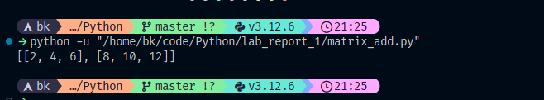

2. Flatten nested loop

list=[ True,False,["hello","good morning"],5,1414,["bk","kg"]]

flat_list=[]

for i in range(len(list)):

if type(list[i])==type(list):

for j in range(len(list[i])):

flat_list.append(list[i][j])

else:

flat_list.append(list[i])

print(flat_list)

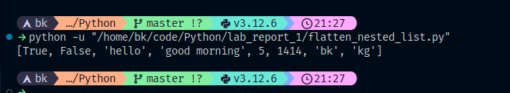

3. List element frequency

list=[[1,2,3],[4,5,6],[1,2,3]]

dict={}

for i in range(len(list)):

for j in range(len(list[0])):

if list[i][j] in dict:

dict[list[i][j]]+=1

else:

dict[list[i][j]]=1

print(dict)

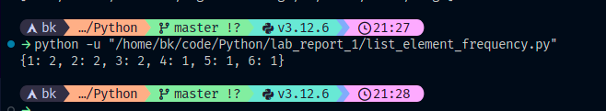

4. Transpose matrix

matrix1=[[1,2,3],[4,5,6],[7,8,9]]

matrix2=[[0 for i in range(len(matrix1[0]))] for j in range(len(matrix1))]

for i in range(len(matrix1)):

for j in range(len(matrix1[0])):

matrix2[i][j]=matrix1[j][i]

print(matrix2)

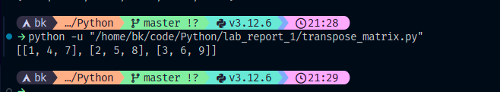

5. List of list concatenation

list=[[1,2,3],[4,5,6]]

list2=[5,6,7,8,9,10]

for i in range(len(list)):

if type(list[i])==type(list):

list2.append(list[i])

else:

list2.append(list[i])

print(list2)

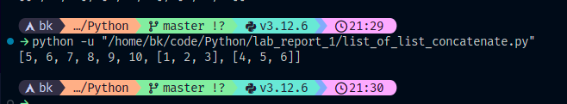

6. Tuple concatenate

tuple1=(1,2,3)

tuple2=(4,5,6)

tuple3=tuple1+tuple2

print(tuple3)

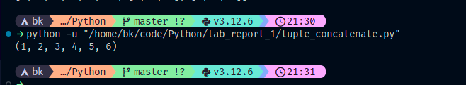

7. Tuple unpacking

tuple1=(1,2,3)

x,y,z=tuple1

print(tuple1)

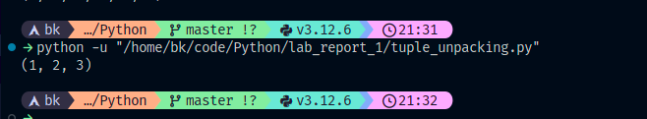

8. Tuple sorting

tuple1=(2,4,7,5,3,1,0)

list=list(tuple1)

list.sort()

print(tuple(list))

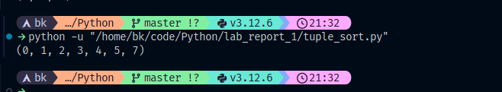

9. Tuple frequency

tuple=((1,2,3),(4,5,6),(1,2,3))

dict={}

for i in range(len(tuple)):

for j in range(len(tuple[0])):

if tuple[i][j] in dict:

dict[tuple[i][j]]+=1

else:

dict[tuple[i][j]]=1

print(dict)

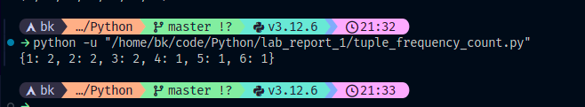

10. Tuple to list

tuple=(2,4,7,5,3,1,0)

list=list(tuple)

print(list)

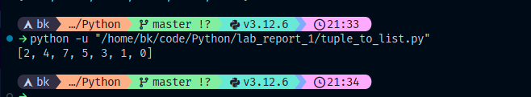

11. Tuple reversal

tuple=(2,4,7,5,3,1,0)

list=[]

for i in range(len(tuple)):

list.append(tuple[len(tuple)-1-i])

print(list)

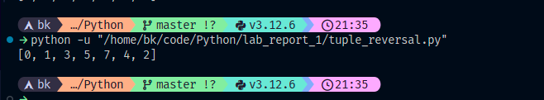

12. Tuple slicing

tuple=(2,4,7,5,3,1,0)

tuple2=tuple[1:6:2]

print(tuple2)

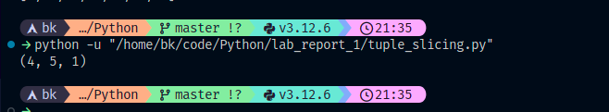

13. Duplicate removal

list=[1,2,3,3,2,1,5,6,7,4,9,7,8]

set=set()

for i in range(len(list)):

set.add(list[i])

print(set)

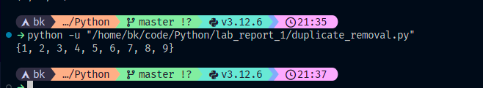

14. Second max number

if __name__ == '__main__':

n = int(input())

arr = list(map(int, input().split()))

arr=set(arr)

arr.remove(max(arr))

print(max(arr))

15. Swap adjacent

list=[1,2,3,4,5,6,7,8,9]

for i in range(0,len(list)-1,2):

temp=list[i]

list[i]=list[i+1]

list[i+1]=temp

print(list)

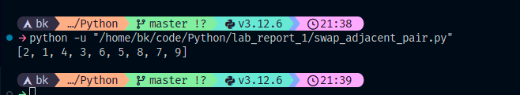

16. Max min swap

list=[1,2,3,3,2,1,5,6,7,4,9,7,8]

min= min(list)

max= max(list)

list[list.index(max)]=min

list[list.index(min)]=max

print(list)

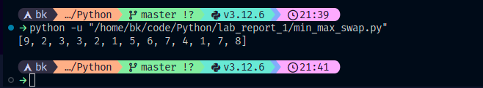

17. Count string

list=['abc', 'xyz', 'aba', '1221']

count=0

for i in range(len(list)):

if list[i][0]==list[i][len(list[i])-1]:

count+=1

print(count)

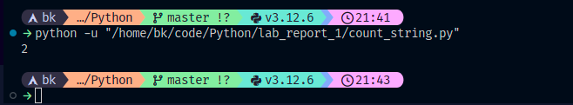

18. Item List

anime_names = ["Attack on Titan","Death Note","One Punch Man","My Hero Academia","Naruto","Bleach","Dragon Ball Z","Sword Art Online"]

length_list=[]

for i in range(len(anime_names)):

length_list.append(len(anime_names[i]))

print(length_list)

new_anime_names=[]

for i in range(len(anime_names)):

new_anime_names.append(anime_names[i].swapcase())

print(new_anime_names)

