1. String reverse

*def* reverse(*str*):

new_str=""

for i in range(len(*str*)):

new_str+=*str*[len(*str*)-1-i]

return new_str

str="hello world"

new_str= reverse(str)

print(new_str)

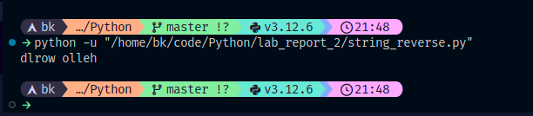

2. Type conversion

list=[1,2,3,4,5,6,7]

str_list=[]

for i in range(len(list)):

str_list.append(str(list[i]))

print(str_list)

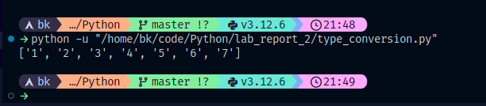

3. Temperature converter

celsius=float(input())

fahrenheit = (celsius * 9 / 5) + 32

print(fahrenheit)

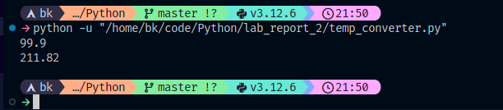

4. String palindrome

str='aabbaa'

for i in range(len(str)):

if str[i]!=str[len(str)-1-i]:

print("not palindrome")

break

print("palindrome")

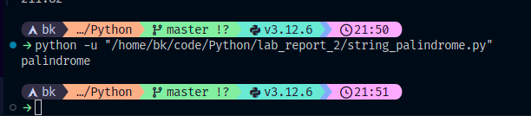

5. String reverse with slicing

str="hello world"

new_str=str[::-1]

print(new_str)

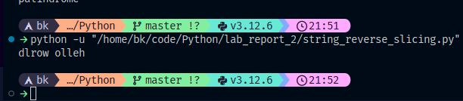

6. Grade classification

student_percent=float(input())

grade=""

if student_percent >=90:

grade+="A+"

elif student_percent >=80 and student_percent<90:

grade+="A"

elif student_percent >=70 and student_percent<80:

grade+="B"

elif student_percent >=60 and student_percent<70:

grade+="C"

else :

grade+="fail"

print(grade)

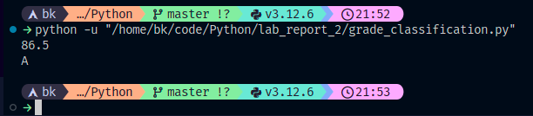

7. Table of a number

number = 9

for i in range(11):

print(*f*'{number} * {i} = {number*i}')

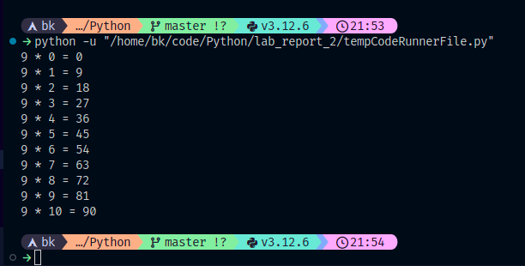

8. Count digit

number=100010

count=0

while number != 0:

count+=1

number=number//10

print(count)

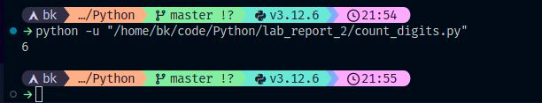

9. Fibonacci sequence

list=[0,1]

number=int(input())

for i in range(number):

list.append(list[i]+list[i+1])

print(list)

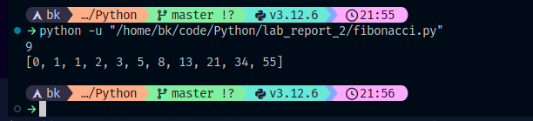

10. Sum of even numbers

number=int(input())

sum=0

for i in range(number+1):

if i%2==0:

sum+=i

print(sum)

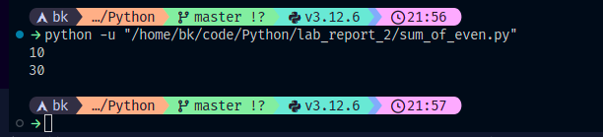

11. Print patterns

num=5

for i in range(num):

for j in range(i):

print(" * ",*end*='')

print()

for i in range(num):

for j in range(num-i):

print(" * ",*end*='')

print()

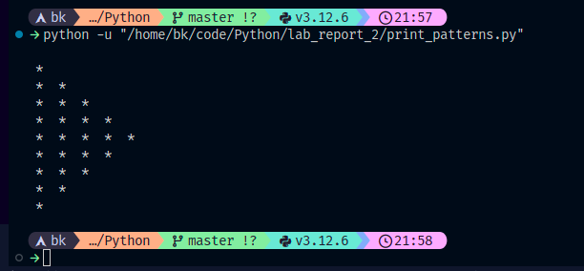

12. Prime number checker

number=int(input())

prime=True

for i in range(2,number):

if(number%i==0):

prime=False

break

if(prime):

print("prime")

else:

print("non prime")

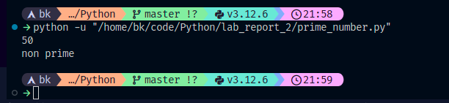

13. List manipulation

list=[1,2,3,4,5,6,7,8,9]

sum=0

max=list[0]

min=list[0]

for i in range(len(list)):

sum=sum+list[i]

if(list[i]>max):

max=list[i]

if(list[i]<min):

min=list[i]

print(sum)

print(sum//len(list))

print(max)

print(min)

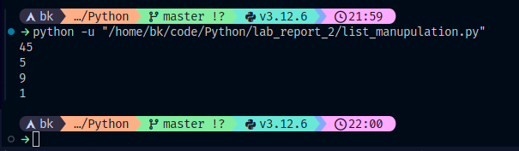

14. Reverse string

str="hello world"

new_str=""

for i in range(len(str)):

new_str+=str[len(str)-1-i]

print(new_str)

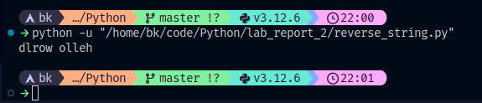

15. List sum

list=[1,2,3,4,5,6,7,8,9]

sum=0

for i in range(len(list)):

sum=sum+list[i]

print(sum)

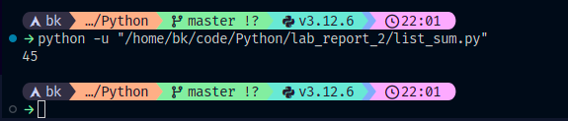

16. List average

list=[1,2,3,4,5,6,7,8,9]

sum=0

for i in range(len(list)):

sum=sum+list[i]

print(sum//len(list))

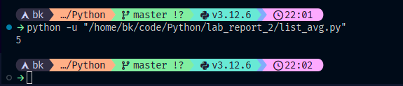

17. List max and min

list=[1,2,3,4,5,6,7,8,9]

max=list[0]

min=list[0]

for i in range(len(list)):

if(list[i]>max):

max=list[i]

if(list[i]<min):

min=list[i]

print(max)

print(min)

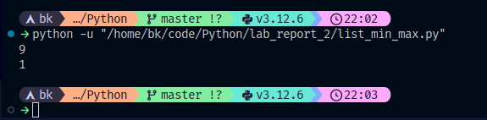

18. List sorting

list=[9,8,7,6,5,4,3,2,1]

for i in range(len(list)):

for j in range(len(list)-1-i):

if list[j]>list[j+1]:

temp=list[j]

list[j]=list[j+1]

list[j+1]=temp

print(list)

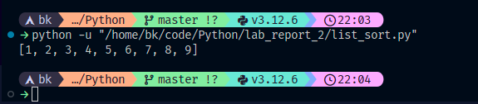

19. List filtering

list=[1,2,3,4,5,6,7,8,9]

list2=[]

for i in range(len(list)):

if list[i]%2==0:

list2.append(list[i])

print(list2)

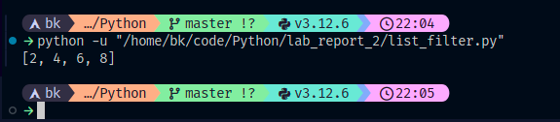

20. List reverse

list=[1,2,3,4,5,6,7,8,9]

reversed_list=[]

for i in range(len(list)-1,-1,-1):

reversed_list.append(list[i])

print(reversed_list)

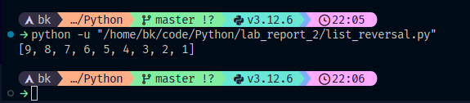

21. List manipulation 2

list1=[1,2,3,4,5,6,7,8,9]

list2=[5,6,7,8,9,10,11,12,13,14]

new_list=[]

for i in range(len(list1)):

if list1[i] in list2:

new_list.append(list1[i])

print(new_list)

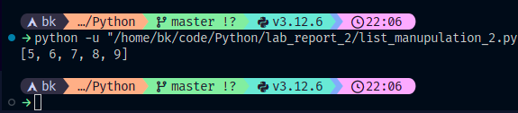

22. List element count

list=[1,2,3,4,5,5,5,6,6,6,7,8,9,10,11,12,13,14]

dict={}

for i in range(len(list)):

if list[i] in dict:

dict[list[i]]+=1

else:

dict[list[i]]=1

print(dict)

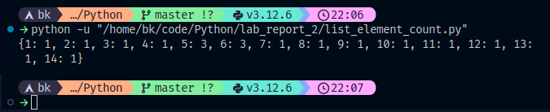

23. List duplicate removal

list=[1,2,3,4,5,5,5,6,6,6,7,8,9]

list2=[]

for i in range(len(list)):

if list[i] not in list2:

list2.append(list[i])

print(list2)

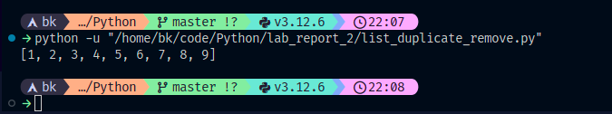

24. List comprehension

list1=[1, 2, 3, 4, 5, 6, 7, 8, 9]

list2=[i**2 for i in list1]

print(list2)

