**Software Requirements**

**Specification**

**for**

**SmartCode**

**Version 1.0 approved**

**Prepared by Bishwajit Chakraborty**

**Daffodil International University**

**0242220005101414**

**17 November,2023**

**Table of Contents**

**Table of Contents..............................................................................…...................... 2**

**Revision History.......................................................................................................... 2**

**1. Introduction.....................................................................................................…….3**

1.1 Purpose ...................................................................................................……..................... 3 1.2 Document Conventions.................................................………………..................................... 3

1.3 Intended Audience and Reading Suggestions..................................………………............ 3

1.4 Project Scope ...................................................................................................................... 3

1.5 References.......................................................................................................…………… 3

**2. Overall Description........................................................................................….....4**

2.1 Product Perspective .....................................................................................…………….. 4

2.2 Product Features ................................................................................................……........ 4

2.3 User Classes and Characteristics......................................………………………….......... 4

2.4 Operating Environment.......................................................................………................... 5

2.5 Design and Implementation Constraints.............................................……....................... 5

2.6 User Documentation ......................................................................…………………....... 5

2.7 Assumptions and Dependencies .....................................................……………............... 5

**3. System Features........................................................………………......................6**

3.1 System Feature 1.....................................................................………….......................... 6

3.2 System Feature 2 (and so on).................................................…………........................... 7

**4. External Interface Requirements..................................………….........................8**

4.1 User Interfaces...........................................................................……………………....... 8

4.2 Hardware Interfaces..............................................................………………………........ 8

4.3 Software Interfaces...............................................................……………………............ 8

4.4 Communications Interfaces ....................................................……….............................. 8

**5. Other Nonfunctional Requirements...............................………...........................9**

5.1 Performance Requirements..................................................................………………...... 9

5.2 Safety Requirements....................................................................…………….................. 9

5.3 Security Requirements................................................................……………………....... 9

5.4 Software Quality Attributes......................................................……………………......... 9

**6. Other Requirements ..................................................……………………….......10**

**Appendix A: Glossary...........................................………………………….............10**

**Appendix B: Analysis Models..........................................………........................11-12**

**Appendix C: Issues List................................................................................……....13**

**Revision History**

|  |  |  |  |
| --- | --- | --- | --- |
| **Name** | **Date** | **Reason For Changes** | **Version** |
|  |  |  |  |
|  |  |  |  |

**1. Introduction**

**1.1 Purpose**

This SRS describes the specifications of the SmartCode platform used for learning and communicate with other tech enthusiasts and Fresher man.

For a fresher man it is too hard to find guidelines , resources and communicate with other students.

SmartCode is a platform where students can learn , share ideas , teach others, share information , communicate with students of other universities , get to know how the big giant tech and other companies are doing their work.

**1.2 Document Conventions**

The document focuses on the high priority requirements which will be implemented for the final deliverable

Each requirement has a unique identification number that consists of a string of letters followed by a number, for example, REQ1.1. These numbers are assigned when the requirement is created.

**1.3 Intended Audience and Reading Suggestions**

The document is intended for requirements students, engineers, domain experts, developers and project managers. Before reading this document it is highly recommended to visit the prototype to get an overview of the product.

**1.4 Project Scope**

The software system SmartCode being developed to solve the connectivity problem, learning problem. So it has the potential to reach the next hight of learning, communicating and knowledge shearing.

It has major features like community chats, problem lists, contests, courses and many more.

**1.5 References**

Project title : **SmartCode**

Version : 1.0

Author : Bishwajit Chakraborty

date : 17 November 2023

System requirement : Android 6 up, iOs 11.5 up

Project UI : [SmartCode UI](https://xd.adobe.com/view/e39fd31d-1cf9-49a9-ae5c-340061a0e1aa-b6cc/) (Designed in Adobe Xd)

Source : <https://xd.adobe.com/view/e39fd31d-1cf9-49a9-ae5c-340061a0e1aa-b6cc/screen/6522ff1a-0a3e-4a98-b6d4-7852df7e6b7f>

**2. Overall Description**

**2.1 Product Perspective**

For a fresher man it is too hard to find guidelines , resources and communicate with other students . For a wish thinker or a graduate the problem is the platform of sharing ideas or teaching others the topics in which he is good at.

**SmartCode** is a complete platform using real time video conferences, chatting and problem solving using Flutter framework based on Dart programming language.

**2.2 Product Features**

|  |  |  |
| --- | --- | --- |
| **Product Feature** | **Description** | **Priority** |
| User Authentication | Login and Sign Up is required to use maximum features | Highest |
| University based chatting system | All university will have separate community page where the students connect each other | Medium |
| Community based chatting system | Communities like ML,CP, DSA will have their separate community page | High |
| Courses with Certification | Certification for professional grade courses | Medium |
| Coding Contests | Coding contests to sharpen programming skills | High |
| Interview problem solving | Selected coding questions of big Tech companies | High |
| Guideline | Proper career guideline for new comers | Medium |
| Course control | Great courses with proper monitoring | Medium |
| Interview experiences | Shear the interview experience of others in a specific company | Low |
| Regular progress tracking | A member should know how much he/she progress, so specified progress tracking | High |

**2.3 User Classes and Characteristics**

|  |  |
| --- | --- |
| **User Class** | **Description** |
| Contests Managers | There should be lot of Contests going on to manage there will be a team of contest managers who will look after all the operations regarding to contests and participants and prizing. |
| Problem list setters | There are a lot of Interview questions to solve and this questions and answers are managed by problem list setters. |
| Contents Managers | Manages quality contents for learning and certifications |
| Security In-charges | This team will ensure Cyber security and safe use of **SmartCode** platform and look after all reports by the users. |
| Administrators/Moderators | They monitor and manage everything like functionalities, contents, environment an so on. |

**2.4 Operating Environment**

The SmartCode only requires Apache Server and MySQL to setup which can be easily done using the XAMPP which is a free and open source cross-platform web server package consisting mainly of the Apache HTTP Server, MySQL database and Flutter 3.13 which is mainly used for front end development.

|  |  |
| --- | --- |
| OE-1 | System shall operate with the following web browsers: Microsoft Internet Explorer version 5.0 up, Chromium 13.0 up, Netscape versions 6.6 up. |
| OE-2 | Supports Android 6 up any device. |
| OE-3 | Supports iOS version 11 up any device. |
| OE-4 | Supports Windows 10 and 10 up any device. |
| OE-5 | Supports Linux systems like Arch, Debian, Fedora and so on. |
| OE-6 | Supports Mac Os 11 up any device. |

**2.5 Design and Implementation Constraints**

* Signing up/ Logging in with Users social media accounts like Google, Facebook, LinkedIn, Twitter, GitHub.
* Access Subscribed contents.
* Access to communities, contests.
* Submit and code review.
* Contact app support for any problem or error.
* Chart of Users daily, weekly, monthly and overall progress.

**2.6 User Documentation**

* For support there is dedicated feedback and support system
* User manual and tutorials will be released in project page in Adobe XD site
* There is online customer service for always help users.

**2.7 Assumptions and Dependencies**

* Initially only two locations are connected to SmartCode.
* Each User must have a UserId and password.
* There are serval Administrator.
* Server must always runs under Linux system.
* Internet connection is a must.(Special case recorded Courses)
* For Development purpose Flutter 3.13 and API and database knowledge and

setup is necessary. Docker file is also implemented for easy development setup.

**3. System Features**

**3.1 Chatting in new community**

3.1.1 Description and Priority

Allows anyone using the system to join new community and chat with them, video calls and audio calls are also included.

3.1.2 Stimulus/Response Sequences

* + Search for new community.
  + Option to join varsity based communities.
  + Display the community list.
  + Display Chat and calling options.
  + Leave a community.

3.1.3 Functional Requirements

REQ-1:Distributed DataBase

* + Some sites are client sites and others are server sites.
  + All the data resides at the server sites.
  + All applications execute at the client sites.

REQ-2: API integration

* + Tackle invalid inputs and show error screen.
  + Use trackers to detect spam and rapid undeclared chats.

**3.2 Courses**

3.2.1 Description and Priority

Allows anyone using the system to learn from new courses by great professionals.

3.2.2 Stimulus/Response Sequences

* + Search for new Courses.
  + Demo videos to know about teaching style.
  + Display the courses list.
  + Ask doubts.
  + Leave a rating about the course.

3.2.3 Functional Requirements

REQ-1:Distributed DataBase

* + More ftp support to easy video play.
  + Easy enrollment using international payment services

REQ-2: Support system

* + A automated support system using ai integration.

**3.3 Contest and Problems**

3.1.1 Description and Priority

Allows anyone using the system to join coding contests.

3.1.2 Stimulus/Response Sequences

* + Search for new contests.
  + Option to join varsity based contests.
  + Contests time and result system

3.1.3 Functional Requirements

REQ-1: Responds

* + Send answer and show the respond
  + count the Correct responds
  + finish the contest based on database timing.

**3.4 User Authentication**

3.1.1 Description and Priority

Everyone must have to log In and sign up. It ensure security of everyone.

3.1.2 Stimulus/Response Sequences

* + Show Log in and Sign up page.
  + Generate new registration key for new users.
  + Unique OTP for verification.

3.1.3 Functional Requirements

REQ-1: Responds

* + Send user data and save them in server.
  + Creating hash-code for password and generate API integration.
  + User data update and 2 step authentication.

**4. External Interface Requirements**

**4.1 User Interfaces**

* Front-end software: Flutter 3.13
* Back-end software: MySQL, FireBase
* Ftp and large Cloud database(like AWS) for video streaming.

**4.2 Hardware Interfaces**

* Androids, iPhone, Mac Books, Windows, Linux and web
* A device with Jdk and Flutter Engin.
* A browser that supports CGI, HTML & Javascript.
* Internet connection is required.

**4.3 Software Interfaces**

|  |  |
| --- | --- |
| **Software used** | **Description** |
| Operating system | Flutter Support all modern os |
| Database | To store users Chats, Courses, Results and so on |
| Flutter | To implement the project we have chosen Flutter framework based on Dart language for its more interactive support. |
| Software project model | Agile model |

**4.4 Communications Interfaces**

This project supports all types of web browsers and devices. We are using simple Text form fields for User interaction. Using UDP protocol for calls and video streaming part and HTTP for other uses. Using data Firebase data encryption model. Servers are configured to transfer data at 100 GB/S speed.

**5. Other Nonfunctional Requirements**

**5.1 Performance Requirements**

* Logged in user doesn’t need to log in again and the log in and sign up response time should must be less then 3 seconds.
* Contests submission should be response in 1 seconds but the code testing and returned answer must not take more than 10 seconds.
* Live courses buffer time must be less then 5 seconds.
* Community chats should be in real time and data response time should be under 100ms.
* For contests time is the key so starting time and ending time should must followed correctly.

**5.2 Safety Requirements**

Security was taken as a very serious non functional requirement so that the data and information of each user is protected from visibility and possible alteration by the other users. Thus the SmartCode system provides a user account which enables users to enter their respective profile as a participant using a login id and password mechanism. Two-factor authentication and Encryption protocols are also used to Encrypt sensitive user data.

**5.4 Software Quality Attributes**

* **Flexibility:** Customized settings, themes, downloadable files should be adapt on individual’s preferences.
* **MAINTAINABILITY:** The Software and web application must support regular updates to ensure compatibility with the latest technologies, Bug fixes, and security patches.
* **USABILITY:** The software should satisfy a maximum number of Users’ needs. The application should be accessible on multiple devices, including desktop and mobile and supports a large group of people without any issue.
* **API (Application Programming Interface) -** A set of protocols, tools, and definitions allowing different software systems to communicate and interact with each other.

**6. Other Requirements**

**Appendix A: Glossary**

* Account – Information maintained by the SmartCode for each user.
* User – An individual who has created an Account on the SmartCode
* Active Participants – Individuals who are active in communities
* Important maintainers – Who are responsible for maintained the code of conduct
* Strong Conflict- A strong date conflict is when no date can be found within the date range and outside all exclusion sets.
* Weak Conflict - A weak date conflict is when dates can be found within the date range and outside all exclusion sets, but no date can be found at the intersection of all preference sets.
* JSON (JavaScript Object Notation) – used for data transmission between server and application using key and data pair value.
* YAML(YAML isn’t a Markup Language) - used for configuration files and in applications where data is being stored or transmitted
* CRUD (Create, Read, Update, Delete) - Basic functions of persistent storage, referring to the four essential database operations.
* RESTful API (Representational State Transfer) - An architectural style that defines a set of constraints used for creating web services.
* Payment Gateway -A service that securely handles online payment transactions between customers and businesses.

**Appendix B: Analysis Models**

**Use Case Diagram**

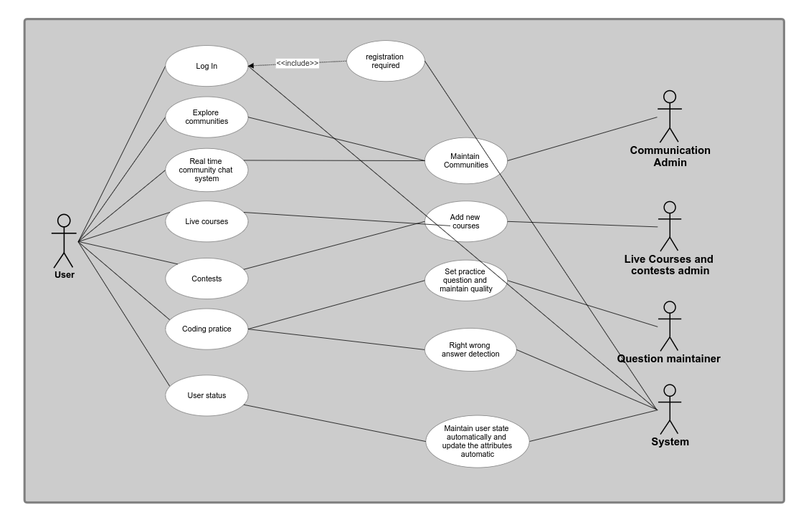

**UML Diagram**

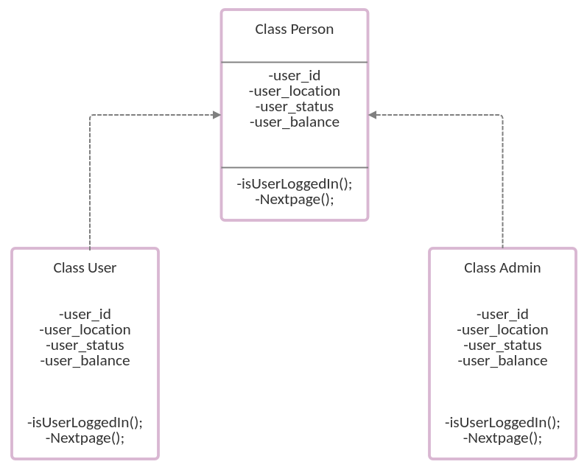

**Object Diagram**

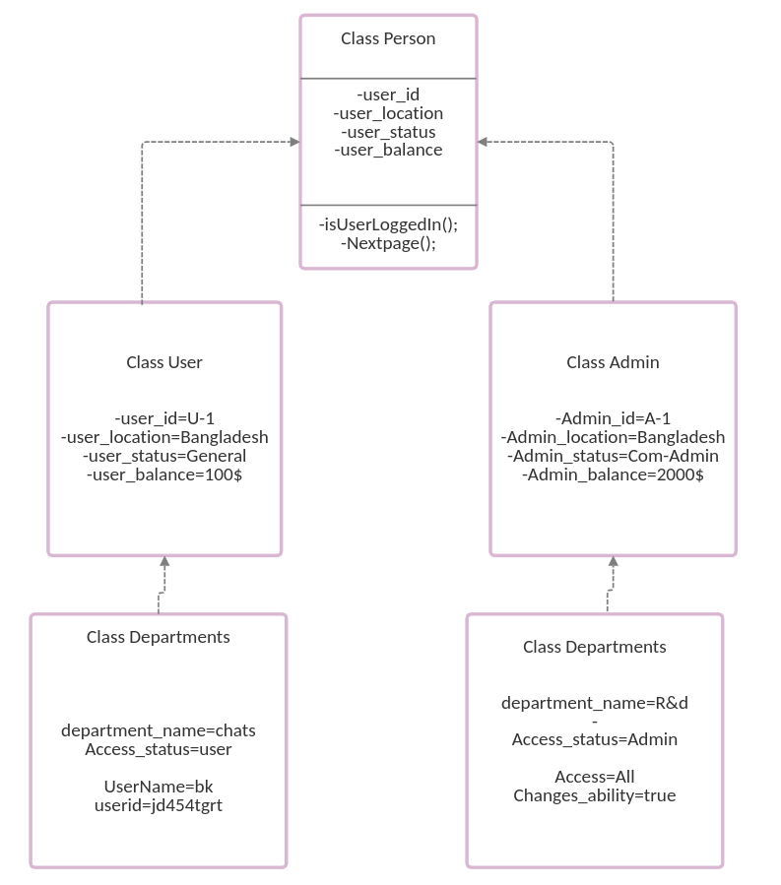

**Appendix C: Issues List**

* Dark mode is no implemented
* A large database system is in use but farther we have to use cloud-databases.
* For making the community healthy we have to work on verbal abuse detection models.
* Docker images are not Available for development purpose
* The git Hub repository is not public right now due to security purpose but we can make it open source for contribution
* For cloud-based streaming we have to implement more servers for better streaming performance.
* The number of backbend Developers have to increase to deliver better support