**Software Requirements**

**Specification**

**for**

**Exclusive**

**Version 1.0**

**Prepared by**

**Bishwajit Chakraborty**

**0242220005101414**

**ShaidunNahar Shela**

**0242220005101417**

**Daffodil International University**

**20 September, 2024**

**Table of Contents**

**Table of Contents..............................................................................…...................... 2**

**Revision History.......................................................................................................... 2**

**1. Introduction....................................................................................................…….3**

1.1 Purpose ...................................................................................................……..................... 3 1.2 Document Conventions.................................................………………..................................... 3

1.3 Intended Audience and Reading Suggestions..................................………………............ 3

1.4 Project Scope ...................................................................................................................... 3

1.5 References.......................................................................................................…………… 3

**2. Overall Description........................................................................................….....4**

2.1 Product Perspective .....................................................................................…………….. 4

2.2 Product Features ................................................................................................……........ 4

2.3 User Classes and Characteristics......................................………………………….......... 4

2.4 Operating Environment.......................................................................………................... 5

2.5 Design and Implementation Constraints.............................................……....................... 5

2.6 User Documentation ......................................................................…………………....... 5

2.7 Assumptions and Dependencies .....................................................……………............... 5

**3. System Features........................................................………………......................6**

3.1 System Feature 1.....................................................................………….......................... 6

3.2 System Feature 2 (and so on).................................................…………........................... 7

**4. External Interface Requirements..................................………….........................8**

4.1 User Interfaces...........................................................................……………………....... 8

4.2 Hardware Interfaces..............................................................………………………........ 8

4.3 Software Interfaces...............................................................……………………............ 8

4.4 Communications Interfaces ....................................................……….............................. 8

**5. Other Nonfunctional Requirements...............................………...........................9**

5.1 Performance Requirements..................................................................………………...... 9

5.2 Safety Requirements....................................................................…………….................. 9

5.3 Security Requirements................................................................……………………....... 9

5.4 Software Quality Attributes......................................................……………………......... 9

**6. Other Requirements ..................................................……………………….......10**

**Appendix A: Glossary..........................................………………………….............10**

**Appendix B: Analysis Models........................................………........................11-12**

**Appendix C: Issues List................................................................................……....13**

**Revision History**

|  |  |  |  |
| --- | --- | --- | --- |
| **Name** | **Date** | **Reason For Changes** | **Version** |
|  |  |  |  |
|  |  |  |  |

**1. Introduction**

**1.1 Purpose**

This SRS describes the specifications of the Exclusive platform used for seamless shopping.

Exclusive is an online e-commerce store designed to provide a seamless shopping experience for customers. The platform aims to offer a wide range of products, easy navigation, secure payment processing, and excellent customer service.

**1.2 Document Conventions**

The document focuses on the high priority requirements which will be implemented for the final deliverable

Each requirement has a unique identification number that consists of a string of letters followed by a number, for example, REQ1.1. These numbers are assigned when the requirement is created.

**1.3 Intended Audience and Reading Suggestions**

The System Requirements Specification (SRS) document is intended for project managers, software developers, quality assurance testers, and business stakeholders who need to understand the functional and non-functional requirements of the Exclusive online e-commerce store. It outlines the key features and functionalities that are expected from the system, including user registration, product catalog, secure payment processing, and excellent customer service. To get the most out of this document, we recommend reading it in sequence, starting with the overview, then the purpose statement, and finally the functional and non-functional requirements sections. This will provide a comprehensive understanding of the Exclusive online e-commerce store's system requirements and how they can be met through effective project planning, development, testing, and deployment.

**1.4 Project Scope**

The Exclusive online e-commerce store project scope includes the development of an online e-commerce platform that allows customers to browse, purchase, and manage their products in a secure and user-friendly manner. The scope also encompasses the creation of a comprehensive product catalog that includes all necessary information about each product, such as product descriptions, images, prices, and inventory levels. Additionally, the project involves the implementation of secure payment processing systems that protect customer payment information and prevent unauthorized transactions. Other key components of the project scope include order management, shipping integration, and customer relationship management, all designed to provide an exceptional shopping experience for customers while ensuring efficient operations and streamlined workflows for business stakeholders.

**1.5 References**

Project title : **Exclusive**

Version : 1.0

Author : Bishwajit Chakraborty

date : 20 September 2024

System requirement : Any with Modern Browser

Project UI : [Exclusive UI](https://www.figma.com/design/bhme2A3PF0yFeeqXuiVW5m/SP-3?node-id=0-1&t=nbkC2ChcBormAg66-1) (Designed in Figma)

Source : <https://www.figma.com/design/bhme2A3PF0yFeeqXuiVW5m/SP-3?node-id=0-1&t=nbkC2ChcBormAg66-1>

**2. Overall Description**

**2.1 Product Perspective**

The **Exclusive** online e-commerce store is a software system that serves as a digital storefront, enabling customers to browse, select, and purchase products from various categories in a secure and user-friendly manner. The product's key features include a vast array of products, easy navigation and search functionality, secure payment processing systems, product reviews and ratings for informed purchasing decisions, and order management and tracking for efficient logistics.

**Exclusive** is a complete platform uses web development tools HTML, CSS, JavaScript.

**2.2 Product Features**

|  |  |  |
| --- | --- | --- |
| **Product Feature** | **Description** | **Priority** |
| User Authentication | Login and Sign Up is required to use maximum features | Highest |
| Product Catalog | A comprehensive catalog of products from various categories, including clothing, accessories, electronics, and home goods. | Medium |
| Product Filtering and Sorting | Users can filter and sort products by price, brand, category, and other attributes to find what they need quickly and easily. | High |
| Product Reviews and Ratings | Customers can leave reviews and ratings for products they have purchased to help others make informed purchasing decisions. | Medium |
| Secure Payment Processing | The store will use secure payment processing systems to protect customer payment information and prevent unauthorized transactions. | High |
| Customer Account Management | Customers can create an account to save their information, view order history, and track packages. | High |
| Free Shipping and Gift Wrapping | The store will offer free shipping on orders above a certain amount or for specific products. Customers can opt for gift wrapping services for their purchased items. | Medium |
| Personalized Recommendations | Great courses with proper monitoring | Medium |
| Interview experiences | Customers will receive personalized product recommendations based on their purchase history and preferences. | Low |
| Reporting and Analytics | Admins will have access to reporting and analytics tools to track sales, customer behavior, and other key metrics. | High |

**2.3 User Classes and Characteristics**

|  |  |
| --- | --- |
| **User Class** | **Description** |
| Customer | Age 18-65, Male/Female, Middle to Upper-Middle Class. Regularly shops online, Interested in fashion, electronics, and home goods. |
| Visitor | Same as customer demographics. May be researching products, Comparing prices, Looking for information on a specific topic |
| Admin | Age 25-55, Male/Female, Business Owner or Marketing Professional. Regularly updates product information, Manages orders, Monitors analytics |
| Guest | Anonymous user, No demographic data available. Does not have access to account features, Cannot save products for later. |
| Administrators/Moderators | They monitor and manage everything like functionalities, contents, environment an so on. |

**2.4 Operating Environment**

The Exclusive only requires Apache Server and MySQL to setup which can be easily done using the XAMPP which is a free and open source cross-platform web server package consisting mainly of the Apache HTTP Server, MySQL database and HTML, CSS, JavaScript which is mainly used for front end development.

|  |  |
| --- | --- |
| OE-1 | System shall operate with the following web browsers: Microsoft Internet Explorer version 5.0 up, Chromium 13.0 up, Netscape versions 6.6 up. |
| OE-2 | Supports Android 6 up any device. |
| OE-3 | Supports iOS version 11 up any device. |
| OE-4 | Supports Windows 10 and 10 up any device. |
| OE-5 | Supports Linux systems like Arch, Debian, Fedora and so on. |
| OE-6 | Supports Mac Os 11 up any device. |

**2.5 Design and Implementation Constraints**

* Signing up/ Logging in with Users social media accounts like Google, Facebook, LinkedIn, Twitter, GitHub.
* Access personalized products.
* Customer data will be encrypted using SSL/TLS certificates to ensure confidentiality and integrity.
* The website will integrate with shipping providers to offer fast and reliable delivery options.
* Contact support desk for any problem or error.
* The website will integrate with multiple payment gateways to provide customers with a variety of payment options..

**2.6 User Documentation**

* For support there is dedicated feedback and support system
* User manual and tutorials will be released in project page in Figma site
* There is online customer service for always help users.

**2.7 Assumptions and Dependencies**

* Initially only two locations are connected to Exclusive.
* Each User must have a UserId and password.
* There are several Administrator.
* Server must always runs under Linux system.
* Internet connection is a must.
* For Development purpose web development and API and database knowledge and setup is necessary.

**3. System Features**

**3.1 Chatting in new community**

3.1.1 Description and Priority

Allows anyone using the system to join new community and chat with them, video calls and audio calls are also included.

3.1.2 Stimulus/Response Sequences

* + Search for new community.
  + Option to join location based communities.
  + Display the community list products.
  + Display Product options.
  + Leave a community.

3.1.3 Functional Requirements

REQ-1:Distributed DataBase

* + Some sites are client sites and others are server sites.
  + All the data resides at the server sites.
  + All applications execute at the client sites.

REQ-2: API integration

* + Tackle invalid inputs and show error screen.
  + Use trackers to detect spam and rapid undeclared mails.

**3.2 Courses**

3.2.1 Description and Priority

Allows anyone using the system without sign up but ordering product need to login.

3.2.2 Stimulus/Response Sequences

* + Search for new products.
  + Demo videos/images to know about product.
  + Display the category list.
  + Ask about products.
  + Leave a rating about the product.

3.2.3 Functional Requirements

REQ-1:Distributed DataBase

* + More ftp support to easy video play.
  + Easy purchase using international payment services

REQ-2: Support system

* + A automated support system using ai integration.

**3.3 Contest and Problems**

3.1.1 Description and Priority

Allows anyone using the system to order products.

3.1.2 Stimulus/Response Sequences

* + Search for new items.
  + Option to join location based shops/distributer.
  + Contests time and result system

3.1.3 Functional Requirements

REQ-1: Responds

* + Send answer and show the respond
  + count the Correct responds
  + finish the contest based on database timing.

**3.4 User Authentication**

3.1.1 Description and Priority

Everyone must have to log In and sign up. It ensure security of everyone.

3.1.2 Stimulus/Response Sequences

* + Show Log in and Sign up page.
  + Generate new registration key for new users.
  + Unique OTP for verification.

3.1.3 Functional Requirements

REQ-1: Responds

* + Send user data and save them in server.
  + Creating hash-code for password and generate API integration.
  + User data update and 2 step authentication.

**4. External Interface Requirements**

**4.1 User Interfaces**

* Front-end software: HTML, CSS, JavaScript
* Back-end software: MySQL, FireBase, MongoDB
* Ftp and large Cloud database(like AWS) for video streaming.

**4.2 Hardware Interfaces**

* Androids, iPhone, Mac Books, Windows, Linux and web
* A device with Browser.
* A browser that supports CGI, HTML & JavaScript.
* Internet connection is required.

**4.3 Software Interfaces**

|  |  |
| --- | --- |
| **Software used** | **Description** |
| Operating system | Support all modern OS |
| Database | To store users Chats, Courses, Results and so on |
| HTML, CSS, JavaScript | To implement the project we have chosen web framework based on JavaScript for its more interactive support. |
| Software project model | Agile model |

**4.4 Communications Interfaces**

This project supports all types of web browsers and devices. We are using simple Text form fields for User interaction. Using UDP protocol for calls and video streaming part and HTTP for other uses. Using Database’s data encryption model for security. Servers are configured to transfer data at 100 GB/S speed.

**5. Other Nonfunctional Requirements**

**5.1 Performance Requirements**

* Logged in user does not need to log in again and the log in and sign up response time should must be less then 3 seconds.
* The system must be able to scale horizontally to accommodate increasing traffic and user growth, with the ability to add or remove servers as needed.
* The system must be available at least 99.9% of the time, with scheduled maintenance performed during off-peak hours to minimize downtime.
* Cart should be in real time and data response time should be under 100ms.
* Server resources will be optimized to ensure efficient use of CPU, memory, and disk storage.

**5.2 Safety Requirements**

The safety requirements for Exclusive are designed to protect users from unauthorized access, data breaches, and other potential threats. These requirements include the encryption of sensitive user data using advanced protocols, two-factor authentication to verify user identities, secure payment processing through trusted third-party gateways, regular security updates to prevent vulnerabilities, and intrusion detection and prevention systems to monitor for potential threats. Additionally, Exclusive employs a robust access control system that limits access to authorized personnel only, ensuring that sensitive information is not compromised.

**5.4 Software Quality Attributes**

* **Flexibility:** Customized settings, themes, downloadable files should be adapt on individual’s preferences.
* **MAINTAINABILITY:** The Software and web application must support regular updates to ensure compatibility with the latest technologies, Bug fixes, and security patches.
* **USABILITY:** The software should satisfy a maximum number of Users’ needs. The application should be accessible on multiple devices, including desktop and mobile and supports a large group of people without any issue.
* **API (Application Programming Interface) -** A set of protocols, tools, and definitions allowing different software systems to communicate and interact with each other.

**6. Other Requirements**

**Appendix A: Glossary**

* Account – Information maintained by the Exclusive for each user.
* User – An individual who has created an Account on the Exclusive
* Active Participants – Individuals who are active in communities
* Important maintainers – Who are responsible for maintained the code of conduct
* Strong Conflict- A strong date conflict is when no date can be found within the date range and outside all exclusion sets.
* Weak Conflict - A weak date conflict is when dates can be found within the date range and outside all exclusion sets, but no date can be found at the intersection of all preference sets.
* JSON (JavaScript Object Notation) – used for data transmission between server and application using key and data pair value.
* YAML(YAML isn’t a Markup Language) - used for configuration files and in applications where data is being stored or transmitted
* CRUD (Create, Read, Update, Delete) - Basic functions of persistent storage, referring to the four essential database operations.
* RESTful API (Representational State Transfer) - An architectural style that defines a set of constraints used for creating web services.
* Payment Gateway -A service that securely handles online payment transactions between customers and businesses.

**Appendix B: Analysis Models**

**UML Diagram**

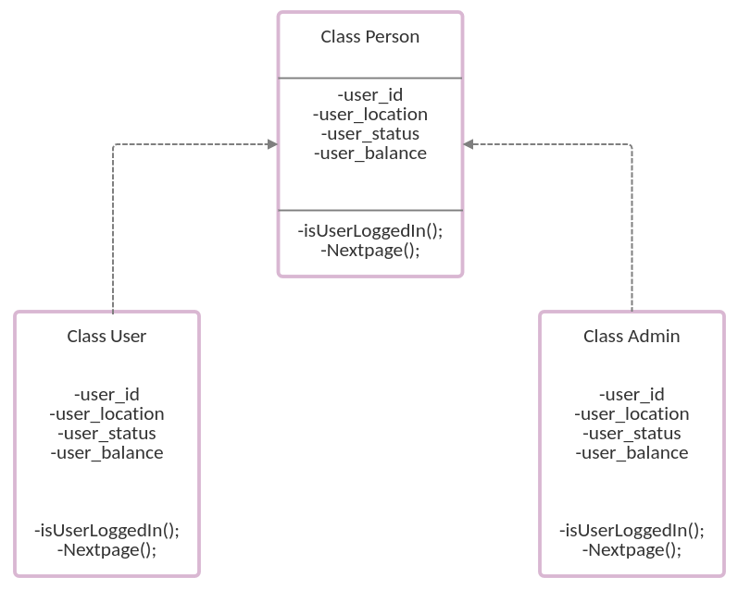

**Object Diagram**

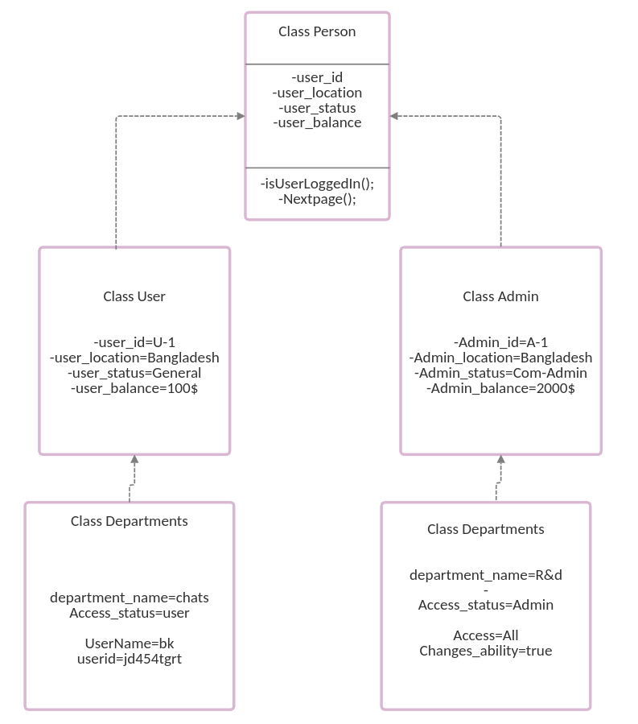

**Appendix C: Issues List**

* A large database system is in use but farther we have to use cloud-databases.
* For making the community healthy we have to work on verbal abuse detection models.
* Docker images are not Available for development purpose
* The git Hub repository is not public right now due to security purpose but we can make it open source for contribution
* The number of backend Developers have to increase to deliver better support