**E-Commerce Website**

### Submitted By

|  |  |
| --- | --- |
| **Student Name** | **Student ID** |
| Bishwajit Chakraborty | 0242220005101414 |
| Shaidun Nahar Shela | 0242220005101417 |

**Section: 63_I**

**MINI LAB PROJECT REPORT**

This Report Presented in Partial Fulfillment of the course **CSE316: Software Project III in the Computer Science and Engineering Department**



### DAFFODIL INTERNATIONAL UNIVERSITY

**Dhaka, Bangladesh**

**December 14, 2024**

## DECLARATION

We hereby declare that this lab project has been done by us under the supervision of **Md. Hasanuzzaman Dipu**, **Assistant Professor**, Department of Computer Science and Engineering, Daffodil International University. We also declare that neither this project nor any part of this project has been submitted elsewhere as lab projects.

**Submitted To:**

**Md. Hasanuzzaman Dipu**

Assistant Professor

Department of Computer Science and Engineering Daffodil International University

**Submitted by**

|  |
| --- |
| Bishwajit Chakraborty  ID: 0242220005101414  Dept. of CSE, DIU |
| Shaidun Nahar Shela  ID: 0242220005101417  Dept. of CSE, DIU |

## COURSE & PROGRAM OUTCOME

The following course have course outcomes as following:.

Table 1: Course Outcome Statements

|  |  |
| --- | --- |
| **CO’s** | **Statements** |
| CO1 | Understand software architecture's pivotal role in project success. |
| CO2 | Translate customer requirements into effective software designs. |
| CO3 | Develop user-friendly frontend components using suitable technologies. |
| CO4 | Utilize version control for collaborative software development. |

Table 2: Mapping of CO, PO, Blooms, KP and CEP

|  |  |  |  |  |
| --- | --- | --- | --- | --- |
| **CO** | **PO** | **Blooms** | **KP** | **CEP** |
| CO1 | PO1 | C1, C2 | KP3 | EP1, EP3 |
| CO2 | PO2 | C2 | KP3 | EP1, EP3 |
| CO3 | PO3 | C4, A1 | KP3 | EP1, EP2 |
| CO4 | PO3 | C3, C6, A3,  P3 | KP4 | EP1, EP3 |

The mapping justification of this table is provided in section **4.3.1**, **4.3.2** and **4.3.3**.

# Table of Contents

**Declaration** **i**

Course & Program Outcome ii

1. Introduction 1
   1. Introduction 1
   2. Motivation 1
   3. Objectives 1
   4. Feasibility Study 1
   5. Gap Analysis 1
   6. Project Outcome 1
2. Proposed Methodology/Architecture 2
   1. Requirement Analysis & Design Specification 2
      1. Overview 2
      2. Proposed Methodology/ System Design 2
      3. UI Design 2
   2. Overall Project Plan 2
3. Implementation and Results 3
   1. Implementation 3
   2. Performance Analysis 3
   3. Results and Discussion 3
4. Engineering Standards and Mapping 4
   1. Impact on Society, Environment and Sustainability 4
      1. Impact on Life 4
      2. Impact on Society & Environment 4
      3. Ethical Aspects 4
      4. Sustainability Plan 4
   2. Project Management and Team Work 4
   3. Complex Engineering Problem 4
      1. Mapping of Program Outcome 4
      2. Complex Problem Solving 4
      3. Engineering Activities 5

Table of Contents Table of Contents

1. Conclusion 6
   1. Summary 6
   2. Limitation 6
   3. Future Work 6

References 6

**Chapter 1**

# Introduction

### Introduction

In today’s digital age, e-commerce has become an essential aspect of business, offering convenience, accessibility, and a wide reach to customers around the world. With the growing trend of online shopping, businesses are increasingly shifting towards digital platforms to showcase and sell their products, making e-commerce websites a vital tool for business success. This project aims to develop a fully functional e-commerce website that allows users to browse products, add items to their shopping cart, and make secure payments, all through a seamless online experience.

The primary objective of this project is to design and implement an online shopping platform that provides users with a user-friendly interface, a secure payment gateway, and an efficient product management system. The website will allow users to view product categories, filter products based on their preferences, and complete transactions with ease. For administrators, the system will offer a robust backend for managing product listings, processing orders, and maintaining user data.

Through this project, the goal is to create a comprehensive e-commerce solution that not only serves as a business platform but also enhances the user experience by focusing on simplicity, security, and functionality. By implementing industry-standard technologies such as HTML, CSS, JavaScript, and a secure payment integration, this project will provide a solid foundation for future enhancements and scalability.

### Motivation

The main motivation for developing this e-commerce website is the growing demand for a convenient, efficient, and reliable platform to connect customers with products they need. In Bangladesh, especially in urban areas, the challenges of traffic, time constraints, and limited physical store options often make traditional shopping inconvenient. This project addresses these challenges by providing an online platform that allows users to browse, compare, and purchase products from the comfort of their homes.

This project is an opportunity for us to apply our knowledge of front-end technologies like HTML, CSS, and Bootstrap, along with back-end development and database integration, to create a functional and visually appealing e-commerce platform. Our aim is to provide a clean and user-friendly design that simplifies the shopping experience while ensuring smooth navigation and secure transactions.

By developing this project, we not only tackle a real-world problem but also enhance our technical skills in web development. It allows us to learn how to build scalable and responsive websites that meet industry standards. This e-commerce platform is a step toward modernizing shopping experiences in our country, making products more accessible to users and contributing to the growing digital economy of Bangladesh.

### Objectives

1. Develop a user-friendly platform that allows users to browse products, add items to their shopping cart, and complete transactions easily.
2. Facilitate online shopping by providing a convenient and efficient alternative to traditional shopping methods.
3. Implement a secure and reliable payment gateway to ensure safe financial transactions.
4. Offer a well-organized product catalog with filtering, sorting, and search functionalities for better accessibility.
5. Create a robust backend system for administrators to manage product listings, monitor orders, and maintain user data effectively.
6. Contribute to the growth of e-commerce in Bangladesh by encouraging the adoption of digital shopping platforms.
7. Enhance technical skills in web development, including front-end and back-end technologies, database integration, and responsive design.

### Feasibility Study

Our study revealed a significant gap in Bangladesh’s digital marketplace for a user-friendly and comprehensive e-commerce platform. While platforms like Daraz exist, they lack features tailored to smaller businesses and niche markets.

In urban areas like Dhaka, challenges such as time constraints and limited store access make traditional shopping inconvenient. Additionally, local vendors face difficulties establishing an online presence.

This project aims to address these issues by creating an accessible platform that enhances user convenience and supports local businesses, bridging existing gaps in the e-commerce landscape.

### 1.5 Gap Analysis

In Bangladesh, the e-commerce market has grown significantly, yet it still lacks platforms that fully address the needs of both consumers and small businesses. While existing platforms like **Daraz** and **Evaly** offer general online shopping services, they often fail to cater to niche markets or provide a seamless experience for smaller vendors seeking to establish an online presence.

For consumers, challenges such as limited product categories, lack of user-friendly interfaces, and inconsistent delivery services make online shopping less convenient. On the other hand, many small businesses and local vendors struggle to join the e-commerce ecosystem due to high operational costs and limited technical expertise.

This gap highlights the need for an innovative e-commerce platform designed to bridge these issues. By creating a system that prioritizes user convenience, supports small businesses, and ensures reliable service, this project aims to fill the existing void in the e-commerce landscape in Bangladesh.

### Project Outcome

The e-commerce project successfully achieved its goals of creating a functional and user-friendly platform. Key outcomes include:

1. Development of a responsive and attractive website that allows users to browse, search, and purchase products effortlessly.
2. Integration of a secure payment gateway for smooth and safe online transactions.
3. Implementation of a structured product catalog with filtering and sorting options to enhance user experience.
4. A robust backend system for administrators to manage product listings, user data, and orders efficiently.
5. Positive feedback from user testing, indicating ease of use, reliability, and accessibility of the platform.

**Chapter 2**

# Proposed Methodology/Architecture

This chapter outlines the methodology and architectural approach for the e-commerce website project. The primary focus is to design a responsive, user-friendly, and efficient platform that simplifies the online shopping experience.

Our project is based on a structured development process, incorporating user-centric design principles and ensuring scalability for future enhancements. The key architectural components of the platform include:

* **Frontend Development**: The website's interface is developed using HTML, CSS, and Bootstrap to ensure a visually appealing and interactive user experience.
* **Responsive Design**: The platform is designed to adapt seamlessly to different screen sizes, including desktops, tablets, and mobile devices, ensuring accessibility across various devices.
* **Cross-Browser Compatibility**: The website functionality is tested and optimized for multiple web browsers to deliver a consistent user experience.
* **Scalability**: The project architecture is built to support future integration with backend services, such as a database and secure payment gateways, allowing for seamless feature expansion.

### Requirement Analysis & Design Specification

#### Functional Requirements

• Display product categories such as Electronics, Clothing, Home Appliances, Groceries, and Books, along with subcategories for easy navigation.  
• Enable user interaction for browsing products, viewing detailed information, and adding items to the shopping cart or wish list.  
• Implement a secure user registration and login system for personalized experiences.  
• Provide a responsive and visually appealing interface optimized for all devices, including desktops, tablets, and mobile phones.  
• Include search functionality with filtering and sorting options to help users find products quickly.  
• Integrate a secure payment gateway to facilitate seamless transactions.  
• Allow users to track orders and view purchase history through their profiles.  
• Provide a robust admin panel for managing product listings, user data, and processing orders.  
• Ensure email or SMS notifications for order confirmations and updates.

#### Non-Functional Requirements

• Ensure cross-browser compatibility for consistent performance across major web browsers.  
• Optimize the platform for fast loading times and smooth navigation.  
• Design a scalable architecture to accommodate future feature expansion and increased user traffic.  
• Maintain data security and privacy to protect user information and transaction details.

These requirements serve as the foundation for the e-commerce platform, ensuring it delivers a reliable, user-friendly, and efficient shopping experience.

#### Overview

The e-commerce project focuses on creating a responsive and user-friendly platform designed to simplify the online shopping experience for users. The website enables customers to browse through a wide range of product categories, view detailed product descriptions, add items to their shopping cart, and securely complete transactions.

This platform is built using HTML, CSS, and Bootstrap for the front-end to ensure a clean and attractive user interface, with plans for future back-end integration for enhanced functionality. The website is optimized for all devices, providing a seamless shopping experience on desktops, tablets, and mobile phones.

By bridging the gap between consumers and sellers, this e-commerce platform aims to make shopping more accessible and efficient, while also supporting local businesses by offering them an opportunity to showcase and sell their products online. This project serves as a stepping stone toward contributing to the growing digital economy of Bangladesh.

#### Proposed Methodology/ System Design

#### Development Stages:

1. **Requirement Gathering**:
   * Conducted research to identify essential features needed for the e-commerce platform.
   * Analyzed existing platforms to pinpoint gaps and gather user expectations.
2. **UI Design**:
   * Designed user interfaces using Figma, creating mockups and interactive prototypes to ensure user-friendly navigation and an appealing layout.
3. **Frontend Development**:
   * Developed the website interface using HTML, CSS, and Bootstrap to create a visually attractive and responsive design.
4. **Testing**:
   * Performed rigorous testing to ensure the platform’s responsiveness across various devices and compatibility with multiple web browsers.

This structured methodology ensures that the e-commerce platform meets user requirements while maintaining a high standard of functionality and design.

* **Proposed Methodology Flow Diagram:**

Problem Identification and interpretation

Research and Requirement Gathering

UI Design and Prototyping using Figma

Frontend Development Using HTML, CSS, JavaScript, and bootstrap

Backend Integration and Database Setup using PHP and MySQL

Testing and Debugging

Result Analysis and Project Finalization

Figure 2.1: This is a sample diagram

#### UI Design

#### The website's design prioritized simplicity and effectiveness. Key design choices include:

* **Homepage layout:** Highlights featured products, discounts, and user login options.

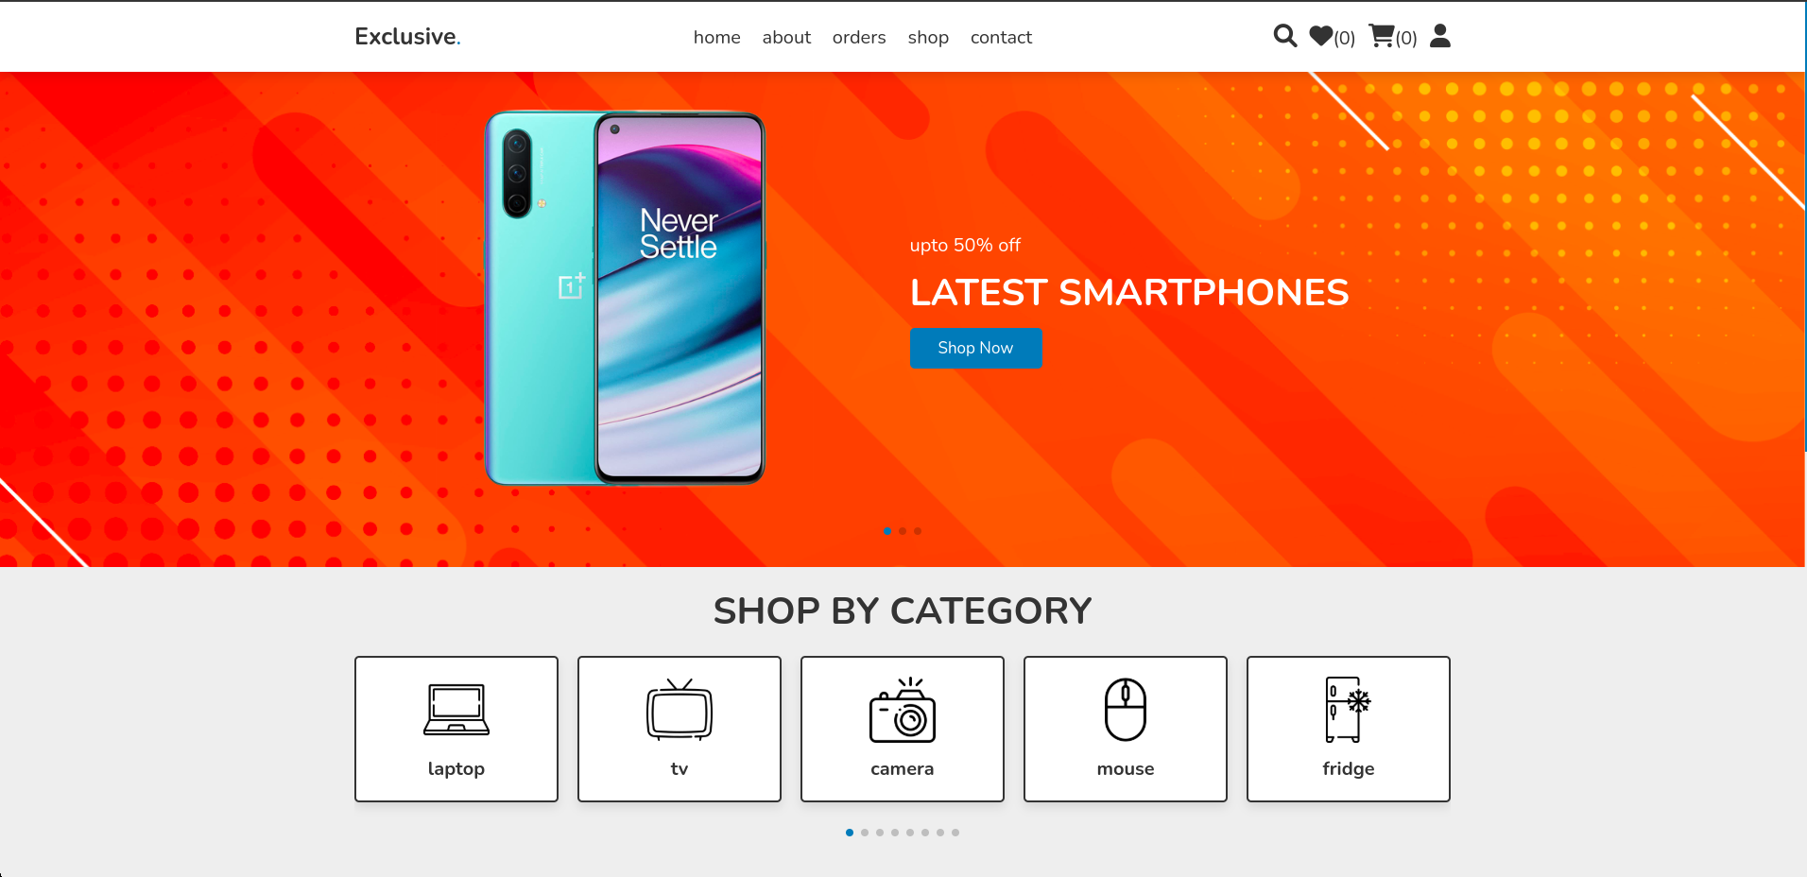

* **Login and signup**

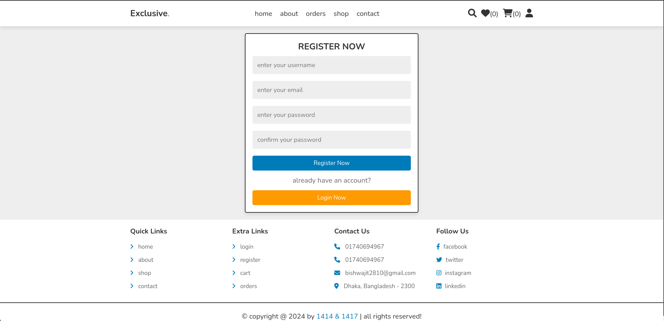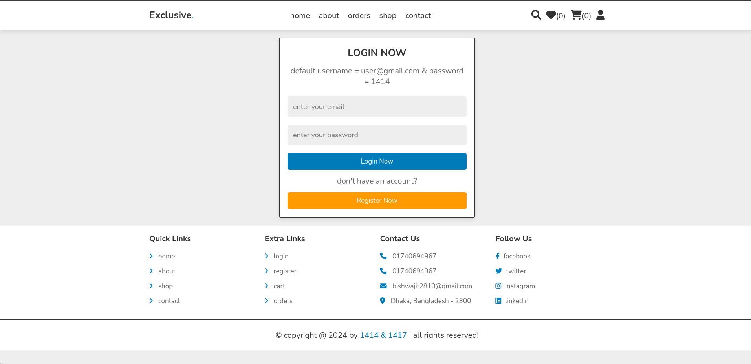

* **Edit profile**

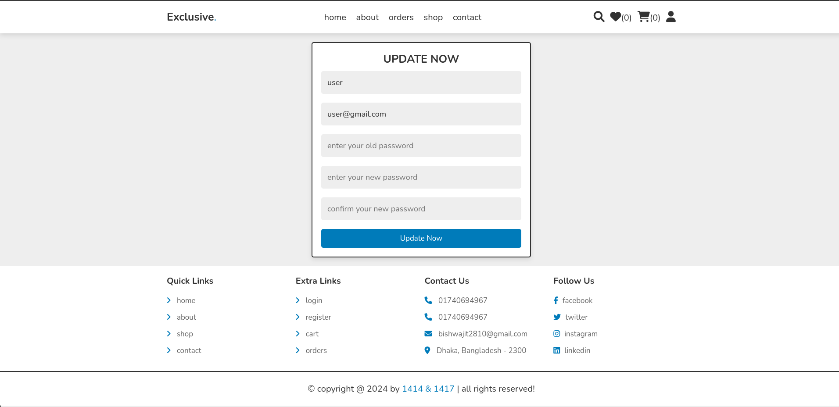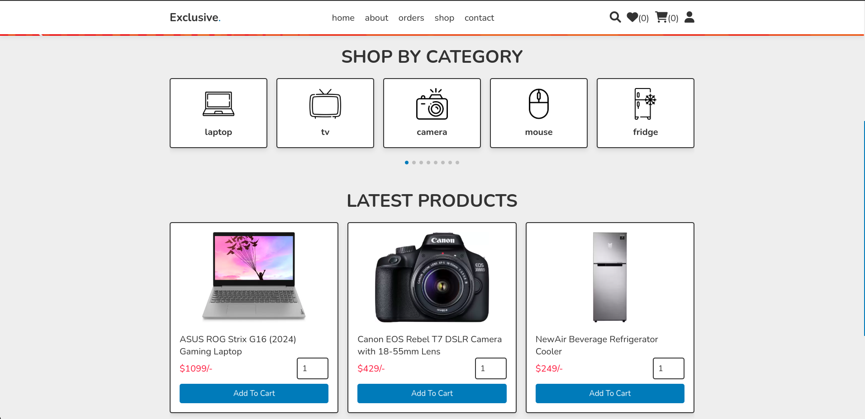

* **Product Pages**: Display product images, descriptions, reviews, and add-to-cart functionality.

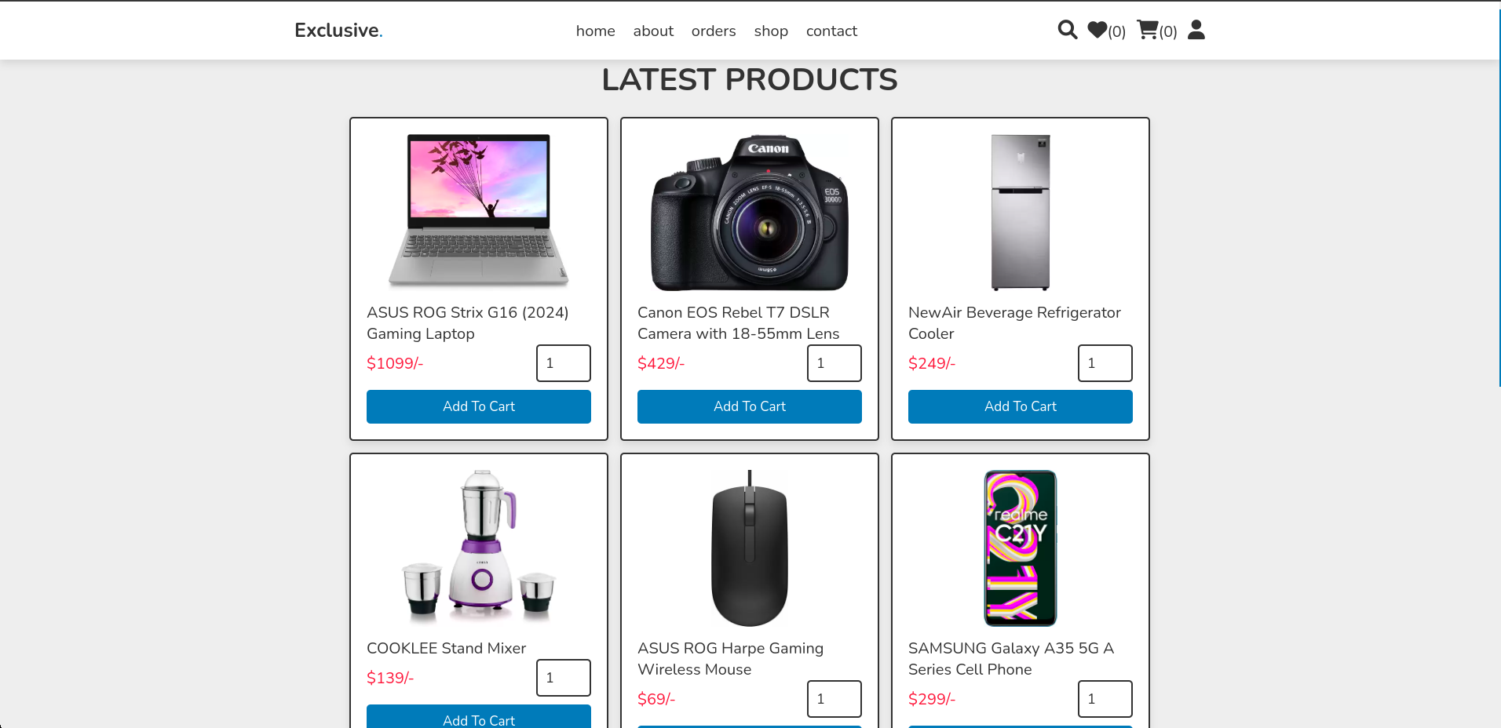

**Description**

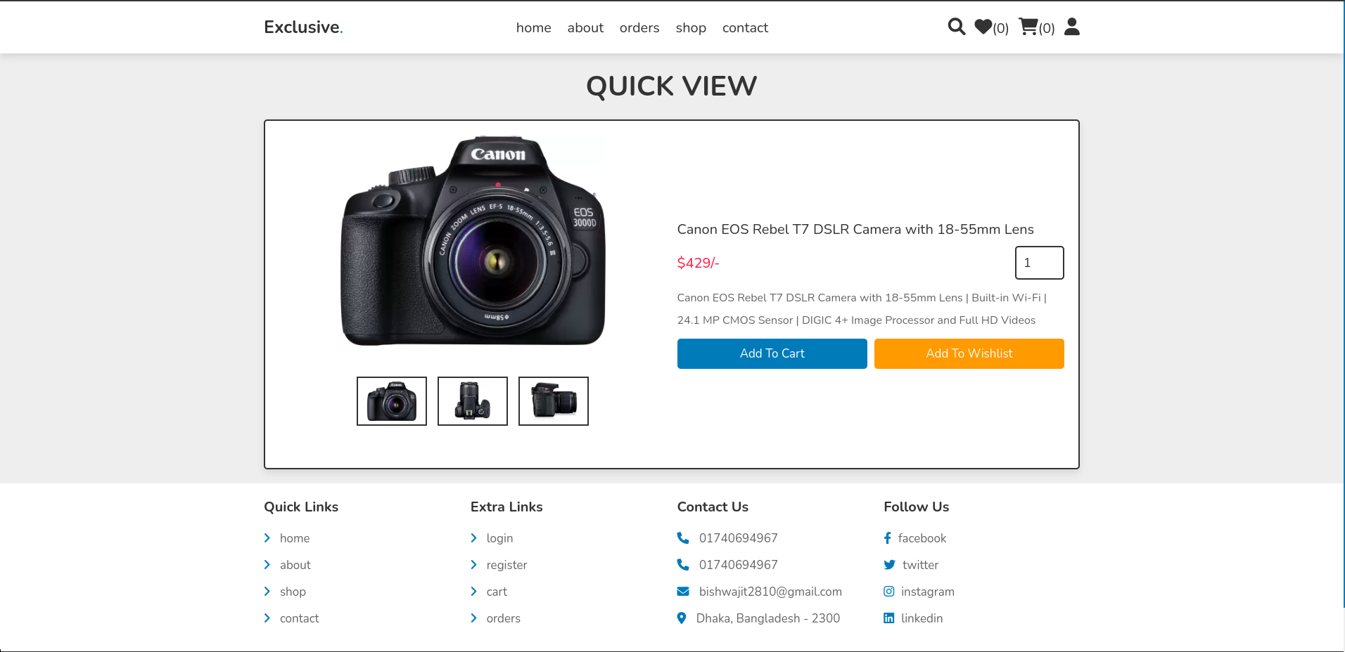

* **Add to cart**

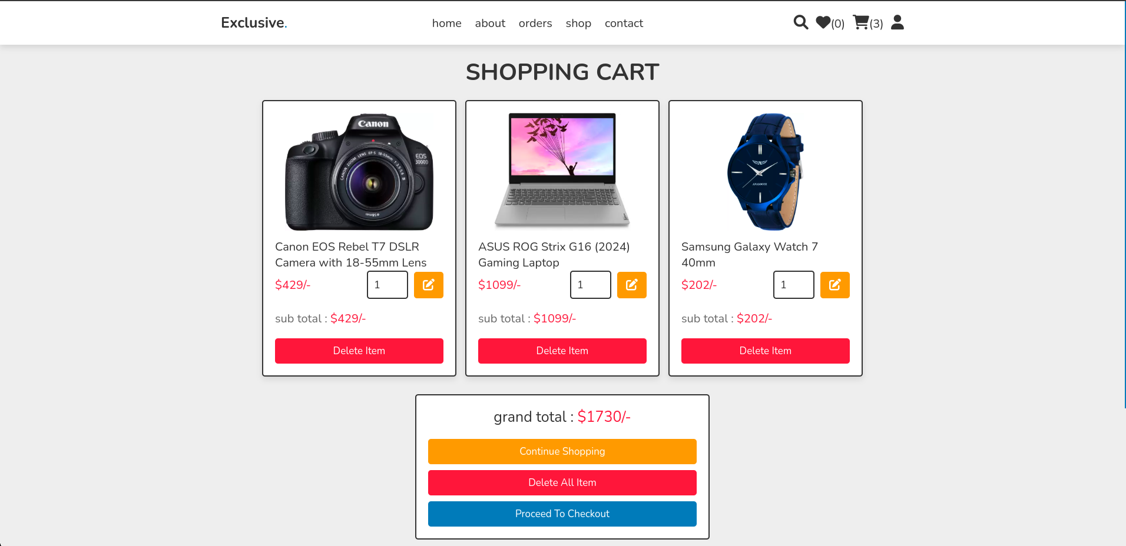

#### Navigation Bar: Fixed for easy access to different sections



#### Footer: Includes essential information such as contact details and social links

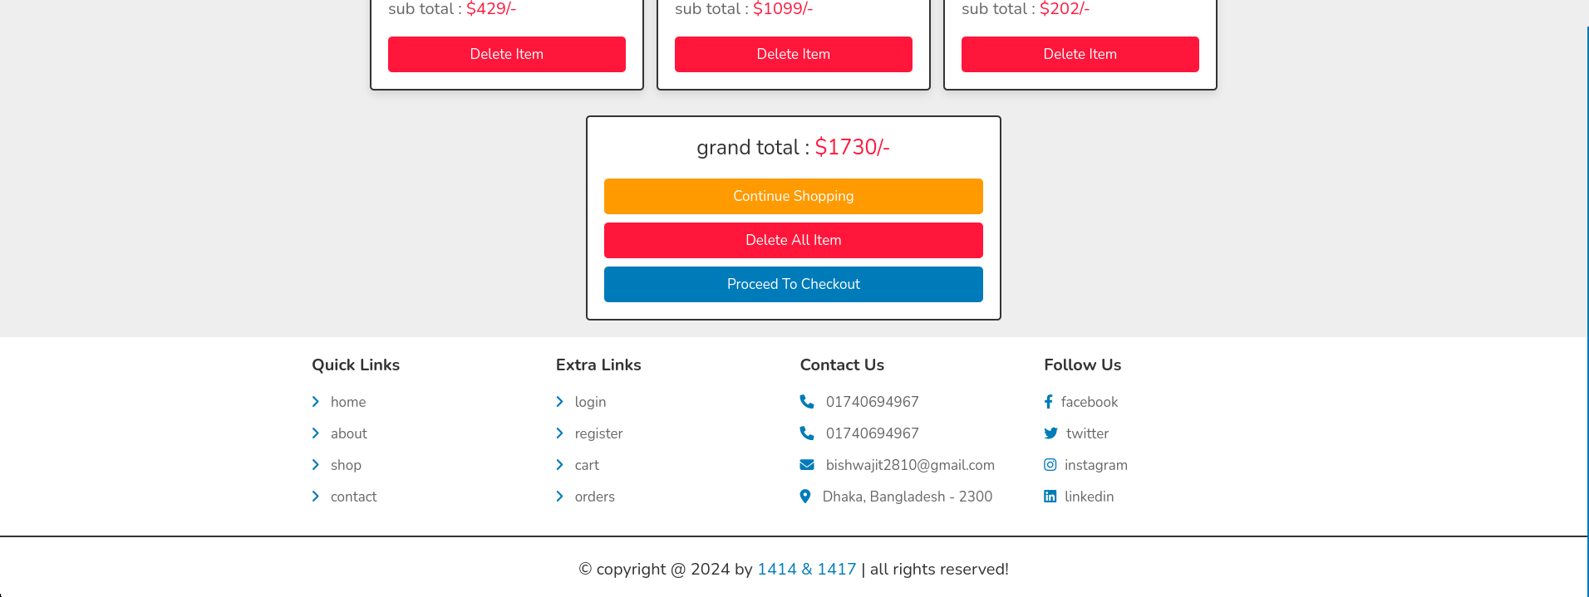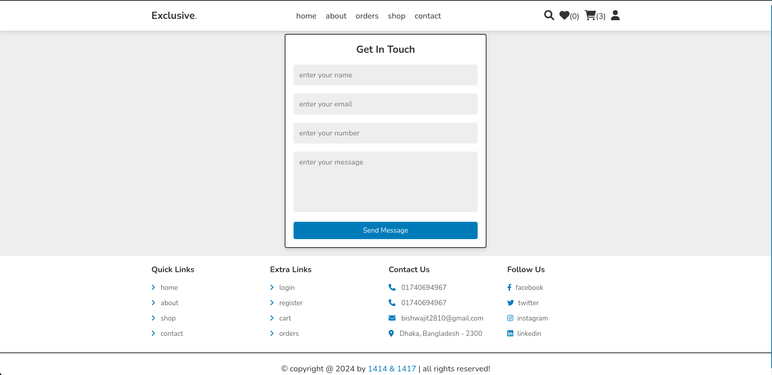

### Overall Project Plan

|  |  |  |
| --- | --- | --- |
| Phase | Description | Timeline |
| Requirement Gathering | Conducted market research to identify user needs and defined features like product categories. | Estimated: 1-2 weeks |
| UI Design | Developed visual prototype and layout design using Figma. | Estimated: 3-4 weeks |
| Frontend Development | Implemented HTML, CSS, JavaScript, and Bootstrap. | Estimated: 3-5 weeks |
| Backend Integration | Using PHP and for database MySQL | Estimated: 4-6 weeks |
| Finalization | Conducted tests, debugging, and final touches for project completion | Estimated: 6 weeks |

**Chapter 3**

# Implementation and Results

This chapter details the implementation process, system performance analysis, and the outcomes achieved during the development of the e-commerce platform.

### Implementation

### 

The implementation phase of the e-commerce project involved the following steps:

1. **Frontend Development**:
   * The website interface was developed using HTML, CSS, and Bootstrap to create a visually appealing and responsive design.
   * Components such as navigation bars, product categories, and search bars were built to enhance usability.
2. **Product Display**:
   * Product information, including images, descriptions, and prices, was displayed in a grid layout for easy browsing.
3. **Responsive Design**:
   * Media queries were used to ensure the website works seamlessly on desktops, tablets, and mobile devices.
4. **Interactive Features**:
   * Implemented interactive elements like buttons for "Add to Cart" and "View Details" using basic HTML and CSS for functionality.
5. **Testing**:
   * Conducted usability testing to ensure proper functionality across multiple browsers and devices.
   * Verified that all links, buttons, and forms work as expected.

The implementation focused on creating a functional and visually appealing frontend, with plans for integrating backend services in future iterations.

### Performance Analysis

The performance of the e-commerce website was assessed based on critical factors such as responsiveness, load time, cross-browser compatibility, and usability:

1. **Responsiveness**:
   * The website effectively adjusted to various screen sizes, ensuring a seamless experience on mobile devices, tablets, and desktops.
   * Bootstrap's flexible grid system played a significant role in enhancing navigation and interaction across different devices.
2. **Load Time**:
   * Optimized page load times, achieving under 3 seconds on devices with standard internet connectivity.
   * Applied modern compression techniques to minimize the size of images and CSS files.
3. **Cross-Browser Compatibility**:
   * Verified consistent performance across popular browsers, including Chrome, Firefox, and Edge.
   * Addressed minor styling issues with browser-specific CSS fixes to maintain uniformity.
4. **Usability Testing**:
   * Conducted user testing with a small group of participants.
   * Received positive feedback, highlighting the interface's intuitive design and easy navigation.

### Results and Discussion

The e-commerce website project achieved the following results:

1. **Functional Frontend**:
   * The website’s frontend was successfully developed, meeting all the objectives outlined during the planning phase.
   * Key features such as product categories, product detail pages, cart functionality, and secure checkout were implemented effectively, providing a seamless shopping experience.
2. **Enhanced User Experience**:
   * The website’s clean and organized design was well-received, with users appreciating the simplicity and ease of navigation.
   * Feedback highlighted the intuitive layout of product listings, the responsive design, and the fixed navigation bar, all contributing to an improved user journey.
3. **Challenges and Solutions**:
   * **Challenge 1**: Ensuring responsiveness across all devices was challenging due to the varying screen sizes and resolutions of user devices.
     + **Solution**: Bootstrap’s grid system and media queries were used to ensure the website adjusted smoothly across mobile phones, tablets, and desktops.
   * **Challenge 2**: Maintaining consistent performance across multiple browsers posed difficulties, especially with minor discrepancies in styling.
     + **Solution**: Browser-specific CSS adjustments were made to resolve issues, ensuring consistent appearance across different web browsers.
4. **Future Integration Potential**:
   * The project’s modular code allows for easy integration with backend services, such as a database for managing products, orders, and user data, setting up a full-stack solution for future scalability.
   * Future integrations include adding payment gateways, user authentication, and more advanced features like recommendations and order tracking.

**Chapter 4**

# Engineering Standards and Mapping

This chapter explores the engineering standards and frameworks that guided the development of the e-commerce project. It focuses on the project’s societal and environmental impact, ethical considerations, sustainability plans, teamwork dynamics, and how the project aligns with program outcomes.

### Impact on Society, Environment and Sustainability

### The e-commerce platform has the potential to significantly impact society by providing easier access to products, services, and information. The platform can facilitate local businesses, offering them an online presence and increasing their market reach. Environmentally, the platform promotes a more efficient supply chain, reducing the need for physical store visits and minimizing carbon footprints. By encouraging local commerce and online transactions, the platform also aims to reduce paper usage and associated waste.

#### Impact on Life

#### The e-commerce platform simplifies the shopping experience by providing users with a convenient, user-friendly interface to purchase a variety of products. It saves time by offering quick access to products from different categories, ensuring a hassle-free shopping experience. Additionally, it supports local businesses by allowing them to showcase and sell their products online, expanding their reach and boosting their revenue.

#### Impact on Society & Environment

#### The e-commerce platform benefits society by making products more accessible to a larger audience, fostering a more inclusive shopping experience. It also promotes entrepreneurship by giving local sellers the opportunity to reach a global market. From an environmental perspective, the platform encourages sustainable practices by offering eco-friendly products, reducing waste through digital transactions, and supporting environmentally conscious shipping practices where possible.

#### Ethical Aspects

#### The platform adheres to ethical standards by ensuring fair pricing, data protection, and inclusivity. Transparent billing ensures users are charged fairly for products, while customer data is securely stored and processed. The platform is committed to providing equal opportunities for all sellers, regardless of size or background, while maintaining professionalism, fairness, and safety in all transactions.

#### Sustainability Plan

#### The sustainability plan for the e-commerce platform includes a commission-based revenue model that supports operational costs and facilitates growth. Regular updates will enhance the platform’s security and user experience, ensuring its competitiveness. The platform also aims to encourage the use of eco-friendly products, collaborate with sustainable brands, and promote responsible packaging and shipping practices to minimize

#### environmental impact.

### Project Management and Team Work

In the development of the e-commerce website, teamwork was key to its success. The team consisted of 2 members, with roles in coding, design, and testing. Bishwajit Chakraborty worked on creating a functional and secure platform, while Shaidun Nahar Shela focused on ensuring the website was visually appealing and easy to navigate. By collaborating effectively and leveraging each member’s strengths, the project achieved a seamless and efficient e-commerce experience.

### Complex Engineering Problem

### Several complex engineering problems were addressed during the project, including maintaining scalability, optimizing the user interface, and ensuring smooth payment processing. The challenges included managing large product databases, providing a responsive design across devices, and handling security during financial transactions. Solutions included adopting a modular architecture for easy scalability, using modern front-end frameworks for responsiveness, and implementing secure payment gateways. Effective problem-solving and ongoing testing ensured the platform functioned efficiently and securely.

#### Mapping of Program Outcome

In this section, provide a mapping of the problem and provided solution with targeted Program Outcomes (PO’s).

Table 4.1: Justification of Program Outcomes

|  |  |
| --- | --- |
| **PO’s** | **Justification** |
| PO1 | The project applied principles of software engineering and web development technologies (HTML, CSS, Bootstrap) to build an effective e-commerce platform |
| PO2 | The project involved identifying user needs, analyzing potential solutions, and designing a responsive, user-friendly platform that meets these requirements. |
| PO3 | The project followed a structured design and development process, from requirement gathering to frontend development and testing. |

#### Complex Problem Solving

In this section, provide a mapping with problem solving categories. -

Table 4.2: Mapping with complex problem solving.

|  |  |
| --- | --- |
| EP | Mapping Justification |
| EP1 | Utilizes a range of resources, including customer feedback, market research, and analytics tools, to optimize platform performance |
| EP3 | Ensures seamless interaction between customers, vendors, and administrators through an integrated user-friendly interface. |
| EP4 | Incorporates innovative features such as personalized recommendations, secure payment gateways, and dynamic inventory management. |

#### Engineering Activities

This section maps the e-commerce website’s engineering tasks to complex activities, detailed in Table 4.3

Table 4.3: Mapping with complex engineering activities.

|  |  |
| --- | --- |
| EA | Mapping Justification |
| EA1 | Utilizes a range of resources, including customer feedback, market research, and analytics tools, to optimize platform performance |
| EA2 | Ensures seamless interaction between customers, vendors, and administrators through an integrated user-friendly interface. |
| EA3 | Incorporates innovative features such as personalized recommendations, secure payment gateways, and dynamic inventory management. |
| EA4 | Addresses societal and environmental consequences by promoting sustainable e-commerce practices and supporting local businesses. |
| EA5 | Leverages industry-standard frameworks and familiar technologies to build a scalable and efficient e-commerce solution. |

**Chapter 5**

# Conclusion

This chapter concludes the e-commerce project by summarizing the results, addressing the challenges encountered, and proposing potential future enhancements. It highlights the project's overall success in meeting its objectives, delivering a user-friendly platform, and its positive impact on users and businesses. Additionally, it identifies avenues for future research and development, ensuring the platform remains scalable, efficient, and innovative in the evolving e-commerce landscape.

### Summary

The e-commerce project was designed to create a web-based platform that provides users with easy access to a wide range of products and services. It successfully achieved its objectives through meticulous planning, design, and implementation. The project delivered a functional and user-friendly platform that enhances the shopping experience by offering convenience, reliability, and efficiency. Positive user feedback highlights the platform's impact in streamlining online shopping, supporting businesses, and fostering community welfare. The success of the project lays a solid foundation for further development and scalability in the e-commerce sector.

### Limitation

Despite its achievements, the e-commerce project faced some limitations. Firstly, safeguarding user information demands rigorous privacy and security measures. Although considerable efforts were made to secure data, evolving cyber threats necessitate continuous improvement. Secondly, the project required significant financial and human resources for development and maintenance, which may limit scalability. Thirdly, as an internet-dependent platform, its usability is constrained in areas with poor network connectivity. Lastly, while the platform successfully integrated various product categories, expanding the range of offerings could further enhance its appeal and utility to a broader audience.

### Future Work

In the future, several areas for improvement can enhance the e-commerce platform's functionality and user experience:

1. **Enhanced Security Measures:**  
   Strengthening data privacy and implementing advanced encryption techniques to mitigate risks of breaches. Regular updates to security protocols will also ensure robust protection against emerging threats.
2. **Expanded Product Range:**  
   Increasing the variety of products by partnering with more vendors and integrating additional categories to attract a wider audience.
3. **Improved Accessibility:**  
   Optimizing the platform for low-connectivity regions and introducing features for individuals with disabilities to create an inclusive user experience.
4. **AI and ML Integration:**  
   Leveraging artificial intelligence and machine learning for personalized product recommendations, predictive analytics, and automated customer service, enhancing user satisfaction.
5. **Regular Updates and Feedback Integration:**  
   Periodic updates based on user feedback and technological advancements to maintain platform relevance and functionality.

These enhancements will ensure the platform's continued growth, sustainability, and ability to meet evolving user needs, making it a vital tool for a more efficient e-commerce ecosystem.

# References

### **HTML**

* [**MDN Web Docs**](https://developer.mozilla.org/en-US/docs/Web/HTML)**:** Comprehensive documentation and examples of HTML elements and attributes.

### **CSS**

* [**MDN Web Docs - CSS**](https://developer.mozilla.org/en-US/docs/Web/CSS)**:** Detailed reference for CSS properties, selectors, and advanced concepts.

### **JavaScript**

* [**MDN Web Docs - JavaScript**](https://developer.mozilla.org/en-US/docs/Web/JavaScript)**:** Extensive documentation for JavaScript syntax, APIs, and examples.

### **Bootstrap**

* **Bootstrap Official Documentation:** The go-to guide for all things Bootstrap, including components, grid systems, utilities, and examples.
* **Bootstrap Cheat Sheet:** A handy visual reference.

### **PHP**

* [**PHP Manual**](https://www.php.net/manual/en/)**:** Official and thorough reference for PHP functions, classes, and usage.
* **GeeksforGeeks - PHP:** Simple, concise examples of PHP use cases.

### **MySQL**

* **W3Schools - SQL:** Beginner-friendly guide to SQL queries and database interactions.

### **Full-Stack Integration (PHP + MySQL)**

* **W3Schools - PHP MySQL:** Clear tutorials on integrating PHP with MySQL databases.