Assignment – 8
Q1. Create a JSP page to display "Hello World" on the web page. Also display today’s date.
<%@ page import="java.util.Date" %>
<html>
<body>
<h1>Hello World</h1>
<p>Today's Date is: <%= new Date() %></p>
</body>
</html>
Output:
Q2. Design an employee details page with fields like–employeeid, name, mobile, email,
gender, date of birth, address, country, and languages known. The country must be a
drop-down menu. With two options: India and other. Language known should be a
check box with 3 to 4 options to select. Design a JSP page to get all the details from the
form and display it.
form.jsp
<html>
<head>
<title>Employee Form</title>
</head>
<body>
<h2>Employee Details Form</h2>
<form action="display.jsp" method="post">
Employee ID: <input type="text" name="id"><br><br>
Name: <input type="text" name="name"><br><br>
Mobile: <input type="text" name="mobile"><br><br>
Email: <input type="email" name="email"><br><br>
Gender:
<input type="radio" name="gender" value="Male"> Male
<input type="radio" name="gender" value="Female"> Female <br><br>
DOB: <input type="date" name="dob"><br><br>
Address:<br>
<textarea name="address"></textarea><br><br>
Country:
<select name="country">
<option value="India">India</option>
<option value="Other">Other</option>
</select><br><br>
Languages Known:
<input type="checkbox" name="lang" value="English"> English
<input type="checkbox" name="lang" value="Hindi"> Hindi
<input type="checkbox" name="lang" value="Odia"> Odia
<input type="checkbox" name="lang" value="Spanish"> Spanish
<br><br>
<input type="submit" value="Submit">
</form>
</body>
</html>
display.jsp
<%@ page import="java.util.*" %>
<html>
<body>
<h2>Employee Details</h2>
ID: <%= request.getParameter("id") %><br>
Name: <%= request.getParameter("name") %><br>
Mobile: <%= request.getParameter("mobile") %><br>
Email: <%= request.getParameter("email") %><br>
Gender: <%= request.getParameter("gender") %><br>
DOB: <%= request.getParameter("dob") %><br>
Address: <%= request.getParameter("address") %><br>
Country: <%= request.getParameter("country") %><br>
Languages Known:
<%
String langs[] = request.getParameterValues("lang");
if (langs != null) {
for(String lang : langs){
out.println(lang + " ");
}
}
%>
</body>
</html>

Output:
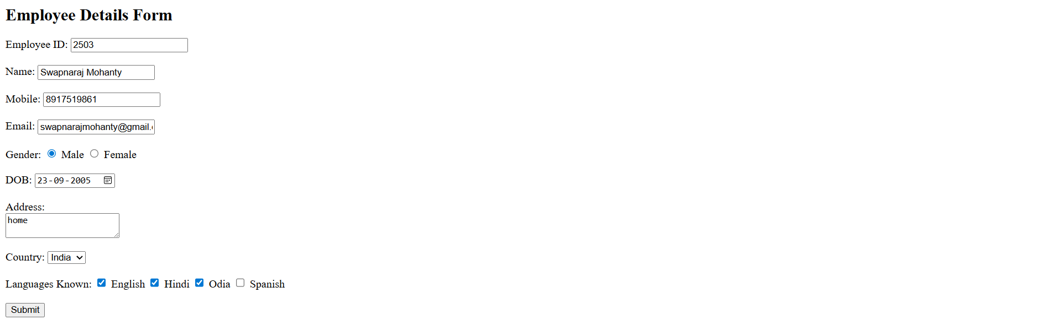
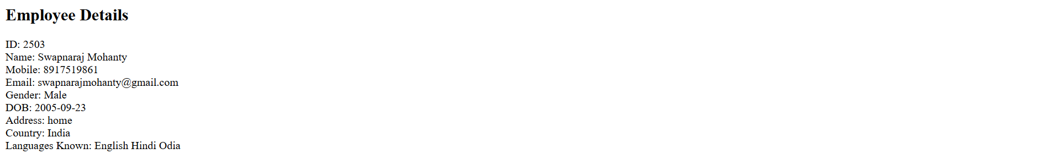
Q3. Create a JSP page to take a number as input from the user and determine if the number
is a prime number or not.
form.jsp
<html>
<body>
<h2>Prime Number Check</h2>
<form action="result.jsp">
Enter Number: <input type="text" name="num">
<input type="submit" value="Check">
</form>
</body>
</html>
display.jsp
<html>
<body>
<%
int n = Integer.parseInt(request.getParameter("num"));
boolean isPrime = true;
if (n <= 1) {
isPrime = false;
} else {
for (int i = 2; i <= n / 2; i++) {
if (n % i == 0) {
isPrime = false;
break;
}
}
}
%>
<h2>
<%= n %> is
<%= (isPrime ? "Prime" : "Not Prime") %>
</h2>
</body>
</html>
Output:
Q4. Design a BMR calculator with the fields Age, Gender, Height (CM), and Weight (KG).
Use the following formula to calculate and display the BMR (Calories/day).
o For men: BMR=(10xWeight)+(6.25xHeight)–(5xAge)+5
o For women: BMR=(10xWeight)+(6.25xHeight)–(5xAge)-161
form.jsp
<html>
<body>
<h2>BMR Calculator</h2>
<form action="result.jsp">
Age: <input type="text" name="age"><br><br>
Gender:
<input type="radio" name="gender" value="male"> Male
<input type="radio" name="gender" value="female"> Female <br><br>
Height (cm): <input type="text" name="height"><br><br>
Weight (kg): <input type="text" name="weight"><br><br>
<input type="submit" value="Calculate">
</form>
</body>
</html>
display.jsp
<html>
<body>
<%
int age = Integer.parseInt(request.getParameter("age"));
double height = Double.parseDouble(request.getParameter("height"));
double weight = Double.parseDouble(request.getParameter("weight"));
String gender = request.getParameter("gender");
double bmr;
if (gender.equals("male")) {
bmr = (10 * weight) + (6.25 * height) - (5 * age) + 5;
} else {
bmr = (10 * weight) + (6.25 * height) - (5 * age) - 161;
}
%>
<h2>Your BMR is: <%= bmr %> Calories/day</h2>
</body>
</html>
Output:
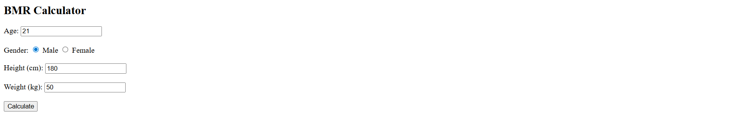
Q5. Write JSP code to do the following:
o Create header.jsp and footer.jsp files.
o header.jsp should contain as it etitle and navigation links.
o footer.jsp should contain footer content (e.g., Year, Contact info).
o Create three JSP pages: home.jsp, about.jsp, and contact.jsp.
o Homepage: must include a heading, a short paragraph, and an image with a caption.
o About page: must include atleast two paragraphs describing the site/ organization.
o Contact page: must contain a contact form with fields (Name, Email, Phone, Subject,
Message ). Submitted data should be displayed on a JSP page.
Use the include directive to add the same header and footer to all three pages, and apply
an external CSS file to style them.
header.jsp
<html>
<head>
<style>
body {
font-family: Arial;
margin: 20px;
}
h1 {
color: blue;
}
a {
margin-right: 10px;
text-decoration: none;
color: black;
}
a:hover {
color: red;
}
</style>
</head>
<body>
<h1>My Website</h1>
<a href="home.jsp">Home</a> |
<a href="about.jsp">About</a> |
<a href="contact.jsp">Contact</a>
<hr>
home.jsp
<%@ include file="header.jsp" %>
<h2>Contact Form</h2>
<form action="contact.jsp">
Name: <input type="text" name="name"><br><br>
Email: <input type="email" name="email"><br><br>
Phone: <input type="text" name="phone"><br><br>
Subject: <input type="text" name="subject"><br><br>
Message:<br>
<textarea name="message"></textarea><br><br>
<input type="submit" value="Submit">
</form>
<%@ include file="footer.jsp" %>
contact.jsp
<%@ include file="header.jsp" %>
<h2>Submitted Details</h2>
Name: <%= request.getParameter("name") %><br>
Email: <%= request.getParameter("email") %><br>
Phone: <%= request.getParameter("phone") %><br>
Subject: <%= request.getParameter("subject") %><br>
Message: <%= request.getParameter("message") %><br>
<%@ include file="footer.jsp" %>
about.jsp
<%@ include file="header.jsp" %>
<h2>About Us</h2>
<p>This website is developed using JSP.</p>
<p>It demonstrates basic web application features.</p>
<%@ include file="footer.jsp" %>
footer.jsp
<hr>
<p>� 2026 My Website | Contact: info@example.com</p>
</body>
</html>
Output:
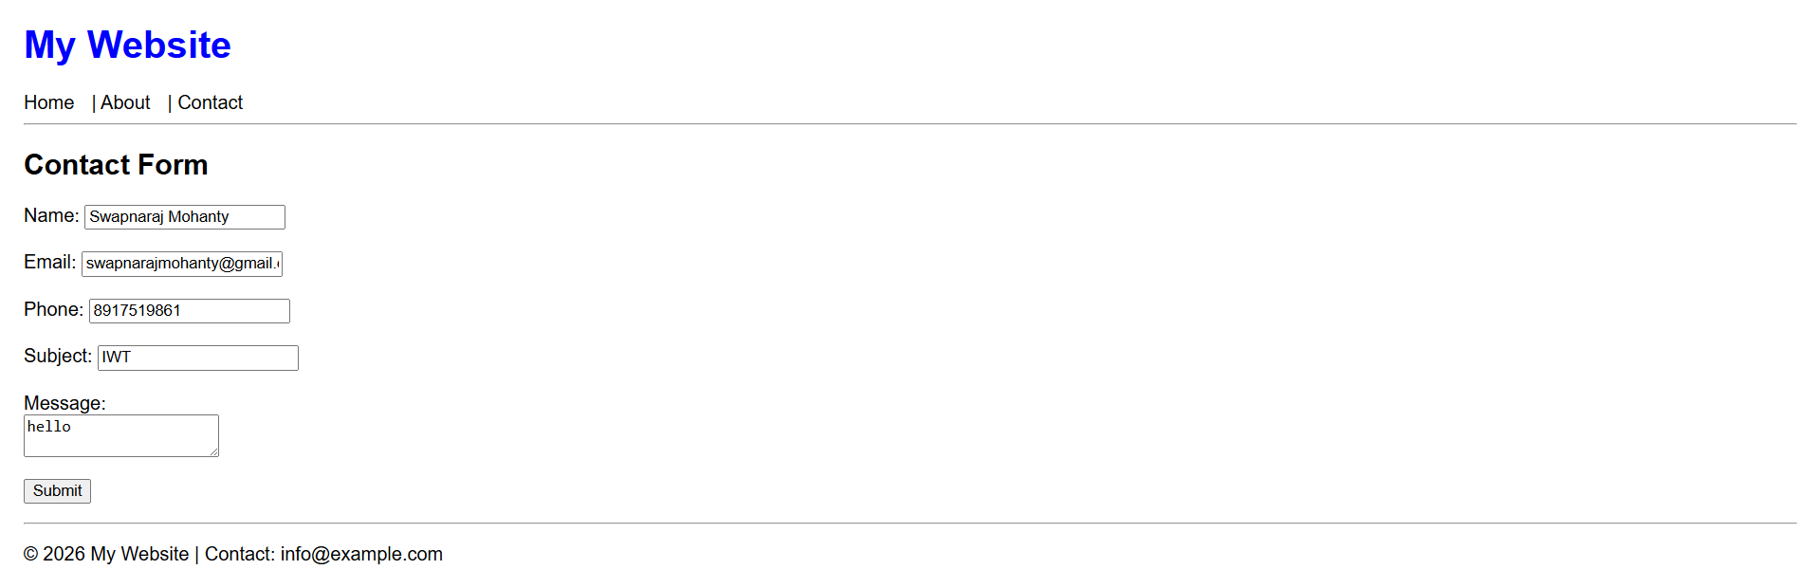
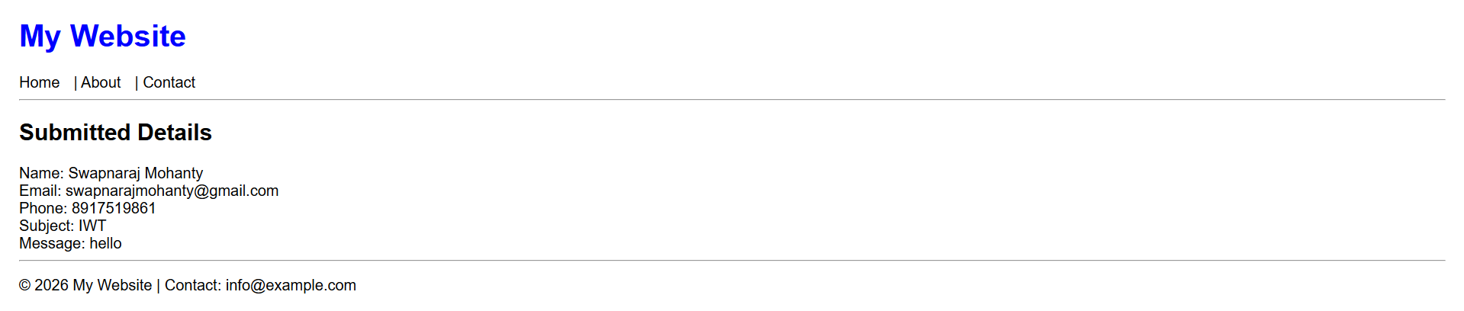
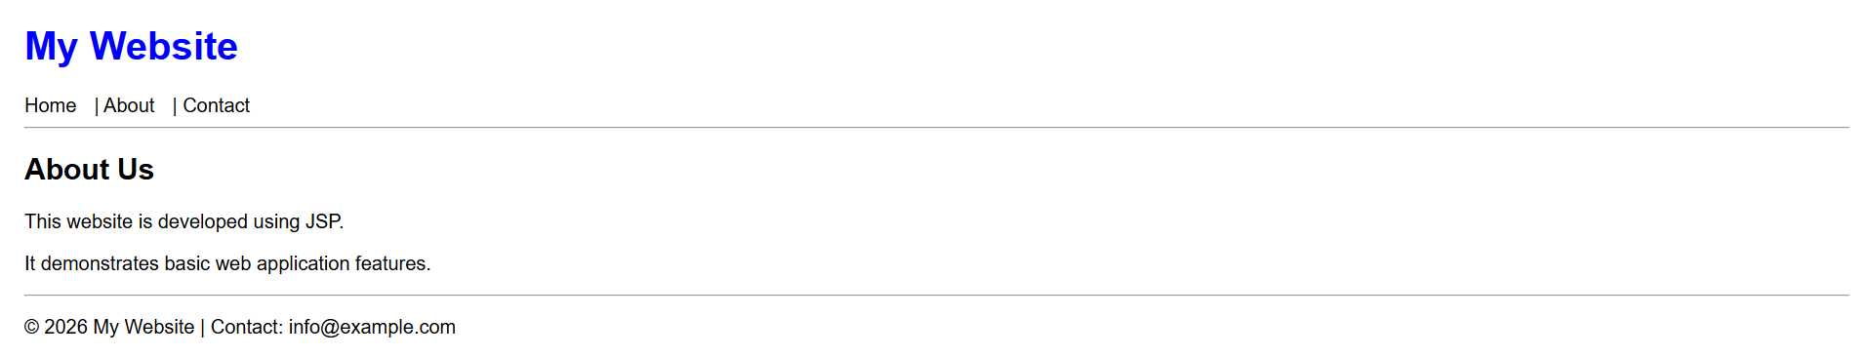
Q6. Design a login form with an email and password field. If the email id is given by the user
as admin@gmail.com and the password as admin, forward the request to welcome.jsp
else display “Invalid Credentials” message.
login.jsp
<html>
<body>
<h2>Login</h2>
<form action="check.jsp">
Email: <input type="text" name="email"><br><br>
Password: <input type="password" name="password"><br><br>
<input type="submit" value="Login">
</form>
</body>
</html>

check.jsp
<%
String email = request.getParameter("email");
String password = request.getParameter("password");
if (email.equals("admin@gmail.com") && password.equals("admin")) {
request.getRequestDispatcher("welcome.jsp").forward(request, response);
} else {
out.println("<h3>Invalid Credentials</h3>");
}
%>
welcome.jsp
<html>
<body>
<h2>Welcome Admin!</h2>
</body>
</html>
Output:
