Assignment – 2
Q1. Create a table to display student information with the following fields and insert atleast two student details: Roll Number, Name, Email, Mobile Number, Profile Photo.
<html>
<body>
<h1><u>Student Information</u></h1>
<table border=1 cellpadding=8 cellspacing=0>
<tr>
<th>Roll No.</th>
<th>Name</th>
<th>Email</th>
<th>Mobile No.</th>
<th>Profile Photo</th>
</tr>
<tr>
<td>3</td>
<td>Anwesh Barpanda</td>
<td>cse.24bcsh15@gmail.com</td>
<td>7854880406</td>
<td><img src="https://erp.silicon.ac.in/uploads/student_photo/SITBBS_B.TECH_2024-2028/CSE/24BCSH15/24BCSH15_64X64.jpg"></td>
</tr>
<tr>
<td>11</td>
<td>Swapnaraj Mohanty</td>
<td>cse.24bcsh93@gmail.com</td>
<td>8917519861</td>
<td><img src="https://erp.silicon.ac.in/uploads/student_photo/SITBBS_B.TECH_2024-2028/CSE/24BCSH93/24BCSH93_64X64.jpg"></td>
</tr>
<tr>
<td>34</td>
<td>Anshuman Ayush Baral</td>
<td>cse.24bcsi78@gmail.com</td>
<td>943856648</td>
<td><img src="https://erp.silicon.ac.in/uploads/student_photo/SITBBS_B.TECH_2024-2028/CSE/24BCSI78/24BCSI78_64X64.jpg"></td>
</tr>
</table>
</body>
</html>

Output:
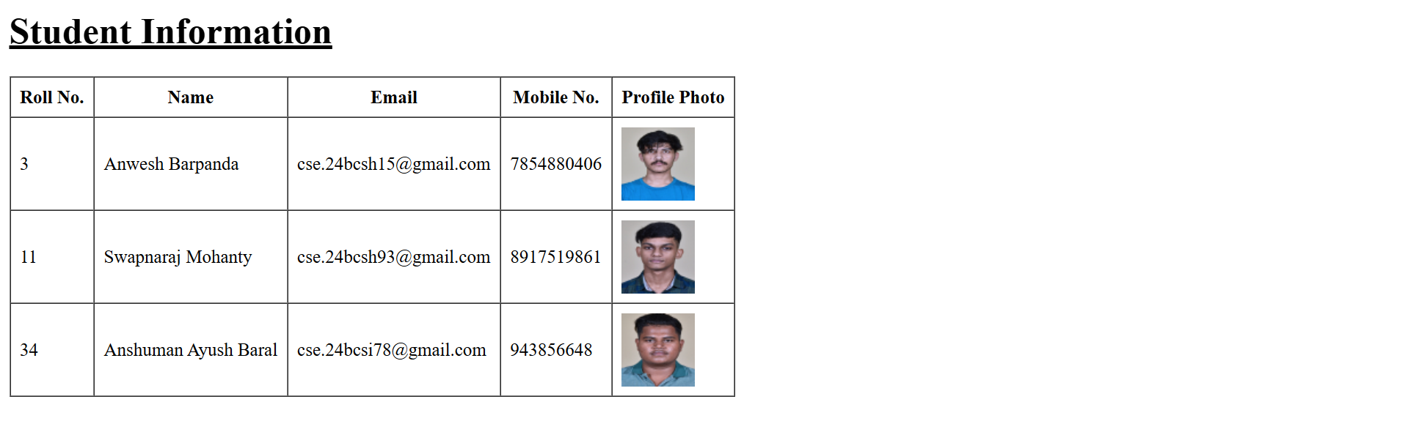
Q2. Design the following time table using HTML table tags and attributes only:
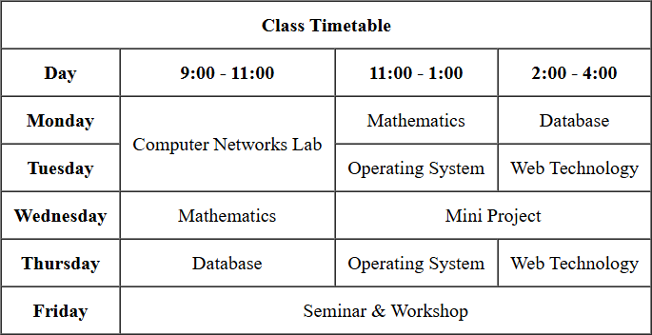
<html>
<style>
th, td {
text-align: center;
}
</style>
<body>
<table border=1 cellpadding=8 cellspacing=0>
<tr>
<th colspan="4">Class Timetable</th>
</tr>
<tr>
<th>Day</th>
<th>9:00 - 11:00</th>
<th>11:00 - 1:00</th>
<th>2:00 - 4:00</th>
</tr>
<tr>
<th>Monday</th>
<td rowspan="2">Computer Networks Lab</td>
<td>Mathematics</td>
<td>Database</td>
</tr>
<tr>
<th>Tuesday</th>
<td>Operating System</td>
<td>Web Technology</td>
</tr>
<tr>
<th>Wednesday</th>
<td>Mathematics</td>
<td colspan="2">Mini Project</td>
</tr>
<tr>
<th>Thursday</th>
<td>Database</td>
<td>Operating System</td>
<td>Web Technology</td>
</tr>
<tr>
<th>Friday</th>
<td colspan="3">Seminar & Workshop</td>
</tr>
</table>
</body>
</html>
Output:
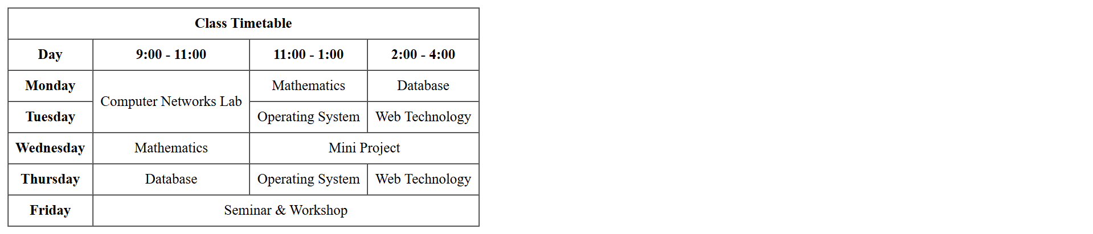

Q3. Create a registration form for an online course with the following fields:
o Full Name(text)
o Email(text)
o Password and Confirm Password(password)
o Gender(radio buttons :Male, Female, Other)
o Date of Birth(date picker)
o Course(drop down: B.Tech, M.Tech, MCA ,MBA)
o Skills(checkboxes: HTML, CSS, JavaScript, Python, Java)
o Address(text area)
o Upload Resume(file input)
o Submit and Reset buttons
<html>
<body>
<h1>Online Course Registration Form</h1>
<form>
<label for="name">Full Name:</label>
<input type="text" id="name" name="name"><br><br>
<label for="email">Email:</label>
<input type="email" name="email"><br><br>
<label for="password">Password:</label>
<input type="password" name="password"><br><br>
<label for="confirm password">Confirm Password:</label>
<input type="password" id="confirm password" name="confirm password"><br><br>
<label for="gender">Gender:</label>
<input type="radio" name="gender" value="male">Male
<input type="radio" name="gender" value="female">Female
<input type="radio" name="gender" value="other">Other<br><br>
<label for="dob">Date of Birth:</label>
<input type="date" name="date"><br><br>
<label for="course">Course:</label>
<select name="course">
<option value="btech">B.Tech.</option>
<option value="mtech">M.Tech.</option>
<option value="mca">MCA</option>
<option value="mba">MBA</option>
</select><br><br>

<label for="skills">Skills:</label><br>
<input type="checkbox" name="html" value="html">HTML<br>
<input type="checkbox" name="css" value="css">CSS<br>
<input type="checkbox" name="js" value="js">JavaScript<br>
<input type="checkbox" name="py" value="py">Python<br>
<input type="checkbox" name="java" value="java">Java<br><br>
<label for="address">Address</label><br>
<textarea rows=5 cols=30></textarea><br><br>
<label for="resume">Upload Resume</label>
<input type="file" name="resume"><br><br>
<input type="submit" name="submit" value="Submit">
<input type="reset" name="reset" value="Reset">
</form>
</body>
</html>
Output:
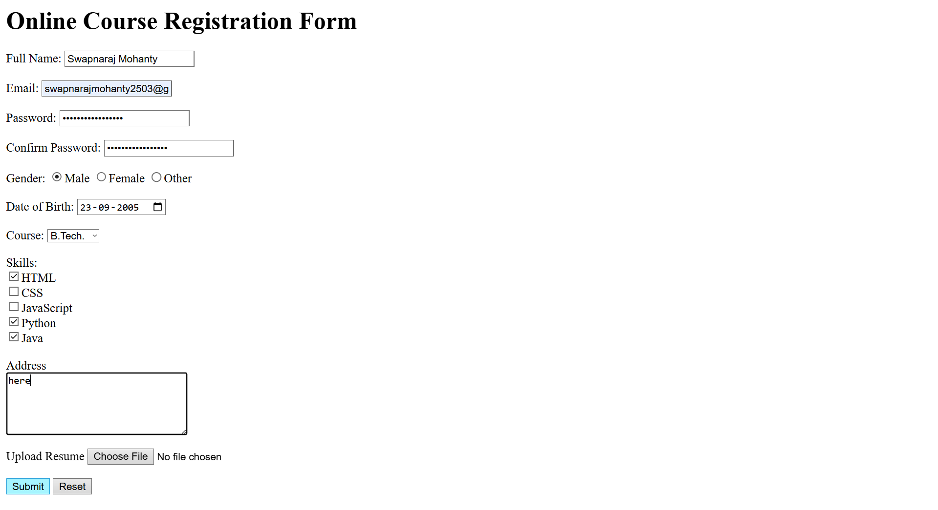

Q4. Create a webpage that demonstrates multimedia integration:
a. Embed an audio file with controls(play/pause).
b. Embed a video file with controls.
<html>
<body>
<label for="audio">Audio:</label><br><br>
<audio controls>
<source src="audio.mp3" type="audio/mpeg">
</audio>
<br><br>
<label for="video">Video:</label><br><br>
<video width="800" height="450" controls>
<source src="video.mp4" type="video/mp4">
</video>
</body>
</html>
Output:
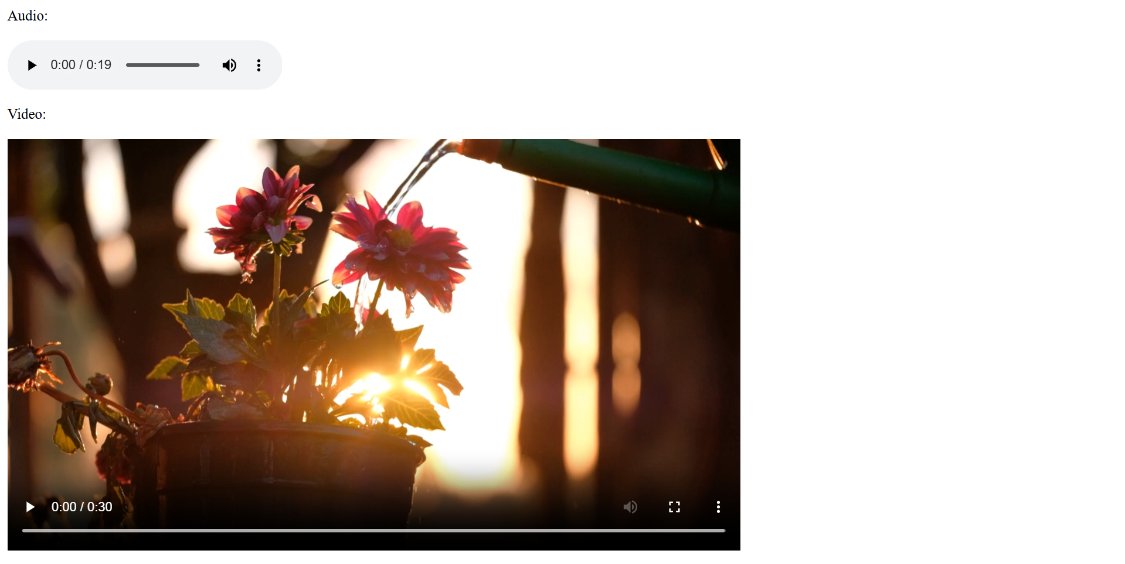

Q5. Create a webpage named My Profile using HTML5 semantic elements. Your page must
use appropriate semantic tags (for example: <header>, <nav>, <main>, <section>,
<footer>) and must satisfy all of the following requirements:
a. Use a <nav> with anchor links (bookmarks) to the sections on the same page: About,
Education, and Hobbies.
b. Use a <header> element that contains your name as the main heading (<h1>), your
phone number and your email.
c. Use a <main> element to wrap the primary page content.
d. Create three <section> elements with id attributes about, education, and hobbies.
Each section must have a heading (<h2>) and atleast one paragraph describing the
topic.
e. In the about section, Include your profile image and a paragraph about yourself. Use
a list to showcase your skills.
f. In the education section, use a table to showcase your academic records.
g. In the hobbies section, add a list of hobbies.
h. The footer section must contain hyperlinks to your social media handles.
<html>
<head>
<title>My Profile</title>
</head>
<body>
<nav>
<a href="#about">About</a> |
<a href="#education">Education</a> |
<a href="#hobbies">Hobbies</a>
</nav>
<header>
<h1>Name: Swapnaraj Mohanty</h1>
<p>Phone no: 8917519861</p>
<p>Email: swapnarajmohanty2503@gmail.com</p>
</header>
<main>
<section id="about">
<h2>About</h2>
<img src="https://erp.silicon.ac.in/uploads/student_photo/SITBBS_B.TECH_2024-2028/CSE/24BCSH93/24BCSH93_64X64.jpg">
<p>
I am a student who is interested in learning new technologies and improving my skills in
programming and web development. I enjoy understanding how things work behind the
scenes and like experimenting with code to build simple but useful projects.
</p>
<h3>Skills</h3>

<ul>
<li>HTML and CSS</li>
<li>Basic Python Programming</li>
<li>Problem Solving</li>
<li>Database Fundamentals</li>
<li>Basic Web Design</li>
</ul>
</section>
<section id="education">
<h2>Education</h2>
<p>
I am currently pursuing my studies and focusing on subjects related to computer science
and technology. My education has helped me build a strong foundation in programming
concepts, databases, and web technologies, which I continue to improve through practice.
</p>
<table border="1" cellpadding="8" cellspacing="0">
<tr>
<th>Qualification</th>
<th>Institution</th>
<th>Year</th>
<th>Result</th>
</tr>
<tr>
<td>Secondary School</td>
<td>SAI International School</td>
<td>2022</td>
<td>90%</td>
</tr>
<tr>
<td>Higher Secondary</td>
<td>SAI International School</td>
<td>2024</td>
<td>92%</td>
</tr>
<tr>
<td>Undergraduate (Pursuing)</td>
<td>Silicon University</td>
<td>2028</td>
<td>-</td>
</tr>
</table>
</section>

<section id="hobbies">
<h2>Hobbies</h2>
<p>
In my free time, I enjoy exploring new tech tools, coding, and learning about computers. I
also like playing games and spending time online discovering new ideas and content that
help me relax and stay curious.
</p>
<ul>
<li>Coding and learning new programming concepts</li>
<li>Playing video games</li>
<li>Exploring new technologies and tools</li>
<li>Browsing the internet and reading tech-related content</li>
<li>Listening to music</li>
</ul>
</section>
</main>
<footer>
<h2>Social Media</h2>
<p>
<a href="https://www.github.com/Dream2503">GitHub</a> |
<a href="https://www.linkedin.com/in/swapnaraj-mohanty-a62905218">LinkedIn</a> |
<a href="https://wa.me/918917519861">WhatsApp</a>
</p>
</footer>
</body>
</html>

Output:
