Assignment – 4
Q1. In an HTML page-
o Use 3 different heading tags to write HTML, CSS, and JavaScript. Use a suitable
display property to display them on the same line.
o Use 3 different <span> tags to write JSP, JDBC, and MySQL. Use a suitable display
property to display them in separate lines.
<html>
<head>
<style>
h1, h2, h3 {
display: inline;
margin-right: 15px;
}
span {
display: block;
margin-bottom: 8px;
}
</style>
</head>
<body>
<h1>HTML</h1>
<h2>CSS</h2>
<h3>JavaScript</h3>
<br><br>
<span>JSP</span>
<span>JDBC</span>
<span>MySQL</span>
</body>
</html>
Output:
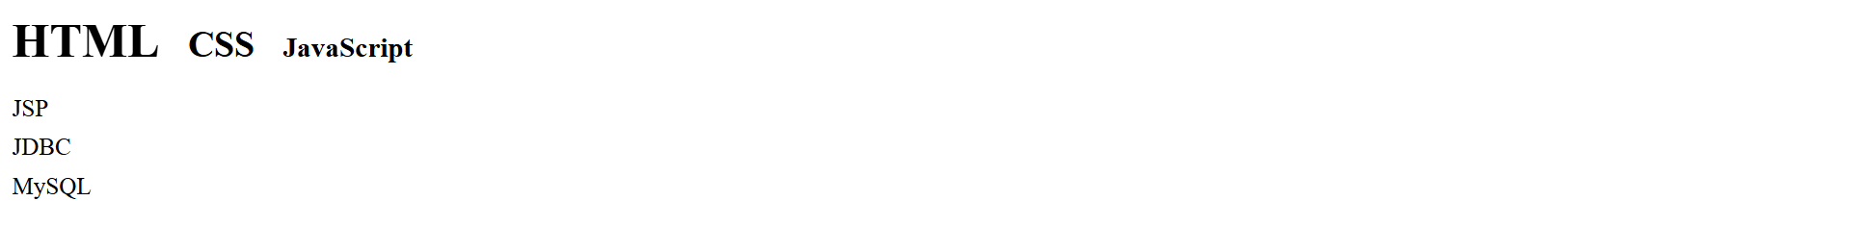

Q2. Design the following login form inside a styled card. Centre align the card with the help
of flex box.
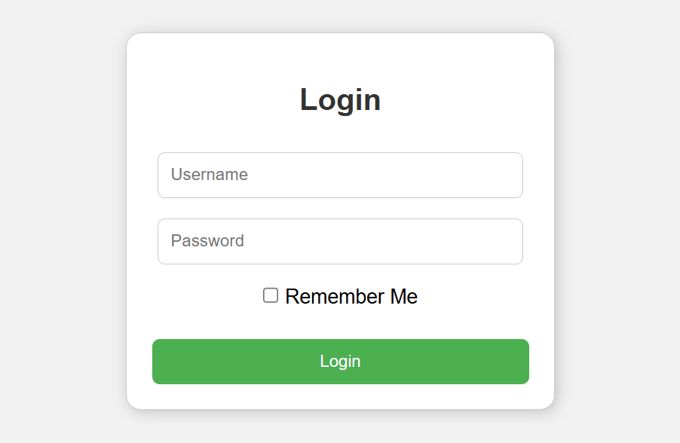
<html>
<head>
<style>
body {
margin: 0;
height: 100vh;
display: flex;
justify-content: center;
align-items: center;
font-family: Arial;
}
.card {
background-color: white;
width: 400px;
padding: 35px 40px;
border-radius: 15px;
box-shadow: 0 10px 25px rgba(0, 0, 0, 0.2);
}
.card h1 {
text-align: center;
margin-bottom: 30px;
}
.card input[type="text"],
.card input[type="password"] {
width: 95%;
padding: 14px;
margin-bottom: 18px;
border: 1px solid lightgray;
border-radius: 8px;
font-size: 15px;
}
.remember {
display: flex;
justify-content: center;
align-items: center;
margin-bottom: 25px;
}
.card button {
width: 100%;
padding: 14px;
background-color: #4CAF50;
color: white;
border: none;
border-radius: 8px;
font-size: 16px;
cursor: pointer;
}
</style>
</head>
<body>
<div class="card">
<h1>Login</h1>
<input type="text" placeholder="Username">
<input type="password" placeholder="Password">
<div class="remember">
<input type="checkbox" id="remember">
<label for="remember">Remember Me</label>
</div>
<button>Login</button>
</div>
</body>
</html>
Output:
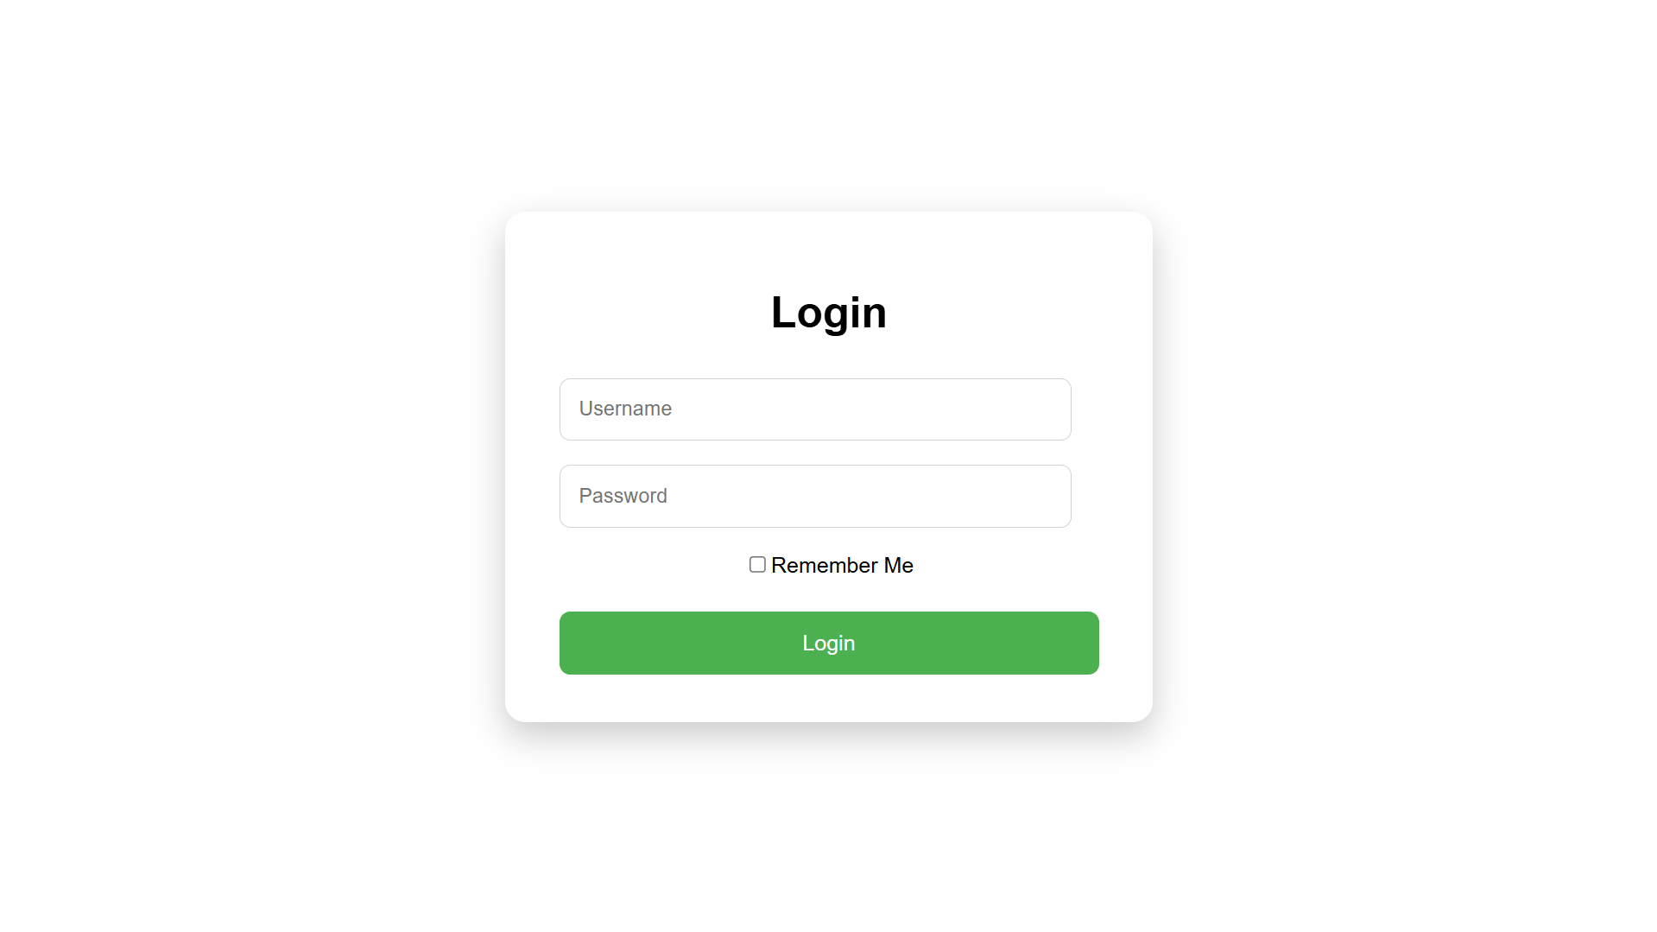
Q3. Design a Product Section for an eCommerce webpage using Flexbox. Create a container
<div> with the title “Featured Products”. Inside the container add 4 product cards in a
single row. Each product card must include: Product image, Product name (heading),
Price (paragraph), “Add to Cart” button.
<html>
<head>
<style>
body {
font-family: Arial;
padding: 40px;
}
.product-section {
max-width: 1100px;
margin: auto;
}
h2 {
text-align: center;
margin-bottom: 30px;
}
.products {
display: flex;
justify-content: space-between;
gap: 20px;
}
.product-card {
width: 23%;
padding: 15px;
border-radius: 10px;
box-shadow: 0 4px 10px rgba(0, 0, 0, 0.15);
text-align: center;
}
img {
width: 100%;
height: 150px;
object-fit: cover;
border-radius: 8px;
margin-bottom: 10px;
}
h3 {
margin: 10px 0;
}
p {
font-size: 16px;
margin-bottom: 15px;
}
button {
padding: 10px 15px;
background-color: #ff6f00;
color: white;
border: none;
border-radius: 5px;
}
</style>
</head>
<body>
<div class="product-section">
<h2>Featured Products</h2>
<div class="products">
<div class="product-card">
<img src="https://m.media-amazon.com/images/I/71W+S88m5JL._AC_SL1500_.jpg">
<h3>SmartWatch</h3>
<p class="price">4,999</p>
<button>Add to Cart</button>
</div>
<div class="product-card">
<img src="https://images-na.ssl-images-amazon.com/images/I/71Rz4nN%2BNFL._AC_SL1500_.jpg">
<h3>Wireless Headphones</h3>
<p class="price">2,499</p>
<button>Add to Cart</button>
</div>
<div class="product-card">
<img src="https://m.media-amazon.com/images/I/61Mk3YqYHpL.jpg">
<h3>Gaming Mouse</h3>
<p class="price">999</p>
<button>Add to Cart</button>
</div>
<div class="product-card">
<img src="https://m.media-amazon.com/images/I/81wdmgabXFL._AC_.jpg">
<h3>Bluetooth Speaker</h3>
<p class="price">11,299</p>
<button>Add to Cart</button>
</div>
</div>
</div>
</body>
</html>
Output:
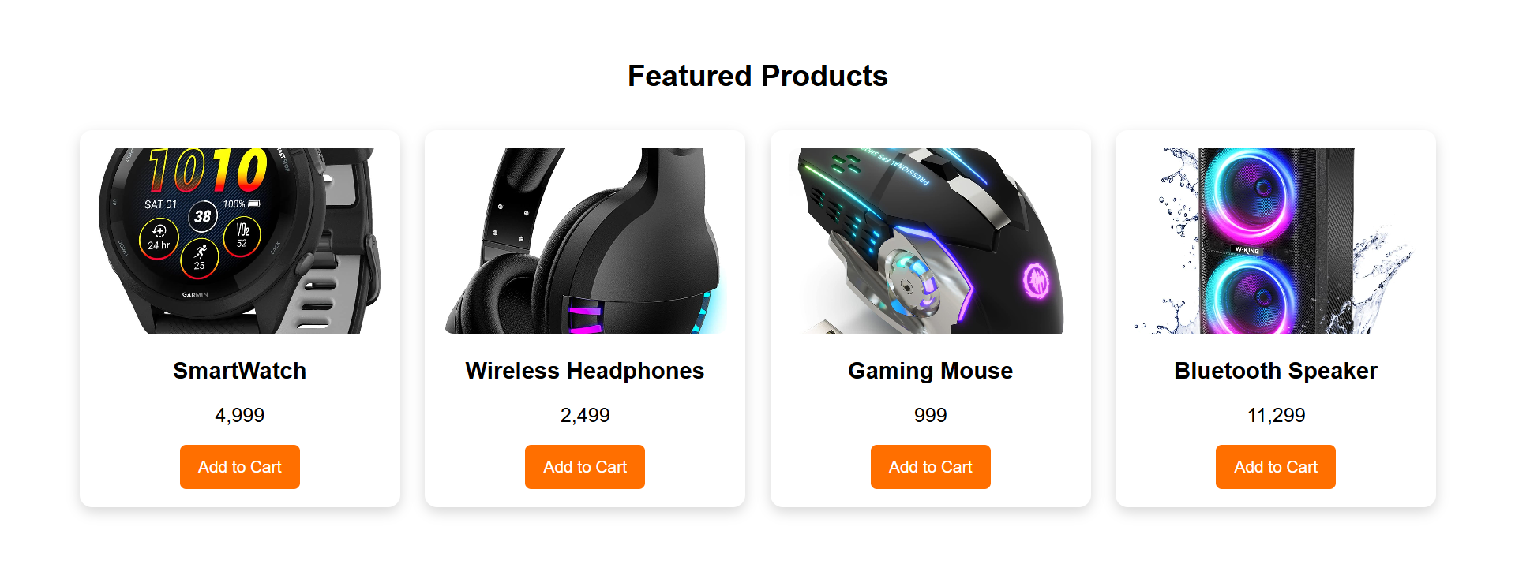
Q4. Enhance the “My Profile” page created in Assignment 2 to build a Personal Portfolio
Website.
<html>
<head>
<style>
body {
margin: 0;
font-family: Arial;
line-height: 1.6;
}
header {
background-color: #2c3e50;
color: white;
padding: 25px;
text-align: center;
}
nav {
background-color: #34495e;
padding: 12px;
text-align: center;
}
nav a {
color: white;
text-decoration: none;
margin: 0 15px;
font-weight: bold;
}
main {
max-width: 1000px;
margin: 30px auto;
padding: 0 20px;
}
section {
background-color: white;
padding: 25px;
margin-bottom: 30px;
border-radius: 10px;
box-shadow: 0 5px 15px rgba(0, 0, 0, 0.1);
}
section h2 {
margin-top: 0;
color: #2c3e50;
}
#about {
display: flex;
gap: 25px;
align-items: center;
}
#about img {
width: 120px;
height: 120px;
border-radius: 50%;
border: 3px solid #2c3e50;
}
ul {
padding-left: 20px;
}
table {
width: 100%;
border-collapse: collapse;
margin-top: 15px;
}
table th, table td {
border: 1px solid #ccc;
padding: 10px;
text-align: center;
}
table th {
background-color: #ecf0f1;
}
footer {
background-color: #2c3e50;
color: white;
text-align: center;
padding: 20px;
}
</style>
</head>
<body>
<nav>
<a href="#about">About</a>
<a href="#education">Education</a>
<a href="#hobbies">Hobbies</a>
</nav>
<header>
<h1>Swapnaraj Mohanty</h1>
<p>Phone No: 8917519861</p>
<p>Email: swapnarajmohanty2503@gmail.com</p>
</header>
<main>
<section id="about">
<img src="https://erp.silicon.ac.in/uploads/student_photo/SITBBS_B.TECH_2024-2028/CSE/24BCSH93/24BCSH93_128X128.jpg" alt="Profile Image">
<div>
<h2>About Me</h2>
<p>
I am a student interested in learning new technologies and improving my skills in programming and web development.
I enjoy understanding how systems work behind the scenes and experimenting with code to build useful projects.
</p>
<h3>Skills</h3>
<ul>
<li>HTML & CSS</li>
<li>Basic Python Programming</li>
<li>Problem Solving</li>
<li>Database Fundamentals</li>
<li>Basic Web Design</li>
</ul>
</div>
</section>
<section id="education">
<h2>Education</h2>
<p>
My academic journey has helped me build a strong foundation in computer science, programming concepts,
and web technologies, which I continue to strengthen through practice.
</p>
<table>
<tr>
<th>Qualification</th>
<th>Institution</th>
<th>Year</th>
<th>Result</th>
</tr>
<tr>
<td>Secondary School</td>
<td>SAI International School</td>
<td>2022</td>
<td>90%</td>
</tr>
<tr>
<td>Higher Secondary</td>
<td>SAI International School</td>
<td>2024</td>
<td>92%</td>
</tr>
<tr>
<td>Undergraduate (Pursuing)</td>
<td>Silicon University</td>
<td>2028</td>
<td>-</td>
</tr>
</table>
</section>
<section id="hobbies">
<h2>Hobbies</h2>
<p>
Outside academics, I enjoy exploring new technologies, coding, and learning about computers.
These activities help me stay curious and motivated.
</p>
<ul>
<li>Coding and learning new concepts</li>
<li>Playing video games</li>
<li>Exploring new technologies</li>
<li>Reading tech-related content</li>
<li>Listening to music</li>
</ul>
</section>
</main>
</body>
</html>
Output:
