**Kathmandu Bernhardt College**

**(Affiliated to Tribhuvan University)**



**A Project Proposal**

**On**

**“Face Mask Detection in ML”**

**Submitted by**

**Ashish Poudel**

**4610524**

**Submitted to**

**Department of Computer Application**

**Kathmandu BernHardt College**

**Bafal, Kathmandu, Nepal**

**February, 2022**

**Table of Contents**

**Title** **Page No.**

**1. INTRODUCTION** **1**

**3. OBJECTIVES** **2**

**4. METHODOLOGY** **2**

**A.** **REQUIREMENT IDENTIFICATION** **3**

**i. Study of Existing System** **3**

**ii. Literature Review** **3**

**iii. Requirement Analysis** **4**

**B.** **FEASIBILITY STUDY** **6**

**i. Technical** **6**

**ii. Operational** **6**

**iii.** **Economic** **6**

**C.** **HIGH LEVEL DECISION OF SYSTEM** **7**

**i. Working Mechanism** **7**

**ii. Description of Algorithms** **7**

**5. GANTT CHART** **9**

**6. EXPECTED OUTCOME** **9**

**7. REFERENCES** **10**

**i**

**1. Introduction**

**Face Mask Detection System is a system that detects whether or not the person is wearing face mask. Face detection is a key area in the field of Computer Vision and Pattern Recognition. In recent decades, facial recognition has become the object of research worldwide [1] [2]. In addition, with the advancement of technology and the rapid development of artificial intelligence, very significant advances have been made [3].For this reason, public, private companies and many other sectors use facial recognition systems to identify and control the access of people in airports, schools, offices, and other places [4] [5]. On the other hand, with the spread of the COVID-19 pandemic, government entities have established several biosafety regulations to limit infections [6] [7] [8]. Among them is the mandatory use of face masks in public places, as they have been shown to be effective in protecting users and those around them [9]. To mandate the use of facemasks, it becomes essential to devise some techniques that enforce individuals to apply a mask before exposure to public places. The proposed method used here is carried out in two steps. The first step is to train the face mask detector using transfer learning. The second step is to use this trained face mask detector on images or videos of people to identify if they are wearing a mask. Therefore, it has become necessity to develop such precise system. It is based on the real time facial images analysis for visualizing the person’s face.**

**2. Problem Statement**

**As the spread of the virus occurs through physical contact, conventional recognition systems (such as fingerprints) or typing a password on a keyboard become insecure. Thus, facial recognition systems are the best option, as they do not require physical interaction as in other cases. However, the use of the face mask within these systems has represented a great challenge for artificial vision, because at the time of facial recognition, half of the face is covered and several essential data are lost [10]. This clearly denotes the need to create algorithms that recognize a person when they are wearing a face mask. This has made it necessary to implement new strategies to achieve robustness in the current systems [11].**

**1**

**Nepal, along with rest of the world is struggling to get out of this virus attack and the government implemented lockdown for the long way. But still new variants are on rise and many people are getting out without a face mask this may increase the spread of covid-19. Centers for Disease Control and Prevention (CDC) has stated that " Survey Shows that 90 percent Nepalese are aware, but only 64 percent wearing a mask " [12]. https://wwwnc.cdc.gov/travel/notices/covid-3/coronavirus-nepal This survey clearly points that people are aware but they are not wearing the mask due to some discomfort in wearing and carelessness. Hence, object detection techniques for identification of persons wearing and not wearing facemasks are being used. The real time images from the camera are compared with the trained dataset and detection of wearing or not wearing a mask is done. The trained dataset is made by using machine learning technique which is the deciding factor of the result. The algorithm created by means of using a trained dataset will find the persons with and without wearing face masks.**

**3. Objectives**

**The major objectives of this project are:**

* 1. **To develop an object detection method from real-time video streams**
  2. **To localizing the person who is violating the health norms in public areas**
  3. **To create facemask dataset with imbalance ratio equals to nearly one.**
  4. **To optimize trained model faster & accurately in order to keep people alert**

1. **Methodology**

**Considering that the proportion of face masks in the image is often not uniform in size, they often do not occupy the whole image. The features at the highest level have relatively wealthy semantic information, the candidate region’s features can only be obtained by pooling the target region in the last convolution layer. Therefore, in order to solve the problem of multi-scale detection, the feature pyramid network is introduced that takes a single-scale image of an arbitrary size as input, and outputs proportionally sized feature maps at multiple levels.**

**2**

**a. Requirement Identification**

1. **Study of Existing System**

**In existing research, the most frequently used methods for face mask detection and masked face recognition are transfer learning of pre-trained deep learning models and support vector machine (SVM) [13]. But it takes long training time and huge memory requirements for a large dataset. Whereas in transfer learning, overfitting and negative transfer are the most alarming limitations. Also, due to the lack of accurate labelled datasets, masked facial recognition is very challenging. To resolve these issues of transfer learning and SVM, a novel model is proposed that can be used to reliably detect face masks (binary classification) and recognize masked faces (multiclass classification) [14].**

**Existing research works on face mask detection and masked facial recognition have certain limitations, i.e., the absence of a unified method and dataset to tackle both problems, low accuracy of masked face recognition, less uncovered face exposure that makes it difficult to capture enough facial landmarks, etc. The proposed technique is robust to variations in face angles, lightning conditions, gender, skin tone, age, types of masks, occlusions (glasses), etc.**

1. **Literature Review**

**In 2001, Viola and Jones proposed a real-time object detection called the Viola-Jones object detection framework. This process can determine competitive object detection rates in real-time to solve various detection problems. Moreover, it was used primarily in face detection. Although this algorithm was very slow in training, it could detect faces in real-time with impressive speed. The method divided the image into many smaller sub-regions and required checking many different positions and scales because an image had many faces of different sizes [15].**

**An effective and economic approach to the use of AI in a manufacturing setting to build a secure environment. Using a face mask detection dataset, we will use Open CV to perform real-time face detection from a live stream from our webcam. Using Keras, Python, Tensorflow and Open CV, and, it will build a COVID-19 face mask detector with computer vision. Using computer vision and CNN, I aim to decide whether or not the person in the image or video streaming is wear a mask [16].**

**3**

**Existing works on face mask detection can be categorized into conventional machine learning (ML) methods, deep learning (DL) based methods, and hybrid methods. Hybrid approaches contain algorithms that use both the deep learning and traditional machine learning (ML) based methods. The deep learning-based methods were utilized in the majority of studies on face mask detection, while conventional ML-based methods by Nieto-Rodríguez are limited. In Nieto-Rodríguez et al, an automated system was designed that activates an alarm in the operational room when the healthcare workers do not wear the face mask. This system used the Viola and Jones face detector for face detection and Gentle AdaBoost for face mask detection [17].**

**In the content based image classification using deep learning, Joseph Redmon et.al proposed You Only Look Once (YOLO) algorithm for real time object detection [18].**

**Sanzidul Islam et.al 2020, gave a deep learning based assistive System to classify COVID-19 Face Mask which is implemented in rasbperrypi-3 [19].**

**Velantina et.al 2020, made an COVID-19 facemask detection by means of using Caffe model.**

**Senthilkumar et.al 2017, compared the two most frequently used ma-chine learning algorithms K-Nearest Neighbour and Support Vector Ma-chine in his work for face recognition.**

**Senthilkumar et.al 2018, proposed a new and fast approach for face recognition.**

**With this, based on the above literature surveys, an effective algorithm for face mask detection has been made. The details are elaborated in forthcoming chapters.**

1. **Requirement Analysis**

**Requirement analysis results in the specification of operational characteristics of software: indicates interface of software with other system elements and establishes constrains the software must meet. The requirement analysis is mainly categorized into two types functional and non-functional:**

**Functional Requirements of Face Mask Dataset:**

**The system must have an unbiased ‘with_mask’ dataset. 4**

**The dataset must have over 500+ images in both ‘with_mask’ and ‘without_mask’ classes.**

**The dataset must not re-use the same images in training and testing phases.**

**Functional Requirements of Face Mask Detector:**

**The system must be correctly able to load the face mask classifier model. The system must be able to detect faces in images or video stream.**

**There must not be any object between the system and the face of the user for a successful face mask detection.**

**The end position of the face must be fit inside the webcam frame and must be closer to the camera.**

**Correctly able to detect masks in ‘png’, ‘jpg’, ‘jpeg’, and ‘gif’ format images.**

**The system must be able to detect face masks on human faces on every frame in a live video.**

**The results must be viewed by showing the probability along with the output of ‘Mask’ or ‘No Mask’.**

**Non-functional Requirements**

**The face should be localized by detecting the facial landmarks and the background must be ignored.**

**The user must not move his/her face out of camera’s sight in order to get correct results.**

**The background must not be too bright or too dark while detecting the face mask. The system must be portable and can be applied to embedded devices with limited computational capacity (ex., Raspberry Pi, Google Coral, NVIDIA Jetson Nano,**

**etc.).**

**The output response operation must be fast and under 5 seconds per person.**

**The system must be able to correctly detect more than one face if present, and hence the presence of mask in the frame.**

**5**

**b. Feasibility Study**

1. **Technical**

**Technical feasibility assesses the current resources (hardware and software) and technologies, which are required to accomplish user requirements. It requires a computer with python anaconda installed. Today every organization has computer, so it is not an extra cost.**

1. **Operational**

**The proposed system performs effective outcome. It used to dig into the data and quickly conduct experiments to establish baseline performance on a task. The system recognizes a person without wearing a mask which requires no human involvements.**

1. **Economic**

**In this project work, the system developed is a webcam application; which requires all the basic hardware and software support as required by other application. To integrate real surveillance may require software and manpower with developing skills. The proposed model is cost effective.**

**6**

**c. High Level Decision of System**

1. **Working Mechanism**

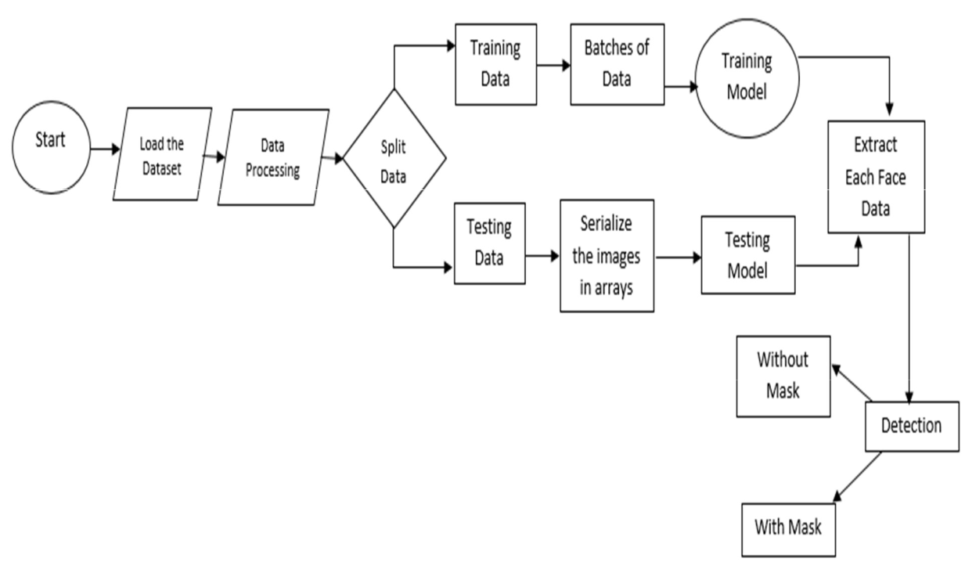

**Figure 1: Working Mechanism of Mask Detection System**

**When the system will be started, the webcam should be activated. The model extracts dataset after cleaning the dataset and only process ahead the frames of images containing faces ignoring the background or any other things. The system should detect the user’s face mask. After the detection of user’s face, the system should detect whether the user’s wearing a mask or not. If the user will be detected wearing mask, then the system should show green box around user’s face and keep monitoring else the system should display a red alert kind of box-interface to the user. Then, again the system will start monitoring the user.**

1. **Description of Algorithms**

**Here YOLO machine learning technique is used to identify persons wearing and not wearing facemasks. Joseph Redmon et al. introduced You look only once also known as YOLO in 2015. The algorithm applies a single neural network to the full image, and then divides the image into regions and predicts bounding boxes and probabilities for each region. These bounding boxes are weighted by the predicted probabilities. YOLO is**

**7**

**extremely fast. It scans the entire image during training and also during testing. It learns generalizable representations of objects so that when it is trained on natural images and tested, the algorithm performs excellently when compared to other top detection methods. This algorithm employs convolutional neural networks (CNN) to detect objects in real-time. As the name suggests, the algorithm requires only a single forward propagation through a neural network to detect objects.**

**The algorithm works using the following three techniques:**

**Residual blocks:**

**First, the image is divided into various grids. Each grid has a dimension of S x S. The following image shows how an input image is divided into grids.**

**Bounding box regression:**

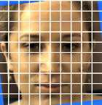

**Figure 2: Grid Blocks**

**Each bounding box can be described using four descriptors:**

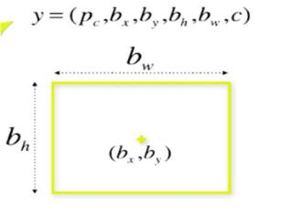

**Center of the box (bx, by), Width (bw), Height (bh), Value c corresponding to the class of an object. Along with that we predict a real number Pc, which is the**

**probability that there is an object in the bounding box.**

**Intersection Over Union (IOU):**

**To resolve the problem Non-max suppression, it eliminates the bounding boxes that are very close by preforming the IoU (Intersection over Union) with the one having the highest class probability among them.**

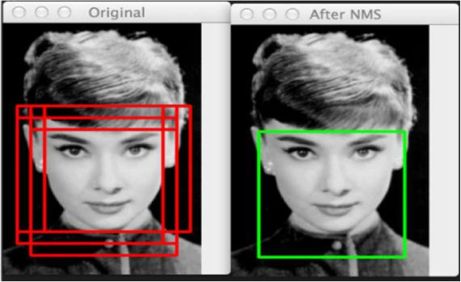

**Figure 3:Before and after Non** **Max**

**Suppression**

**8**

**5. Gantt Chart**

**It is prepared on graph paper. In case if it is complex, it is prepared using application such as Microsoft Excel.**

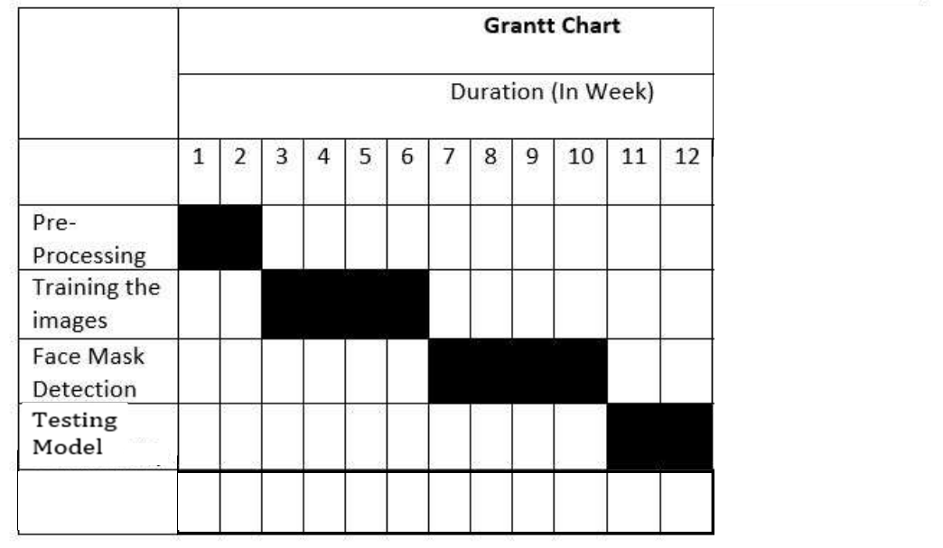

**Documentation**

**In the First Phase of the project, the dataset is to be built and a preprocessing model to extract the features of the dataset. Preprocessing takes two weeks. After that, the Training the images will be entered and it may three weeks to complete. Third part, Face mask detection phase will take three to four weeks to complete training and Recognition.**

**6. Expected Outcome**

**After the successful completion of this project, application should be able to detect whether the user is wearing mask or not. If detected no mask, then the system must alert the user with the help of an alarm. The alarm turns off automatically if the person is wearing mask so that it’s confirmed the user is alert. The system is expected to help the users who are being careless not wearing mask in the pandemic situation in public places.**

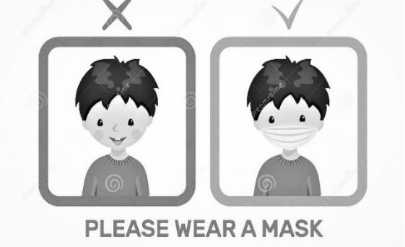

**9**

1. **References**
   1. **A. Voulodimos, "PubMed," 01 February 2018, Past, Present, and Future of Face Recognition: A Review, Available: https://pubmed.ncbi.nlm.nih.gov/29487619/. [Accessed 27 January 2022].**
   2. **A. Benzaoui, "MDPI," 02 March 2020, Facial Recognition System for People with and without Face Mask in Times of the COVID-19 Pandemic, Available: https://www.mdpi.com/2079-9292/9/8/1188. [Accessed 27 January 2022].**
   3. **Biplab Ketan, "ScholarWorks," 24 April 2017, Review of constraints on vision-based**

**gesture recognition for human–computer interaction, Available: https://scholarworks.iupui.edu/handle/1805/17801. [Accessed 05 February 2022].**

* 1. **Byoungchul Ko, "Research Gate" January, 2018, A Brief Review of Facial Emotion Recognition Based on Visual Information, Available:. [Accessed 05 February 2022].**
  2. **Egger M, "Semantics Scholar", 28 June 2018, A Review of Emotion Recognition Using Physiological Signals, Available: https://www.semanticscholar.org/. [Accessed 05 February 2022].**
  3. **Qiu S, Liu Zhou, "MDPI," 02 March 2020, Review of artificial intelligence adversarial**

**attack and defense technologies, Available: https://books.google.com.np/books?id=YBwgEAAAQBAJ&pg=PA304&lpg=PA304. [Accessed 05 February 2022].**

* 1. **C. Quazi, "U-Texas," 02 March 2020, Machine Learning Project, Available: https://www.cs.utexas.edu/~mooney/cs391L/paper-template.html. [Accessed 05 February 2022].**
  2. **Cook, C.M.; Howard, J.J.; Sirotin, Y.B.; Tipton, J.L.; Vemury, A.R. Demographic Effects in Facial Recognition and Their Dependence on Image Acquisition: An Evaluation of Eleven Commercial Systems. IEEE Trans. Biom. Behav. Identity Sci.**

**10**

1. **Dargan, S.; Kumar, M. A comprehensive survey on the biometric recognition systems based on physiological and behavioral modalities. Expert Syst. Appl. 2020**
2. **Jeon, B.; Jeong, B.; Jee, S.; Huang, Y.; Kim, Y.; Park, G.H.; Kim, J.; Wufuer, M.; Jin, X.; Kim, S.W.; et al. A facial recognition mobile app for patient safety and biometric identification: Design, development, and validation. JMIR mHealth uHealth 2019**
3. **Gonzalez-Sosa, E.; Fierrez, J.; Vera-Rodriguez, R.; Alonso-Fernandez, F. Facial soft biometrics for recognition in the wild: Recent works, annotation, and COTS evaluation. IEEE Trans. Inf. Forensics Secur.**
4. **Cheng, V.C.C.; Wong, S.C.; Chuang, V.W.M.; So, S.Y.C.; Chen, J.H.K.; Sridhar, S.; To, K.K.W.; Chan, J.F.W.; Hung, I.F.N.; Ho, P.L.; et al. The role of community-wide wearing of face mask for control of coronavirus disease 2019 (COVID-19) epidemic due to SARS-CoV-2. J. Infect. 2020, 81, 107–114.**
5. **Rahman, A.; Hossain, M.S.; Alrajeh, N.A.; Alsolami, F. Adversarial Examples— Security Threats to COVID-19 Deep Learning Systems in Medical IoT Devices. IEEE Internet Things J. 2020, 8, 9603–9610**
6. **Mundial, I.Q.; Ul Hassan, M.S.; Tiwana, M.I.; Qureshi, W.S.; Alanazi, E. Towards facial recognition problem in COVID-19 pandemic. In Proceedings of the 2020 4th International Conference on Electrical, Telecommunication and Computer Engineering, ELTICOM 2020—Proceedings, Medan, Indonesia, 3–4 September 2020**
7. **Ting, D.S.W.; Carin, L.; Dzau, V.; Wong, T.Y. Digital technology and COVID-19. Nat. Med. 2020, 26, 459–461**
8. **Yao, G.; Lei, T.; Zhong, J. A review of Convolutional-Neural-Network-based action recognition. Pattern Recognit. Lett. 2019, 118, 14–22**
9. **McCann, M.T.; Jin, K.H.; Unser, M. Convolutional neural networks for inverse problems in imaging: A review. IEEE Signal Process.**

**11**

1. **Lalmuanawma, S.; Hussain, J.; Chhakchhuak, L. Applications of machine learning and artificial intelligence for Covid-19 (SARS-CoV-2) pandemic: A review. Chaos Solitons Fractals 2020, 139, 110059**
2. **Schroff, F.; Kalenichenko, D.; Philbin, J. FaceNet: A unified embedding for face recognition and clustering. In Proceedings of the 2015 IEEE Conference on Computer Vision and Pattern Recognition, Boston, MA, USA, 7–12 June 2015; pp. 815–823**

**12**