1.What are the two values of the Boolean data type? How do you write them?

Answer 1:

True, False.

2. What are the three different types of Boolean operators?

Answer 2:

AND, OR, NOT

3. Make a list of each Boolean operator's truth tables (i.e. every possible combination of Boolean values for the operator and what it evaluate ).

|  |  |  |
| --- | --- | --- |
| AND | | |
| Input 1 | Input 2 | Out |
| 1 | 0 | 0 |
| 1 | 1 | 1 |
| 0 | 1 | 0 |
| 0 | 0 | 0 |

|  |  |  |
| --- | --- | --- |
| OR | | |
| Input 1 | Input 2 | Out |
| 1 | 0 | 1 |
| 1 | 1 | 1 |
| 0 | 0 | 0 |
| 0 | 1 | 1 |

|  |  |
| --- | --- |
| NOT | |
| Inp | Out |
| 1 | 0 |
| 0 | 1 |

4. What are the values of the following expressions?

Answer4:

(5 > 4) and (3 == 5) : False

not (5 > 4): False

(5 > 4) or (3 == 5) : True

not ((5 > 4) or (3 == 5)) : False

(True and True) and (True == False) : False

(not False) or (not True) : True

5. What are the six comparison operators?

Answer 5:

Equal to ==, Less than <, Greater than >, Less than equal to, <=, Greater than equal to >=, Not equal to !=.

6. How do you tell the difference between the equal to and assignment operators?Describe a condition and when you would use one.

Equal to represented as ==

While assignment operator used as =

7. Identify the three blocks in this code:

spam = 0

if spam == 10:

print('eggs')

if spam > 5:

print('bacon')

else:

print('ham')

print('spam')

print('spam')

N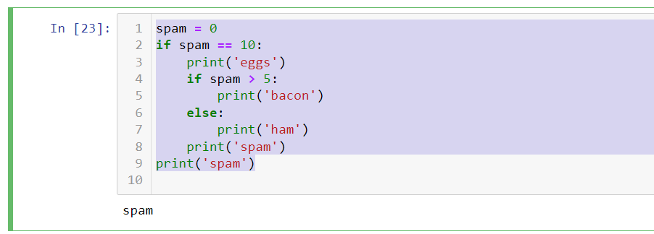

8. Write code that prints Hello if 1 is stored in spam, prints Howdy if 2 is stored in spam, and prints Greetings! if anything else is stored in spam.

Answer 8:

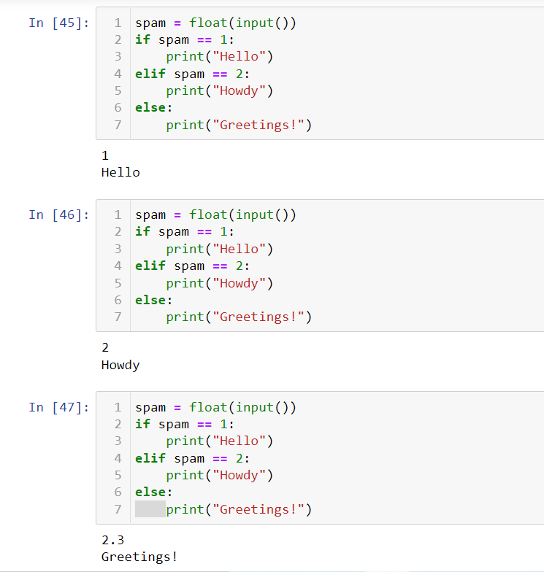

9.If your programme is stuck in an endless loop, what keys you’ll press?

Answer 9:

**CTRL C**

10. How can you tell the difference between break and continue?

Break is used to stop the execution of the loop at a specific condition and control exits from the loop. While the continue skips the execution and control remains inside the loop.

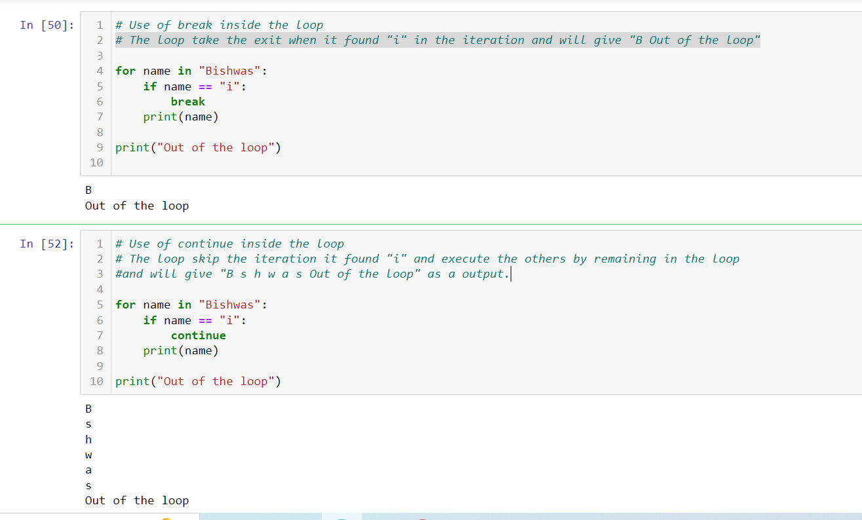

11. In a for loop, what is the difference between range(10), range(0, 10), and range(0, 10, 1)?

Answer 11:

Range(10) means first 10 integers.

Range(0,10) means defining the integer range from 0 to 10. (10 not included in the result)

Range(0,10,1) means defining the integer range from 0 to10 at every 1 step.

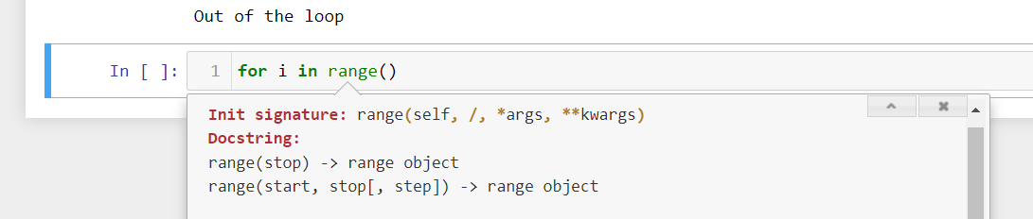

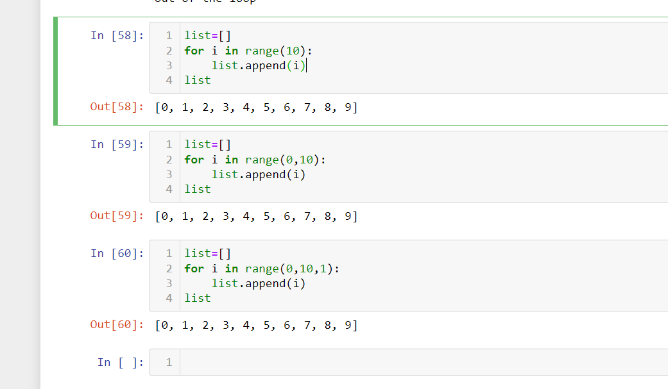

12. Write a short program that prints the numbers 1 to 10 using a for loop. Then write an equivalent program that prints the numbers 1 to 10 using a while loop.

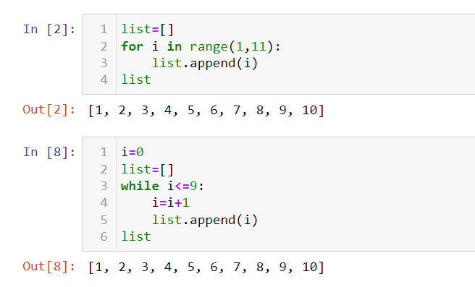

13. If you had a function named bacon() inside a module named spam, how would you call it after importing spam

Answer 13: Spam.bacon()