1. Why are functions advantageous to have in your programs?

Answer1:

Advantages of functions:

1. Reusability
2. Readable
3. Structured
4. Multiple Inputs, Multiple outputs

Functions helps to code the program in blocks and make it more readable, structured and reusable. Can also have multiple inputs and outputs.

2. When does the code in a function run: when it's specified or when it's called?

Answer2:

The function is specified when we need to define the function to operate. To execute the function we call.

3. What statement creates a function?

Answer 3:

A function created by using “def”.

def function():`

4. What is the difference between a function and a function call?

Answer 4:

A function is a set of instructions provided in a body, either with parameters or not. While the function call executes the function by passing the arguments.

Function:- def func(a,b):

return a+b

Function call:- func(4,3)

The output is 7.

5. How many global scopes are there in a Python program? How many local scopes?

Answer 5:

There is total 4 scopes in python and one is global scope. Variables that are defined outside the function body or in the main body of the python have global scope. We can also define the global variable by mentioning global before the variable, anywhere in the function. The value assigned to the variable inside the function having local scope.

6. What happens to variables in a local scope when the function call returns?

Answer 6: The variable still exist in the function with the local scope and on calling the function, it returns the local scope.

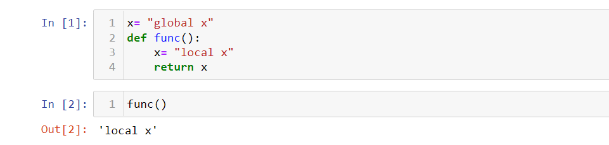

7. What is the concept of a return value? Is it possible to have a return value in an expression?

Answer 7:

The return calls the function when the function execute its expression. If there is logical meaning of putting return in an expression then it is definitely possible to add the return value in an expression.

8. If a function does not have a return statement, what is the return value of a call to that function?

Answer 8:

On calling the function, it will not return any value and the type of the function will be none

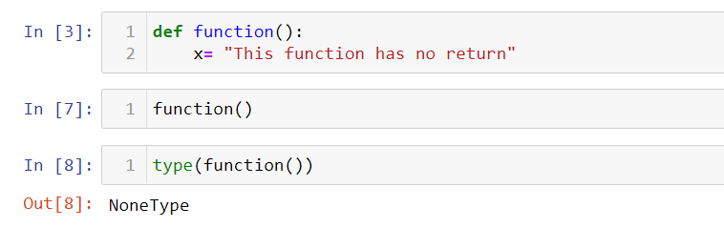.

9. How do you make a function variable refer to the global variable?

Answer 9:

By using global keyword.

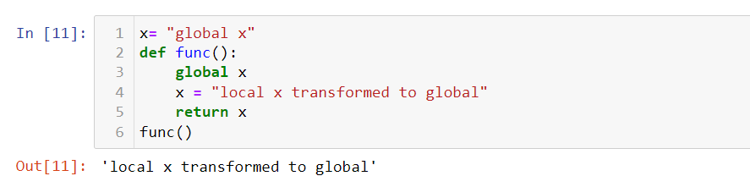

10. What is the data type of None?

Answer 10:

Type.

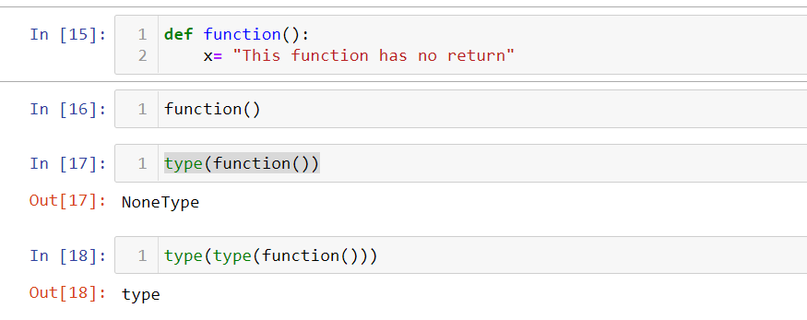

11. What does the sentence import are all your pets name deric do?

Answer 11: The import helps to get the module. Initially it searches in the local directory and import that in the code.

12. If you had a bacon() feature in a spam module, what would you call it after importing spam?

Answer 12: It will be called as spam.bacon()

13. What can you do to save a programme from crashing if it encounters an error?

Answer 13: I should use the exception handling technique.

Try, except, else and finally.

14. What is the purpose of the try clause? What is the purpose of the except clause?

Answer 14: Try keeps the body of the code, that is going to be executes. If there is possibility of any exception, then that can be handle by except.