1. What exactly is []?

Answer: This is list.

1. In a list of values stored in a variable called spam, how would you assign the value 'hello' as the third value? (Assume [2, 4, 6, 8, 10] are in spam.)

Answer: spam[2]=”hello”

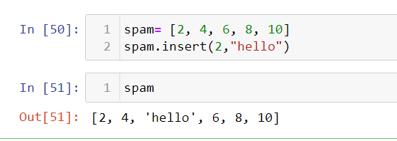

Let's pretend the spam includes the list ['a', 'b', 'c', 'd'] for the next three queries.

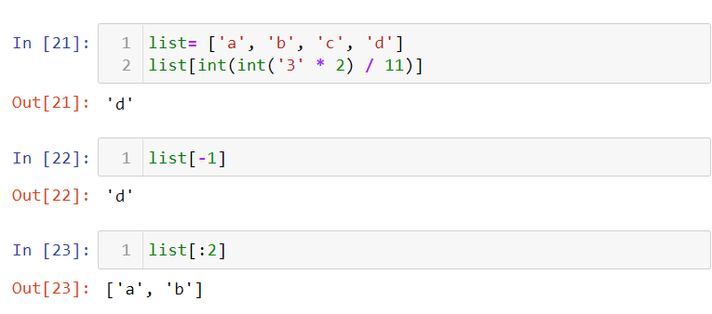

1. What is the value of spam[int(int('3' \* 2) / 11)]?

Answer: ‘d’

1. What is the value of spam[-1]?

Answer: ‘d’

1. What is the value of spam[:2]?

Answer: [‘a’,’b’]

Let's pretend bacon has the list [3.14, 'cat,' 11, 'cat,' True] for the next three questions.

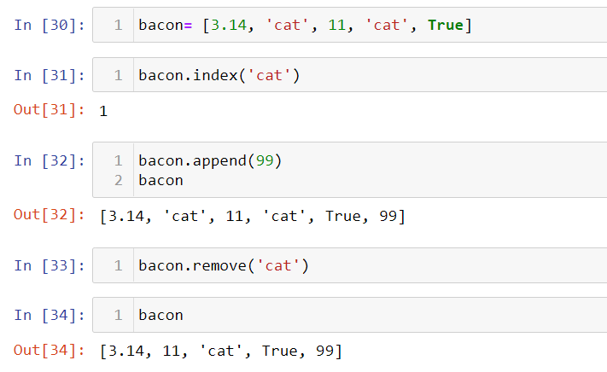

1. What is the value of bacon.index('cat')?

Answer: 1

1. How does bacon.append(99) change the look of the list value in bacon?

Answer: Added 99 at the end of the list.

1. How does bacon.remove('cat') change the look of the list in bacon?

Answer: ‘cat’ removed from the second index.

1. What are the list concatenation and list replication operators?

Answer: list concatenation operator: +

list replication operators: \*

1. What is difference between the list methods append() and insert()?

Answer: By using insert, we can add the value in the list at any index we want. But the append adds the value at the last index of the list.

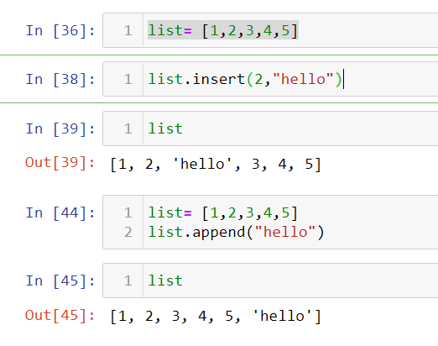

1. What are the two methods for removing items from a list?

Answer: list.pop(), list.remove().

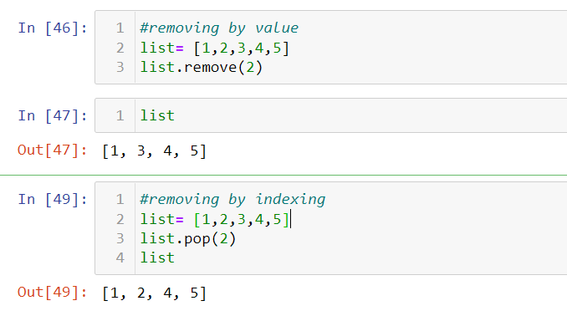

1. Describe how list values and string values are identical.

Answer: List and string both are used to store value /data and both are sequence.

1. What's the difference between tuples and lists?

Answer: Lists are mutable: values can be added, removed or updated.

Tuples are immutable: values can’t be changed.

1. How do you type a tuple value that only contains the integer 42?

Answer: tuple= (42,)

1. How do you get a list value's tuple form? How do you get a tuple value's list form?

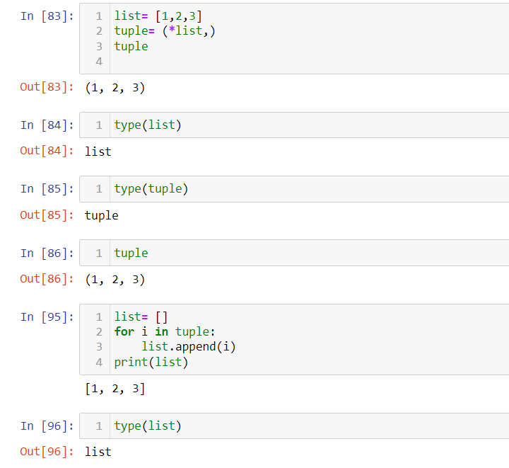

1. Variables that "contain" list values are not necessarily lists themselves. Instead, what do they contain?

Answer: All datatypes can be contained in the list.

1. How do you distinguish between copy.copy() and copy.deepcopy()?

Answer: Copy creates another reference to each element and deepcopy copies the data of an object recursively.

Copy.deepcopy() takes more time than copy.copy().