1. What does an empty dictionary's code look like?

Answer: dict= {}

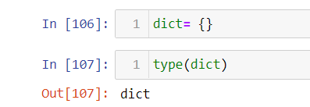

1. What is the value of a dictionary value with the key 'foo' and the value 42?

Answer: dict= {“foo”:42}

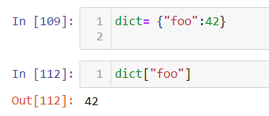

1. What is the most significant distinction between a dictionary and a list?

Answer: list is the collection of index values while dictionary is a hashed structure of keys and values.

1. What happens if you try to access spam['foo'] if spam is {'bar': 100}?

Answer: spam[‘bar’] gives the result 100 while spam[‘foo’] is giving keyerror.

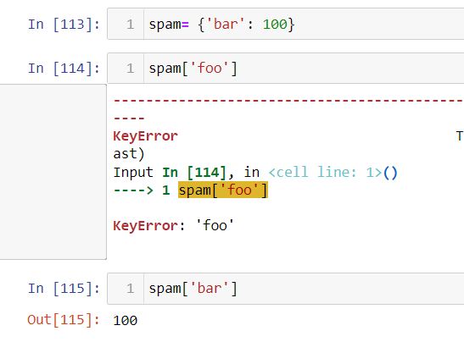

1. If a dictionary is stored in spam, what is the difference between the expressions 'cat' in spam and 'cat' in spam.keys()?

Answer: There is no difference. The in operator checks whether a value exists as a key in the dictionary.

1. If a dictionary is stored in spam, what is the difference between the expressions 'cat' in spam and 'cat' in spam.values()?

Answer: 'cat' in spam checks whether there is a 'cat' key in the dictionary, while 'cat' in spam.values() checks whether there is a value 'cat' for one of the keys in spam.

7. What is a shortcut for the following code?

if 'color' not in spam:

spam['color'] = 'black'

Answer: spam.setdefault('color', 'black') then the result is “black”.

8. How do you "pretty print" dictionary values using which module and function?

Answer: pprint.pprint()