1. What are escape characters, and how do you use them?

Answer: Escape characters represent characters in string values that would otherwise be difficult or impossible to type into code.

1. What do the escape characters n and t stand for?

Answer: \n is a newline and \t is a tab.

1. What is the way to include backslash characters in a string?

Answer: \\.

1. The string "Howl's Moving Castle" is a correct value. Why isn't the single quote character in the word Howl's not escaped a problem?

Answer: The single quote in Howl's is fine because we’ve used double quotes to mark the beginning and end of the string.

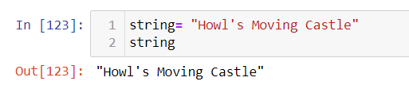

1. How do you write a string of newlines if you don't want to use the n character?

Answer: Multiline strings allow you to use newlines in strings without the \n escape character.

6. What are the values of the given expressions?

'Hello, world!'[1]

'Hello, world!'[0:5]

'Hello, world!'[:5]

'Hello, world!'[3:]

Answer: ‘e', 'Hello', 'Hello', 'lo world’.

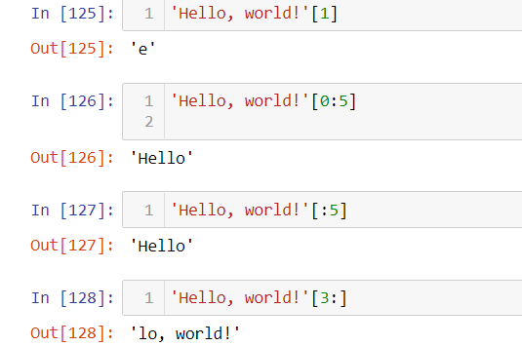

7. What are the values of the following expressions?

'Hello'.upper()

'Hello'.upper().isupper()

'Hello'.upper().lower()

Answer:

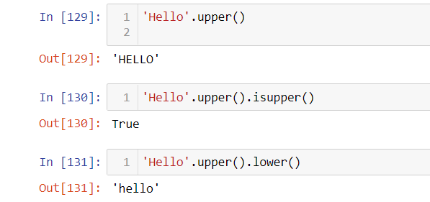

8. What are the values of the following expressions?

'Remember, remember, the fifth of July.'.split()

'-'.join('There can only one.'.split())

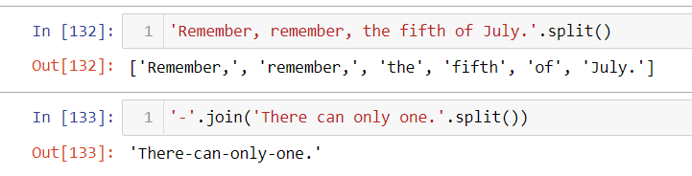

9. What are the methods for right-justifying, left-justifying, and centering a string?

Answer: The rjust(), ljust(), and center() string methods, respectively.

10. What is the best way to remove whitespace characters from the start or end?

Answer: The lstrip() and rstrip() methods remove whitespace from the left and right ends of a string, respectively.