# **Study of the Status of Hydroelectricity in Nepal**

A PROJECT WORK SUBMITTED FOR THE PARTIAL FULFILLMENT OF THE k REQUIREMENT FOR THE GRADE 12 SCIENCE IN PHYSICS

By:

Bishwas Poudel

Grade: 12

Section: MA2

ID: 26853



Trinity International SS & College

Dillibazaar Height, Kathmandu

Falgun, 2080

i

# **CERTIFICATE OF APPROVAL**

The project work entitled “Study of the Status of Hydroelectricity in Nepal” by Mr.Bishwas Poudel, under the supervision Mr. Ajay Shakya and Mr. Roshan Hona of Trinity International SS & College, is hereby submitted for the partial fulfillment of requirement of Physics in Grade 12. This project work has not been submitted in any other school or institution previously for award of Grade 12.

Mr. Roshan Hona

Supervisor

The Department of Physics

Mr. Ajay Shakya

Supervisor

The Department of Physics

–

Mr. Jivan Panta

Head of Department

The Department of Physics

ii

**DECLARATION**

I, Bishwas Poudel hereby declare that the project work entitled “Study of the Status of Hydroelectricity in Nepal” under the supervision the Physics department of Trinity International SS and College is done originally by me and not been submitted from elsewhere for the award of any degree. All sources of information have been specifically acknowledged by reference to the authors or institutions.

Bishwas Poudel

iii

# **RECOMMENDATION LETTER**

This is to certify that the project work entitled “Study of the Status of Hydroelectricity in Nepal” has been carried out by Bishwas Poudel as a partial fulfillment of Grade 12 in physics under my supervision. To the best of knowledge, this work has not been submitted to any other purpose in this institute. I, therefore recommend the project work report for appraisal.

Mr. Ajay Shakya

Supervisor

The Department of Physics

Mr. Roshan Hona

Supervisor

The Department of Physics

–

Mr. Jivan Panta

Head of Department

The Department of Physics

iv

# **Acknowledgements**

I would like to express my gratitude to my supervisors, Mr. Ajay Shakya and Mr. Roshan Hona for their admirable cooperation, inspirable guidance, their continuous support and valuable suggestions throughout the process of project work.

Furthermore, I would like to express my sincere gratitude to all my teachers, friends, college staff who directly or indirectly helped me in completion of the study and skill development.

Specially, I would like to express my gratitude to the head of department, Mr. Jivan Panta for all the support and homely environment throughout the work.

Additionally, I would like to thanks to all my family members and all my relatives for their unconditional support. Lastly, I would like to thanks to all the respondents, who provided me the accurate first hand, data for my research work.

v

**Table of Contents**

**Cover Page i**

**Certificate of Approval ii**

**Declaration iii**

**Recommendation Letter iv**

**Acknowledgements v**

**Table of Contents……………..…………………………………………………………………………………………………..vi**

**Abstract…………………………………………………………………………………………………………………………………1**

**Introduction …………………2-3**

**Objective: 4**

**Materials and Methods: 5**

**Results and Discussion 6-13**

**Conclusion: 14**

**References: 15**

vi

**Abstract:**

This study was conducted to analyze the situation of hydroelectricity and its potential in Nepal. Nepal, by the virtue of the Himalayas, has over 6000 fast flowing rivers and rivulets from which hydropower can be generated. This project explores what can be done to accelerate the hydropower generation in Nepal and provides suggestions for improvements based on real data of previous projects and geographical arrangement.

1

**Introduction:**

Hydropower, or hydroelectric power, is a renewable source of energy that generates power by using a dam or diversion structure to alter the natural flow of a river or other body of water.

Hydropower relies on the endless, constantly recharging system of the water cycle to produce electricity, using a fuel water--that is not reduced or eliminated in the process. There are many types of hydropower facilities, though they are all powered by the kinetic energy of flowing water as it moves downstream. Hydropower utilizes turbines and generators to convert that kinetic energy into electricity, which is then fed into the electrical grid to power homes, businesses, and industries. There are several types of hydroelectric facilities; they are all powered by the kinetic energy of flowing water as it moves downstream. Turbines and generators convert the energy into electricity, which is then fed into the electrical grid to be used in homes, businesses, and by industry.

**Generation of Hydroelectricity:**

In the generation of hydroelectric power, water is collected or stored at a higher elevation and led downward through large pipes or tunnels (penstocks) to a lower elevation; the difference in these two elevations is known as the head. At the end of its passage down the pipes, the falling water causes turbines to rotate. The turbines in turn drive generators, which convert the turbines mechanical energy into electricity. Transformers are then used to convert the alternating voltage suitable for the generators to a higher voltage suitable for long-distance transmission. The structure that houses the turbines and generators, and into which the pipes or penstocks feed, is called the powerhouse.

Hydroelectric power plants are usually located in dams that impound rivers, thereby raising the level of the water behind the dam and creating as high a head as is feasible. The potential power that can be derived from a volume of water is directly proportional to the working head, so that a high-head installation requires a smaller volume of water than a low-head installation to produce an equal amount of power. In some dams, the powerhouse is constructed on one flank of the dam, part of the dam being used as a spillway over which excess water is discharged in times of flood. Where the river flows in a narrow steep gorge, the powerhouse may be located within the dam itself.

2

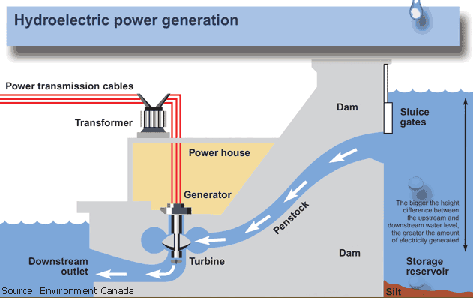

Fig: Hydropower Generating Mechanism

3

# **Objectives**:

* To properly introduce hydroelectricity
* ﻿﻿﻿To know the basics of how energy transmissions take place.
* To learn the current situation of the hydroelectricity in Nepal
* ﻿﻿﻿To find the problems regarding hydroelectricity in Nepal and offer sustainable solutions.

4

# **Materials** **and** **Methods**:

1. **Field data Collection Methodology:**

Data was collected from documents and research papers as well as technicians on the hydropower plants and the people that live around it in order to get a real sense of what the facts are.

**Primary data collection:**

The primary data were collected by the following ways:

1. Documents written on Hydropower in Nepal
2. Interview with technicians

**Secondary data collection:**

Various publications such as books, project reports, journals, government reports and ______ websites were used as a means of secondary data.

1. **Data Analysis:**

MS-office was used to analyze the primary and secondary data along with table charts and figure as required.

5

**Results and Discussion:**

**History of Hydropower and its Start in Nepal:**

Hydropower has been used since ancient times to grind flour and perform other tasks. In the late 18th century hydraulic power provided the energy source needed for the start of the Industrial Revolution. At the beginning of the 20th century, many small hydroelectric power stations were being constructed by commercial companies in mountains near metropolitan areas. Grenoble, France held the International Exhibition of Hydropower and Tourism, with over one million visitors. By 1920, when 40% of the power produced in the United States was hydroelectric, the Federal Power Act was enacted into law. The Act created the Federal Power Commission to regulate hydroelectric power stations on federal land and water.

The history of hydropower development in Nepal began on May 22, 1911 (9

Jestha 1968 BS) by installing 500 kW electricity at Pharping named as Chandra Jyoti. After 25 years, long duration, Prime Minister Dev Shamsher initiated 640 kW, Sundarijal Hydropower plant with a capacity of 900 kW in 1936.

Sundarijal, hydroelectricity development in Nepal was once again stalled for decades. Some years later, Morang Hydropower Company established in 1939and completed construction of third Letang hydropower plant with an installed capacity of 1800 kW in AD 1943 under public-private partnership

Its benefits are that it is non-polluting in the sense that it releases no heat or harmful gases, it has low operating and maintenance cost, its technology offers reliable and flexible operation, and hydropower stations have increased efficiencies along with long life. Nepal's huge potential in hydropower is still untapped. Though Nepal has not yet been able to tap even one percent of its potential electricity capacity and 60 percent of Nepal's population is still deprived of electricity, it is fascinating to note that Nepal's start in 1911 in the hydropower generation almost dates back to a century. As a cheap, renewable source of energy with negligible environmental impacts, small hydropower has an important role to play in Nepal's future energy supply.

**Potential of Hydroelectricity in Nepal and its Current Status:**

Nepal's river has a storage capacity of 202,000 million m3, which includes about 74% amount from three major rivers, Koshi, Gandaki, and Karnali. Geographically, perennial nature of rivers estimated an annual runoff accounting up to 170 billion m3 that flows from steep gradient and rugged topography and estimated 45,610 MW, feasible for hydropower generation which is equivalent to 50% of the total theoretical potential of 83,290 MW. The hydropower system is dominated by run-of-river schemes in Nepal while storage schemes have been benefited to control flood, provide irrigation facility, drinking water supply, navigation, recreation, tourism, aquaculture, and generate revenue.

6

The source of energy shares from a conventional source in Nepal is 87% as a significant share of electricity and renewable energy with 56.1% households have access of electricity Hydropower is the main source of energy in Nepal, nearly 90% installed capacity and 90% generation of electricity. Nepal Electricity Authority (NEA) has a total installed capacity of about 746 MW and 26 MW operating from mini and micro hydropower plants in the hills and mountains of Nepal. There is a significant energy deficit due to the poor economic and instable government to continue the electricity supply. However, the country has three strategic considerations for exploring large-scale hydropower like storage types of projects, to fulfill country's required demands through installation of medium sized projects and finally small hydropower projects targeting to fulfill demand of the local communities

The hydropower potential of Nepal's river systems is about 83,000 MW. Hydropower utilization is currently less than one per cent of the proven potential. The total installed hydroelectric generation capacity is around 650 MW. This power has been made available to 2.053.259 consumers through 1980 km of transmission and distribution lines (2011 data).

The national grid represents the overall hydroelectricity industry of Nepal as it accounts for almost 98 per cent of the capacity and 99 per cent of the energy supplied. Apart from national grid, both the public and private sectors and independent power producers manage isolated supply systems. At present there are 11 major hydroelectric plants, 16 grid connected small hydroelectric plants, 23 isolated small hydroelectric plants, 22 Private Sector Hydro Projects known as Independent Power producers (IPPs) connected to Integrated Nepal Power System (INPS) in operation in the country. During 2010/11 Nepal Electricity Authority (NEA) signed Power Purchase Agreements (PPAs) worth 714.77 MW, which was almost double the total capacity of power purchase agreement signed in the past. Total capacity of power purchase agreement signed by NEA so far has reached 1,18,35 MW. There are 4 major hydro power projects under construction and 8 small scale hydropower projects under 10MW being developed by IPPs.

Electricity prices in Nepal had been kept too low and below cost-recovery levels in the past in absence of adequately independent regulatory regime. However, NEA was able to generate an operating profit in 2018 due to actions taken in the recent past including bringing an end to load-shedding. controlling operational expenses, and implementing financial reform measures. Low average price of imported electricity also contributed to the profitability. Yet, NEA still has about NRs10 billion in cumulative losses. Nepal's water resources endowments are extraordinary. It endows approximately 6,000 rivers with a total length of 45,000 kilometers (km). Average water runoff from these rivers is about 220 billion cubic meters annually. Based on the water resources availability, Nepal's technical potential for hydropower has been estimated to be 83 gigawatts (GW). However, all the technically potential water resources cannot be developed due to other constraints. Hence, about 42 GW is considered economically viable.

7

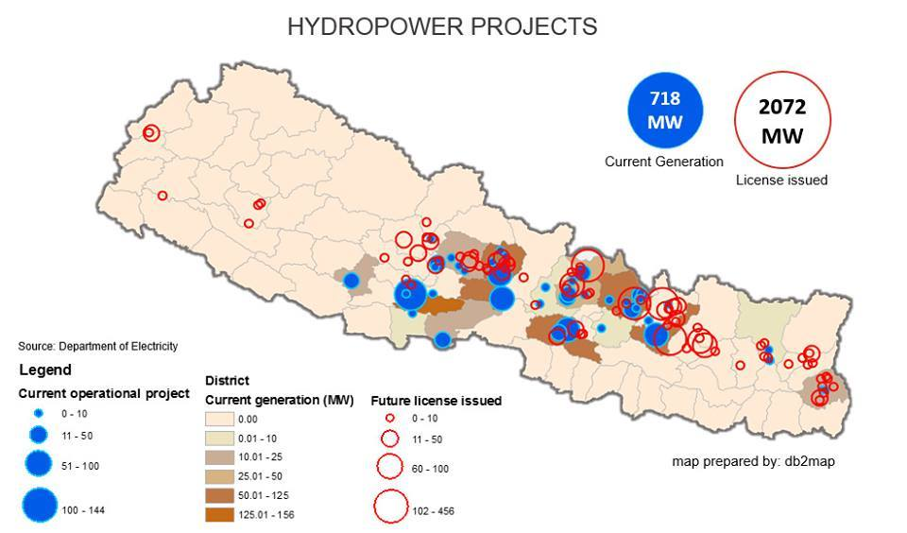



Hydropower Projects in Nepal (2016, NEA)

**Hydroelectricity Generation in Recent Years (2021- 2023):**

During the 2022, 20 hydropower projects larger than 1 MW have started commercial production. According to the data of the Department of Electricity Development, the total capacity of these projects connected to the national transmission in the fiscal year 2022/23 is 466 MW.

The largest hydropower project completed in the 2022 fiscal year is the 86 MW Solu Khola (Dudh Koshi) project. This project built by Sahas Urja Limited is in Solukhumbu district. Similarly, the 54 MW Super Dordi ‘B’ Hydropower Project in Lamjung district was also completed in the last fiscal year.

The 44 MW Super Madi project in Kaski district and the 38.46 MW Upper Kalanga Gad Hydroelectric Project in Bajhang were also completed in the same year. The 36 MW Upper Balephi and 28.1 MW Lower Likhu Hydropower Projects were also completed in the last fiscal year.

The Dordi Khola Hydropower Project of 27 MW capacity and the Upper Dordi ‘A’ of 25 MW capacity were also completed last year. Similarly, the 19.8 MW Upper Solu Khola and 18 MW Madhya Modi projects also started commercial production in the last fiscal year.

Dordi-1 with a capacity of 12 MW and Chepe Khola with a capacity of 8.63 MW also started commercial production in the same year. Similarly, the production of 4.96 MW Puwa 2, and 9.5 MW Mid Solu Khola has also started this year.

8

In 2023, 15.33 MW Kalanga Gad, 4.55 MW Upper Machha Khola, 4.72 MW Upper Piluwa Khola, 10 MW Makri Gad, 5 MW Rukum Gad and 14.9 MW Maya Khola hydropower projects have started commercial production.

Currently, 141 projects across the country are producing hydropower commercially, according to the department.

In the country, the total capacity of hydropower projects alone is 2,551 megawatts. By incorporating solar, cogeneration, alternative energy promotion centers, and less than 1-megawatt capacity diesel plants, the total power generation capacity has now reached 2,784 megawatts.

The department of electricity is said to anticipate that in the ongoing fiscal year, the construction of hydropower projects of around 900 MW in capacity will be completed.

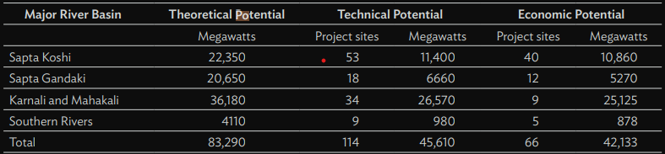

Fig: Generating potential of 4 major rivers

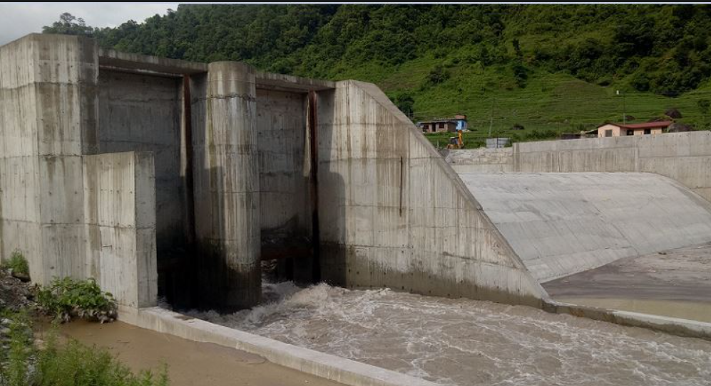

Fig: Dordi Khola Hydropower Project

9

**Benefits and Importance of Hydroelectricity:**

* Clean fuel source, since hydropower is fueled by water. Therefore, it doesn’t pollute the environment.
* Domestic source of energy, so each state or province can produce their own energy without relying on international fuel sources.
* Renewable power source, which is more reliable and affordable than fossil fuels.
* Hydropower plants can provide power to the grid immediately, and provide back-up power during major electricity outages.
* Hydroelectricity increases the stability and reliability of electricity systems.
* It is a reliable source of energy.
* It is a one-time investment as once built it can be used for a long time.

10

**Problems in the Hydropower Sector:**

Though Nepal is rich in water resources there are very few hydropower plants in operation it is because of the following reasons:

* Lack of political will and unstable political condition.
* Lack of capital for investment
* Lack of specialized and highly skilled manpower for its operation and

maintenance.

* Problems caused due to landslides and other natural calamities.
* Inadequate transmission lines and its insufficient capacity.
* Lack of public-private partnership.
* Lack of needed resources for operation and maintenance.

**Solutions to the Problems:**

11

Majority of the problems in the hydroelectricity sector as be solved by active involvement of the general people in the projects and by having a much more stable political situation. Further solutions are stated in precise points as follows:

* Foreign capital investment should be promoted skilled manpower should be produced for this sector.
* ﻿﻿﻿Transmission lines should be upgraded and should reach each household.
* The geographical and region-specific problems should be fixed by the involvement of the locals.

It is to be highly emphasized that the problems in the country absolutely cannot be solved without the people’s involvement and the coordination between them and a fair government.

12

**Summary of the Analysis:**

The total installed generation capacity in Nepal is only 1,182 megawatts (MW) against a peak electricity demand of 1,320 MW in fiscal year 2018–2019. Of this, the Nepal Electricity Authority (NEA) owned 621 MW (generating 34% of total sold electricity) while private investors owned 560 MW of the total installed capacity (generating 29% of total sold electricity). The remaining requirements were satisfied by importing electricity from India (38% of total electricity sale, maximum import of about 596 MW). Electricity generation capacity in Nepal is rapidly increasing. In terms of the recent progress in hydropower development, survey licenses for 302 projects with a total capacity of 15,885 MW have been already issued, out of which 172 projects have secured generation licenses and construction is ongoing for total capacity of 4,642 MW. Power purchase agreements have been completed for 244 projects with total capacity of 4,138 MW.

Twenty percent of Nepal’s economic potential of hydropower is a massive build-up from the existing power generation capacity. As results demonstrate in the next section, Hydro20 is an attractive prospect for Nepal. However, the realization of Hydro20 depends on a number of uncertainties. First and foremost is the degree to which the “20% of potential” goal can be realized in a short span of time. Cost of alternative energy for electricity production is the other important source of uncertainty. Low cost of fossil fuels will reduce the cost effectiveness of hydropower. Very few experts expect falling oil prices as leading energy institutions like the International Energy Agency have sharply increased their trend estimates for oil prices over the last decade. While oil price is expected to increase in the future, it is particularly strange that Nepal heavily depends on fossil fuels for electricity generation despite large endowments of water resources. In this context, hydropower development should provide insurance against oil price increase.

Nepal has not been able to live up to its potential and, now more than ever, it needs to put in collective effort to attain that goal.

13

**Conclusion:**

Nepal has huge potential of hydroelectricity production. It has enough potential to satisfy its own electricity/energy needs and still have plenty left for export which can lead to huge economic gains. However, in the current state Nepal is nowhere close to producing hydroelectricity as per its calculated potential. In the modern world of global warming and depleting natural resources Nepal and its citizen needs to make a collective effort to sustainably develop the hydropower industry.

14

# **References:**

<https://www.adb.org/sites/default/files/publication/612641/hydropower-development-economic-growth-nepal.pdf>

<https://www.investopaper.com/news/dordikhola-hydropower-project/>

<https://english.onlinekhabar.com/new-hydropower-projects-500-mw.html>

https://www.aboutcivil.org/how-hydropower-plant-works.html

15