**PIZZA SALES SQL QUERIES**

**A. KPI’S:**

1. Total Revenue

SELECT SUM(total_price) as TotalRevenue

from pizza_sales

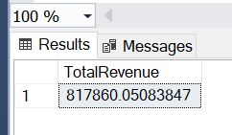

1. Average order value

SELECT SUM(total_price)/Count(DISTINCT order_id) AS AvgOrderValue

from pizza_sales

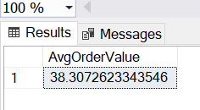

1. Total Pizza Sold

SELECT SUM(quantity) as TotalPizzaSold

From pizza_sales

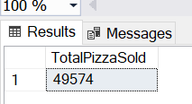

1. Total Orders

SELECT COUNT(distinct order_id) as TotalOrders

from pizza_sales

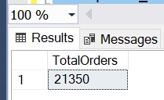

1. Average Pizza per order

SELECT CAST(CAST(SUM(quantity) AS decimal(10,2))/CAST(COUNT(DISTINCT order_id)AS decimal(10,2)) AS decimal(10,2)) AS AvgPizzaPerOrder

from pizza_sales

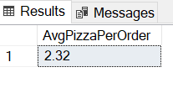

1. **Daily trend for total orders**

SELECT DATENAME(DW,order_date) AS OrderDay, COUNT(DISTINCT order_id) AS TotalOrders

FROM pizza_sales

GROUP BY DATENAME(DW,order_date)

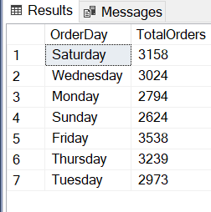

1. **Monthly trends for Total orders**

SELECT DATENAME(MONTH, order_date) AS Month_Name, COUNT(DISTINCT order_id) AS TotalOrders

FROM pizza_sales

GROUP BY DATENAME(MONTH, order_date)

ORDER BY TotalOrders desc

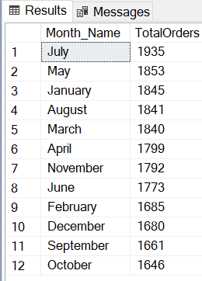

1. **Total Revenue in Percentage by category**

SELECT pizza_category, SUM(total_price)*100/(SELECT SUM(total_price) from pizza_sales) AS TotalRevenuePercentage

FROM pizza_sales

GROUP BY pizza_category

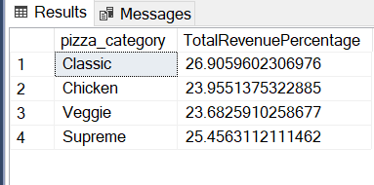

1. **Total Revenue in Percentage by size**

SELECT pizza_size, SUM(total_price) AS TotalRevenue, CAST(SUM(total_price)*100/(SELECT SUM(total_price) from pizza_sales) AS decimal(10,2)) AS TotalRevenuePercentage

FROM pizza_sales

GROUP BY pizza_size

ORDER BY TotalRevenuePercentage DESC

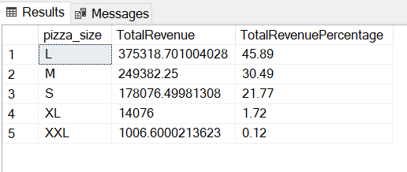

1. **Top 5 pizza by Revenue**

SELECT TOP 5 pizza_name, SUM(total_price) AS TotalRevenue

from pizza_sales

GROUP BY pizza_name

ORDER BY TotalRevenue DESC

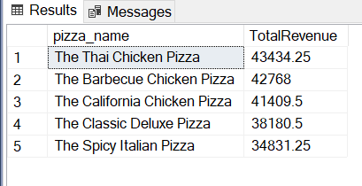

1. **Bottom 5 pizza by revenue**

SELECT TOP 5 pizza_name, SUM(total_price) AS TotalRevenue

from pizza_sales

GROUP BY pizza_name

ORDER BY TotalRevenue ASC

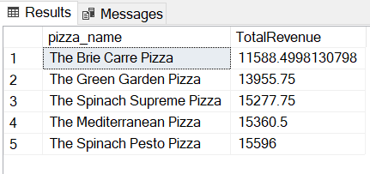

**12. Top 5 Pizzas by Quantity**

SELECT Top 5 pizza_name, SUM(quantity) AS Total_Pizza_Sold

FROM pizza_sales

GROUP BY pizza_name

ORDER BY Total_Pizza_Sold DESC

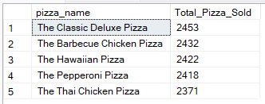

**13.Bottom 5 Pizzas by Quantity**

SELECT TOP 5 pizza_name, SUM(quantity) AS Total_Pizza_Sold

FROM pizza_sales

GROUP BY pizza_name

ORDER BY Total_Pizza_Sold ASC

***Output***

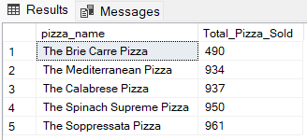

**14.Top 5 Pizzas by Total Orders**

SELECT Top 5 pizza_name, COUNT(DISTINCT order_id) AS Total_Orders

FROM pizza_sales

GROUP BY pizza_name

ORDER BY Total_Orders DESC

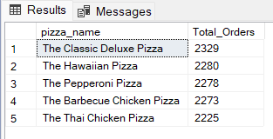

**15. Bottom 5 Pizzas by Total Orders**

SELECT Top 5 pizza_name, COUNT(DISTINCT order_id) AS Total_Orders

FROM pizza_sales

GROUP BY pizza_name

ORDER BY Total_Orders ASC

